main
Analysis and Implementation of a Modified Jansen-Based Walking Mechanism
Design log and kinematic analysis of a reduced-topology, single-DOF leg mechanism
Simulation: https://youtu.be/PFEDmKlTlRk?si=vWkerZGaBaEz1gjp

Abstract
This report documents the design and kinematic analysis of a reduced Jansen-type walking mechanism. The mechanism's core motion-generation subsystem is a crank-rocker four-bar linkage, to which additional links are coupled to shape the foot trajectory. Starting from the standard eight-bar Jansen leg, several links were consolidated or re-routed to simplify the topology while preserving single-degree-of-freedom motion and mimicking a more human-like gait trajectory. The resulting mechanism was implemented in SolidWorks, mirrored to produce a second leg, and coupled to a common input so that both legs move from a single driven crank. Measured link dimensions are compared against the standard Jansen proportions, and the effect of one key dimension on the shape of the foot trajectory is analysed.

1. Introduction
Theo Jansen's linkage is a well-known single-degree-of-freedom, eight-bar planar mechanism that converts rotary input into a leg-like walking trajectory. The objective of this project was to reduce the visual and part-count complexity of the standard Jansen leg — consolidating links where they do not affect the underlying kinematics — while keeping the mechanism at one degree of freedom and retaining a Jansen-like foot trajectory that closely matched human gait. The design was carried out in SolidWorks, using its Motion Study add-in to verify the trajectory and animate the assembled mechanism.

2. Mechanism Overview
The design is a reduced re-interpretation of the standard Jansen leg (Fig. 1), in which several links were merged or removed for compactness without altering the underlying kinematic behaviour.
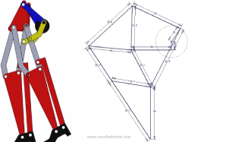
Figure 1. The reduced mechanism (left) alongside the reference eight-bar Jansen linkage it is derived from (right).

2.1 Topology Reduction
- The bottom horizontal link was removed and the two lower-left links were straightened into a single rigid link.
- The upper-right horizontal link and the middle-right link were removed and replaced with one rigid bent link (shown in yellow in Fig. 3), which is a compaction choice rather than a kinematic change.
- Ignoring the foot and the outermost link that drives it, the crank disk becomes the effective ground-mounted driver.
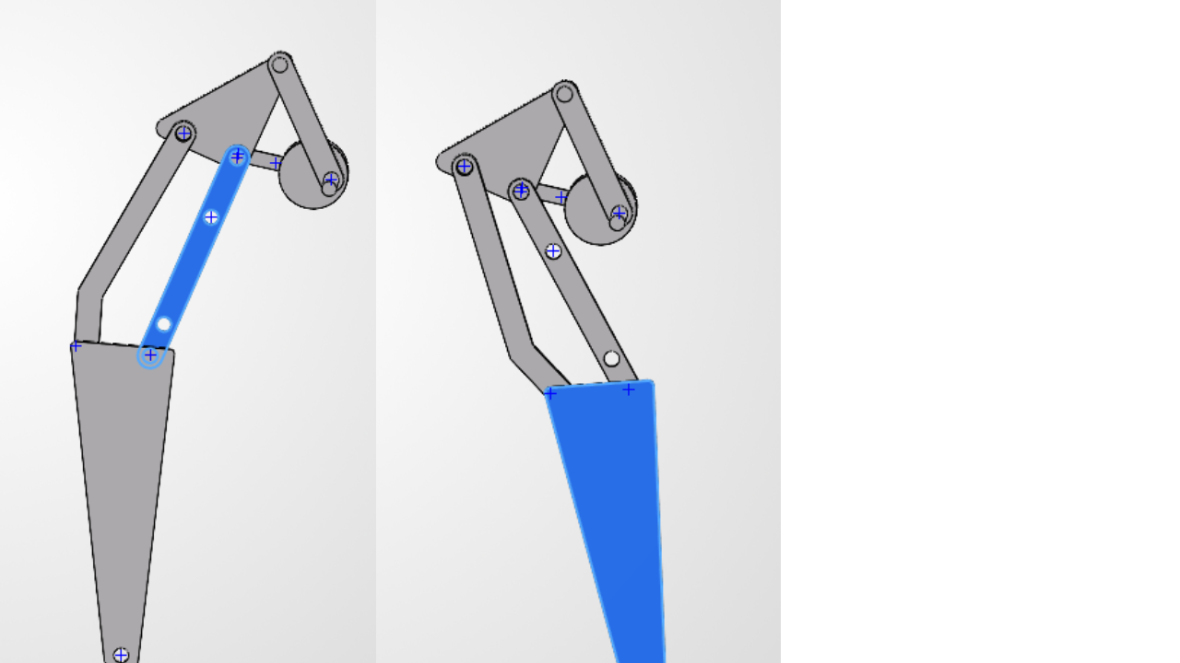
Figure 2. Before (left) and after (right) consolidating the lower-leg links into a single rigid member.
This reduction is visual rather than kinematic: the point where the lower right link meets the ternary (triangular) link is still pinned to the ground in the underlying sketch, even though this is not obvious from the solid geometry alone. The mechanism therefore reduces, functionally, to the same four-bar linkage present in the upper-right portion of the standard Jansen leg.

2.2 The Driving Four-Bar Subsystem
Colour-coding the assembly makes the reduction explicit (Fig. 3): the crank disk (black) rotates about the fixed ground pivot, driving the coupler link (blue), which in turn drives the ternary link (red). The ternary link is itself pinned to ground at a second, fixed point — completing the crank-rocker four-bar. The bent link (yellow) is an output link riding on the ternary link, carrying motion down to the lower leg (grey).
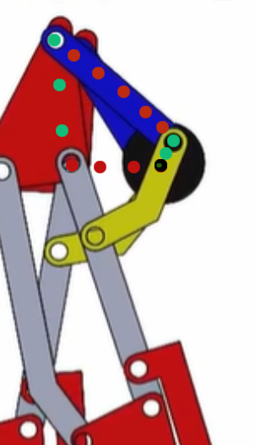
Figure 3. Colour-coded four-bar subsystem — crank (black), coupler (blue), ternary/rocker link (red), and the output bent link (yellow).

3. Methodology
The mechanism was built up incrementally in SolidWorks, verifying at each stage that the added constraints produced the intended single-degree-of-freedom behaviour before proceeding.

3.1 Ground Link and Ternary Link Placement
A disk was used as the ground link. One corner of the ternary link was pinned to this ground link at a separation of 15.8 mm (Fig. 4). The ternary link was chosen as the member fixed to ground because it plays the same structural role as the corresponding rocker link in the upper four-bar of the standard Jansen leg (Section 2.2); the 15.8 mm separation itself was arrived at empirically, by sweeping the dimension and observing its effect on the foot trajectory — this trade-off is examined in Section 4.2.
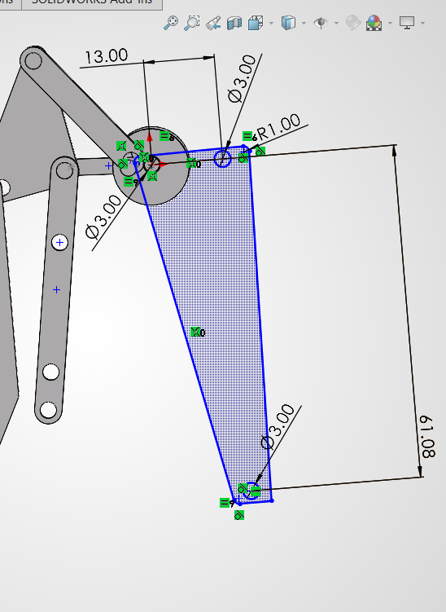
Figure 4. Ternary link sketch showing the fixed-pivot separation and hole geometry.

3.2 Crank–Coupler Assembly
A second disk was added as the crank, driven by a protruding input shaft, and connected to the ternary link through a coupler link (Fig. 5). This sub-assembly is a crank-rocker four-bar mechanism [1], with the crank providing continuous rotary input and the ternary link rocking in response.
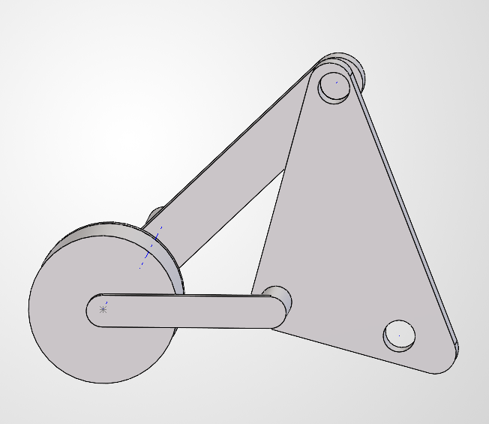
Figure 5. Crank–coupler–ternary link four-bar sub-assembly.

3.3 Constraining the Lower Leg
With only the four-bar and the lower leg links connected, the assembly was under-constrained: each crank angle admitted multiple valid positions for the lower leg. An additional bent link, dimensioned as shown in Fig. 6 (9.86 mm and 12.83 mm segments at 139.31°), was introduced to remove this ambiguity and fully constrain the leg to a single configuration per input angle. The remaining sketch dimensions for this stage of the assembly are given in Fig. 7.
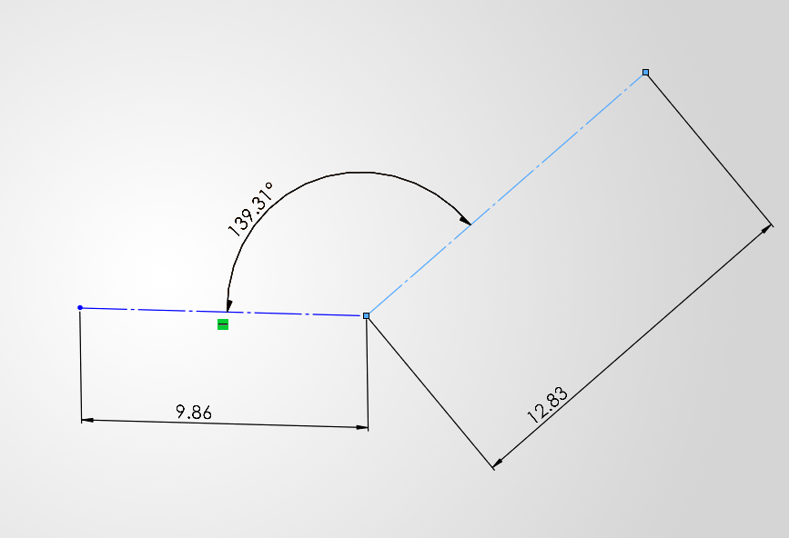
Figure 6. Bent-link geometry added to remove the residual assembly ambiguity.
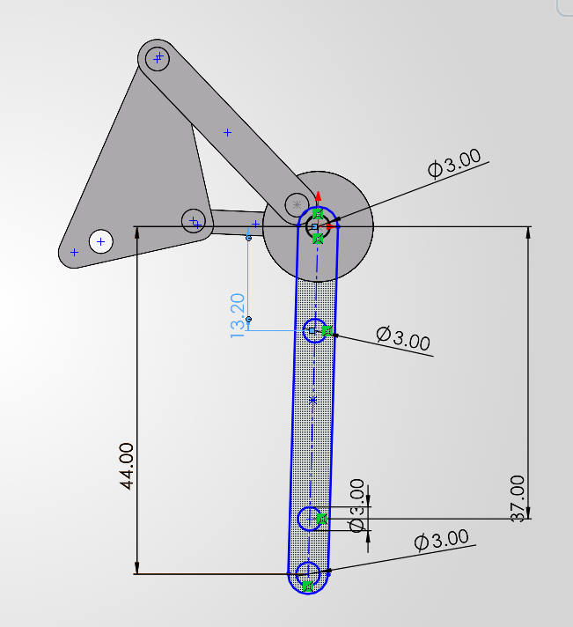
Figure 7. Fully dimensioned four-bar and lower-leg sketch after the additional constraint was applied.

3.4 Leg Assembly, Mirroring, and Coupling
The completed leg was assembled and mirrored using SolidWorks' “create opposite hand components” option, and the mirrored files were saved and reassembled independently. Both legs were then joined by a connecting link (highlighted in blue in Fig. 8), which mechanically couples them to a single common input — keeping the overall mechanism at one degree of freedom while the two legs remain permanently offset by a phase difference. This offset was set experimentally (matching the legs at their extremum positions) to give a more natural walking gait.
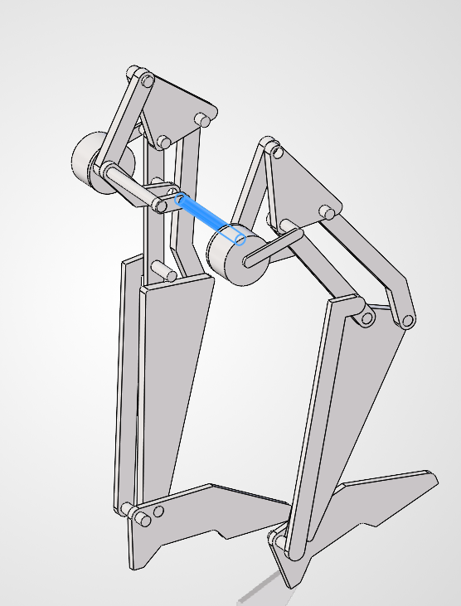
Figure 8. Both legs coupled through a common connecting link (blue), sharing a single driven input.

3.5 Padding and Animation
Foot padding was added to each leg, and the assembly was driven with a simple rotary motor input in a SolidWorks Motion Study to animate the complete walking cycle (see Fig. 10, Section 5).

4. Kinematic Analysis
The modified mechanism retains several dimensional characteristics of the conventional Jansen linkage. Table 1 compares the measured link dimensions of this design against the closest corresponding dimensions of the standard Jansen linkage.
Table 1. Measured link dimensions versus standard Jansen proportions.
Mechanism feature | Measured value (mm) | Closest Jansen value (mm) | Difference
Upper crank / ternary-link connection | 23.24 | 15.0 | +54.9%
Upper fixed-pivot separation | 24.19 | 15.0 | +61.3%
Upper (major) coupler link | 44.02 | 41.5 | +6.1%
Major lower-leg link | 37.92 | 38.0 | −0.2%
Short lower connector | 14.58 | 15.0 | −2.8%
Small connector | 7.39 | 7.8 | −5.3%
Bent-link segment (short arm) | 9.86 | 7.8 | +26.4%
Bent-link segment (long arm) | 12.83 | 15.0 | −14.5%
Long lower-leg dimension | 61.08 | 61.9 | −1.3%
Upper positional dimension | 13.00 | 15.0 | −13.3%
Component offset | 43.17 | 41.5 | +4.0%
The lower-leg dimensions (37.92 mm, 14.58 mm, 61.08 mm) track the standard Jansen values (38 mm, 15 mm, 61.9 mm) closely, to within about 3%. The upper four-bar dimensions, by contrast, deviate substantially — in places by more than 50% — reflecting the deliberate re-proportioning of this stage to accommodate the reduced topology and a more compact envelope.

4.1 Foot Trajectory
The traced path of a point at the centre of the foot's bottom face (Fig. 9) depends on both the input crank angle and the link dimensions and separations described above.
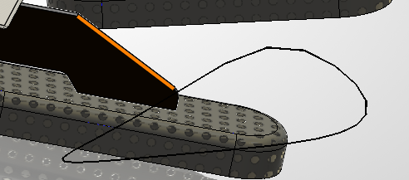
(my mechanism)
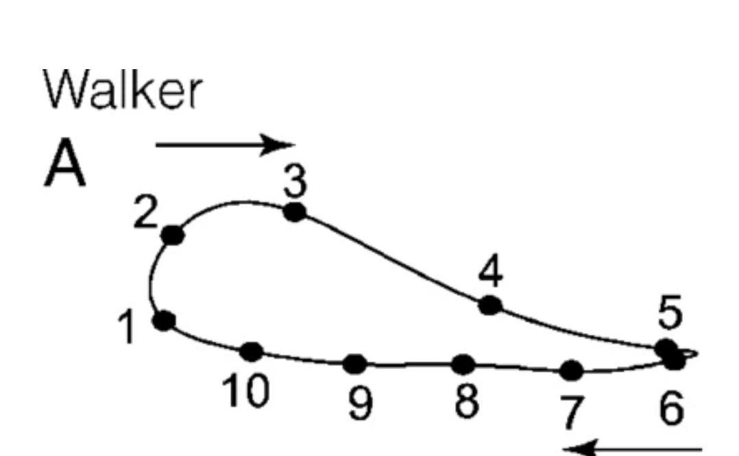
(human gait [7])
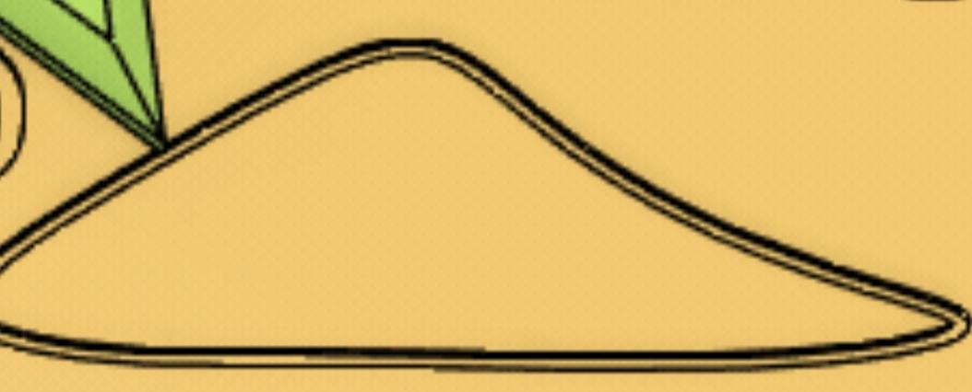
(standard jansen gait[6])
Figure 9. Traced trajectory of the foot contact point over one input revolution. My mechanism vs human walking gait [7] vs standard jansen gait[6]

4.2 Effect of the 15.8 mm Pivot Separation
The separation between the ground pivot and the ternary link (Section 3.1) was found to directly shape the trajectory:
- At 15.8 mm, the trajectory is somewhat front-heavy.
- Increasing the separation moves the path closer to the stretched-D shape of the standard Jansen trajectory.
- Increasing it further makes the trajectory back-heavy.
- Decreasing it too far causes the four-bar to lose continuous rotary motion — consistent with the mechanism moving out of a Grashof-satisfying link proportion, though this was not formally verified against Grashof's condition in this iteration.
The final value of 15.8 mm was retained because it produces a trajectory whose apex sits slightly forward of centre, relative to the standard Jansen path. This was a deliberate design choice, motivated by three considerations: it mimics human stride, where the apex of foot motion typically sits ahead of the body rather than at its midpoint; it reduces the stride length, improving stability and reliability; and it produces a smoother displacement curve, with a more gradual transition from the rising to the falling phase of the stride.

5. Results
The completed assembly was driven with a simple rotary motor input and animated in SolidWorks Motion Study (Fig. 10), confirming that the coupled two-leg mechanism produces continuous, single-DOF walking motion with the intended phase offset between legs.
Simulation video:
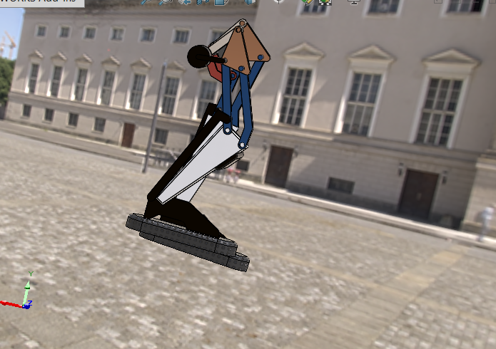
Figure 10. Animated mechanism during a Motion Study walking-cycle simulation.

6. Conclusion and Future Work
The reduced mechanism achieves a Jansen-like walking trajectory with a simplified upper-stage topology, while preserving single-degree-of-freedom motion and close dimensional agreement with the standard Jansen leg in its lower stage. The empirically tuned 15.8 mm pivot separation shifts the foot-trajectory apex forward, giving a more human-like stride at the cost of reduced stride length.
Future work includes: formally verifying the degrees of freedom of the coupled two-leg assembly and the Grashof condition of the driving four-bar using Grübler's equation; quantifying the trajectory sweep described in Section 4.2 with a table or plot of pivot separation versus trajectory apex position; and physically fabricating the mechanism to validate the simulated motion.

References
[1] Four bar crank-rocker mechanism demonstration. https://www.youtube.com/watch?v=hrvIBtrDNV0
[2] Theo Jansen mechanism walking demonstration. https://www.youtube.com/watch?v=clGEbGLUyoQ
[3] Theo Jansen mechanism build/analysis video. https://www.youtube.com/watch?v=vAEZ4BYAmGE&t=120s
[4] The Jansen leg: a 1-degree-of-freedom planar linkage of eight links, seven revolute joints. ResearchGate figure. https://www.researchgate.net/figure/The-Jansen-leg-a-1-degree-of-freedom-planar-linkage-of-eight-links-seven-revolute_fig2_277606519
[5] Educational model of the Theo Jansen mechanism. https://www.printables.com/model/1503557-educational-model-of-theo-jansen-mechanism
[6] Theo Jansen mechanism reference video. https://www.youtube.com/watch?v=FFuDU1Uiu9k
[7] Reference human walker gait – Acceleration carries the local inversion effect in biological motion perception
https://www.researchgate.net/figure/The-full-gait-trajectory-with-the-10-starting-positions-A-and-the-individual-150-ms_fig1_24187266

mechanism description
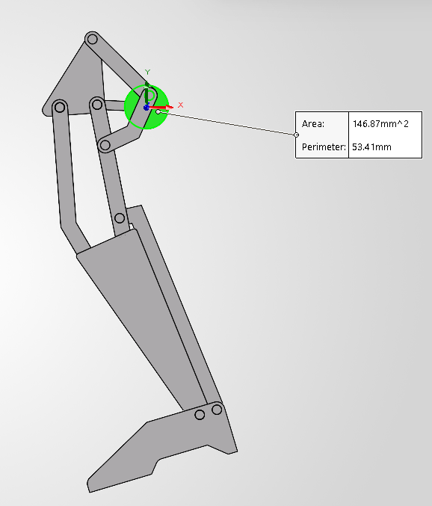

Flipped to the other side→ (for measuring connector from base link to upper ternary):
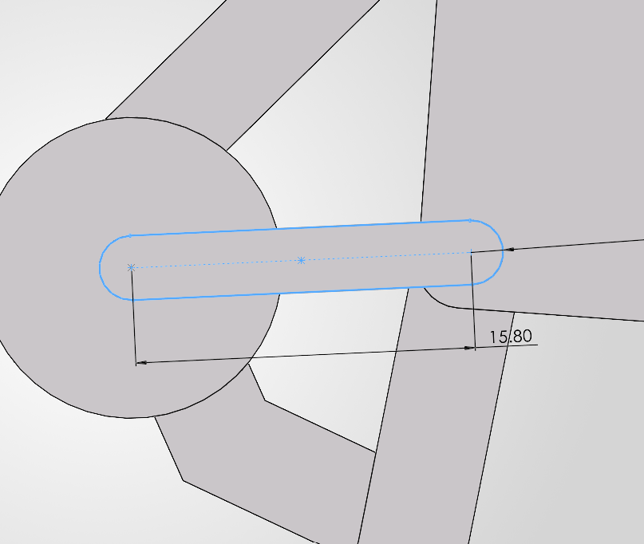
Upper Ternary–
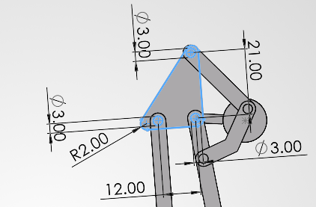

Straight link from upper ternary to lower ternary–
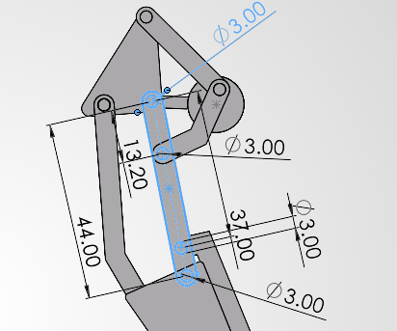
Bent link from upper ternary to lower ternary–
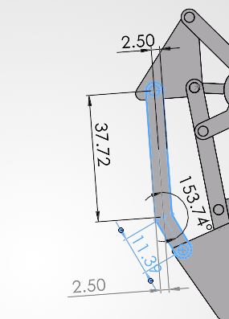
Lower ternary–
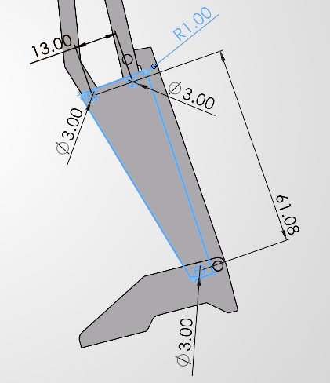
(may ignore R1, it’s just rounded padding for stylistic /visual reasons)

FOOT measurements–

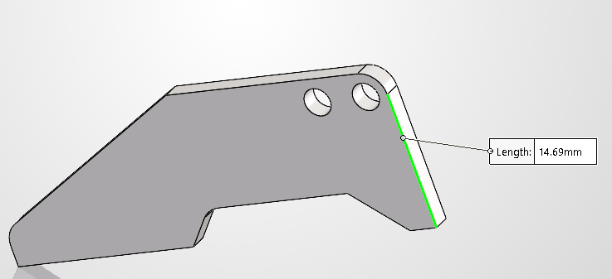
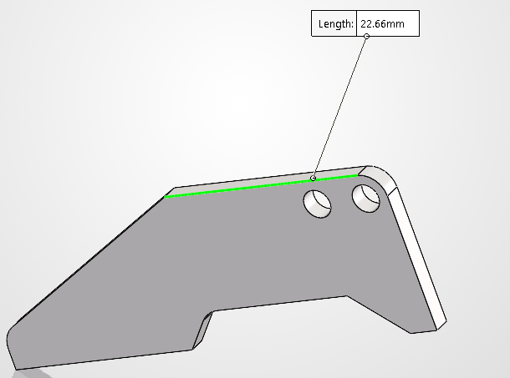
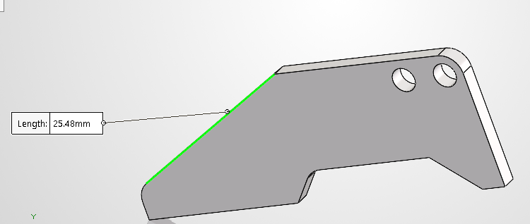
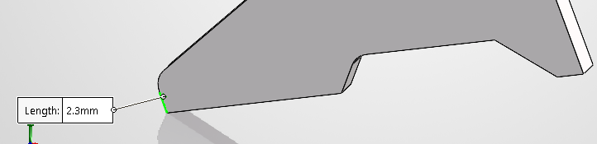
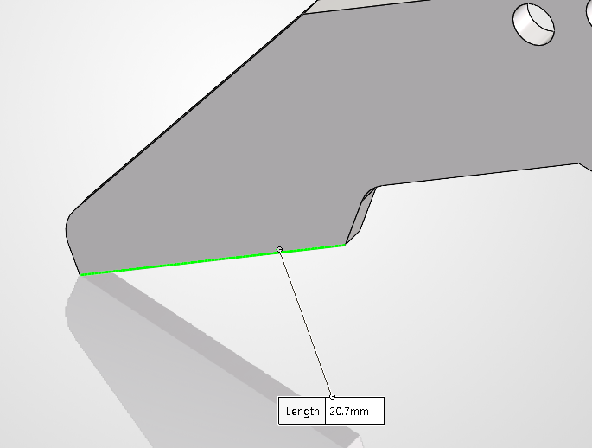
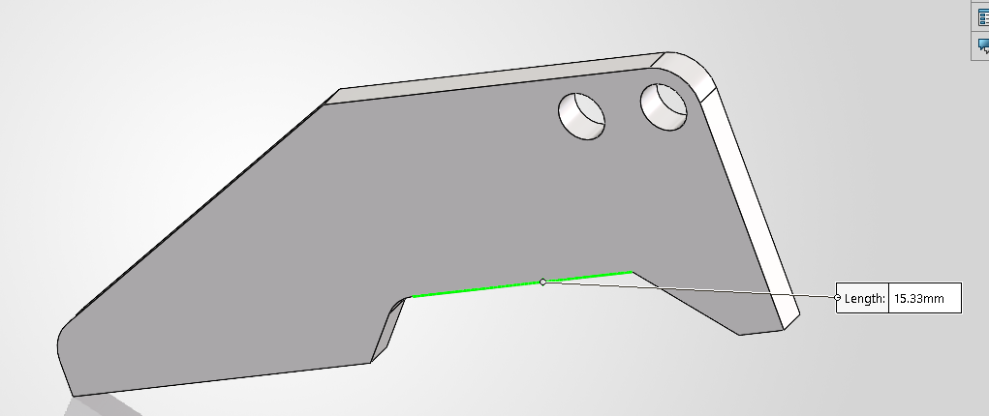
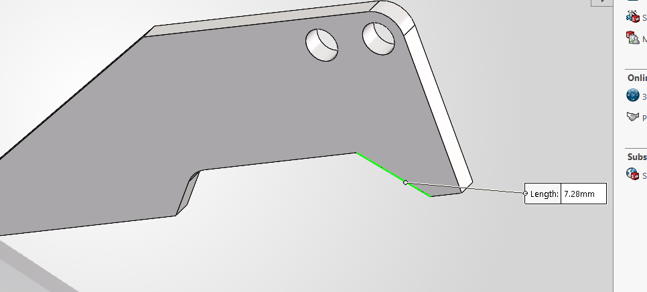
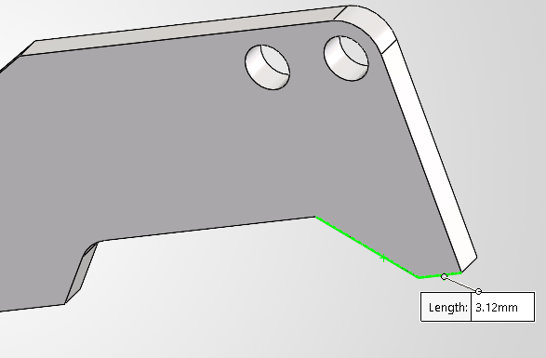

Initial naming schema proposed--
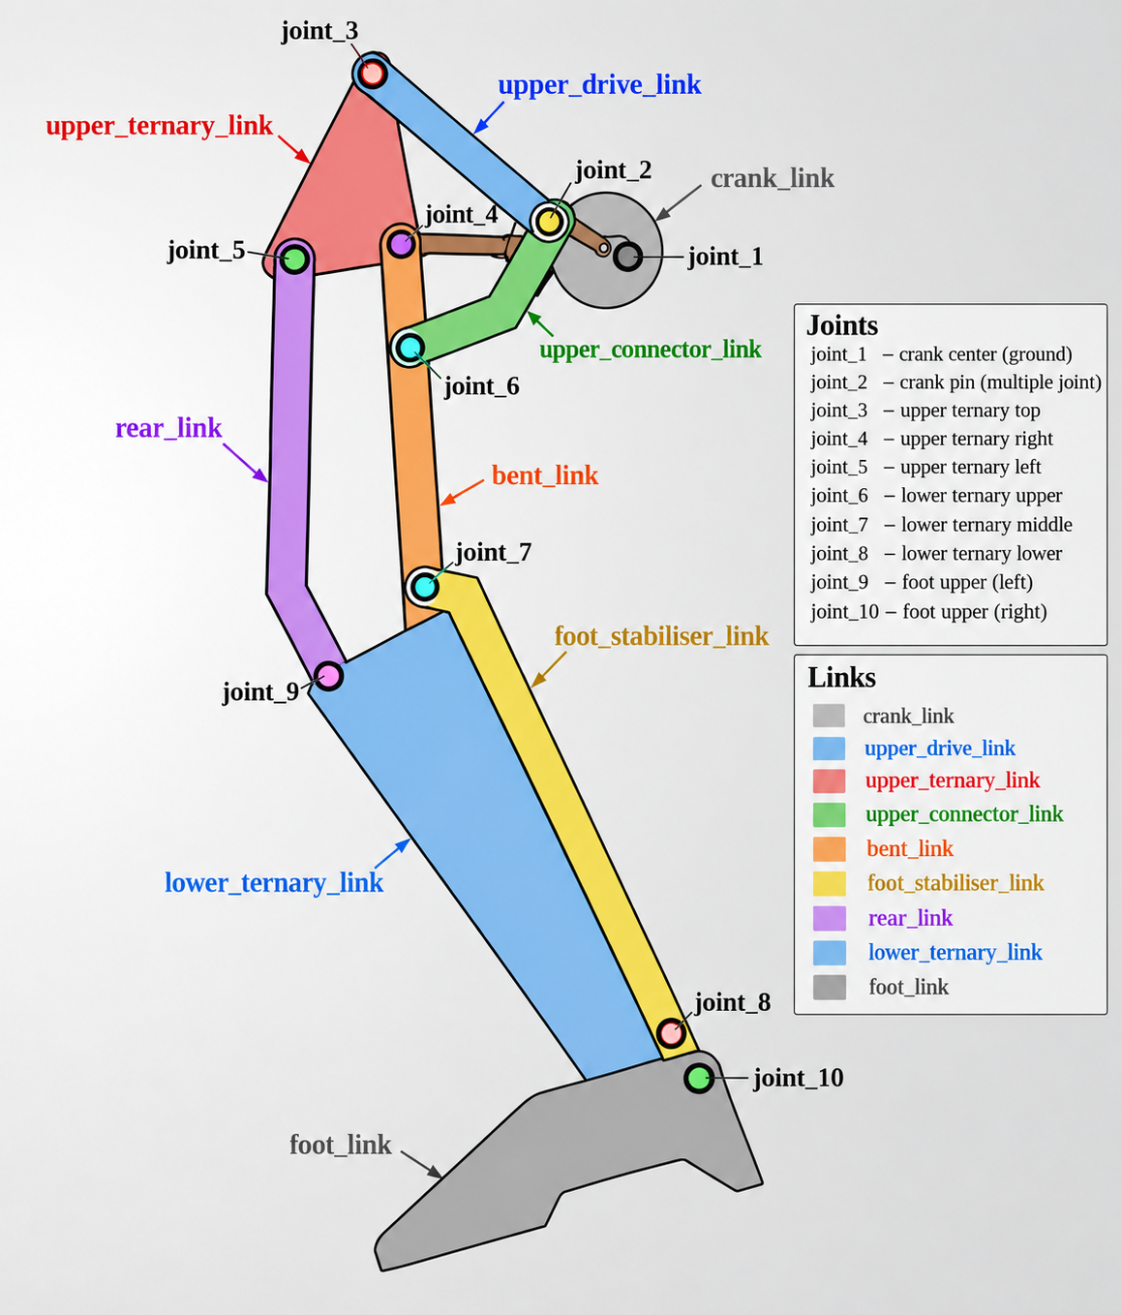

upper_ternary_link:
type: ternary
joints:
- joint_3
- joint_4
- joint_5

distances:
joint_3_joint_4: 21.00
joint_4_joint_5: 12.00
joint_3_joint_5: 24.19

simulation

First we recreate the mechanism using meshes extracted from the solidworks assembly one by one, into mujoco viewer using the native MJCF format. 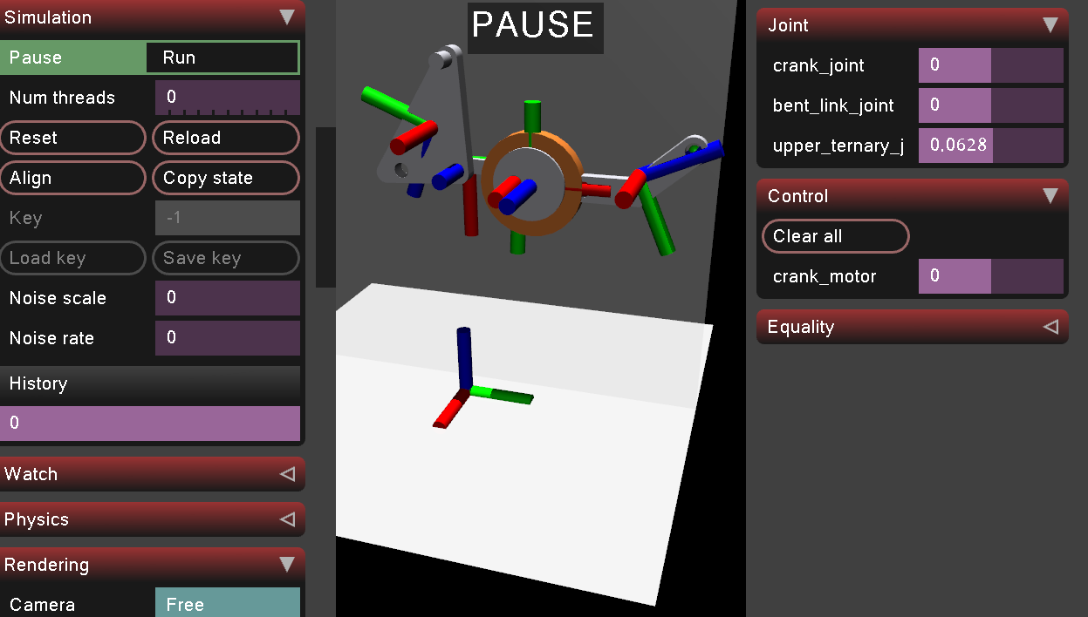
https://github.com/google-deepmind/mujoco/issues/172 : closed loop simulation example (four bar linkage) . – I learnt about equality constraints here.
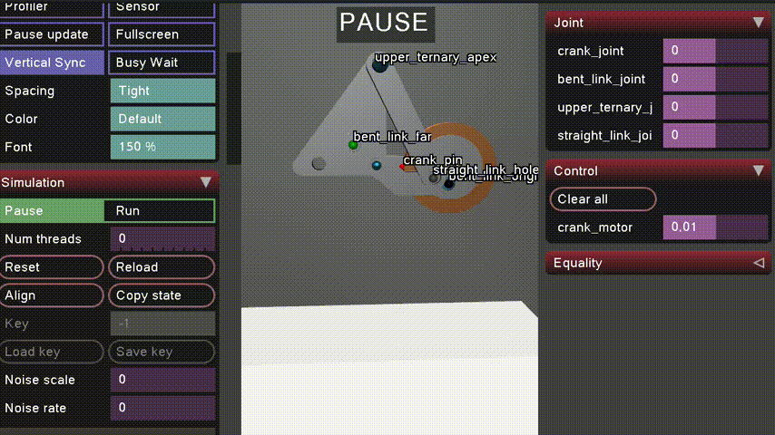
I created joints for parent and child links. For closing the kinematic loops, I used equality tags to connect 2 defined sites (points on links): straight link and base link.
Initially while simulating, I encountered a problem where they did not feel connected and instead felt more like magnets attracting each other.
On further digging, I found out that equality constraints are soft constraints. The solver finds forces that satisfy them, parameterized by impedance d, stiffness k, and damping b. solref controls the reference acceleration, i.e. how quickly the constraint tries to rectify a violation.
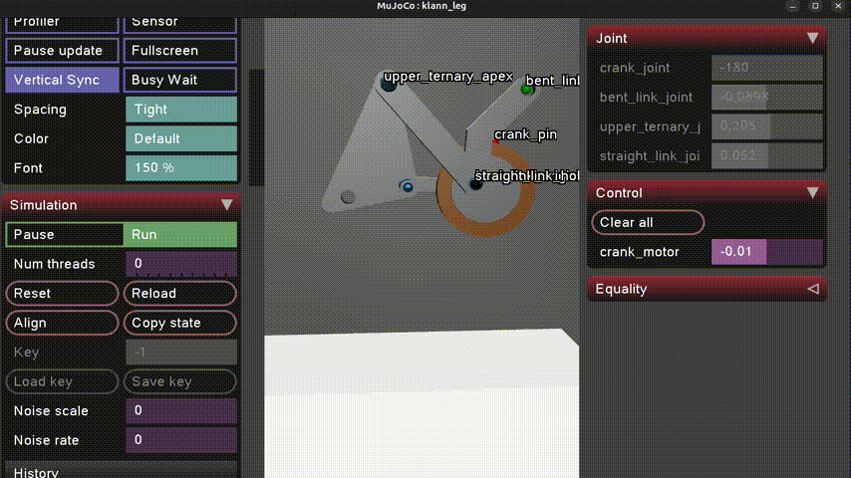

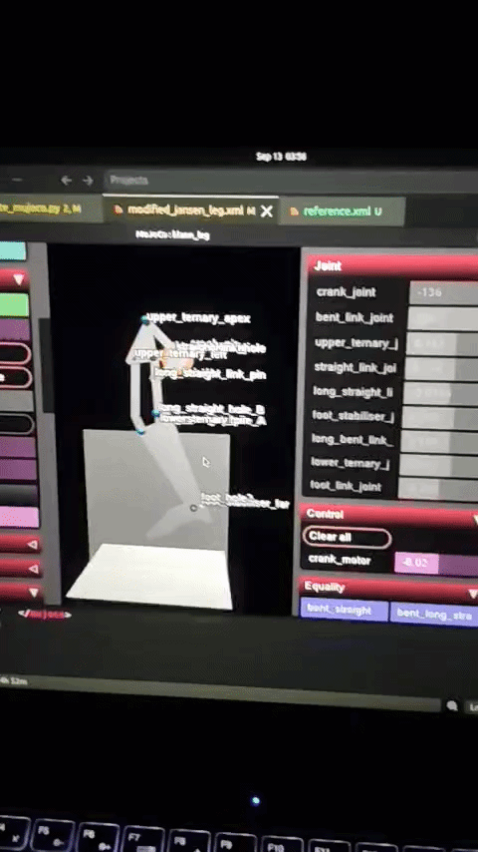

Deformable object as shoe, attempt one–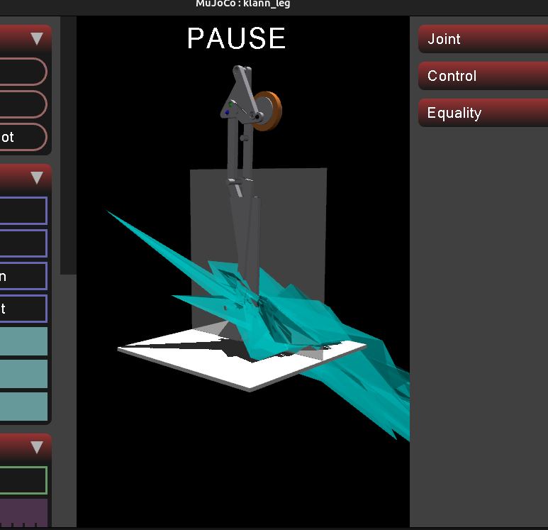

Found stable results when using higher number of nodes. Consequently, scaled the overall system to match foot dimensions to adult foot size.

Next most of the system was stable but the deformable object started passing through the floor
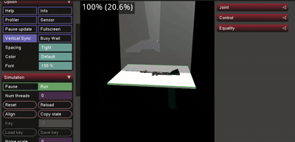

Figured out its approximate young 's modulus and Solref which controls roughly how quickly the constraint tries to correct the penetration,
the damping constant for the dynamics solver that finally worked without breaking the system. Increased the width of the plane to prevent bleeding under high no. of nodes (as found on github issues for mujoco)
young="8e4"
damping="0.001"
poisson="0.2"
solref="0.003 1"
solimp=".95 .99 .0001"

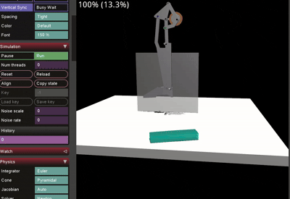
(lowered young’s modulus for visualisation purposes)
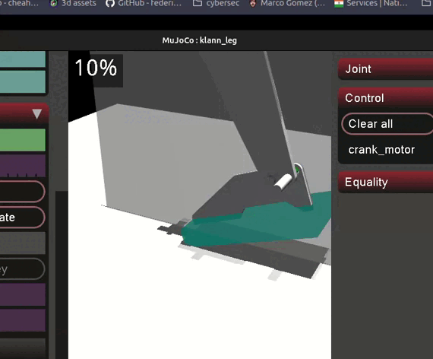
Visually attached the shoe (blue) to the foot link.

To add contact physics, I referred to this paper – https://arxiv.org/html/2411.14701v1

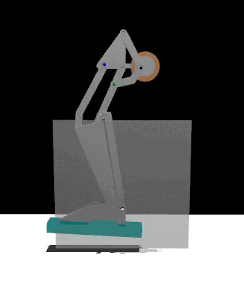
I finalised the dimensions and mass of the links , assuming the links to be aluminum, the shoe to be the mass of the standard adult male shoe (~300g) , the motor’s weight (initially) to be of a standard 1.7N motor.
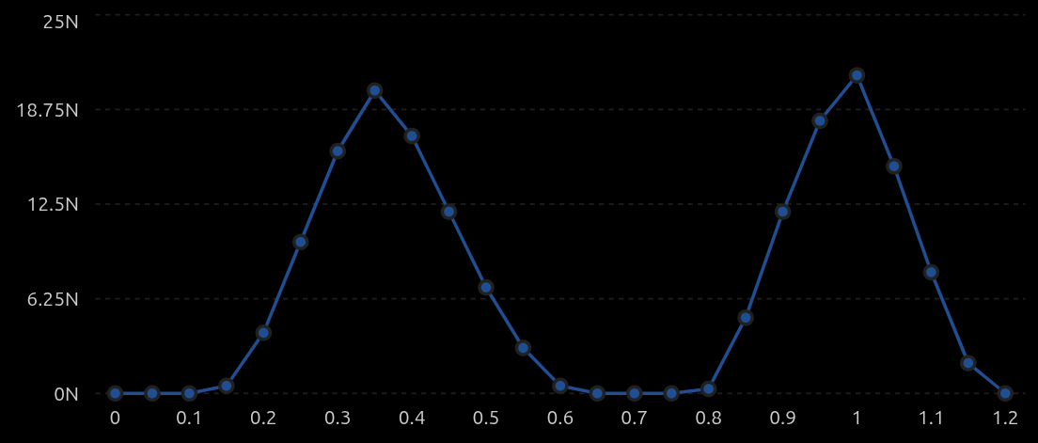
(theoretical contact force-time plot at 0.08N-m torque, FSR under base of big toe)

Proposed hardware –

12 V OG555 geared motor with encoder
ESP32
BTS7960 or any other high power H bridge that can handle the 12V motor
AS5600 (for measuring foot orientation at given time)
MPU6050 (the standard IMU I tend to use in projects involving acceleration measurement)
Adafruit Alpha MF01A-N-221-A05 (Force sensor , rated for 1-100N contact force,<1 ms response, well-compatible mature library for ESP32) – need to use in 3 standard foot contact points (heel , big toe, little toe)
[or alternate– Load cell + HX711]
Mean Well LRS-75-12 psu– 12V 6A adjustable (a good headroom for future add-ons)

Control loop–
┌──────────────────────────┐
│ ESP32 MCU │
│ │
Desired crank speed ───►│ Speed/Position Controller│
│ │ │
└───────────┼──────────────┘
│ PWM / DIR
▼
┌─────────────┐
│ BTS7960 / │
│ H-Bridge │
└──────┬──────┘
│
┌──────▼──────┐
│ 12 V OG555 │
│ Geared Motor│
└──────┬──────┘
│
CRANK
│
┌──────▼──────┐
│ LINKAGE │
└──────┬──────┘
│
FOOT
│
┌───────────────────┼──────────────────┐
│ │ │
Heel FSR Big-toe FSR Little-toe FSR
│ │ │
└───────────────────┼──────────────────┘
│
▼
┌─────────────┐
│ ESP32 │
│ │
│ Contact │
│ detection │
└─────────────┘

Motor encoder ─────────────────────► ESP32
│
AS5600 ────────────────────────────►│
│
MPU6050 ───────────────────────────►│

