**Report of SciPandas**

**Why Use SciPandas?**

There are [many benefits of](https://data-flair.training/blogs/advantages-and-disadvantages-of-python/) SciPandas library, listing them all would probably take more time than what it takes to learn the library. Therefore, these are the core advantages of using this toolbox:

#### **Data representation:** SciPandas provide extremely streamlined forms of data representation. This helps to analyze and understand data better. Simpler data representation facilitates better results for data science projects.

#### **An extensive set of features:** SciPandas provides the user with a huge set of important commands and features which are used to easily analyze your data. We can use SciPandas to perform various tasks like filtering your data according to certain conditions, or segmenting and segregating the data according to preference, etc.

#### **An extensive set of features:** Sci[Pandas](https://pandas.pydata.org/) is really powerful. They provide you with a huge set of important commands and features which are used to easily analyze your data. We can use Pandas to perform various tasks like filtering your data according to certain conditions, or segmenting and segregating the data according to preference, etc.

**Comparision of results between SciPandas and Pandas Library**

**1.Pandas library read functions and dataframe access**

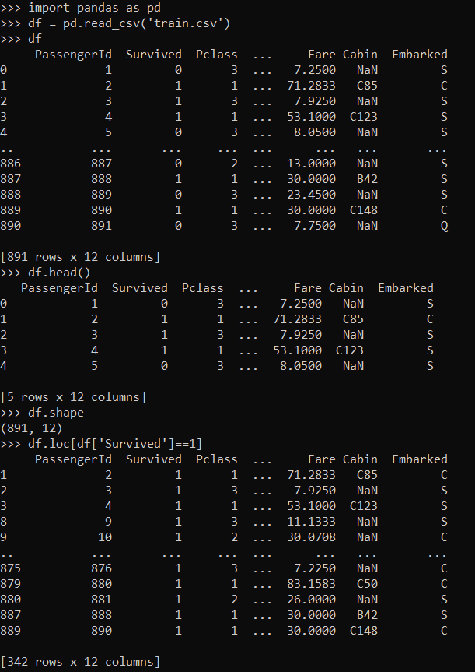

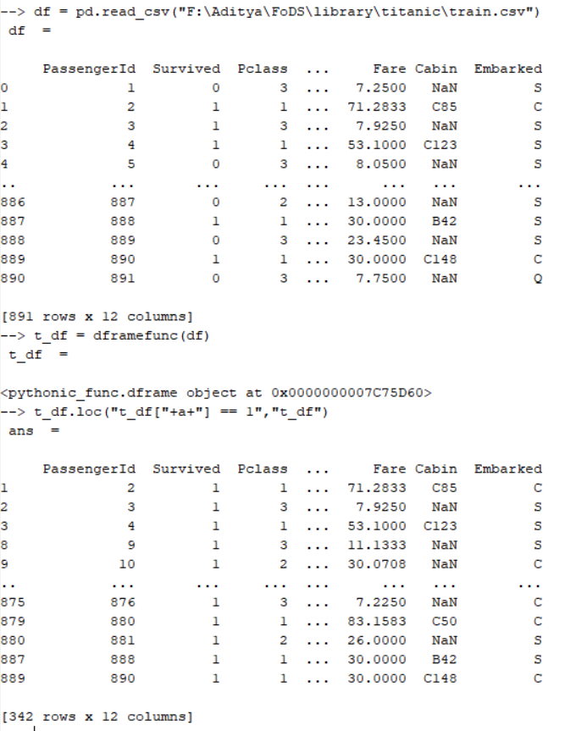

**2. Pandas Library Dataframe creation**

