

DTS-ESB
(Data Tokenization System- Enterprise Service Bus)

Production Guide

V1.30
2015-09-16

Proprietary Information Notice:
This document has been developed and created by CGI. The information contained in this document cannot be used for any other reason than the agreement between CGI and Bell Canada in connection with the processes used to support Bell Canada’s systems.
The recipient of this document, by its retention and use, agrees to hold this document and its content in strict confidence and agrees to protect the same from loss, theft or unauthorized use. This document shall not be copied or communicated to any third party, in whole or in part, by any means, without the prior written consent of CGI. This Proprietary Information Notice is an integral part of this document and shall not be removed or altered.



Revision History
Version | Date | Author | Description
1 Draft 0 | 2012-01-31 | Christine Desjardins | draft
1 Draft 1 | 2012-02-02 | Christine Desjardins | Draft – Updated document with Alan, Ghislain emails.
1 Draft 2 | 2012-02-06 | Christine Desjardins | Draft
1 Draft 3 | 2012-02-06 | Christine Desjardins | Draft
1 Draft 4 | 2012-02-12 | Christine Desjardins | Draft
1 Draft 5 | 2012-02-15 | Christine Desjardins | Application description  Section 7 – call flow and wording
1 Draft 6 | 2012-02-15 | Christine Desjardins | Application description  Section 7 – call flow and wording
1 Draft 7 | 2012-02-16 | Christine Desjardins | Sections 6 – 7 updates
1 Draft 8 | 2012-02-17 | Christine Desjardins | Section 2-6-7-8 – see track changes
1 Draft 9 | 2012-02-23 | Christine Desjardins | Removed paragraph under section 7.3  Updated in application description section 2, section 6.2.12, 3.2.2, 3.5.
1 Draft 10 | 2010-05-10 | Ross Yu | Updated document with the new application name (from ESB-PCI to DTS-ESB)  Updated document for Virgin Enhancements Project
1 Draft 11 | 2010-05-10 | Ross Yu | Updated section 6.2.26 with Equifax contact information
1 Draft 12 | 2010-06-02 | Ross Yu | Updated document with new application name for DTS-PCI (from DTS-PCI to DTS-RTS)
1 Draft 13 | 2010-06-06 | Ross Yu | Updated section 3.2.2 and 4.1
1 Draft 14 | 2010-06-07 | Ross Yu | Updated Figure 1
1 Draft 15 | 2012-07-13 | Pavan Kulkarni | Updated document with BRS R23 Credit Check Service project
1 Draft 16 | 2012-07-17 | Pavan Kulkarni | Updated with comments
1 Draft 17 | 2012-08-08 | Mrinal Chakraborty | Updated with comments
1 Draft 18 | 2012-10-12 | Ross Yu | Added support contacts for Virgin Mobile and eBCCS under section 6.2
1 Draft 19 | 2013-01-03 | Ross Yu | Added reference to Equifax InterConnect for BRS R25  Updated 6.2.27 Equifax contact info
1 Draft 20 | 2013-01-22 | Paul Mak | Added new Bell Mobility Credit Check Service (BMCCS)  - Sections 2.1, 2.3.4, 2.3.6, 3.2.3, 6.1.4, Appendix D
1 Draft 21 | 2013-02-20 | Alan Choy | Add NMO B-SIDE as new consumer to CCAV service  - Sections 2.1, 2.3.2, 2.3.6, 3.2.3 and 6.2.30
1 Draft 22 | 2013-12-16 | Ragavendran Jaganathan | Updated Equifax contact info  - Section 6.2.27
1 Draft 23 | 2014-03-27 | Ragavendran Jaganathan | Updated Equifax contact info  - Section 6.2.27
1.24 | 2014-05-15 | Christine Desjardins | Updates in regards of the Avalanche project:  Added GPS info:  Section 2.1 Description, section 2.3.6 added GPS in interface table, sections 6 and 7.3 added CGI MAS GPS, section 6 updated CSD and IMC contacts tables.
1.25 | 2014-05-20 | Christine Desjardins | Updates : Removed N/A appendix, Replaced all Remedy wording by ITSM and sev 1 & 2 by Critical/high priority, added GPS conceptual Diagram in section 2.3.5, replaced AMS by MAS, updated contacts table for CGI Unix team, CGI Wintel Team, Bell DNSS, Virgin Mobile, CGI MAS eBCCS, and NM1 Amdocs.
1.26 | 2014-05-23 | Christine Desjardins | Updated 6.1.1, 7.4 new links for SLAs and replaced Platinum for Gold, SCM contacts table, section 6.2.15 DNSS contacts table, 6.2.9 and 6.2.10 replaced Remedy by ITSM, 8.3 ITSM table, section added Moneris contacts table, 6.2.3 and 6.2.21 added ticket assignments.
1.27 | 2014-07-29 | Maria Giacomini | Added:  Section 6.1.1: ITSM Configuration  Section 6.2.31 Added Moneris Solution
1.28 | 2014-09-12 | Maria Giacomini | Updated:  Section 2.1: Included Moneris (from deleted Section 2.2)  Section 2.3.7 System Interfaces: Added DTS-ESB GPS Service
 | 2015-04-16 | Alex Ignatius | Production Guide reviewed and no updates required.
1.29 | 2015-07-22 | Alex Ignatius | As part of SLBOS decomm, Removed the SLBOS/CSG entries from Sections 2.1,2.3,2.3.7,2.4,3.2.3,3.4,3.5,6.1.4, 6.2
1.30 | 2015-07-16 | Priti Ranjan Sahu | Update Equifax contact details in Section 6.2.25

Table of Contents
1. Introduction 9
1.1 Document Objective 9
1.2 Document Overview 9
1.3 Document Custodian Group 9
2. System Overview 10
2.1 System Description 10
2.2 Client Community 11
2.3 Environment 11
2.3.1 CCAV Service 12
2.3.2 Credit Check Service 12
2.3.3 Bell Mobility Credit Check Service 13
2.3.4 GPS System Architecture 14
2.3.5 Server Configuration 16
2.3.6 System Interfaces 17
2.3.7 PatchLink 20
2.3.8 ILO With Remote Console Access to Servers 20
2.3.9 McAfee 20
2.3.10 ArcSight 22
2.3.11 Middle-ware patching process 22
2.4 Security Measures 24
3. Production Schedules 25
3.1 Daily Operations 25
3.1.1 Start of Day Operations 25
3.1.2 Intra-Day Operations 25
3.1.3 End of Day Operations 25
3.1.4 Overnight Operations 25
3.2 Periodic Operations 25
3.2.1 Monthly Operations 25
3.2.2 SSL certificate renewal process 26
3.2.3 Virgin, NMO B-SIDE, eBCCS and NM1 username/password will have to be updated for PCI compliance process 26
3.3 Non-periodic Operations 26
3.3.1 Ad Hoc Operations 26
3.4 Operations Backup 27
3.5 Critical Dates 27
4. Application Recovery Procedures 28
4.1 Application Files 28
4.2 Application Interfaces 29
4.3 Application Recovery Steps 29
4.4 Repatriation and Clean Up Steps 30
4.5 Application Recovery Test Plan 30
5. Disaster Recovery Procedures 31
5.1 DR Strategy 31
5.1.1 Strategy Description 31
5.1.2 Data Loss 31
5.2 DR Environment 32
5.2.1 General Information 32
5.2.2 In-scope and Out-of-scope 32
5.2.3 DR Configuration 32
5.3 DR Security Measures 32
5.4 DR Production Schedules 32
5.5 System Files 32
5.6 System Interfaces 32
5.7 Recovery Point Determination 32
5.8 Disaster Recovery Steps 32
5.9 Disaster Recovery Timeline 33
5.10 Disaster Recovery Contacts 33
5.11 Repatriation and Clean Up Steps 33
5.12 Disaster Recovery Test Plan 33
5.12.1 DR Test Strategy 33
5.12.2 Problem logs 33
6. Support Model 34
6.1 Support Scope 34
6.1.1 CGI Tier 2 Service Level Classification 34
6.1.2 In Scope 35
6.1.3 Out of Scope 35
6.1.4 Interfacing Applications 36
6.2 Support Groups 36
6.2.1 CGI CSD (BC/ BM / BDI / BELL TV) – Service Restoration Analysts (SRA) 36
6.2.2 CGI IMC (BC / BM / BDI / BTV) - Service Recovery Specialists (SRS) 37
6.2.3 DTS-ESB Managed Application Services (MAS) 39
6.2.4 CGI Unix Team 40
6.2.5 Software Configuration Management (SCM) 40
6.2.6 Service Management 41
6.2.7 CGI Backup & Restore 41
6.2.8 CGI Wintel Server Support 42
6.2.9 CGI DSO Security Team (McAfee suite) 44
6.2.10 CGI MAS - MPC (Compuware) 45
6.2.11 CGI Patchlink 45
6.2.12 CGI ArcSight GMSS 46
6.2.13 Red Hat 46
6.2.14 Oracle (WebLogic and Oracle Service Bus) 47
6.2.15 Bell DNSS – ICN Support 47
6.2.16 Bell Canada Corporate Security C&M 48
6.2.17 Bell Corporate Emergency Management - National Incident Center 48
6.2.18 Bell NIDS and WAF team 49
6.2.19 CGI EDS Managed Application Services (MAS) 49
6.2.20 CGI CHIP/SLB Managed Application Services (MAS) 51
6.2.21 CGI DTS-RTS Managed Application Services (MAS) 52
6.2.22 CGI GPS Managed Application Services (MAS) 54
6.2.23 IVR – Bell INMC Helpdesk 55
6.2.24 Virgin Mobile Applications (PeopleSoft, Web Activation, Web MyAccount Virgin 55
6.2.25 Equifax 56
6.2.26 CGI MAS eBCCS 58
6.2.27 NM1 and OneBill (aka CSM Conso) - AMDOCS 60
6.2.28 B-SIDE MAS 61
6.2.29 Moneris Solutions 63
6.2.30 BELL Application Owner 65
7. Problem Identification and Resolution: update for Moneris ? 66
7.1 Call Flow 66
7.2 Reporting an Incident 67
Bell TV Interfacing applications’ support teams 67
Bell Canada Interfacing applications’ support teams 67
CGI MAS DTS-ESB Team 67
Monitoring Alarms 67
Security Alarm from NIDS 67
Security Alarm from WAF 67
7.3 Responding to an Incident- 68
3B CGI Helpdesk 68
CGI CSD Helpdesk 68
7.4 Incident Escalation 70
8. Monitoring/Support Tools 71
8.1 Monitoring 71
8.2 OTSS ITSM CI Flagged 71
8.3 ITSM assignments 71
9. Change Management 73
Appendix A - System Messages 74

Introduction

Document Objective
To provide system operators (e.g. support groups) with all the required information to understand, operate and recover the system in the production environment.

Document Overview
This document is intended for the personnel who are responsible for the correct operation of the on-line system and all batch processes within the system. As a reference document, this guide will assist them in performing their tasks, such as inputting the required parameters and verifying the control reports.
This document consists of eight sections that cover the following topics:
System Overview – Short description of the environment (hardware, software, network, etc.) required to run the system.
Production Schedules – Description of the production sequences and their scheduling.
Application Recovery Procedures – Instructions on how to recover following an application or sub-system failure.
Disaster Recovery Procedures – Instructions on how to recover the entire system or subsystem at an alternate site or on different hardware environment following a disaster or major hardware failure.
Support Model – Identification of key support contacts for main System Support functions.
Problem Identification and Resolution – Description of call flow and how to handle various errors generated by the system.
Monitoring/Support Tools – Description of monitoring/support tools or processes.
Change Management – Description of processes and responsibilities to introduce fixes or enhancements to the system.
Appendix A – System messages.

Document Custodian Group
Custody and maintenance responsibility for DTS-ESB Production Guide rests with <enter group name here.
Current Owner | Group | Phone Number | As of Version | As of Date
Ghislain Pepin | MAS | (514) 415-3068 | 1.0 | 2012-02-18

System Overview

System Description

This project is introducing a new instance called DTS-ESB. It will be located in the secure cardholder data environment (CDE). DTS-ESB shall perform the de-tokenization upon request and forward the message to external backend application. Any de-tokenization required shall take place in the CDE environment to comply with the PCI DSS requirements. In other words, DTS-ESB is a new interface between some billing applications that need to communicate with their respective backend application(s) with credit card information. Since these billing applications now have tokens to communicate credit card information, and that their external backend applications do not recognize these tokens; therefore, DTS-ESB would actually be sent the token which would in turn send a request to DTS (Data Tokenization Service) to obtain the corresponding credit card information, and send the information back where need be.
Application will be supported 7/24.
Overall flow between systems that involves DTS-ESB:

For the Virgin Enhancements Project, a new CCAV (Credit Card and Address Verification) service is created in DTS-ESB.
The CCAV service in DTS-ESB shall perform the de-tokenization upon request from Virgin applications. DTS-ESB de-tokenizes the token in the transaction by calling DTS, replaces the token with the credit card number, and calls the Equifax Quick Match service for credit card and address verification. The service will not include any payment functionality.

CCAV Service:
Virgin or bell.ca/NMO B-SIDE (token) ←> DTS-ESB (token) ←> DTS-RTS (PAN) ←> DTS-ESB (PAN) ←> Equifax (PAN)
Note: Tokenization means to convert PAN (PAN is Primary Account Number (i.e. 15 or 16 digits credit card number)) to token, and de-tokenization means to convert token to PAN. Token is a random numerical string which does not have any mathematical relationship with the PAN.

CreditCheckService
CreditScreener(MVS)←→eBCCS(token)←→DTS-ESB(token) ←→DTS-RTS(PAN) ←→ DTS-ESB (PAN) ←→Equifax InterConnect (PAN)
For the BRS R23 Project, CreditCheckService is created in DTS-ESB
The CreditCheckService in DTS-ESB shall perform the de-tokenization upon request from eBCCS. DTS-ESB de-tokenizes the token in the transaction by calling DTS, replaces the token with the credit card number and calls the Equifax InterConnect service. Adding mapping will be done to map the request/response to/from Equifax InterConnect service. The Service will not include any payment functionality
Note: The Equifax InterConnect service which will be used for CreditCheck service.

Bell Mobility Credit Check Service (BMCCS)
NM1 (token) ←→ DTS-ESB (token) ←→DTS-RTS (token) ←→ DTS-ESB (PAN) ←→ Equifax Interconnect (PAN)
The Bell Mobility Credit Check Service is a web service in DTS-ESB, which will be called by NM1 from the Bell Mobility space. BMCCS calls DTS-RTS for credit card de-tokenization, replaces the token with the credit card number, and calls Equifax InterConnect (the Fixed File Format, or FFF, version of InterConnect) for credit check purpose. The service will not include any payment functionality.

GPS:
For GPS application, it specifically process online requests coming from GPS requiring a de-tokenisation step before interacting with Moneris.

GPS (token) ←→ DTS-ESB (token) ←→DTS-RTS (token) ←→ DTS-ESB (PAN) ←→ Moneris (PAN)

Client Community
No direct end users to DTS-ESB. DTS-ESB is a backend interface. BellTV IVR Support Team may get an error message through the IVR application if DTS-ESB has an issue.
For the DTS-ESB: CCAV Service, Virgin Web and Virgin CRM (PeopleSoft) will involve DTS-ESB: CCAV service.

Environment

CCAV Service
The CCAV is a web service in DTS-ESB, which will be called by Virgin or bell.ca via NMO B-SIDE. CCAV calls DTS-RTS for de-tokenization and calls Equifax for credit card and address verification.

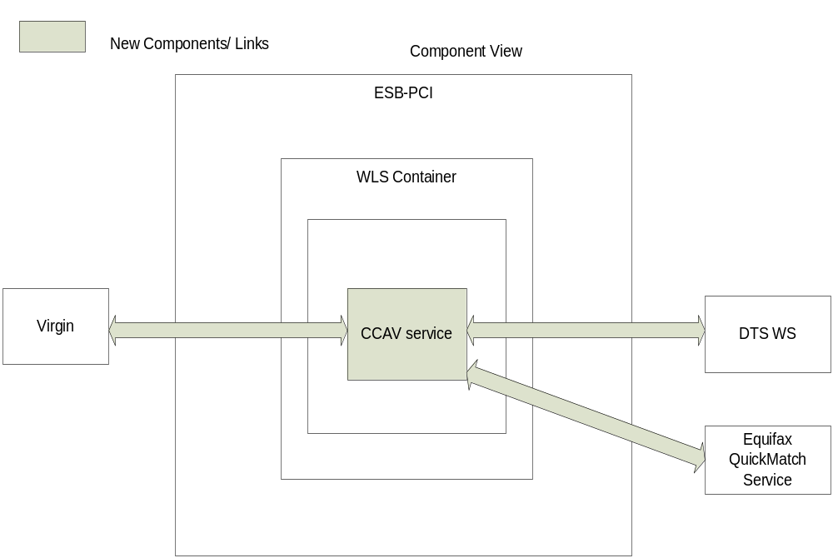

Credit Check Service
The CreditCheckService is a web service in DTS-ESB, which will be called by eBCCS. CreditCheckService calls DTS-RTS for de-tokenization and calls Equifax InterConnect for credit check
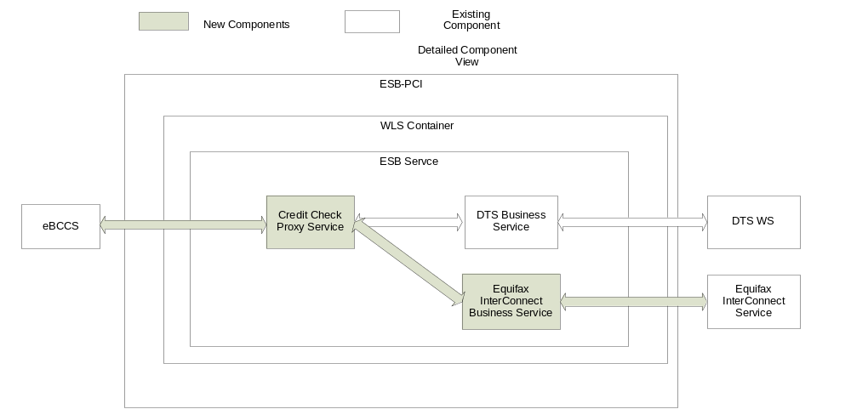
Note: The CreditCheckService will call an intermediate ProcessEnquiry web-service within DTS-ESB, this ProcessEnquiry web-service will redirect the request to Equifax.

Bell Mobility Credit Check Service
The Bell Mobility Credit Check Service is a web service in DTS-ESB, which will be called by NM1. BMCCS calls DTS-RTS for de-tokenization and calls Equifax InterConnect FFF for credit check
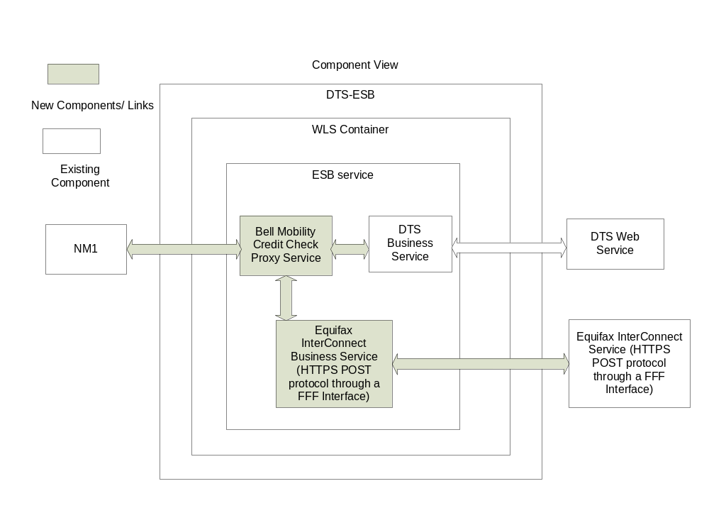

GPS System Architecture
The DTS-ESB is a DTS system component acting as a gateway for DTS service functions required for online interactions with external 3rd parties. For GPS application, it includes an interface to specifically process online requests coming from GPS requiring a de-tokenisation step before interacting with Moneris.
DTS-ESB contacts DTS-RTS for credit information, and DTS-RTS returns the information to DTS-ESB.
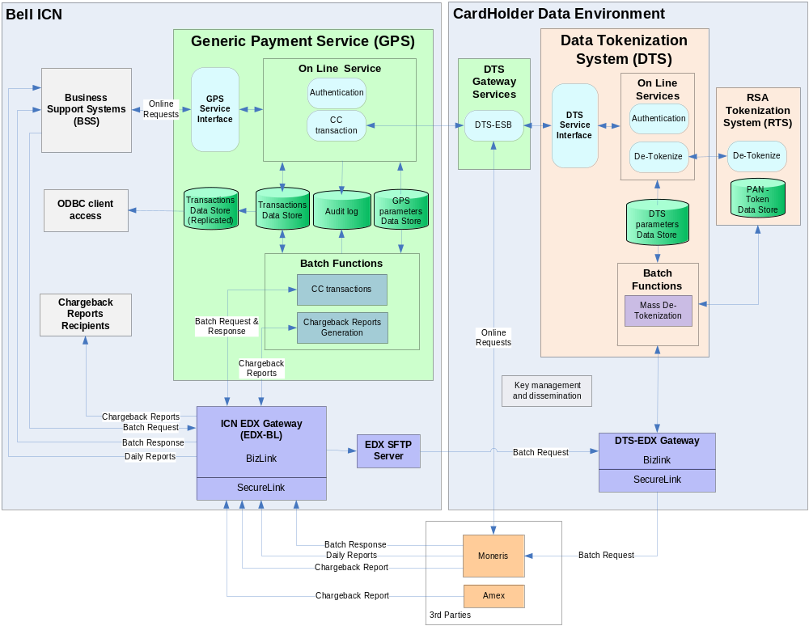

Server Configuration
This section defines the configuration of each component (hardware, software, network) required to install and operate the system.

Hardware | Configuration | Supported by
Production  DC4CFY-D07 (HP DL360 Virtual Machine)  142.117.172.28 / 172.24.75.159  Bouchard, Quebec | 8 GB RAM  120 GB Disk  Linux Red Hat 5.5  WebLogic 10.3.4  Oracle Service Bus 11gR1 | CGI Unix
Production  DM5CE1-D07 (HP DL360 Virtual Machine)  142.182.191.148 / 172.28.199.26  Wynford, Ontario | 8 GB RAM  120 GB Disk  Linux Red Hat 5.5  WebLogic 10.3.4  Oracle Service Bus 11gR1 | CGI Unix
UAT
DC4CH6-D08 (HP DL360 Virtual Machine)  142.117.172.27  Bouchard, Quebec | 4 GB RAM  120 GB Disk  Linux Red Hat 5.5  WebLogic 10.3.4  Oracle Service Bus 11gR1 | CGI Unix

System Interfaces
Application | Endpoint | Description | Supported by
DTS-ESB: CCAV Service | https://pcidts.int.bell.ca:446/PCI/CCAV | Web service for Virgin or bell.ca (via NMO B-SIDE) to call DTS for de-tokenization, and then call Equifax for credit card and address verification | CGI
DTS-ESB CreditCheckService | https://pcidts.int.bell.ca:446/PCI/CreditCheckService | Web service for eBCCS to call DTS for de-tokenization, and then call Equifax InterConnect for Credit Check | CGI
DTS-ESB: Bell Mobility Credit Check Service | https://pcidts.int.bell.ca:446/PCI/BellMobilityCreditCheckService | Web service for NM1 to call DTS for de-tokenization, and then call Equifax InterConnect for credit check | CGI
DTS-ESB: GPS Service | https://pcidts.int.bell.ca:446/PCI/ | Web service for the GPS Online application calling DTS-RTS for de-tokenization and then forwarding the requests with the PAN to Moneris. | CGI

The DTS-ESB application communicates with the following systems:
Upstream/Downstream | Service | Endpoint | Description | Supported by
GPS |  | Direct upstream and downstream of GPS | For GPS application, it specifically process online requests coming from GPS requiring a de-tokenisation step before interacting with Moneris.  DTS-ESB contacts DTS-RTS for credit information, and DTS-RTS returns the information to DTS-ESB. | CGI
Virgin Web and CRM  (Upstream | CCAV | N/A | Virgin Mobile Systems | Virgin
NMO B-SIDE | CCAV | N/A | Bell.ca via NMO B-SIDE | CGI
DTS (Up/Downstream) | CCAV  CreditCheckService  BellMobilityCreditCheckService | ON  https://142.182.191.143:444/certDtsService/DTSServicePort/processDtsService  https://142.182.191.145:444/certDtsService/DTSServicePort/processDtsService  QC  https://142.117.172.18:444/certDtsService/DTSServicePort/processDtsService  https://142.117.172.20:444/certDtsService/DTSServicePort/processDtsService | System which provide services for tokenization/de-tokenization | CGI
Equifax (Downstream) | CCAV | https://www.equifax.ca/sts/ProcessInquiry.asp | Equifax QuickMatch service - third party system outside of ICN and CDE for Credit Card and Address Verification | Equifax
eBCCS (Upstream) | CreditCheckService | N/A | eBCCS | eBCCS
Equifax (Downstream) | CreditCheckService  BellMobilityCreditCheckService | https://interconnect.ext.sts.equifax.ca/bellmob/services/DecisionService | Equifax Credit Check Service - third party system outside of ICN and CDE for Credit Check | Equifax
NM1 (Upstream) | BellMobilityCreditCheckService | N/A | Bell Mobility | Amdocs
Moneris | GPS | *** Add Moneris EndPoint here *** | Third party system used for banking credit card transactions. | Moneris Solution

PatchLink
Please refer to section 2.3.4 in DTS-RTS guide for the most updated information.
Patch Management System (PatchLink) is a system that manages critical OS server Security updates. The configurations are as follows:
Class | Class Description
Class 1a | PatchLink can patch and reboot the server weekly
Class 2 | PatchLink can patch the server weekly but does not reboot the server

ILO With Remote Console Access to Servers
Please refer to section 2.3.8 in DTS-RTS Pguide for the most updated information.
Connecting to ILO and then remote console into server is not permitted for 5 DMZ servers (Console not opening). The ILO is only for rebooting physical server.
Access to DMZ ILO from CDE servers is NOT allowed, only via Nexus and restricted to rebooting functionality.

McAfee
Please refer to section 2.3.9 in DTS-RTS Pguide for the most updated information.
These McAfee products are installed in the CDE environment.
- VSE/NAILS for Virus scanning
- Virus signature updated daily Monday to Sunday from 10:00 am to 10:30 am
- Update done sequentially on each server
- No down-time required
- HIPS for host intrusion control
- Content filter updated monthly
- New content filter must be tested in pre-prod first
- The same deployment / testing cycle than Patchlink will be used
- If an issue is found in pre-prod, the DTS MAS team should open an ITSM ticket to the McAfee team (Refer to Section 6)
- The mention “DTS-RTS” should be added in the comments
- FIM (File Integrity Monitor)
- No content update. This product uses roles and policies
- Changes to FIM must be done within a project (one week of effort should be provisioned)
- The team is to be involved at UAT phase
- NOTE: FIM logs will always point to the Jump server as the source of a file access. MAS will need to consolidate the content of the FIM log with other system log to identify the real source
- The user account though will always be identified in the FIM log
- No active monitoring/alarms issued by FIM. The tool is for investigation/audit only
- If FIM request information they should open an ITSM Service Request to the McAfee team (Refer to Section 6)
- NOTE: FIM will not be involved in any notification process
- PA (Policy Auditor)
- Content updates are required but not on a regular basis
- Agents are installed locally on the system. Looks at system configuration in terms of security (similar to the Foundstone product)
- Scans are done quarterly and a report is prepared by the DSO Security team and sent to Bell Corporate Security
- NIDS (Network Intrusion Detection System)
- Is located in the CDE DMZ *and* SF (to detect eventual attacks directly to the SF from the external)
- Detect attacks from the external only, not internal
- Focused on Network only, does not know anything about applications
- Currently in Active mode
- Using a policy set from the vendor for blocking and alerting. No custom rules in place or planned
- When an alert condition is detected NIDS should follow the process describe on section 7.2 to report an incident.
- WAF (Web Application firewall)
- Located in the CDE DMZ
- Application focused (e.g. aware of the length of a data field for instance)
- Currently in Passive (aka Learning) mode
- Using a policy set from the vendor for blocking and alerting
- Custom rules will be implemented. First pass of requirements gathering completed. This will be an on-going process.
- When an alert condition is detected WAF should follow the process describe on section 7.2 to report an incident.
McAfee consoles mapping
- The pre-production CDE servers are mapped to Dev (aka Soak) McAfee console
- The development CDE servers are mapped to the Production McAfee console
- The production CDE servers are mapped to the Production McAfee console
Note : The RFC process will be used for communications concerning the McAfee products in the CDE

ArcSight
Please refer to section 2.3.10 in DTS-RTS Pguide for the most updated information.
There are 3 components in the ArcSight architecture currently implemented in the CDE:
- ArcSight agents
- Running locally on the CDE servers
- Quarterly version updates and patches need to be tested in the CDE pre-production environment
- Connector Appliance
- Independent stand-alone devices
- 2 in the CDE, 2 on the ICN
- Quarterly version updates and patches DO NOT need to be tested in the CDE pre-production environment because it cannot impact the other CDE components. They will be tested by the ArcSight team on their test environment before being deployed in production
- ArcSight Logger
- Central repository
- Resides on the ICN
- Quarterly version updates and patches DO NOT need to be tested in the CDE pre-production environment because it cannot impact the other CDE components. They will be tested by the ArcSight team on their test environment before being deployed in production
The ArcSight content (e.g. PCI compliancy report) are updated monthly

Middle-ware patching process
Please refer to section 2.3.11 in DTS-RTS Production guide for the most updated information.
In scope components
- Oracle WL and OSB

Note : Updates to any embedded components will have to be evaluated on a case by case basis as they can have a significant impact on the application which would require more than 30 days for implementation. However the assessment should be provided within 30 days unless otherwise agreed.

Roles & Responsibilities
- Watcher (Bell AO with Corporate Security):
  - Monitor the issuance of any security patches/fixes by the middle-ware vendors and monthly produce a list of all security patches/fixes published in the last 30 days by all vendors of middle-ware listed above
  - Submit the list of candidate security patches/fixes for the next cycle to MAS
- Application Owner (AO)
  - Get in agreement with MAS on final list for the next cycle
  - In collaboration with MAS, perform functional sanity testing of the application in the pre-production environment after the patches/fixes have been applied
  - Review results of the functional sanity testing and provide go/no go decision
  - Maintain a global list of security patches/fixes with their status. For example: applied on (history), discarded (requires a justification), postponed to, planned on
- MAS:
  - Assess the list of security patches/fixes and make recommendations:
    - To be planned for current month
    - To be discarded, with a justification of why it is not required
    - To be postponed, with justification and target date
  - Get in agreement with the AO on final list for the cycle
  - Once a Project is opened:
    - Install the patches/fixes in the pre-production environment
    - Assist the AO in Application functional sanity testing
    - Assist the AO in reviewing test results
    - Depending on go / no go results
      - Perform the deployment in production in accordance to IS/IT Request For Change process
      - Perform sanity testing
      - Perform back-out in pre-production if required
To take into consideration:
- Include Performance Testing in the cycle

Security Measures
DTS-ESB has one-way SSL to Virgin, with clear text username/password authentication. This authentication is for application to application. This authentication has nothing to do with NTUser and any access to Bell ICN. The credentials is defined in DTS-ESB application, and is not controlled or maintained by Bell Corporate Security (except it is required to change once a year with PCI compliance).
Application Profile
Only the application accounts or maintenance/monitoring scripts should have the application profile. Their passwords don’t expire or can’t be accidently locked to avoid applications connection failure or system unavailability.
The functional ids and passwords do not expire, however; if functional ids and/or passwords need to be changed, the Bell AO must provide concurrence to the changes and the processes documented in Design Documentation need to be followed.

Production Schedules

Daily Operations

Start of Day Operations
This section provides the operators with the required procedures to start-up the system (online and batch). These steps include all setup required to maintain a secure and efficient system in operation (e.g. data backup, database reorganization). These operations have already been grouped into autonomous Production Sequences.
N/A

Intra-Day Operations
This section describes the operations initiated during the day at the same time as the on-line system is running. Those operations have already been grouped into autonomous Production Sequences.
N/A

End of Day Operations
This section provides the operators with the required procedures to shut down the system (online and batch). These steps include different operations required to maintain a secure and efficient system in operation (e.g. data backup, database reorganization). These operations have already been grouped into autonomous Production Sequences.
N/A

Overnight Operations
This section describes the operations to initiate jobs running at night.
N/A

Periodic Operations
This section contains the scheduled operations that have different frequencies.

Monthly Operations
Archive managed and admin server logs (both.log and .out files) every month/30 days
This section provides information about how to initiate Monthly operations.
Goto prod machine using putty and to the domain_home/servers/managed_server/log and domain_home/servers/admin_server/log. Archive all log files which are more then 30 days old – use tar command

The following script can automated the process.
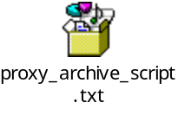

SSL certificate renewal process
In the case of the DTS-ESB certificate to DTS, Bell Corporate Security recommends:
- Change the certificate at least on an annual basis
- Send an email to Terry Hill (terry.hill@bell.ca), to arrange swapping the old certificate with a new one
- Install the Advantage certificate to both ON and QC regions
- Provide the certificate to DTS MAS team

Virgin, NMO B-SIDE, eBCCS and NM1 username/password will have to be updated for PCI compliance process
On the PCI DSS site there is an FAQ on this topic: http://selfservice.kb.net/article.aspx?article=5419&p=81
In our case for Virgin and ESB, Bell Corporate Security recommends:
- Change the password at least on an annual basis, or whenever a team member who knows the password leaves the company
- The password complexity should follow our corporate standard (see attached, section 2.2.2)

- Configure iptables (or similar) to restrict the Virgin and eBCCS connections to ESB (i.e. prevents users from using the service account)

Non-periodic Operations

Ad Hoc Operations
This section provides information on how to initiate ad-hoc/on-demand operations (e.g. statistical reports).
N/A

Operations Backup

Operation Backup same as DTS-RTS Application.

Critical Dates

CRITICAL DATES | REASON (month end, holiday, etc.)
Feb 19th every year | DTS-ESB certificate expires on a yearly basis  (the current certificate will be expired on April 1st, 2013)
TBD | Virgin username/password will have to be updated for PCI compliance

Application Recovery Procedures
This section provides information on how to recover following an application or sub-system failure. The failing application is restarted in the original environment.

Application Files
Application files required for DTS-ESB (CDE)
- PCI project configuring jar
- Please refer table below for others
Type | Location | Files
Property files | $DOMAIN_HOME/properties | CSGEnvironmentVariables.properties  dtstransactionid.properties  log4j.properties  CCAVEnvironmentVariables.properties  CreditCheckServiceEnvironmentVariables.properties
Jars | $DOMAIN_HOME/jars | commons-codec-1.3.jar  commons-httpclient-3.0.jar  log4j.jar
keystores | QC - Dorval DC4CFY-D07  Identity Keystore - /esbprod/osb/domains/ESB_CDE_PROD_QC/security/  Trust Keystore - /esbprod/osb/domains/ESB_CDE_PROD_QC/security/ | Identity Keystore –  PCI-ESBIdentity.jks  Trust Keystore –  ESBPROD1Trust.jks
keystores | ON - Wynford DM5CE1-D07  Identity Keystore - /esbprod/osb/domains/ESB_CDE_PROD_ON/security/  Trust Keystore - /esbprod/osb/domains/ESB_CDE_PROD_ON/security/ | Identity Keystore –  PCI-ESBIdentity.jks  Trust Keystore –  ESBPROD1Trust.jks

Application Interfaces
See section 2.3.1

Application Recovery Steps
DTS-ESB has no separate off-site DR environment. The servers take about 15 minutes to come online. The load balancers health check can determine they are online in 2 minutes after the servers are fully up. So it would be safe to say that from the time they are started to the time they can handle traffic would be about 5 minutes. This does not take into account the time needed to contact MAS and for MAS to respond.
To recover the system (each region) to its original state, (i.e. start weblogic servers) would take about 20 minutes. So in order to recover the whole system to its original state (QR and OR), it would take about 40 minutes.

To recover the system in the event of an application failure:
- Restart the Weblogic managed server (do not restart the admin server nodes):
  - Goto WLS console and then to Managed server’s control page
  - Forcefully shutdown the managed server
  - Confirm that the server is now in Shutdown state
  - Goto managed server’s control page and start managed server
  - Confirm that the managed server comes up directly into “Running” state
If the above (a) does not recover the system:
- Restart the admin server nodes:
  - Goto WLS console and then to Admin server’s control page
  - Forcefully shutdown the Admin server
  - Confirm that the server is now in Shutdown state by reloading the admin web page
  - Login to prod machine using putty
  - Goto Domain Home and start the Admin server by running ./startAdminServer.sh

Note: In the event that the above steps do not recover the application, check the server logs to find the exact root of the failure

Repatriation and Clean Up Steps
N/A

Application Recovery Test Plan
N/A

Disaster Recovery Procedures

The Disaster Recovery (DR) Procedures are created to meet the Disaster Recovery requirements of the system. The requirements are defined as:
Recovery Time Objective: Maximum elapsed time required to complete recovery of an application - how long can you be without the application before having an unacceptable impact on the organization?
Recovery Point Objective: Point in time (prior to the disaster) to which applications data must be recovered to resume business transactions - how much data can be lost?
N/A
These are typically established following a Business Impact Analysis (BIA) completed by the Business Prime. The BIA should be included as an attachment to the Production Guide and reviewed/updated annually.
Business Prime: _________________________
Recovery Time Objective: ___________ Recovery Point Objective: _____________
Disaster Declaration can only be made by the following:
Prime: ___________________________
Backup: __________________________

Is there a Service Level Agreement for this application: __Y__
Where is the SLA documented: ______________________________

This section provides information about how to recover the entire system or subsystem at an alternate site or on a different hardware environment following a site disaster or a major hardware failure. The entire system or sub-system has to be reinstalled at the alternate site or on the new/repaired piece of hardware, including data recovered from the original site/equipment.

DR Strategy

Strategy Description

Data Loss
N/A
Note: There is no production DB in ESB-CDE

DR Environment

General Information
N/A

In-scope and Out-of-scope
N/A

DR Configuration
N/A

DR Security Measures
N/A

DR Production Schedules
N/A

System Files
N/A

System Interfaces
N/A

Recovery Point Determination
N/A

Disaster Recovery Steps
N/A

Disaster Recovery Timeline
N/A

Disaster Recovery Contacts
N/A

Repatriation and Clean Up Steps
N/A

Disaster Recovery Test Plan
N/A

DR Test Strategy
N/A

Problem logs
N/A

Support Model

Support Scope

CGI Tier 2 Service Level Classification

Portfolio Name: | Billing / Bell Canada
Service Level Category | Gold
Application Criticality | NA (Not Applicable)

From the CGI network:
- In Canada: http://whmm14502/slm
- In India: http://whmm14502.csb.cginet/slm
From the Bell network or for Bell clients: http://whmm14502.bell.corp.bce.ca/SLM
If there is any discrepancy between the information included in this document and the information from the link, the information from the link will prevail.

ITSM URL: https://itsm-prod-mt.cgi.com/arsys/shared/login.jsp?/arsys/home
ITSM Configuration:
Support Group Name DTS SUP
Support Group Organization: Application Management Tier 2
CI name: DTS-ESB
Service+ = BC Gold / BM Gold / BTV Gold

Product Categorization
Product Categorization tier1 – Software
Product Categorization tier2 – Business
Product Categorization tier3 – Wireline
Product Name – DTS-ESB
Product Model/Version: None
Manufacture – Bell Canada
OTSS Flag – Yes

In Scope
The following is in Scope for CGI:
- CGI Helpdesks;
- CGI Incident Management Teams;
- DTS-ESB application Support;
- CGI Server - Linux Support Team;
- CGI Software Configuration Management (SCM);
- CGI Service Management (SM);
- CGI Backup & Restore;
- CGI DSO Security Team;
- CGI MAS MPC (Compuware);
- CGI PatchLink;
- CGI MAS – ArcSight.

Out of Scope
The following is out of scope for CGI:
- No Database;
- Data Continuity;
- End users training;
- Third Party Support Commitments;
- Bell AO (Application Owner);
- Red Hat;
- Oracle Weblogic;
- Bell Data Network Services & Support Team (DNSS);
- Bell Canada Corporate Security;
- Bell Corporate Emergency Management - National Incident Center;
- Bell Canada NIDS and WAF Team.

Interfacing Applications
- IVR – Bell INMC Helpdesk;
- EDS;

- DTS-RTS – CGI MAS DTS-RTS;

- Virgin – Virgin (3rd party Vendor)
- Equifax – Equifax (3rd party Vendor)
- eBCCS – CGI MAS eBCCS
- NM1 - Amdocs
- CGI MAS – GPS
- Moneris Solutions.

Support Groups

CGI CSD (BC/ BM / BDI / BELL TV) – Service Restoration Analysts (SRA)

The CGI Help Desk (CSD) is the single point of contact for Bell employees (includes Bell Canada, Bell Mobility, Bell and Virgin Retail Stores and Partners and Bell TV). The Service Recovery Analyst (SRA) will be providing first line support for these clients.

SRA responsibilities are:
- Provide bilingual support in French and English through a toll free number and a local Montreal number.
- Answer calls based on predefined Service Level Agreement (SLA).
- Open an ITSM ticket for every new incident reported.
- Assess, troubleshoot and document the incident.
- Incidents that cannot be resolved directly by the Help Desk will be assigned to the appropriate Support Team (internal or external).
- Assign a priority level based on contractual agreement with Bell Canada / Bell Mobility / BDI / BELL TV.
- Follow up, update and close the ITSM ticket based on client’s confirmation.
- Engage the Service Recovery Specialists (SRS) for Critical and High Priority ITSM tickets.

ITSM Support group assignment:

CGI Support to BC/BM/BDI/BTV -> User Service Desk -> Service Restoration L1

Role | Name | Hours of Operation | Phone | Cellular
SRA TEAM | N/A | Based on SLA | 514-523-5523 in Montreal area  888-920-8888 otherwise | N/A
Manager | Marc-André Cormier | 8 AM - 5 PM Mon-Fri | (514) 878-8438 | (514) 237-8439

CGI IMC (BC / BM / BDI / BTV) - Service Recovery Specialists (SRS)

CGI’s Service Recovery Specialists (SRS) is responsible for monitoring and coordinating the resolution of all Critical and High Priority ITSM tickets.

SRS responsibilities are:
- Manage Critical and High Priority incidents to resolution for not Minted incidents.
- Coordinate incidents that require multiple support teams (internal or external) within the scope of the Bell ICN and BC / BM / BDI / BELL TV’s respective support teams.
- Follow up with support teams and escalate if need be.
- Initiate Problem Management process for reoccurring incidents if needed.
- Escalate the tickets that are passed the agreed SLA.
- Owner of all Critical and High Priority incidents not Minted.
- Initiate Major Incident Manager Process in case of Critical and High Priority incidents for Minted applications (Refer to Service Management website for Platinum list).

ITSM Support group assignment:

CGI Support to BM/BDI/BTV/BC -> Incident Management -> Service Restoration Coordination

Role | Name |  | Hours of Operation | Pager/Cellular
SRS | On rotation | Bell Canada  Bell Mobility  Bell Distribution  Bell TV | 8 AM - 5 PM EST Mon-Fri* | 9620231899@nma.vodafone.in  9620231899@mobileemail.vodafone.in
SRS | On rotation | Bell Canada  Bell Mobility  Bell Distribution  Bell TV | 8 AM - 5 PM EST Mon-Fri* | 9620231898@nma.vodafone.in 9620231898@mobileemail.vodafone.in
Escalation | Mithun Venkatesh  Maria Joseph |  | 8 AM - 5 PM EST Mon-Fri* | 1-877-320-6958, x8014039  Or  011-91-80-66984039
Manager | Bobby Pais |  | 8 AM - 5 PM EST Mon-Fri* | 011-91-9620231901
* CGI SRS is available via either pager outside of these hours.

DTS-ESB Managed Application Services (MAS)

- Investigating and troubleshooting DTS-ESB incidents.
- Reset the application password on February 19th of every year for SLOB
- Reset the application password on (TBD) of every year for Virgin

Ticket Assigment:
  - CGI Support to BC/BDI/BM/BTV -> Application Management Tier 2 -> DTS SUP

The contacts for the CGI IGDC MAS – DTS-ESB Team are:
Role | Name | Phone | Pager/Cell/Email
DTS-ESB Support (IGDC) | N/A | Helpdesk | 8095598229@mobileemail.vodafone.in  DTS.PCI.INFRASUPP.ban.india@cgi.com  DTS.PCI.APPSUPP.ban.india@cgi.com
Team Leader (IGDC) | Kurian Mathew | +1-866-354-9295 x8011783 | 011-91-988-079-4795  kurian.mathew@cgi.com
Application Delivery Manager  (IGDC) | Pramod Kumar S | +1-866-354-9295 x8011826 | 011-91-988-674-8824  Pramod.Kumar.S@cgi.com
Service Delivery Manager  (IGDC) | Joe Koshy | +1-866-354-9295 x8011625 | 011-91-988-621-2891  Joe.Koshy@cgi.com

The contacts for the CGI Montreal MAS – DTS-ESB Team are:
Role | Name | Phone | Pager/Cell/Email
Manager (MAS) | Ghislain Pepin | 514-415-3068 | 514-216-9210  ghislain.pepin@cgi.com
Director (MAS) | Ganesh Rajamani | 905-762-2878 | Cell: 416-434-1691  ganesh.rajamani@cgi.com

Respond to Compuware Vantage alerts for application alerts that are issued to:
  - For PCI-DTS all alert DTS.PCI.INFRASUPP.ban.india@cgi.com and DTS.PCI.APPSUPP.ban.india@cgi.com
  - For PCI-DTS critical alert 8095598229@mobileemail.vodafone.in

    - CGI Unix Team
ITSM Support group assignment:
CGI Support to BC-Server Management-Unix -> IM-UNIX ADMIN

Role | Name | Contact Information:
Prime | Unix Team | Work # 1 866 354 9295 # 8011345  ON CALL Support Cell phone # 91 974 226 8555  Email DL for the team - IGDC_T1_Hwy_Unix.BAN.INDIA@cgi.com  Pager DL : IGDC_T1_Bell_Unix_Pager.BAN.INDIA@cgi.com
Team Leader | Amlan Roy | Work: 1 866 354 9295 x 8011694  Cell: 011 91 994 510 3246  Email:amlan.roy@cgi.com
Manager – Unix | Tahseen Raza | Work: 1-866-354-9295 #8011725  Cell: 91-99-80130280  Email: tahseen.raza@cgi.com
II Level Escalation Manager | Anand S | Work: 1-866-354-9295 # 8011253  Cell: 011 91 974 226 8520  Email: anand.s@cgi.com
Director | Mahesh Murthy | Work: 1-866-354-9295 # 8011400  Cell: 011 91 988 662 3400  Email: mahesh.murthy@cgi.com

Software Configuration Management (SCM)
The CGI Software Configuration Management (SCM) team ensures quality Configuration Management (CM) processes are being followed, and is responsible for the following activities:
- Managing the Corporate CM tools
- Maintaining CM baselines
- Providing mentoring of CM processes
- Application build management (as per CM Plan)

Role | Name | Phone | Pager/Cellular
CMA (Distributed) | Neeharika Sivaprasad | 1-866-354-9295 ext 8013258 | N/A
CMA Manager | Narayanan Chennakesavan | 1-866-354-9295 ext 8011399 | +91-9036825330
SCM Manager | Serge Turpin | 514-415-3771 | 514-233-1073

Service Management
The CGI Service Management team (SM) is responsible for managing the CGI Service Level Agreement. At a high level SM will:
- Establish System Support Service Level Agreement
- Administer and manage the Service Level Agreement
- Track and compare trends of Service Level Agreement measures
- Customer Satisfaction Management

Role | Name | Hours of Operation | Phone | Cellular
Prime | Ravi Teja Kothapalli | 8 -5 M – F | 1-866-354-9295 (x 8066489) | N/A
Manager | Myles Huntoon | 8 -5 M - F | 514-415-3036 | N/A

CGI Backup & Restore
CGI Backup & Restore Level 1
The CGI Backup & Restore Level 1 support high level responsibilities include:
- All NetBackup actions (backup, restore and troubleshooting
- Issue recall requests
- Bare Metal Recovery of servers
- Issuing tickets for audit compliance
- Yearly & semi-annual validations/ audits
- Configuration of tape drives (SLConsole and VOP GUI’s)
- Adhoc backup requests
CGI Backup & Restore Stay Back
- Complex NetBackup Operations
    - SRT creation/configuration
    - Master server recovery
    - Addition of new users into java auth configuration
    - Provisioning of new backups
- Backup & Restore Stay Back
- Complex NetBackup Operations
- SRT creation/configuration
- Master server recovery
- Addition of new users into java auth configuration
- Provisioning of new backups
- Onsite Operations
- All media handling
- Physical support of tape library and master server
Role | Name | ITSM | e-Mail
Backup & Restore Prime | N/A | IM-STORAGE-BACKUPS | Hway.Storage.team.BAN.INDIA@cgi.com

CGI Wintel Server Support
The CGI Wintel Operations IGDC team provides support of the hardware and middleware resident including the following activities:
- Distribution of server software.
- Server Building deployment activities.
- Back-up and restore deployment activities.
- Incident analysis and trouble-shooting of server software and middleware incidents.
- CGI WINTEL Operations IGDC team will provide support of the MQseries Client 5.3
- Implement any application change, code change, or other change that requires console access to the server (Separate Funding).
- Monitoring, execution of change activities.
- Ops Center is responsible for:
- Providing support of the hardware and middle-ware resident on the ICN.
- Incident analysis and trouble-shooting of server software and middle-ware incidents.
- Server platform monitoring of ICN servers on a 7x24 basis.
- Monitoring of servers on the ICN and in the DMZ on a 7x24 basis.
- Implementing any application change, code change, or other change that requires console access to the server (Separate Funding).
- Opening and/or updating ITSM with defect investigation and resolution actions.
- Notifying IMC for Major Outages.
- IGDC OCC team will provide round the clock support from Monday to Sunday from CGI India office premises. This will be all day 24 X 7 support.

ITSM Support group assignment:
CGI Support to BM/BTV/BC -> Server Management-> Wintel
OCC Role | Name | Phone | Mobile | Email
Prime (Office Hours) | OCC Team | (+91) 8066422434 #8012434 | (+91) 9742268514 | IGDC_T1_Hwy_OCC.BAN.INDIA@cgi.com
Team Leader | Gowrishankar Raju | (+91) 8066422434 #8012434 | (+91) 9620224833 | gowrishankar.raju@cgi.com
Service Delivery Manager | Bobby Pais | 1-866-354-9295 (#8011253) | +91 962-023-1901 | bobby.pais@cgi.com
Director | Mahesh Murthy | 1-866-354-9295 (#8011400) | +91 98866 23400 | mahesh.murthy@cgi.com

Wintel Role | Name | Phone | Mobile | Email
Prime (Office Hours) | N/A | 1-866-354-9295 (# 8012121)
Team Leader | Amit Ambast | 1-866-354-9295 (#8012606) | +91 888 403 0399 | amit.ambast@cgi.com
Service Delivery Manager | Anand S | 1-866-354-9295 (#8011253) | +91 974226 8520 | anand.s@cgi.com
Director | Mahesh Murthy | 1-866-354-9295 (#8011417) | +91 98866 23400 | mahesh.murthy@cgi.com
Stayback Manager | Marissa Decepida-Wong | 416-446-2343 | 416-809-3987 | marissa.decepida@cgi.com
Stayback Manager for Centralized Enterprise Storage | Ramdane Ourahmoune | (514) 415-3774 | (514) 238-1630 | ramdane.ourahmoune@cgi.com

    - CGI DSO Security Team (McAfee suite)
CGI DSO Security is responsible for maintaining and operating the McAfee products installed in the CDE (see section 2)
Role | Name | ITSM | Phone | Pager / Cell
N/A | N/A | DSO-SECURITY | N/A | As per ITSM

CGI MAS - MPC (Compuware)
The CGI CSB Monitoring, Performance and Capacity (MPC) support team will perform a primary Tier 2 support role for the Compuware software suite and Foglight scripted testing tool. Incidents identified as application related by the customer or the Help Desk will refer the calls to the Compuware ITSM queue. At a high level the team will:
- Monitor availability of system via the existing Compuware alerts
- Perform problem determination on the Compuware software incident
- Lead the recovery from system crashes with assistance from DSO
- Escalate alerts to IMC Bell Canada or Bell Mobility / BDI Help Desk when appropriate.
- Perform activities as per Compuware Operations Procedures
- Manage access Control to the Compuware software
- Participate in problem resolution processes related to Compuware suite
- Ensure appropriate server backup processes are running as per operational procedures
- Interface with Compuware Vantage Vendor Support

Role | Name | ITSM | House of Operations (EST) | Phone
CGI MPC MAS Team | MPC_SUPPORT.CSB@CGI.COM | IM-COMPUWARE | Mon– Fri 8am–5pm  If weekends Pager Support | +91 953-896-6431  (24/7)
IGDC-Escalation Manager for MPC | S Raja Ramachandran  rajaramachandran.s@cgi.com |  | Mon– Fri 8am–5pm | +919448832658
CSB-Escalation Manager for MPC | Alan Gordon  alan.gordon@cgi.com |  | Mon– Fri 8am–5pm | 514-705-9125

CGI Patchlink
The CGI Patchlink team coordinates the patch installation on servers…..
Role | Name | ITSM | House of Operations (EST) | Phone
CGI-Patchlink MAS Team |  | DSO-Patchlink
IGDC-Escalation Manager
CSB-Escalation Manager

CGI ArcSight GMSS
- Investigate and resolve Archsight Agent related incidents
- Forward Arcsight ITSM incidents to CGI MAS GMSS via Soc.mss@cgi.com (By DSO-Security)
- Engage CGI MAS GMSS via Soc.mss@cgi.com
- Refer to Appendix
The contacts within CGI MAS GMSS (DSO-Security) are as follows:
Role | Name | ITSM | Phone | Pager
Primary | Brenda Thorne | DSO-SECURITY
Manager | Lisa Chaffey | N/A | 519-686-8078 | 519-280-7934
Client Service Manager | Andrew Atkinson | N/A | 613-740-5900 #5680 | 613-203-2554

The contacts within CGI MAS GMSS (Ottawa) are as follows:
Role | Name | Email | Phone | Pager
Primary | CGI GMSS | Soc.mss@cgi.com | 1-866-677-7472 or 613-742-2417
Team Leader | Tim Hersey | Tim.hersey@cgi.com | 613740-5900 x5354
Manager | Marc Bercier | Marc.bercier@cgi.com | 613-740-5912
Client Service Manager | Andrew Atkinson | N/A | 613-740-5900 x5680 | 613-203-2554

Red Hat
Red Hat (the company) is responsible for the support of Linux Application Server.
Role | Name | Phone | e-Mail
Bell Canada Prime | N.A | N/A | N/A
Bell Canada Backup | N/A | N/A | N/A
Red Hat Web Site | https://www.redhat.com/support/process/production/

Oracle (WebLogic and Oracle Service Bus)
Role | Name | Phone | e-Mail
Oracle Phone Support | N/A | .800.668.8921 or +1.905.890.6690 | N/A
Bell Canada Support ID | 18072385

Bell DNSS – ICN Support
- Engaged via TIM;
- Investigate and resolve all connectivity problems;
- Investigate Firewall issues & contact 3rd line Support as required.
Role | Name | Phone | Cell / Pager
Tier D – Escalation  ICN NOC  08:00 to 06:00 | Gurpreet Bhogal | 416-353-0332 | (416) 407-5478 (C)
After hours escalation at the ICN NOC | Rotation TSAM |  | 416-581-6719 (P)
Service Manager | Lorenzo Casanova | (514) 870-1430 | (514) 248-8000 (C)
Service Manager | Maja Hjalmarsson | 416-353-5138 | 416-347-1834 (C)
Tier C – Escalation | Denis Battiston | (416) 215-2741 | (416) 407-9594 (C)
Tier B – Escalation | Gid Morson | 416) 353-4783 | 416) 580-1611 (C)  416) 378-4057 (P)
Tier A – Escalation | Guy Raymond | 514-420-4752 | 514-386-5533 (C)
BST / NSS Escalation 1 | Don Sellers | 613-781-0866 | 613-761-0282
BST / NSS  Escalation 2 | Rod Hynes | 416-215-3409 | 416-919-0066
BST / NSS  Escalation 3 | Mark Strachan | 905-614-5630 | 416-735-0745

Bell Canada Corporate Security C&M
Bell Canada Corporate Security C&M is part of the third line of support of DTS-ESB and is responsible for:
- Define and enforce the Corporate Policy on the Servers, Databases, Applications etc.
- Investigate Policy non-compliance incidents
- Investigate server intrusion incidents
- Interface with Bell owners on the various types on non-compliancy issues
- Manage Policy version control
- Advise CGI MAS DTS-ESB and anyone else for changes to the security Policy version
The contacts within Bell Canada Corporate Security C&M are as follows:
Role | Name | Phone Number | Pager
Primary | Via email: cm@bell.ca
Escalation – Prime | Benoit Joubert | (613) 244-6211 | (613) 294-5615
Escalation - Backup  Associate Dir. (eDiscovery & Compliance Monitoring) | Scott Beauchamp | (613) 244-6180 | (613) 794-9276

Bell Corporate Emergency Management - National Incident Center
The Bell Corporate Emergency Management team is responsible for the following:
- The Bell Corporate Emergency Management team shall be involved in the coordination of any Critical priority incident response and Post Incident activities.

Role | Name | Phone | e-Mail
Prime  (Including Incident and Post Incident activities) | Variable | 1-866-714-0911 | nic@bell.ca

Bell NIDS and WAF team
The Bell NIDS and WAF team are responsible for the following:
- Detect external intrusion and provide an alert.

Role | Name | Phone | e-Mail
Prime | Via email: ssc.support@bell.ca |  | ssc.support@bell.ca

Interfacing Applications Support Teams

CGI EDS Managed Application Services (MAS)

MAS Support – Toronto
The contacts for the MAS teams are:
Role | Name | ITSM | Phone | Cell | Email
CGI MAS Team Lead | Kevin Leadbeater |  | 416.380.7805 ext. 1462011 |  | kevin.leadbeater@cgi.com
CGI MAS Manager | Shantanoo Joshi | N/A | 1-703-267-5600 #8028265 | 91-9892829411 | shantanoo.joshi@cgi.com
CGI Bell TV eBusiness Support Director – Escalation | Brad Long | N/A | 416 -446-2585 | 416- 553-6154 | brad.long@cgi.com

IGDC Support – India
The contacts for the IGDC team are:
Role | Name | ITSM | Phone | Pager | Availability
CGI/IGDC Application Support  (JAVA 1st line of Tier II support, India) | n/a |  | +91- 9742268542 (cell phone )  +91-9742269024 (cell phone) | 9742268542@mobileemail.vodafone.in  9742269024@mobileemail.vodafone.in  9742268529@mobileemail.vodafone.in
CGI/IGDC Application Support  (.NET 1st line of Tier II support, India) | n/a |  | +91-9742269022 (cell phone) | 9742269022@mobileemail.vodafone.in
CGI/IGDC Application Support  (.NET 1st line of Tier II support, India) | n/a |  | +91-9742269022 (cell phone) | 9742269022@mobileemail.vodafone.in
CGI / IGDC Manager | Bala Gopala Raju Krishna Raju | N/A | +91 8095598246 (cell phone)
CGI / IGDC Manager | Pallavi Tamhane | N/A | +91 9980599001
CGI / SDM | Hithesh Koyileri | N/A | +91 8095598245 (cell phone)

CGI CHIP/SLB Managed Application Services (MAS)

MAS Support – Toronto
The contacts for the MAS teams are:
Role | Name | ITSM | Phone | Cell | Email
CGI MAS Team Lead | Kevin Leadbeater |  | 416.380.7805 ext. 1462011 |  | kevin.leadbeater@cgi.com
CGI MAS Manager | Shantanoo Joshi | N/A | 1-703-267-5600 #8028265 | 91-9892829411 | shantanoo.joshi@cgi.com
CGI Bell TV eBusiness Support Director – Escalation | Brad Long | N/A | 416 -446-2585 | 416- 553-6154 | brad.long@cgi.com

IGDC Support – India
The contacts for the IGDC team are:
Role | Name | ITSM | Phone | Pager | Availability
CGI/IGDC Application Support  (JAVA 1st line of Tier II support, India) | n/a |  | +91- 9742268542 (cell phone )  +91-9742269024 (cell phone) | 9742268542@mobileemail.vodafone.in  9742269024@mobileemail.vodafone.in  9742268529@mobileemail.vodafone.in
CGI/IGDC Application Support  (.NET 1st line of Tier II support, India) | n/a |  | +91-9742269022 (cell phone) | 9742269022@mobileemail.vodafone.in
CGI/IGDC Application Support  (.NET 1st line of Tier II support, India) | n/a |  | +91-9742269022 (cell phone) | 9742269022@mobileemail.vodafone.in
CGI / IGDC Manager | Bala Gopala Raju Krishna Raju | N/A | +91 8095598246 (cell phone)
CGI / IGDC Manager | Pallavi Tamhane | N/A | +91 9980599001
CGI / SDM | Hithesh Koyileri | N/A | +91 8095598245 (cell phone)

CGI DTS-RTS Managed Application Services (MAS)
- Investigating and troubleshooting DTS incidents.
- Engage CGI CSD for load balancer incident
- Working in cooperation with and engaging the other support teams to analyze, troubleshoot, and resolve incidents.
- Managing implementation of defect resolution.
- Sanity testing, if required, after any application/server/environmental updates.
- Provide input to auditors to be covered by Base-Flex funding
- Manage certificate covered by Base-Flex funding
- Creation of RFC, when required.
- CGI MAS Manager to engage Bell Corporate Emergency Team for any Security incidents
- Assign account creation and modification to THE MONTREAL MAS TEAM
- Install Middleware & Application builds on PCI-DTS Servers`
- Follow Dual Control Password Instructions:
  - Contact Bell AO Client Owner to start synchronization process
  - Refer to Section 2.4.2 Dual Control Password - Protecting Encryption Key Storage, for complete instructions
  - Response time for Dual Control Password completion is within 3.0 hours.

Respond to Compuware Vantage alerts for application alerts that are issued to:
  - For PCI-DTS all alert DTS.PCI.INFRASUPP.ban.india@cgi.com and DTS.PCI.APPSUPP.ban.india@cgi.com
  - For PCI-DTS critical alert 8095598229@mobileemail.vodafone.in

Ticket Assigment:
  - CGI Support to BC/BDI/BM/BTV -> Application Management Tier 2 -> DTS SUP

The contacts for the CGI IGDC MAS –DTS-RTS Team are:
Role | Name | ITSM | Phone | Pager/Cell/Email
DTS Support (IGDC) | N/A | CI:  DTS-RTS  Group :  DTS SUP | Helpdesk | 8095598229@mobileemail.vodafone.in  DTS.PCI.INFRASUPP.ban.india@cgi.com  DTS.PCI.APPSUPP.ban.india@cgi.com
Team Leader (IGDC) | Kurian Mathew | N/A | +1-866-354-9295 x8011783 | 011-91-988-079-4795  kurian.mathew@cgi.com
Service Delivery Manager  (IGDC) | Joe Koshy | N/A | +1-866-354-9295 x8011625 | 011-91-988-621-2891  Joe.Koshy@cgi.com

The contacts for the CGI Montreal MAS – DTS-RTS Team are:
Role | Name | ITSM | Phone | Pager/Cell/Email
Manager (MAS) | Ghislain Pepin | N/A | 514-415-3068 | 514-216-9210  ghislain.pepin@cgi.com
Director (MAS) | Ganesh Rajamani | N/A | 905-762-2878 | Cell: 416-434-1691  ganesh.rajamani@cgi.com

CGI GPS Managed Application Services (MAS)
The CGI MAS GPS team provides support of the overall GPS environment. They are responsible for:
- Investigating environment incidents (e.g. server down, service down, etc.)
- Taking corrective actions to ensure environment is up and running when possible
- Responding to SLA Alerts
- Engaging CGI or External teams for batch job related incidents
- Engaging other support teams when required

The contacts for the CGI IGDC MAS GPS Team are:
ITSM Support Group - CGI Support to BC → Application Management Tier 2 → GPS SUP
Role | Name | ITSM Support Group | Phone | Pager/Cell/Email
GPS Support (IGDC) | N/A | GPS SUP | Helpdesk | 8095598229@mobileemail.vodafone.in  IGDC.BELL.GPS.ind@cgi.com
Team Leader (IGDC) | Kurian Mathew | N/A | +1-866-354-9295 x8011783 | 011-91-988-079-4795  kurian.mathew@cgi.com
Application Delivery Manager (IGDC) | Prafull Agrawal | N/A | +1 866-354-9295 x8011744 | 011-91-991-604-8411  prafull.agrawal@cgi.com
Service Delivery Manager  (IGDC) | Joe Koshy | N/A | +1-866-354-9295 x8011625 | 011-91-988-621-2891  Joe.Koshy@cgi.com

The contacts for the CGI onshore MAS GPS Team are:
Role | Name | ITSM | Phone | Pager/Cell/Email
Manager (MAS) | Ghislain Pepin | N/A | 514-415-3068 | 514-216-9210  ghislain.pepin@cgi.com
Director (MAS) | Ganesh Rajamani | N/A | 905-762-2878 | Cell: 416-434-1691  ganesh.rajamani@cgi.com

IVR – Bell INMC Helpdesk
Role | Name | Hours | ITSM | Phone | eMail
INMC  Help Desk | Agents | 7/24 | N/A | 800-698-0800
Queue Manager | On duty | 8 – 17 M-F | Type: MSP-310  Group: CSD-BCCS-AGENTS or NEQ  Individual: MSP IVR | N/A | msp310bell@bell.ca
Manager | Judy Stuart | 8 – 17 M-F | N/A | 613-660-3218

Bell Canada IVR Application Owner
The Bell Canada Application Owner is responsible for the MSP-IVR application from a business perspective and for any escalations from CGI for non-response from the vendor.
Role | Name | Hours of Support | Phone | Cell
Application Owner | Fred MacKenzie  fred.mackenzie@bell.ca | 7/24 for Sev.1/2 | 416-353-0826 | 416-801-2897
Tier B | Russ McAlpine  russ.mcalpine@bell.ca |  | 416-353-3999 | 416-407-4170

Virgin Mobile Applications (PeopleSoft, Web Activation, Web MyAccount Virgin

Support Virgin Mobile applications

ITSM Support group assignment:
- Virgin PeopleSoft Bell Mobility -> Support to BDI/BM/BDI/BTV -> OTSS-V-Peoplesoft
- Virgin Middleware Bell Mobility -> Support to BDI/BM/BDI/BTV -> OTSS-V-Middleware
- Virgin Dw & Scorecard Bell Mobility -> Support to BDI/BM/BDI/BTV -> OTSS-V-Datawarehouse
- Virgin Website Bell Mobility -> Support to BDI/BM/BDI/BTV -> OTSS-V-Infrastructure

Role | Name / e-Mail | Hours | ITSM | Phone
Support Leads  (Escalation 1) | Pratheeban Premathas  pratheeban.premathas@virginmobile.ca | Mon-Fri 9am-5pm | Assign to:  - Virgin Peoplesoft – for Peoplesoft related issues  - Virgin Middleware – for middleware related issues  - Virgin Datawarehouse – for data warehouse related issues | 416.607.8374 (office)  416.655.3980 (mobile)
Support Leads  (Escalation 1) | Andy Ho  andy.ho@virginmobile.ca | Mon-Fri 9am-5pm |  | 416.348.1027 (office)  416.524.7377 (mobile)
Program Manager  (Escalation 2) | Roger Parent  roger.parent@bell.ca | Mon-Fri 9am-5pm |  | 905.282.2089 (office)  647.233.2222 (mobile)

Equifax
Equifax application is not supported by CGI.
The following is the contact information for Equifax support:

Advanced Delivery Systems
Network and Application Support
August 15, 2012

Monday through Friday (08:00 to 18:00 ET)
 | Contact Details | Telephone | Cellular
 | STS@equifax.com | 1-800-387-9986
  ADS Team
 |  | 1-800-563-1436
  ADS Fax
  1st Level Escalation: Team, ADS
  Team, ADS
  647-537-4973
  2nd Level Support: Specialist, ADS
  Avi Hanukaiva
  416-227-5471
  3rd Level Support: Manager, ADS
  Paul Kulybanycz
  416-227-5219
  416-994-5134

After Hours, Weekends and Statutory Holidays
 |  | Telephone | Cellular
  ADS Team
  1-800-387-9986
  1st Level Escalation: Team, ADS
  After Hours Team ADS
  647-537-4973
  2nd Level Escalation: Manager, ADS
  Paul Kulybanycz
  416-994- 5134

System Availability Summary
Consumer (Production and Test Availability) ET
Maintenance Hours
 | Monday | Tuesday-Saturday | Sunday
Down | 00:30 AM | 03:30 AM | 02:30 AM
Up | 04:30 AM | 04:00 AM | 06:30 AM

Commercial (Production and Test Availability) ET
Maintenance Hours
 | Monday-Monday
Down | 01:30 AM
Up | 06:30 AM

After Hours Escalation Procedures (urgent requests)

- Contact: 1-800-387-9986: (Leave message, escalate to next level after 15 minutes)
- First Level Escalation: Afterhours Team ADS (Escalate after 15 minutes)
- Second Level Escalation: Manager, ADS (Escalate after 15 minutes)
- Third Level Escalation: Manager, Infrastructure – Vas Grigoropoulos – 514-688-4357 (Escalate after 15 minnutes)
- Fourth Level Escalation: SVP, Technology – Harold Boutin – 404-643-3667
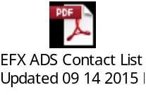

CGI MAS eBCCS
The CGI Managed Appliction Service (MAS) - eBCCS team provides support of the eBCCS components and is responsible for the following activities:
- Manage code on the eBCCS infrastructure;
- eBCCS application build scripts;
- Analyzing and troubleshooting eBCCS application incidents;
- Developing and testing eBCCS defect resolutions;
- Investigation and resolution of system errors through use of the DigiTEK;
- Managing the implementation of eBCCS defect resolutions;
- Sanity testing for downstream components, such as BCRIS and CIMS, where required;
- Interfacing with IBM and Bell Nexxia where required;
- Managing BCRIS IDs used by eBCCS;
- Manage reporting query capability.

The contacts within CGI MAS - eBCCS are as follows:
Role | Name | Hours of Operation | CGI ITSM Queue | Phone | Pager/Mobile | Support email
CGI MAS | CGI - IGDC MAS Team | 24*7 | (i)Company*+: Bell Canada  (ii)CI+: EBCCS  (iii)Assigned Group*+: CGI Support to BC/ Application Management Tier 2 / EBCC JT2 | +1 866 354 9295 (x8011260) | Pager: 97422690645@mobileemail.vodafone.in  Mobile: +91 9742269045 | JT2.IGDC.BAN.INDIA@cgi.com
Team Lead – Escalation Level 1 | Nalini Kantha Reddy | 9 AM to 5 PM ET * | N/A | Work: +91 80 6642-2182  VOIP: +1 866 354 9295(X8012182) | +91 9342970986 | nalini.kanthareddy@cgi.com
Manager (IGDC) – Escalation Level 2 | Prafull Agrawal | 9 AM to 5 PM ET * | N/A | +91 9986024565 | +91 9986024565 | prafull.agrawal@cgi.com
Manager (CSB) – Escalation Level 3 | James Beausoleil | 9 AM to 5 PM ET * | N/A | Office: 514-415-3683 | 514-580-1453 | james.beausoleil@cgi.com
*Support personnel will be available on-site during normal office hours, but should be contacted via cell/pager after office hours. Cell phone/Pager support is available 24/7.

NM1 and OneBill (aka CSM Conso) - AMDOCS
ITSM Assignment
- ACMS - > Support to BM - > ACMS

Amdocs Escalation Contact Info
Amdocs Escalation Procedure
1st Escalation – Incident Manager | 2nd Escalation – Q. Manager | 3rd Escalation – HD Group Leader | 4th Escalation – Service Desk Manager
Send email to IndiaIncidentManagementBellCanada@amdocs.com  Office : 514-338-4006|514-338-3110  Contact Incident Manager found within ticket by visiting:  https://dc1cng.qc.bell.ca/clarify/  And  https://dcoc1w.qc.bell.ca/tickets/ | ACMS_HD_QMGR@Amdocs.com  GL: Nitin Gupta Nitin.Gupta4@amdocs.com  514-338-3145 | Alex Weiss  Office:  Alexander Weiss alexander.weiss@amdocs.com  514-338-3408  Cell: 514-290-4557 | Joe Novielli  Office:  Joe Novielli joe.novielli@amdocs.com  514-338-3459  Cell: 514-214-4935

B-SIDE MAS
The CGI MAS – B-SIDE team provides support of the overall B-SIDE environment. They are responsible for:
- Investigating environment incidents (e.g. server down, service down, etc.)
- Taking corrective actions to ensure environment is up and running when possible
- Engaging the CGI MAS bell.ca team for incidents relating to the configuration of the WSD load balancer
- Engaging the CGI DSO team for incidents relating to the support of the physical WSD load balancer device
- Interface with Systinet and BEA (Bell’s 3rd party vendors) as required.

The contacts within CGI MAS Old B-SIDE are as follows:
Role | Name / e-mail | ITSM | Phone | Pager/Cell
CGI MAS  Old B-SIDE | bell.cgi.igdc.ams.jt3.BAN.INDIA@cgi.com | Type:  B-SIDE  Group:  IM-B-SIDE | +91-97422-68534  +91-97422-68545 | 9742268534@mobileemail.vodafone.in  9742268545@mobileemail.vodafone.in
Team Lead – Escalation Level 1 | Prafull Agrawal | N/A | +1 8663549295 x8011744 | +91 99160 48411 (cell)
Manager – Escalation Level 2 | Pramod Kumar S | N/A | +91 80-6642-1826 | +91 98867-48824 (cell)
Manager (CSB) – Escalation Level 3 | Ghislain Pepin | N/A | 514-415-3068 | 514-216-9210 (cell)

The contacts within CGI MAS-B-SIDE NMO are as follows:
Role | Name / e-mail | ITSM | Phone | Pager/Cell
CGI MAS  B-SIDE NMO | virtstore.BAN.INDIA@cgi.com | Type: B-SIDE  Group: IM-B-SIDE | +91-97422-68534  +91-97422-68545 | 9742268532@mobileemail.vodafone.in
Team Lead – Escalation 1 | Gaurav Yadav | N/A | 1-703-267-5601 | +919916636722 cell
Manager – Escalation 2 | Rahul Nesarikar | N/A | 1-866-354-9295 x8012262 | +91 97422 68548 pager  +91 97422 68548 cell
CSB Manager – Escalation 3 | Ghislain Pepin | N/A | 514-415-3068 | 514-216-9210 (cell)

Moneris Solutions
- Support Moneris application.
- To report an incident to Moneris Solutions: Press #1 Difficulties operating “point of sale equipment”
- Provide to Moneris Solutions : “alternate” Merchant name and it may be necessary to provide Company Name and Address
- Refer to imbedded document for Merchant Details
- 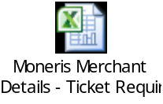

Moneris Contact Details | Contact Number
Level 1 - Opening a ticket with Moneris | 1-866-319-7450
Bilingual Customer Service desk - 24/7/365 availability
Requirments to open a ticket: 1) Merchant ID 2) Full Merchant Name 3) Address validation - Refer to "Condensed Merchant List" tab for these details by application
Escalation Contacts: | Contact Number | Mobile Number | Email Address
Level 2 - Service Manager,  Service Relationship  Management - Celia Gonzalez | 416-734-1415/1-866-379-3284 | 647-638-5589 | celia.gonzalez@moneris.com
Level 3 - Senior Manager,  Service Relationship  Management - Linda Glimps | 416-734-1741 | 416-456-5648 | linda.glimps@moneris.com
Level 4 - Director, Customer Experience - Bree McKibbon | 416-734-1723 | 416-904-9782 | bree.mckibbon@moneris.com
Level 5 - Chief Operations  Officer - Fern Glowinsky | 416-734-1218 | 416-457-5601 | fern.glowinsky@moneris.com

BELL Application Owner
Role | Name | Phone | Pager
DTS-RTS owner  Billing Services | Filomena Sauro  filomena.sauro@bell.ca | 514-870-6626 | 514) 347-8503
DTS AO Manager -  Billing Services | Rebecca Sedore  rebecca.sedore@bell.ca | 613-354-7200 | 613-328-5795
DTS AO Director  IT Operations – Billing Services | Steve Batah  s.batah@bell.ca | 514-786-8800 | 514-869-6811

Problem Identification and Resolution: update for Moneris ?

Call Flow

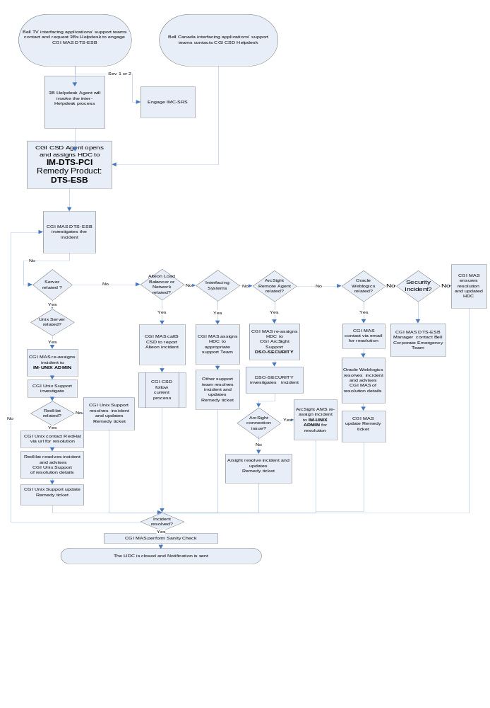

Reporting an Incident

Bell TV Interfacing applications’ support teams
If the Bell TV interfacing applications’ support teams recognizes an DTS-ESB incident:
- They will contact the 3B CGI Helpdesk to report an issue with DTS-ESB as per the existing process.

Bell Canada Interfacing applications’ support teams
If the Bell Canada interfacing applications’ support teams recognizes an DTS-ESB incident:
- They will contacts the CGI CSD Helpdesk to report an issue with DTS-ESB as per the existing process

CGI MAS DTS-ESB Team
If the CGI MAS DTS-ESB team recognizes an incident, they:
- Create an ITSM ticket and record the details of the incident
- Investigates the incident and determines the priority of the incident
If incident is Critical or High priority, they
- Notify SRS (via pager only) of incident and provide them with ITSM

Monitoring Alarms
CGI monitors the servers for potential problems. In the event the monitoring identifies a problem:
- CGI OCC creates an ITSM ticket, with product DTS-ESB.
- For Critical or high priority incidents, CGI OCC must page SRS to invoke Incident Management.
- CGI DSO investigates and resolves the incident, involving other support teams, as required

Security Alarm from NIDS
If NIDS receive an alarm event;
- They send it to ArcSight.
- SSC L1 team monitors the events in the Arcsight console
If NIDS or the ICN NOC get an alarm from NIDS and recognizes an incident, they:
- Call in the CGI CSD and mention that this is regarding an DTS-ESB potential Cyber attack. CDE server IP addresses / host name should be provided.

Security Alarm from WAF
If WAF team or the ICN NOC get an alarm from WAF and recognizes an incident, they:
- Call in the CGI CSD and mention that this is regarding a DTS-ESB potential Cyber attack. CDE DMZ Reverse Proxy servers should be provided.

Responding to an Incident-

3B CGI Helpdesk
For any Bell TV interfacing application’s support teams report an incident:
- The 3B CGI helpdesk agent will create a HEAT ticket with the category DTS-ESB and invoke the inter help desk process to have an ITSM ticket opened ITSM CI = DTS-ESB, ITSM Support group = IM-DTS-PCI) to engage the DTS-ESB MAS team.

CGI CSD Helpdesk
- If CGI CSD Help desk determines that it is an DTS-ESB incident, they will assign the ITSM Ticket to CGI MAS DTS-ESB (ITSM CI = DTS-ESB, ITSM Support group = IM-DTS-PCI).
- If CGI CSD Help desk determines that it is a Security Alarm from NIDS incident, they will create an ITSM Ticket for Critical priority ( ITSM CI = DTS-ESB, ITSM Support Group = IM-DTS-PCI) and will notify SRS of incident and provide them with ITSM Ticket number.
- If CGI CSD Help desk determines that it is a Security Alarm from WAF incident, they will create an ITSM Ticket for Critical priority ( ITSM CI = DTS-ESB, ITSM Support Group = IM-DTS-PCI) and will notify SRS of incident and provide them with ITSM Ticket number.

CGI MAS DTS-ESB
When assigned a DTS-ESB incident via ITSM:
- CGI MAS DTS-ESB investigates the incident
- If CGI MAS DTS-ESB can resolve the incident, they do so, update the ticket, and set the status to “Resolved”
- If the incident is related to Security Alarm from NIDS or WAF, the CGI MAS DTS-ESB team investigates and notifies the Bell Canada Corporate Security C&M team if needed.
- If incident is an information request for Security Alarm from NIDS or WAF, the ITSM ticket will be changed to Service Request and Medium or Low priority and CGI MAS DTS-ESB to investigate.
- If the incident is related to Network, the CGI MAS DTS-ESB team contacts CGI CSD who follow current process
- If the incident is related to an interfacing application, the incident is referred to the interfacing application support team. CGI MAS DTS-ESB will reassign the ticket to the proper support team.
- If the incident is related to Oracle Weblogic incident, the CGI MAS DTS-ESB contacts Oracle as per established process for resolution
- If the incident is related to Moneris Solution, CGI MAS DTS-ESB contacts Moneris Solution as per established process for resolution.

Security Incident
- If the CGI MAS DTS-ESB team can determined that the incident is related to a Security Incident, they will contact the Bell Corporate Emergency Management team with the following information:
  - Information on the observed behaviour of the reported incident;
  - Information necessary to reproduce it (if applicable);
  - Date and time of the observation;
  - System(s) impacted by the incident;
  - Identification of any individuals who may have also witnessed the incident; and
  - Other important pieces of information including error messages, screen dialogs, and unexpected information system outputs.

CGI Linux Server Support
Incidents identified through an ITSM ticket:
- CGI Linux Server Support will investigate the incident;
- If the incident is related to RedHat Linux software, or O/S the CGI Linux team contacts RedHat for resolution
- Otherwise CGI Linux Server Support will resolve the incident; and update the ticket with resolution status

CGI GPS Support
Incidents identified through an ITSM ticket:
- CGI GPS Support will investigate the incident;
- CGI GPS MAS will resolve the incident; they will contact the CGI MAS DTS-ESB team for sanity testing as per the existing process. If the sanity test is successful, CGI MAS GPS will set the ITSM ticket status to Resolved.
Bell Data Network Services & Support Team (DNSS)
- If the incident is related to the Alteon load balancers or is Network related, the CGI MAS DTS-ESB team contacts CGI CSD who follow current process.
RedHat
- RedHat will investigate the incident;
- RedHat will resolve the incident; they will contact the CGI MAS DTS-ESB team for sanity testing as per the existing process. If the sanity test is successful, CGI MAS DTS-ESB will set the ticket status to Resolved.
Oracle Weblogics
- Oracle Weblogics will investigate the incident.
- Oracle Weblogics will resolve the incident; they will contact the CGI MAS DTS-ESB team for sanity testing as per the existing process. If the sanity test is successful, CGI MAS DTS-ESB will set the ticket status to Resolved

Incident Escalation
Critical incidentsare escalated for immediate attention and resolution. The escalation must be performed to ensure that the proper resources have been assigned to resolve the problem in a timely manner. The guidelines are based on the priority level of the problem. If the resolution target is exceeded for a given priority level, then it is raised to the next level.
For escalation contacts refer to section 6.2 of this document. DTS-ESB has a Gold SLA.
For Tier 2 Master Service Classification times, including the coverage and response time, consult the Bell Canada Master Service Level Agreement at:
In Canada:
http://whmm14502/slm
In India:
http://whmm14502.csb.cginet/slm
Select Bell:
View: Bell CANADA Master Service Level Agreement

- Monitoring/Support Tools

Monitoring
Please refer to DTS-RTS prod guide for the monitoring of the servers on the DTS-ESB.

OTSS ITSM CI Flagged
The following tools are used to support this application:

General
- ITSM is used by all CGI support teams to record and track incidents.

Please note that when an ITSM CI is used to open a ticket, a copy of the ITSM ticket is sent to the Bell Service Manager Ticketing Tool.

ITSM assignments

DTS-ESB Incidents
Incident Type |  | ITSM CI | ITSM Support Group
ArcSight Devices |  | N/A | Assigned Group: CGI Support to BC -> Security Management -> ArcSight Application Support
Backup & Restore |  | EBRS or DTS-RTS | CGI Support to BM /BTV / BDI/ BC → Backup & Storage Management → Centralized Backup Operations
Compuware |  | Bell Server Monitoring Platform | CGI Support to BC/BDI/BM/BTV -> Application Management Tier 1 -> COMPUWARE
DTS-RTS |  | DTS-RTS | CGI Support to BC/BDI/BM/BTV -> Application Management Tier 2 -> DTS SUP
DTS-ESB |  | DTS-ESB | CGI Support to BC/BDI/BM/BTV -> Application Management Tier 2 -> DTS SUP
Linux Hardware |  | DTS-ESB or server name CI | CGI Support to BC-Server Management-Unix -> IM-UNIX ADMIN
McAFEE |  | SOFTWARE/SERVER/ALL | DSO-SECURITY
Operating System – Linux Server |  | DTS-ESB or server name CI | CGI Support to BC-Server Management-Unix -> IM-UNIX ADMIN
ORACLE |  | N/A | 800.668.8921 or +1.905.890.6690
Patchlink Support |  | DTS-ESB or server name CI | CGI Support to BC/BM/BDI/BTV -> Release Management -> Patch Management - Server
RedHat |  | N/A | https://www.redhat.com/support/process/production/
Client Critical priority incident |  | N/A | nic@bell.ca
Non Compliance |  | N/A | 613-294-5615
GPS |  | GPS | CGI Support to BC -> Application Management Tier 2 -> GPS SUP
Credit and Payment Service Providers
Company | Assignment Info
CT Payment | Call 1-800-268-4280 x9944 (1-888-800-6622 alternate)  Provide Bell DTS customer number 5144866000 and take note of the CTP ticket number

Change Management
Please refer to DTS-RTS prod guide.
Appendix A - System Messages

 | System Code | System Message Text | Error Message Code | Error Message Text | Scenario / Conditions
 | 2 | System Error | ESB001 | Invalid Request-Schema validation failed. | Client is trying to access the service with invalid request. Schema validation failed.
 | 2 | System Error | ESB002 | Backend Service Unavailable | Backend service is down or unreachable
3 | 2 | System Error | ESB003 | Error processing back end response | Error processing back end response
4 | 2 | System Error | ESB004 | Proxy service unexpected error | Unknown, unexpected error occurred within the proxy message flow
5 | 2 | System Error | ESB005 | Proxy service invalid data | Proxy service contains invalid data and request cannot be forwarded to provider.
6 | 2 | Backend System Error | ESB006 | Backend Service has returned an error – “” | Backend Service has thrown an error

BMCCS specific System Messages

 | System Code | System Message Text | Error Message Code | Error Message Text | Scenario / Conditions
1 | 0 | Success | - | - | The transaction has been treated successfully by DTS-ESB and forwarded from Equifax to NM1.
2 | 2 | System Error | ESB001 | Invalid Request - Header segment validation failed. | Client is trying to access the service with invalid request. Input validation failed. Only the request Header will be validated. Other segments will not be validated
3 | 2 | System Error | ESB002 | Backend Service Unavailable - Equifax - <code>::<message> | Equifax service is down or unreachable  The message text will be appended with the fault information resulting from the failed connection (timeout or connection rejection)
4 | 2 | System Error | ESB003 | Error processing back end response – DTS Service | DTS returns a response that does not conform to its schema definition
5 | 2 | System Error | ESB004 | Proxy service unexpected error | Unknown, unexpected error occurred within the ESB internal processing
6 | 2 | System Error | ESB005 | Proxy service invalid data: Request contains invalid token  Proxy service invalid data: Equifax Authentication Failed | If proxy service contains invalid data and request cannot be forwarded to provider (i.e. Invalid Token). Error message “Proxy service invalid data: Request contains invalid token“ will be returned.  If this is a failed authentication with Equifax (i.e. invalid Equifax passkey), then error message “Proxy service invalid data: Equifax Authentication Failed” will be returned.
7 | 2 | System Error | ESB006 | Backend service has returned an unexpected error - <service> - <code>::<message> | Backend Service has returned an unexpected error  The message text will be appended with the name of the backend service and the error code/message coming back from the backend.  However, if Equifax returns a response containing the SERX segment (i.e. error response), ESB will consider this as a successful transaction and will NOT return ESB006 to the consumer.
8 | 2 | System Error | ESB007 | Backend Service Unavailable - DTS Service - <code>::<message> | DTS service is down or unreachable  The message text will be appended with the fault information resulting from the failed connection (timeout or connection rejection)

