Configuring JMS on WebSphere

Overview:

Queue connection factories
A Queue connection factory is required to be creating in the Websphere console. Here are the parameters of this factory:

Batch Queue Connection Factory
- name: DTS Batch Queue Connection Factory
- JNDI Name: jms/BatchQueueConnectionFactory

Error Queue Connection Factory
- name: Error Queue Connection Factory
- JNDI Name: jms/ErrorQueueConnectionFactory

Notification Queue Connection Factory
- name: Notification Queue Connection Factory
- JNDI Name: jms/NotificationQueueConnectionFactory

JMS Queues

DTS Batch Queue:
A DTS Batch JMS Queue is required to be creating in the Websphere console. Here are the parameters of this queue:
- Name: DTS Batch Queue
- JNDI Name: jms/DTSBatchQueue
- Redelivery Delay Override: 900000 (15 minutes between each replies)
- Redelivery Limit: 3 (3 retries)
- Error Destination: Error Handler Queue

DTS Notification Queue:
A DTS Notification JMS Queue is required to be creating in the Websphere console. Here are the parameters of this queue:
- Name: DTS Notification Queue
- JNDI Name: jms/DTSNotificationQueue
- Redelivery Delay Override: 900000 (15 minutes between each replies)
- Redelivery Limit: 3 (3 retries)
- Error Destination: Error Handler Queue

Error Handler Queue:
An Error Handler JMS Queue is required to be creating in the Websphere console. Here are the parameters of this queue:
- Name: Error Handler Queue
- JNDI Name: jms/ErrorHandlerQueue
- Redelivery Delay Override: 0
- Redelivery Limit: 0

J2C Authentication:
- Username=dtsBatch
- Password=**Provided on demand**

Activation Specifications:
DTSBatchMDB | eis/DTSBatchMDB
ErrorHandlerMDB | eis/ErrorHandlerMDB
DTSNotificationMDB | eis/DTSNotificationMDB

DTS Batch JMS Configurations

Setting J2C data entries
To set the J2C data entries, complete the following steps:
- Log in to the WebSphere Administrative Server administrative console.
- Go to Security > Global security > JAAS Configuration > J2C Authentication Data and click New. The resulting Configuration tab is shown in Figure 1.
Figure 1. J2C entry
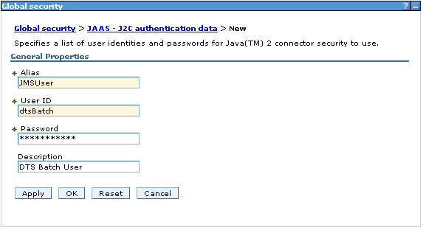
- Specify the username and password.
- Click OK to create an alias for the instance of service integration (SI) bus to use.
- Remember to save the changes by clicking OK. Figure 2 shows the resulting J2C entries.

Figure 2. J2C entries
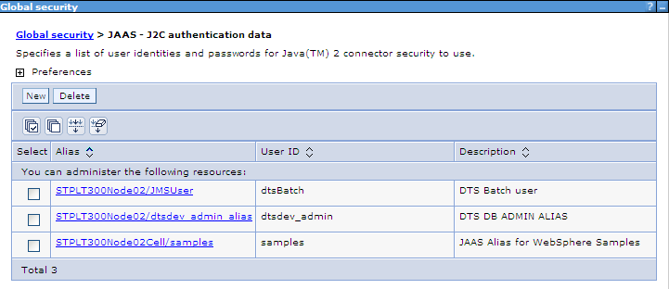
Creating a SI bus member

- Go to Service Integration > Buses and click New.
DTSBatchBus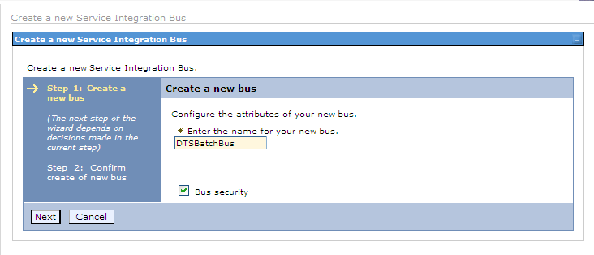
- Enter the name as DTSBatchBus and continue to next step and uncheck “Require clients use SSL protected transports” as show in the figure.
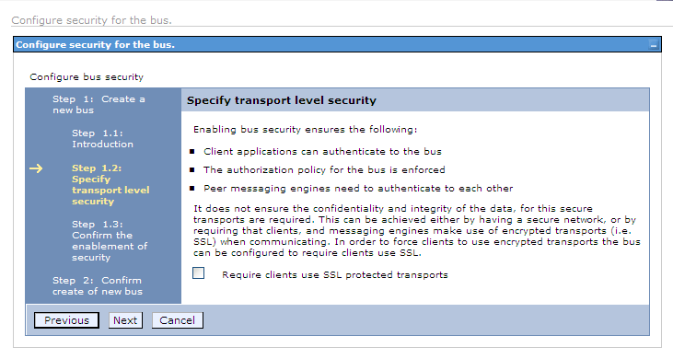
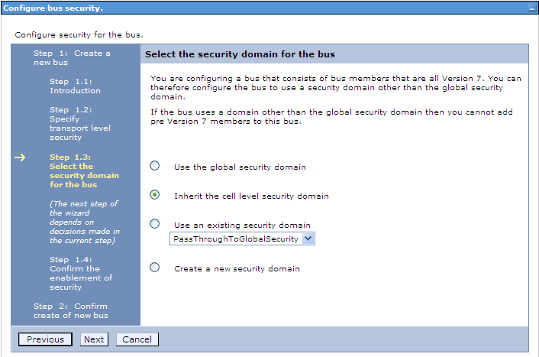
- Navigate till last step with default settings and save.
Creating a bus member
- Select the bus created.
- Go to Bus Members under Topology.
DTSBatchBus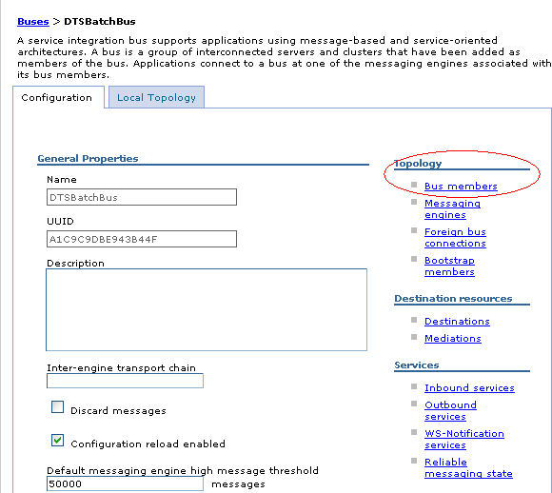
- Create Bus Member by completing the following steps.
- Click Add button
- Select the node for the server
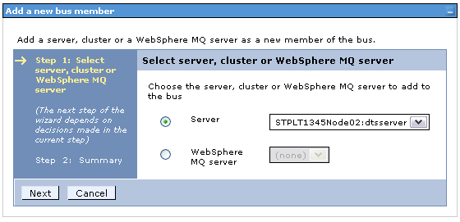
- Select File store option (default)
- Click next till end and save.

Creating a queue destination
- Select the bus created.
- Go to Destinations under Destination Resources.
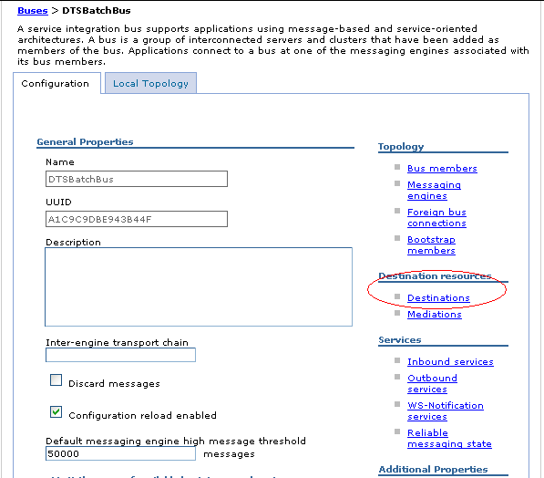
- Create a queue destination as DTSBatchDestination by completing the following steps:
  - Click on the destinations to add an entry that creates a new queue destination.
  - Select Queue as the destination type.
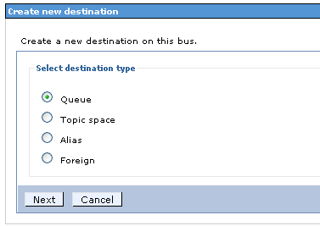
  - Enter an Identifier DTSBatchDestination and click Next.
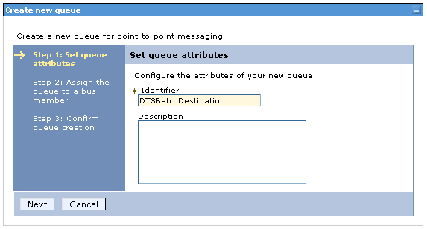
  - Assign the queue to a bus member.
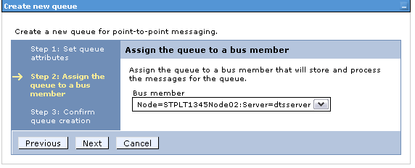
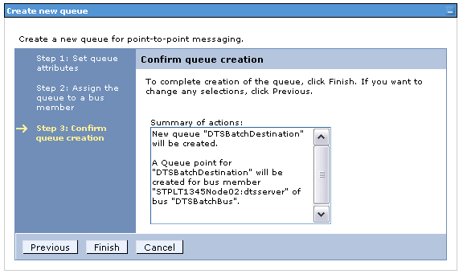
  - Click Finish.
The destination queue creation is complete. Click OK to save the modification to the SI bus member as shown in the figure.

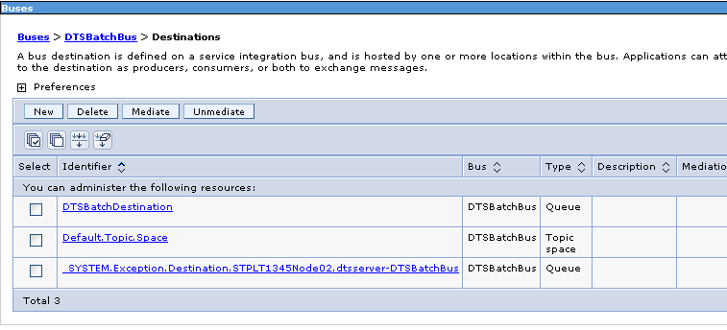

Creating a Batch Queue Connection factory

- Under Resources, select JMS > Connection Factories.
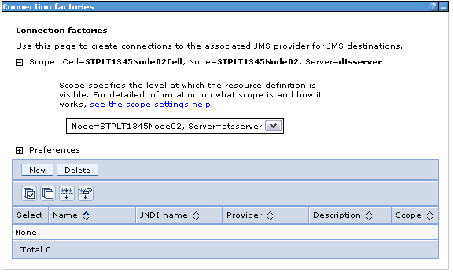
- Click New> Default Connection Factory. The important fields are Name, JNDI Name, Bus name, as shown in Figure.
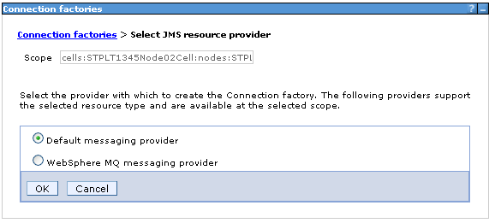
Name: DTS Batch Queue Connection Factory
JNDI name: jms/BatchQueueConnectionFactory
Bus name: Select DTSBatchBus from drop-down
Provider endpoints: hostname:portNumber:BootstrapSecureMessaging (Please replace the hostname with correct host of the server and the port number with correct bootstrap secure port number)
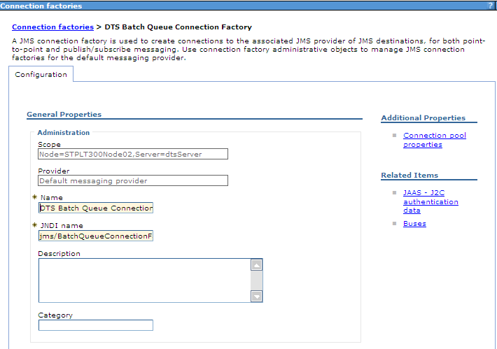
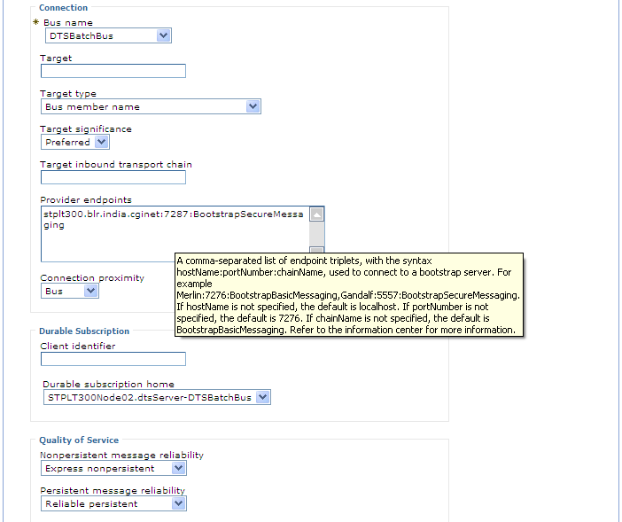
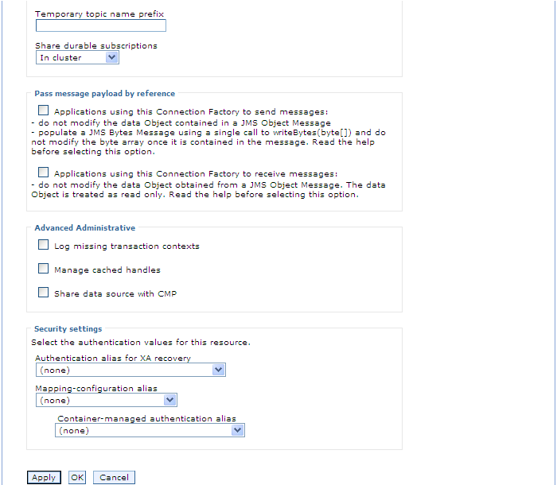

- Click OK to save the Queue Connection factory.
- Save the changes.

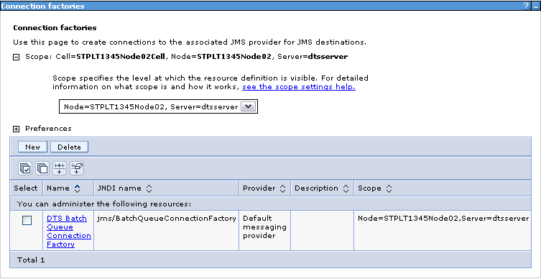

Creating the DTS Batch Queue

- Under Resources, select JMS > Queues.
- Click New. Select Default messaging provider
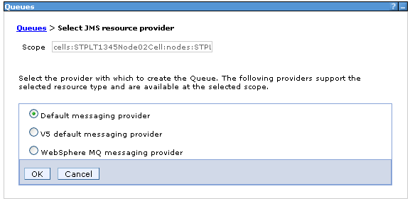
- Click OK. The important fields are Name, JNDI Name as shown in Figures
Name: DTS Batch Queue
JNDI name: jms/DTSBatchQueue
Bus name: Select DTSBatchBus from drop-down
Queue name: DTSBatchDestination from drop-down
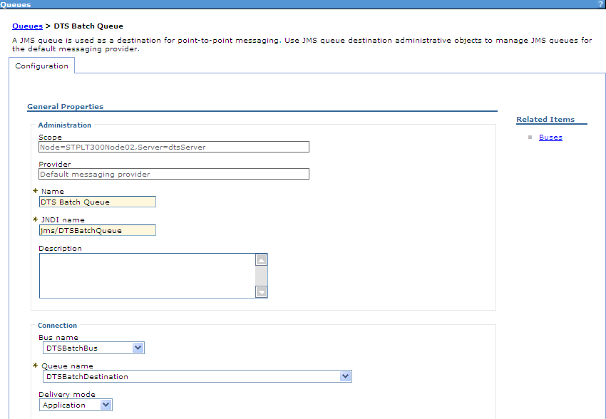
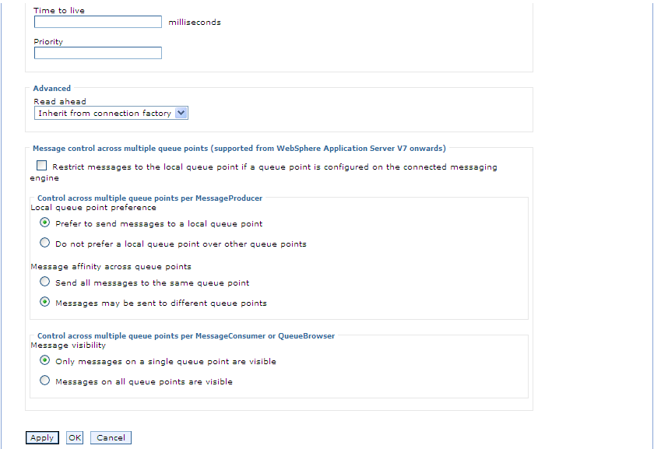

- Select bus name and queue destination drop-down values
- Click OK. Save the changes.

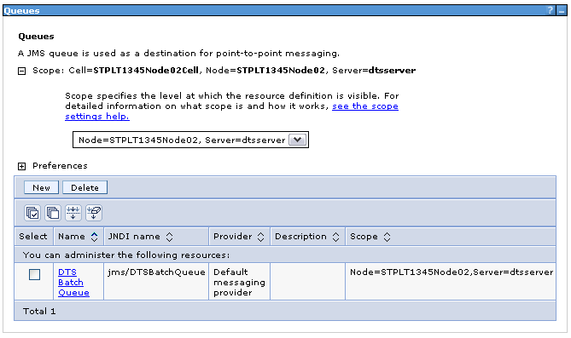

Creating a DTS Batch activation specification
The message driven bean (MDB) uses this activation specification.
- Under Resources, select JMS > Select JMS activation specification.
- Expand scope and select the server node.
- Click New. Select Default messaging provider and click OK. The important fields are Name, JNDI Name, Bus name, Queue name, and Authentication alias, as shown in Figure.
- Click OK and save the Queue activation specification.
- Save the changes.

Name: DTSBatchMDB
JNDI name: eis/DTSBatchMDB
Destination type: Queue
Destination JNDI name: jms/DTSBatchQueue
Provider endpoints: hostname:portNumber:BootstrapSecureMessaging
Authentication Alias: Select JMSUser from the from-down

Check the automatically stop end points on repeated message failure check-box.
- Redelivery Delay Override: 900000 (15 minutes between each replies)
- Redelivery Limit: 3 (3 retries)

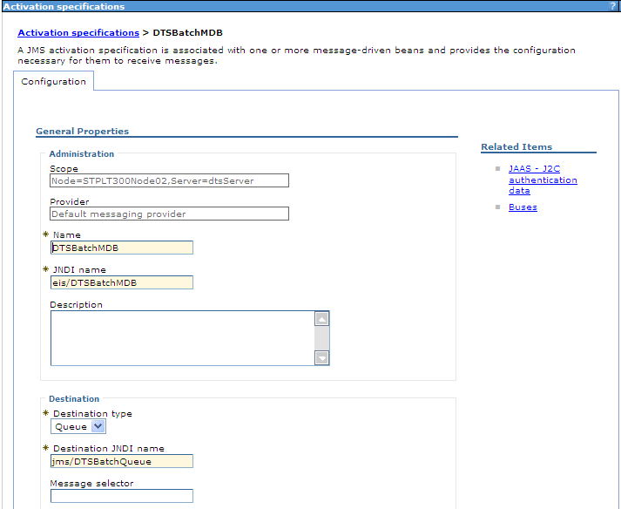
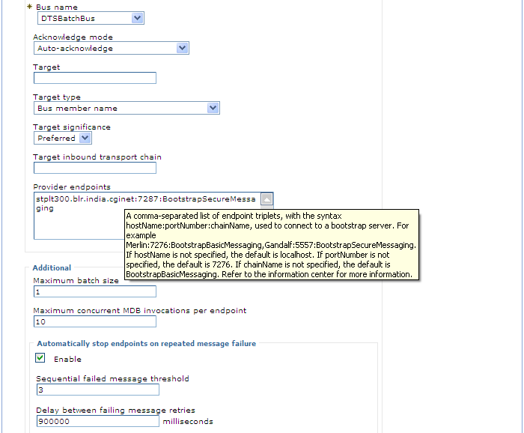
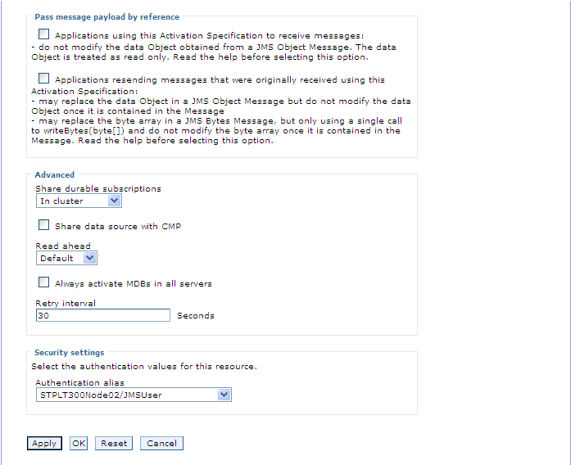

DTS Notification JMS Configurations

Setting J2C data entries
To set the J2C data entries, complete the following steps:
- Log in to the WebSphere Administrative Server administrative console.
- Go to Security > Global security > JAAS Configuration > J2C Authentication Data and click New. The resulting Configuration tab is shown in Figure 1.

Figure 1. J2C entry
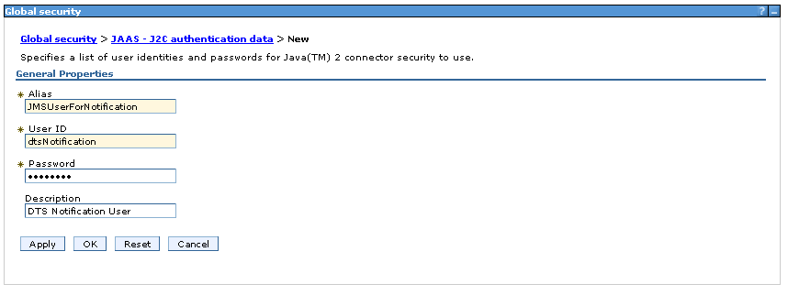
- Specify the username and password.
- Click OK to create an alias for the instance of service integration (SI) bus to use.
- Remember to save the changes by clicking OK. Figure 2 shows the resulting J2C entries.

Figure 2. J2C entries
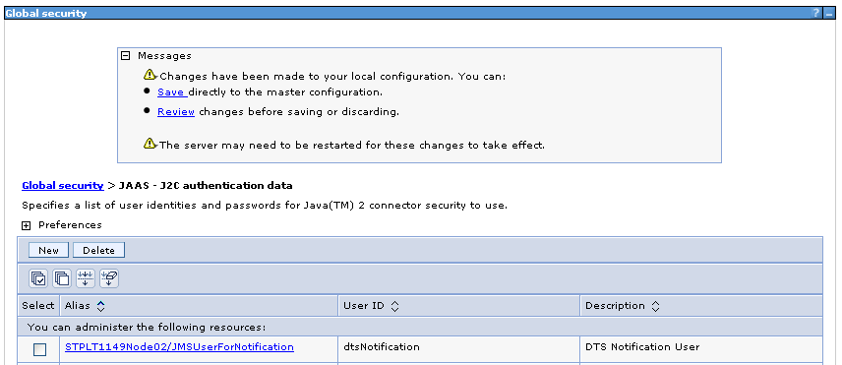

Creating a SI bus member

- Go to Service Integration > Buses and click New.
DTSNotificationBus

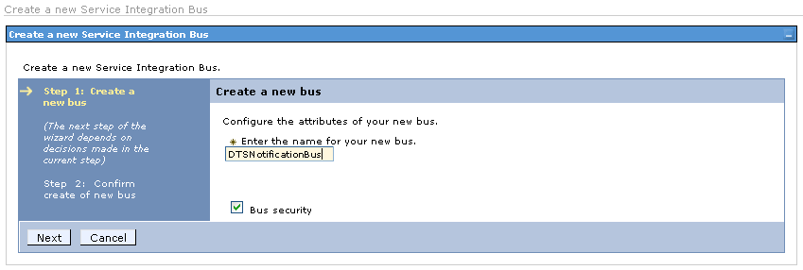

- Enter the name as DTSNotificationBus and continue to next step and uncheck “Require clients use SSL protected transports” as show in the figure.

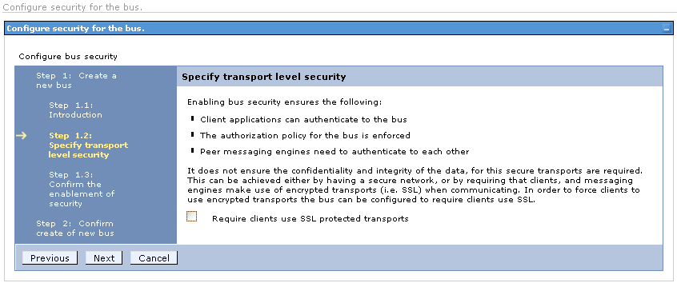
- Navigate till last step with default settings and save.

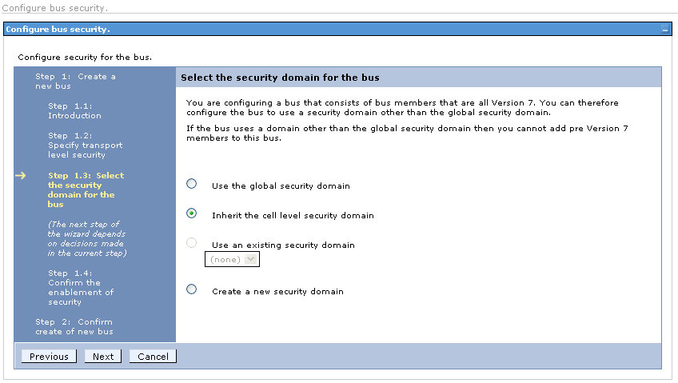

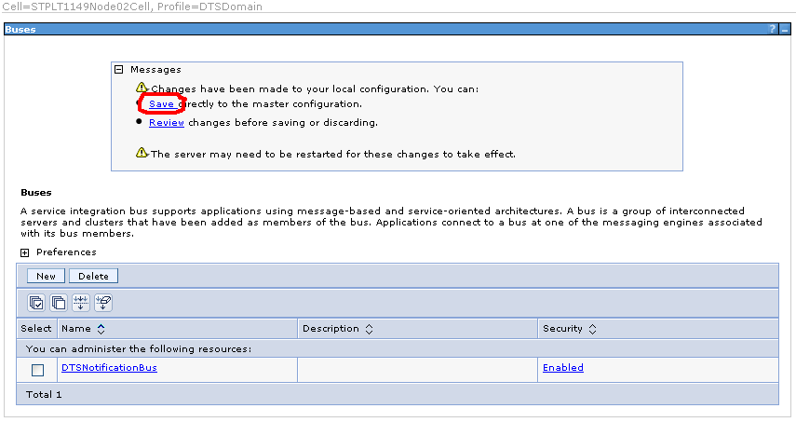

Creating a bus member
- Select the bus created.
- Go to Bus Members under Topology.

DTSNotificationBus
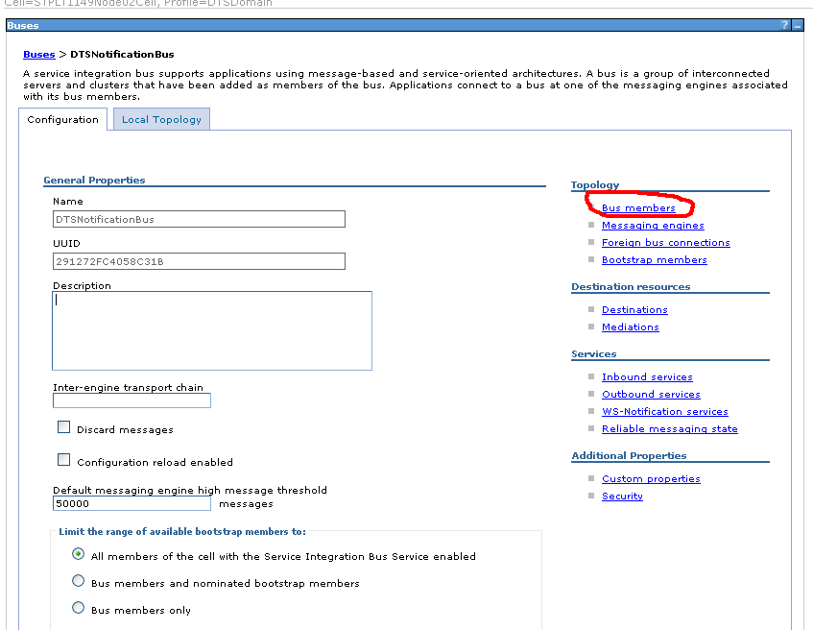
- Create Bus Member by completing the following steps.
- Click Add button
- Select the node for the server
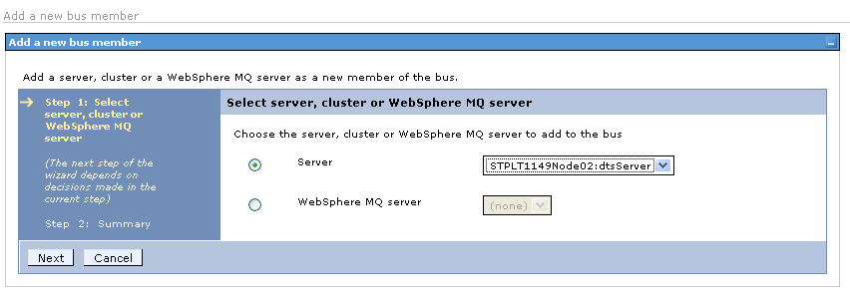
- Select File store option (default)
- Click next till end and save.

Creating a queue destination
- Select the bus created.
- Go to Destinations under Destination Resources.
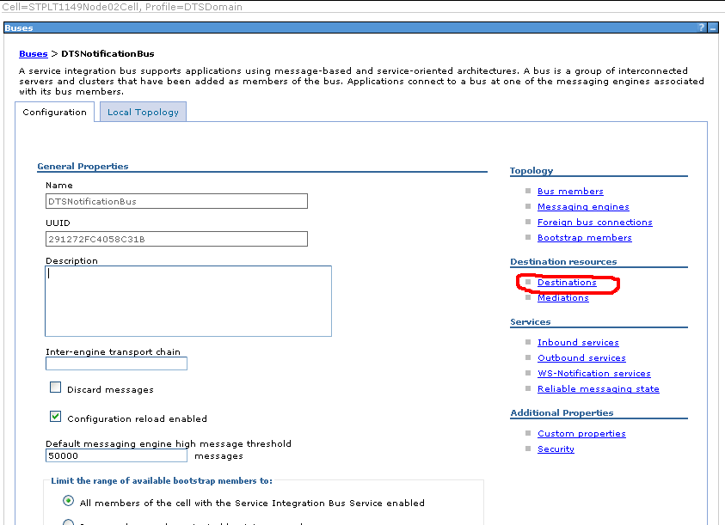
- Create a queue destination as DTSNotificationDestination by completing the following steps:
  - Click on the destinations to add an entry that creates a new queue destination.
  - Select Queue as the destination type.
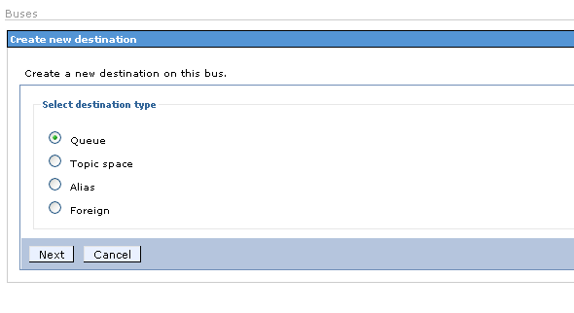
  - Enter an Identifier DTSNotificationDestination and click Next.
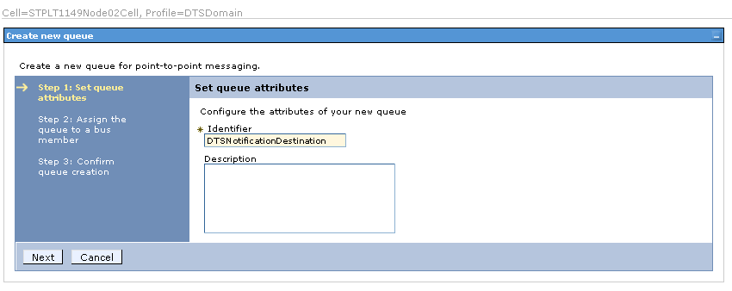
  - Assign the queue to a bus member.
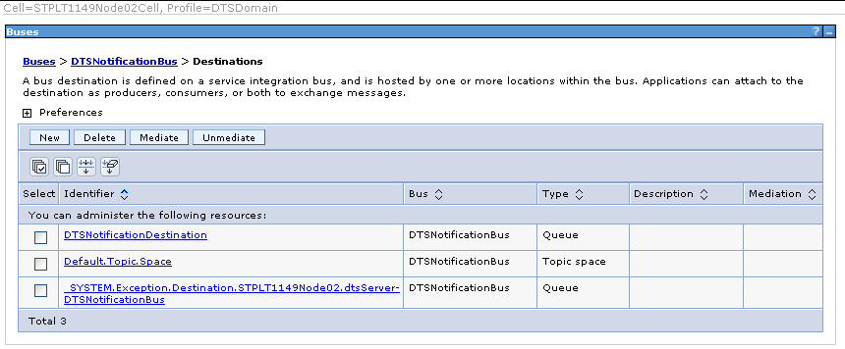
  - Click Finish.
The destination queue creation is complete. Click OK to save the modification to the SI bus member as shown in the figure.

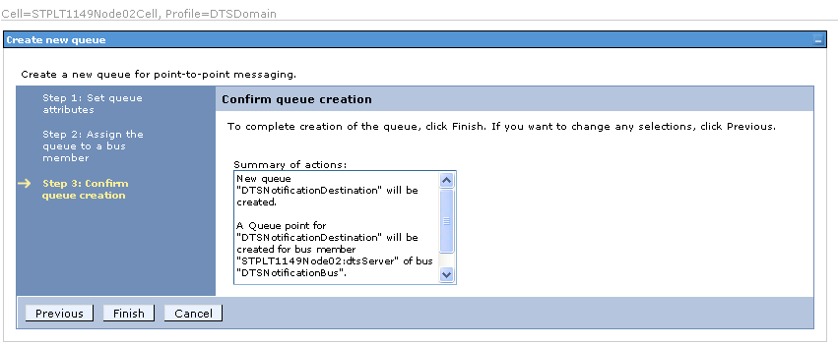

Creating a Notification Queue Connection factory

- Under Resources, select JMS > Connection Factories.
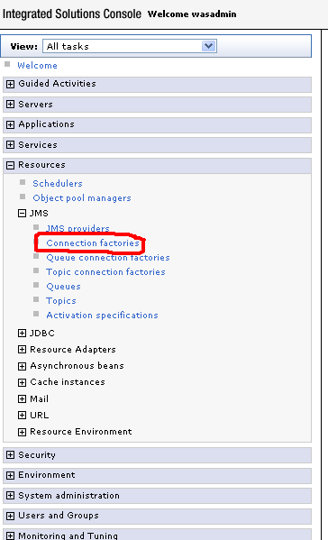
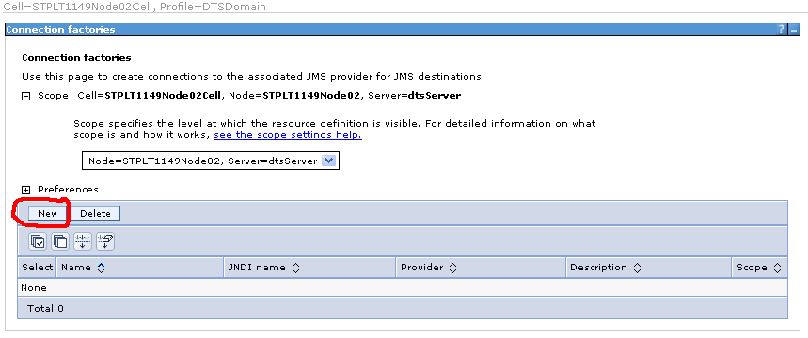
- Click New> Default Connection Factory. The important fields are Name, JNDI Name, Bus name, as shown in Figure.
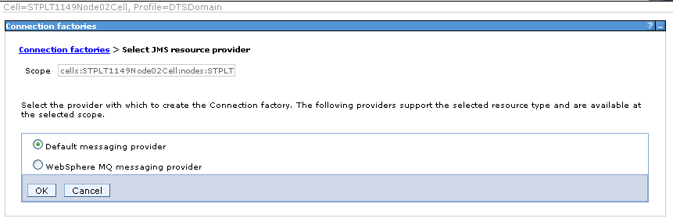
Name: DTS Notification Queue Connection Factory
JNDI name: jms/NotificationQueueConnectionFactory
Bus name: Select DTSBatchBus from drop-down

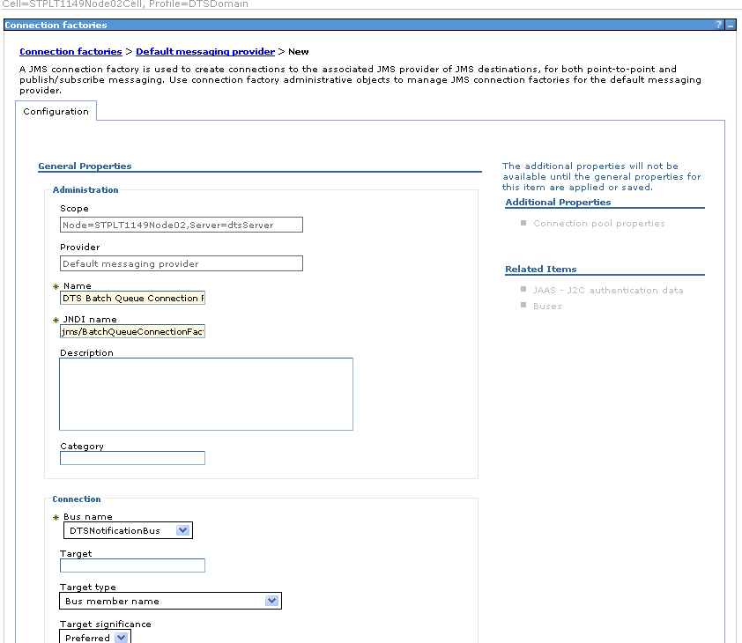

- Click OK to save the Queue Connection factory.
- Save the changes.
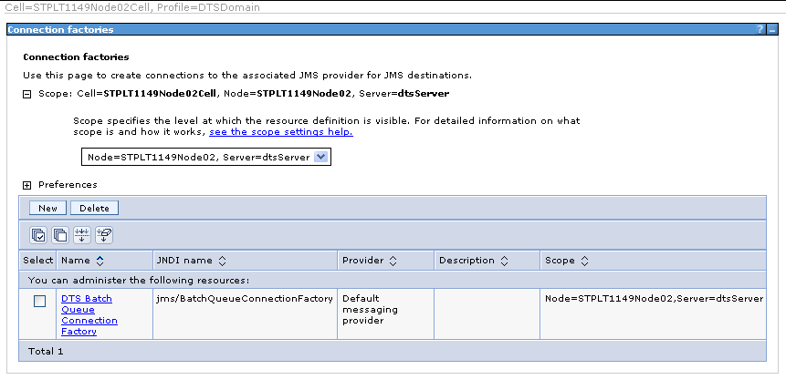

Creating the DTS Notification Queue

- Under Resources, select JMS > Queues.
- Click New. Select Default messaging provider
- Click OK. The important fields are Name, JNDI Name as shown in Figures
Name: DTS Notification Queue
JNDI name: jms/DTSNotificationQueue
Bus name: Select DTSNotificationBus from drop-down
Queue name: DTSBatchDestination from drop-down

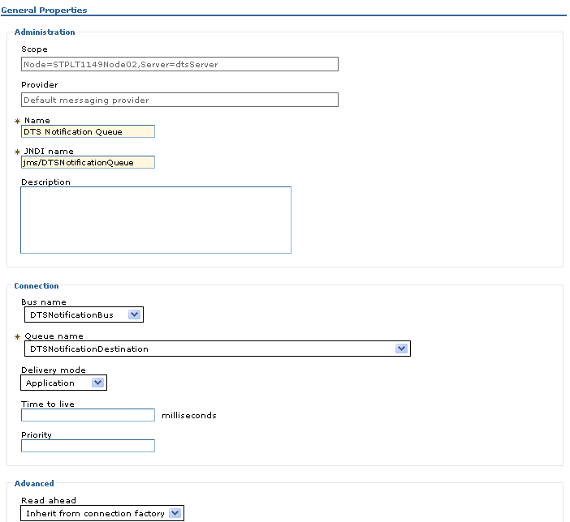

- Select bus name and queue destination drop-down values
- Click OK. Save the changes.

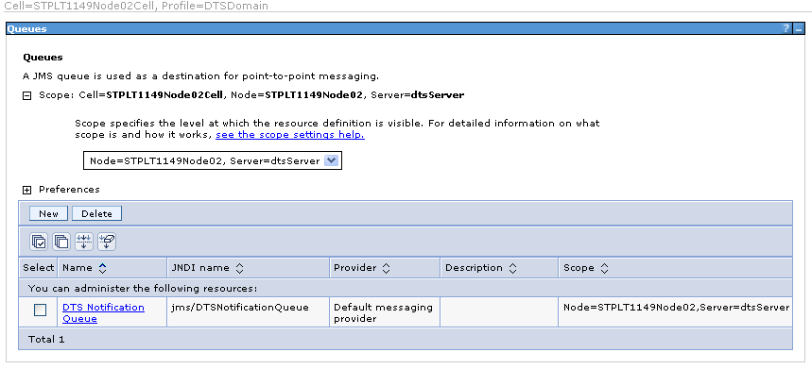
Creating a DTS Notification activation specification
The message driven bean (MDB) uses this activation specification.
- Under Resources, select JMS > Select JMS activation specification.
- Expand scope and select the server node.
- Click New. Select Default messaging provider and click OK. The important fields are Name, JNDI Name, Bus name, Queue name, and Authentication alias, as shown in Figure.
- Click OK and save the Queue activation specification.
- Save the changes.

Name: DTSNotificationMDB
JNDI name: eis/DTSNotificationMDB
Destination type: Queue
Destination JNDI name: jms/DTSNotificationQueue
Authentication Alias: Select JMSUser from the from-down

Check the automatically stop end points on repeated message failure check-box.
- Redelivery Delay Override: 900000 (15 minutes between each replies)
- Redelivery Limit: 3 (3 retries)

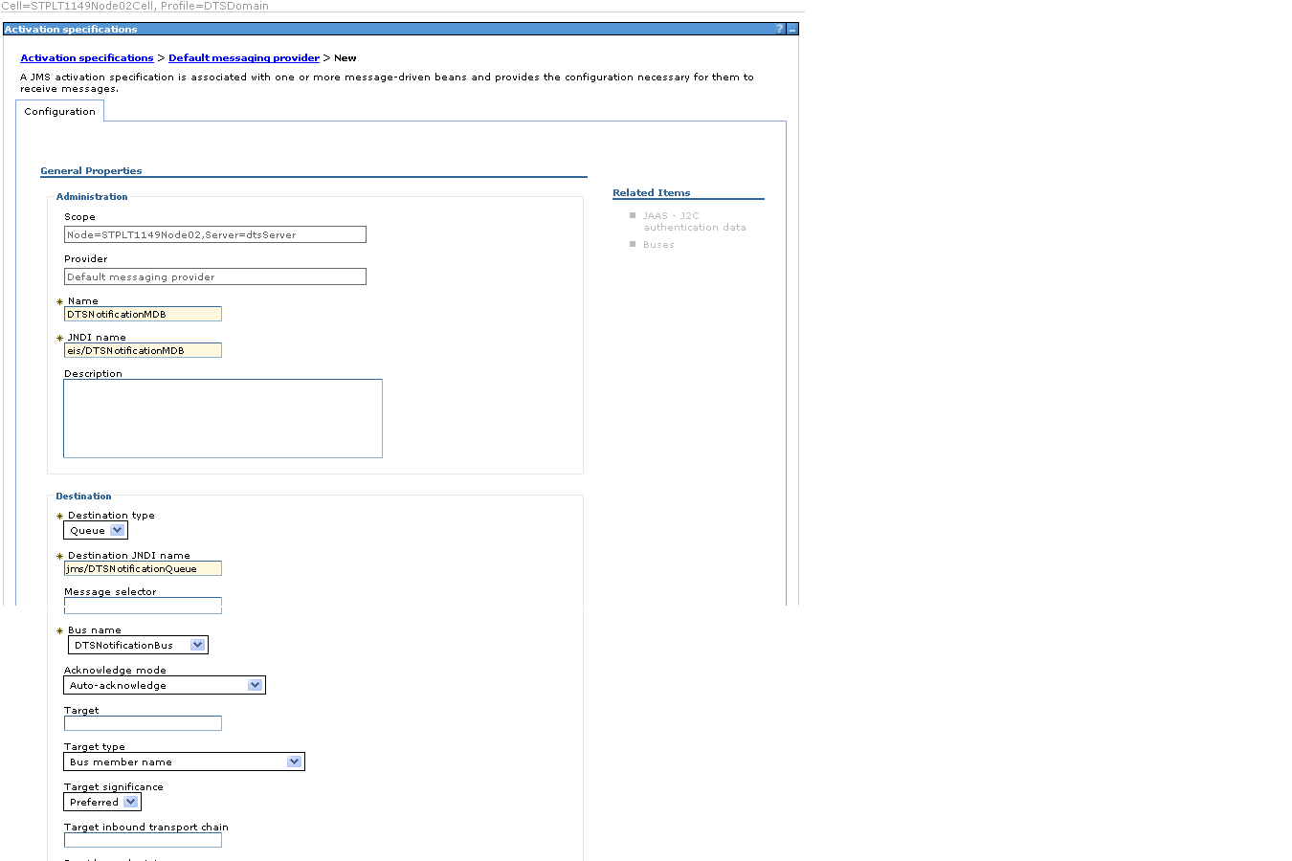

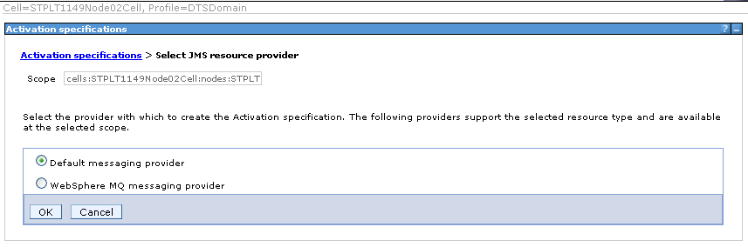

DTS Error JMS Configurations

Creating a queue destination

- Go to Service Integration > Buses select the bus created (DTSBatchBus).
- Go to Destinations under Destination Resources.
- Create a queue destination, such as ErrorHandlerDestination, by completing the following steps:
  - Click on the destinations to add an entry that creates a new queue destination.
  - Select Queue as the destination type.
  - Enter an Identifier.
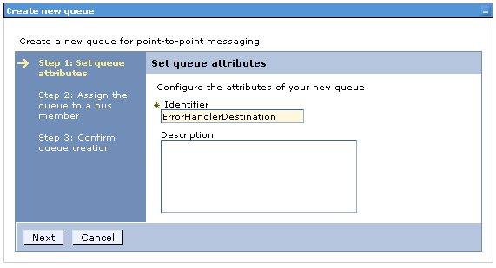
  - Assign the queue to a bus member.

  - Click Finish.
The destination queue creation is complete. Click OK to save the modification to the SI bus member.
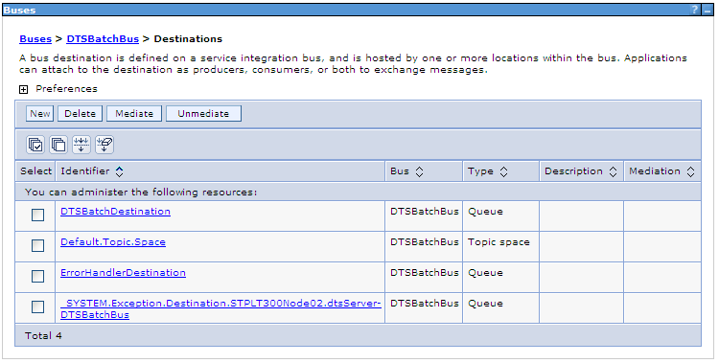

Creating a Error Queue Connection factory

- Under Resources, select JMS > Connection Factories.
- Click New> Default Connection Factory. The important fields are Name, JNDI Name, Bus name, as shown in Figure.
Name: Error Queue Connection Factory
JNDI name: jms/ErrorQueueConnectionFactory
Bus name: Select DTSBatchBus from drop-down
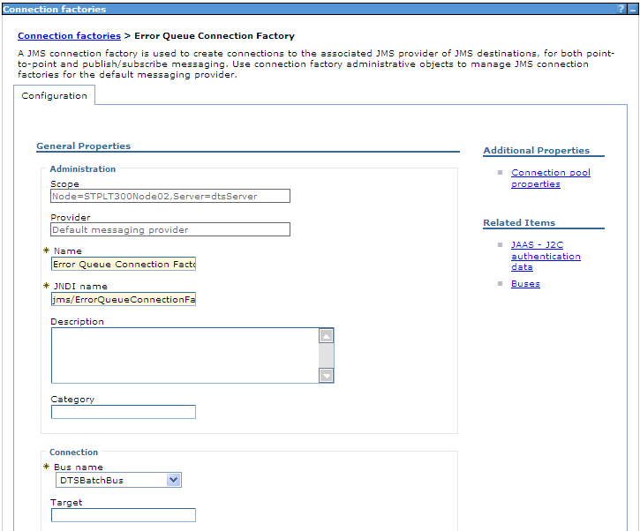

- Click OK to save the Queue Connection factory.
- Save the changes.

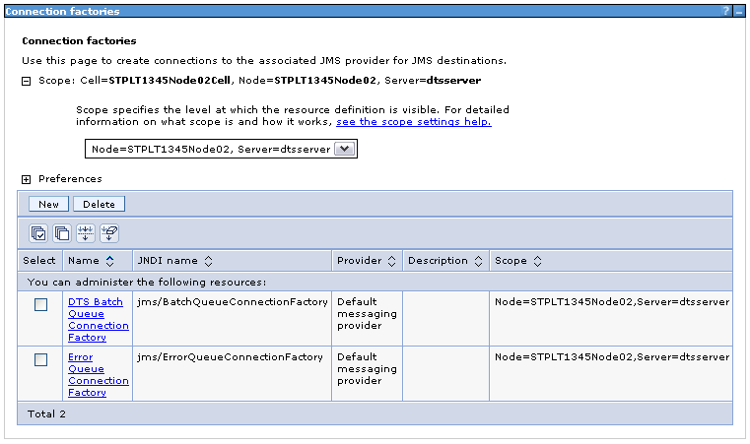

Creating the Error Queue

- Under Resources, select JMS > Queues.
- Click New. Select Default messaging provider
- Click OK. The important fields are Name, JNDI Name as shown in Figures
Name: Error Handler Queue
JNDI name: jms/ErrorHandlerQueue
Bus name: Select DTSBatchBus from drop-down and ErrorHandlerDestination
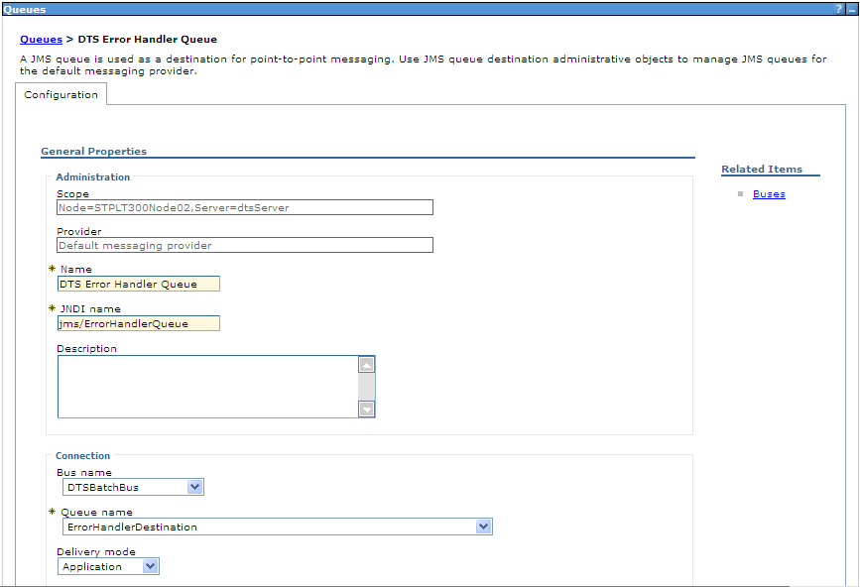

- Select bus name and queue destination drop-down values
- Click OK. Save the changes.

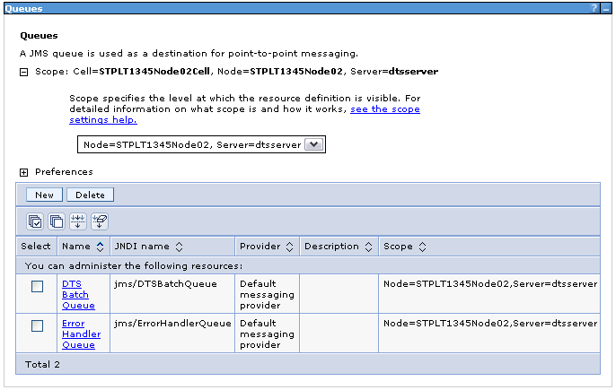

Creating a Error activation specification

The message driven bean (MDB) uses this activation specification.
- Under Resources, select JMS > Select JMS activation specification.
- Expand scope and select the server node.
- Click New. Select Default messaging provider and click OK. The important fields are Name, JNDI Name, Bus name, Queue name, and Authentication alias, as shown in Figure.
- Click OK and save the Queue activation specification.
- Save the changes.

Name: ErrorHandlerMDB
JNDI name: eis/ErrorHandlerMDB
Destination type: Queue
Destination JNDI name: jms/ErrorHandlerQueue and DTSBatchBus
Select the Authentication alias form the drop-down as JMSUser
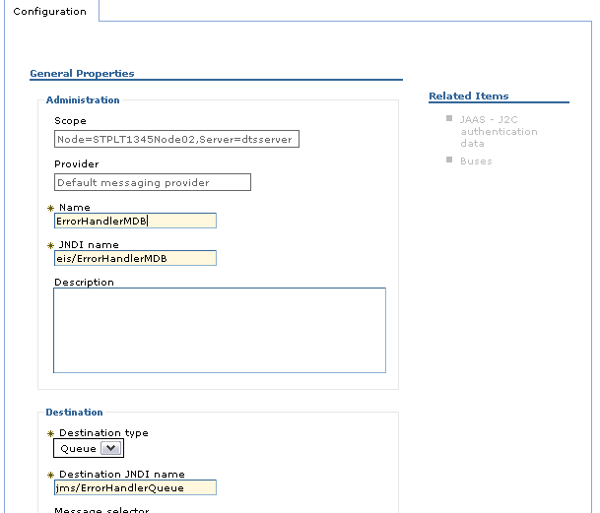
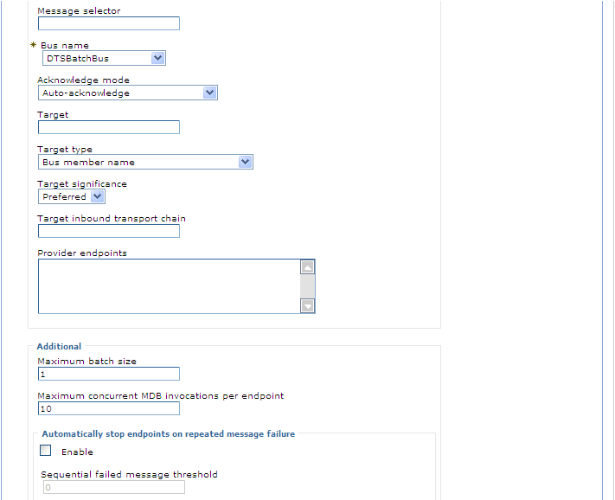
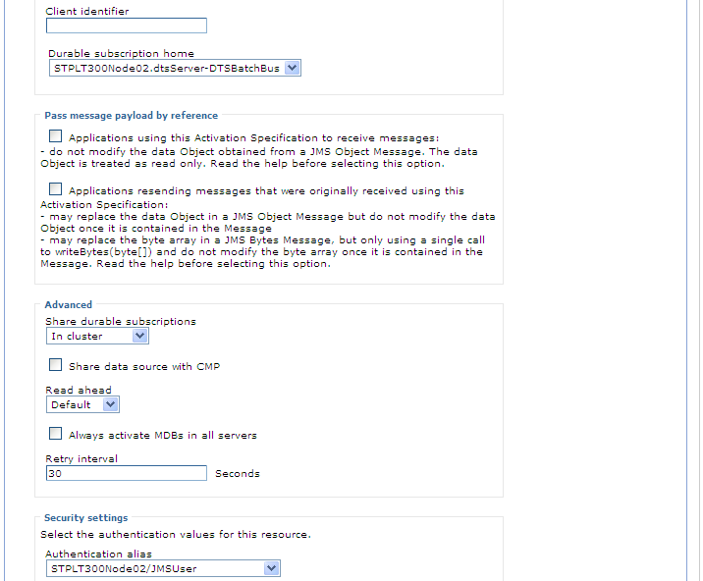

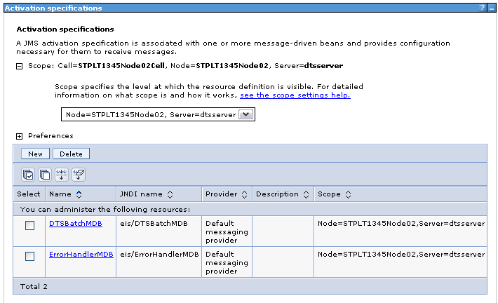

Creating User:

- Under Users and Groups, Select Manage Users > Create

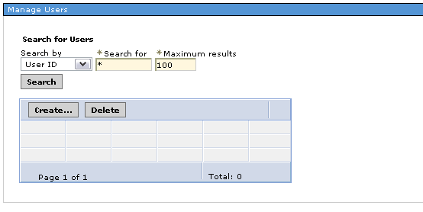

- Enter all mandatory fields same as J2C entries

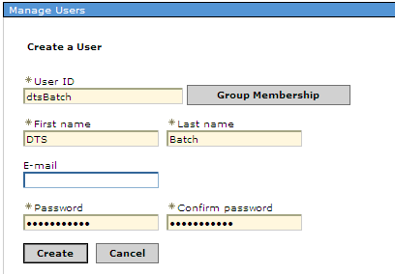

- Click Create and save.

Adding the “dtsBatch” user to the DTS Batch SI bus

- Under Resources, Select JMS> Activation Specifications> select DTSBatchMDB as shown in the figure.

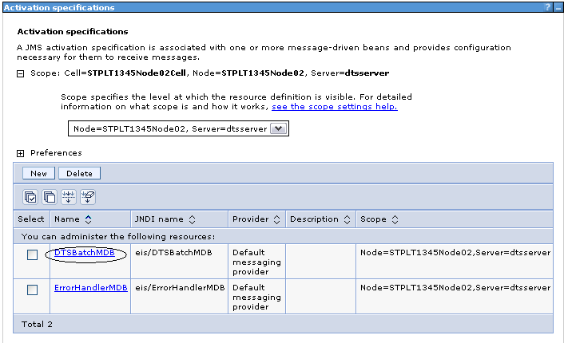

- Select Buses ash shown in the figure.

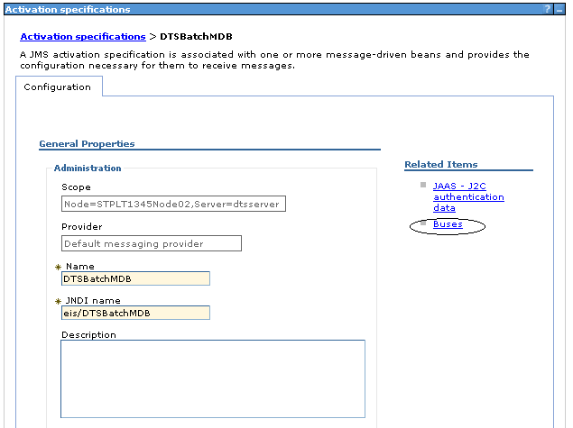

- Click Enabled link as shown in the figure.

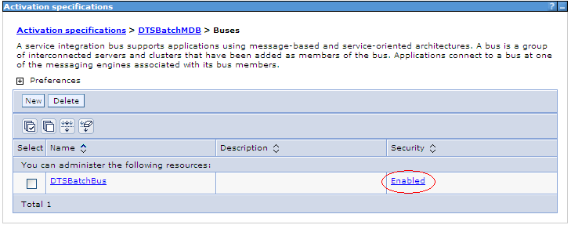

- Select Users and groups in the bus connector role as shown in the figure.

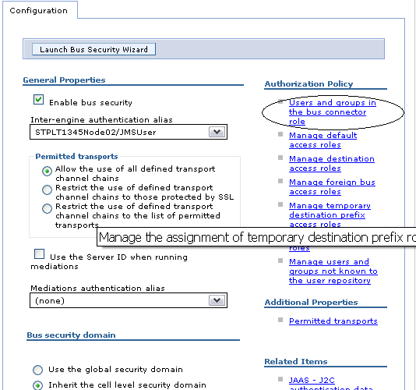

- Click New

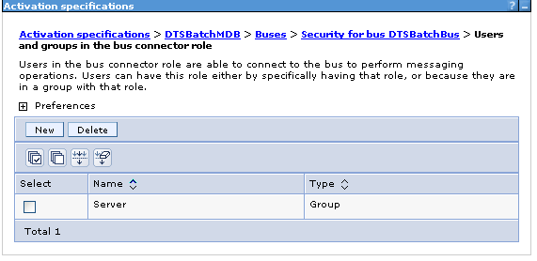

- Select Users radio button and click Next.

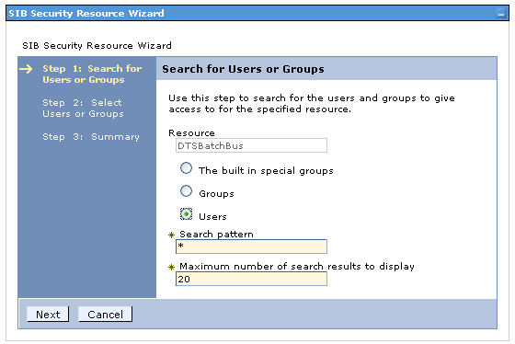

- Select dtsBatch check-box and click Next.

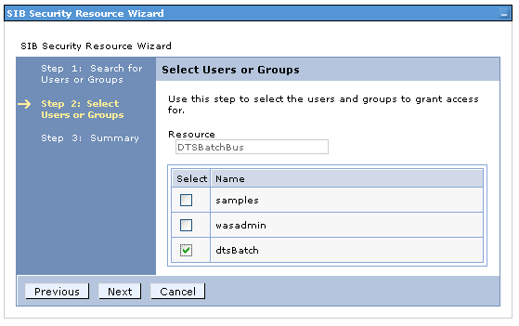

- Save the changes.

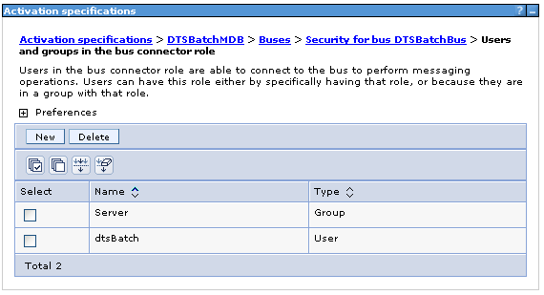

Handling poison messages (Error Handling configuration)

After creating DTSBatchQueue and ErrorHandlerQueue configurations as mentioned above.

DTS Batch Queue: Need to configure the error handler queue on failure of the message processing on Batch Queue.

- Redelivery Delay Override: 900000 (15 minutes between each replies)
- Redelivery Limit: 3 (3 retries)
- Error Destination: Error Handler Queue

- Select Service Integration > Buses.

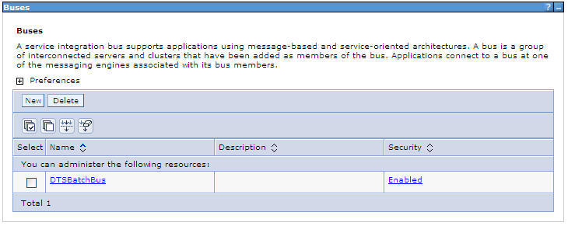

- Select DTSBatchBus > Destinations > DTSBatchDestination.

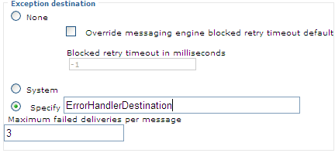

- Change Exception destination section default selection to Specify radio button and specify the name ErrorHandlerDestination as show in the figure above.

- Set Maximum failed deliveries per message to 3.

- Click OK, save the configurations.

Note:
Once these configurations are completed, restart Websphere server for changes to take place.

