Shared Secret Management

Below is the shared secret generation utility window

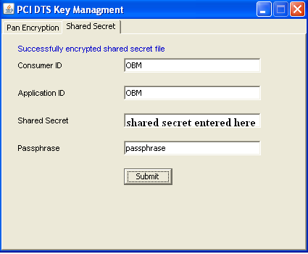

The shared secret file eg “OBM-OBM-2011-06-21-03-14-19” will be created and contain the shared secret and the file will be encrypted using the Passphrase provided in the textbox above. The consumerid_application id is used for file naming as a convention.

The shared secret file is pushed to DTS servers manually in the specified folder configured in “passphrase.properties” application configuration property file.

A new entry has to be added in “passphrase.properties” for the new file with passphrase given at the time of creation. The key should be filename and value should be passphrase.
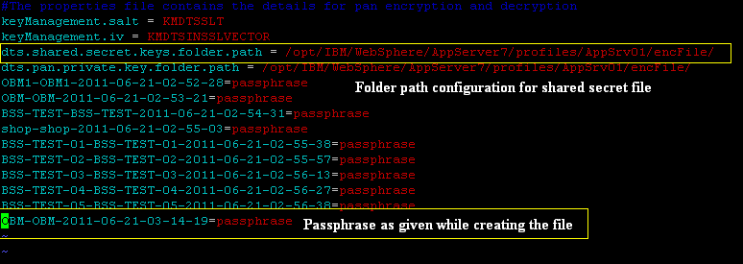

Add a new entry in the database table “BSS_AUTH_SHARED_SECRET_MGMT” with column BSS_AUTH_ID corresponding to the application id and consumer id in “BSS_AUTH” table. ACTIVATION_DATE_TIME and EXPIRATION_DATE_TIME as required but should not overlap with other ACTIVATION_DATE_TIME and EXPIRATION_DATE_TIME for the same BSS_AUTH_ID. The PROP_KEY should be the file name.

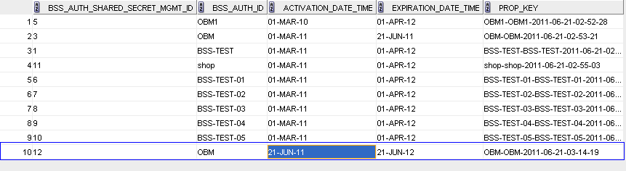

Please ensure the DML is committed in oracle.

Reload the configuration files using the jsp utility https://172.24.204.138:9445/dtsApp/dtsOnline/login.jsp On authentication success the jsp will redirect to jsp with three links as shown below.
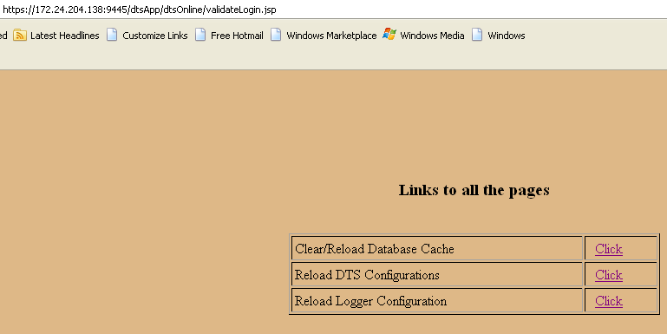

Click on the “Reload DTS Configurations” corresponding link

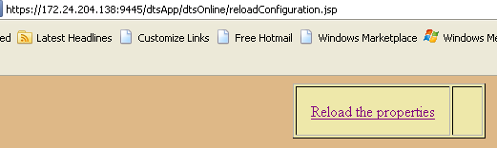

Click “Reload the properties”

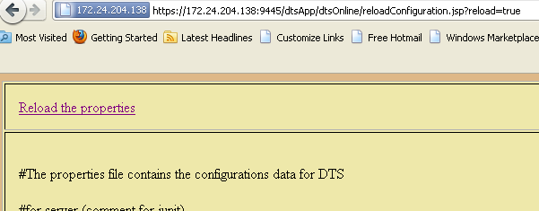

Again Click “Reload the properties” This will load “passphrase.properties” to application memory.

Click on the “Main” link at the right top. This will redirect the main page.

Now click on “Clear/Reload Database Cache” corresponding link.

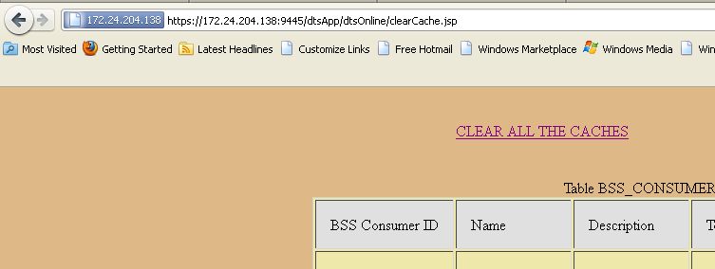

Click on “CLEAR ALL THE CACHES” link. This will load the DB changes to application memory and also drive to decrypt shared secret file and attach shared secret for the particular entity.

Reloading of properties file should be done prior to reloading the cache.

