**Test Report for BuggCars website testing**

Functional testing was carried out for BuggyCars website with focus on Sanity testing. Following are the bugs identified during testing:

**Bug 1:**

**Summary:** Clicking on "View more" fails loading the corresponding page and displays loading icon indefinitely

**Steps to reproduce:**

1. When logged into BuggyCars website, click on 'Popular Make' thumbnail from home page

2. Click on 'View more' link under comments for one of the results displayed

**Expected:**

2. More information related to the selected car should be displayed

**Actual:**

2. fails loading the corresponding page and displays loading icon indefinitely as shown below

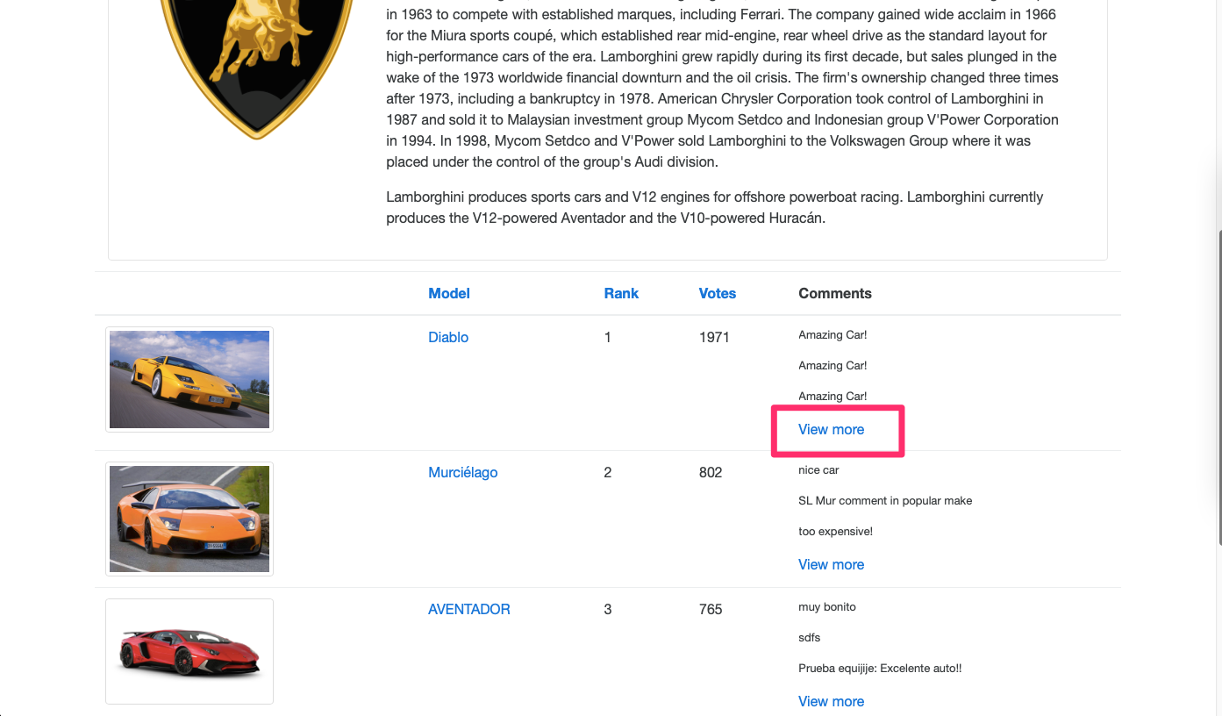

**Bug 2:**

**Summary:** Clicking on 'Popular model' thumbnail doesn't load the page but displays loading icon indefinitely

**Steps to reproduce:**

1. When logged into BuggyCars website, click on 'Popular Model' thumbnail from home page

**Expected:**

2. Popular Model page should be displayed

**Actual:**

2. fails loading the corresponding page and displays loading icon indefinitely as shown below

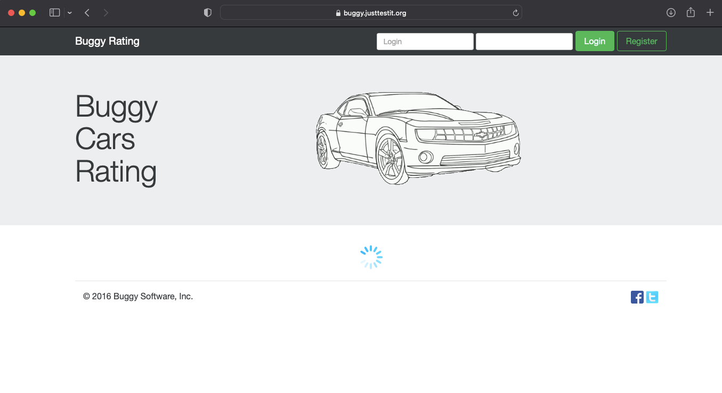

**Bug 3:**

**Summary:** Sorting of Make, Model, Rank, Votes and Engine does not work unless selected from a different column heading

**Steps to reproduce:**

1. Navigate to 'List of ' page

2. Click on Make/Mode/Rank/Votes/Engine column headings

**Expected:**

2. Listing should be displayed in ascending or descending order with each click

**Actual:**

2. Only ascending order of listing is displayed and nothing happens with subsequent clicks

**Note:** However, if a different column heading is selected, listing order changes from ascending <-> descending

