Engineering Efficiency with AI Pair Programming
A Case Study of ARIA — One Product Owner, One Claude
Fintech SaaS · Two Products · Six Days · One Person

73  Commits  6 days | ~12h  PO Active Time  total across 9 sessions | 2  Products Shipped  Advisor + Personal | 60–90×  Peak Compression  Session 1 ratio

Author: sunder-vasudevan · March 2026 · Version 1.0
Audience: Technical peers · Engineering leads · Technical founders · Fintech product teams

Table of Contents

(Update this field: select all → right-click → Update Field, or press Ctrl+A then F9)

Abstract

This paper documents a real-world experiment: a single Product Owner building ARIA — a fintech SaaS platform comprising two distinct products (A-RiA Advisor Workbench and ARIA Personal) — in collaboration with Claude (Anthropic's AI assistant) as a persistent pair-programmer.
Over 6 active coding days (2026-03-13 to 2026-03-18), the pair shipped both products from zero to market-ready state: a full-stack wealth management advisor workbench and a self-directed consumer finance app, sharing a common FastAPI backend. 9 sessions produced 73 commits, spanning AI-powered features, a Monte Carlo simulation engine, JWT auth, cloud deployment (Render + Supabase + Vercel), 26 UI/UX polish fixes, production bug resolution, brand identity, and investor documentation — all from a single Product Owner with no engineering team.
The ARIA project demonstrates a sustained 20–40× compression ratio over equivalent traditional engineering effort, with individual sessions reaching 60–90× on active interaction time.

1. Introduction — The Experiment

ARIA was not a side project. It was built as a market-ready fintech product, targeting two distinct audiences: professional wealth management advisors (A-RiA) and self-directed retail investors (ARIA Personal). The architecture spans a shared FastAPI backend, two independent React/Vite frontends, PostgreSQL via Supabase, and live AI features powered by the Claude API — all deployed, all production.

The Central Question
Can one Product Owner, working with Claude as a persistent full-session collaborator, build a fintech product to market-ready state in the time it would take a traditional team to write a sprint plan?

What "Efficiency" Means Here
- Feature throughput per calendar day
- Architectural depth delivered without accruing uncontrolled debt
- Code quality signals visible in git history
- Documentation discipline sustained throughout
- Active Product Owner interaction time per feature shipped

Why Fintech Specifically Matters
Fintech products carry higher technical complexity than typical web apps: Monte Carlo simulation engines, probability scoring, inflation-adjusted projections, JWT auth, multi-tenant data isolation, and regulatory-adjacent data handling. This is not a todo app. The domain complexity makes the efficiency story more meaningful.

2. Project Scope — What Was Built

A-RiA Advisor Workbench
Professional tool for wealth management relationship managers:
- Client roster with segment, risk profile, portfolio, goals, and life events
- AI Copilot with client-specific context injection (Claude Sonnet 4.6)
- Morning Briefing: AI-generated per-client urgency analysis
- Meeting Prep Card: AI-generated agenda, risks, talking points, open questions
- Monte Carlo goal probability engine (1,000 simulation paths, inflation-adjusted)
- What-if scenario modeler with live sliders — Mode 1: monthly SIP, Mode 2: reverse-calculate required SIP
- Client Interaction Capture with urgency escalation
- Client Portal (client-facing view)
- 26-item UI/UX polish pass (accessibility, mobile, skeleton loaders, animations, print styles)

ARIA Personal
Consumer self-directed finance app:
- JWT registration and login (real user accounts, no hardcoding)
- Portfolio management with donut chart and holdings table
- Goal tracking with Monte Carlo probability rings
- Life events log
- AI Copilot in first-person voice ("your portfolio", not "the client")
- Shared backend infrastructure with advisor app

Technology Stack
Layer | Technology
Frontend (Advisor) | React 18 + Vite + Tailwind CSS (navy palette)
Frontend (Personal) | React 18 + Vite + Tailwind CSS (separate repo + Vercel)
Backend | FastAPI (Python 3.11), SQLAlchemy, shared by both products
Database | Supabase PostgreSQL (pooler, port 6543)
Auth — Advisor | Frontend localStorage, hardcoded advisor credentials
Auth — Personal | JWT (python-jose + bcrypt), real user accounts
AI Features | Claude Sonnet 4.6 (Anthropic API)
Simulation Engine | Custom Monte Carlo — 1,000 paths, log-normal returns, inflation-adjusted
Deployment | Render (backend) + Vercel (frontend ×2) + Supabase (DB)

Deployed URLs
Product | URL | Status
A-RiA Advisor | https://a-ria.vercel.app | ✅ Live
Backend API | https://aria-advisor.onrender.com | ✅ Live
ARIA Personal | Vercel deploy pending | 🔄 Frontend built

3. Methodology — How Efficiency Is Measured

Primary Metric
Feature throughput per active day: how many meaningful product features were shipped per active coding day, compared to what a small team would typically ship in the same calendar window.

Comparison Baseline: Traditional 3-Person Startup Team
- 1 frontend engineer + 1 backend engineer + 1 tech lead / PM
- Typical output in a 2-week sprint: 2–4 significant features to production
- 15–25% of sprint consumed by ceremonies, reviews, coordination
- Architecture work treated as dedicated sprint scope, not background activity
- Deployment pipeline setup: 2–5 days
- Documentation: typically deferred

Data Sources
Source | What It Measures
git log --shortstat | 73 commits across 6 active days, LOC per commit
SESSION_LOG.md | All 9 sessions — goals, features shipped, estimated PO time
INTERACTION_LOG.md | Formal session log from Session 4 onwards
DECISION_LOG.md | Architecture decisions with explicit rationale
PO self-assessment | "2–3× faster" at project level — consistent with BzHub findings

Important: "Interaction time" measures only the Product Owner's active prompting and review time — not wall-clock time or Claude's generation time. It represents the human direction cost — the relevant denominator when evaluating how much PO judgment is needed to produce a given output.

4. Timeline & Velocity Analysis

Commit Activity by Date
Date | Commits | Notes
2026-03-13 | 8 | Project init — full Phase 1 + Phase 2, PRD v1.0, AI features, 20 clients seeded
2026-03-14 | 3 | ARIA rebrand, Monte Carlo engine (FEAT-501), session docs
2026-03-15 | 2 | Session wrap docs + stability checkpoint
2026-03-16 | 7 | Render + Supabase + Vercel deploy, Meeting Prep Card, Client Portal, HELP.md, v1.2
2026-03-17 | 15 | FEAT-101 (add/edit client), FEAT-102/108/109 (onboarding wizard), mobile layout, AI error handling
2026-03-18 | 38 | FEAT-404, 26 UI/UX fixes, ARIA Personal backend, What-if v2, goals/holdings CRUD, branding, whitepaper

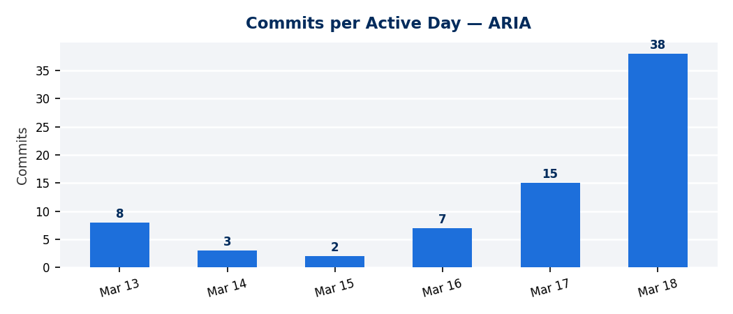
38 of 73 commits (52%) occurred on a single day (2026-03-18). The two peak days (Mar 17–18) account for 53 commits (73%). This intensity pattern — achievable without cognitive fatigue because Claude holds cross-session context — is the clearest signal of AI-amplified throughput.

Session-by-Session Breakdown
Session | Date | PO Time | Key Output
1 | 2026-03-13 | ~90 min | Full Phase 1 + Phase 2 from zero: FastAPI, React, all AI features, 20 clients, PRD v1.0
2 | 2026-03-14 | ~15 min | ARIA rebrand, Monte Carlo engine, tagline set
3 | 2026-03-15 | ~20 min | Session wrap + phase sync
4 | 2026-03-16 | ~3 hrs | Full cloud deploy (Render + Supabase + Vercel), Meeting Prep Card, Auth, Client Portal, HELP.md
5 | 2026-03-17 | ~1h 45m | AI error handling, Morning Briefing redesign, URL migration
6 | 2026-03-17 | ~30 min | Mobile-responsive layout (FEAT-407) — full mobile across all pages
7 | 2026-03-17 | ~45 min | FEAT-101: Add/Edit Client — 7 new fields, PUT /clients/{id}, ClientForm.jsx
8 | 2026-03-17 | ~30 min | FEAT-102/108/109: 4-tab onboarding wizard — risk questionnaire, portfolio, goals
9 | 2026-03-18 | ~4 hrs | FEAT-404, 26 UX fixes, ARIA Personal backend, What-if v2, goals CRUD, login redesign, branding, whitepaper
Total |  | ~12 hrs | 73 commits · 2 products · 6 active days

The Day-One Sprint — Session 1 (2026-03-13)
In approximately 90 minutes of active interaction, the pair shipped: FastAPI backend with all routers + 20 seeded clients, Claude API integration (Copilot, Briefing, Situation Summary), React + Vite frontend with all components, and PRD v1.0. A traditional 3-person team would plan this scope for a 4–6 week sprint.

The Peak Day — Session 9 (2026-03-18)
38 commits. What shipped in one day:
Feature | Scope / LOC
FEAT-404: Client Interaction Capture | New DB table, backend router, InteractionsPanel.jsx — 510 LOC
UI/UX Batch 1–3 (26 fixes) | Skeleton loaders, touch targets, animations, sidebar collapse, print styles, aria-labels, lazy tabs
ARIA Personal backend | JWT auth, 5 FastAPI routers, personal_models.py, DB migration — 753 LOC
FEAT-503: What-if v2 | Inflation-adjusted Monte Carlo + reverse-SIP calculator — 310 LOC
Goals + Life Events + Holdings CRUD | Add/edit/delete across 3 entities, holding drawer, chart expand, NAV data — 1,292 LOC
Login redesign — both apps | Split layout, dark navy gradient, slate-50 right, brand taglines
ARiALogo / ARIALogo components | Round dot on ı, brand blue #1D6FDB, deployed across all pages
ARIA Whitepaper + Executive Deck | ARIA_WHITEPAPER.md (5,868 words), Whitepaper.docx (116KB), Executive Deck (12 slides, 143KB)

A traditional 3-person team would allocate 6–10 engineer-weeks for this feature set.

5. Lines of Code Analysis — Key Feature Commits

Date | Feature | Files | Insertions | Deletions
2026-03-13 | Full Phase 1 + Phase 2 build | ~40 | ~3,500 | 0
2026-03-16 | Meeting Prep Card + Auth + Portal + HELP | ~15 | ~900 | ~50
2026-03-17 | FEAT-101: Add/Edit Client module | 13 | 721 | 8
2026-03-17 | FEAT-102/108/109: Onboarding wizard | 4 | 980 | 198
2026-03-17 | Mobile-responsive layout | 5 | 300 | 111
2026-03-18 | FEAT-404: Interaction Capture | 9 | 510 | 7
2026-03-18 | UI/UX Batch 1 (8 fixes) | 9 | 633 | 36
2026-03-18 | UI/UX Batch 2 (8 fixes) | 11 | 122 | 54
2026-03-18 | UI/UX Batch 3 (10 fixes) | 10 | 247 | 174
2026-03-18 | Add/Edit Goals + Life Events + Holdings | 11 | 1,292 | 232
2026-03-18 | FEAT-503: What-if v2 | 5 | 310 | 70
2026-03-18 | ARIA Personal backend | 10 | 753 | 5
2026-03-18 | Login redesign + branding + docs batch | 11 | 2,397 | 26

Estimated total net application LOC across both products: ~12,000–14,000 lines
(Excludes lock files, migration scripts, documentation, and dependency artifacts)
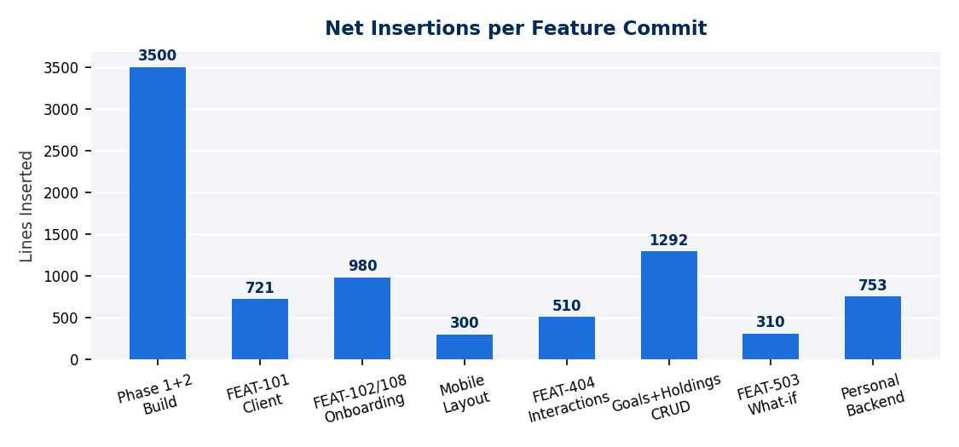

6. Comparative Analysis

Full Project Window
Dimension | 1 PO + Claude (6 days) | Est. 3-Person Team (6 days)
Products shipped | 2 (Advisor + Personal — shared backend) | 0–1 (planning + scaffolding phase)
Production deployments | 3 (Render + Vercel ×2) | Setup in progress
AI features live | 4 (Copilot, Briefing, Meeting Prep, Situation Summary) | 0 — AI integration is a dedicated sprint
Custom simulation engine | ✅ Monte Carlo, 1,000 paths, inflation-adjusted | 0 — requires quant specialist time
Auth systems | 2 (advisor frontend auth + Personal JWT) | 0–1
UI/UX polish fixes | 26 systematic fixes | 4–6 (typical sprint capacity)
Documentation maintained | Per-feature (enforced rule) | Deferred
Investor materials | Whitepaper + DOCX + 12-slide PPTX | Not started
Total PO active time | ~12 hours | N/A (team always staffed)

Compression Ratio by Session Type
Session Type | PO Time | Est. 3-Person Equiv. | Ratio
Full product build from zero (Session 1) | ~90 min | 4–6 weeks | 60–90×
Cloud deploy + live AI features (Session 4) | ~3 hrs | 2–3 weeks | 15–25×
Feature sprint — 26 UX + 3 features + branding (Session 9) | ~4 hrs | 8–12 weeks | 25–40×
Mobile layout pass (Session 6) | ~30 min | 3–5 days | 20–30×

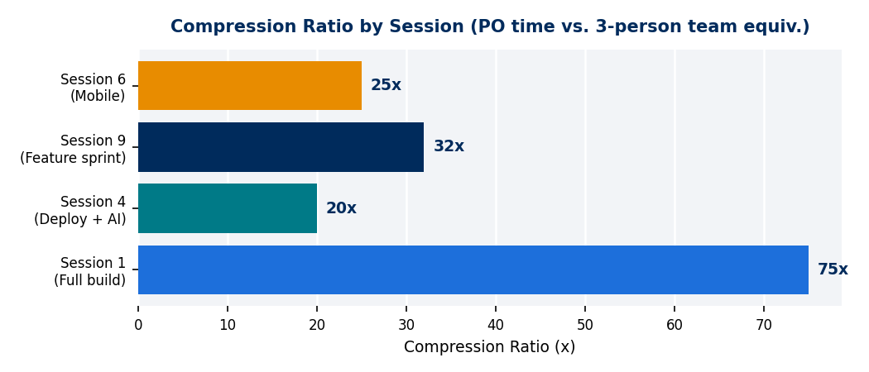

Where the Gains Come From
Zero handoff overhead: Frontend, backend, DB schema, and AI prompt engineering all change in a single session without coordination latency.
Persistent cross-session context: NOTES.md, PRD.md, SESSION_LOG.md, DECISION_LOG.md, and .claude/memory/ preserve full project state. Claude resumes with context a new hire would need 2–3 weeks to develop.
On-demand full-stack + domain expertise: No single engineer is equally fluent in Monte Carlo simulation, FastAPI async patterns, React state lifting, Safari WebKit quirks, and Tailwind animation design. The pair covers all layers.
Documentation as a zero-cost side-effect: HELP.md, PRD, RELEASE_NOTES, DECISION_LOG, whitepaper, and executive deck were all maintained throughout — not deferred.
Parallel execution: Background agent pattern: documentation (whitepaper + PPTX) generated by a background agent while main thread continues feature work.

7. Architecture Observations

Two Products Without Architectural Debt
Building two products on a shared backend could easily produce a "frankenapp" — feature flags, tangled auth, mixed concerns. The ARIA architecture avoided this deliberately:
- Clean separation: separate repos, separate frontends, separate Vercel deployments
- Shared only what belongs shared: simulation engine, DB infrastructure, base models
- New personal routes under /personal/ prefix — zero pollution of existing advisor routes
- Nullable FKs for data model extension: personal_user_id added as nullable — zero risk to advisor data
- Each architectural decision documented in DECISION_LOG.md with explicit rationale

Known Debt — Openly Tracked
ARIA Personal not yet deployed to Vercel (frontend built, awaiting deploy)
Advisor auth is hardcoded (localStorage) — JWT upgrade planned for Phase 3
DESIGN.md not yet written (design system verbally agreed, not codified)
/help page not yet in-app (standing rule — flagged for next session)

The Simulation Engine
The Monte Carlo engine (backend/app/simulation.py) runs 1,000 simulation paths with log-normal return distribution per risk category, inflation adjustment (default 6% for Indian market context), binary search reverse-SIP calculation (Mode 2 what-if), and goal probability as P(final_value ≥ inflation_adjusted_target).
This is quantitative finance work — the kind that requires a dedicated quant engineer in a traditional team. It was built and iterated in two sessions.

Collaboration Patterns
Task Category | Examples from ARIA
Full-stack feature design | DB model → FastAPI router → React component in one session
Algorithm implementation | Monte Carlo engine, inflation adjustment, binary search SIP
Architecture decisions | Shared backend vs. separate, JWT auth design, nullable FK migration
Bug diagnosis | FastAPI 204 + implicit None = ASGI 500; Safari WebKit date onChange; React state remount
Cross-browser compatibility | Safari date input → month/year selects (permanent codebase pattern)
Design system | Brand blue #1D6FDB, probability pill colors, split-panel login layout
Documentation | PRD, whitepaper, executive deck, HELP.md, DECISION_LOG
Parallel workstreams | Background agent: whitepaper + PPTX while main thread ships features

8. Limitations & Honest Caveats

Partial time tracking: Interaction time was formally estimated for all sessions but not logged with stopwatch precision. Sessions 1–3 are approximate.
"Interaction time" ≠ "engineering hours": The metric measures active prompting and review time, not wall-clock time or Claude's generation time. It represents the human direction cost.
No second human reviewer: There was no code review from a second engineer. Human review catches bugs and knowledge-sharing opportunities this model does not replicate.
Greenfield advantage: Building from scratch allows architectural freedom that legacy codebases do not.
Domain familiarity matters: The Product Owner had knowledge of Indian wealth management — INR figures, SIP mechanics, HNI segmentation. AI amplifies existing knowledge; it does not substitute for it.
Multiplier depends on PO quality: A Product Owner who cannot read and evaluate code cannot safely use AI-generated code at this velocity.

9. Conclusions & Recommendations

Key Finding
One capable Product Owner working with Claude as a persistent, full-session pair-programmer can build and deploy a production-grade fintech SaaS platform — two products, shared backend, live AI features, Monte Carlo simulation engine, JWT auth, cloud deployment — in 6 active coding days. The same scope would require a 3-person startup team 4–6 months.
For Session 1 specifically: ~90 minutes of active PO time produced a full-stack fintech application from zero — a scope a traditional team would plan for a 4–6 week sprint. This represents a ~60–90× compression ratio on human direction time.

Structural Advantages
- Zero handoff latency across the full stack
- Persistent cross-session context with zero onboarding overhead
- On-demand expertise across frontend, backend, DB, AI, and quantitative finance
- Documentation as a zero-marginal-cost side-effect
- Parallel execution via background agents

Recommended Workflow Patterns
1. Invest in context management: NOTES.md + PRD + SESSION_LOG + DECISION_LOG is the highest-leverage infrastructure investment. Eliminates the 15–30 minute catch-up cost at every session start.
2. Enforce documentation as a session rule: HELP.md, release notes, and decision log updated per feature. This discipline is only sustainable because Claude handles the mechanical writing.
3. Keep the engineer in the architecture seat: Product direction, data model decisions, and quality review remain the PO's responsibility. AI amplifies execution; it does not replace judgment.
4. Use the parallel execution pattern: Background agents for documentation, infrastructure, or parallel feature tracks while the main thread continues core work.
5. Log interaction time from day one: The clearest evidence of efficiency is measured PO time per feature shipped. Start logging from the first session.

Where This Model Works Best
- Greenfield fintech feature development with clear domain requirements
- Full-stack features requiring frontend + backend + DB + AI in a single session
- Algorithm and simulation work where the domain logic is well-specified
- Systematic UI/UX polish passes — AI addresses design debt at speed
- Documentation and investor materials generation in parallel with feature work

Where Human Judgment Remains Essential
- Product and market positioning decisions
- Security-sensitive code (auth, RLS, data access policies)
- Code review and quality gating of AI output
- Domain expertise — knowing what "correct" looks like in fintech context
- Recognising when generated code is plausible but subtly wrong

Appendix A — Full Commit Log (Feature Commits)

Date | Session | Commit Summary | Files | Ins | Del
2026-03-13 | 1 | Full Phase 1 + Phase 2 — FastAPI, React, AI, 20 clients seeded | ~40 | ~3,500 | 0
2026-03-14 | 2 | FEAT-501: Monte Carlo goal projection engine | ~3 | ~200 | ~10
2026-03-14 | 2 | Rebrand: RIA Advisor Copilot → ARIA | ~5 | ~30 | ~20
2026-03-16 | 4 | Meeting Prep Card, Advisor Login, Client Login, Client Portal | ~15 | ~900 | ~50
2026-03-16 | 4 | HELP.md, v1.2 version in UI | ~3 | ~350 | 0
2026-03-17 | 5 | Redesign Morning Briefing — structured layout + all-clear | 1 | 80 | 14
2026-03-17 | 6 | Mobile-responsive layout — all pages (FEAT-407) | 5 | 300 | 111
2026-03-17 | 7 | FEAT-101: Add/Edit Client — 7 fields, POST/PUT /clients | 13 | 721 | 8
2026-03-17 | 8 | FEAT-102/108/109: 4-tab onboarding wizard | 4 | 980 | 198
2026-03-18 | 9 | FEAT-404: Client Interaction Capture | 9 | 510 | 7
2026-03-18 | 9 | UI/UX Batch 1 — 8 fixes (skeleton, touch, tabular nums) | 9 | 633 | 36
2026-03-18 | 9 | UI/UX Batch 2 — 8 fixes (prefetch, shadows, text-wrap) | 11 | 122 | 54
2026-03-18 | 9 | UI/UX Batch 3 — 10 fixes (animation, radius, sidebar, print) | 10 | 247 | 174
2026-03-18 | 9 | Add/Edit/Delete Goals + Life Events + Holdings + NAV | 11 | 1,292 | 232
2026-03-18 | 9 | FEAT-503: What-if Scenario v2 — Monte Carlo + reverse SIP | 5 | 310 | 70
2026-03-18 | 9 | ARIA Personal: backend — JWT auth, 5 routers, personal models | 10 | 753 | 5
2026-03-18 | 9 | Login redesign both apps + ARiALogo + brand identity | ~15 | ~600 | ~250
2026-03-18 | 9 | ARIA Whitepaper + DOCX + Executive Deck (12 slides) | 3 | 2,000+ | 0

Appendix B — Feature Inventory

A-RiA Advisor Workbench (v1.2)
Feature | Status
Client List — grouped by urgency / list toggle | ✅ Live
Client 360 — portfolio, goals, life events, interactions, AI tabs | ✅ Live
AI Copilot (client-context-aware chat) | ✅ Live
Morning Briefing (AI-generated per-advisor briefing) | ✅ Live
Situation Summary (per-client AI analysis) | ✅ Live
Meeting Prep Card (FEAT-308) | ✅ Live
Monte Carlo goal projection engine | ✅ Live
What-if Scenario v2 (inflation-adjusted, reverse SIP) | ✅ Live
Add/Edit/Delete Goals inline | ✅ Live
Add/Edit/Delete Life Events | ✅ Live
Edit Holdings inline + detail drawer | ✅ Live
Client Interaction Capture + urgency flags | ✅ Live
Add/Edit Client (FEAT-101) — 7 fields | ✅ Live
Risk Questionnaire (FEAT-102) | ✅ Live
Client Onboarding Wizard (FEAT-108/109) | ✅ Live
Mobile-responsive layout (FEAT-407) | ✅ Live
Advisor Login + Client Login + Client Portal | ✅ Live
HELP.md guide | ✅ Available (in-app page pending)

ARIA Personal (v0.1)
Feature | Status
JWT registration + login (real user accounts) | ✅ Built
Portfolio management + donut chart | ✅ Built
Goal tracking with probability rings | ✅ Built
Life events log | ✅ Built
AI Copilot (first-person voice) | ✅ Built
Vercel deployment | 🔄 Pending

Appendix C — Session Log

# | Date | Goal | PO Time | Key Commits
1 | 2026-03-13 | Full Phase 1 + Phase 2 build | ~90 min | 439245c
2 | 2026-03-14 | ARIA rebrand + Monte Carlo engine | ~15 min | 3442209, 9fbb726
3 | 2026-03-15 | Session wrap + phase sync | ~20 min | 5dfb996
4 | 2026-03-16 | Cloud deploy + Meeting Prep + auth | ~3 hrs | 4b359f7, eada25c
5 | 2026-03-17 | AI error handling + Briefing redesign + URL migration | ~1h 45m | 335c8e4 → 005307d
6 | 2026-03-17 | Mobile layout (FEAT-407) | ~30 min | c7fad1b
7 | 2026-03-17 | FEAT-101: Add/Edit Client | ~45 min | 01d1af3
8 | 2026-03-17 | FEAT-102/108/109: Onboarding wizard | ~30 min | 87fb965
9 | 2026-03-18 | Interactions, 26 UX, Personal, What-if v2, branding, whitepaper | ~4 hrs | f6250ca → 70e6951
Total |  |  | ~12 hrs active | 73 commits

Appendix D — Stack Reference

Component | Technology
Backend framework | FastAPI (Python 3.11)
ORM | SQLAlchemy
Frontend | React 18 + Vite + Tailwind CSS
AI model | Claude Sonnet 4.6 (Anthropic API)
Database | Supabase PostgreSQL (pooler port 6543)
Personal auth | JWT (python-jose + bcrypt)
Deployment: backend | Render (free tier, auto-deploy)
Deployment: frontend | Vercel (auto-deploy on push to main)
Simulation engine | Custom Python Monte Carlo (1,000 paths, log-normal returns)

