**Assignment** – Plot Grow Data sensor locations on map based on latitudes and longitudes

Submitted by – Sunderam Palavesam

Matriculation ID – 2474761

Code can be found in

<https://github.com/sunderam-palavesam/mapvisualisation>

Does the following –

Load the required packages

Read the csv and cleanse it

Plot the locations on the map.

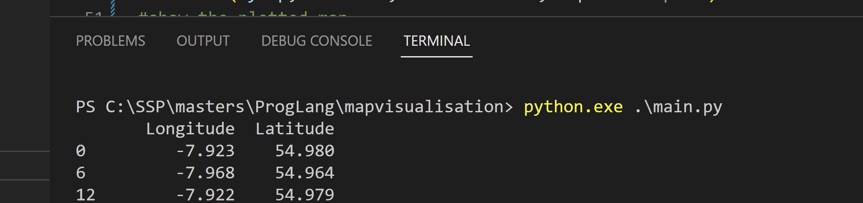

Output

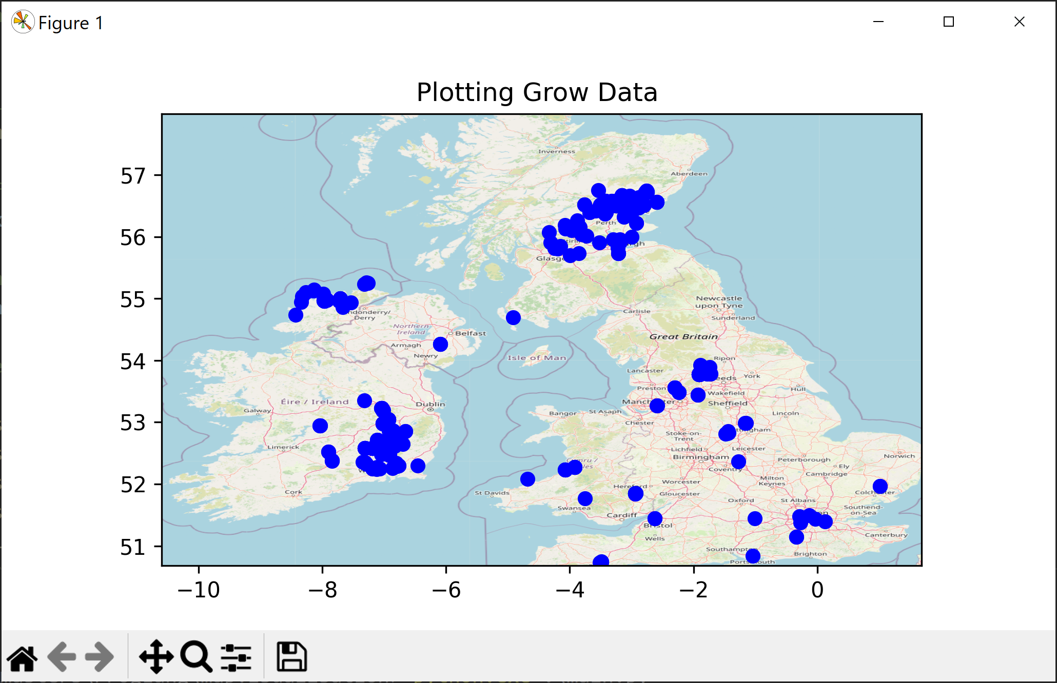

Credits – Plotting of the graph code by Ahmed Qassim

https://towardsdatascience.com/easy-steps-to-plot-geographic-data-on-a-map-python-11217859a2db