Github link: <https://github.com/sundershyam04/File-Search-Sort.git>

A text document (.txt) file is created using notepad++

1. The text document is pre-populated with the student’s data

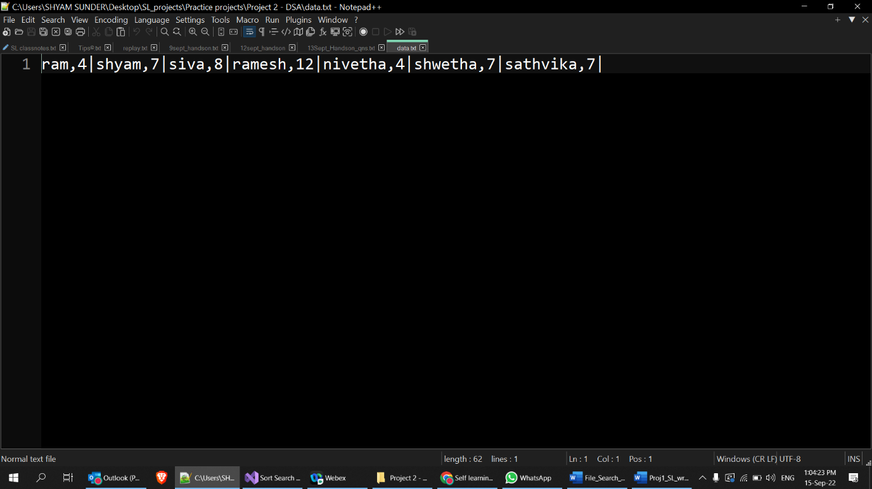

1. C# code is written to read data from student data file (Read operation) with Searching and sorting option
2. Student data file is read with necessary split option to extract the data alone
3. Created a switch case for menu driven approach for sort and search
4. **Search** function searches for the given student input from user in student data file

* If found, displays student’s data and status message
* If not found, display not found message

1. **Sort** function sorts the student data alphabetically depending upon name of student and displays the sorted list of strings in newline

Output:

Search() result: found status

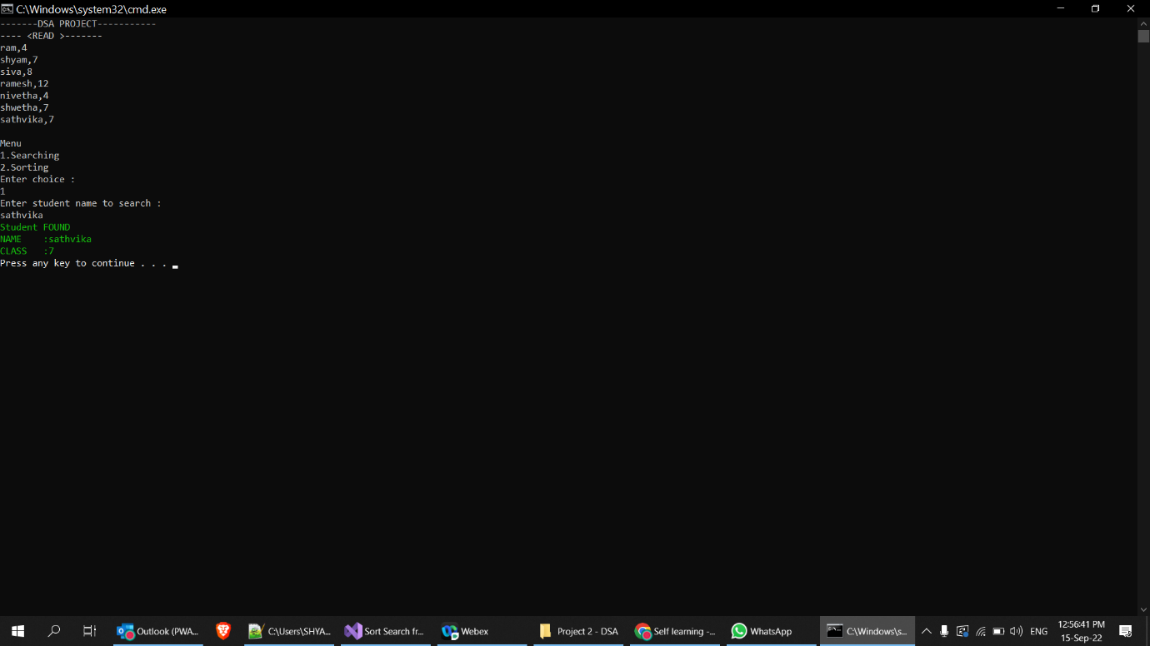

Not found status

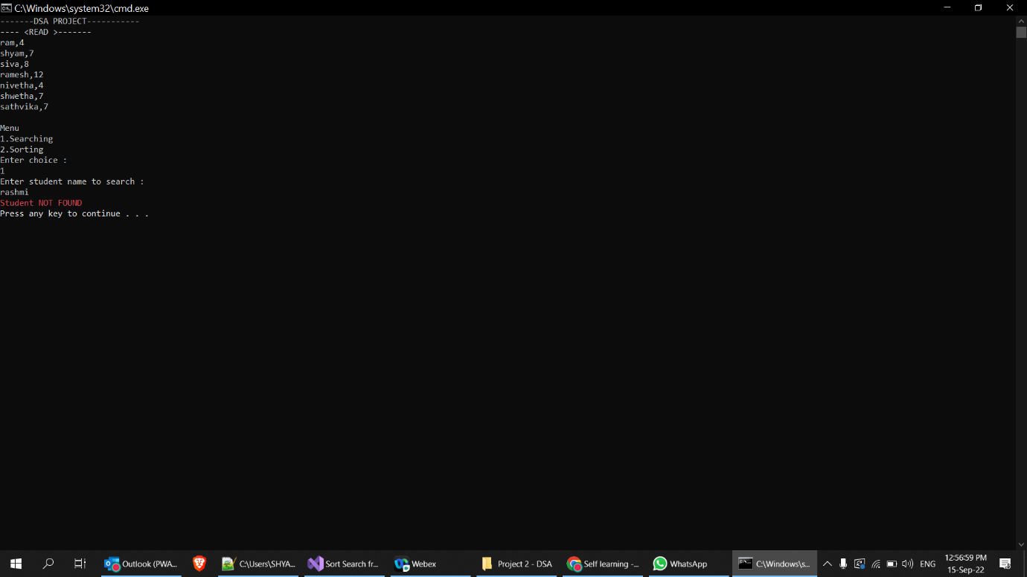

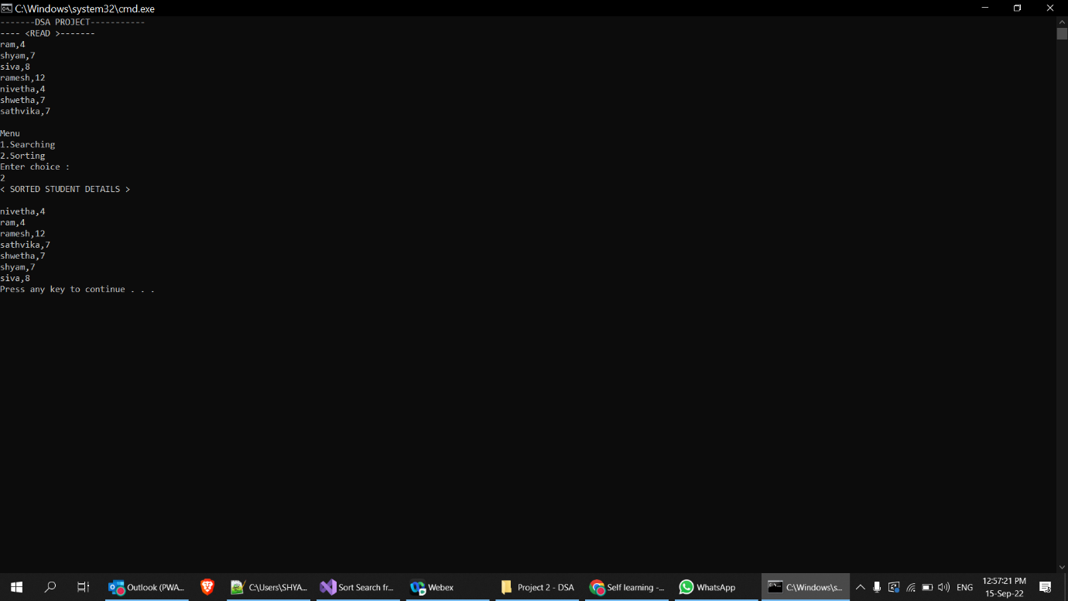Sorts() - result

**Git operations**

1. Project folder is initialized and pushed into git repository

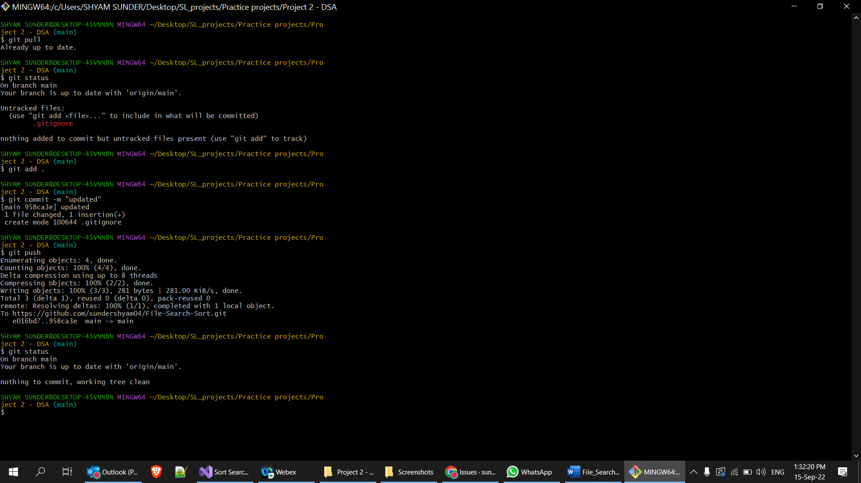

1. It is noted that files and directives included in **.gitignore file** is exclude in the git repository

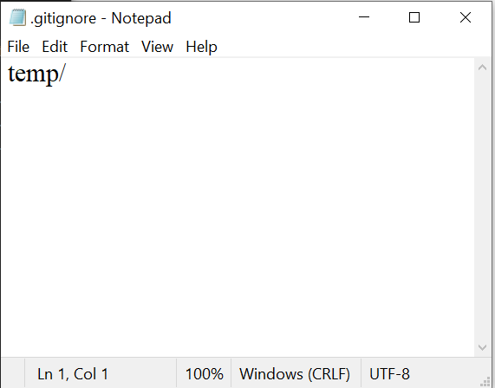.**gitignore file:**

**Untracked files :**

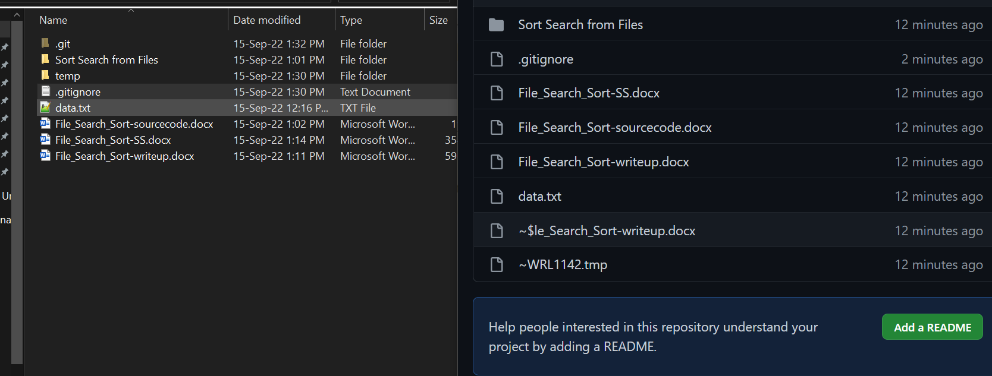

As per **.gitignore** file : **temp** folder should be ignored

In the above image, temp folder is **ignored (untracked)** by git