***Github link:*** <https://github.com/sundershyam04/Phase2-End-Project.git>

**Output:**

All 5 operations in switch case are performed and verified with the correctness in output.

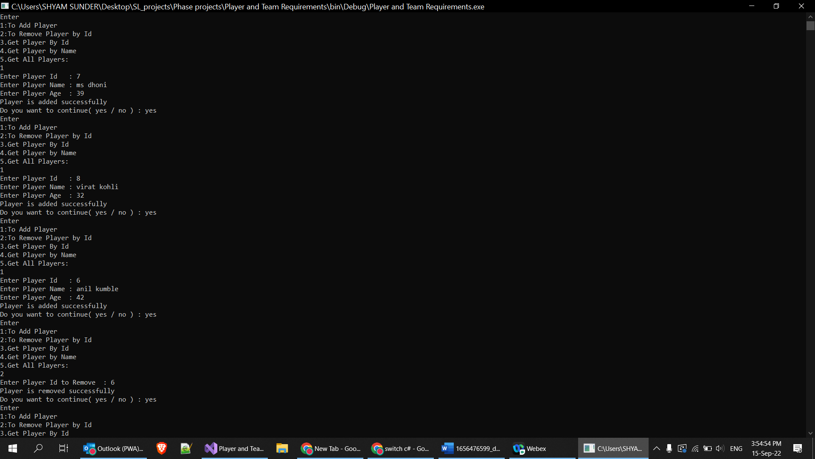1)added 3 players to team(dhoni,kohli, kumble)

2) Removed one player.(Anil Kumble)

3) got details of player **with id** : 7 and 8 Ms Dhoni and kohli

4) got details of player **with name**: Ms Dhoni and kohli

5) Got all details of all players

