Github: <https://github.com/sundershyam04/Phase3-Practice-Project-1-.git>

Screen shots:

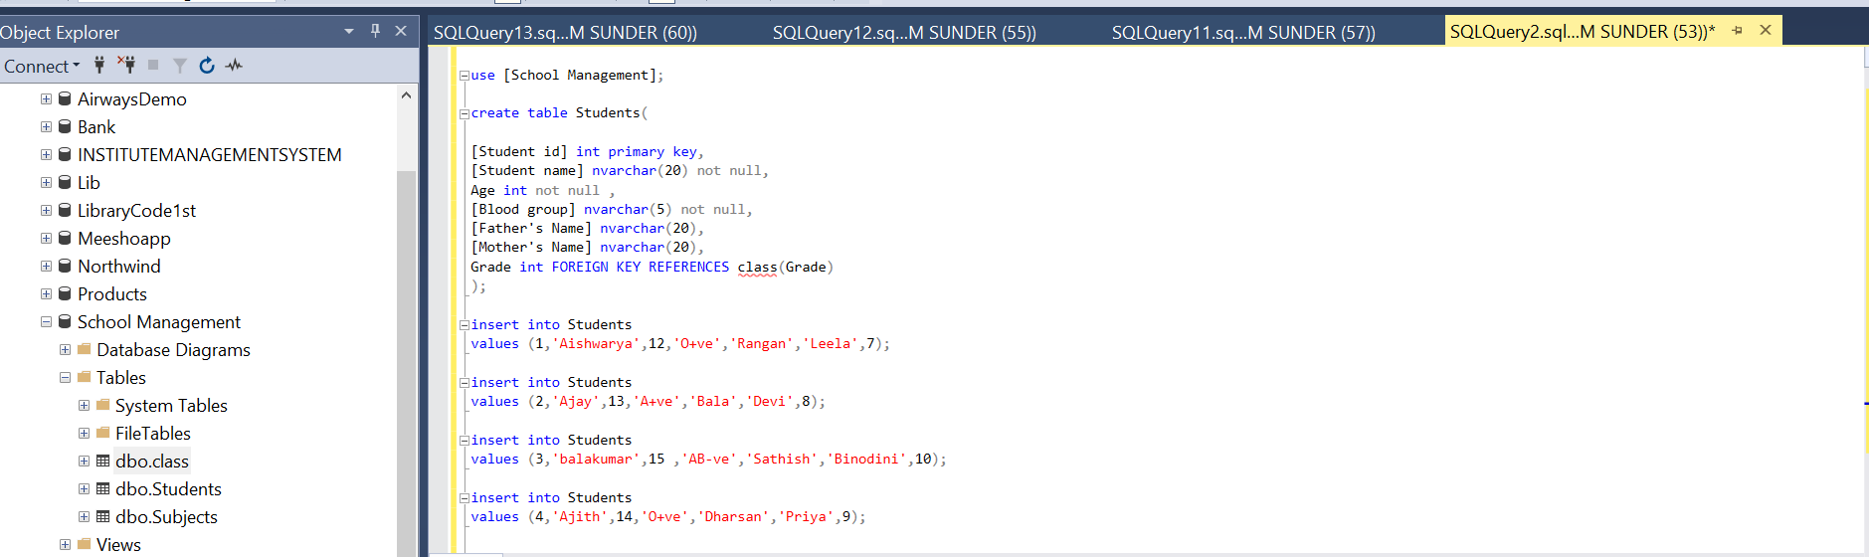database and table creation:

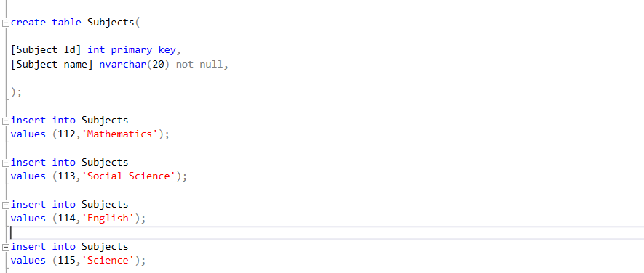

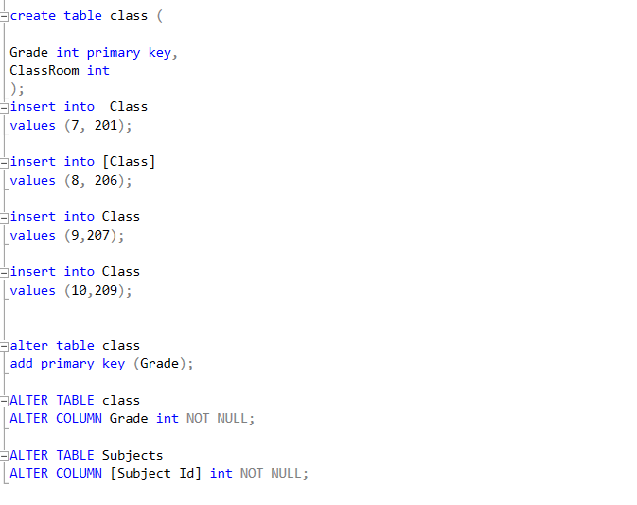

INDEX ON STUDENT ID:

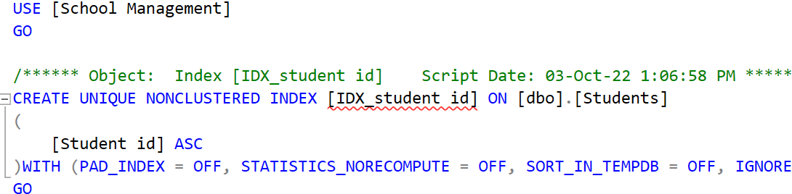

OUTPUT TABLES:  
