Github link: <https://github.com/sundershyam04/Schooldata-OOPS.git>

1. Classes named Student, Teacher, Subject is created in C# console app
2. It pre-populated with the input data

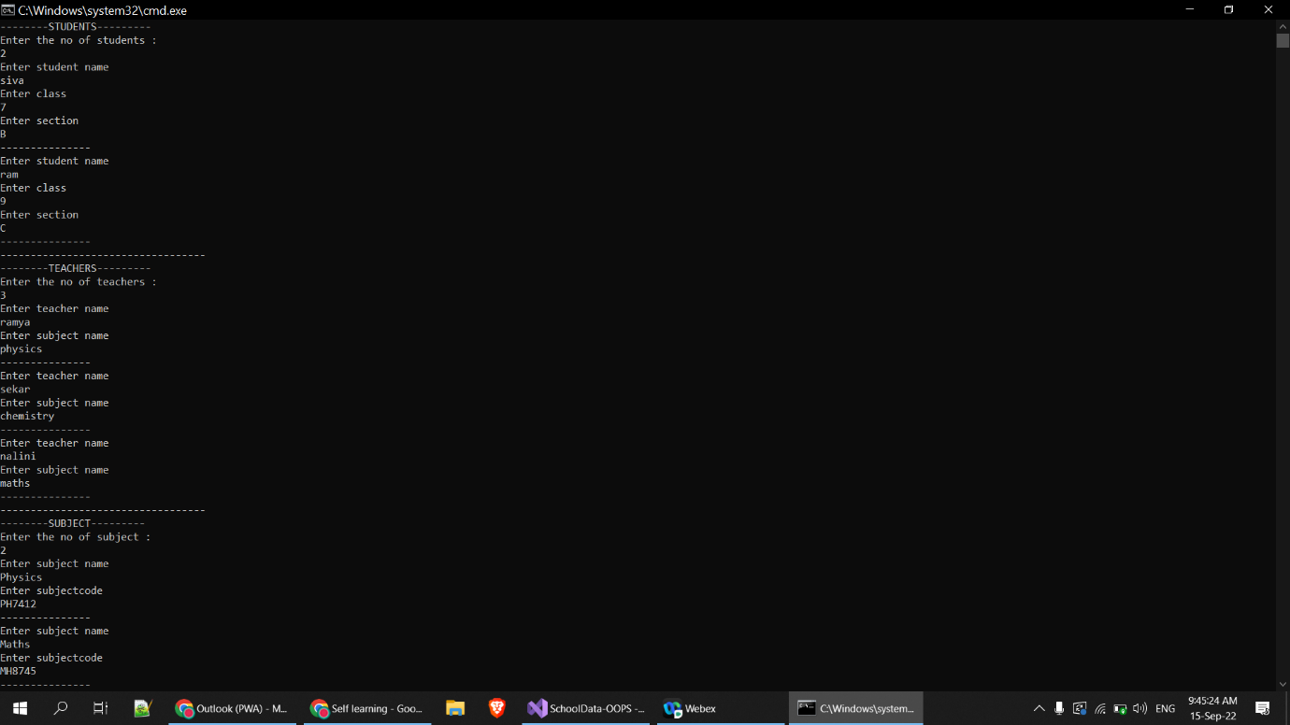

1. C# code is written to display student, teacher, subject details to console

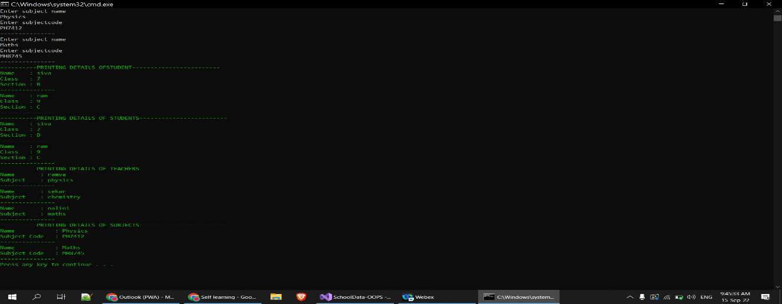Output:

**Git operations**

1. Project folder is initialized and pushed into git repository

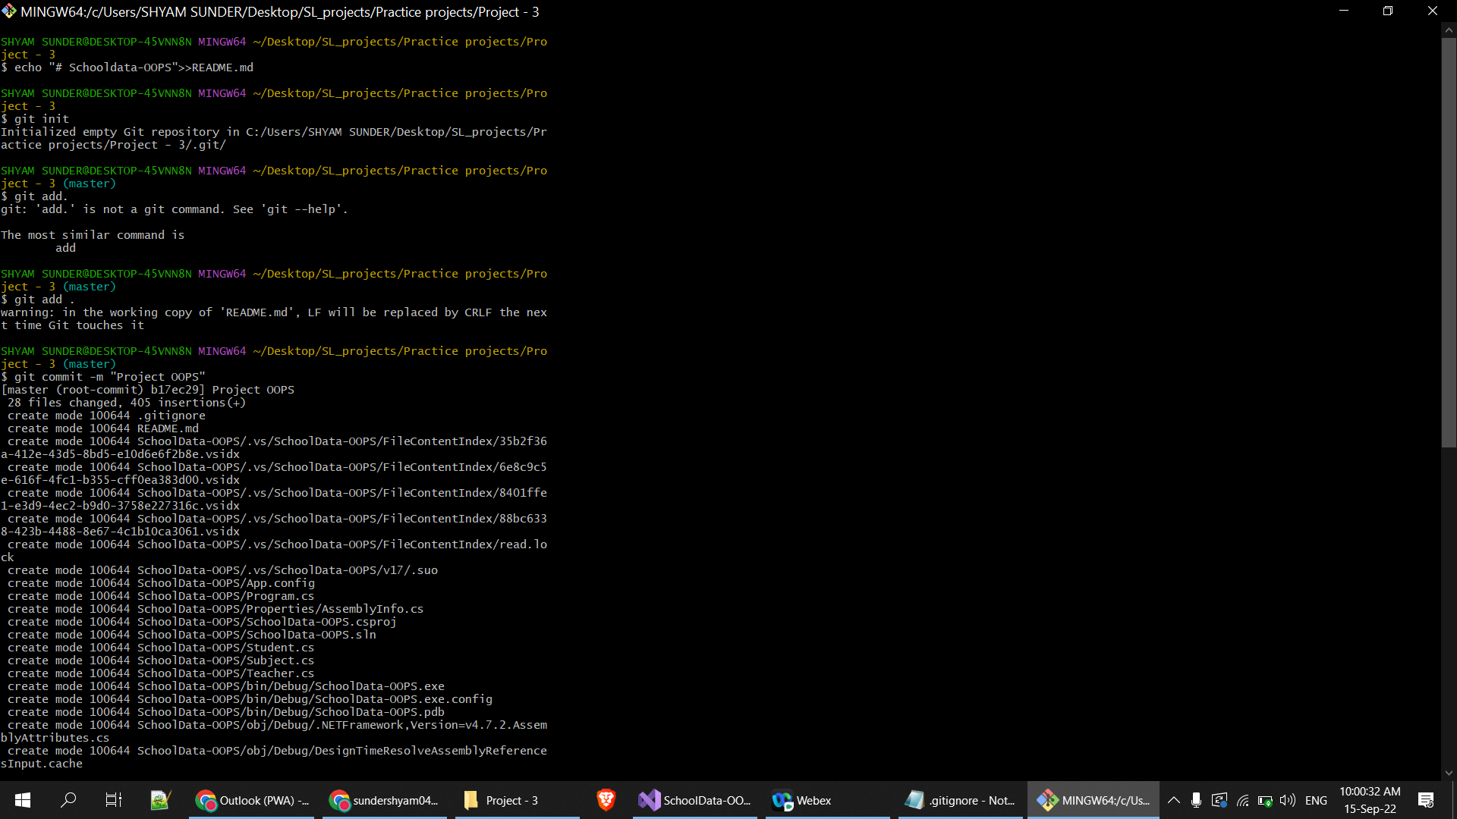

1. It is noted that files and directives included in **.gitignore file** is exclude in the git repository

.**gitignore file:**

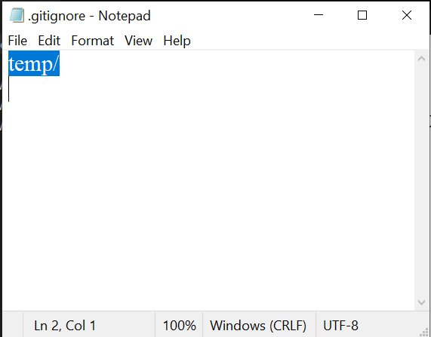

**Untracked files :**

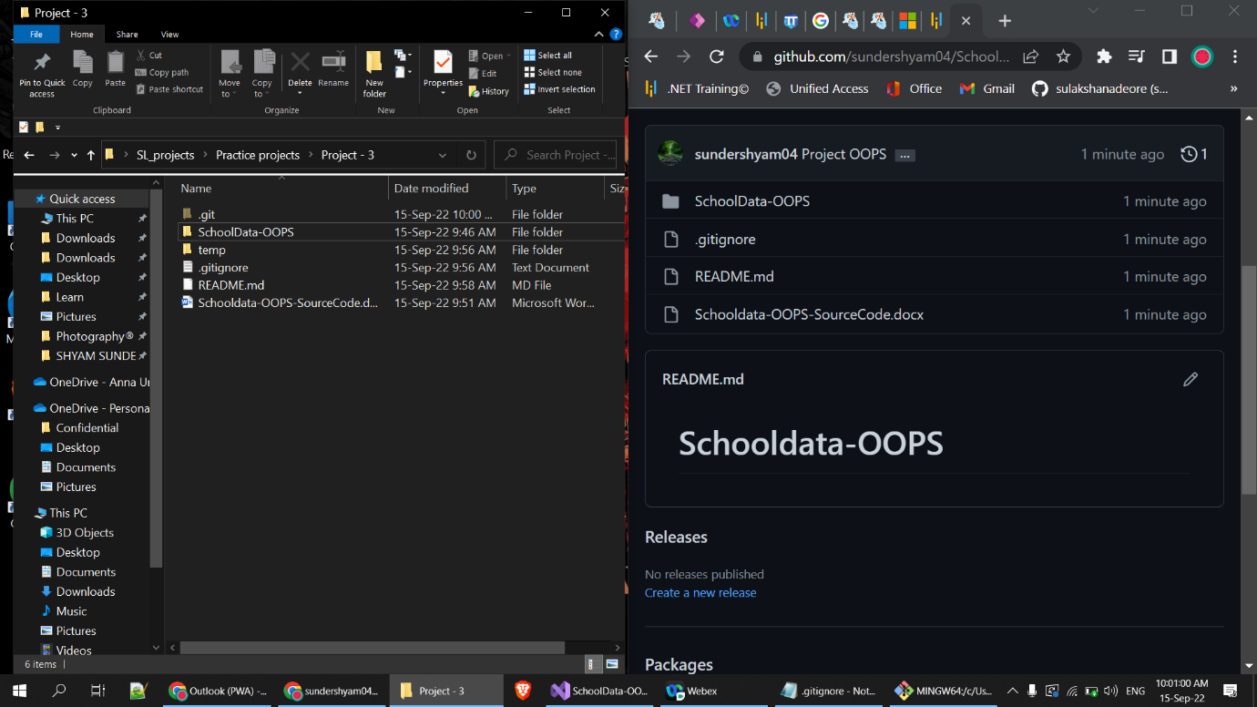

As per **.gitignore** file : **temp** folder should be ignored

In the above image, **temp** folder is **ignored (untracked)** by git