18K41A05H1

T.SUNDER RAJ

1. Explain POS tagging with HMM?

POS tags give a large amount of information about a word and its neighbors. Their applications can be found in various tasks such as information retrieval, parsing, Text to Speech (TTS) applications, information extraction, linguistic research for corpora. They are also used as an intermediate step for higher-level [NLP](https://www.mygreatlearning.com/blog/natural-language-processing-tutorial/) tasks such as parsing, semantics analysis, translation, and many more, which makes POS tagging a necessary function for advanced NLP applications.

**HMM Model**

HMM (Hidden Markov Model) is a Stochastic technique for POS tagging. Hidden Markov models are known for their applications to [reinforcement learning](https://www.mygreatlearning.com/blog/reinforcement-machine-learning/) and temporal [pattern](https://www.mygreatlearning.com/blog/pattern-recognition-machine-learning/) [recognition](https://www.mygreatlearning.com/blog/pattern-recognition-machine-learning/) such as speech, handwriting, gesture recognition, musical score following, partial discharges, and bioinformatics.

Let us consider an example proposed by Dr.Luis Serrano and find out how HMM selects an appropriate tag sequence for a sentence.

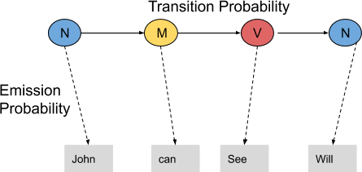

In this example, we consider only 3 POS tags that are noun, model and verb. Let the sentence “ Ted will spot Will ” be tagged as noun, model, verb and a noun and to calculate the probability associated with this particular sequence of tags we require their Transition probability and Emission probability.

The **transition probability** is the likelihood of a particular sequence for example, how likely is that a noun is followed by a model and a model by a verb and a verb by a noun. This probability is known as Transition probability. It should be high for a particular sequence to be correct.

Now, what is the probability that the word Ted is a noun, will is a model, spot is a verb and Will is a noun. These sets of probabilities are **Emission probabilities** and should be high for our tagging to be likely.

Let us calculate the above two probabilities for the set of sentences below

* + Mary Jane can see Will
  + Spot will see Mary
  + Will Jane spot Mary?
  + Mary will pat Spot

Note that Mary Jane, Spot, and Will are all names.

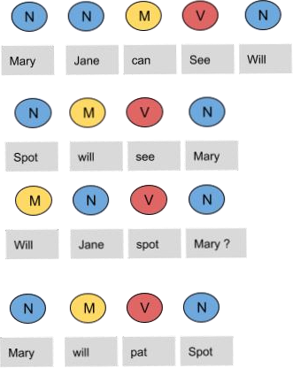

In the above sentences, the word Mary appears four times as a noun. and see appears two times as a verb. we need to calculate the probabilitiy of a word appearing as noun, verb or model. to do this, we need to calculate the emission probabilities, which represented using below table.

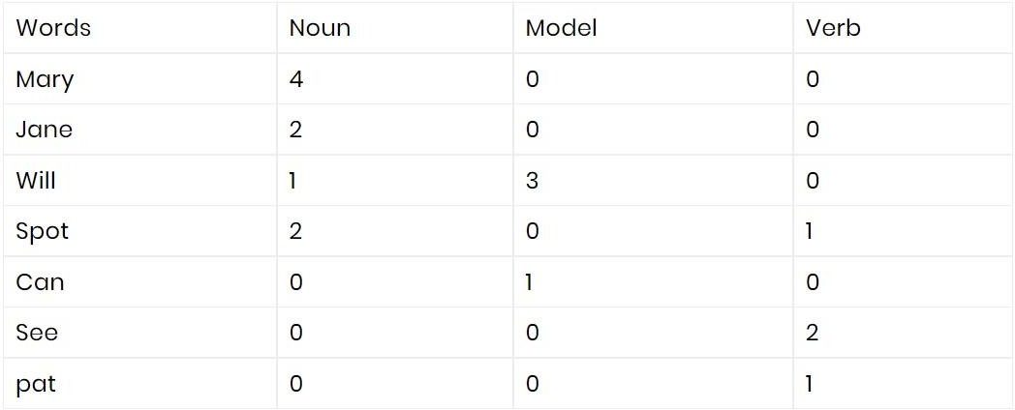

Now divide each column by the total number of their appearances .for example, ‘noun’ appears nine times in the above sentences, so divide each term by 9 in the noun column. and repeat the same for all remaining processes. We get the following table after this operation.

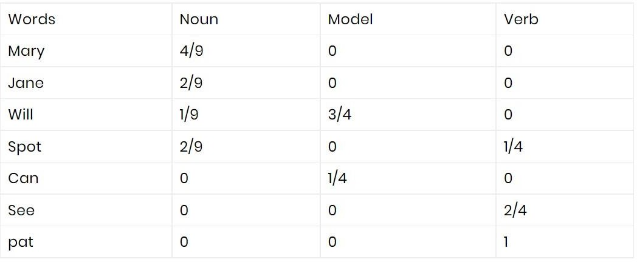

From the above table, we can conclude that The probability that Mary is Noun = 4/9

The probability that Mary is Model = 0 The probability that Mary is Verb = 0 The probability that Will is Noun = 1/9

The probability that Will is Model = 3/4

In a similar manner, we can analyze rest of the probabilities. These are the **emission probabilities.**

Next, we have to calculate the transition probabilities, so define two more tags < S > and < E

>. < S > is placed at the beginning of each sentence and < E > at the end as shown in the figure below.

since for first and last word there is no previous and next words, so we are adding extra dummy words. i.e < E > and < S >

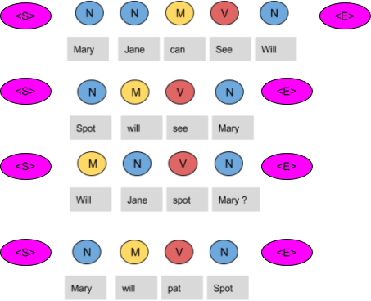

now we need to create a table and fill it with the co-occurrence counts of the tags.

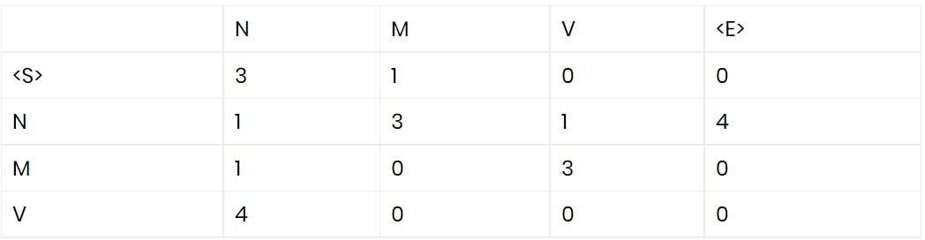

In the above figure, we can see that the < S > tag is followed by the N tag three times, thus the first entry is 3.The model tag follows the < S > just once, thus the second entry is 1. In a similar manner, the rest of the table is filled.

Next, we divide each term in a row of the table by the total number of co-occurrences of the tag in consideration, for example, The Model tag is followed by any other tags four times (in total) as shown below, thus we divide each element in the third row by four.

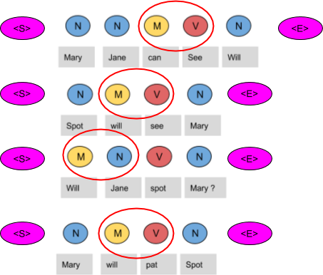

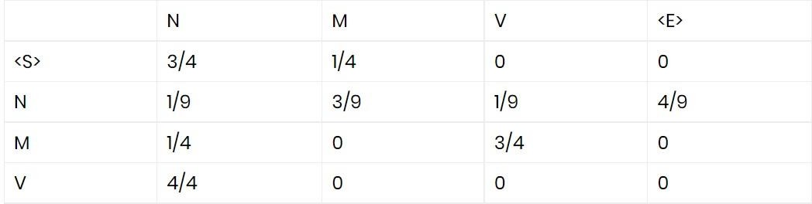

These are the respective transition probabilities for the above four sentences.

**CONCLUSION** : in this way all probabilities are calculated. now when a new sentence is given, all the words of sentence are mapped with all 81 parts of speech and probabilities of all these combinations are calculated. and if probability > 0, tags are considered to be correctly tagged else those are considered to be incorrectly tagged. but it will be time consuming if sentences are large.