**NAAN MUDHALVAN**

**DATA ANALYTICS**

**PHASE-4**

**PROJECT-1**

**PROJECT TITLE:COVID 19 CASES AND DEATH ANALYSIS**

**DOMAIN:DATA ANALYTICS**

Project definition :

✓ The project aims to conduct a comprehensive analysis of COVID-19 cases and deaths data within the EU/EEA region using IBM Cognos.

✓Specifically, the objective is to compare and contrast the mean values and standard deviations of cases and associated deaths per day and by country.

✓This analysis will provide valuable insights into the variability and trends of COVID-19 cases and deaths across the region.

Design Thinking Approach:

1.Analysis Objectives:

✓The primary objective is to compare mean values and standard deviations of cases and deaths.

✓Secondary objectives include identifying trends, patterns, and potential correlations within the data.

2.Data Collection:

✓Acquire the provided data file containing COVID-19 cases and deaths information per day and by country in the EU/. EEA.

✓Verify the integrity, accuracy, and completeness of the dataset.

3.Visualization Strategy:

✓Utilise IBM Cognos to design visualisations that effectively convey the comparison of mean values and standard deviations.

✓Consider employing line charts, bar graphs, and scatter plots to highlight trends and variances.

4.Insights Generation:

•Identify potential insights through the comparison of mean values and standard

Deviations:

✓ Detects anomalies or spikes in case and death rates.

✓Analyze variations in trends between different countries.

✓Assess the impact of public health measures on case and death statistics.

✓Determine if there are correlations between cases and death.

Executive Summary:

• ✓This report showcases the Innovative data analytics approaches And technologies that have played a Pivotal role in comprehending, Managing, and mitigating the impact of COVID-19 cases and deaths. These Innovations have been instrumental in Supporting healthcare systems, Policymakers, and the public in Navigating this unprecedented global Health crisis.

Introduction:

• ✓The COVID-19 pandemic Necessitated the rapid Development of advanced data Analytics techniques to track, analyze,

And respond to the evolving situation. This report delves into key innovations In data analytics applied specifically to COVID-19 cases and deaths.

I. Real-time Data Dashboards:

• ✓Real-time dashboards provided Immediate and updated information on COVID-19 cases, deaths, recoveries, and Other relevant metrics. These dashboards Were made accessible to the public, Enabling informed decision-making.

III. Predictive Modeling and Forecasting:

• Advanced statistical and Machine learning models Were leveraged to forecast The spread of COVID-19, Estimate future cases, and Identify potential hotspots. These models significantly Contributed to resource Allocation and preparedness Planning.

IV. Contact Tracing And Social Network Analysis:

✓Data analytics played a crucial role in Tracing and analyzing connections Between individuals with COVID-19. This information was vital in identifying Sources of infection and understanding Transmission patterns.

V. Genomic Sequencing and Mutation Tracking:

• ✓Genomic data analytics facilitated The tracking of genetic variations in the SARS-CoV-2 virus. This information Was instrumental for vaccine Development and adaptation Strategies.

**DATA SET:**

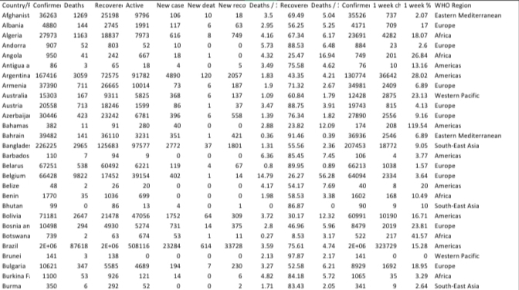

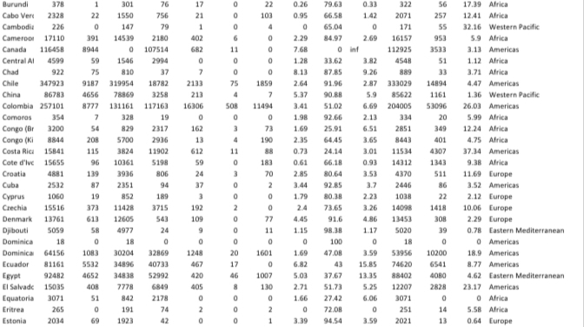

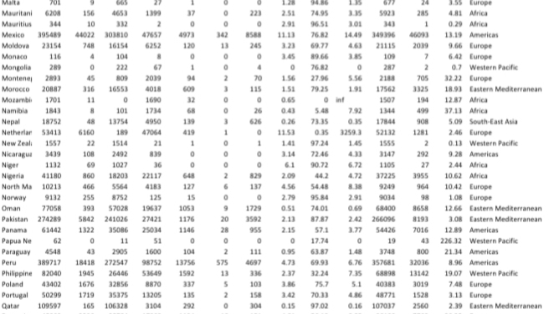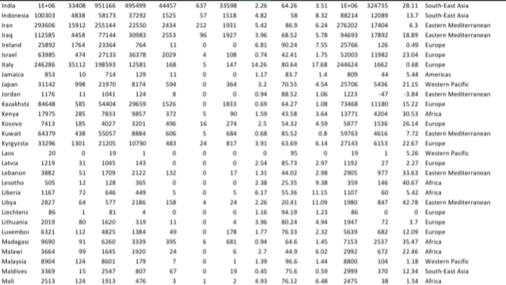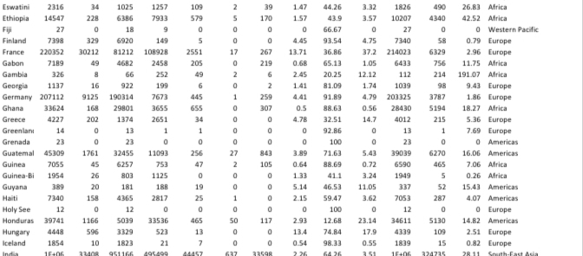

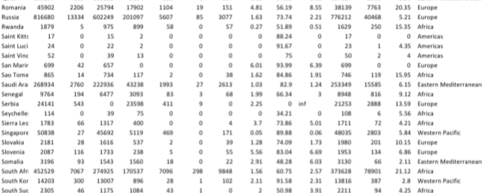

**Project Overview:**

• This section provides an overview of what the project entails and its Significance.

• Describe the background of the COVID-19 pandemic and its relevance To public health and policy.

• Explain the importance of analyzing COVID-19 cases and deaths for Informed decision-making.

• Project Development:

• Here, you’ll detail the methodologies and tools used to conduct the Analysis.

**Project Development:**

Detail how the project was carried out, covering data collection, analysis, and visualization.

Describe the methodologies, techniques, and tools used for data analytics.

Specify the data sources and datasets that were employed for the analysis.

Explain the process of data cleaning, validation, and preprocessing.

# PROGRAM:

# Import the modules

In [1]:

**import** pandas **as** pd **import** numpy **as** np **import** seaborn **as** sns **import** matplotlib.pyplot **as** plt print('Modules are imported.')

Modules are imported.

## importing covid19 dataset

importing "Covid19_Confirmed_dataset.csv" from "./Dataset" folder.

In [2]:

df**=**pd**.**read_csv("../input/covid19/covid19_Confirmed_dataset.csv") df**.**head() Out[2]:

**Province/State Country/Region Lat Long 1/22/20 1/23/20 1/24/20 1/25/20 1/26/20 1/27/20 ... 4/21/20 4/2**

1. NaN Afghanistan 33.0000 65.0000 0 0 0 0 0 0 ... 1092 1
2. NaN Albania 41.1533 20.1683 0 0 0 0 0 0 ... 609
3. NaN Algeria 28.0339 1.6596 0 0 0 0 0 0 ... 2811 2
4. NaN Andorra 42.5063 1.5218 0 0 0 0 0 0 ... 717

-

1. NaN Angola 17.8739 0 0 0 0 0 0 ... 24

11.2027

1. rows × 104 columns

**Let's check the shape of the dataframe**

In [3]:

df**.**shape

Out[3]:

(266, 104)

## Delete the useless columns

In [4]: df**.**drop(["Lat","Long"],axis**=**1,inplace**=True**)

In [5]: df**.**head() Out[5]:

**Province/State Country/Region 1/22/20 1/23/20 1/24/20 1/25/20 1/26/20 1/27/20 1/28/20 1/29/20 ... 4/21/20 4/22**

1. NaN Afghanistan 0 0 0 0 0 0 0 0 ... 1092 11
2. NaN Albania 0 0 0 0 0 0 0 0 ... 609 6
3. NaN Algeria 0 0 0 0 0 0 0 0 ... 2811 29
4. NaN Andorra 0 0 0 0 0 0 0 0 ... 717 7
5. NaN Angola 0 0 0 0 0 0 0 0 ... 24
6. rows × 102 columns

## Aggregating the rows by the country

In [6]:

aggregating**=**df**.**groupby("Country/Region")**.**sum()

In [7]:

aggregating**.**head() Out[7]:

**1/22/20 1/23/20 1/24/20 1/25/20 1/26/20 1/27/20 1/28/20 1/29/20 1/30/20 1/31/20 ... 4/21/20 4/22/2**

**Country/Region**

**Afghanistan** 0 0 0 0 0 0 0 0 0 0 ... 1092 117

**Albania** 0 0 0 0 0 0 0 0 0 0 ... 609 63

**Algeria** 0 0 0 0 0 0 0 0 0 0 ... 2811 291

**Andorra** 0 0 0 0 0 0 0 0 0 0 ... 717 72

**Angola** 0 0 0 0 0 0 0 0 0 0 ... 24 2

5 rows × 100 columns

In [8]:

aggregating**.**shape

Out[8]:

(187, 100)

## Visualizing data related to a country for example China

visualization always helps for better understanding of our data.

In [9]:

aggregating**.**loc["China"]**.**plot() aggregating**.**loc["Italy"]**.**plot() aggregating**.**loc["Spain"]**.**plot() plt**.**legend()

Out[9]:

<matplotlib.legend.Legend at 0x7f482e1e3990>

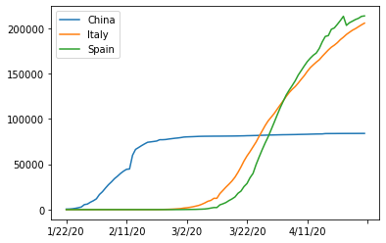

## Calculating a good measure

we need to find a good measure reperestend as a number, describing the spread of the virus in a country.

In [10]:

aggregating**.**loc['China']**.**plot()

Out[10]:

<matplotlib.axes._subplots.AxesSubplot at 0x7f482df94d90>

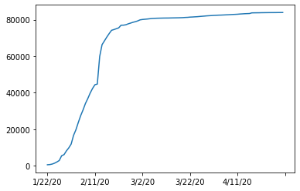

In [11]:

aggregating**.**loc['China'][:3]**.**plot()

Out[11]:

<matplotlib.axes._subplots.AxesSubplot at 0x7f482df83990>

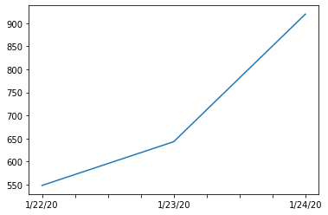

## caculating the first derivative of the curve

In [12]:

aggregating**.**loc['China']**.**diff()**.**plot()

Out[12]:

<matplotlib.axes._subplots.AxesSubplot at 0x7f482df09290>

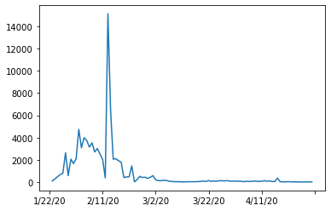

## find maxmimum infection rate for China

In [13]:

aggregating**.**loc['China']**.**diff()**.**max()

Out[13]:

15136.0 In [14]:

aggregating**.**loc['Italy']**.**diff()**.**max()

Out[14]:

6557.0 In [15]:

aggregating**.**loc['Spain']**.**diff()**.**max()

Out[15]:

9630.0

**find maximum infection rate for all of the countries.**

In [16]:

countries**=**list(aggregating**.**index) max_infection_rates**=**[] **for** c **in** countries:

max_infection_rates**.**append(aggregating**.**loc[c]**.**diff()**.**max()) aggregating["max_infection_rates"]**=**max_infection_rates

In [17]:

aggregating**.**head()

Out[17]:

**1/22/20 1/23/20 1/24/20 1/25/20 1/26/20 1/27/20 1/28/20 1/29/20 1/30/20 1/31/20 ... 4/22/20 4/23/2**

**Country/Region**

**Afghanistan** 0 0 0 0 0 0 0 0 0 0 ... 1176 127

**Albania** 0 0 0 0 0 0 0 0 0 0 ... 634 66

**Algeria** 0 0 0 0 0 0 0 0 0 0 ... 2910 300

**Andorra** 0 0 0 0 0 0 0 0 0 0 ... 723 72

**Angola** 0 0 0 0 0 0 0 0 0 0 ... 25 2

5 rows × 101 columns

## create a new dataframe with only needed column

In [18]: data**=**pd**.**DataFrame(aggregating["max_infection_rates"])

In [19]: data**.**head() Out[19]:

**max_infection_rates Country/Region**

**Afghanistan** 232.0

**Albania** 34.0

**Algeria** 199.0

**Andorra** 43.0

**Angola** 5.0

## Task 4.1 : importing the dataset

In [20]: happiness**=**pd**.**read_csv("../input/covid19/worldwide_happiness_report.csv") In [21]:

happiness**.**head() Out[21]:

**Overall Country or GDP per Social Healthy life Freedom to make Perceptions**

**Score Generosity**

**rank region capita support expectancy life choices of corruption**

1. 1 Finland 7.769 1.340 1.587 0.986 0.596 0.153 0.393
2. 2 Denmark 7.600 1.383 1.573 0.996 0.592 0.252 0.410
3. 3 Norway 7.554 1.488 1.582 1.028 0.603 0.271 0.341
4. 4 Iceland 7.494 1.380 1.624 1.026 0.591 0.354 0.118
5. 5 Netherlands 7.488 1.396 1.522 0.999 0.557 0.322 0.298

## Let's drop the useless columns

In [22]:

cols**=**["Overall rank","Score","Generosity","Perceptions of corruption"] In [23]:

happiness**.**drop(cols,axis**=**1,inplace**=True**) happiness**.**head()

Out[23]:

**GDP per Social Healthy life Freedom to make life**

**Country or region**

**capita support expectancy choices**

1. Finland 1.340 1.587 0.986 0.596
2. Denmark 1.383 1.573 0.996 0.592
3. Norway 1.488 1.582 1.028 0.603
4. Iceland 1.380 1.624 1.026 0.591
5. Netherlands 1.396 1.522 0.999 0.557

## changing the indices of the dataframe

In [24]:

happiness**.**set_index("Country or region",inplace**=True**) happiness**.**head() Out[24]:

**GDP per Social Healthy life Freedom to make life**

**capita support expectancy choices**

**Country or region**

**Finland** 1.340 1.587 0.986 0.596

**Denmark** 1.383 1.573 0.996 0.592

**Norway** 1.488 1.582 1.028 0.603

**Iceland** 1.380 1.624 1.026 0.591

**Netherlands** 1.396 1.522 0.999 0.557

## now let's join two dataset we have prepared

**Corona Dataset :**

In [25]: data**.**head() Out[25]:

**max_infection_rates Country/Region**

**Afghanistan** 232.0

**Albania** 34.0

**Algeria** 199.0

**Andorra** 43.0

**Angola** 5.0

**wolrd happiness report Dataset :**

In [26]:

happiness**.**head()

Out[26]:

**GDP per Social Healthy life Freedom to make life**

**capita support expectancy choices**

**Country or region**

**Finland** 1.340 1.587 0.986 0.596

**Denmark** 1.383 1.573 0.996 0.592

**Norway** 1.488 1.582 1.028 0.603

**Iceland** 1.380 1.624 1.026 0.591

**Netherlands** 1.396 1.522 0.999 0.557

In [27]:

final**=**data**.**join(happiness,how**=**"inner") final**.**head() Out[27]:

**GDP per Social Healthy life Freedom to make life**

**max_infection_rates**

**capita support expectancy choices Afghanistan** 232.0 0.350 0.517 0.361 0.000

**Albania** 34.0 0.947 0.848 0.874 0.383

**Algeria** 199.0 1.002 1.160 0.785 0.086

**Argentina** 291.0 1.092 1.432 0.881 0.471

**Armenia** 134.0 0.850 1.055 0.815 0.283

## correlation matrix

In [28]:

final**.**corr() Out[28]:

**GDP per Social Healthy life Freedom to make life**

**max_infection_rates**

**capita support expectancy choices**

**max_infection_rates** 1.000000 0.250118 0.191958 0.289263 0.078196

**GDP per capita** 0.250118 1.000000 0.759468 0.863062 0.394603

**Social support** 0.191958 0.759468 1.000000 0.765286 0.456246

**Healthy life expectancy** 0.289263 0.863062 0.765286 1.000000 0.427892

**Freedom to make life**

0.078196 0.394603 0.456246 0.427892 1.000000

**choices**

## Visualization of the results

our Analysis is not finished unless we visualize the results in terms figures and graphs so that everyone can understand what you get out of our analysis

In [29]:

final**.**head()

Out[29]:

**GDP per Social Healthy life Freedom to make life**

**max_infection_rates**

**capita support expectancy choices Afghanistan** 232.0 0.350 0.517 0.361 0.000

**Albania** 34.0 0.947 0.848 0.874 0.383

**Algeria** 199.0 1.002 1.160 0.785 0.086

**Argentina** 291.0 1.092 1.432 0.881 0.471

**Armenia** 134.0 0.850 1.055 0.815 0.283

## Plotting GDP vs maximum Infection rate

In [30]:

x**=**final["GDP per capita"] y**=**final["max_infection_rates"] sns**.**scatterplot(x,np**.**log(y))

Out[30]:

<matplotlib.axes._subplots.AxesSubplot at 0x7f482de36590>

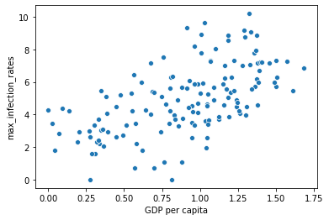

In [31]:

sns**.**regplot(x,np**.**log(y))

Out[31]:

<matplotlib.axes._subplots.AxesSubplot at 0x7f482dd8b3d0>

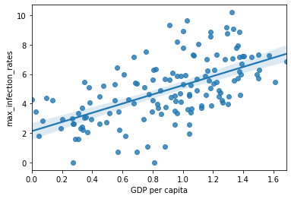

## Plotting Social support vs maximum Infection rate

In [32]:

x**=**final["Social support"] y**=**final["max_infection_rates"] sns**.**scatterplot(x,np**.**log(y)) Out[32]:

<matplotlib.axes._subplots.AxesSubplot at 0x7f482de1b210>

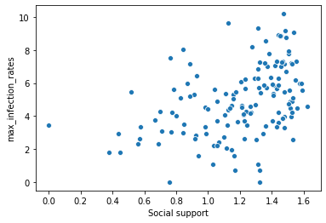

In [33]:

sns**.**regplot(x,np**.**log(y))

Out[33]:

<matplotlib.axes._subplots.AxesSubplot at 0x7f482b49a610>

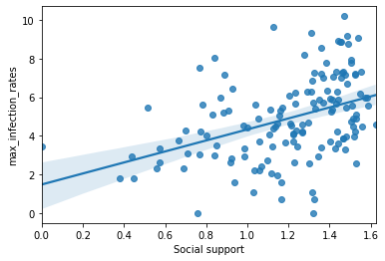

## Plotting Healthy life expectancy vs maximum Infection rate

In [34]:

x**=**final["Healthy life expectancy"] y**=**final["max_infection_rates"] sns**.**scatterplot(x,np**.**log(y))

Out[34]:

<matplotlib.axes._subplots.AxesSubplot at 0x7f482b3d8650>

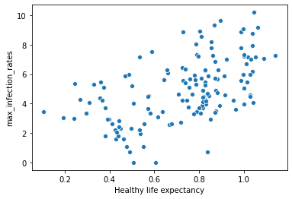

In [35]:

sns**.**regplot(x,np**.**log(y))

Out[35]:

<matplotlib.axes._subplots.AxesSubplot at 0x7f482b3be950>

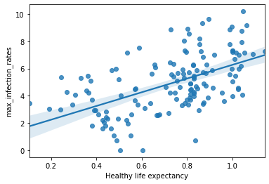

## Plotting Freedom to make life choices vs maximum Infection rate

In [36]:

x**=**final["Freedom to make life choices"] y**=**final["max_infection_rates"] sns**.**scatterplot(x,np**.**log(y))

Out[36]:

<matplotlib.axes._subplots.AxesSubplot at 0x7f482b328c90>

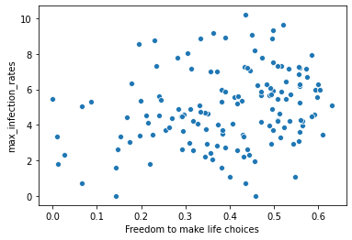

In [37]:

sns**.**regplot(x,np**.**log(y))

Out[37]:

<matplotlib.axes._subplots.AxesSubplot at 0x7f482b2a2450>

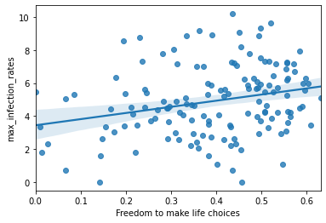

**Conclusion:**

Summarize the key findings and conclusions of the COVID-19 data analytics project.

Highlight significant trends, correlations, or insights discovered during the analysis.

Discuss the implications of these findings for public health strategies or policy decisions.

Provide recommendations for future data analytics projects in the context of pandemics.

**THANK YOU**