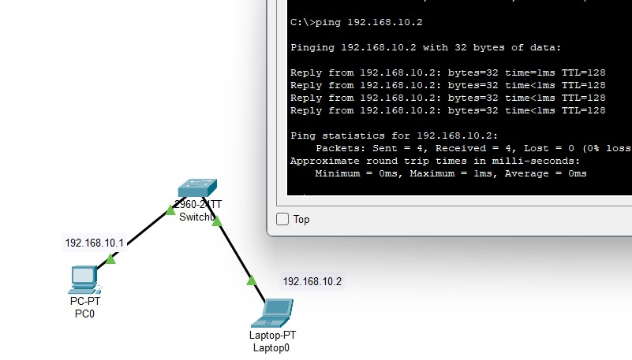
CCNA Practical Lab 1: Basic Switch Connectivity
Objective: To connect two end devices using a switch and verify network connectivity.
Topology: PC0 → Switch0 → Laptop0
IP Configuration:
- PC0: 192.168.10.1/24
- Laptop0: 192.168.10.2/24
- Subnet Mask: 255.255.255.0
Short Explanation: Connected two device through a switch and tested connectivity
Command Used: ping 192.168.10.2
Result: Successful — 4 packets sent, 4 received, 0% packet loss.
What I Learned: IP configuration,switch connectivity, ping testing
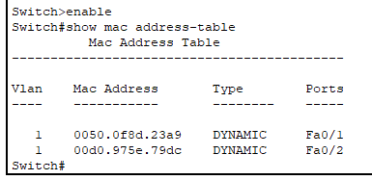
It show mac address table

