SUMMER INTERNSHIP REPORT
“FULLSTACK WEBDEVELOPMENT”
Submitted to:
Shanmuganathan Engineering College

Affiliated to:
Anna University

Submitted by:
R. Sundharavathana (912421104046)
Company Guide:
Mr. S. Fredrick John Michael
Faculty Guide:
Mr.N. Chellapandi(AP/CSE)

Department of Computer Science and Engineering,
Shanmuganathan Engineering College, approved by
AICTE


CERTIFICATE



BONA-FIDE CERTIFICATE


ACKNOWLEDGEMENT

It is a matter of pride and privilege for me to have done a summer internship project in “Accent Techno Soft” and I am sincerely thankful to them for providing this opportunity to me.

I am thankful to “Dr. KL. Muthuramu” the Principal of Shanmuganathan Engineering College, Arasampatti .

I am thankful to the head of the department “Dr.S.Saravanakumar” and all the faculty members of Department of Computer Science and Engineering, Shanmuganathan Engineering College, Arasampatti and particularly my mentor “Mr.N.Chellapandi” for helping me during the project.

I am also thankful to “Mr. S. Fredrick John Michael” for guiding me through this project and continuously encouraging me. It would not have been possible to complete this project without his / her support.

Finally, I am grateful to my family and friends for their unending support.

Sundharavathana.R
S. NO. | PARTICULARS | PAGE NO.
1 | INTRODUCTION | 6
2 | COMPANY PROFILE | 7
3 | SYSTEM ANALYSIS | 8-9
4 | MODULES AND DESCRIPTION | 10
5 | SOFTWARE DESCRIPTION | 11-15
6 | SYSTEM DESIGN AND IMPLEMENTATION | 16-25
7 | SYSTEM REQUIRMENTS | 26
8 | SYSTEM TESTING | 27-34
10 | CODING&OUTPUT | 35-41
11 | CONCLUSION | 42
12 | FUTURE REQUIRMENTS | 42
13 | REFERENCES | 43
Index(Table of Contents)

CHAPTER-I
INTRODUCTION

The College Admission Chatbot is an innovative solution designed to simplify and automate the process of answering common questions related to college admissions. This chatbot allows users, primarily prospective students, to interact with an automated system that provides instant answers based on predefined queries. The system enables college administrators to manage and update these queries via an easy-to-use admin panel, ensuring that users always receive the most accurate and up-to-date information.
The chatbot is designed to streamline the admission process by providing quick responses to frequent questions, such as admission criteria, deadlines, fees, available courses, and more. By doing so, it enhances user experience by reducing waiting times and workload for college staff. Additionally, the admin panel offers features for adding, editing, and deleting queries, making it flexible and scalable for future updates.
With its user-friendly interface and real-time query answering capabilities, the College Admission Chatbot aims to improve communication and assist both students and administrative staff in managing the admission process more efficiently.
The College Admission Chatbot serves as a perfect example of how automation can enhance administrative efficiency, improve communication between students and the institution, and contribute to a more streamlined and accessible college admission process.

CHAPTER-II
COMPANY PROFILE
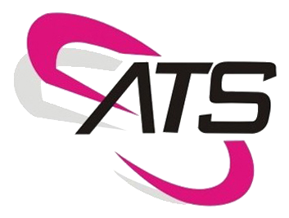
Accent Techno Soft (ATS) provides a wide range of solutions in IT Consulting, technology and Operations space for our clients. To enhance the business value of our service offerings to our customers, we have formed strategic alliances with industry bodies, technologies vendors and system integrators. Through these partnerships we are able to deliver industry-best end –to-end solutions to our customers.
Accent was founded by experienced software professionals and providing the foundation for the company's expertise in E-commerce/Web applications, custom application development, data warehousing, enterprise management solutions, and operations management (support, maintenance, implementation) . Accent Techno Soft, specialize in the business of software Training & HR Consultancy spotlighting in India.
Accent Techno Soft, 203, Nehru Street, Ram Nagar,
Coimbatore - 641009
CHAPTER-III
SYSTEM ANALYSIS
3.1 EXISTING SYSTEM
In traditional college admission systems, prospective students generally rely on static websites, brochures, or direct communication with the college administration to gather information about the admission process. These systems typically involve the following methods:
- Static Information on Websites: Most colleges provide detailed admission guidelines, FAQs, and other documents on their official websites. However, these resources can be overwhelming and difficult to navigate. Students often spend considerable time searching for the exact information they need.
- Email/Phone Communication: Colleges usually offer email or phone support for queries. While this system allows for direct communication, it is often inefficient. Administrators are burdened with answering repetitive questions, and response times can be delayed, especially during peak admission periods. Additionally, this method lacks the immediacy and availability that many students expect.
- Manual Query Handling: College admission offices typically rely on staff members to handle inquiries. However, managing a high volume of queries can lead to delays, human errors, and missed questions, resulting in poor user experience and frustration for prospective students.

3.1.1 DISADVANTAGES
- Time-consuming: Students have to spend time navigating through a large amount of information or waiting for replies via email or phone.
- Limited Availability: Email and phone support have limited working hours and may not be sufficient during high-demand periods.
- Overburdened Staff: College staff often have to answer repetitive questions, leaving less time for other important tasks.
- Inconsistent Response: Human staff can sometimes miss queries or provide inconsistent responses, leading to confusion.

3.2 PROPOSED SYSTEM
User-Friendly Interface:
The chatbot provides a user-friendly interface for prospective students to inquire about the admission process, courses offered, and other relevant information.
Instant Responses:
The chatbot provides instant responses to user queries, eliminating the need for students to wait for email replies or make phone calls.
Efficient Handling of Queries:
By automating responses to frequently asked questions, the chatbot frees up human resources, allowing staff to focus on more complex queries and tasks.
Personalized Interaction:
The chatbot can provide personalized responses based on user inputs, offering tailored information and guidance to each student.

CHAPTER-IV
MODULES AND DESCRIPTION
4.1 LIST OF MODULES
- ADMIN
- USER

4.2 MODULES DESCRIPTION

1. Admin
- Login: Admin can login using credentials.
- Chat Bot: Admin add the chatbot questions, answer and keywords.
2. User
- Chat Bot: User can enquire using chat bot.

CHAPTER-V
SOFTWARE DESCRIPTION

1. Introduction
The College Admission Chatbot is an interactive web-based system designed to automate the query-handling process for prospective students applying to colleges. This chatbot allows students to inquire about admission-related information, such as application deadlines, courses, and fee structures. The system is built with an admin panel where college staff can add, update, and delete queries and responses. The chatbot delivers consistent, instant responses to users based on the data set by the administrator, ensuring an efficient and user-friendly experience for both students and staff.

2. Software Components
The College Admission Chatbot is developed using a combination of PHP, JavaScript, HTML, CSS, and MySQL for data storage. The system is divided into two main parts:
- Frontend (User Interface): Handles interactions between the user (student) and the system.
- Backend (Admin Panel & Database): Manages the storage, retrieval, and update of queries and responses.

3. Frontend (User Interface)
- Chatbot Interaction:
  - The user interface features a chatbot where students can input their questions. It retrieves answers from pre-defined queries that the admin adds through the backend.
  - The chatbot UI interacts dynamically with the server using AJAX (Asynchronous JavaScript and XML) for real-time query handling. This ensures that students receive responses without refreshing the page.
- Navigation & Sidebar:
  - The system includes a collapsible sidebar for easy navigation. The sidebar allows users to access different sections of the site, including the dashboard and query handling.
  - The layout of the pages is designed using Bootstrap 4, ensuring that the system is mobile-friendly and responsive.
- Real-Time Search Functionality:
  - The chatbot offers a search feature where users can type their queries and instantly see responses.
  - The system uses JavaScript/jQuery to handle dynamic interactions, including the AJAX calls to fetch and display query responses.

4. Backend (Admin Panel & Database)
- Admin Panel:
  - The admin panel allows the college staff to manage the queries by adding, updating, or deleting them. Staff members can interact with the system through simple forms where they can input new queries and corresponding responses.
  - Admins can also mark queries as active or inactive. This functionality is crucial for controlling which queries the chatbot can respond to.
- Database:
  - The chatbot’s database is built using MySQL, where all query and response pairs are stored.
  - The table structure contains fields like id, messages (student queries), response (chatbot answers), and status (active/inactive status of the query). The database allows the chatbot to retrieve responses dynamically based on the stored data.
  - Database Operations:
      - The system performs standard CRUD (Create, Read, Update, Delete) operations:
      - Create: Admin adds queries through a form.
      - Read: The chatbot fetches responses based on user input.
      - Update: Admin can modify existing queries and responses.
      - Delete: Admin can remove unwanted queries from the system.
- PHP Logic:
  - The system uses PHP to process and validate the data between the frontend and the backend. PHP is used to manage the admin login, session management, and query operations.
  - For login authentication, PHP handles user verification based on credentials stored in the database. If the admin successfully logs in, they can access the admin panel to manage the queries.

- AJAX & jQuery:
  - AJAX is used to make asynchronous calls to the server, enabling the chatbot to instantly provide answers without refreshing the page. This improves the user experience by providing real-time responses.
  - jQuery is utilized to handle dynamic content updates on the webpage, such as updating the query response list and other elements of the chatbot interface.
5. Key Features
- User Interaction (Chatbot):
  - Students can type their queries into the chatbot interface.
  - The chatbot will respond based on the information added by the admin, providing answers to admission-related questions in real time.

- Admin Panel:
  - Admins can add, update, or delete queries and responses through the admin panel.
  - The admin panel has an easy-to-use interface for maintaining the list of frequently asked questions.
- 24/7 Availability:
  - The chatbot is available around the clock, ensuring that students can get answers to their queries at any time of the day.
- Data Management:
  - Admins can mark queries as active or inactive, ensuring that only relevant and up-to-date information is provided by the chatbot.
- Security:
  - The system uses session management to ensure that only authorized users (admins) can log into the admin panel.
  - Basic input validation and sanitization techniques are implemented to avoid SQL injection attacks and other security issues.

CHAPTER – VI
SYSTEM DESIGN AND IMPLEMENTATION

1. System Design Overview
The College Admission Chatbot is designed to automate the process of responding to frequently asked questions related to the college admission process. The system is designed to have two main components:
- Frontend (User Interface): The chatbot interface where users (students) interact by submitting their queries.
- Backend (Admin Panel): The interface where administrators can manage (add, update, delete) queries and their responses. The backend also handles user authentication and query management through a MySQL database.

2. System Architecture
The system follows a Client-Server Architecture where the frontend interacts with the backend server via AJAX calls for fetching and posting data. Here's a breakdown of the architecture:
- User Interface (Frontend):
  - Chatbot: The chatbot is an interactive component where students can type their questions, and the system will respond based on predefined queries stored in the database.
  - Sidebar Navigation: For easy navigation, the system provides a sidebar to access different sections, such as the dashboard and query management.
  - AJAX Calls: As students type their queries, AJAX calls are made to fetch the response from the backend without refreshing the page. This ensures real-time interaction with the chatbot.

- Server-Side (Backend):
- PHP Scripts: PHP handles all the backend operations, including:
    - User Authentication: Login functionality for administrators.
    - CRUD Operations: Admins can create, read, update, or delete queries and responses.
    - Database Interaction: PHP interacts with the MySQL database to fetch queries, add new queries, and update existing ones.

- Database:
  - MySQL Database: The system uses MySQL to store queries and responses. Each query has the following fields
    - id: Unique identifier for each query.
    - messages: The query that users will ask.
    - response: The corresponding response from the chatbot.
    - status: Indicates whether the query is active or inactive
3. System Components
Frontend (User Interface):
- Chatbot Interface:
  - The chatbot provides a text input field for users to type their queries.
  - The system fetches responses based on predefined queries stored in the database and displays them to the user.
  - The AJAX function listens for user input and sends the query to the backend for a response. The response is then displayed in the chatbot interface.
- Admin Panel:
  - The admin can log in to the panel by entering credentials in the login form.
  - Once logged in, the admin can manage queries:
    - Add Queries: Admins can input new queries and responses using a form.
    - Update Queries: Admins can modify existing queries and responses.
    - Delete Queries: Admins can remove queries that are no longer needed.

Backend (Server-Side):
- Login Authentication:
  - Admin authentication is performed using PHP and MySQL.
  - When the admin enters their credentials, PHP checks the database for a matching username and password. If found, the admin is granted access to the dashboard.
- Database Operations:
  - The system uses CRUD operations (Create, Read, Update, Delete) to interact with the MySQL database.
  - When the admin adds a new query, the data is inserted into the chatbot table. Similarly, updating or deleting a query is handled by SQL queries executed via PHP.

5. System Workflow
- Admin Login:
  - Admin enters their credentials (email and password) on the login page.
  - PHP script (login_check.php) verifies the credentials against the database.
  - If the credentials are correct, the admin is redirected to the dashboard (dashboard.php), where they can manage the queries.

- Admin Panel:
  - The admin can add new queries by filling out a form with the query and response text. On form submission, the data is inserted into the chatbot table.
  - Admin can view existing queries and responses, and update or delete them as needed.
- Chatbot Interaction:
  - The user (student) interacts with the chatbot. As they type their query, an AJAX call is made to fetch the corresponding response from the database.
  - The query is matched with the messages field in the chatbot table, and the response is displayed to the user.

6. System Flow (Data Flow)
- Admin Adds Query:
  - Admin submits the query and response via the admin panel.
  - PHP inserts the data into the MySQL database (chatbot table).
  - The new query is now available for the chatbot to use.

- Student Interacts with Chatbot:
  - The student types a query into the chatbot.
  - An AJAX request is sent to the backend, which queries the database for a matching message.
  - The matching response is sent back to the frontend and displayed in the chatbot interface.

7. Implementation of Key Functionalities
- Admin Panel:
  - Add Query:
    - The admin uses a form to add new queries, which are stored in the database.
    - The PHP INSERT query is used for adding data to the chatbot table.
  - Update Query:
    - The admin can update the content of existing queries.
    - The PHP UPDATE query is used for modifying existing rows in the chatbot table.
  - Delete Query:
    - Queries can be deleted or marked inactive by updating the status field to 2.
    - The PHP UPDATE query is used for marking the query as deleted.
- Student Interaction (Chatbot):
  - The student's query is captured via a text box.
  - An AJAX request is sent to the PHP script, which retrieves the matching query from the database and returns the response.
  - The response is dynamically updated on the user interface without refreshing the page.

6.2 LIST OF DIAGRAMS
The representations used in order to frame a data flow diagrams are:

The circle represents the process. It shows the pair of the Process that transforms input to output.

The arrow represents the graphical flow into or out of a process.

The store is used to model a collection of data packets at rest.

The terminator represents external entities with system
communication

SYSTEM FLOW DIAGRAM

DATA FLOW DIAGRAM

LEVEL 0:
User
Online Ecommerce Chatbot
Admin
Search for product process
Request
Get results
Response

LEVEL 1:
User
Search For Product details
Ecommerce details

Admin
Manage Product Data
Login

Dashboard
(All Querys)
Add Querys
(Edit/ Delete)
Manage data

Level 2

Use case diagram
Search For Product details
Dashboard
Manage Data
USER
ADMIN
Login
Delete
Edit
Add Queries

DATABASE DESIGN:

Table Name: admin
FIELD NAME | DATA TYPE | LENGTH | DESCRIPTION
id | Int | 11 | unique id
Admin_name | Varchar | 255 | Admin name
Admin_email | Varchar | 255 | Admin email id
Admin_password | Varchar | 255 | Admin password

Table Name: chatbot

FIELD NAME | DATA TYPE | LENGTH | DESCRIPTION
id | Int | 11 | unique id
messages | Varchar | 255 | Question has to be entered
response | Varchar | 255 | Answer has to be showed
status | Varchar | 255 | Status of the query

CHAPTER VII
SYSTEM REQUIREMENTS

7.1 SOFTWARE REQUIREMENTS
- Operating system : Windows 10
- Front End : HTML, CSS, BOOTSRAP, JQUERY, JS
- Scripting Language : PHP
- Back End : MYSQL

7.2 HARDWARE REQUIREMENTS
- System : Inteli3
- Hard disk : 160 GB
- Monitor : 15 VGA colour
- Mouse : Logitech.
- Ram : 512 MB
- Keyboard : 110 keys enhanced.

CHAPTER VIII
SYSTEM TESTING

System Testing for College Admission Chatbot Project
System testing is a crucial phase of the software development process where the entire system is tested as a whole to ensure that it functions as intended. In my project, College Admission Chatbot, testing would cover both the backend (PHP and MySQL) and frontend (HTML, CSS, JavaScript) functionalities. Based on the code you provided, here is a detailed System Testing plan:
1. Test Plan Overview
The system consists of several components:
- User Interface (Chatbot): Where users (students) interact with the chatbot by submitting queries and receiving responses.
- Admin Interface: For administrators to add, update, and delete queries stored in the system.
- Backend (PHP & MySQL): The server-side logic and database that handle user authentication, query management, and chatbot responses.

2. Frontend Testing (Chatbot Interaction)
a) User Query Input and Response Output

- Test Case 1: User Submits Valid Query
  - Input: User types a valid query, e.g., "What is the admission process?"
  - Expected Output: The chatbot should respond with a predefined response from the database, e.g., "The admission process involves submitting an online application..."
  - Test Method: Submit various valid queries and check if the chatbot returns correct responses.
  - Pass Criteria: Correct responses are returned from the database for valid queries.

- Test Case 2: User Submits Invalid Query
  - Input: User types an invalid query or one that is not in the database.
  - Expected Output: The chatbot should return a default or error message, e.g., "Sorry, I don't have an answer for that."
  - Test Method: Type an invalid query and check if an appropriate error message is displayed.
  - Pass Criteria: The chatbot responds with an error message for queries not found in the database.

b) AJAX Handling
- Test Case 3: Real-time Interaction with Chatbot
  - Input: User types a query and the system processes it asynchronously.
  - Expected Output: The response from the database is fetched and displayed without reloading the page (AJAX).
  - Test Method: Monitor network requests using browser developer tools and confirm that data is fetched asynchronously without page reload.
  - Pass Criteria: The AJAX request successfully communicates with the backend and displays the result in the chatbot interface.

4. Admin Panel Testing (Query Management)
a) Admin Authentication
- Test Case 4: Admin Login with Correct Credentials
  - Input: Admin enters a valid email and password.
  - Expected Output: Admin is logged in and redirected to the dashboard.
  - Test Method: Enter correct login credentials from the admin table and verify if the admin is granted access.
  - Pass Criteria: The admin is logged in and redirected to the dashboard page.
- Test Case 5: Admin Login with Incorrect Credentials
  - Input: Admin enters an incorrect email or password.
  - Expected Output: The admin is not logged in, and an error message is displayed (via $_SESSION["worng"]).
  - Test Method: Enter incorrect login details and check for the error message.
  - Pass Criteria: An error message appears for incorrect login attempts.

b) CRUD Operations on Queries
- Test Case 6: Add a New Query
  - Input: Admin adds a new query and its response in the form (e.g., "What are the eligibility criteria?" with a response).
  - Expected Output: The new query and response are added to the chatbot table in the database.
  - Test Method: Check if the new query appears in the database and is accessible by the chatbot.
  - Pass Criteria: New queries are successfully added and stored in the database.

- Test Case 7: Update an Existing Query
  - Input: Admin modifies an existing query’s response.
  - Expected Output: The query’s response is updated in the chatbot table in the database.
  - Test Method: Update a query and check if the changes reflect in the database and chatbot.
  - Pass Criteria: The updated query response is correctly reflected in the system.

- Test Case 8: Delete a Query
  - Input: Admin deletes a query.
  - Expected Output: The query’s status is set to 2 (inactive) and is no longer available in the chatbot.
  - Test Method: Delete a query and verify that it no longer appears in the chatbot responses.
  - Pass Criteria: Deleted queries are removed from active responses, or marked as inactive.

5. Backend Testing (PHP & MySQL)
a) Database Operations

- Test Case 9: Insertion of New Query into Database
  - Input: Admin submits a new query and its response via the form.
  - Expected Output: The new query is inserted into the chatbot table in the database.
  - Test Method: Verify the query insertion in the chatbot table using SQL commands (e.g., SELECT).
  - Pass Criteria: Data is correctly inserted into the database.

- Test Case 10: Query Retrieval by Chatbot
  - Input: User submits a query, and the system fetches the response from the database.
  - Expected Output: The correct response is retrieved from the database and displayed in the chatbot interface.
  - Test Method: Manually check if the correct response is fetched from the database when a query is asked.
  - Pass Criteria: The correct response is returned based on the query input.

b) Update and Delete Query from Database
- Test Case 11: Update Query in Database
  - Input: Admin updates a query's response.
  - Expected Output: The query's response is updated in the database.
  - Test Method: Use SQL UPDATE to verify the change.
  - Pass Criteria: The response is updated in the database.

- Test Case 12: Deactivate Query in Database
  - Input: Admin deletes a query.
  - Expected Output: The query’s status is set to 2 in the database.
  - Test Method: Check if the status of the query changes to 2 (inactive).
  - Pass Criteria: The deleted query's status is correctly updated.

6. Security Testing
- Test Case 13: SQL Injection Prevention
  - Input: Admin or user submits SQL injection code (e.g., ' OR '1'='1).
  - Expected Output: The system should reject such inputs and not execute any unintended queries.
  - Test Method: Attempt SQL injections through user input fields and check if the system is secure.
  - Pass Criteria: No SQL injection vulnerabilities are present, and the system safely handles inputs.
- Test Case 14: Session Management
  - Input: Admin logs out of the system.
  - Expected Output: The session is destroyed, and the admin is redirected to the login page.
  - Test Method: Check that the session is destroyed and the user cannot access the admin panel without logging in again.
  - Pass Criteria: Session management works, and the admin is redirected to the login page.

7. Load and Performance Testing
- Test Case 15: Multiple Concurrent Users
  - Input: Multiple users interact with the chatbot at the same time.
  - Expected Output: The system should handle multiple concurrent queries without significant delay or crashes.
  - Test Method: Use a load testing tool to simulate multiple users interacting with the chatbot

CHAPTER IX
CODING

<?php

/* Establishes a connection with the database. The first argument is the server name, the second is the username for the database, the third is the password (blank for me) and the final is the database name
*/
$conn = mysqli_connect("localhost","root","","onlinebot");

// If the connection is established successfully
if($conn)
{
// Get the user's message from the request object and escape characters
$user_messages=mysqli_real_escape_string($conn,$_POST['messageValue']);

// create SQL query for retrieving the corresponding reply
$query = "SELECT * FROM chatbot WHERE messages LIKE '%$user_messages%'";

// Execute query on the connected database using the SQL query
$makeQuery = mysqli_query($conn, $query);

if(mysqli_num_rows($makeQuery) > 0)
{

// Get the result
$result = mysqli_fetch_assoc($makeQuery);

// Echo only the response column
echo $result['response'];
}else{

// Otherwise, echo this message
echo "Sorry, I can't understand you.";
}
}else {
// If the connection fails to establish, echo an error message
echo "Connection failed" . mysqli_connect_errno();
}
?>
<!DOCTYPE html>
<html>
<head>
<title>Chatbot Admin</title>
<head>
<meta name="viewport" content="width=device-width, initial-scale=1">
<link rel="stylesheet" href="https://cdn.jsdelivr.net/npm/bootstrap@4.0.0/dist/css/bootstrap.min.css" integrity="sha384-Gn5384xqQ1aoWXA+058RXPxPg6fy4IWvTNh0E263XmFcJlSAwiGgFAW/dAiS6JXm" crossorigin="anonymous">
<link rel="stylesheet" href="https://cdnjs.cloudflare.com/ajax/libs/font-awesome/4.7.0/css/font-awesome.min.css">
<link rel="stylesheet" href="./assets/css/style.css"></link>
</head>
</head>
<body >+
<?php
include "./adminHeader.php";
include "./sidebar.php";
include_once "./config/dbconnect.php";
?>
<div id="main-content" class="container allContent-section py-4">
<div class="row">
<div class="col-sm-3">
<div class="card">
<i class="fa fa-users mb-2" style="font-size: 50px;"></i>
<h4 style="color:white;">Total Querys</h4>
<h5 style="color:white;">
<?php
$sql="SELECT * from chatbot where status=1";
$result=$conn-> query($sql);
$count=0;
if ($result-> num_rows > 0){
while ($row=$result-> fetch_assoc()) {
$count=$count+1;
}
}
echo $count;
?></h5>
</div>
</div>
</div>
</div>
<?php
if (isset($_GET['query']) && $_GET['query'] == "success") {
echo '<script> alert("query Successfully Added")</script>';
}else if (isset($_GET['query']) && $_GET['query'] == "error") {
echo '<script> alert("Adding Unsuccess")</script>';
}
if (isset($_GET['query']) && $_GET['query'] == "update") {
echo '<script> alert("query Successfully Updated")</script>';
}else if (isset($_GET['query']) && $_GET['query'] == "uerror") {
echo '<script> alert("Updating Unsuccess")</script>';
}
if (isset($_GET['query']) && $_GET['query'] == "delete") {
echo '<script> alert("query Successfully Deleted")</script>';
}else if (isset($_GET['query']) && $_GET['query'] == "derror") {
echo '<script> alert("Deleted Unsuccess")</script>';
}
?>
<script type="text/javascript" src="./assets/js/ajaxWork.js"></script>
<script type="text/javascript" src="./assets/js/script.js"></script>
<script src="https://code.jquery.com/jquery-3.1.1.min.js" ></script>
<script src="https://cdn.jsdelivr.net/npm/popper.js@1.12.9/dist/umd/popper.min.js" ></script>
<script src="https://cdn.jsdelivr.net/npm/bootstrap@4.0.0/dist/js/bootstrap.min.js"></script</body>
</html>

OUTPUT
- Admin Panel
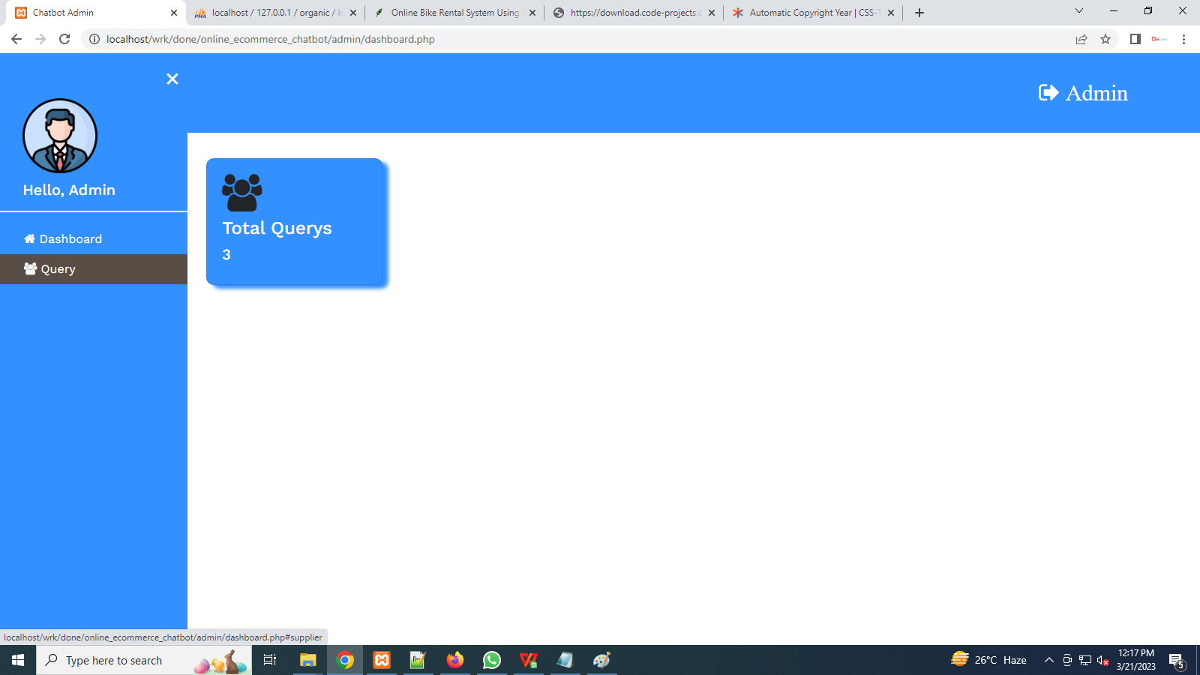

- Adding Queries
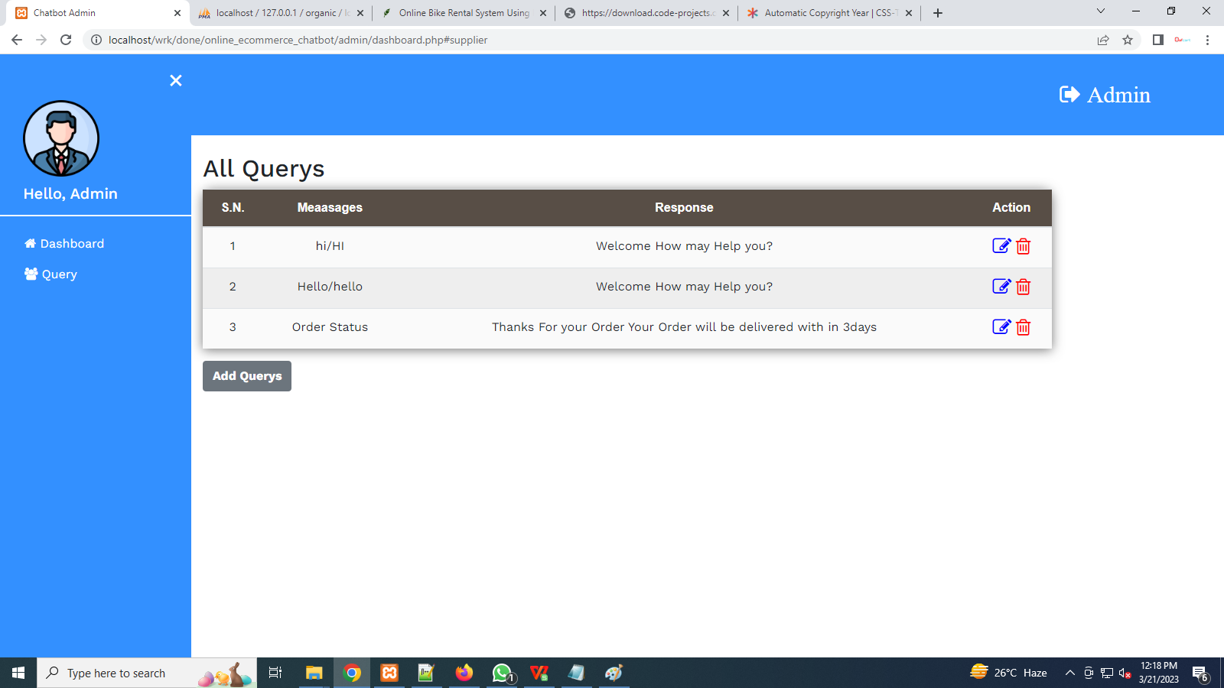

- User Panel
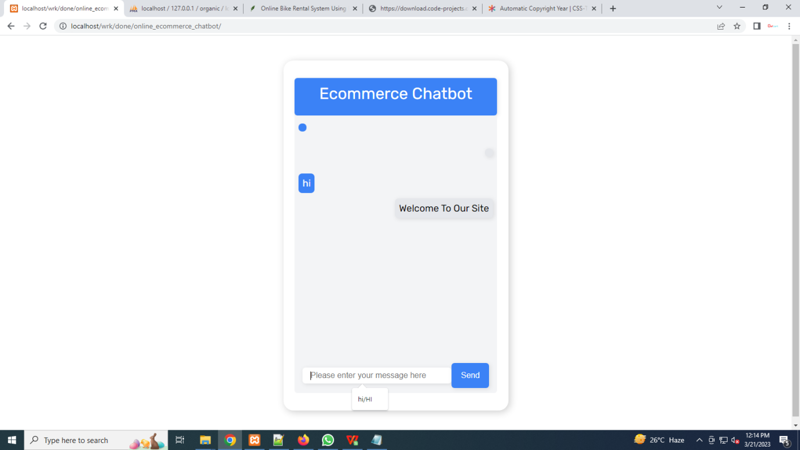

CHAPTER-XI
CONCLUSION

The software is tested with all possible sample of data and performance of the system proves to be much efficient, accurate and user friendly. The software is more interactive, user friendly and menu driven .Hence the user can easily navigate through the system. The end user can access with the at least knowledge of computer sand they find it easy to key in data and understand the error message. This system is flexible and modification if any can be done without much difficulty. The software is more attractive and interactive.
CHAPTER-XII
FUTURE ENHANCEMENT

Every edition of a cakes comes with new topics and modifications if any errors are present. In the similar way, in near future, our System will overcome the flaws if occurred, and attains new features offered to Customers for the Flexible and easy interact with Admin. Following are the Enhancements to the System.
- Providing Good User Interface
- Providing New payment method
- Add more Categories to customers
- Try to implement the GPS system in the rental vehicles

CHAPTER-XIII
REFFERENCES

- Anglo-Bangla Language-Based AI Chatbot for Bangladeshi University Admission System
Koushik Chandra Sarker;Md. Mijanur Rahman;Abu Siam
2023 International Conference on Communications, Computing and
Artificial Intelligence (CCCAI)
Year: 2023 | Conference Paper | Publisher: IEEE

- Introducing an AI Chatbot to Assist in Patient Admission to MRI Examinations
Mohamad Jawad Sharafeddine;Jamal Charara;Maroun Geryes
2023 Seventh International Conference on Advances in Biomedical
Engineering (ICABME)
Year: 2023 | Conference Paper | Publisher: IEEE

- AI Chatbot For Answering FAQ’s
Rachana Vannala;S.B. Swathi;Yuvaraj Puranam
2022 IEEE 2nd International Conference on Sustainable Energy and
Future Electric Transportation (SeFeT)
Year: 2022 | Conference Paper | Publisher: IEEE

