**INTRODUCTION**

A chatterbot or chat bot is a computer program designed to simulate an intelligent conversation with one or more human users via auditory or textual methods. Chatbots can be programmed for small talk, or can also serve as a medium of interaction with users, providing them with answers based on regular questions. The chatbot understands context and delivers a response based on the message given to it. Chatbot is one of many examples of AI. Chatbots were initially designed as means of entertainment and some of them have been designed to pass the Turing Test. [1] The other aspect to be considered is a website. Today most websites rely on menu based navigation and a search bar to provide information to the user. However websites with a large amount of content and poorly structured navigation can make it difficult for user to find the information easily and quickly. For instance if you consider an online shopping portal, it has a large catalogue of products. Browsing through the products can be challenging and time consuming given the variety of features a product can have. In this scenario a chatbot to make it easier for the user to find information. The user has an option to chat with the bot and ask it normal questions to get responses. The chatbot has pre programmed responses, but it can work with dynamic information from a user message in order to make a relevant conversation and suggest relevant information. This is a promising alternative as compared to using search and sort based tools. In this sense, chatbot is used to visualize the contents of a corpus (i.e. samples of real world text) and to give answers to a specific domain[2], which in this context is an ecommerce website. This paper is divided into various sections. Section II talks briefly about the existing work done on chatbots. Section III presents the concept of the project, and what it entails for an end user. Section IV describes the various components involved in the project, while Section V briefly describes the working of the project. Section VI concludes the paper, followed by references.

**SYSTEM ANALYSIS**

**2.1 EXISTING SYSTEM**

Existing systems for college admission enquiry chatbots may incorporate outdated methods in various aspects of their design and functionality. Here are some examples of outdated methods that might be present in such systems:

Static Web Pages: Some older systems may rely on static web pages with limited interactivity and dynamic content. These pages typically require users to navigate through multiple pages to find information, leading to a cumbersome user experience compared to modern single-page applications.

Form-Based Interaction: Traditional chatbot systems may utilize form-based interaction, where users are presented with a series of predefined forms or dropdown menus to select their queries. This rigid approach limits the natural language processing capabilities of the chatbot and may not provide users with the flexibility they desire.

Manual Data Entry: In systems where information is not dynamically retrieved from a database, administrators may need to manually update and maintain the content displayed on the website. This manual data entry process can be time-consuming, error-prone, and inefficient compared to automated systems that fetch data from centralized databases.

**2.1.1 DISADVANTAGES**

The system is not fully automated, it needs data from user for full diagnosis.

**2.2 PROPOSED SYSTEM**

User-Friendly Interface:

The chatbot provides a user-friendly interface for prospective students to inquire about the admission process, courses offered, and other relevant information.

Instant Responses:

The chatbot provides instant responses to user queries, eliminating the need for students to wait for email replies or make phone calls.

Efficient Handling of Queries:

By automating responses to frequently asked questions, the chatbot frees up human resources, allowing staff to focus on more complex queries and tasks.

Personalized Interaction:

The chatbot can provide personalized responses based on user inputs, offering tailored information and guidance to each student.

**MODULES AND DESCRIPTION**

**4.1 LIST OF MODULES**

ADMIN

USER

**4.2 MODULES DESCRIPTION**

**1. Admin**

* **Login:** Admin can login using credentials.
* **Chat Bot:** Admin add the chatbot questions, answer and keywords.

**2. User**

* **Chat Bot:** User can enquire using chat bot.

**SOFTWARE DESCRIPTION**

**5.1 WINDOWS**

Windows is a graphical operating system developed by Microsoft. It allows users to view and store files, run the software, play games, watch videos, and provides a way to connect to the internet. It was released for both home computing and professional works.Microsoft introduced the first version as 1.0

It was released for both home computing and professional functions of Windows on 10 November 1983. Later, it was released on many versions of Windows as well as the current version, Windows 10.

In 1993, the first business-oriented version of Windows was released, which is known as Windows NT 3.1. Then it introduced the next versions, Windows 3.5, 4/0, and Windows 2000. When the XP Windows was released by Microsoft in 2001, the company designed its various versions for a personal and business environment. It was designed based on standard x86 hardware, like Intel and AMD processor. Accordingly, it can run on different brands of hardware, such as HP, Dell, and Sony computers, including home-built PCs.

**5.2 NOTEPAD++**

Notepad++ is a free (as in “free speech” and also as in “free beer”) source code editor and Notepad replacement that supports several languages. Running in the MS Windows environment, its use is governed by GNU General Public License.Based on the powerful editing component Scintilla, Notepad++ is written in C++ and uses pure Win32 API and STL which ensures a higher execution speed and smaller program size. By optimizing as many routines as possible without losing user friendliness, Notepad++ is trying to reduce the world carbon dioxide emissions. When using less CPU power, the PC can throttle down and reduce power consumption, resulting in a greener environment.

**5.3 XAMPP**

XAMPP is the most popular PHP development environment XAMPP is a completely free, easy to install Apache distribution containing MariaDB, PHP, and Perl. The XAMPP open source package has been set up to be incredibly easy to install and to use.Many people know from their own experience that it's not easy to install an Apache web server and it gets harder if you want to add MariaDB, PHP and Perl. The goal of XAMPP is to build an easy to install distribution for developers to get into the world of Apache. To make it convenient for developers, XAMPP is configured with all features turned on. In the case of commercial use please take a look at the product licenses, from the XAMPP point of view commercial use is also free. There are currently distributions for Windows, Linux, and OS X.

**5.4 HTML**

HTML is an acronym which stands for Hyper Text Markup Language which is used for creating web pages and web applications. Let's see what is meant by Hypertext Markup Language, and Web page.

Hyper Text: HyperText simply means "Text within Text." A text has a link within it, is a hypertext. Whenever you click on a link which brings you to a new webpage, you have clicked on a hypertext. HyperText is a way to link two or more web pages (HTML documents) with each other.

Markup language: A markup language is a computer language that is used to apply layout and formatting conventions to a text document. Markup language makes text more interactive and dynamic. It can turn text into images, tables, links, etc.

Web Page: A web page is a document which is commonly written in HTML and translated by a web browser. A web page can be identified by entering an URL. A Web page can be of the static or dynamic type. With the help of HTML only, we can create static web pages.

Hence, HTML is a markup language which is used for creating attractive web pages with the help of styling, and which looks in a nice format on a web browser.

**5.5 CSS**

CSS stands for Cascading Style Sheets. It is a style sheet language which is used to describe the look and formatting of a document written in markup language. It provides an additional feature to HTML. It is generally used with HTML to change the style of web pages and user interfaces. It can also be used with any kind of XML documents including plain XML, SVG and XUL.

CSS is used along with HTML and JavaScript in most websites to create user interfaces for web applications and user interfaces for many mobile applications.

**What does CSS do**

You can add new looks to your old HTML documents.

You can completely change the look of your website with only a few changes in CSS code.

Why use CSS

These are the three major benefits of CSS:

**1) Solves a big problem**

Before CSS, tags like font, color, background style, element alignments, border and size had to be repeated on every web page. This was a very long process. For example: If you are developing a large website where fonts and color information are added on every single page, it will be become a long and expensive process. CSS was created to solve this problem. It was a W3C recommendation.

**2) Saves a lot of time**

CSS style definitions are saved in external CSS files so it is possible to change the entire website by changing just one file.

**3) Provide more attributes**

CSS provides more detailed attributes than plain HTML to define the look and feel of the website.

**5.6 JAVASCRIPT**

JavaScript is a dynamic computer programming language. It is lightweight and most commonly used as a part of web pages, whose implementations allow client-side script to interact with the user and make dynamic pages. It is an interpreted programming language with object-oriented capabilities.

JavaScript was first known as LiveScript, but Netscape changed its name to JavaScript, possibly because of the excitement being generated by Java. JavaScript made its first appearance in Netscape 2.0 in 1995 with the name LiveScript. The general-purpose core of the language has been embedded in Netscape, Internet Explorer, and other web browsers.

The ECMA-262 Specification defined a standard version of the core JavaScript language.

JavaScript is a lightweight, interpreted programming language.

Designed for creating network-centric applications.

Complementary to and integrated with Java.

Complementary to and integrated with HTML.

Open and cross-platform

**Client-Side JavaScript**

Client-side JavaScript is the most common form of the language. The script should be included in or referenced by an HTML document for the code to be interpreted by the browser.

It means that a web page need not be a static HTML, but can include programs that interact with the user, control the browser, and dynamically create HTML content.

The JavaScript client-side mechanism provides many advantages over traditional CGI server-side scripts. For example, you might use JavaScript to check if the user has entered a valid e-mail address in a form field.

The JavaScript code is executed when the user submits the form, and only if all the entries are valid, they would be submitted to the Web Server.

JavaScript can be used to trap user-initiated events such as button clicks, link navigation, and other actions that the user initiates explicitly or implicitly.

**Advantages of JavaScript**

**The merits of using JavaScript are**

**Less server interaction** − You can validate user input before sending the page off to the server. This saves server traffic, which means less load on your server.

**Immediate feedback to the visitors** − They don't have to wait for a page reload to see if they have forgotten to enter something.

**Increased interactivity** − You can create interfaces that react when the user hovers over them with a mouse or activates them via the keyboard.

**Richer interfaces** − You can use JavaScript to include such items as drag-and-drop components and sliders to give a Rich Interface to your site visitors.

**Limitations of JavaScript**

We cannot treat JavaScript as a full-fledged programming language. It lacks the following important features −

Client-side JavaScript does not allow the reading or writing of files. This has been kept for security reason.

JavaScript cannot be used for networking applications because there is no such support available.

JavaScript doesn't have any multi-threading or multiprocessor capabilities.

Once again, JavaScript is a lightweight, interpreted programming language that allows you to build interactivity into otherwise static HTML pages.

**JavaScript Development Tools**

One of major strengths of JavaScript is that it does not require expensive development tools. You can start with a simple text editor such as Notepad. Since it is an interpreted language inside the context of a web browser, you don't even need to buy a compiler.

To make our life simpler, various vendors have come up with very nice JavaScript editing tools. Some of them are listed here −

**Microsoft FrontPage** − Microsoft has developed a popular HTML editor called FrontPage. FrontPage also provides web developers with a number of JavaScript tools to assist in the creation of interactive websites.

**Macromedia Dreamweaver MX** − Macromedia Dreamweaver MX is a very popular HTML and JavaScript editor in the professional web development crowd. It provides several handy prebuilt JavaScript components, integrates well with databases, and conforms to new standards such as XHTML and XML.

Macromedia HomeSite 5 − HomeSite 5 is a well-liked HTML and JavaScript editor from Macromedia that can be used to manage personal websites effectively.

**Where is JavaScript Today ?**

The ECMAScript Edition 5 standard will be the first update to be released in over four years. JavaScript 2.0 conforms to Edition 5 of the ECMAScript standard, and the difference between the two is extremely minor.

The specification for JavaScript 2.0 can be found on the following site: http://www.ecmascript.org/

Today, Netscape's JavaScript and Microsoft's JScript conform to the ECMAScript standard, although both the languages still support the features that are not a part of the standard.JavaScript can be implemented using JavaScript statements that are placed within the <script>... </script> HTML tags in a web page.

You can place the <script> tags, containing your JavaScript, anywhere within your web page, but it is normally recommended that you should keep it within the <head> tags.

The <script> tag alerts the browser program to start interpreting all the text between these tags as a script. A simple syntax of your JavaScript will appear as follows.

<script ...>

JavaScript code

</script>

**The script tag takes two important attributes**

Language − This attribute specifies what scripting language you are using. Typically, its value will be javascript. Although recent versions of HTML (and XHTML, its successor) have phased out the use of this attribute.

Type − This attribute is what is now recommended to indicate the scripting language in use and its value should be set to "text/javascript".

**5.7 JQUERY**

jQuery is a fast, small, cross-platform and feature-rich JavaScript library. It is designed to simplify the client-side scripting of HTML. It makes things like HTML document traversal and manipulation, animation, event handling, and AJAX very simple with an easy-to-use API that works on a lot of different type of browsers.

The main purpose of jQuery is to provide an easy way to use JavaScript on your website to make it more interactive and attractive. It is also used to add animation.

jQuery is a small, light-weight and fast JavaScript library. It is cross-platform and supports different types of browsers. It is also referred as ?write less do more? because it takes a lot of common tasks that requires many lines of JavaScript code to accomplish, and binds them into methods that can be called with a single line of code whenever needed. It is also very useful to simplify a lot of the complicated things from JavaScript, like AJAX calls and DOM manipulation.

jQuery is a small, fast and lightweight JavaScript library.

jQuery is platform-independent.

jQuery means "write less do more".

jQuery simplifies AJAX call and DOM manipulation.

**jQuery Features**

* + HTML manipulation
  + DOM manipulation
  + DOM element selection
  + CSS manipulation
  + Effects and Animations
  + Utilities
  + AJAX
  + HTML event methods
  + JSON Parsing
  + Extensibility through plug-ins

**Why jQuery is required**

Sometimes, a question can arise that what is the need of jQuery or what difference it makes on bringing jQuery instead of AJAX/ JavaScript? If jQuery is the replacement of AJAX and JavaScript? For all these questions, you can state the following answers.

It is very fast and extensible.

It facilitates the users to write UI related function codes in minimum possible lines.

It improves the performance of an application.

Browser's compatible web applications can be developed.

It uses mostly new features of new browsers.

So, you can say that out of the lot of JavaScript frameworks, jQuery is the most popular and the most extendable. Many of the biggest companies on the web use jQuery.

**Some of these companies are**:

* + Microsoft
  + Google
  + IBM
  + Netflix

**5.8 BOOTSRAP**

Bootstrap is the most popular HTML, CSS and JavaScript framework for developing a responsive and mobile friendly website.

It is absolutely free to download and use.

It is a front-end framework used for easier and faster web development.

It includes HTML and CSS based design templates for typography, forms, buttons, tables, navigation, modals, image carousels and many others.

It can also use JavaScript plug-ins.

It facilitates you to create responsive designs.

**Why use Bootstrap**

Following are the main advantage of Bootstrap:

It is very easy to use. Anybody having basic knowledge of HTML and CSS can use Bootstrap.

It facilitates users to develop a responsive website.

It is compatible on most of browsers like Chrome, Firefox, Internet Explorer, Safari and Opera etc.

**What is a responsive website**

A website is called responsive website which can automatically adjust itself to look good on all devices, from smart phones to desktops etc.

**What Bootstrap package contains**

**Scaffolding**: Bootstrap provides a basic structure with Grid System, link styles, and background.

**CSS**: Bootstrap comes with the feature of global CSS settings, fundamental HTML elements style and an advanced grid system.

**Components**: Bootstrap contains a lot of reusable components built to provide iconography, dropdowns, navigation, alerts, pop-overs, and much more.

**JavaScript Plugins**: Bootstrap also contains a lot of custom jQuery plugins. You can easily include them all, or one by one.

**Customize**: Bootstrap components are customizable and you can customize Bootstrap's components, LESS variables, and jQuery plugins to get your own style.

**5.9 AJAX**

AJAX stands for Asynchronous JavaScript and XML. AJAX is a new technique for creating better, faster, and more interactive web applications with the help of XML, HTML, CSS, and Java Script.

Ajax uses XHTML for content, CSS for presentation, along with Document Object Model and JavaScript for dynamic content display.

Conventional web applications transmit information to and from the sever using synchronous requests. It means you fill out a form, hit submit, and get directed to a new page with new information from the server.

With AJAX, when you hit submit, JavaScript will make a request to the server, interpret the results, and update the current screen. In the purest sense, the user would never know that anything was even transmitted to the server.

XML is commonly used as the format for receiving server data, although any format, including plain text, can be used.

AJAX is a web browser technology independent of web server software.

A user can continue to use the application while the client program requests information from the server in the background.

Intuitive and natural user interaction. Clicking is not required, mouse movement is a sufficient event trigger.

Data-driven as opposed to page-driven.

**Rich Internet Application Technology**

AJAX is the most viable Rich Internet Application (RIA) technology so far. It is getting tremendous industry momentum and several tool kit and frameworks are emerging. But at the same time, AJAX has browser incompatibility and it is supported by JavaScript, which is hard to maintain and debug.

**AJAX is Based on Open Standards**

AJAX is based on the following open standards −

* Browser-based presentation using HTML and Cascading Style Sheets (CSS).
* Data is stored in XML format and fetched from the server.
* Behind-the-scenes data fetches using XMLHttpRequest objects in the browser.
* JavaScript to make everything happen.

**5.10 MYSQL**

MySQL, the most popular Open Source SQL database management system, is developed, distributed, and supported by Oracle Corporation.

The MySQL website (http://www.mysql.com/) provides the latest information about MySQL software.

**MySQL is a database management system.**

A database is a structured collection of data. It may be anything from a simple shopping list to a picture gallery or the vast amounts of information in a corporate network. To add, access, and process data stored in a computer database, you need a database management system such as MySQL Server. Since computers are very good at handling large amounts of data, database management systems play a central role in computing, as standalone utilities, or as parts of other applications.

**MySQL databases are relational**.

A relational database stores data in separate tables rather than putting all the data in one big storeroom. The database structures are organized into physical files optimized for speed. The logical model, with objects such as databases, tables, views, rows, and columns, offers a flexible programming environment. You set up rules governing the relationships between different data fields, such as one-to-one, one-to-many, unique, required or optional, and “pointers” between different tables. The database enforces these rules, so that with a well-designed database, your application never sees inconsistent, duplicate, orphan, out-of-date, or missing data.

The SQL part of “MySQL” stands for “Structured Query Language”. SQL is the most common standardized language used to access databases. Depending on your programming environment, you might enter SQL directly (for example, to generate reports), embed SQL statements into code written in another language, or use a language-specific API that hides the SQL syntax.

SQL is defined by the ANSI/ISO SQL Standard. The SQL standard has been evolving since 1986 and several versions exist. In this manual, “SQL-92” refers to the standard released in 1992, “SQL:1999” refers to the standard released in 1999, and “SQL:2003” refers to the current version of the standard. We use the phrase “the SQL standard” to mean the current version of the SQL Standard at any time.

**MySQL software is Open Source.**

Open Source means that it is possible for anyone to use and modify the software. Anybody can download the MySQL software from the Internet and use it without paying anything. If you wish, you may study the source code and change it to suit your needs. The MySQL software uses the GPL (GNU General Public License), http://www.fsf.org/licenses/, to define what you may and may not do with the software in different situations. If you feel uncomfortable with the GPL or need to embed MySQL code into a commercial application, you can buy a commercially licensed version from us. See the MySQL Licensing Overview for more information (http://www.mysql.com/company/legal/licensing/).

The MySQL Database Server is very fast, reliable, scalable, and easy to use.

If that is what you are looking for, you should give it a try. MySQL Server can run comfortably on a desktop or laptop, alongside your other applications, web servers, and so on, requiring little or no attention. If you dedicate an entire machine to MySQL, you can adjust the settings to take advantage of all the memory, CPU power, and I/O capacity available. MySQL can also scale up to clusters of machines, networked together.

MySQL Server was originally developed to handle large databases much faster than existing solutions and has been successfully used in highly demanding production environments for several years. Although under constant development, MySQL Server today offers a rich and useful set of functions. Its connectivity, speed, and security make MySQL Server highly suited for accessing databases on the Internet.

**MySQL Server works in client/server or embedded systems**.

The MySQL Database Software is a client/server system that consists of a multithreaded SQL server that supports different back ends, several different client programs and libraries, administrative tools, and a wide range of application programming interfaces (APIs).

We also provide MySQL Server as an embedded multithreaded library that you can link into your application to get a smaller, faster, easier-to-manage standalone product.

A large amount of contributed MySQL software is available.

MySQL Server has a practical set of features developed in close cooperation with our users. It is very likely that your favorite application or language supports the MySQL Database Server.

**5.11 PHP**

PHP (recursive acronym for PHP: Hypertext Preprocessor) is a widely-used open source general-purpose scripting language that is especially suited for web development and can be embedded into HTML.

Instead of lots of commands to output HTML (as seen in C or Perl), PHP pages contain HTML with embedded code that does "something" (in this case, output "Hi, I'm a PHP script!"). The PHP code is enclosed in special start and end processing instructions <?php and ?> that allow you to jump into and out of "PHP mode."

What distinguishes PHP from something like client-side JavaScript is that the code is executed on the server, generating HTML which is then sent to the client. The client would receive the results of running that script, but would not know what the underlying code was. You can even configure your web server to process all your HTML files with PHP, and then there's really no way that users can tell what you have up your sleeve.

The best part about using PHP is that it is extremely simple for a newcomer, but offers many advanced features for a professional programmer. Don't be afraid to read the long list of PHP's features. You can jump in, in a short time, and start writing simple scripts in a few hours.

Although PHP's development is focused on server-side scripting, you can do much more with it. Read on, and see more in the What can PHP do? section, or go right to the introductory tutorial if you are only interested in web programming.

**5.12 APACHE**

Apache is free and open-source software of web server that is used by approx 40% of websites all over the world. Apache HTTP Server is its official name. It is developed and maintained by the Apache Software Foundation. Apache permits the owners of the websites for serving content over the web. It is the reason why it is known as a "web server." One of the most reliable and old versions of the Apache web server was published in 1995.

If someone wishes to visit any website, they fill-out the name of the domain in their browser address bar. The web server will bring the requested files by performing as the virtual delivery person.

**SYSTEM DESIGN AND IMPLEMENTATION**

**5.1 SYSTEM OVERVIEW**

System analysis can be defined, as a method that is determined to use the resources, machine in the best manner and perform tasks to meet the information needs of an organization. It is also a management technique that helps us in designing a new systems or improving an existing system.

The four basic elements in the system analysis are

* Output
* Input
* Files
* Process

The above-mentioned are mentioned are the four basis of the System Analysis.

**5.1.1 FEASIBILITY STUDY**

Feasibility is the study of whether or not the project is worth doing. The process that follows this determination is called a Feasibility Study. This study is taken in right time constraints and normally culminates in a written and oral feasibility report. This feasibility study is categorized into seven different types. They are

* Technical Analysis
* Economical Analysis
* Performance Analysis
* Control and Security Analysis
* Efficiency Analysis
* Service Analysis

**5.1.2 TECHNICAL ANALYSIS**

This analysis is concerned with specifying the software that will successfully satisfy the user requirements. The technical needs of a system are to have the facility to produce the outputs in a given time and the response time under certain conditions.

**5.1.3 ECONOMIC ANALYSIS**

Economic Analysis is the most frequently used technique for evaluating the effectiveness of prepared system. This is called Cost/Benefit analysis. It is used to determine the benefits and savings that are expected from a proposed system and compare them with costs. If the benefits overweigh the cost, then the decision is taken to the design phase and implements the system.

**5.1.4 PERFORMANCE ANALYSIS**

The analysis on the performance of a system is also a very important analysis. This analysis analyses about the performance of the system both before and after the proposed system. If the analysis proves to be satisfying from the company’s side then this analysis result is moved to the next analysis phase. Performance analysis is nothing but invoking at program execution to pinpoint where bottle necks or other performance problems such as memory leaks might occur. If the problem is spotted out then it can be rectified.

**5.1.5 EFFICIENCY ANALYSIS**

This analysis mainly deals with the efficiency of the system based on this project. The resources required by the program to perform a particular function are analyzed in this phase. It is also checks how efficient the project is on the system, in spite of any changes in the system. The efficiency of the system should be analyzed in such a way that the user should not feel any difference in the way of working. Besides, it should be taken into consideration that the project on the system should last for a longer time.

**INPUTDESIGN:**

Input design is the process of converting user-originated inputs to web-based format. Input design is one of the most expensive phases of the operation of the major problem of a system. Input facilities the entry of data into the computer system Input design involves the selection of the best strategy for getting data into the computer system at the right time and as accurately as possible. This is because the most difficult aspect of input designs in accuracy. The use of well-defined document can encourage used to record data accurately without omission. Input design must capture all the data that the system needs, without introducing any errors. Input errors can be greatly reduced when inputting directly by using appropriate forms for data capture and well-designed computer screen layout. The input design is the part of overall system design, which requires very careful attention. If the data going into the system is incorrect then the processing and output will magnify the errors. The objectives considered during input design are:

* Nature of input processing
* Flexibility and thoroughness of validation rules.
* Handling of properties within the input documents.

Screen design to ensure accuracy and efficiency of the input relationship with files Careful design of the input also involves attention to error handling, in the project: the input design is made in various window forms with various methods.

**OUTPUT DESIGN**

Output design generally refers to the results and information that are generated by the system for many end-users: output is the main reason for developing the system and the basis on which they evaluate the usefulness of the SYSTEM. In any system, the output design determines the input to be given to the SYSTEM.

Output design is very important concept in the computerized system.without reliable output his user may feel the entire system is unnecessary and avoids using it.

Output design is the process which involves designing necessary output which helps the user according to their requirement.Efficient output design should improve the system relationship with the user and helps in decision-making.Since the reports are directly required by the management for taking decision and to draw the conclusion must be simple, descriptive and clear to the user. Option for outputs and forms are given in the system menus.

**5.2 LIST OF DIAGRAMS**

**SCHEMA DIAGRAM**

**ENTITY DIAGRAM**

Anentity-relationshipdiagram is a graphical depiction of organizational system elementsand the association among the elements. E-R diagram scan help define system boundaries. The entity relationship diagram is also called as ERD or E-RDis anetworkmodelthatdescribesthestoreddatalayoutofthe system atthehighlevelofabstraction.Entityrelationship diagram depictdatainitsreststate-datastores.Anentityis anythingrealofabstractaboutwhichwewanttostoredata. Mostentitiescorrespondtoperson,objects,eventsorlocations. Itisrepresentedbyrelationshipsymbol,whichisadecisionbox.

**DATAFLOW DIAGRAM**

A data-flow diagram (DFD) is a way of representing a flow of a data of a process or a system (usually an information system). The DFD also provides information about the outputs and inputs of each entity and the process itself. A data-flow diagram has no control flow, there are no decision rules and no loops. Specific operations based on the data can be represented by a flowchart.

There are several notations for displaying data-flow diagrams. The notation presented above was described in 1979 by Tom DeMarco as part of Structured Analysis.

For each data flow, at least one of the endpoints (source and / or destination) must exist in a process. The refined representation of a process can be done in another data-flow diagram, which subdivides this process into sub-processes.

The data-flow diagram is part of the structured-analysis modelling tools. When using UML, the activity diagram typically takes over the role of the data-flow diagram. A special form of data-flow plan is a site-oriented data-flow plan.

Data-flow diagrams can be regarded as inverted Petri nets, because places in such networks correspond to the semantics of data memories. Analogously, the semantics of transitions from Petri nets and data flows and functions from data-flow diagrams should be considered equivalent.

The representations used in order to frame a data flow diagramare:

The circle represents the process. It shows the pair of the Process that transforms input to output.

The arrow represents the graphical flow into or out of a process.

The store is used to model a collection of data packets at rest.

The terminator represents external entities withsystem

Communication.

**SYSTEM REQUIREMENTS**

**6.1 SOFTWARE REQUIREMENTS**

* Operating system : Windows 10
* Front End : HTML,CSS,BOOTSRAP,Jquery,javascript,
* Scripting Language : PHP
* Back End : MYSQL

**6.2 HARDWARE REQUIREMENTS**

* System : Inteli3
* Hard disk : 160 GB
* Monitor : 15 VGA colour
* Mouse : Logitech.
* Ram : 512 MB
* Keyboard : 110 keys enhanced.

**SYSTEM TESTING**

The purpose of testing is to discover errors. Testing is the process of trying to discover every conceivable fault or weakness in a work product. It provides a way to check the functionality of components, sub assemblies, assemblies and/or a finished product. It is the process of exercising software with the intent of ensuring that the software system meets its requirements and user expectations and does not fail in an unacceptable manner. There are various types of test. Each test type addresses a specific testing requirement.

**7.1 TYPES OF TESTS**

**7.1.1 UNIT TESTING**

Unit testing involves the design of test cases that validate that the internal program logic is functioning properly, and that program input produces valid outputs. All decision branches and internal code flow should be validated. It is the testing of individual software units of the application .it is done after the completion of an individual unit before integration. This is a structural testing, that relies on knowledge of its construction and is invasive.

Unit tests perform basic tests at component level and test a specific business process, application, and/or system configuration. Unit tests ensure that each unique path of a business process performs accurately to the documented specifications and contains clearly defined inputs and expected results.

**7.1.2 INTEGRATION TESTING**

Integration tests are designed to test integrated software components to determine if they actually run as one program. Testing is event driven and is more concerned with the basic outcome of screens or fields. Integration tests demonstrate that although the components were individually satisfaction, as shown by successfully unit testing, the combination of components is correct and consistent. Integration testing is specifically aimed at exposing the problems that arise from the combination of components.

**7.1.3 FUNCTIONAL TESTING**

Functional tests provide a systematic demonstration that functions tested are available as specified by the business and technical requirements, system documentation, and user manuals.

Functional testing is cantered on the following items:

Valid Input : identified classes of valid input must be accepted.

Invalid Input : identified classes of invalid input must be rejected.

Functions : identified functions must be exercised.

Output : identified classes of application outputs must be

Exercised.

Systems/Procedures: interfacing systems or procedures must be invoked.

Organization and preparation of functional tests is focused on requirements, key functions, or special test cases. In addition, systematic coverage pertaining to identify business process flows, data fields, predefined processes, and successive processes must be considered for testing. Before functional testing is complete, additional tests are identified and the effective value of current tests is determined.

**7.1.4 SYSTEM TESTING**

System testing ensures that the entire integrated software system meets requirements. It tests a configuration to ensure known and predictable results. An example of system testing is the configuration oriented system integration test. System testing is based on process descriptions and flows, emphasizing pre-driven process links and integration points.

**7.1.5 WHITE BOX TESTING**

White Box Testing is a testing in which the software tester has knowledge of the inner workings, structure and language of the software, or at least its purpose. It is used to test areas that cannot be reached from a black box level.

**7.1.6 BLACK BOX TESTING**

Black Box Testing is testing the software without any knowledge of the inner workings, structure or language of the module being tested. Black box tests, as most other kinds of tests, must be written from a definitive source document, such as specification or requirements document, such as specification or requirements document. It is a testing, in which the software under test is treated, as a black box, cannot “see” into it. The test provides inputs and responds to outputs without considering how the software works.

**6.3 Basic Path Testing :**

Established technique of flow graph with Cyclomatic complexity was used to derive test cases for all the functions. The main steps in deriving test cases were: Use the design of the code and draw correspondent flow graph. Determine the Cyclomatic complexity of resultant flow graph, using formula: Determine the basis of set of linearly independent paths.

**6.4 Conditional Testing :**

In this part of the testing each of the conditions were tested to both true and false aspects. And all the resulting paths were tested. So that each path that may be generate on particular condition is traced to uncover any possible errors.

**6.5 Data Flow Testing :**

This type of testing selects the path of the program according to the location of definition and use of variables. This kind of testing was used only when some local variable were declared.The definition-use chain method was used in this type of testing. These were particularly useful in nested statements.

**6.6 Loop Testing :**

In this type of testing all the loops are tested to all the limits possible. The following exercise was adopted for all loops:

* All the loops were tested at their limits, just above them and just below them.
* All the loops were skipped at least once.
* For nested loops test the inner most loop first and then work outwards.
* For concatenated loops the values of dependent loops were set with the help of connected loop.
* Unstructured loops were resolved into nested loops or concatenated loops and tested as above.
* Each unit has been separately tested by the development team itself and all the input have been validated.

**SYSTEM FLOW DIAGRAM**

**DATA FLOW DIAGRAM**

**LEVEL 0:**

User

Admin

Search for admission process

Request

Get results

Response

**LEVEL 1:**

User

Admission details

**Level 2**

Admin

Login

Dashboard

(All Querys)

Add Querys

(Edit/ Delete)

Manage data

**Use case diagram**

USER

ADMIN

**DATABASE DESIGN:**

**Table Name: admin**

|  |  |  |  |
| --- | --- | --- | --- |
| **FIELD NAME** | **DATA TYPE** | **LENGTH** | **DESCRIPTION** |
| id | Int | 11 | unique id |
| Admin_name | Varchar | 255 | Admin name |
| Admin_email | Varchar | 255 | Admin email id |
| Admin_password | Varchar | 255 | Admin password |

**Table Name: chatbot**

|  |  |  |  |
| --- | --- | --- | --- |
| **FIELD NAME** | **DATA TYPE** | **LENGTH** | **DESCRIPTION** |
| id | Int | 11 | unique id |
| messages | Varchar | 255 | Question has to be entered |
| response | Varchar | 255 | Answer has to be showed |
| status | Varchar | 255 | Status of the query |

**CODING**

**<?php**

**/* Establishes a connection with the database. The first argument is the server name, the second is the username for the database, the third is the password (blank for me) and the final is the database name**

**\*/**

**$conn = mysqli_connect("localhost","root","","onlinebot");**

**// If the connection is established successfully**

**if($conn)**

**{**

**// Get the user's message from the request object and escape characters**

**$user_messages = mysqli_real_escape_string($conn, $_POST['messageValue']);**

**// create SQL query for retrieving the corresponding reply**

**$query = "SELECT * FROM chatbot WHERE messages LIKE '%$user_messages%'";**

**// Execute query on the connected database using the SQL query**

**$makeQuery = mysqli_query($conn, $query);**

**if(mysqli_num_rows($makeQuery) > 0)**

**{**

**// Get the result**

**$result = mysqli_fetch_assoc($makeQuery);**

**// Echo only the response column**

**echo $result['response'];**

**}else{**

**// Otherwise, echo this message**

**echo "Sorry, I can't understand you.";**

**}**

**}else {**

**// If the connection fails to establish, echo an error message**

**echo "Connection failed" . mysqli_connect_errno();**

**}**

**?>**

**<!DOCTYPE html>**

**<html>**

**<head>**

**<title>Chatbot Admin</title>**

**<head>**

**<meta name="viewport" content="width=device-width, initial-scale=1">**

**<link rel="stylesheet" href="https://cdn.jsdelivr.net/npm/bootstrap@4.0.0/dist/css/bootstrap.min.css" integrity="sha384-Gn5384xqQ1aoWXA+058RXPxPg6fy4IWvTNh0E263XmFcJlSAwiGgFAW/dAiS6JXm" crossorigin="anonymous">**

**<link rel="stylesheet" href="https://cdnjs.cloudflare.com/ajax/libs/font-awesome/4.7.0/css/font-awesome.min.css">**

**<link rel="stylesheet" href="./assets/css/style.css"></link>**

**</head>**

**</head>**

**<body >**

**<?php**

**include "./adminHeader.php";**

**include "./sidebar.php";**

**include_once "./config/dbconnect.php";**

**?>**

**<div id="main-content" class="container allContent-section py-4">**

**<div class="row">**

**<div class="col-sm-3">**

**<div class="card">**

**<i class="fa fa-users mb-2" style="font-size: 50px;"></i>**

**<h4 style="color:white;">Total Querys</h4>**

**<h5 style="color:white;">**

**<?php**

**$sql="SELECT * from chatbot where status=1";**

**$result=$conn-> query($sql);**

**$count=0;**

**if ($result-> num_rows > 0){**

**while ($row=$result-> fetch_assoc()) {**

**$count=$count+1;**

**}**

**}**

**echo $count;**

**?></h5>**

**</div>**

**</div>**

**</div>**

**</div>**

**<?php**

**if (isset($_GET['query']) && $_GET['query'] == "success") {**

**echo '<script> alert("query Successfully Added")</script>';**

**}else if (isset($_GET['query']) && $_GET['query'] == "error") {**

**echo '<script> alert("Adding Unsuccess")</script>';**

**}**

**if (isset($_GET['query']) && $_GET['query'] == "update") {**

**echo '<script> alert("query Successfully Updated")</script>';**

**}else if (isset($_GET['query']) && $_GET['query'] == "uerror") {**

**echo '<script> alert("Updating Unsuccess")</script>';**

**}**

**if (isset($_GET['query']) && $_GET['query'] == "delete") {**

**echo '<script> alert("query Successfully Deleted")</script>';**

**}else if (isset($_GET['query']) && $_GET['query'] == "derror") {**

**echo '<script> alert("Deleted Unsuccess")</script>';**

**}**

**?>**

**<script type="text/javascript" src="./assets/js/ajaxWork.js"></script>**

**<script type="text/javascript" src="./assets/js/script.js"></script>**

**<script src="https://code.jquery.com/jquery-3.1.1.min.js" ></script>**

**<script src="https://cdn.jsdelivr.net/npm/popper.js@1.12.9/dist/umd/popper.min.js" ></script>**

**<script src="https://cdn.jsdelivr.net/npm/bootstrap@4.0.0/dist/js/bootstrap.min.js"></script>**

**</body>**

**</html>**

**SCREEN SHOTS**

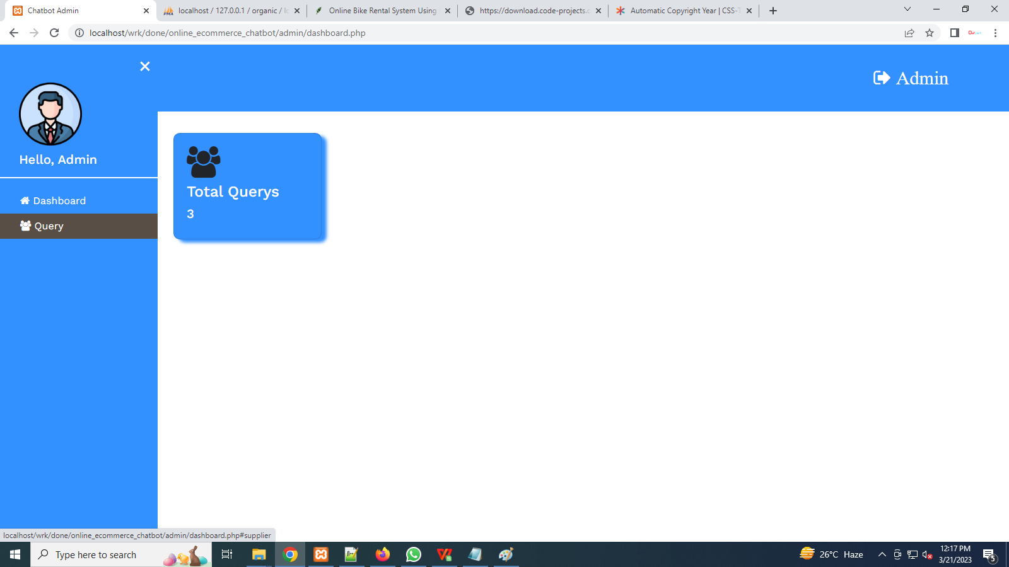

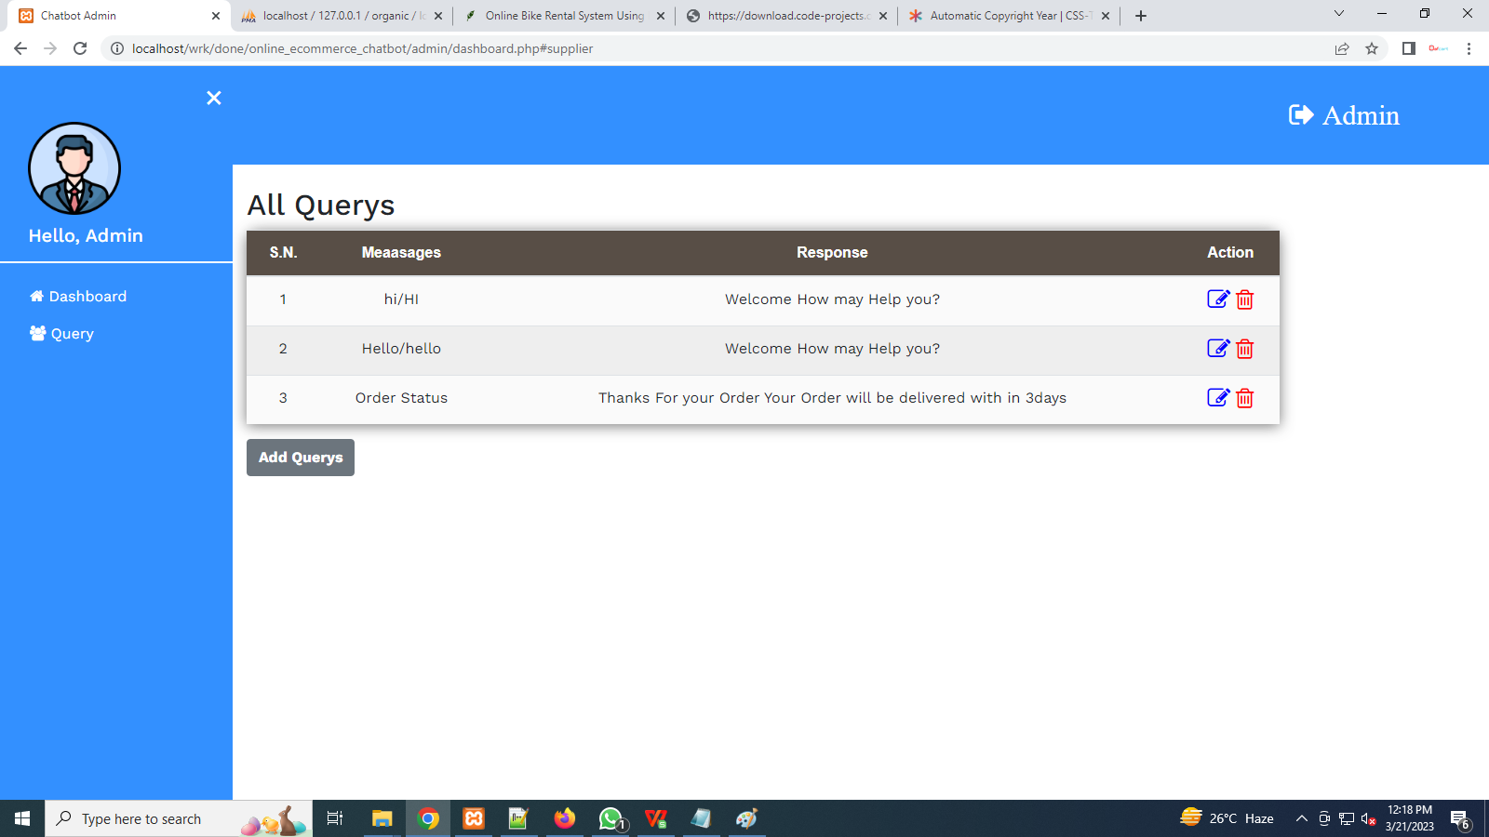

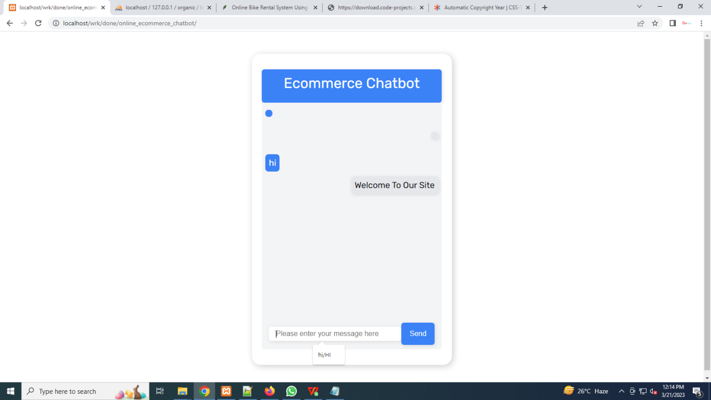

**CONCLUSION**

The software is tested with all possible sample of data and performance of the system proves to be much efficient, accurate and user friendly. The software is more interactive, user friendly and menu driven .Hence the user can easily navigate through the system. The end user can access with the at least knowledge of computer sand they find it easy to key in data and understand the error message. This system is flexible and modification if any can be done without much difficulty. The software is more attractive and interactive.

**FUTURE ENHANCEMENT**

Every edition of a cakes comes with new topics and modifications if any errors are present. In the similar way, in near future, our System will overcome the flaws if occurred, and attains new features offered to Customers for the Flexible and easy Intract with Admin. Following are the Enhancements to the System.

* Providing Good User Interface
* Providing New payment method
* Add more Categories to customers
* Try to implement the GPS system in the rental vehicles

**REFFERENCES**

**TEXTBOOKS**

1.AlistairMcMonnies,“PHPAdvance”AlistairMcMonnies, “PHPAdvancedprogramming”,PearsonEducation,and ISBN:81-297-0649-0,FirstIndianReprint2004.

2.FrancescoBalena,“SQLbasics”,MicrosoftPress.

**WEBLIOGRAPHY:**

1.http://vbdotnetheaven.com

2.http://www.codeproject.com

3.http://msdn.microsoft.com

4.www.vbtutor.net