PHASE 3:WEBSITE TRAFFIC ANALYSIS

TOPIC:Building the website traffic analysis using IBM cognos for visualization define the objectives of the analysis and load websitetraffic data from the source shared.



**INTRODUCTION:**

* IBM Cognos Analytics integrates reporting, modeling, analysis, dashboards, stories, and event management so that you can understand your organization's data, and make effective business decisions.
* IBM Cognos Analytics provides analytic insights that help you to detect and validate important relationships and meaningful differences based on the data.

**HOW TO CLEAN DATA:**

Step 1: Remove duplicate or irrelevant observations. Remove unwanted observations from your dataset, including duplicate observations or irrelevant observations.

Step 2: Fix structural errors.

Step 3: Filter unwanted outliers.

Step 4: Handle missing data.

Step 5: Validate and QA.

**DATA CLEANSING:**

Data cleansing, also referred to as data cleaning or data scrubbing, is the process of fixing incorrect, incomplete, duplicate or otherwise erroneous data in a data set. It involves identifying data errors and then changing, updating or removing data to correct them.

**DATA SET:**

|  |  |  |  |  |  |  |  |
| --- | --- | --- | --- | --- | --- | --- | --- |
| Row | Day | Day.Of.Week | Date | Page.Loads | Unique.Visits | First.Time.Visits | Returning.Visits |
| 1 | Sunday | 1 | 9/14/2014 | 2,146 | 1,582 | 1,430 | 152 |
| 2 | Monday | 2 | 9/15/2014 | 3,621 | 2,528 | 2,297 | 231 |
| 3 | Tuesday | 3 | 9/16/2014 | 3,698 | 2,630 | 2,352 | 278 |
| 4 | Wednesday | 4 | 9/17/2014 | 3,667 | 2,614 | 2,327 | 287 |
| 5 | Thursday | 5 | 9/18/2014 | 3,316 | 2,366 | 2,130 | 236 |
| 6 | Friday | 6 | 9/19/2014 | 2,815 | 1,863 | 1,622 | 241 |
| 7 | Saturday | 7 | 9/20/2014 | 1,658 | 1,118 | 985 | 133 |
| 8 | Sunday | 1 | 9/21/2014 | 2,288 | 1,656 | 1,481 | 175 |
| 9 | Monday | 2 | 9/22/2014 | 3,638 | 2,586 | 2,312 | 274 |

IMPORTING LIBRARIES:

import pandas as pd

import matplotlib.pyplot as plt

import numpy as np

**in [1]:**

import pandas as pd

FILE_LOCATION = ('/kaggle/input/daily-website-visitors/daily-website-visitors.csv')

whole_dataset =pd.read_csv(FILE_LOCATION,index_col='Date',thousands=',')

whole_dataset.index = pd.to_datetime(whole_dataset.index)

whole_dataset

**out [1]:**

|  |  |  |  |  |  |  |  |
| --- | --- | --- | --- | --- | --- | --- | --- |
| Row | Day | Day.Of.week | Date | Page.Loads | Unique.Visits | First.Time.Visits | Returning.Visits |
| 1 | Sunday | 1 | 9/14/2014 | 2,146 | 1,582 | 1,430 | 152 |
| 2 | Monday | 2 | 9/15/2014 | 3,621 | 2,528 | 2,297 | 231 |
| 3 | Tuesday | 3 | 9/16/2014 | 3,698 | 2,630 | 2,352 | 278 |
| 4 | Wednesday | 4 | 9/17/2014 | 3,667 | 2,614 | 2,327 | 287 |

|  |  |  |  |  |  |  |  |
| --- | --- | --- | --- | --- | --- | --- | --- |
| 5 | Thursday | 5 | 9/18/2014 | 3,316 | 2,366 | 2,130 | 236 |
| 6 | Friday | 6 | 9/19/2014 | 2,815 | 1,863 | 1,622 | 241 |
| 7 | Saturday | 7 | 9/20/2014 | 1,658 | 1,118 | 985 | 133 |
| 8 | Sunday | 1 | 9/21/2014 | 2,288 | 1,656 | 1,481 | 175 |
| 9 | Monday | 2 | 9/22/2014 | 3,638 | 2,586 | 2,312 | 274 |

**In [2]:**

import matplotlib.pyplot as plt

fig, axs = plt.subplots(3, figsize=(12, 5))

axs[0].plot(whole_dataset['First.Time.Visits'])

axs[1].plot(whole_dataset['Unique.Visits'])

axs[2].plot(whole_dataset['Returning.Visits'])

plt.show()

**out [2]:**

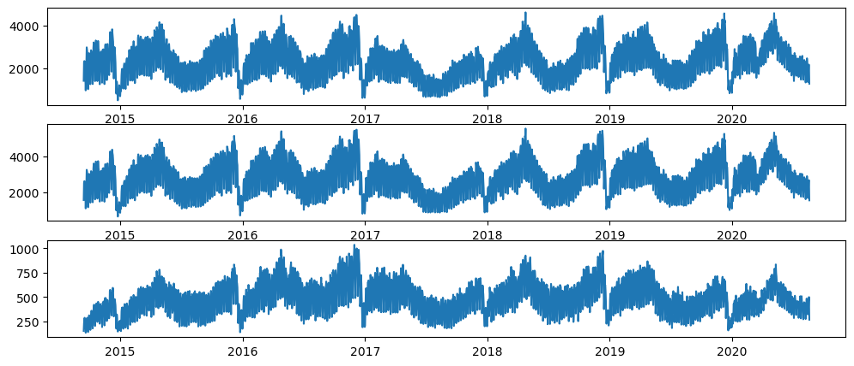

**In [3]:**

target_column = whole_dataset['Returning.Visits']

target_column

**out [3]:**

Date

2014-09-14 152

2014-09-15 231

2014-09-16 278

2014-09-17 287

2014-09-18 236

...

2020-08-15 323

2020-08-16 351

2020-08-17 457

2020-08-18 499

2020-08-19 267

Name: Returning.Visits, Length: 2167, dtype: int64

**In [4]:**

target_column.plot(figsize=(15, 3))

plt.show()

**out [4]:**

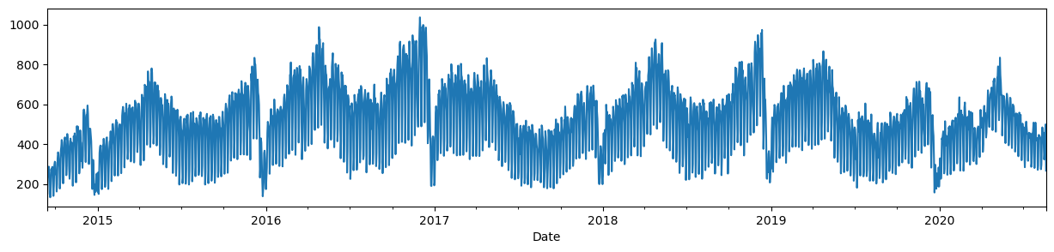

**In [5]:**

TEST_DATA_PERCENTAGE = 0.1

TEST_DATA_BOUNDARY_INDEX = int((1 - TEST_DATA_PERCENTAGE) * len(target_column))

print(f"Train data:**\t**Returning Visits [:**{**TEST_DATA_BOUNDARY_INDEX**}**] (**{**TEST_DATA_BOUNDARY_INDEX + 1**}**)")

print(f"Test data:**\t**Returning Visits [**{**TEST_DATA_BOUNDARY_INDEX**}**:] (**{**len(target_column) - TEST_DATA_BOUNDARY_INDEX**}**)")

print(f"**\n**Last target on train data: **{**target_column[TEST_DATA_BOUNDARY_INDEX]**}**")

**out [5]:**

Train data: Returning Visits [:1950] (1951)

Test data: Returning Visits [1950:] (217)

**In [6]:**

target_column[TEST_DATA_BOUNDARY_INDEX10:TEST_DATA_BOUNDARY_INDEX+10].

values, (list(train_dataset)[-1][0][-1].numpy(), list(train_dataset)[-1][1][-1].numpy())

**out [6]:**

(array([429, 423, 442, 464, 372, 253, 277, 515, 434, 394, 441, 413, 246, 314, 443, 484, 473, 490, 353, 249]),

(array([277, 515, 434]), 394))

Plot the train and test datasets

**In [7]:**

import numpy as np

import matplotlib.dates as mdates

def plot_time_series(predictions = None, start_index=1500):

timesteps = pd.to_datetime(target_column.index)

fig,ax = plt.subplots(1,figsize=(15,5))

ax.xaxis.set_major_locator(mdates.MonthLocator(bymonth=(1, 7)))

ax.xaxis.set_minor_locator(mdates.MonthLocator())

ax.xaxis.set_major_formatter(mdates.DateFormatter('%Y-%b'))

*# Plot train dataset*

plt.plot(timesteps[start_index:TEST_DATA_BOUNDARY_INDEX], target_column[start_index:TEST_DATA_BOUNDARY_INDEX],

color='blue')

*# Plot test dataset*

plt.plot(timesteps[TEST_DATA_BOUNDARY_INDEX:], target_column[TEST_DATA_BOUNDARY_INDEX:],

color='green', linewidth=0.4)

if predictions **is** **not** None:

pred_timesteps = timesteps[TEST_DATA_BOUNDARY_INDEX:]

plt.plot(pred_timesteps, predictions, linewidth=0.4, color='red')

plt.scatter(pred_timesteps, predictions, s=0.4, color='red')

plot_time_series()

**out [7]:**

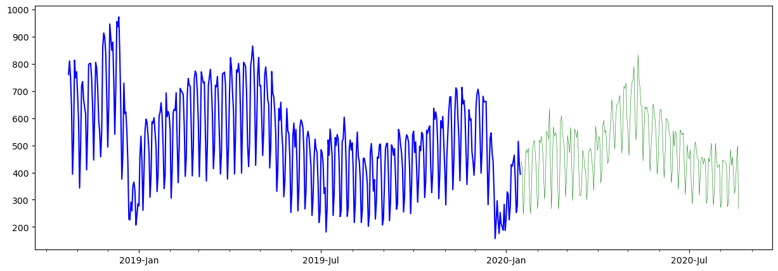

**In [8]:**

import tensorflow as tf

from tensorflow.keras.layers import Layer

from tensorflow.keras import Model

class **NaiveForecastLayer**(Model):

def __init__(self):

super().__init__()

def call(self, inputs):

result = inputs[:, -1]

return result[:, tf.newaxis]

baseline_model = NaiveForecastLayer()

baseline_model._name = 'model_0'

baseline_model.compile(metrics=[tf.keras.metrics.MeanAbsoluteError()])

baseline_predictions = baseline_model.predict(test_dataset)

plot_time_series(baseline_predictions.ravel(), start_index=1900)

**out [8]:**

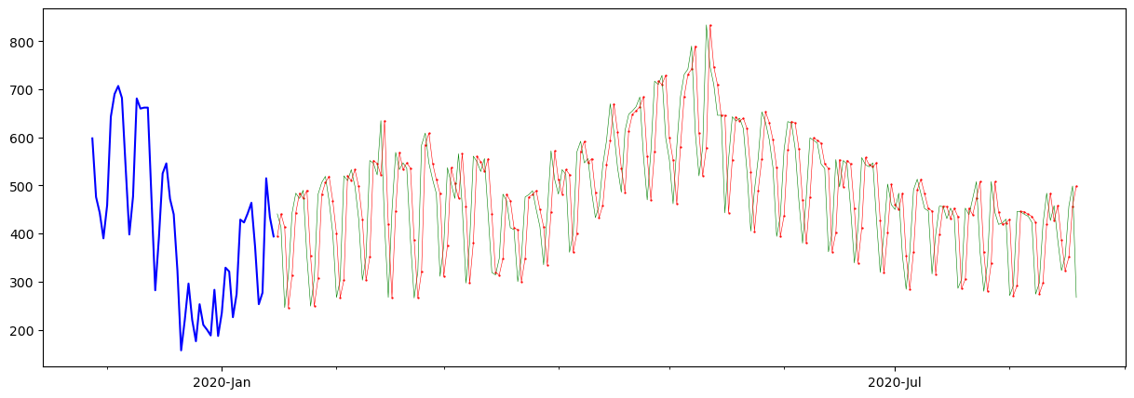

**In [9]:**

y_true = target_column[TEST_DATA_BOUNDARY_INDEX : ]

len(y_true), y_true

**out [9]:**

(217,

Date

2020-01-16 441

2020-01-17 413

2020-01-18 246

2020-01-19 314

2020-01-20 443

...

2020-08-15 323

2020-08-16 351

2020-08-17 457

2020-08-18 499

2020-08-19 267

Name: Returning.Visits, Length: 217, dtype: int64)

**In [10]:**

DAYS_OF_WEEK = ['Monday', 'Tuesday', 'Wednesday', 'Thursday', 'Friday', 'Saturday', 'Sunday']

pd.DataFrame(dataset_by_day['Returning.Visits'].mean()).loc[DAYS_OF_WEEK].plot(kind='bar')

**out [10]:**

<Axes: xlabel='Day'>

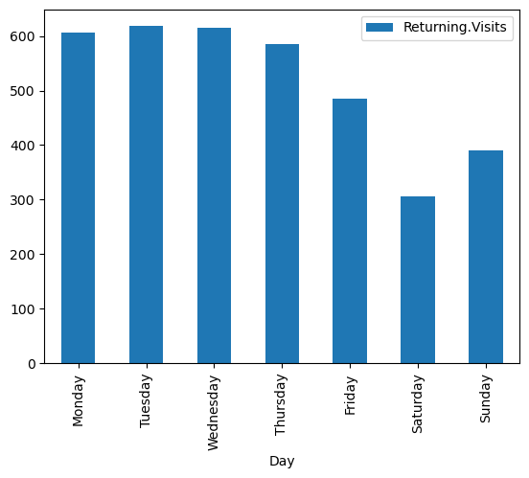

**In [11]:**

dataset_by_day['Returning.Visits'].hist(legend=True, alpha=0.5)

plt.show()

**out [11]:**

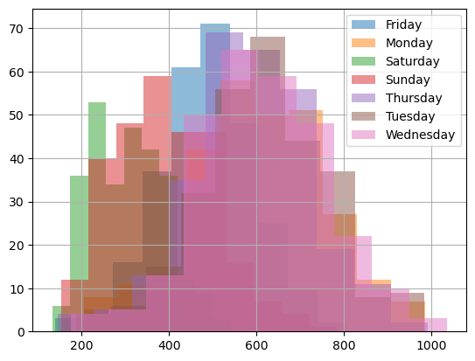

**In [12]:**

pd.DataFrame(dataset_group_by_month['Returning.Visits'].mean()).loc[MONTH_NAMES].plot(kind='bar')

plt.show()

**out [12]:**

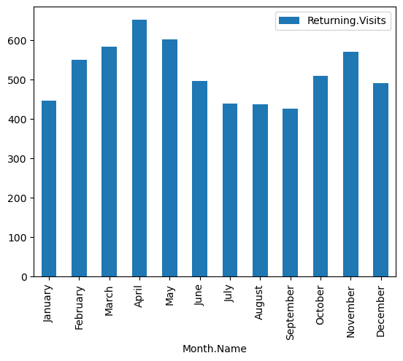

**In [13]:**

from tensorflow.data import Dataset

model3_history = model_3.fit(x=[dataset2_rv_history_features, X_cat_encoded], y=train_dataset2, epochs=5)

pd.DataFrame(model3_history.history).plot()

**out [13]:**

Epoch 1/5

61/61 [==============================] - 3s 7ms/step - loss: 232.3113

Epoch 2/5

61/61 [==============================] - 0s 7ms/step - loss: 105.8665

Epoch 3/5

61/61 [==============================] - 0s 7ms/step - loss: 90.6746

Epoch 4/5

61/61 [==============================] - 0s 7ms/step - loss: 82.1568

Epoch 5/561/61 [==============================]- 0s 7ms/step - loss: 80.3541

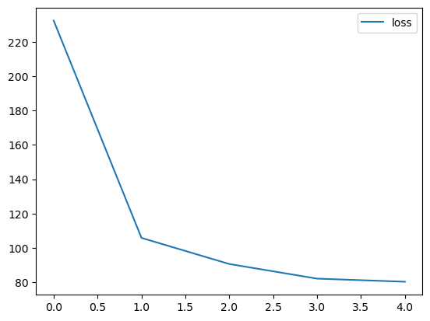

<Axes: >

**In [14]:**

y_dataset = test_dataset2['Returning.Visits']

y_dataset

**out [14]:**

Date

2020-01-16 441

2020-01-17 413

2020-01-18 246

2020-01-19 314

2020-01-20 443

...

2020-08-15 323

2020-08-16 351

2020-08-17 457

2020-08-18 499

2020-08-19 267

Name: Returning.Visits, Length: 217, dtype: int64

**In [15]:**

def evaluate_model_predictions(y_true, predictions, model_name):

metrics = evaluate_predictions(y_true, predictions)

MODEL_METRICS.loc[model_name] = metrics

plot_time_series(predictions.ravel(), start_index=1900)

return metrics

evaluate_model_predictions(y_dataset, model_3_preds, 'model_3 (multi-input)')

**out [15]:**

{'mae': 72.46600053497174,

'mse': 8797.218902262757,

'rmse': 93.79349072437147,

'mape': 0.15300125677432075}

: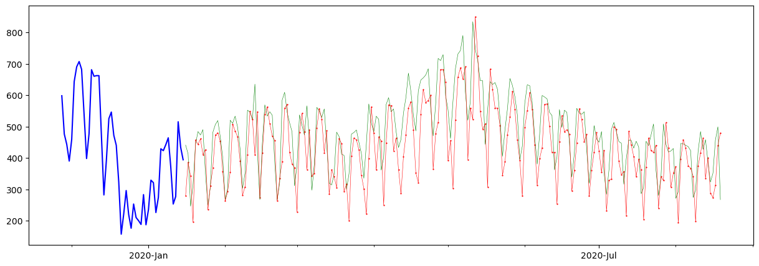

**CONCLUTION:**

In conclusion, website traffic is a crucial aspect of any online business. By investing in SEO, social media, content marketing, and paid advertising, businesses can attract more visitors to their website and increase brand awareness, lead generation, and search engine rankings.