CyberRange — Technical Capabilities Compliance Matrix
Red, Blue and Purple Team Training and Security Control Validation Platform
Version 1.0 | Scope: shipping capability of the current build. Roadmap items are marked explicitly and are not claimed as available today.
1. Cyber Range Classification (Mandatory Declaration)
The solution is offered as an EMULATION-class cyber range. A single class is declared deliberately, so that the scope of supply, the target estate to be built, and the price are unambiguous and comparable across bidders.
Range Class | Offered | Basis
Simulation | No (not as the delivered class) | A modelled environment emitting synthetic telemetry with no live systems under test. The solution includes a simulation adapter, but it is a declared degradation tier within the emulation range, not the delivered range class. See the note below.
Overlay | No | A range overlaid on the Purchaser live or production infrastructure. Explicitly excluded. The solution never attaches to, instruments, or executes against production assets. Every target is a disposable asset created and destroyed by the platform.
Emulation | Yes — this is the delivered class | Adversary behaviour is executed as genuine commands against real, purpose-built target systems inside an isolated range with no egress, capturing actual stdout, stderr, exit code and timing. Targets include a persistent victim host, a reachable web application and a real LDAP directory seeded with synthetic users.
Hybrid | No | A deliberate combination of two or more of the classes above delivered as co-equal scope. Not offered under this response. See the scope and pricing note below.
Note on the simulation adapter. Where a target platform is unavailable (for example the Windows modules, or any host on which the container execution tier is not present), the platform falls back to a simulation adapter that emits the telemetry the module declares it would produce, and every timeline event is labelled real or simulated so the fidelity of each record is explicit. This fallback is a resilience property of the emulation range. It is not a second range class, it is not separately scoped, and it does not make this response a hybrid submission.
Scope and pricing note. A requirement for a second range class delivered as co-equal scope — most commonly emulation combined with an overlay onto live Purchaser infrastructure — is a materially different engagement. It changes the target estate, the safety and authorisation model, the isolation boundary, and the assurance obligations. Such a requirement is treated as a separate scope of supply and is subject to separate pricing. It is not covered by, and must not be assumed to be included in, the price submitted against this matrix.
2. Technical Capabilities Compliance Matrix
The Architecture Reference column maps every requirement to the mandatory components of the reference architecture at Appendix A. A bidder claiming compliance is required to evidence the named components. Component references are given in the form used in Figure A-1 and Table A-1.
Sl No | Description | Bidder's Compliance (Yes/No) | Architecture Reference (Appendix A)
1 | Red, Blue and Purple Team Exercise Delivery  The solution MUST deliver red team, blue team and purple team training from a single platform, supporting red-blue collaborative exercises, solo guided exercises in which one learner runs both attacker and defender phases on a single timeline, and purple detection sprints, without requiring separate products, environments or licences. | Yes | H1, H2
2 | Real Adversary Execution, Not Scripted Transcripts  The solution MUST execute adversary behavior as genuine commands inside isolated targets, capturing actual stdout, stderr, exit code and timing as timeline telemetry rather than replaying pre-recorded transcripts. Execution containers MUST be network-isolated for atomic runs, capped for memory, CPU and process count, started with no-new-privileges, given no host mounts, removed on exit, and bounded by a per-module timeout of 60 to 600 seconds. | Yes | E2, T1
3 | Persistent, Connected Live Ranges  The solution MUST support persistent live ranges in which provisioning stands up a per-range internal network with no egress plus persistent hosts, so that a foothold established in one step survives into the next and behaviors traverse a connected environment rather than a series of disconnected atomic actions. Identity scenarios MUST stand up a real LDAP directory seeded with synthetic domain users to provide a genuine directory-enumeration attack surface (T1087). Range reset MUST recycle targets to a clean state while preserving the range and its network; destroy MUST remove all containers and the network. | Yes | E2, T1, T2, T3
4 | Graceful Degradation and Honest Fidelity Labelling  Where a container execution tier is unavailable, or where a module carries no execution specification, the solution MUST fall back to a simulated adapter that emits the declared telemetry rather than failing the exercise. Every timeline event MUST record and display which mode produced it, so an operator is never in doubt whether an event is real or simulated. | Yes | E2, E5
5 | Content Library Depth  The solution MUST ship with a populated content library comprising, in the current build, 10 launch scenarios (1 introductory, 5 intermediate, 4 advanced), 25 behavior modules of which 12 execute a genuine command inside an isolated container, 2 topology templates (five-VM enterprise range and container range), and guided lessons for all 10 scenarios. All behavior modules MUST be cryptographically signed, and unsigned modules MUST be refused at execution. | Yes | G3
6 | MITRE ATT&CK Alignment and Tactic Coverage  Scenario and module content MUST be mapped to MITRE ATT&CK, covering 22 techniques (T1003, T1005, T1018, T1021, T1041, T1053, T1059, T1070, T1071, T1078, T1087, T1190, T1204, T1486, T1548, T1552, T1560, T1566, T1595, T1610, T1611, T1613) across the full chain: Reconnaissance, Initial Access, Execution, Persistence, Privilege Escalation, Defense Evasion, Credential Access, Discovery, Lateral Movement, Collection, Command and Control, Exfiltration and Impact, plus container-specific Container Discovery and Escape-to-Host. | Yes | G2, G3
7 | Safety Classification of All Executable Content  Every module MUST carry an explicit safety class with a defined approval authority: S0 simulation (synthetic telemetry or benign endpoint call, scenario author), S1 atomic emulation (bounded behavior on disposable assets with auto-cleanup, security content reviewer), S2 high-impact lab action (may disrupt a lab VM or change identity state, admin plus explicit scenario policy), and Prohibited (self-propagation, external targeting, real credential theft and live malware, not executable by anyone). | Yes | G1, E1
8 | Automatic Detection Engine  The solution MUST evaluate versioned, Sigma-style detection rules against the exercise timeline automatically and without human input. The shipping build provides 15 rules, of which 12 are log-basis rules that regex-match real captured log lines and 3 are technique-basis rules covering simulated behaviors, at 8 high, 5 medium and 2 low severity. Each detection MUST record the rule that fired, the evidence line matched, the severity, and the latency from activity to verdict. Manual analyst verdicts MUST be supported in addition to, not in place of, the automatic baseline. | Yes | E4
9 | Defender-Side Redaction (Fog of War)  Blue analysts MUST work from a SIEM-style search console over the exercise log store with free-text matching across log line, source, actor and event kind, plus filters by source and kind. The defender view MUST be redacted at the query layer rather than by participant instruction: technique attribution, module identifiers, executed command lines, safety class and adapter metadata MUST be stripped, and the event source relabelled from attacker tooling to the affected asset. | Yes | H1, E5
10 | Synchronized Evidence Timeline with Integrity Hashing  All activity MUST land on one synchronized UTC timeline carrying integrity hashes and shared across roles, covering module execution, real process output, detections, instructor injects and analyst evidence submissions. Evidence MUST be lockable at exercise completion to provide an immutable record for after-action review or accreditation. | Yes | E5
11 | Real SIEM Integration  The solution MUST optionally support detection in a production SIEM rather than the built-in engine. A full Wazuh deployment (manager, indexer and dashboard) ships with the platform; with ingest enabled, every event is streamed as JSON to a file a Wazuh agent tails, the manager evaluates detection rules and raises genuine alerts, and a forwarder posts those alerts back onto the exercise timeline while they remain visible in the Wazuh dashboard. The telemetry contract MUST be normalized so that substituting Elastic, Sentinel, Splunk or an existing customer SOC stack is an adapter exercise rather than a redesign. Requires a Docker host with approximately 4 GB of RAM for the indexer. | Yes | E4, E5
12 | Explainable, Override-Audited Scoring  Scoring MUST be a weighted sum of five dimensions less safety and policy penalties: red execution 25%, detection 25%, investigation 20%, response 20%, collaboration 10%. The scoring response MUST return every dimension raw score, its weight and its contribution, alongside each penalty and each override. Every instructor override MUST be audited with a named instructor and a written justification. Dimension scores MUST also be derived directly from observed exercise activity so that a score exists before any human judgement is applied. | Yes | E5, E6
13 | Purple Replay Coverage Comparison  Purple exercises MUST be reported as a baseline-to-replay detection coverage delta, per technique and in aggregate, rather than as a win or loss outcome, so that the report answers whether a specific control improvement changed detection coverage for a given technique. | Yes | E4, H1
14 | After-Action Reporting and Export Formats  The solution MUST generate after-action reports covering technique coverage, detection gaps, evidence inventory and recommendations, exportable in JSON for machine ingestion and downstream analytics, CSV for spreadsheet analysis, HTML for sharing or print, and DOCX as a formal deliverable for management or accreditation. Class gradebooks MUST export to CSV separately. | Yes | E4, E5
15 | Role-Based Access Control  The solution MUST enforce role-based access control server-side on every API call across seven roles with explicit permission sets: admin (20 permissions, including user provisioning, image management, any lifecycle step, S2 execution, score override, audit ledger, emergency pause and kill, and sole authority to release a quarantined range), instructor (11), red, blue, purple and solo (8 each), and security_leader (5, read-only oversight). The live permission matrix MUST be served by the API and rendered inside the product. | Yes | H1, H2
16 | Authentication and Session Security  Passwords MUST be stored as PBKDF2-HMAC-SHA256 with a per-user random salt and never in plaintext. Login MUST issue an opaque random session token with a 12-hour time to live. Login failures MUST return a generic error whether the username is unknown, the password is wrong or the account is disabled, so that the endpoint does not enumerate accounts. Disabling a user MUST immediately revoke all live sessions. Unauthenticated API calls MUST be rejected, and any developer header-identity shortcut MUST be off by default. | Yes | H2
17 | Integrated Learning and Delivery Platform  The solution MUST deliver instruction inside the product without requiring an external learning management system. Instructors MUST be able to create classes and bulk-enrol students from CSV, with missing accounts created as learners and generated passwords returned for distribution; assign any scenario carrying a lesson to a class; and track per-student status and score, with class completion and average score exportable as CSV for accreditation evidence. | Yes | G3, H1, H2
18 | Guided Lessons with Auto-Graded Assessment  Every scenario MUST carry a guided lesson comprising a briefing, key concepts, ordered hands-on steps that run a real or simulated module on the learner's own auto-provisioned range with explicit guidance on what to watch for, and an auto-graded knowledge check with explanations. The platform MUST run curated S2 steps on the learner's behalf so that students receive the full experience without holding S2 authority themselves. | Yes | G3, H1, E3
19 | Framework Crosswalks for Curriculum and Accreditation  Techniques used in the platform MUST be crosswalked to NIST Cybersecurity Framework 2.0 (Govern, Identify, Protect, Detect, Respond, Recover), the NICE Workforce Framework (NIST SP 800-181r1 work roles), CIS Critical Security Controls version 8, and NSA/DHS CAE-CD Knowledge Units, and served through the API for curriculum mapping and accreditation evidence. This is a curated, indicative alignment for curriculum purposes rather than an official MITRE mapping dataset, and is presented as such in the product. | Yes | G2
20 | Safety Enforcement in the Service Layer  Safety controls MUST be enforced in code rather than documented as policy. Unsigned modules MUST be refused at execution; the Prohibited class MUST NOT be executable by any role including admin; S2 execution MUST be gated to instructor and admin except for curated S2 steps run on a learner's behalf within a guided lesson; ranges MUST default to egress-deny with the control plane placed on a network never reachable from tenant workloads; and any anomalous workload MUST transition to QUARANTINED, releasable or destroyable only by an administrator. | Yes | G1, E1, E3
21 | Range Lifecycle State Machine  Range state MUST be governed by an enforced state machine (REQUESTED, PREFLIGHT, PROVISIONING, SEEDING, READY, RUNNING, PAUSED, COMPLETING, EVIDENCE_LOCKED, ARCHIVED, DESTROYED, with a QUARANTINED branch under administrator-only release). Illegal transitions MUST be rejected with a conflict response rather than silently tolerated. | Yes | H2
22 | Append-Only Audit Ledger  Every state change MUST be written to an append-only audit ledger readable by administrators, providing an auditable trail of platform activity for governance and accreditation review. | Yes | E6
23 | Deployment Flexibility  The solution MUST offer multiple deployment options: local execution (Python 3.10 or later, no package install and no build step), Docker Compose as a single service on port 8080, hosted deployment via Dockerfile with managed TLS, and customer-hosted deployment on any Docker host, which is recommended where real container execution is required. Real container execution requires a reachable Docker daemon, local or remote; a hosted platform providing no Docker daemon inside the application container will fall back to simulation with technique-basis detection, while lifecycle, scoring, reporting, learning platform and audit ledger continue to operate normally. | Yes | H2, T1
24 | Data Residency and Persistence Options  The solution MUST support on-premises and private-infrastructure deployment to satisfy data-residency requirements. Persistence MUST sit behind a single interface: SQLite by default with zero configuration, switching to PostgreSQL or Supabase by setting a connection string with no code change. Tables MUST be created on boot, and a standalone schema file MUST be provided for customers who prefer to provision the schema and apply row-level security in advance. The same code MUST be verified against real PostgreSQL in the automated test suite. | Yes | H2, E5
25 | Complete Programmatic API Surface  A complete REST and JSON API MUST sit under /api with bearer-token authentication, exposing everything the dashboard does, across authentication and users, catalog, ranges, exercises, SOC and blue team log access, evidence and detection, scoring, reporting, purple replay, learning, SIEM and admin. Errors MUST be structured with meaningful status codes (400, 401, 403, 404, 409 for illegal lifecycle transition, and 500), and catalog queries MUST support filtering by role, tactic, difficulty, technique, platform, safety class and free text. | Yes | H2
26 | Quality Assurance and Verifiable Build  The solution MUST ship with an automated test suite. The current build carries 132 tests covering the API surface, catalog, database layer including PostgreSQL migration, detection engine, execution adapters, framework crosswalks, learning platform, lifecycle state machine, log search and redaction, provisioning, reporting formats, scoring, service orchestration, SIEM integration and user management. The suite MUST run against the standard library with no external services required, with Docker and PostgreSQL dependent tests skipping cleanly when unavailable. | Yes | All layers
27 | Hypervisor Provisioning (KVM, Proxmox, VMware)  Full virtual-machine targets provisioned through a hypervisor. The integration seam is defined via topology templates and the execution adapter interface already present in the product; the adapter itself is on the delivery roadmap and is not part of the shipping container tier. | No — Roadmap | Outside Appendix A scope
28 | Real Windows Endpoints and Active Directory Domain  Real Windows endpoints and a genuine Active Directory domain (Kerberos, SMB, Group Policy) require the virtual machine tier above and are operator-hosted. The shipping build provides a Linux identity stand-in using a real LDAP directory, which is described as such in the product and is not presented as a Windows domain controller. On the delivery roadmap. | No — Roadmap | Outside Appendix A scope
29 | Kernel-Level Runtime Sensing and Network Intrusion Detection  Kernel-level runtime sensors and network intrusion detection feeds. The telemetry contract is defined; sensor integration is on the delivery roadmap. | No — Roadmap | Outside Appendix A scope
30 | SSO and OIDC Identity Integration  Enterprise single sign-on and OIDC in place of local login. The RBAC layer is already isolated from the identity layer, so this is an identity swap rather than a permissions redesign, but it is on the delivery roadmap and does not ship today. | No — Roadmap | Outside Appendix A scope
31 | Kubernetes-Managed Hypervisor Pools and Cloud-Hosted Ranges  Elastic, Kubernetes-managed hypervisor pools and multi-tenant cloud-hosted ranges. The control plane is designed to scale to this; the capability is on the delivery roadmap. | No — Roadmap | Outside Appendix A scope
All counts and capabilities stated above were verified directly against the platform content catalog, API surface and automated test suite at the time of writing. Items marked "No — Roadmap" are documented integration seams rather than shipping capability, and are listed so that scope is unambiguous.

Appendix A — Reference Architecture (Mandatory Conformance)
This appendix defines the mandatory functional decomposition of the solution. It is issued as part of the requirement, not as descriptive material. Every requirement in the compliance matrix carries an Architecture Reference to the components below, and a bidder claiming compliance against a requirement is required to evidence each referenced component.
Conformance rule. The four layers of Figure A-1 are mandatory and must be supplied as one integrated platform by a single supplier. A response that omits a layer, that sources a layer from a third-party product the bidder does not control, or that satisfies a layer by manual process or documented policy in place of enforcement in the product, does not meet this requirement. In particular, the guardrail layer (E1 to E6) must be enforced in the execution path itself, so that a non-compliant action is prevented rather than merely recorded.
Figure A-1 — CyberRange emulation-class reference architecture
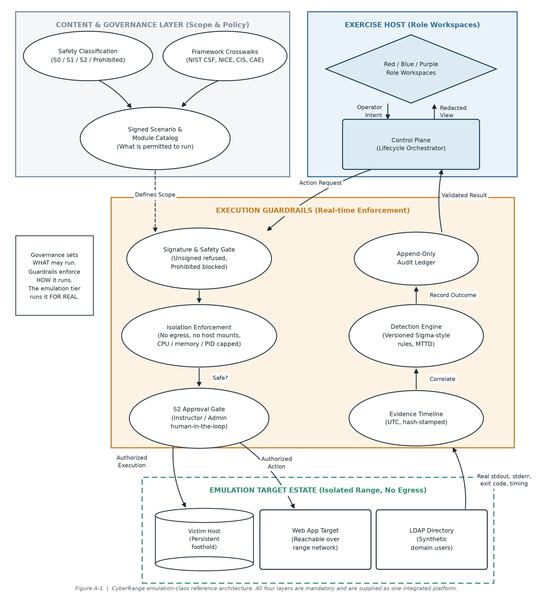
Table A-1 — Mandatory architecture components
Ref | Layer | Component | Mandatory function
G1 | Content & Governance | Safety Classification | Every executable item carries S0, S1, S2 or Prohibited with a named approval authority.
G2 | Content & Governance | Framework Crosswalks | Technique-level mapping to NIST CSF 2.0, NICE, CIS v8 and CAE-CD for curriculum and accreditation evidence.
G3 | Content & Governance | Signed Scenario & Module Catalog | The authoritative record of what is permitted to run. Unsigned content is not executable.
H1 | Exercise Host | Red / Blue / Purple Role Workspaces | Role-separated workspaces, including the redacted defender view (fog of war).
H2 | Exercise Host | Control Plane (Lifecycle Orchestrator) | Enforced range lifecycle state machine, RBAC, authentication and the programmatic API.
E1 | Execution Guardrails | Signature & Safety Gate | Refuses unsigned modules and blocks the Prohibited class for every role including administrators.
E2 | Execution Guardrails | Isolation Enforcement | No egress, no host mounts, CPU, memory and process-count caps, and bounded per-module timeouts.
E3 | Execution Guardrails | S2 Approval Gate | Human-in-the-loop authorisation for high-impact lab actions, restricted to instructor and administrator.
E4 | Execution Guardrails | Detection Engine | Versioned rules evaluated automatically against captured telemetry, recording the rule, matched evidence, severity and detection latency.
E5 | Execution Guardrails | Evidence Timeline | One synchronized UTC timeline carrying integrity hashes, lockable at exercise completion.
E6 | Execution Guardrails | Append-Only Audit Ledger | Immutable record of every state change, including score overrides and quarantine release.
T1 | Emulation Target Estate | Victim Host | Persistent target on which a foothold established in one step survives into the next.
T2 | Emulation Target Estate | Web App Target | Reachable over the range network so behaviours traverse a connected environment.
T3 | Emulation Target Estate | LDAP Directory | Real directory seeded with synthetic domain users, providing a genuine identity attack surface.
Evaluation note. Bidders are required to submit a completed copy of Table A-1 identifying, for each component, the module or subsystem of their solution that performs the stated function, together with the evidence by which it can be demonstrated in a technical evaluation. A component evidenced only by roadmap commitment is recorded as non-compliant for that row.

