AIML SUMMER INTERNSHIP 2026
IIHMF, MNNIT Allahabad, Prayagraj

STUDENT PERFORMANCE
PREDICTION SYSTEM
A Capstone Project Report Submitted for the AIML Summer Internship Program

Submitted by
Sundram Pandey (Team Leader)
Swastik Shukla
Under the Guidance of
Mr. Subhas Chaganti
July 2026

Certificate
This is to certify that the capstone project report entitled “Student Performance Prediction System” is a bona fide record of work carried out by Sundram Pandey (Team Leader) and Swastik Shukla, submitted in fulfilment of the requirements of the AIML Summer Internship 2026 conducted by IIHMF, MNNIT Allahabad, Prayagraj.
The work presented in this report has been carried out under my supervision and guidance. To the best of my knowledge, the work reported here does not form part of any other project report or dissertation on the basis of which a degree or award was conferred on an earlier occasion.

Mr. Subhas Chaganti
Project Guide
AIML Summer Internship 2026, IIHMF, MNNIT Allahabad

Declaration
We, Sundram Pandey and Swastik Shukla, hereby declare that the capstone project entitled “Student Performance Prediction System”, submitted as part of the AIML Summer Internship 2026 at IIHMF, MNNIT Allahabad, Prayagraj, is our own original work carried out under the guidance of Mr. Subhas Chaganti.
We further declare that this project, or any part of it, has not been submitted elsewhere for the award of any degree, diploma, or certificate, and that all sources of information used have been duly acknowledged in the references section of this report.

Sundram Pandey
Team Leader
Swastik Shukla
Team Member

Acknowledgement
We would like to express our sincere gratitude to our project guide, Mr. Subhas Chaganti, for his invaluable guidance, continuous encouragement, and constructive feedback throughout the course of this project. His insights into machine learning practices and structured mentorship were instrumental in shaping this work.
We are also thankful to IIHMF, MNNIT Allahabad, Prayagraj, for organising the AIML Summer Internship 2026 and providing us with the opportunity, resources, and learning environment necessary to undertake this capstone project.
Finally, we extend our appreciation to our peers and family for their steady support and motivation throughout this internship.

Abstract
Academic performance is influenced by a complex interplay of demographic, social, and academic factors, and identifying at-risk students early remains a persistent challenge for educational institutions. This project presents a machine learning-based Student Performance Prediction System that estimates a student's final grade (G3) using academic indicators, study habits, and prior performance.
The system was built using the UCI/Kaggle “Student Performance” dataset (Portuguese language course), comprising 649 student records and 33 attributes collected from two Portuguese secondary schools. Following a complete data science pipeline—data cleaning, exploratory data analysis, feature engineering, and model development—three regression models were trained and compared: Linear Regression, Random Forest Regressor, and XGBoost Regressor.
Model performance was evaluated using Mean Absolute Error (MAE), Mean Squared Error (MSE), Root Mean Squared Error (RMSE), and the R² score. Linear Regression achieved the strongest generalisation on the held-out test set, with an R² score of 0.863, and was selected for deployment. The final model was deployed as an interactive Streamlit web application that accepts live student information and returns a predicted final grade along with performance recommendations, demonstrating a complete, end-to-end machine learning workflow from raw data to a usable prediction tool.

Keywords: Student Performance Prediction, Machine Learning, Regression, Educational Data Mining, Linear Regression, Random Forest, XGBoost, Streamlit.

Table of Contents

Chapter 1: Introduction

1.1 Background
Educational institutions increasingly rely on data to understand and improve student outcomes. As students progress through a course, they generate a rich trail of information—attendance, assignment scores, study habits, and internal assessments—that reflects far more than any single exam result. Educational Data Mining (EDM) and Learning Analytics have emerged as fields dedicated to extracting meaningful patterns from this data, enabling institutions to move from reactive grading to proactive academic support.
Machine Learning (ML), in particular, offers a powerful set of tools for this purpose. Regression-based ML models can learn the relationship between a student's academic and behavioural indicators and their eventual performance, producing predictions that are both data-driven and reproducible. This project applies that idea directly: it builds a regression pipeline that predicts a student's final grade using real academic records, following the complete machine learning lifecycle from raw data to a deployed, interactive application.
The work was carried out as the Capstone Project for the AIML Summer Internship 2026 at IIHMF, MNNIT Allahabad, Prayagraj, and corresponds to Project 1 (Student Performance Prediction System) of the available project topics.

1.2 Problem Statement
Academic performance is shaped by a wide mix of factors—attendance, study habits, family background, and prior grades—making early, manual identification of at-risk students slow and inconsistent. Teachers and academic mentors often rely on informal judgment or end-of-term results to identify students who need additional support, by which point meaningful intervention windows may already have closed.
There is, therefore, a need for a systematic, data-driven approach that can estimate a student's likely final performance well before the final assessment, using information that is already available earlier in the academic term. This project addresses that need by formulating student performance prediction as a supervised regression problem: given a student's demographic, academic, and behavioural attributes, predict their final grade (G3) on a 0–20 scale.

1.3 Objectives
The specific objectives of this project are to:
- Understand the data: explore the academic, demographic, and behavioural attributes that influence student outcomes in the chosen dataset.
- Clean and prepare the data: handle missing values, encode categorical fields, and engineer meaningful features suitable for regression modelling.
- Build predictive models: train and compare multiple regression algorithms to estimate the final grade (G3) of a student.
- Evaluate rigorously: assess each model using standard regression metrics (MAE, MSE, RMSE, R²) on a held-out test set to identify the best-performing approach.
- Deploy for real use: package the selected model as an interactive Streamlit web application that accepts live input and returns a prediction with actionable feedback.

Chapter 2: Literature Review

2.1 Existing Approaches
Early approaches to predicting student performance relied largely on statistical techniques such as multiple linear regression and correlation analysis applied to grade histories and demographic records. While straightforward to interpret, these methods struggled to capture non-linear interactions between the many factors that influence a student's outcome, such as the combined effect of study time, family support, and past failures.
The rise of data mining and machine learning introduced more flexible techniques—decision trees, support vector machines (SVM), neural networks, and ensemble methods—into educational analytics. These approaches are generally grouped into two task formulations: classification, where the goal is to predict a discrete outcome such as pass/fail or a grade band, and regression, where the goal is to predict a continuous grade value, as adopted in this project.
A recurring theme in this literature is the strong predictive value of a student's own prior performance. Early-period grades tend to explain a large share of the variance in the final grade, since they already encode the combined effect of ability, effort, and circumstance. Consequently, many practical systems deliberately include first- and second-period grades as model inputs, using demographic and behavioural attributes to refine the prediction rather than to carry the entire predictive burden.

2.2 Research Studies
The dataset used in this project originates from the study by Cortez and Silva (2008), who collected academic, demographic, and social data from two Portuguese secondary schools using school reports and student questionnaires, and used it to model student achievement in Mathematics and Portuguese language courses with data mining techniques. Their work, and subsequent studies built on the same dataset, consistently report that models incorporating prior grades (G1, G2) alongside behavioural attributes such as study time and past failures achieve substantially better predictive accuracy than models based on demographic factors alone.
Kotsiantis, Pierrakeas, and Pintelas (2004) examined the use of machine learning techniques—including decision trees, neural networks, and Naive Bayes—for predicting student performance in distance learning settings, finding that ensemble and rule-based methods could reliably flag students at risk of underperforming well before course completion. More recent work has extended this line of research toward deep learning architectures combined with explainability techniques such as SHAP and LIME, aiming to balance high predictive accuracy with the transparent, auditable reasoning that educators and institutions require before acting on a model's output.
Across this body of research, a consistent conclusion emerges: simple, interpretable models such as linear regression often perform competitively with more complex ensemble methods on structured educational datasets of this scale, particularly when strong predictors like prior grades are available—a finding that is echoed in the comparative results obtained in this project (see Chapter 5).

Chapter 3: Methodology
This project follows the standard machine learning lifecycle—problem understanding, data collection, preprocessing, exploratory data analysis, feature engineering, model building, evaluation, and deployment—ensuring that every stage of the pipeline is grounded in the actual dataset and reproducible from the accompanying source code.

3.1 Dataset Description
The project uses the UCI / Kaggle “Student Performance” dataset (Portuguese language course subset), which contains real records from two Portuguese secondary schools. The dataset combines academic, demographic, and social attributes for each student.
Source | UCI Machine Learning Repository / Kaggle (Cortez & Silva, 2008)
Subject | Portuguese language course (student-por.csv)
Number of records | 649 students
Number of attributes | 33 (demographic, social, and academic)
Target variable | G3 — final grade, scale 0–20
Missing values | None (0 across all 33 attributes)
Duplicate records | None

The 33 attributes fall broadly into three categories:
- Academic attributes: studytime, failures, absences, and period grades G1, G2, G3.
- Demographic attributes: age, sex, address (urban/rural), family size, parents' education (Medu, Fedu) and occupation (Mjob, Fjob).
- Social attributes: internet access at home, participation in extracurricular activities, family relationship quality, free time, and alcohol consumption (workday and weekend).

3.2 Data Preprocessing
Before modelling, the raw dataset was checked and prepared using the following steps:
- Missing value check: all 33 columns were verified for null values using df.isnull().sum(); none were found, so no imputation was required.
- Duplicate removal: the dataset was checked for duplicate rows to prevent data leakage between the training and test sets; none were found.
- Categorical encoding: binary and categorical fields relevant to the modelling features (e.g., higher, internet) were label-encoded into numeric form using scikit-learn's LabelEncoder, so they could be consumed by the regression algorithms.
- Feature selection: eight features were retained for the final modelling pipeline—age, studytime, failures, absences, G1, G2, higher, and internet—balancing predictive strength with the practical constraint of keeping the deployed application's input form short and usable.
- Train–test split: the processed data was split into training and test sets in an 80:20 ratio (519 training records, 130 test records) using a fixed random_state of 42 for reproducibility.

3.3 Algorithms Used
Three supervised regression algorithms were selected for comparison, chosen to span a range of model complexity from a simple linear baseline to non-linear ensemble methods:

3.3.1 Linear Regression
Linear Regression models the final grade as a weighted linear combination of the input features. It is fast to train, easy to interpret through its coefficients, and serves as a baseline against which more complex models are compared.

3.3.2 Random Forest Regressor
Random Forest is an ensemble method that builds many decision trees on bootstrapped subsets of the training data and averages their predictions. It can capture non-linear relationships and feature interactions that a purely linear model cannot, at the cost of reduced interpretability.

3.3.3 XGBoost Regressor
XGBoost (Extreme Gradient Boosting) builds an ensemble of decision trees sequentially, with each new tree correcting the errors of the previous ones. It is widely used in applied machine learning for its strong performance on structured, tabular data.

Chapter 4: Implementation
This chapter describes the practical implementation of the project, covering exploratory data analysis, feature engineering decisions, and the model development process, all carried out in a Google Colab notebook (Student_Performance_Prediction.ipynb).

4.1 Exploratory Data Analysis (EDA)
Exploratory Data Analysis was performed to understand the distribution of individual attributes and the relationships between them before any modelling was attempted. This included univariate analysis of grades, absences, and study time; bivariate analysis between the period grades (G1, G2) and the final grade (G3); and a full correlation analysis across all numeric features, visualised using a heatmap.
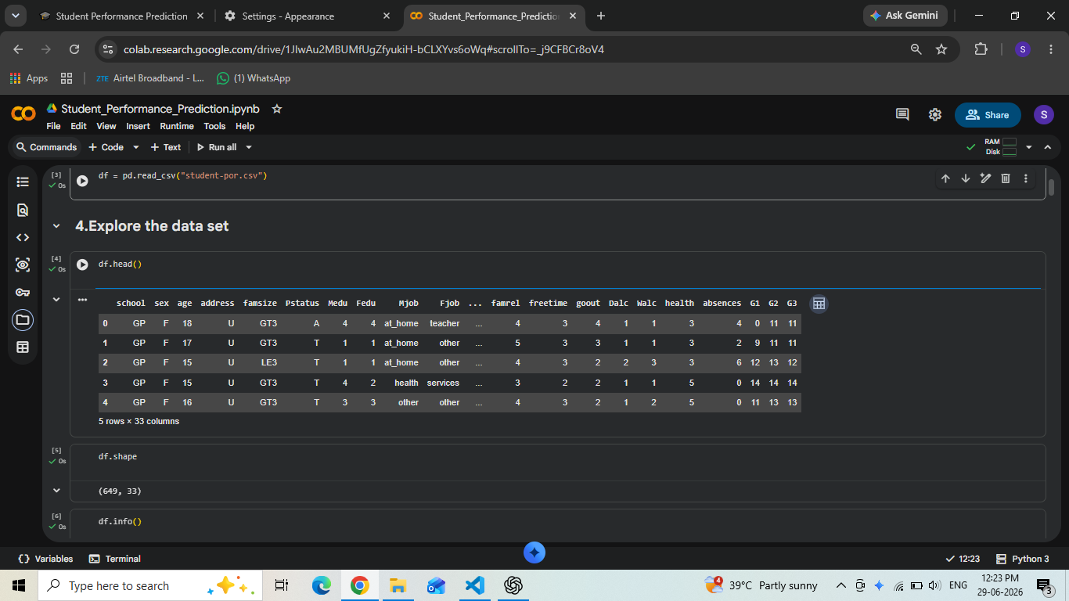
Figure 4.1: Notebook view showing initial dataset exploration (df.head(), df.shape, df.info()).
The correlation analysis (Figure 4.2) confirmed the pattern reported in the source literature: the final grade G3 is very strongly correlated with the second-period grade G2 (r = 0.92) and the first-period grade G1 (r = 0.83). Among the remaining attributes, number of past failures showed the strongest negative correlation with G3 (r = −0.39), followed by workday alcohol consumption (r = −0.20) and weekend alcohol consumption (r = −0.18). Study time showed a modest positive correlation with G3 (r = 0.25), as did mother's and father's education level (r = 0.24 and 0.21 respectively).
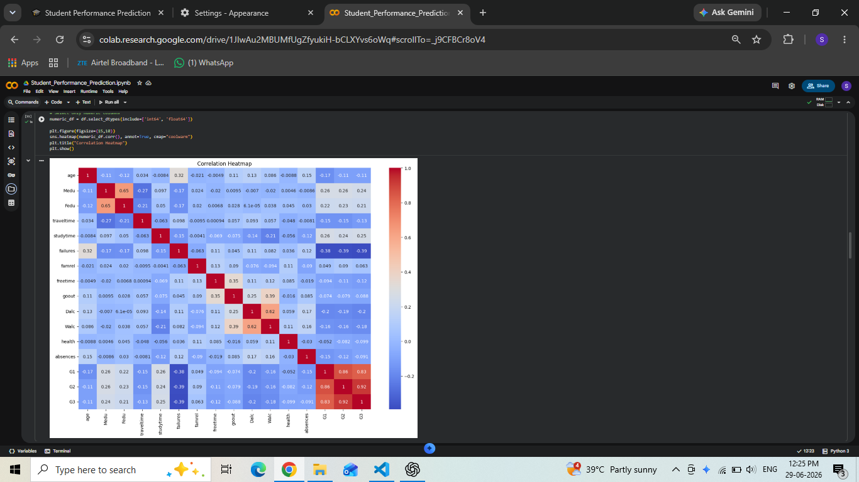
Figure 4.2: Correlation heatmap across all numeric features in the dataset.
Boxplot analysis (Figure 4.3) was used to inspect the spread and identify potential outliers in key numeric attributes, particularly absences and failures, both of which showed right-skewed distributions with a small number of students having unusually high absence counts.
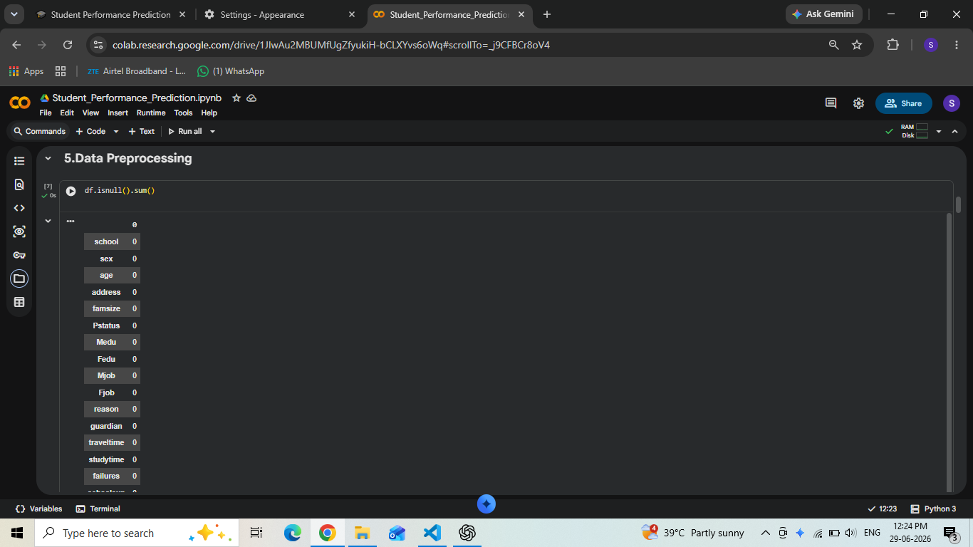
Figure 4.3: Boxplot analysis used to examine outliers in behavioural and academic attributes.

4.2 Feature Engineering
Based on the correlation analysis and practical considerations around building a usable prediction application, eight features were selected for the final model: age, studytime, failures, absences, G1, G2, higher (whether the student aspires to higher education), and internet (whether the student has internet access at home). This selection deliberately balances two goals: retaining the features with the strongest statistical relationship to the final grade (G1, G2, failures, studytime), while keeping the set small enough that the deployed application's input form remains quick and simple for an end user to fill in.
The two categorical fields in this feature set, higher and internet, were label-encoded into binary numeric values (0/1) using scikit-learn's LabelEncoder, and the fitted encoders were saved alongside the trained model so that the same encoding could be applied consistently to new input at prediction time.

4.3 Model Development
With the feature set finalised, the data was split into training and test sets (519 and 130 records respectively, an 80:20 split with random_state=42), and three regression models were trained on the identical training data and feature set to ensure a fair comparison: Linear Regression, Random Forest Regressor, and XGBoost Regressor.
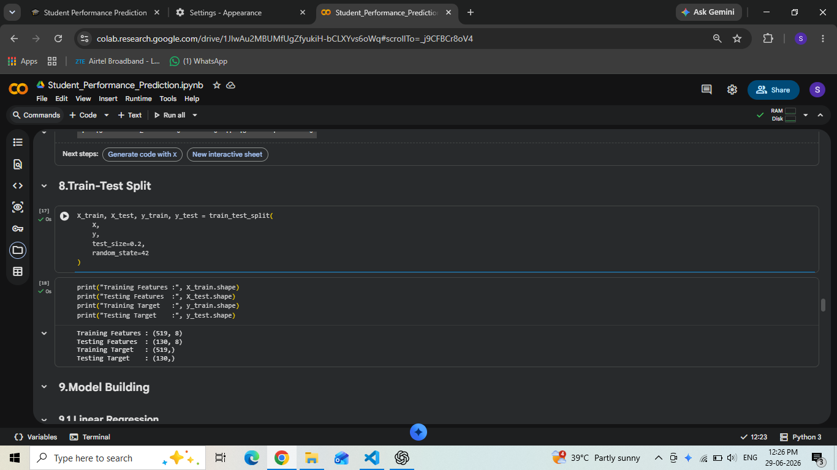
Figure 4.4: Train–test split configuration and confirmation of resulting shapes (519 train / 130 test).
Each model was trained using its default or lightly tuned hyperparameters (200 estimators for the ensemble methods) and evaluated on the same held-out test set using four standard regression metrics, described and compared in detail in Chapter 5.

Chapter 5: Results and Discussion

5.1 Performance Metrics
Four complementary metrics were used to evaluate each regression model on the 130-record test set:
- MAE (Mean Absolute Error): the average absolute difference between predicted and actual grades, in the same units as G3 (0–20 scale).
- MSE (Mean Squared Error): the average squared difference between predicted and actual grades, penalising larger errors more heavily.
- RMSE (Root Mean Squared Error): the square root of MSE, expressed in the original grade units for easier interpretation.
- R² Score: the proportion of variance in the final grade explained by the model, where 1.0 indicates a perfect fit.
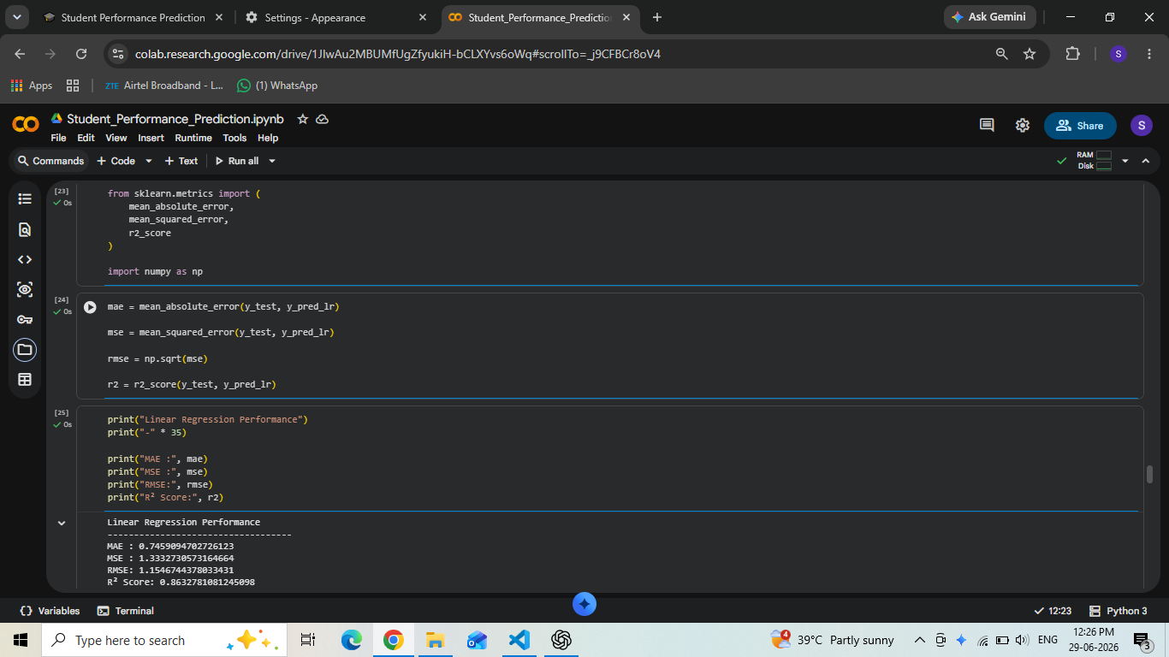
Figure 5.1: Notebook output showing evaluation metrics computed for the Linear Regression model.

5.2 Comparative Analysis
The table below summarises the performance of all three models on the identical held-out test set (130 students), using the same eight-feature input pipeline described in Chapter 4.

Model | MAE | MSE | RMSE | R² Score
Linear Regression | 0.746 | 1.333 | 1.155 | 0.863
Random Forest Regressor | 0.751 | 1.549 | 1.245 | 0.841
XGBoost Regressor | 0.806 | 1.797 | 1.341 | 0.816

Contrary to the common assumption that ensemble methods always outperform simpler linear models, Linear Regression achieved the best results across every metric on this dataset, with the lowest error (MAE 0.746, RMSE 1.155) and the highest R² score (0.863). Random Forest was a close second, while XGBoost showed comparatively higher error, likely reflecting mild overfitting on a dataset of this size (519 training records).
This result is consistent with the observation made in Chapter 2: when a small set of strongly linear predictors is available—here, the prior grades G1 and G2 dominate the relationship with G3—a simple linear model can match or exceed more complex ensemble methods, while remaining faster to train, easier to interpret, and cheaper to deploy. For this reason, Linear Regression was selected as the final model for deployment in the Streamlit application described below.
An R² score of 0.863 indicates that the model explains roughly 86% of the variance in students' final grades using only eight readily available inputs, with a typical prediction error (MAE) of under 0.75 grade points on a 0–20 scale—a strong result for a lightweight, interpretable model suitable for real-time deployment.

5.3 Deployment and Demonstration
The selected Linear Regression model was deployed as an interactive Streamlit web application. The interface accepts a student's age, study time, past failures, absences, first- and second-period grades, higher education aspiration, and internet access, and returns a predicted final grade along with a qualitative performance category and tailored recommendations.
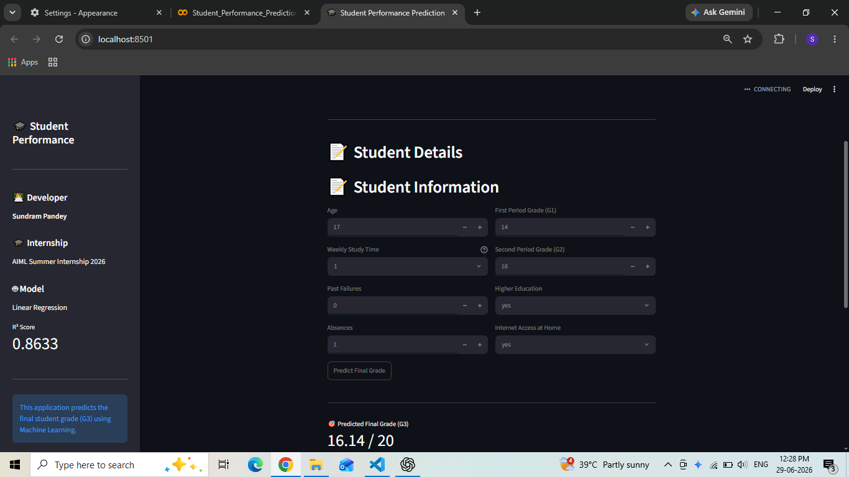
Figure 5.2: Streamlit application — student information input form.
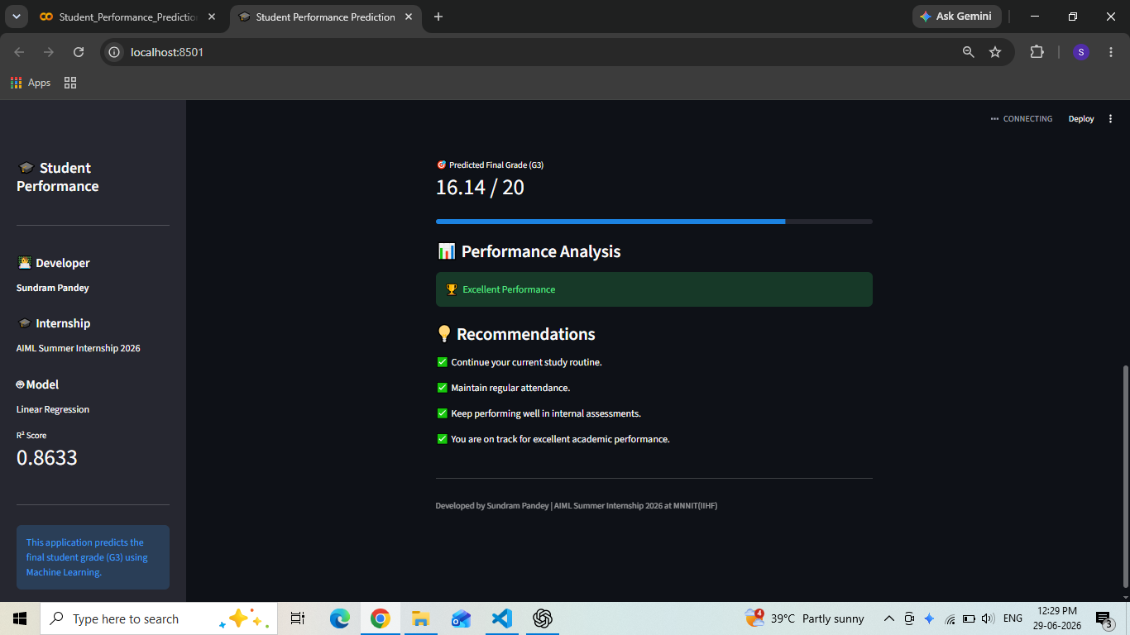
Figure 5.3: Streamlit application — predicted final grade with performance analysis and recommendations.
In the sample run shown above, a student with a first-period grade of 14 and second-period grade of 16, one week of study time, no past failures, and one absence receives a predicted final grade of 16.14 out of 20, categorised as “Excellent Performance,” along with recommendations to maintain their current study routine and attendance. This demonstrates the complete pipeline functioning end-to-end, from raw input to an actionable, human-readable prediction.

Chapter 6: Conclusion and Future Scope

6.1 Conclusion
This project successfully demonstrates a complete, end-to-end machine learning pipeline for predicting student academic performance, from raw educational records to a deployed, interactive prediction tool. Working with the UCI/Kaggle Student Performance dataset (649 records, 33 attributes), the project followed the full machine learning lifecycle: problem understanding, data preprocessing, exploratory data analysis, feature engineering, model development, evaluation, and deployment.
Three regression models—Linear Regression, Random Forest, and XGBoost—were trained and rigorously compared using MAE, MSE, RMSE, and R² on an identical test set. Linear Regression emerged as the strongest and most practical choice, achieving an R² score of 0.863 while remaining simple, fast, and interpretable. The final model was deployed as a live Streamlit application that predicts a student's final grade from readily available academic and behavioural inputs and offers actionable feedback, fulfilling the project's core objective of enabling early, data-driven identification of student performance trends.

6.2 Future Scope
- Larger and more diverse datasets: extending the pipeline to multi-school and multi-year data would improve generalisability beyond the two Portuguese schools represented in the current dataset.
- Deep learning approaches: exploring neural network architectures could capture richer, non-linear feature interactions, particularly if combined with explainability techniques such as SHAP or LIME to preserve interpretability.
- Real-time teacher dashboards: building a dashboard that surfaces at-risk students to teachers and academic mentors in real time, rather than relying on individual predictions.
- Personalised interventions: extending the system to recommend individualised study strategies or support resources based on each student's specific predicted risk factors, rather than a single overall grade prediction.
- Additional data modalities: incorporating attendance logs, assignment submission timestamps, or LMS engagement data could further improve predictive accuracy beyond the survey-based attributes used in this project.

References
1. Cortez, P., & Silva, A. (2008). Using Data Mining to Predict Secondary School Student Performance. In A. Brito & J. Teixeira (Eds.), Proceedings of the 5th Annual Future Business Technology Conference (FUBUTEC 2008), Porto, Portugal, pp. 5–12.
2. Kotsiantis, S., Pierrakeas, C., & Pintelas, P. (2004). Predicting Students' Performance in Distance Learning Using Machine Learning Techniques. Applied Artificial Intelligence, 18(5), 411–426.
3. UCI Machine Learning Repository. Student Performance Data Set. Retrieved from https://archive.ics.uci.edu/dataset/320/student+performance
4. Pedregosa, F., et al. (2011). Scikit-learn: Machine Learning in Python. Journal of Machine Learning Research, 12, 2825–2830.
5. Chen, T., & Guestrin, C. (2016). XGBoost: A Scalable Tree Boosting System. In Proceedings of the 22nd ACM SIGKDD International Conference on Knowledge Discovery and Data Mining, pp. 785–794.
6. Streamlit Inc. Streamlit Documentation. Retrieved from https://docs.streamlit.io
7. AIML Summer Internship 2026 — Capstone Project Guidelines and Submission Instructions, IIHMF, MNNIT Allahabad, Prayagraj.

