SOFTWARE ENGINEERING LAB
Experiment No. 4: Project-Based Data Flow Diagram (DFD)
Online Quiz System
Name | Akshay kumar | Roll No. | 20251651012
Class/Section | MCA | Date | 3sept 2026

3. Your Project Details
Project Title | Online Quiz System
One-line purpose of the project | To conduct online quizzes, evaluate submitted answers, and provide results to students and authorized staff.
Main users/external systems | Student; Teacher/Quiz Admin
Three to six major functions | User authentication; Quiz/question management; Quiz attempt; Answer evaluation; Result generation/reporting.
Earlier project document used (requirements/use case, if available) | Online Quiz System requirements and use-case design prepared for the project.

4. Before Drawing the DFD
Look at your project requirements/use cases. Write only the items that really belong to your project.
S. No. | External Entity | Data sent to system | Data received from system
1 | Student | Registration/login details; quiz request; selected answers; submission | Login status; available quiz; questions; submission confirmation; score/result
2 | Teacher / Quiz Admin | Quiz details; questions/options; correct answers; quiz updates | Quiz confirmation; quiz status; student performance/results report
- | - | - | -
- | - | - | -
- | - | - | -

5. Major Processes of Your Project
Process No. | Process Name | What does this process do?
1.0 | Manage User Accounts | Register users, authenticate login details, and maintain user information.
2.0 | Manage Quizzes & Questions | Create, update, publish and store quizzes, questions, options and correct answers.
3.0 | Conduct Quiz | Provide available quiz questions, receive student answers, and record quiz submission.
4.0 | Evaluate Quiz | Compare submitted answers with stored correct answers and calculate the score.
5.0 | Generate Results | Store and display scores and prepare performance information for authorized staff.
- | - | -

6. Data Stores
Write the important places where your project stores data.
Data Store | Name | What data is stored?
D1 | User Data | Student and teacher/admin account details and login information.
D2 | Quiz & Question Data | Quiz details, questions, options, correct answers, and quiz status.
D3 | Attempt Data | Student quiz attempts, selected answers, submission details, and timestamps.
D4 | Result Data | Scores, evaluation status, and student performance/results.

7. Context Diagram
Draw the whole project as ONE process. Show the main external entities and major input/output data. Do not show internal processes or data stores here.
Context Diagram:
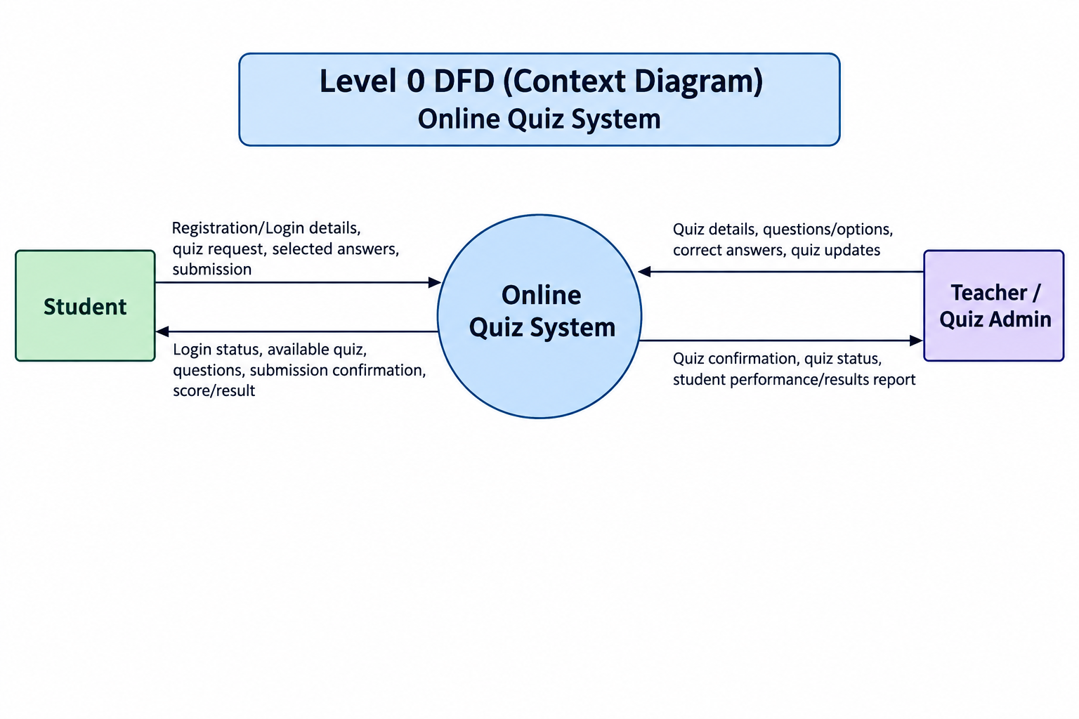

8. Level 0 DFD
Break your project into its major processes. Add required data stores and connect everything using labelled data arrows.
Level 0 DFD:
│ STUDENT │
│ Login / Answers / Quiz Reques
▼
│ ONLINE QUIZ SYSTEM │
│ Score / Quiz / Result
▼
STUDENT

│ ADMIN (Entity) │
│
│ Quiz / Questions / Management Data
│
▼
│ ONLINE QUIZ SYSTEM │
│
│ Reports / Results
▼

ADMIN

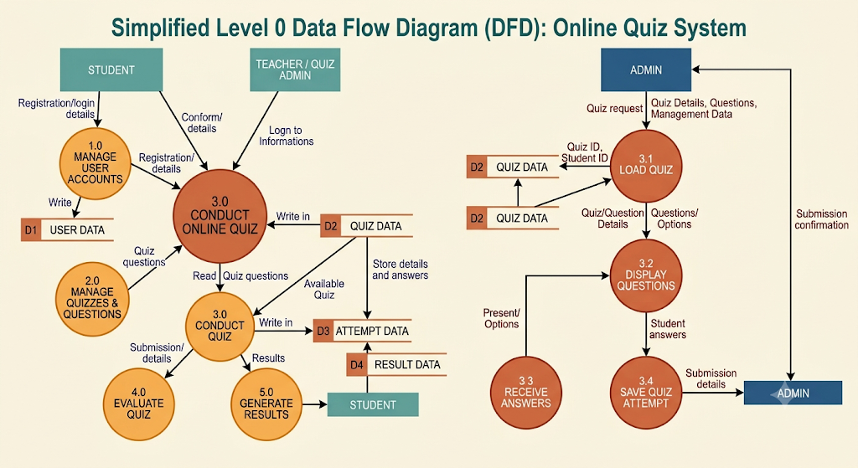9. Level 1 DFD
Choose ONE process from your Level 0 DFD and break it into smaller steps.
Selected Level 0 Process | 3.0 Conduct Quiz
Why did you select it? | It is the main interaction between the student and the system during a quiz, including loading questions, receiving answers and saving the submission.
Smaller sub-processes | 3.1 Load Quiz; 3.2 Display Questions; 3.3 Receive Answers; 3.4 Save Quiz Attempt
Level 1 DFD:
│ STUDENT
│
Login Details
│
▼
│ 1.0 AUTHENTICATE │
│
│ User Data
▼
║ D1 USER DATA ║

│ ADMIN │
│
Quiz / Questions
│
▼

│ 2.0 QUIZ & QUESTION MANAGEMENT │

│
│ Quiz / Question Data
▼
║ D2 QUIZ DATA ║

│ STUDENT │
│
Quiz Request
│
▼
│ 3.0 ATTEMPT QUIZ │
│
Questions / Answers
│
▼
║ D2 QUIZ DATA ║
│
│ Student Answers
▼

│ 4.0 EVALUATION & │
│
│ Score / Result
▼
║ D3 RESULT DATA ║
│
│ Result
▼
│ STUDENT │

10. Balancing Check
Check that the same important input/output data is represented consistently when you move from one DFD level to the next.
Check | Yes/No | Correction made, if any
Context Diagram and Level 0 are consistent. | Yes | The same student/teacher inputs and quiz/result outputs are represented at Level 0.
Selected Level 0 process and Level 1 are consistent. | Yes | Level 1 expands only process 3.0 Conduct Quiz and preserves its main input/output flow.
No unrelated data suddenly appears in Level 1. | Yes | Level 1 uses only quiz and attempt data required by the selected process.

11. Final Review
□ The work is based on my own project.
□ Process names match my project requirements/functions.
□ Arrows show data, not actions/control flow.
□ Every important arrow has a clear data label.
□ External entities are not directly connected to data stores.
□ Context, Level 0 and Level 1 are easy to read.
□ I can explain the diagram in simple words.

12. Result
The Context Diagram, Level 0 DFD and Level 1 DFD were prepared for the Online Quiz System. The diagrams show how students and quiz administrators exchange data with the system and how quiz, attempt and result data are stored and processed.

