CS-A1121 Project plan

Linus Sundström, 432021, Automaatio- ja Informaatioteknologia, starting year 2014

Dated 17.2.2020

# General description

The aim of the project is to create a simulation of a 2-dimensional robot arm. The aim is to fulfil all the criteria for a medium hard assignment, with the possibility of expanding to a hard criteria if the time allows. As such the system will be able to:

* Graphically show a 2-dimensional robot arm. The planned architecture should allow for multiple arms in the same simulation but that is not a primary goal to achieve.
* The arm should support an arbitrary number of joints, up to some limit based on performance. More on this in the technical specifications.
* Perform changes to joint angles and have these visualized.
* The joint movements will be animated so that they move at a predetermined speed. If time allows joint movement may be remodelled to act according to a transfer function.
* The robot arm will be programmable so that the user may define some set of commands, for example stringing together a set of joint adjustments.
* The robot arm will be able to grab and move objects. Object physics will most likely not be simulated.
* The control actions should be performed asynchronously, allowing changes to multiple joints at once.
* If possible, within the time constraints, the system should be able to move the end of the arm to a specified location. The implementation of this would be limited to a set number of joints (2 or 3). This should be considered an extra feature beyond the primary scope.

# User Interface

The final user interface will be a window showing the robot arm as dots (joints) connected by lines (arms).

The user will be able to alter individual joint angles using sliders. The user will also be able to use a button to grab / release. There will also be functionality to import a csv with multiple commands, allowing the user to make a simple program in a spreadsheet editor. The actual simulation will run in real time, responding to user changes or preprogramed inputs.

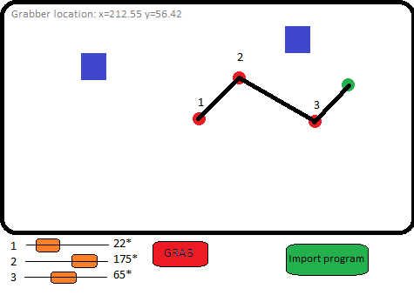

# Files and File formats

The program will be able to parse csv files with predetermined control actions. The csv will be of the following format:

*timestamp ; joint ; angle_setpoint ; grab ;*

where:  
*timestamp = number of seconds after beginning of execution the control action should be initiated  
joint = joint to be modified  
angle_setpoint = desired joint angle  
grab = orders the arm to grab an object*

The csv parser will be built so that added functionality can later be added by expanding the number of data fields, without breaking existing functionality.

# System testing

The project will be completed in several iterations, outlined in the technical specifications. An iteration will be considered complete when end to end testing has been successfully completed for the planned features of that iteration. As such the specifications for each iteration will also be the testing requirements. End to end tests will be written to allow easy execution of them during later iterations.

Iteration 1

* Visualization loads, shows a single joint.
* Changes to a single joint angle without animations registers correctly in UI.
* Sliders for changing joint angles.

Iteration 2

* Animated arm movements
* Visualization for arm with multiple joints.
* Arm endpoint is correctly calculated.

Iteration 3

* Moveable objects are created and rendered
* Arm can grab objects when above them and release them
  + Arm fails to grab object if not above it.

Iteration 4

* Command import from CSV
  + Correctly made csv parses correctly
  + Incorrect csv is rejected

Iteration 5 (bonus tasks if possible, within time constraints)

* Automatically set arm to specified position.
* Arm movements simulated with transfer function.