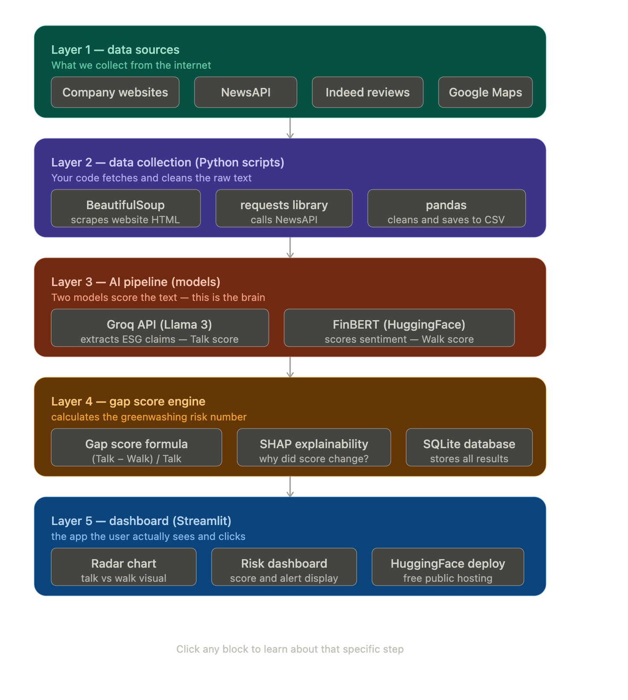

APIs:
BeautifulSoup will work fine for scraping genuine websites, like penneys, brown thomas, arnotts, etc. But NewsAPI’s free API key did not worked properly, it was not able to fetch correct articles/headlines even with the proper keywords. So, used Google News RSS, it is a public feed, no key, no tracking, no rate limit in the same way. The broader lesson: always check if a public feed exists before registering for an API. RSS feeds are older technology but often more reliable for free use cases.
Groq API:
1. 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
2. 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
NewsAPI:
e50c221fd5904260b8188bcc9859cc90

