API Testing
- Rest API
- Soap API

API – Application Programming Interface
- An interface that allows two applications or systems to communicate with each other.
- Example: A weather app using an API to get weather data from a server.

REST – Representational State Transfer
- A style of API architecture.
- It defines how systems should exchange data over the web using HTTP.
- REST APIs are stateless, lightweight, and use standard HTTP methods like GET, POST, PUT, DELETE.
Rest Assured:
- REST Assured is a Java DSL (Domain-Specific Language) designed to simplify the testing of RESTful web services. It is built on top of libraries like HTTP Builder and internally uses Apache HTTP Client or Java's URLConnection for HTTP communication.

Built On:
REST Assured is built on top of popular libraries like:
- Apache HTTP Client
- HTTP Builder
- Java’s URLConnection
REST Assured internally uses these libraries to perform the actual HTTP communication.
Purpose:
It is mainly used for API Automation Testing, allowing testers to:
- Send GET, POST, PUT, PATCH, DELETE requests.
- Validate status codes, headers, and response bodies.
- Perform JSON and XML schema validation.
Integrate with JUnit, TestNG, and Maven/Gradle.

Key Features:
- Easy syntax similar to natural language.
- Supports BDD-style (Given–When–Then) syntax.
- Handles JSON & XML easily.
- In-built support for authentication methods (OAuth, Basic, Digest, etc.).
- Supports logging, parameterization, and reusable specifications.
- Integrates well with CI/CD pipelines and other testing frameworks.

SOAP – Simple Object Access Protocol
- A protocol for exchanging structured information in web services.
- Uses XML format and works over HTTP, SMTP, and more.
- Heavier than REST and often used in enterprise-level applications (e.g., banking systems).
Basics of API:
- HTTP
- HTTP Authentication -who you are?
- HTTP Authorization - Permissions
- HTTP Methods Get, Put, Post, Patch, Options, Delete, Head..etc.
- Cookies – Text with key and value -logins (session management, tracking, personalization)
- Payload
- URL (Uniform Resource Locators)
- Param, QP and PP
- Body, Response, request
- End points
- JSON /XML
- Status codes
HTTP: Hypertext transfer protocol
HTTP is a resource.
- Client always send request and server will respond.
MIME – Multi Media types

MIME Type | Meaning
text/html | HTML document
text/plain | Plain text
application/json | JSON data
application/xml | XML data
image/png | PNG image
image/jpeg | JPEG image
audio/mpeg | MP3 audio
video/mp4 | MP4 video
application/pdf | PDF document
multipart/form-data | File uploads via forms

- When we send URL it’ll convert as IP address. This ip is the address of the server.

NOTE: Get, Put, Post, Patch, Options, Delete, Head..etc all these methods are belong to HTTP protocol not belong to API or Rest API.

Client sends request to server to fetch the resource/HTML page.
Port | Protocol | Purpose
80 | HTTP | Default for standard web traffic (non-secure)
443 | HTTPS | Default for secure web traffic (SSL/TLS)
8080 | HTTP (alt) | Often used for development/test servers
8443 | HTTPS (alt) | Secure dev/test API servers
3000 | Node.js apps | Often used by Express/Node.js APIs
5000 | Flask apps | Default for Python/Flask APIs

Method | Purpose | Common Use Case
GET | Retrieve data | Fetch a list or a single item (read-only)
POST | Create a new resource | Create a new user/order/item
PUT | Update a full resource | Replace entire user data
PATCH | Update part of a resource | Update only the email of a user
DELETE | Remove a resource | Delete a user or record
OPTIONS | Fetch supported methods (metadata) | Used in preflight checks for CORS
HEAD | Like GET but without the body | Check if resource exists (faster)
- To make to GET request we need the URL.
- In the postman tool when we search with only HEAD it will show only headers and no body.
When we want check only the time which available in header, we will send only HEAD no need the body to interact.

node –version
npm –version

npm -g install json-server – to download json server

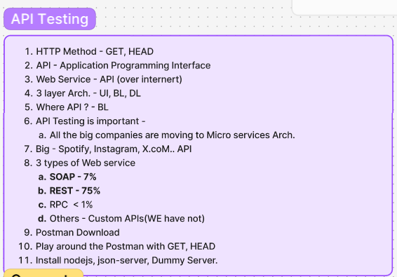

3-layer arch:
UL – UI layer
BL- Business layer
DL – Database layer

What to Test in API ?

Functional Testing
- Test the core business logic and functionality of the API to ensure it works as expected .
- Verify API responses against the database or other APIs .
- Focus on critical APIs like login, authentication, and health check APIs first.
- Validate input data with malformed inputs to check error handling .

Integration Testing
- Verify the API integrates correctly with other systems and services.
- Test for seamless data flow and communication between integrated components.

Additional Tips:
- Shift left and incorporate API testing early in the development lifecycle.
- Automate API tests using tools like Postman, SoapUI, Nightwatch.js, etc.
- Use clear and comprehensive test cases to cover all key scenarios.
- Continuously monitor APIs in production to catch issues proactively.

Read article - https://scrolltest.com/2018/12/15/api-testing-tutorial

Json/XML:

Different ways to send request client to server and response server to client:

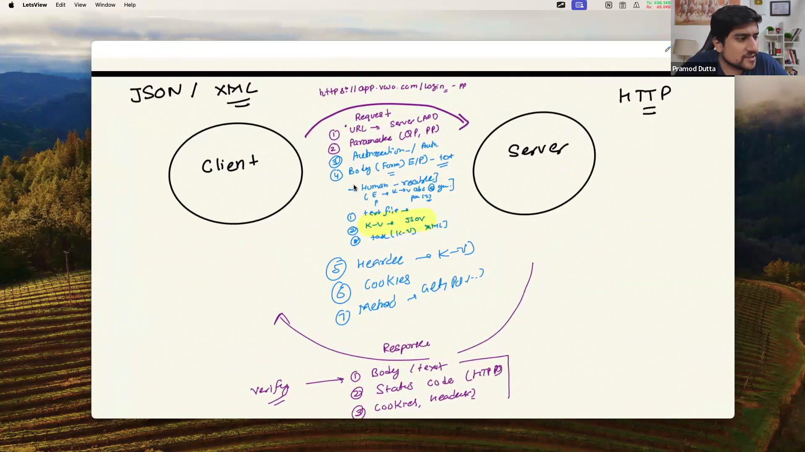
Java script object notation -Json: Key – value pair

Json is used to trafer data from one to another.
Clinet might have writtern in different lang so we need a convert to send in json.
Json is similar to text file.
Json is human readable.
Front end back supports json.
Json is very lite weight.
Json is lng indipendent.
{} – Json object
Json is used to transfer data from client to server know as payload.

Benefits of JSON:
- Human-readable: JSON is easy to read and write.
- Lightweight: JSON is a text format that is easy to transmit over networks.
- Language-independent: JSON can be used with many programming languages, making it a versatile choice
- Supports complex data structures: JSON can represent nested objects and arrays, allowing for complex data structures

JSON supports the following data types:
- String: A sequence of characters enclosed in double quotes.
- Number: An integer or floating-point number.
- Object: An unordered set of key/value pairs.
- Array: An ordered list of values.
- Boolean: true or false.
- Null: An empty value.
- Json allows empty string also (“”);

https://jsoncrack.com/editor

XML:
- XML stands for extensible Markup Language.
- XML was designed to store and transport data.
- XML was designed to be both human- and machine-readable.

“This” file tells Maven how to build your Java project.
TestNG uses “this” XML file to run test cases.

Area | Usage Example
✅ Web services (SOAP) | For sending/receiving requests in SOAP APIs
✅ Configuration files | Like pom.xml in Maven, web.xml in Java EE
✅ Data exchange | Between applications (Java ↔ .NET, frontend ↔ backend)
✅ Android apps | Layouts are written in XML (activity_main.xml)
✅ Selenium | TestNG uses testng.xml for test suite configuration
✅ Document formats | Used in Microsoft Word .docx, Excel .xlsx, etc.

Benefit | Description
✅ Data Sharing | XML allows sharing of data between different systems (Windows/Linux, Java/.NET, etc.).
✅ Data Storage | Can be used to store and backup structured data.
✅ Platform Independent | No dependency on platform, language, or OS.
✅ Readable Format | Easily readable and editable by humans.
✅ Supports Web Services | XML is widely used in SOAP-based web services and API communication.
✅ Used in Configuration Files | Many tools and frameworks (like Maven, Spring, Selenium) use XML for config.
✅ Integration Friendly | Easily integrates with other tools (e.g., database, APIs, applications).

Feature | Description
💡 Extensible | You can define your own tags.
📚 Structured | Maintains a hierarchy (like a tree).
🧑‍💻 Human-readable | Easy to understand and edit.
🌐 Platform-independent | Works on any system/language.
🔐 Supports Unicode | Can handle any language/text.

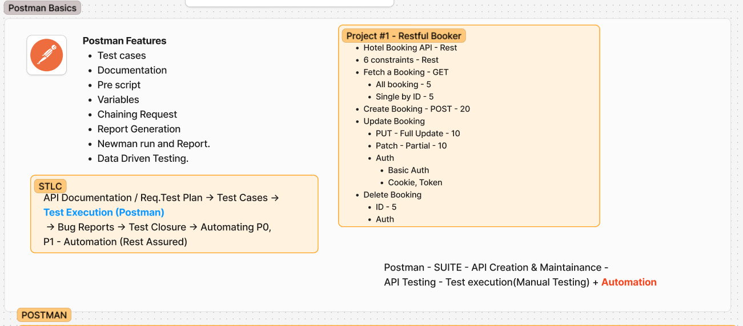

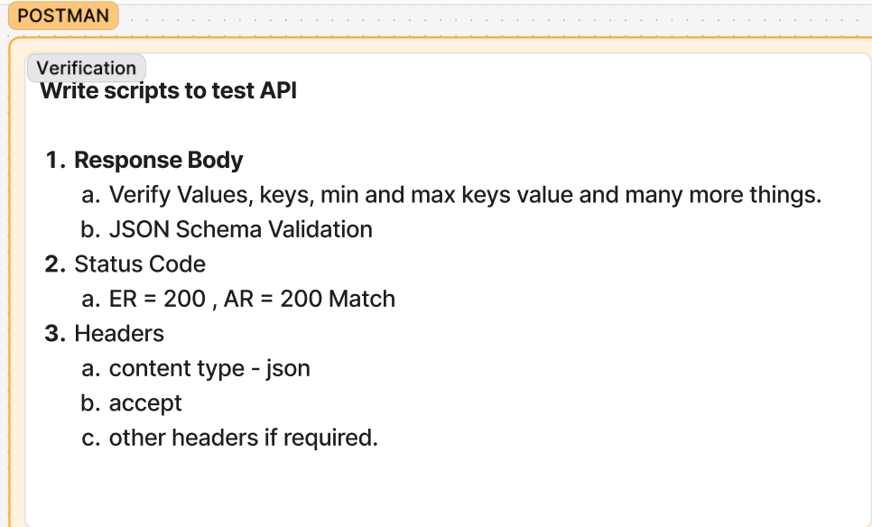

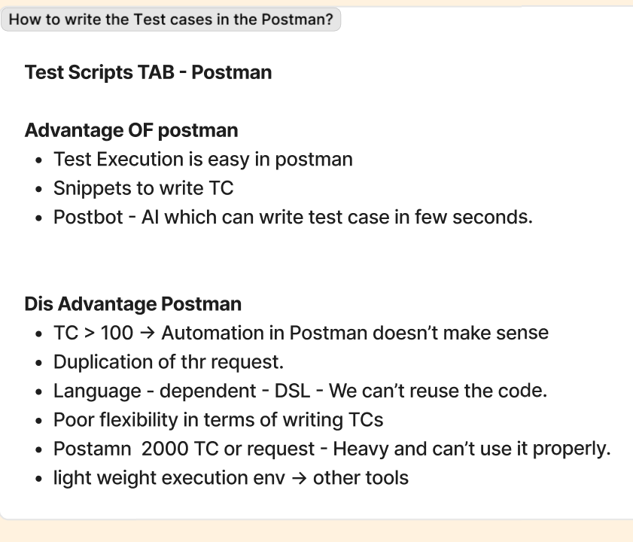
- 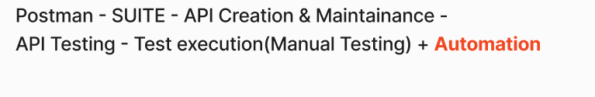

Features of postman:

- 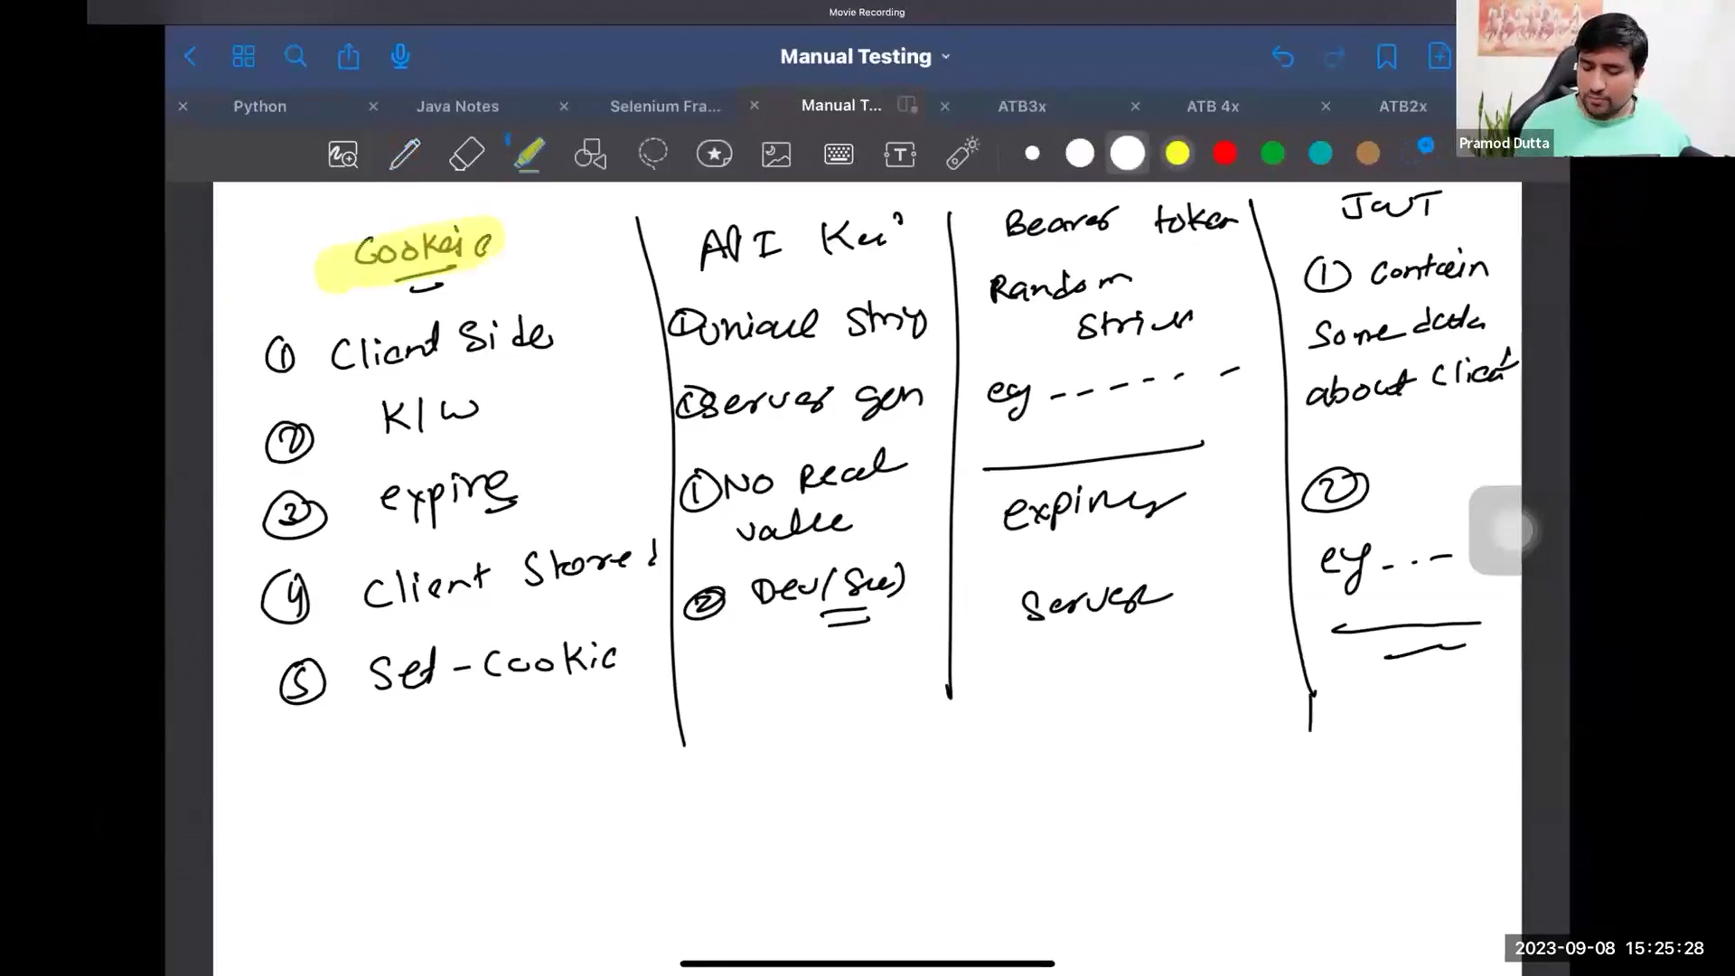

- 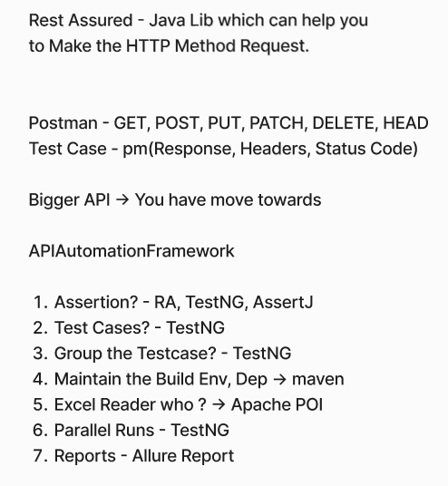

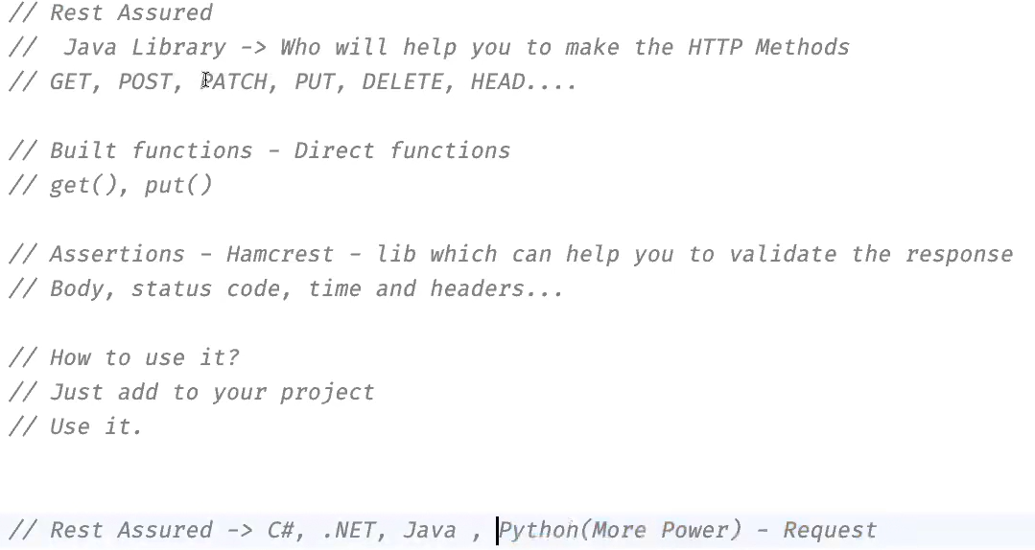

Builder patterns:
“this” always points to current/calling object. Returning the same to

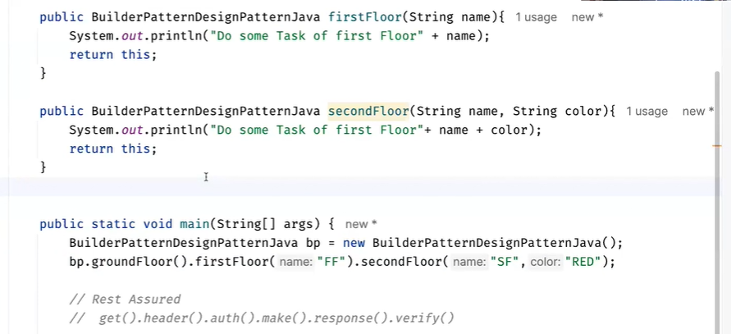
It’s like first constructing first floor and second then 3rd, one after one in proper way.

How to create testing.xml file in testng:
1.From plugins download Create TestNG XML
2.Right click on project level and click on create TestNG XML
2. Right click on project level and click on Reload from Disk

For testng default report generation:
<dependency>
<groupId>org.testng</groupId>
<artifactId>reportng</artifactId>
<version>1.2.2</version>
<scope>test</scope>
</dependency>

Alllure Report:
1.Install allure command line
2.To install allure command we to install node JS then we need to run allure command – [npm i allure-commandline] npm install -g allure-commandline --save-dev

- allure serve allure-results
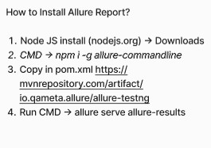

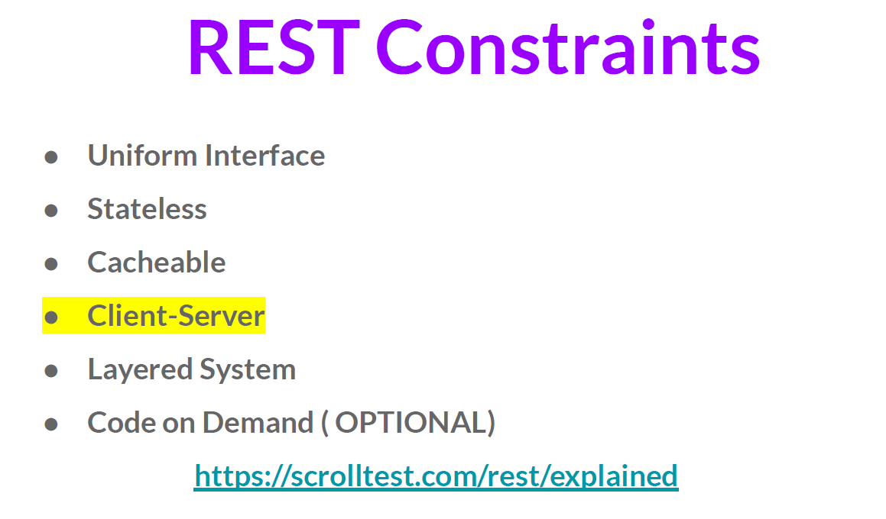

1️⃣ Client-Server Architecture
- Separation of concerns between:
  - Client (frontend/UI)
  - Server (backend/data)
- They communicate over HTTP.
📌 Why?
So the client and server can evolve independently.

2️⃣ Statelessness
- Each request from the client must contain all the information needed to process the request.
- The server does not store session/state between requests.
📌 Why?
It improves scalability, simplicity, and reliability.
Example:
Each API call must include auth token and user details, not rely on previous requests.

3️⃣ Cacheability
- API responses must indicate whether they can be cached (temporarily stored) or not.
- Caching improves performance and reduces server load.
📌 How?
Via HTTP headers like:
http
CopyEdit
Cache-Control: no-cache

4️⃣ Uniform Interface
This is the core constraint of REST.
It means all REST APIs should use a consistent structure and standard HTTP methods.
📌 Uniform Interface includes:
Rule | Description
Resource-based | Use nouns in URLs (/users, /orders) not verbs
Standard Methods | Use GET, POST, PUT, DELETE
Representation | Use JSON/XML to represent resources
Stateless Interactions | Each request is self-contained

5️⃣ Layered System
- The architecture is composed of layers, like:
  - Client layer
  - Authentication layer
  - Server layer
  - Database layer
- The client should not care or know how many layers exist.
📌 Why?
Helps with scalability, security, load balancing.

6️⃣ Code on Demand (Optional)
- Server can send executable code (like JavaScript) to the client to run.
📌 Example:
A REST API that sends back JavaScript for client-side validation.
🔸 This is the only optional constraint in REST.

📊 Summary Table:
# | Constraint | Description
1 | Client-Server | UI and data logic are separate
2 | Stateless | No session is stored on server
3 | Cacheable | Responses can be cached
4 | Uniform Interface | Use standard URLs and methods (GET, POST)
5 | Layered System | Multiple architecture layers allowed
6 | Code on Demand | Server can send executable code (optional)

given() // Precondition: request setup (headers, body, params)
.when() // Action: HTTP method (GET, POST, etc.)
.then() // Assertion: validate the response (status, body, etc.)

given() – Setup / Precondition
This is where you set up the request.
You can define:
- Headers
- Query/path parameters
- Request body
- Authentication
- Content type
given()
.header() // Send headers like auth, content type
.body() // Send request body (for POST/PUT)
.queryParam() // Send query parameters (?id=1)
.pathParam() // Send path parameters (/users/{id})

given()
.baseUri("https://api.example.com")
.header("Authorization", "Bearer token")
.contentType("application/json")
.body("{ \"name\": \"Suneel\" }")
when() – Action / Trigger
This is where you send the HTTP request, like:
- .get()
- .post()
- .put()
- .delete()
.when()
.post("/users") // Send POST to /users
then() – Verification / Assertion
Here, you check:
- Status code
- Body content
- Headers
- Response time

.then()
.statusCode(201)
.body("name", equalTo("Suneel"));

Final code:
given()
.baseUri("https://api.example.com")
.contentType("application/json")
.body("{ \"name\": \"Suneel\" }")
.when()
.post("/users")
.then()
.statusCode(201)
.body("name", equalTo("Suneel"));
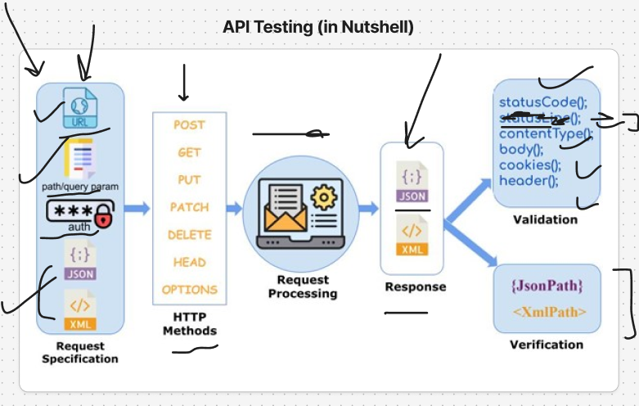

log.all() – print the all the logs.

There are two ways to create RA testcases 1.BDD style 2.Non BDD style
1.BDD Style:
Given, When, Then
2.Non BDD style:
This is a more Java OOP style — using interfaces and objects to structure our code.
Using class and objects
To make a request rest assured provides a interface called RequestSpecification.
To get the response rest assured provides a interface called ResponseSpecification.
RA interfaces:
Request specification
Response
Validatable response

1.RequestSpecification interface:
We well send the request
2. Response Interface
Using this interface we store our responsefor furtureuse
3. Validatableresponse Interface
Using this interface we store our validation

There are 3 ways t verify the response. They are
1.Matchers – RA
//RA- Matchers -1
vr.body("firstname", Matchers.equalTo("James"));
2.TESTNG Asserts
//TestNG Asserts -2
String firstname= res.then().log().all().extract().path("firstname");
Assert.assertEquals(firstname,"James");
//TestNG assertions With JSON Path Lib -2
String fullresponse=res.asString();
JsonPath jsonPath=new JsonPath(fullresponse);
String firtnameJsonPath=jsonPath.getString("firstname");
Assert.assertEquals(firtnameJsonPath,"James");
3.AsserJ Matching
//AssertJ Matching
assertThat(firtnameJsonPath).isEqualTo("James").isNotEmpty().isNotEmpty();
https://assertj.github.io/doc/

- TestNG allowes us to prioatize or test case cases and testNG allowes negatove priority also.
Ex: @Test(priority=1), @Test(priority=--1)…etc.
- When we set same priority to multiple testcases it followes the order which they apper in the code.
- When we don’t set any priority it won’t followe anyorder -random.

Grouping of testCases:
- If we have 100 testcases we group 40 testcases as smoke and 60 testcases a regression.

dependsOnMethods:
when we want run a pertical method but before that we want make some other requred method need to run for that we will use dependOnMethod annotation.
@Test(dependsOnMethods={“getToken”})
Same way we have dependsOnGroups

Listeners:
🔍 Feature / Purpose | ✅ Advantage / Benefit
Centralized Reporting | Automatically log test status (pass/fail/skip) in one place without repeating code
Retry Mechanism | Automatically retry failed or flaky tests using IRetryAnalyzer
Better Debugging | Capture logs, API responses, or screenshots on failure using ITestListener
Suite-Level Hooks | Run setup/teardown once for all tests using ISuiteListener or IExecutionListener
Custom Report Generation | Create custom HTML/Excel reports with IReporter
Dynamic Test Modification | Modify test behavior at runtime (like assign groups, retries) using IAnnotationTransformer
Save Time & Effort | Write once, apply to all tests — no need to duplicate setup or logging code
Global Resource Management | Initialize/clean up databases, services, or connections globally
Framework Integration | Easily integrate tools like Allure, ExtentReports, Email notifications, etc.
Execution Timing / Stats | Log total suite time, test method timings, or collect metrics

Listeners are interface they are incomplete in nature.
Listeners are reusable.
ITestListnere : I listen events related to test methods.
Such as @Beforetest, @AfterTest
IInvokedMethodListeners: listen to events to invoked of any method, including configuration.
Such as @BeforeMethod, @AfterMethod
ISuiteListener: Listen to events related to test suite.
Such as @BeforeSuite, @AfterSuite
IReporter : Generate custom reports based on the test results.Tracks our pass or fail test results.
IAnnotationTransformer: This listener is used tomodify TestNG annotations at runtime.

Listener Interface | Method(s) | Purpose / Use Case
ITestListener | onTestStart, onTestSuccess, onTestFailure, onTestSkipped, etc. | Logs test status, captures response/screenshot on failure, updates reports
IRetryAnalyzer | retry(ITestResult result) | Retries failed tests automatically (e.g., flaky API/UI tests)
IAnnotationTransformer | transform() | Modifies test method annotations at runtime (e.g., attach retry logic dynamically)
ISuiteListener | onStart, onFinish | Runs before/after entire <suite> — used for setup/cleanup
IInvokedMethodListener | beforeInvocation, afterInvocation | Executes code before and after every method (including @Before, @After)
IExecutionListener | onExecutionStart, onExecutionFinish | Runs before and after entire TestNG run (all suites/tests combined)
IReporter | generateReport() | Used to create custom HTML/Excel reports, ExtentReport integrations

Serialization and deserialization
When we send payload(Object data) to server directly server can’t understand so it converts into ByteStream.
PayloadObjectJsonString(ByteStream) -Serialization
Server also won’t give direct object data it gives JsonString(ByteStream)
JsonString(ByteStream)Object -Deserialization

POJO- Plain old java Object

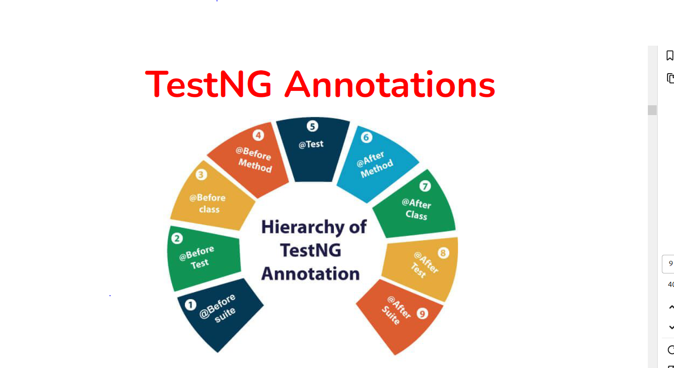

Using Jason to POJO utility we can convert our jason to to POJO Classes: jsonschema2pojo.org

Jason schema validate: we will place our response in jsonschema.net in thise web side wewill get one scehma with that we will verify the schema.

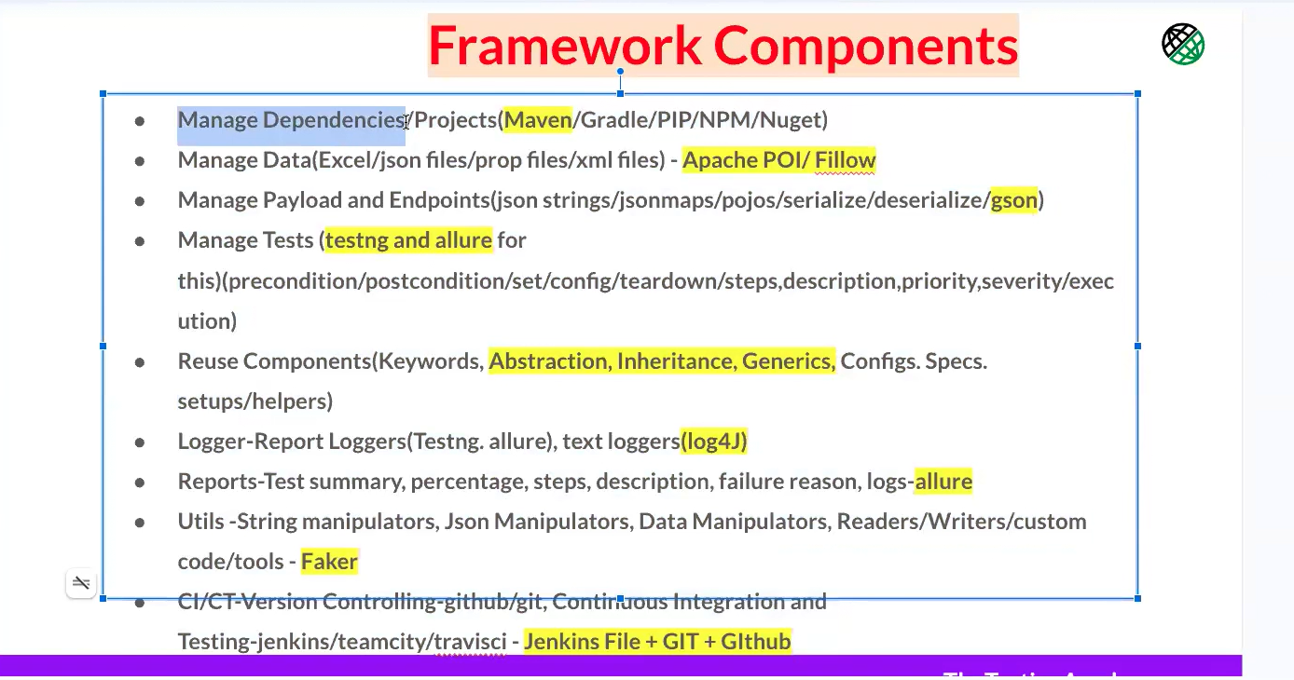

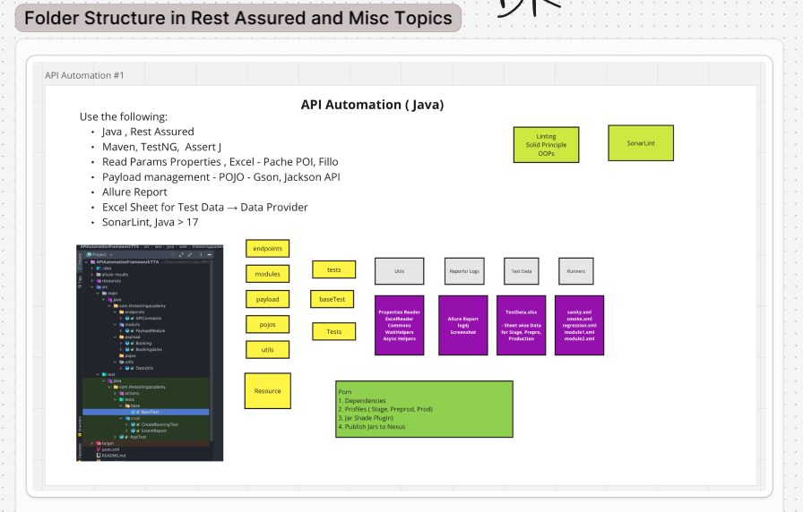

Rest Assured :
Purpose: Used to send HTTP requests and receive HTTP responses.
Role: Helps us test REST APIs (GET, POST, PUT, DELETE, etc.)

Maven:
Purpose: Build automation tool & dependency manager.
Role: Helps us maintain, update, and import required libraries.
TestNG:
Purpose: Testing framework
Role: Helps us write, manage, organize, and run test cases.

AssertJ:
Purpose: Advanced assertion library
Role: Helps us validate response values in a cleaner way.

SonarLint:
An advanced linter in our IDE for Clean code.
SonarLint is a static code analysis tool that helps you write clean, bug-free, and maintainable code. It is like Grammarly for our code.

Purpose of SonarLint:
SonarLint helps you:
- Detect code problems before running the program
- Improve code quality
- Follow coding standards
- Prevent bugs, vulnerabilities, and bad practices
- Keep your framework clean and maintainable.

What Issues SonarLint Can Detect
It checks for:
✔ Bad coding practices
✔ Bugs
✔ Security vulnerabilities
✔ Code smells
✔ Unused variables
✔ Null pointer risks
✔ Hardcoded values
✔ Duplicate code
✔ Naming convention issues

New Maven project Creation:
- Files- New Project – initially it will be on java so please select Maven Arc (Give project Name, Location, and mark Create Git Repository)
- Select arch type as quick start: org.apache.maven.archetypes:maven-archetype-quickstart
- Quick start is the main project which will give us main folder and test folder.
- Change advanced setting based on your requirement.
- Click on Create

After creating framework by default it will add Junit.
It always best to add READ ME file
To add ReadMe file:
- Right click on the project select new and click on File then give README.MD as file name.

Endpoints nothing but URL’s
Modules- this is where we will keep payloads.

JSON,GSON and JACKSON these are very important topics

Cucumber BDD API

To work on cucumber, we need feature file so we will create a feature file in src – test package.
When we want work with cucumber bdd and API to combine these two we need a binding file(GLUE) which is runner file.
We will create this runner file in test-java -runner package- testRunner.java.
Feature file nothing but a given() when(), then()

Jason Path online evaluator: if you want validate particular element this help us to pick that element
https://jsonpath.com/

Jason crack editor: from normal Jason tree structure
https://jsoncrack.com/editor

Jenkins install:
https://www.jenkins.io/download/
- Select required os(windows)
After clicking on windows it will automatically downloads as exe file.
- While installing jenkns it will ask for jdk location for that we need toinstall jdk
  - https://openjdk.org/
  - https://www.oracle.com/in/java/technologies/downloads/#jdk25-windows
  - https://Jdk.java.net/22/
- After installing jenks we need to search http://localhost:8080/ 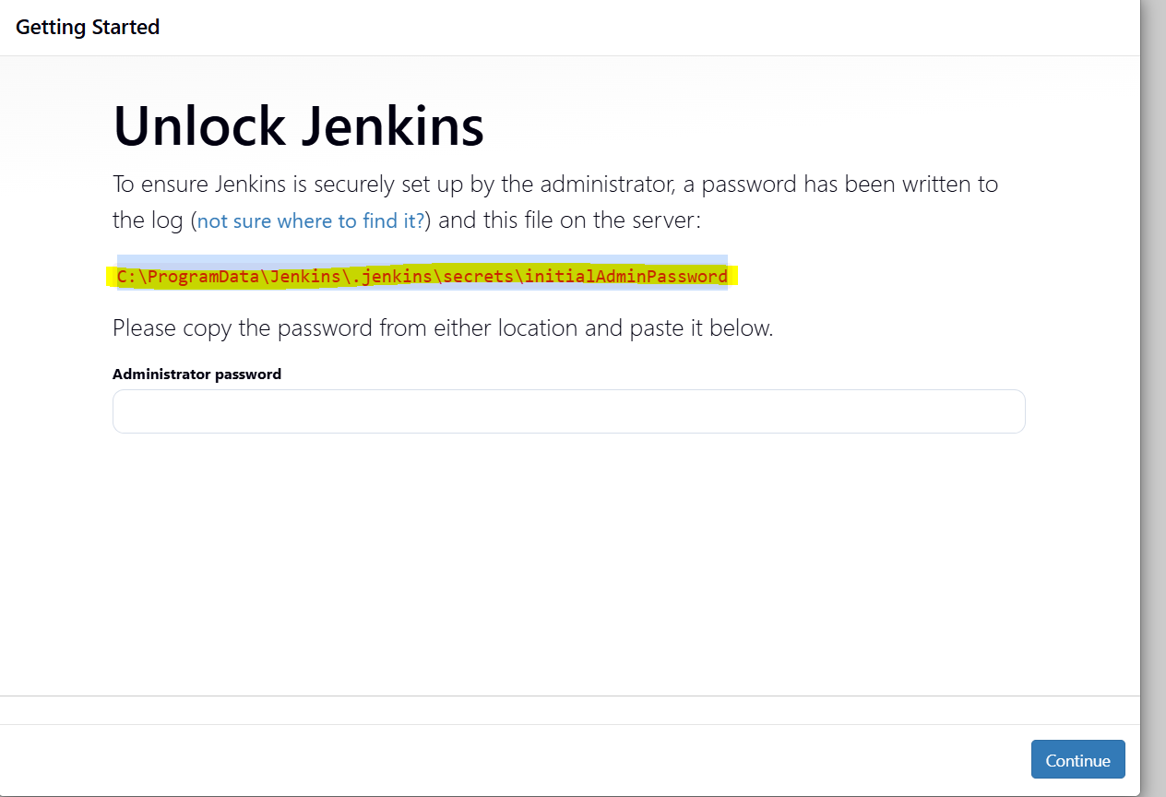
- First copy the path search in new chrome tab then we will get the password. Password we need to paste in jenks and click on cotinue.
- Enter password and username as admin and ok
- Click on start using jenkins
- This is our jenkins URL http://localhost:8080/
Check jenkis is working or not
- Click on create a job give name as TestJob and select freestyle project.
- Go to build steps and select build step ad Execute Windows bath command(for widows) for mac select shell commend and click on save.
- For Windows we use dir and mac ls or pwd
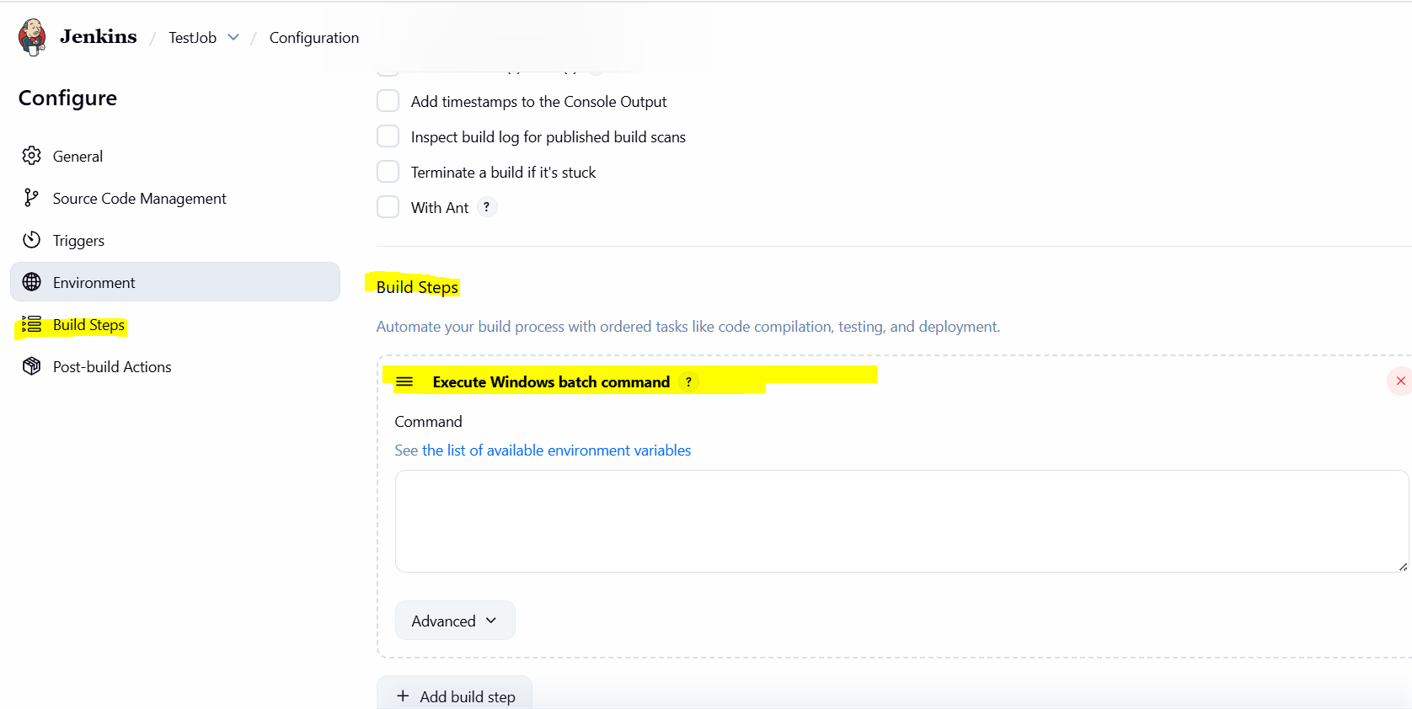
- After clicking in save we will get Builde Now click on that it will build the project.
- 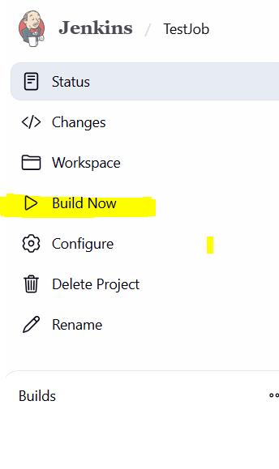
- 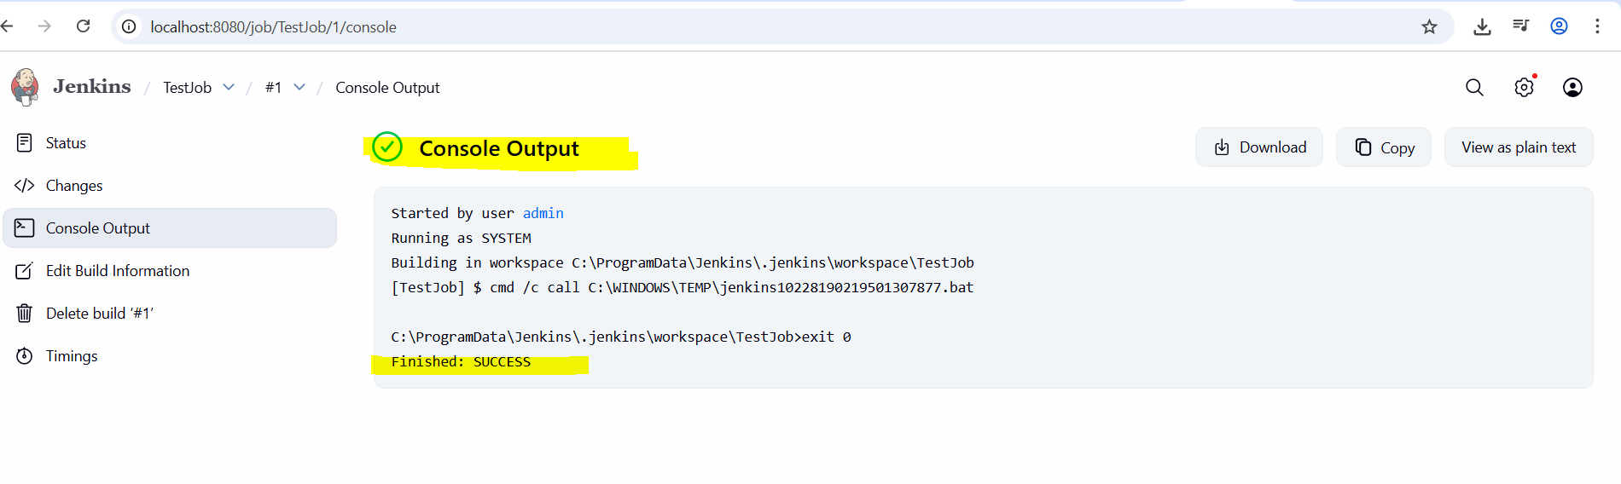

Apache POI and Data Driven Testing with Selenium
What is Apache POI?
- Apache POI is a Java library for working with Microsoft Office documents. (after Office Open XML, (OOXML)).
- It allows you to read and write Excel, Word, PowerPoint, and other Microsoft Office documents from your Java applications.
- You can use it to create, modify, and save documents, or to extract data from documents for use in your applications.
- XLS and XLSX (can convert to the CSV also).
Commonly used components of Apache POI
- HSSF (Horrible Spreadsheet Format): It read and write xls format of MS-Excel files.
- XSSF (XML Spreadsheet Format): It is used for xlsx file format of MS-Excel.
- POIFS (Poor Obfuscation Implementation File System): This component is the basic factor of all other POI elements. It is used to read different files explicitly.
- HWPF (Horrible Word Processor Format): It is used to read and write doc extension files of MS-Word.
- HSLF (Horrible Slide Layout Format): It is used for read, create, and edit PowerPoint presentations

