Selenium Java Automation

What is Selenium:
Selenium Automates the browser. Primarily it is for automating web applications for testing purpose.
Selenium is an open-source web automation framework that provides programming libraries (WebDriver) to automate browser actions, along with supporting tools like Selenium Grid for parallel execution and Selenium IDE for record-and-playback.

1. Selenium IDE
a. Record and Playback Tool.
b. This is a extensions- not suitable for real time projects.

2. Selenium WebDriver
a. a Collection of language specific bindings (code) to drive a browser. - Automate the browser.

3. Selenium Grid
a. Running tests on several machines
b. Manage multiple environments from a central point
C. making it easy to run the tests against a vast combination of browsers/OS. – Cross browser Testing.
https://qajobsboard.jobboardly.com/

Selenium Flow:
Selenium will follow the below flow steps.
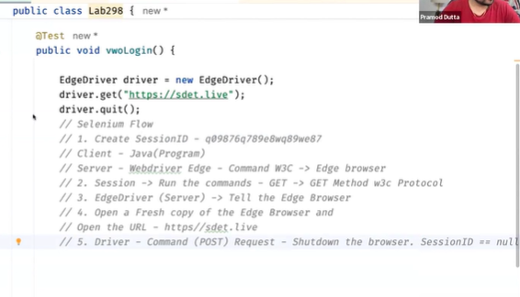

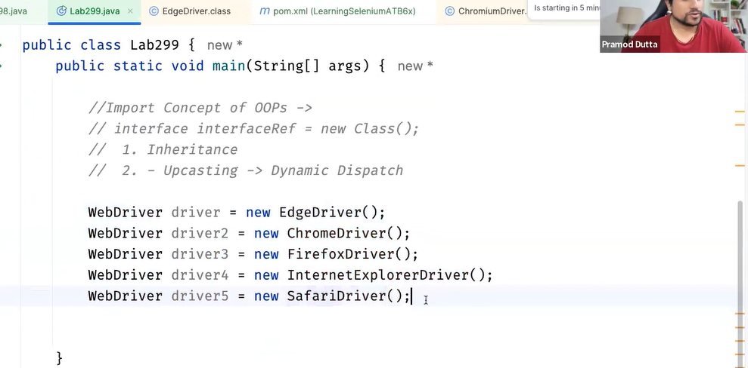

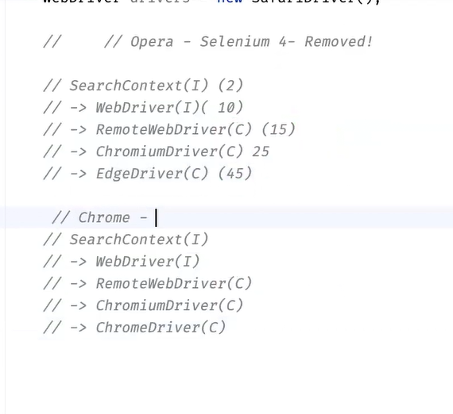

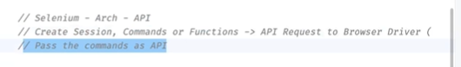

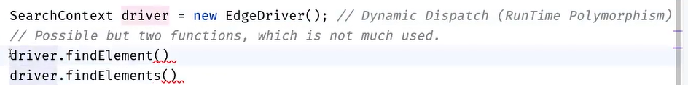

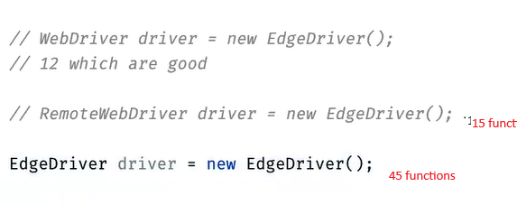

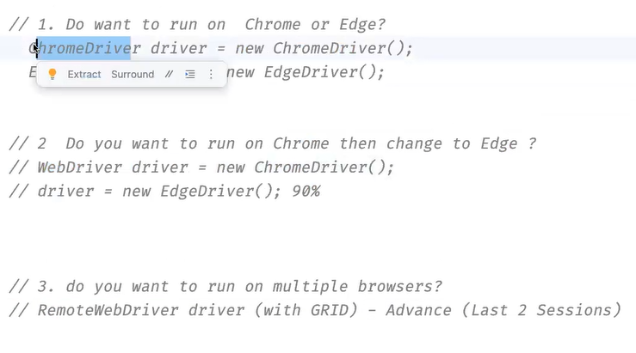

Quit() vs Close():
driver.close(): closes current window not the browser and session won’t be null (browser session still running).
driver.quit(): closes all the windows and the browser (session id will be null)

When we use driver.get() we can’t go back or forward but when we driver.navigate() we can go back and forward. 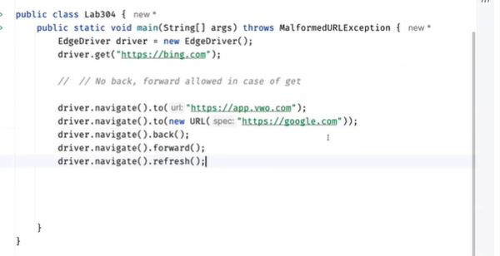
------------------------------------------********************************__________________________
Q: Which is better and why?
A: driver.get() is better when I just want to open a webpage because it is simpler, more readable, and semantically meant for loading a URL.
driver.navigate().to() is better when I'm using other navigation actions like back(), forward(), or refresh() since it keeps the code consistent.
Q: Which is faster?
A: Both have the same speed. There is no performance difference.
Q: Do both use the same function behind the scenes?
A: Yes. Internally, both driver.get(url) and driver.navigate().to(url) call the same underlying WebDriver command ("Navigate To"), so the behavior and performance are identical.

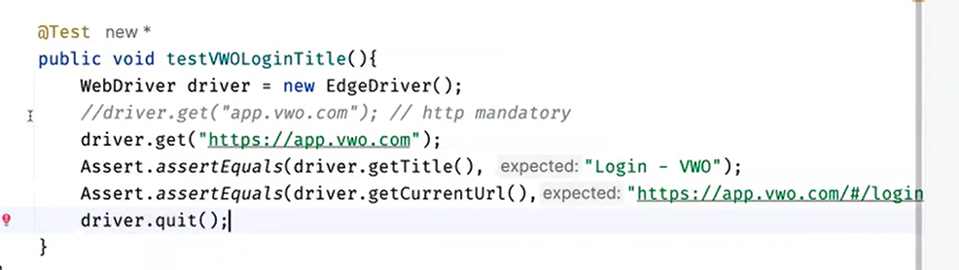
------------------------------------------********************************__________________________
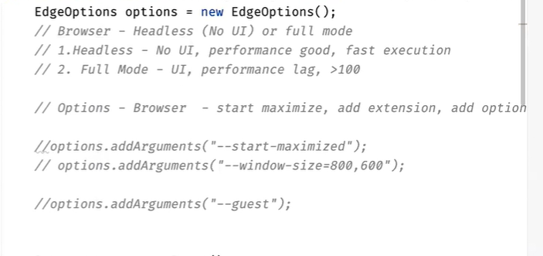

While launching the browser we can add arguments like capabilities to our browser user ChromeOptions class
ChromeOptions options = new ChromeOptions();
options.addArguments("--start-maximized");
options.addArguments("--ignore-certificate-errors");
options.addArguments("--disable-popup-blocking");
options.addArguments("--incognito");

Using selenium, we can connect to a proxy also:
//Proxy
Proxy proxy=new Proxy();
proxy.setHttpProxy("12.40.185.42:1080");
options.setCapability("proxy",proxy);

There are 3 types of PageLoadStrategy:
1.Normal
2.Eager
3.None
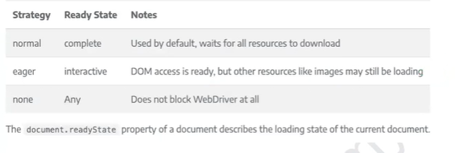
ChromeOptions options=new ChromeOptions() ;
options.setPageLoadStrategy(PageLoadStrategy.EAGER);
options.setPageLoadStrategy(PageLoadStrategy.NORMAL);
options.setPageLoadStrategy(PageLoadStrategy.NONE);
ChromeDriver driver=new ChromeDriver();
driver.get("https://app.vwo.com/#/login");

X Path Cheat Sheet:
https://devhints.io/xpath

XPath vs CSS Selector:

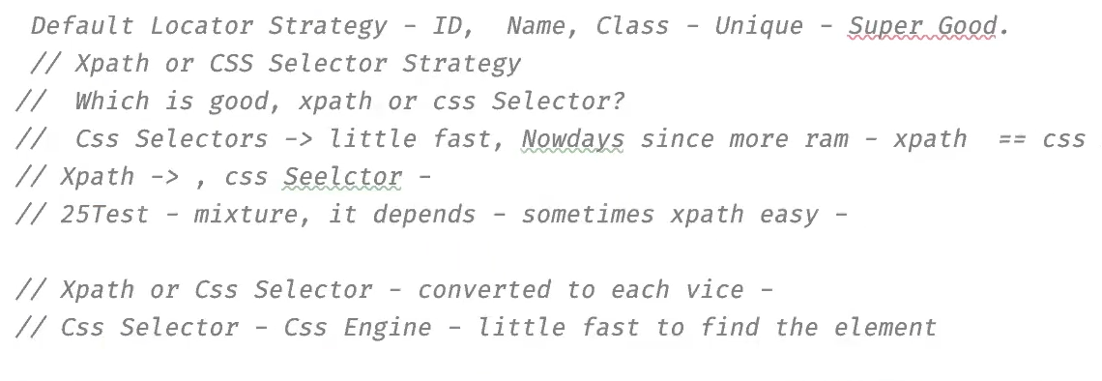

While using the class name if there is any spaces in the class name we will replace them with . (dot).

Contains and Starts-with:

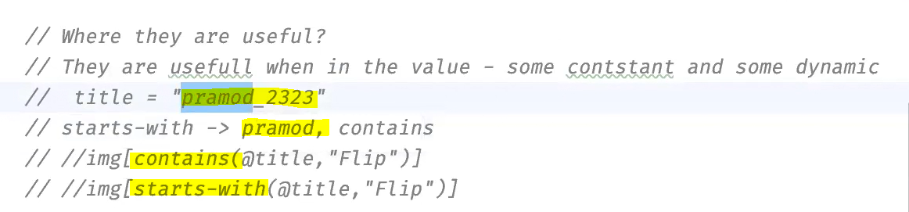

X Path Axes:
Website to practice: https://awesomeqa.com/xpath/
https://awesomeqa.com/webtable.html
practice.html

