First Install Jenkins server In same server also install Ansible



After plugin Install

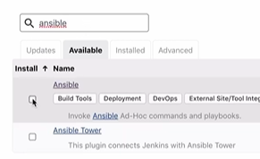

After Global Tool configuration Ansible add the path specify like /usr/bin **only**

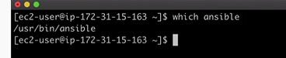

Next create job

After Pipeline syntax git and next ansible write it. In ansible specify ssh credential like remote server (apache) pem file copy it.

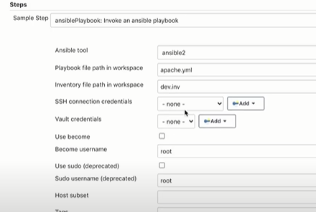

Disable host key checking click on it.



After pipeline declarative

