Single Provider Multiple Configuration:

Till now, we have been hardcoding the aws-region parameter within the providers.tf

This means that resources would be created in the region specified in the providers.tf file

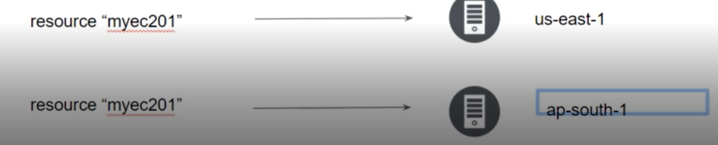

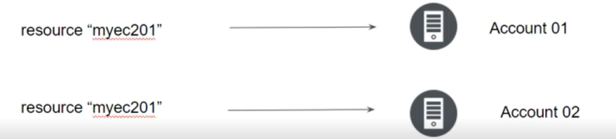

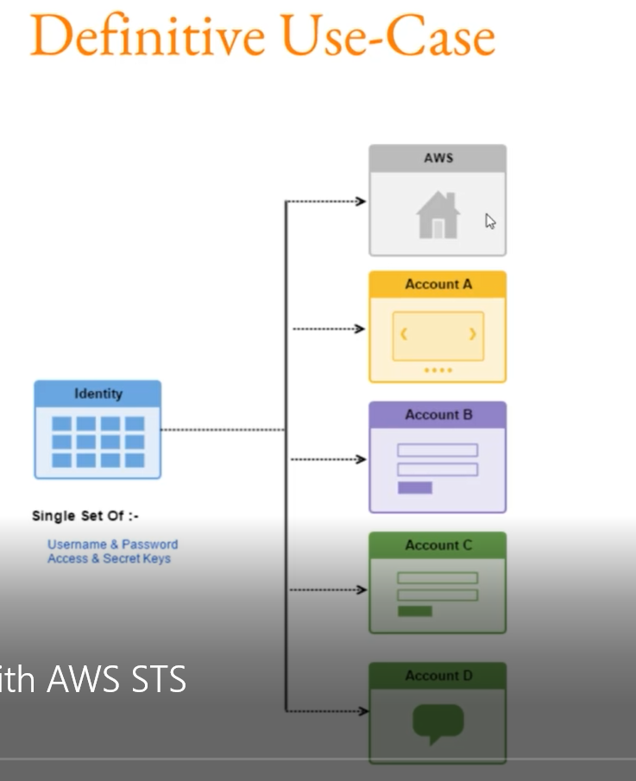

Senstive Parameter:

With organization managing therir entire infrastructure in terraform, it is likely that you will see some sensitive information embedded in the code.

When working with a field that contains information likely tobe considered sensitive, it is best to set the sensitive property on its schema to true.

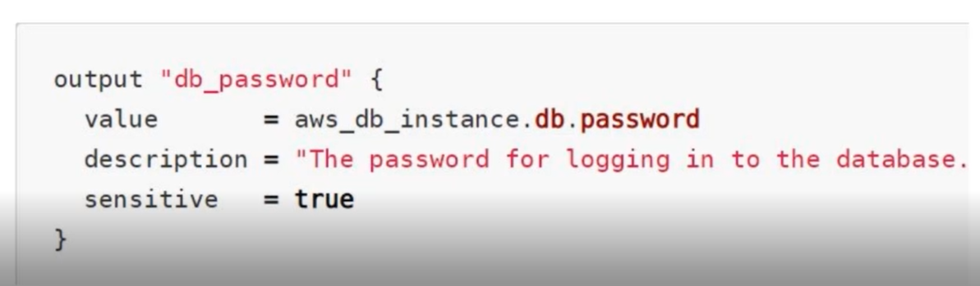

Setting the sensitive to “true” will prevent the fields values from showing up in CLI output and in Terraform cloud.

It will not encrypt or obscure the value in the state, how ever

