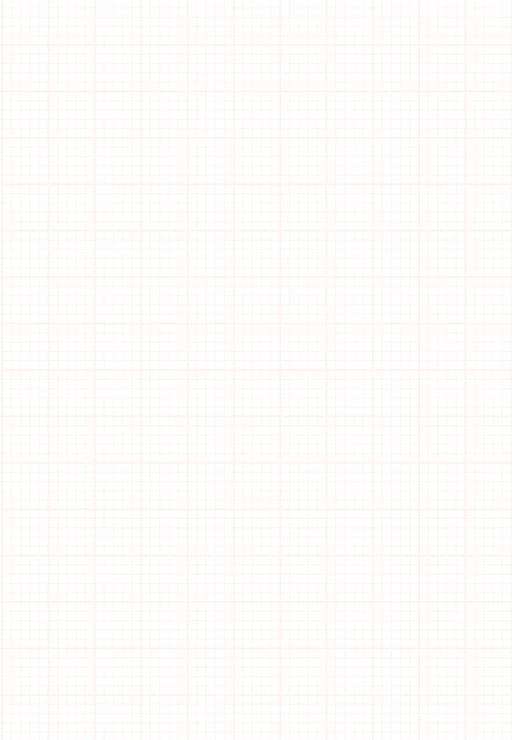
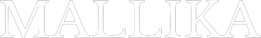
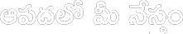



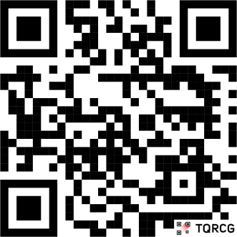


FREE CAMP

Date: {{date}}

Full Name: {{name}}
Age: {{age}} Gender: {{gender}}
Mobile Number: {{number}} Address:

Height (Cm): {{ht}} Weight (Kg): {{wt}} BMI (Category): {{cat}}
Pulse: {{pul}} B.P: {{bp}} R.R: {{rr}}
Temperature: {{temp}} Blood Sugar: {{bs}}

Impression:
{{imp}}

For Appointments
9674 108 108

#Near Railway Station, Rajendranagar, Mahbubnagar - Pin-509001

Follow us:

@mallikahospitals

