Valkyrie,

|  |
| --- |
|  |

Anonymous

It is you that I love.

Copyright © 2020

by Samantha Petreska

ISBN: 123-45678-9

Printed in Canada

Table of Contents

Collide by Anoynmous 1

Forbidden by Anonymous 2

Cessation by Anonymous 3

Death by Anonymous 4

5

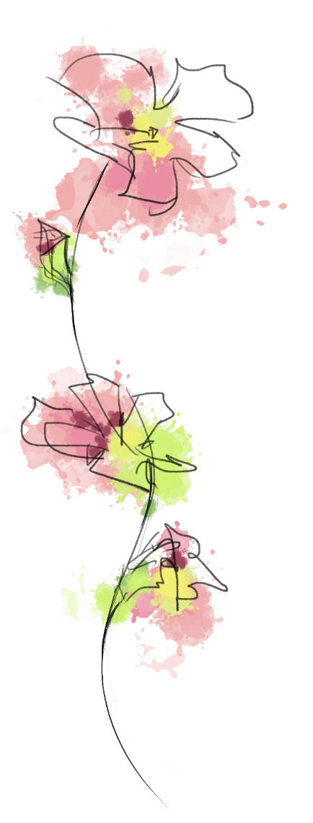Collide  
by Anoynmous

Riding through heaven, lance and speed with a band of

nine. Their byrnies with blood as red and from their spears the sparks flew forth.

By Odin, you tumbled onto the naked rawboned earth. Thou has’t seen different, for thy steed was anew, a man you believed you once knew. What was, was now no more and wars began abandoned for the sake of lover’s quarrels. Commands replaced with soft words. War cries traded with kisses and salutes with breathless mornings. It is he that softened the mighty rock, and on heaven’s field you lay no more. Undying sworn fealties melted by the crushing blows of time, and mortal wounds unearthed themselves and as we became one, our wounds became none. Unforgiving seas give wake to unforgiving waves. Krakens and giants, you have slain, necromancers mumbling wicked charms, conjuring the moon in leu of the sun, all which you have rid. Thou carri’st a wagon of burden what of which is hard to congeal. Though this has made you once fierce, into the fiercest lover one’s heart may pierce.

Forbidden  
by Anonymous

Valhalla is sick, tradition sicker. It is no be wonderment that all men seek your light. Promised to another in the twist of a night. Like a bastard’s quarrel, wherefore must we stand in the plague of custom, and permit Odin to separate a tree from the earth. O’ disgraceful I am, allied by Sir Ego of Vegabond to take sword into the pits of darkness. Enlightened as you were, you could not budge the stifle of a fool, so you watch as darkness approaches dawn with a terrible and agonizing scream.

 Cessation

By Anonymous

You waited by a tree. Hatred spews more of itself, tis a cycle like any earthly cycle whence it was made. The outburst of mine wrath eliminated all but one. You waited by a tree. How foolish am I, a hero of all heroes, knowing none of my bounds even Odin and Thor’s Thor, for my eyes were shut with the crust of your lovely morning breath. O’ how brutally fair your smile it is all that mattered. A blind wanderer will always remain blind, and though a heart has been opened; eyes do not follow so.

Death

By Anonymous

Thy brother art thou, aided by Odin’s wrath. Sought a ruin to love, unlike any other. Valkyrie’s chronicles have not ended but merely have only begun, for an energy so bright that the path for thy is lit as the seeker of knowledge above all else. For knowledge is love you say, these words you say to me before the entrance of my punishment. Ostergotland sends its finest, only remaining and with the spear of Odin, you slay me out of love. Perchance pity, so that we may meet again. On another accord.

# 