1. Archived ad image also needs to be in light gray color

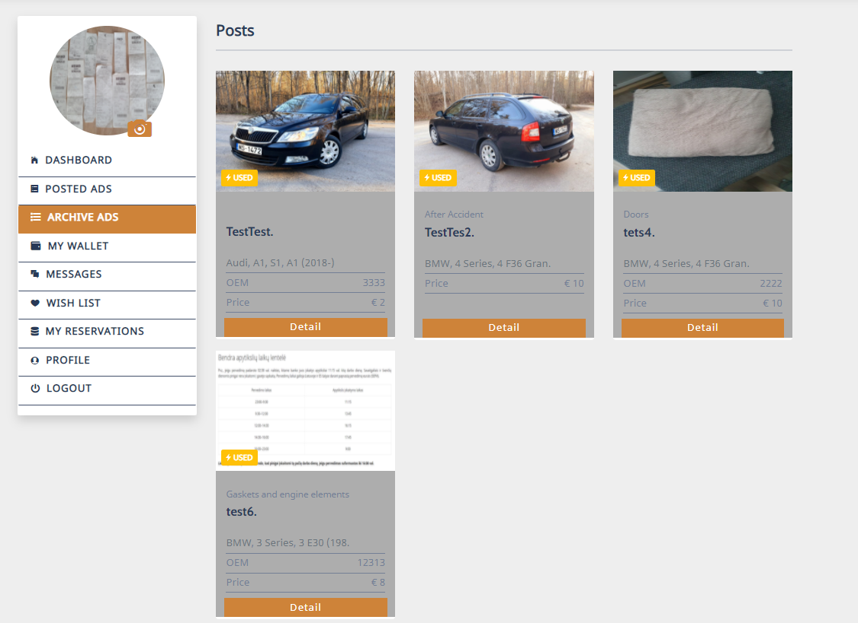

1. Please add commas after street, city, country

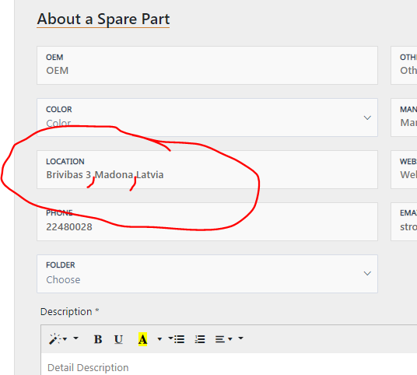

1. Can‘t zoom 2nd picture, only the first one.

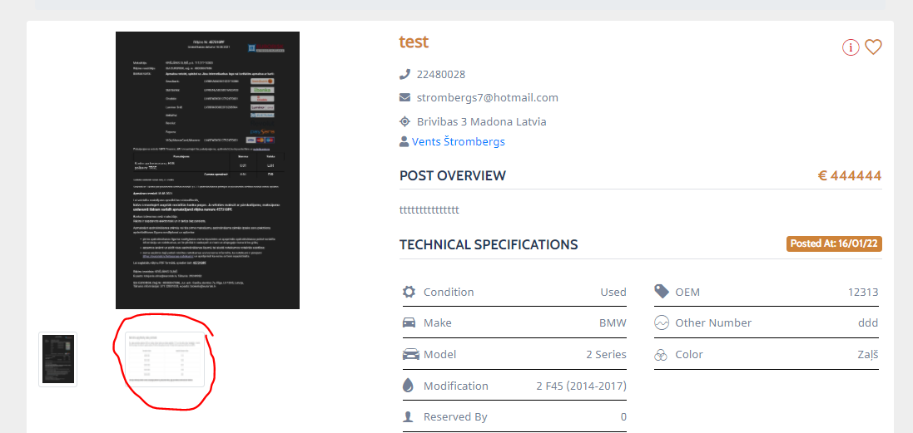

1. While posting an ad, please remove Color selection field for all categories **except – Bodywork; Rims; Cars.**

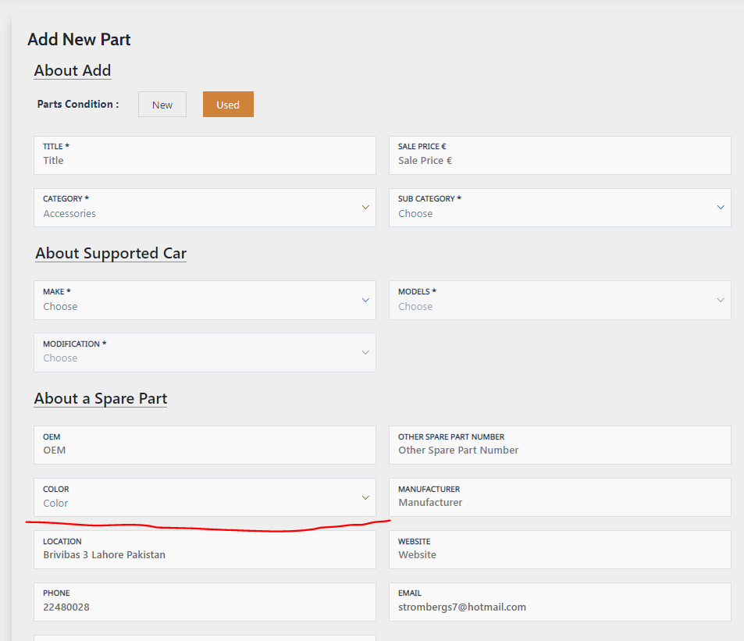

1. Please insert better car brand images for these ones:

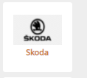 Attēls, kurā ir teksts

Apraksts ģenerēts automātiski Attēls, kurā ir teksts

Apraksts ģenerēts automātiski 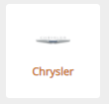

Also VAZ (Lada) logo needs to be changed to this one : 

1. Please change the template for the ads posted so the Make and model is in one line and the modification is in different line, currently full modification information is not visible  
   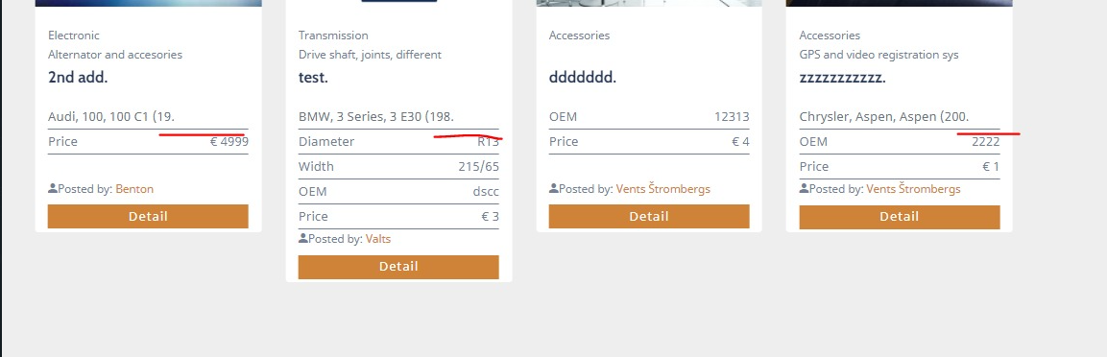  
   like this  
   Attēls, kurā ir teksts

   Apraksts ģenerēts automātiski
2. Right now if the Sub category exceeds 30 characters, full subcategory name is not visible. But to make it look not so bad, make an rule that **max characters are 25 and after them we want to see … (three dots).** This way it will be understandable that sentence continues.

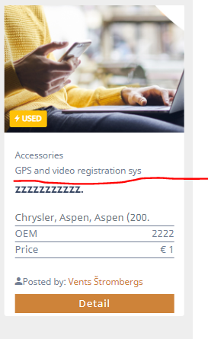

1. Gaps between images needs to be with the same width

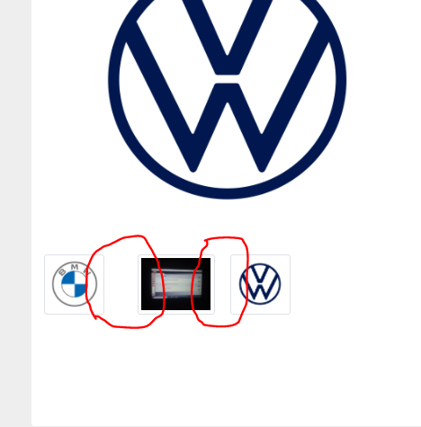

1. When I click on seller, I can see SOLD ads under his profile, but its not understandable that these ads are actually sold. So please add a ticket SOLD for these sold ads on the right top corner

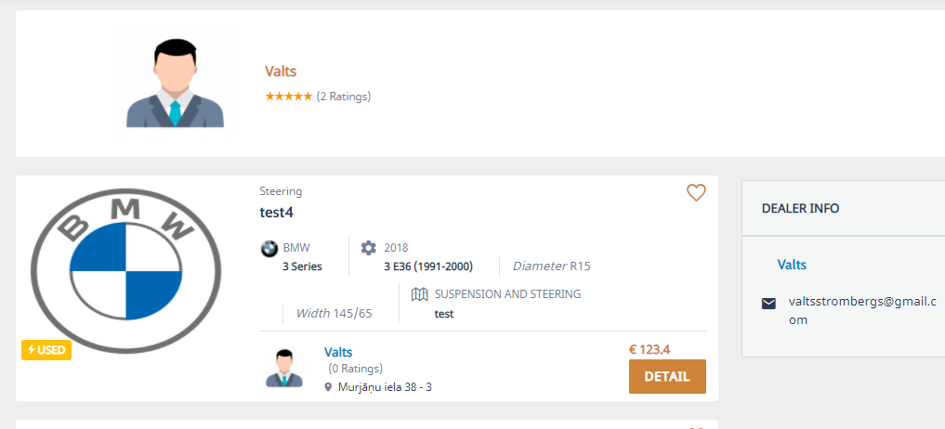

Ticket like this:

Attēls, kurā ir teksts, zīme

Apraksts ģenerēts automātiski

1. There still is compleate mess with chat when I **try to apply for different ads from one seller**. To avoid this issues **there needs to be a new chat opened for each part reserved, even if the ad is posted by the same person twice. Simply for each reserved ad we need new chat.**

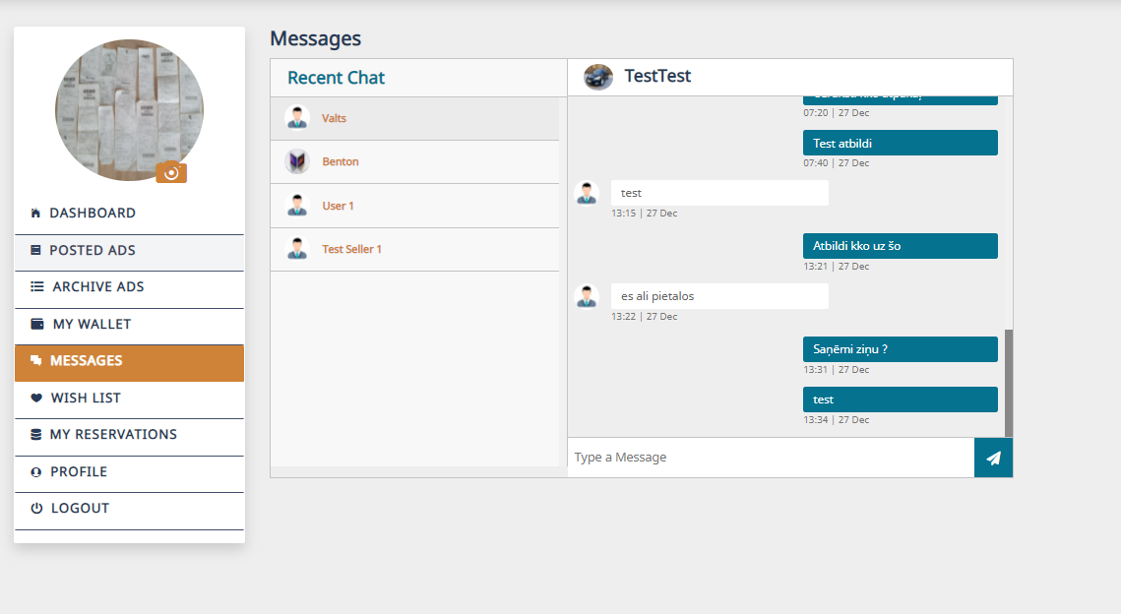

1. Row ad view needs be the main view, scatter as an option

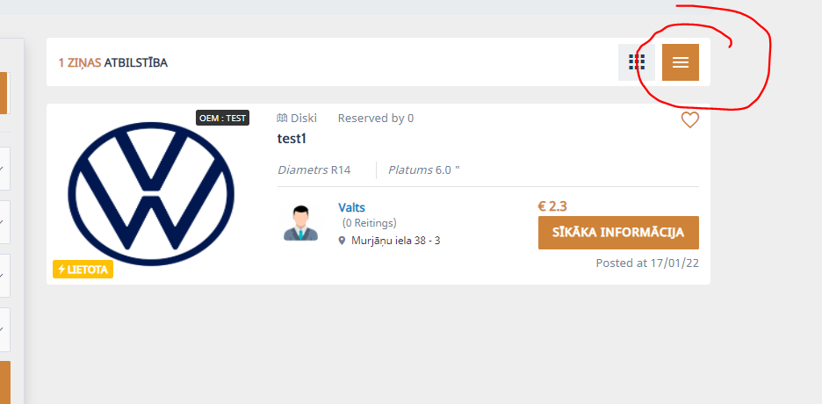

1. When I Submit review **its not visible**. Also Your rating of this seller **needs to be a mandetory field to fill**.

Attēls, kurā ir teksts

Apraksts ģenerēts automātiski

1. All ads needs to be one lenght

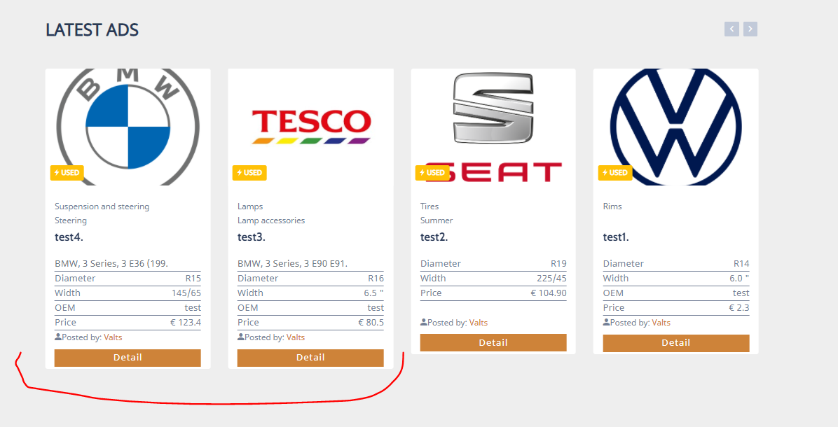

1. This is how ad information should look in row view for Tires:

* Ad title in the middle between category and diameter
* Tire season next to width
* Reserved by on the button

Attēls, kurā ir teksts

Apraksts ģenerēts automātiski

1. This is how ad information should look in row view for Rims:

* Ad title in the middle between category and diameter
* Tire season Bolt pattern to width
* Reserved by on the button

Attēls, kurā ir teksts

Apraksts ģenerēts automātiski

1. This is how ad information should look in row view for Rims:

* Ad title in the middle between category and make
* Make, model and modification in one line
* Reserved by on the button

Attēls, kurā ir teksts

Apraksts ģenerēts automātiski

1. **New ad row view styling** also needs to be visible the same way under seller profile information

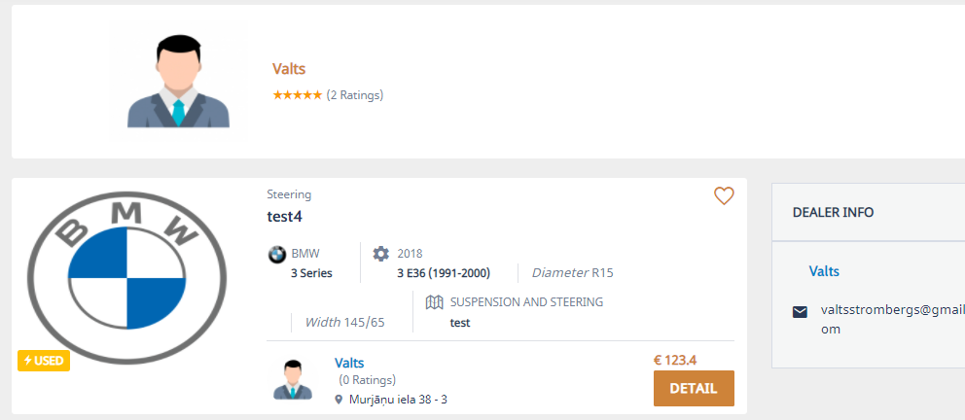

1. There needs to be an option for Archived ads to Edit. And while editing an option to Post this ad again.

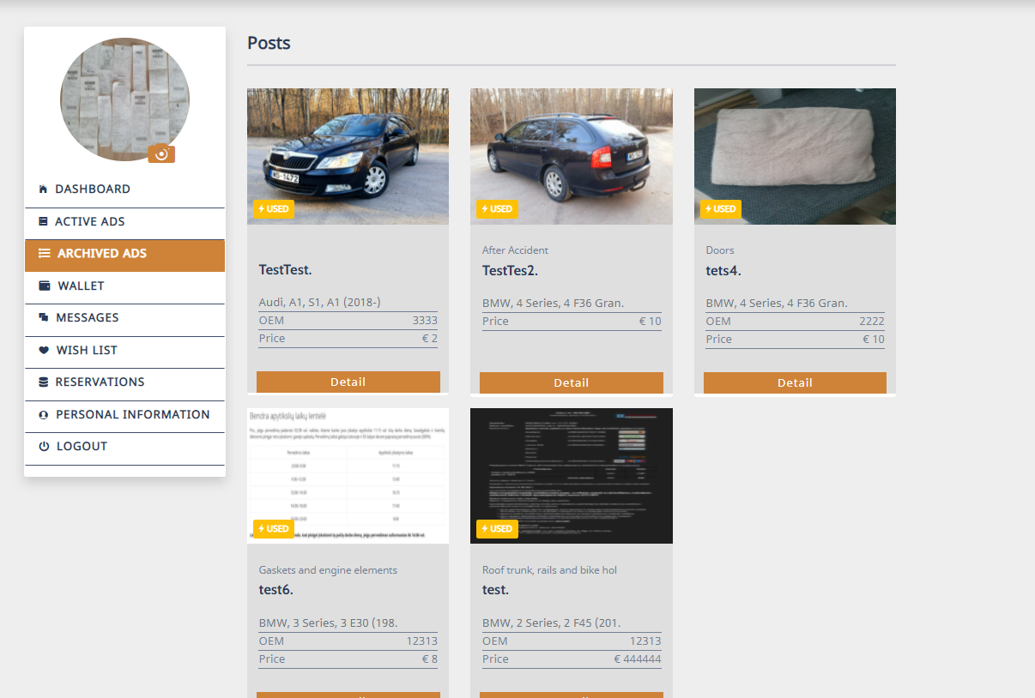

1. **Post Editing needs to work the same way as it works for Posting and ad !**

By example if I choose Category Rims I need to see fields like diameter and width etc.

We have send to you multiple times on feedbacks how Post an and function should work for each Category, just tie it all together with the rest if the webpage !

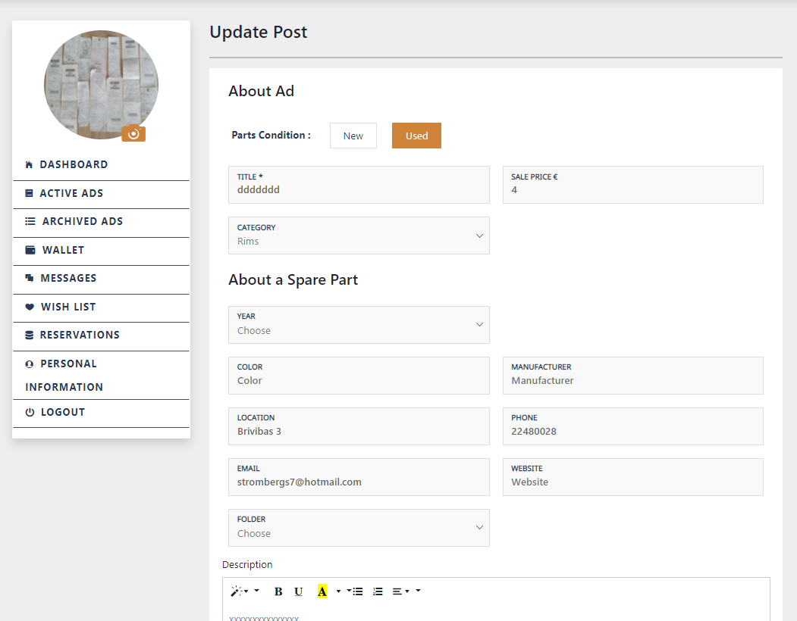

1. When we change language from ENG to different, ad discription information disappears.

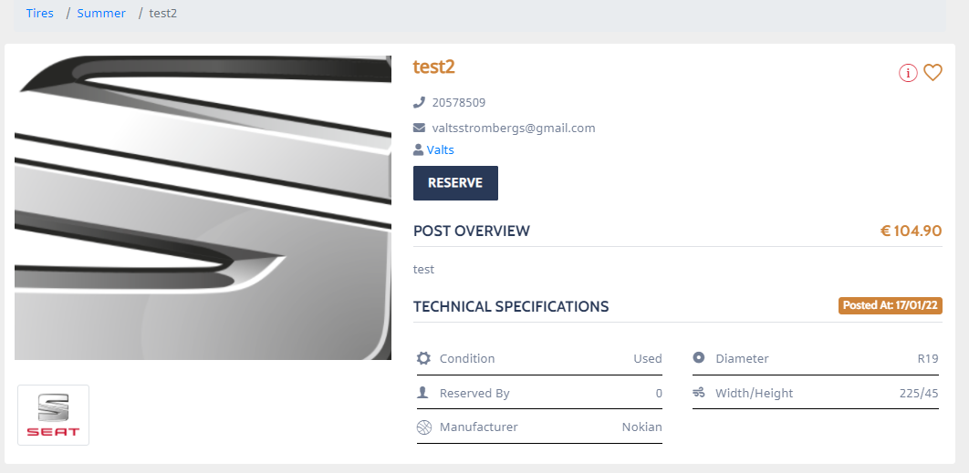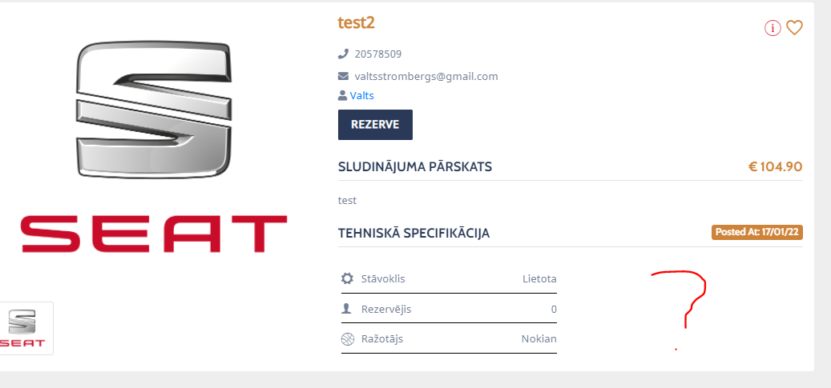Those issue are for multiple ads, something is not working right, please overlook webpage by yourself a bit detailed and you will see that overall sync is poor.

1. Please add another translation specificly for these two  
   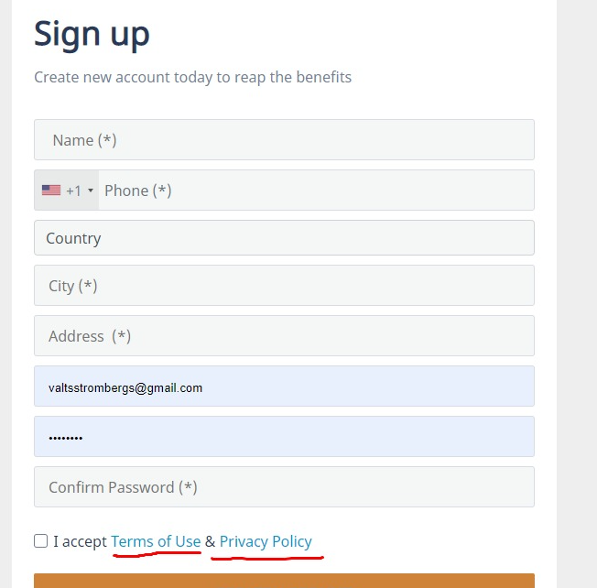  
   and under post and ad also  
   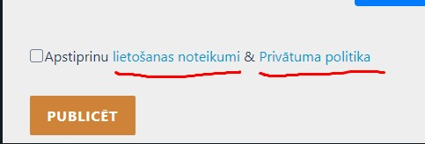
2. I ask you for the third time to remove the animation „smaller to big“ in the dashboard buttom where latest ads pops up form nowhere  
   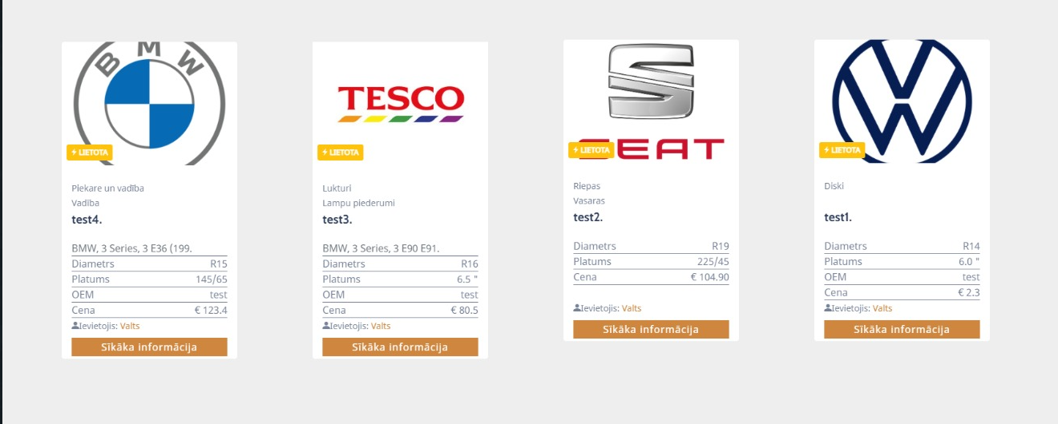
3. Add translation also for this  
   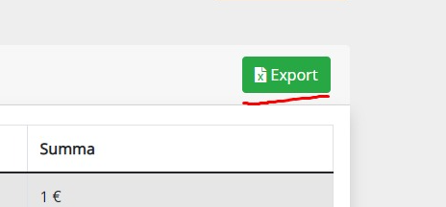
4. The font changes when we press post an ad  
   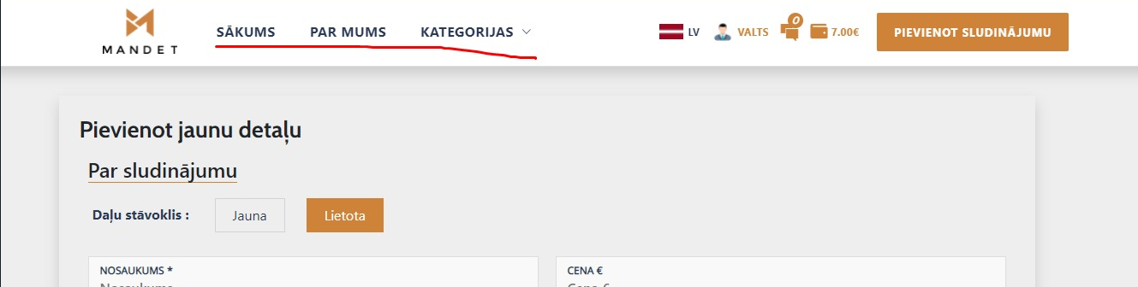
5. If we select edit an ad then the font changes   
   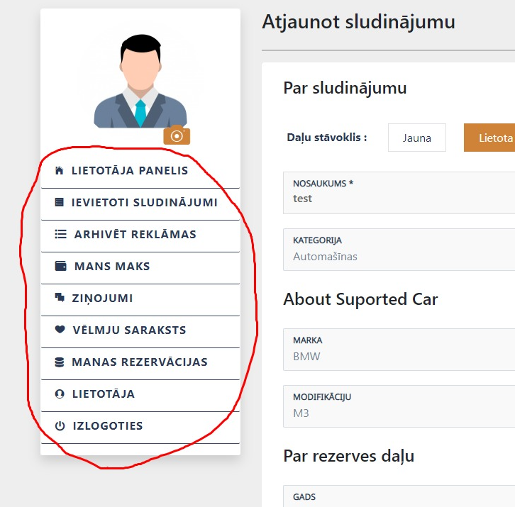
6. For „Edit an ad“ please translate these:  
   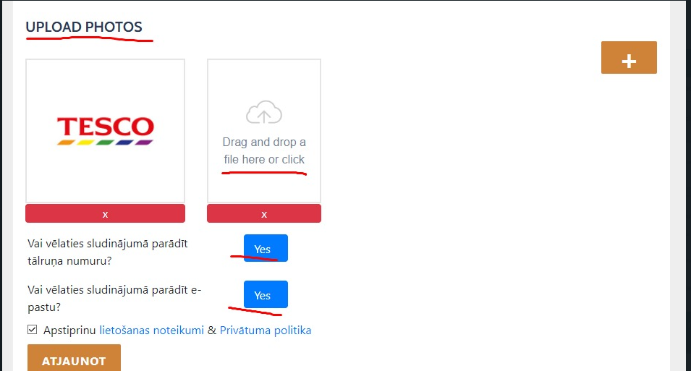  
   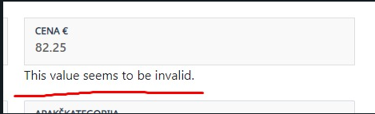
7. When we are trying to edit an ad we can‘t change price to decimals, please fix this  
   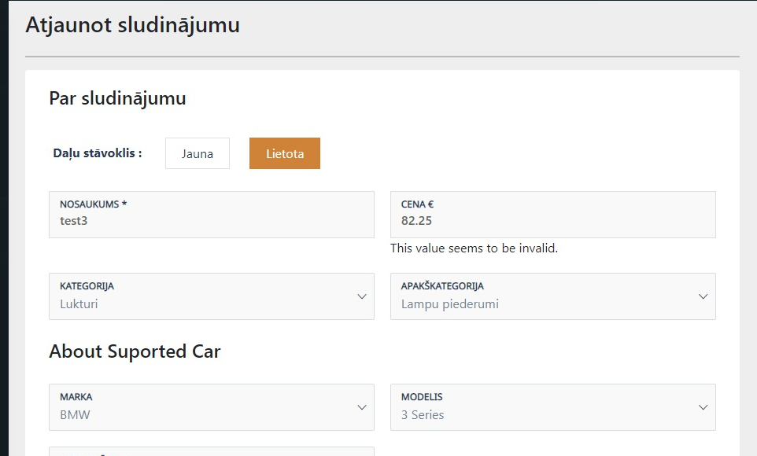
8. When you select post an ad please add another translation for Modification  
   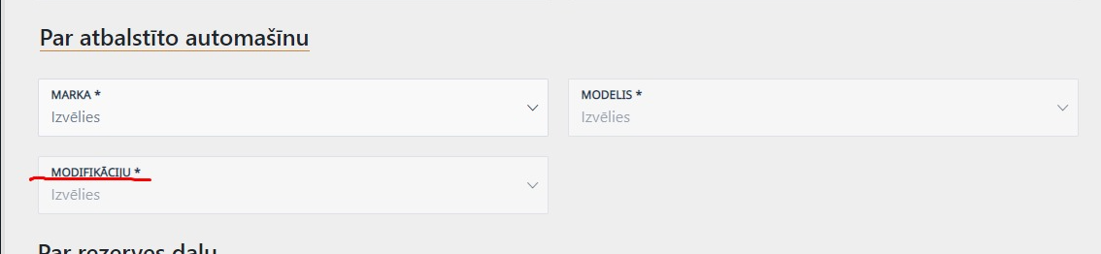
9. For Rims please change the distribution of the fields so everything looks in the correct place  
   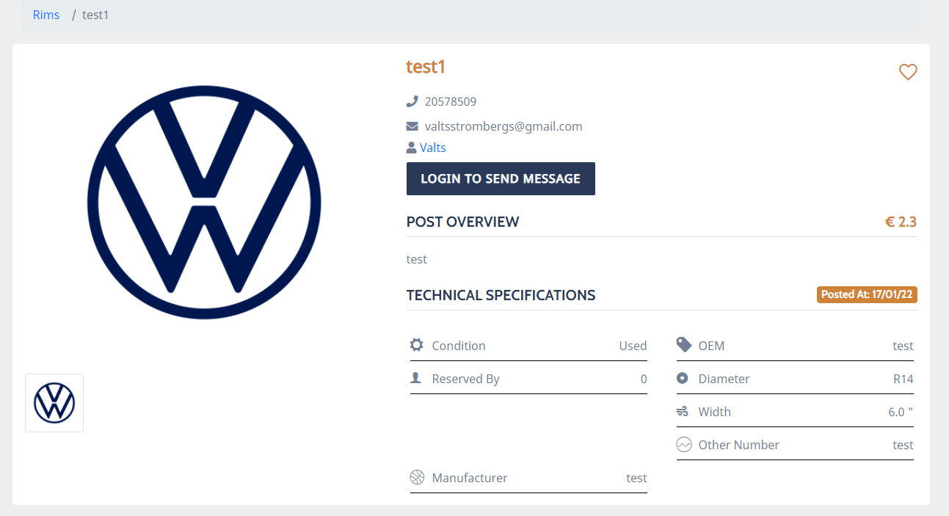
10. PLEASE ADD COLOR TRANSLATIONS!  
    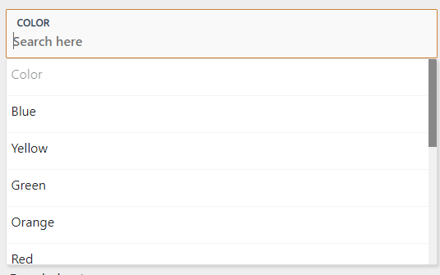
11. Please add motor liters to this section for „About the supported car  
    Graphical user interface, application

    Description automatically generated