**Company:** >>***strong entity***

create table Company

(

address_com varchar(20),

company_id number(10) primary key,

name_com varchar(10),

application varchar(4)

);

insert into company values('Germany',100,'Uber Tech','Uber');

insert into company values('India',101,'Paytm Inc','Pytm');

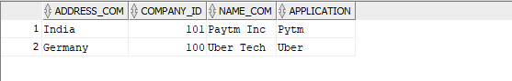

**Advertising_company:** >>***weak entity***

create table Advertisingcompany

( type varchar(10),

name_ad number(10) );

select * from advertising_company;

insert into Advertising_company values('Youtube',5);

insert into Advertising_company values('AdMob',5);

insert into Advertising_company values('Chrome',5);

alter table Advertisingcompany rename to Advertising_Company;

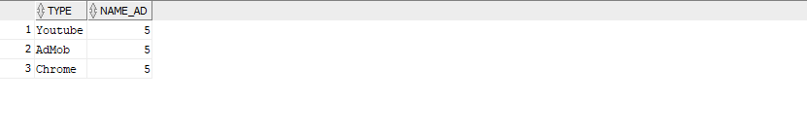

**Driver:** >> ***Strong entity***

create table driver

(

did int,

name_driver varchar(20),

phonenumber_driver varchar(10),

rate_driver int,

gender varchar(6)

);

alter table driver add driver_password varchar(10);

insert into driver values(1,'mahar sunil','1111111111',4,'Male','password');

insert into driver values(2,'Aditya Ganeshan','1111111111',3,'Male','password');

insert into driver values(3,'Manoz rayal','1111111111',1,'Male','password');

insert into driver values(4,'Sankala Sankeert','1111111111',2,'Female','password');

select * from driver;

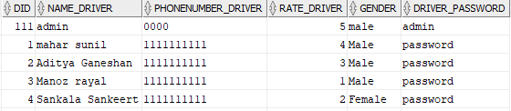

**Car:** >>***normal entity***

create table car

(

color varchar(10),

nodelno number(10),

carid number(5) primary key,

name_car varchar(10),

model varchar(10)

);

insert into car values('Red',800,'1','Maruti','800');

insert into car values('White',801,'2','hyundai','i10');

insert into car values('Blue',802,'3','hyundai','i20');

insert into car values('Black',803,'4','Nissan','Sunny');

insert into car values('Violet',804,'5','Ambassador','Hindusthan');

alter table car rename column nodelno to model_no;

alter table driver add primary key(did);

select*from car;

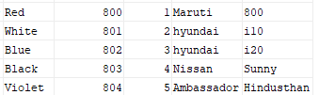



**Client:** >>***entity***

create table client

(

rate_client number(10),

password varchar(15) ,

phonenumber_client number(10) primary key,

clientid varchar(6) ,

location_client varchar(20)

);

insert into client values(4.5,'password',9876543210,1,'Rishikonda');

insert into client values(4,'password',9898989898,2,'MVP colony');

insert into client values(3,'password',9797979797,3,'Rama talkies');

insert into client values(4.9,'password',1215316211,11,'endada');

insert into client values(3.98,'password',1215316234,34,'Gitam');

select * from client;

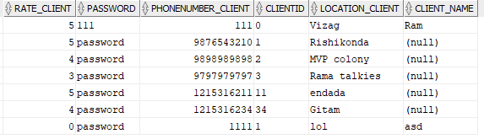

**Request:**  >>***weak entity***

create table Request

(

location char(20),

request_time varchar(10),

nearest_car varchar(10)

);

**Trip:** >>***entity***

create table trip

(

distance number(20),

tripid varchar(10) primary key,

pick_up varchar(5),

drop_off varchar(10)

);

**Parttime:**

create table parttime

( paddress varchar(20),

psalary float,

did number(6) primary key

);

alter table parttime

add foreign key (did) references driver(did);

commit;

**Contarct:**

create table contract

(

caddress varchar(20),

csalary Float,

did number(6));

alter table contract

add foreign key (did) references driver(did);

**Payfor:**>> ***identifying relationship***

create table payfor

(

name_ad number(10),

type varchar(10),

company_id number(10),

primary key(name_ad,company_id),

foreign key(company_id) references Company(company_id)

);

**Sendto:** >>***identifying relationship***

create table sendto

(

nearest_car varchar(10),

company_id number(10),

request_time varchar(10),

location char(20),

primary key(nearest_car,company_id),

foreign key(company_id) references Company(company_id)

);

**Recieves_a:**>> ***identifying relationship***

create table recieves_a

(

did int,

nearest_car varchar(10),

location char(20),

request_time varchar(10),

primary key(did,nearest_car),

foreign key(did) references driver

);

**Drives_a:**>> ***relationship***

create table drives_a

(

did int references driver(did),

carid number(5) references car(carid),

primary key(did,carid)

);

**Bill:** >>***relationship***

create table bill

( did int references driver(did),

phonenumber_client number(10) references client(phonenumber_client) ,

pmoney varchar(4) references paytmwallet,

umoney varchar(4) references uberwallet,

primary key(did,phonenumber_client,pmoney,umoney)

);

**Add_a:** >>***identifying relationship***

create table add_a

(

phonenumber_client number(10),

nearest_car varchar(10),

location char(20),

request_time varchar(10),

primary key(nearest_car,phonenumber_client),

foreign key(phonenumber_client) references client

);

**Has:** >>***relationship***

create table has

(

did int,

name_driv varchar(20),

phonenumber_driver number(10),

rate_driver number(5),

gender varchar(4),

tripid varchar(10),

primary key(did),

foreign key(phonenumber_client) references client

);

**Drivenby:** >>***relationship***

create table drivenby

(

owner_carid number(5),

employee_carid number(5),

primary key(owner_carid,employee_carid),

foreign key(owner_carid)references car(carid),

foreign key(employee_carid)references car(carid)

);

alter table payfor rename to pay_for;

alter table sendto rename to send_to;

alter table parttime rename to part_time;

alter table drivesa rename to drives_a;

**Paytmwallet:**

create table paytmwallet

(

pmoney varchar(4) primary key

);

**Uberwallet:**

create table uberwallet

(

umoney varchar(4) primary key

);

**Paidas:**

create table paidas

(

pmoney varchar(4) references paytmwallet,

umoney varchar(4) references uberwallet,

primary key(pmoney,umoney)

);