**CI/CD with Jenkins**

Jenkins: Lab Guide



This section will guide you to:

* Use labs for executing all the demos included in this course

This lab has two subsections, namely:

* + 1. Starting practice labs on LMS
    2. Using Jenkins and different software required for CI/CD with Jenkins

**Step 1:** Starting practice labs on LMS

* Log in to the Simplilearn LMS
* Navigate to the respective course and click on it
* You will see the course table of contents page on the left side of the screen. Click on **PRACTICE LABS**

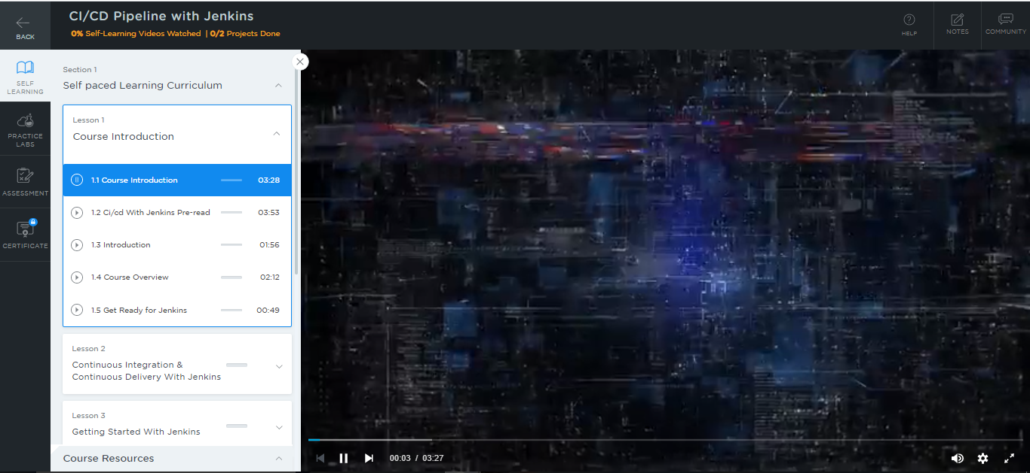

* A new window will open. Read the instructions and click on **LAUNCH LAB.** This will launch the practice labs for this course.

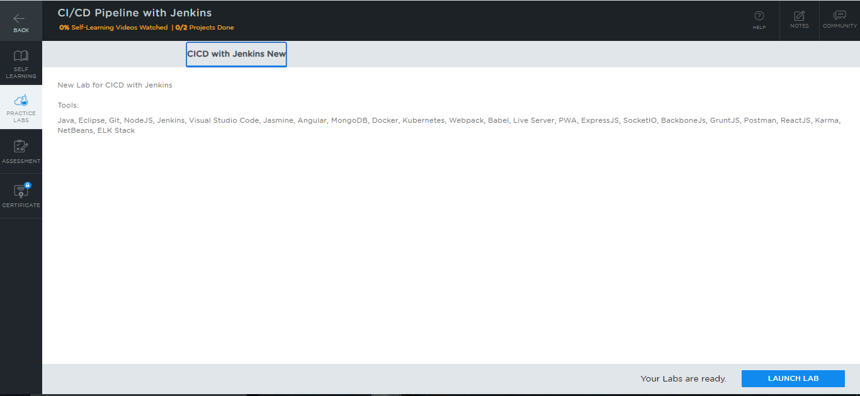

* You will be able to access IDEs and softwares which are present in the labs.

**Step 2:** Using Jenkins and different software required for CI/CD with Jenkins

**Jenkins:**

* Log in to Jenkins by opening your browser and navigating to **localhost:8081**
* Provide your username and password, and then click on **Log in**

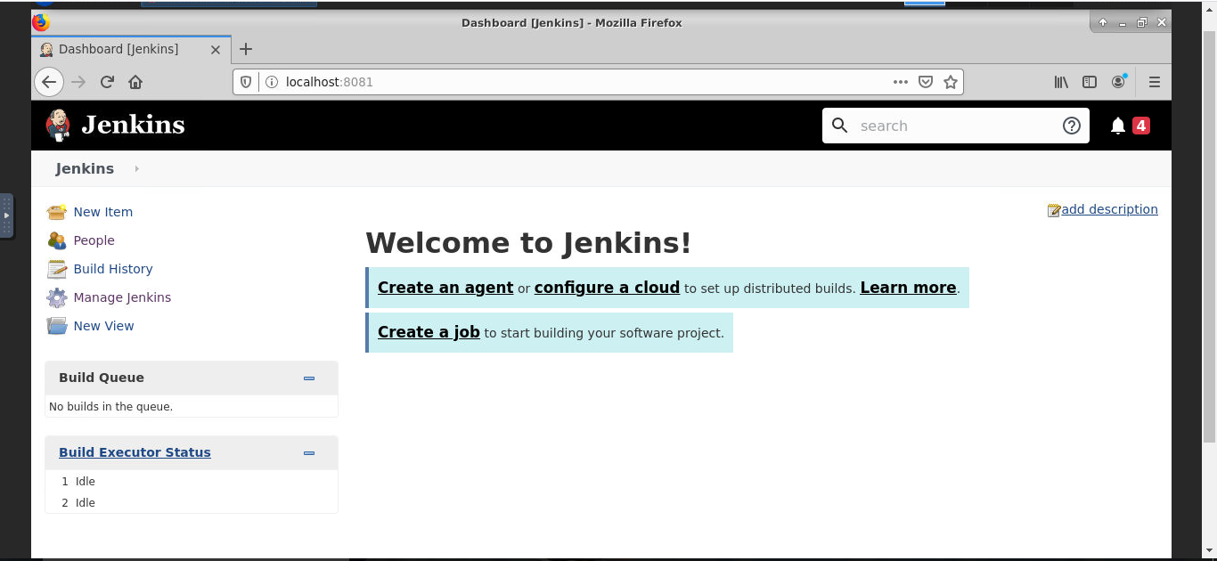

* If Jenkins is not installed in your system, then type the following commands:

*sudo apt-get update*

*sudo apt-get install openjdk-8-jre*

*wget –q –O - https://pkg.jenkins.io/debian/jenkins.io.key | sudo apt-key add –*

*sudo nano /etc/apt/sources.list*

* Scroll to the bottom of the **sources.list** file and add the following lines:

*# Jenkins software repository*

*deb https://pkg.jenkins.io/debian binary*

**Terminal:**

*sudo apt update*

*sudo apt install Jenkins*

*sudo systemctl status jenkins*

*sudo ufw allow 8080*

*sudo ufw status*

* If you have not configured the firewall, then it will display as **inactive** in the default UFW**.** Enable UFW by the following command:

*sudo ufw enable*

**JMeter:**

* To use JMeter, install the latest version of Java
* Select a directory where your JMeter root is located

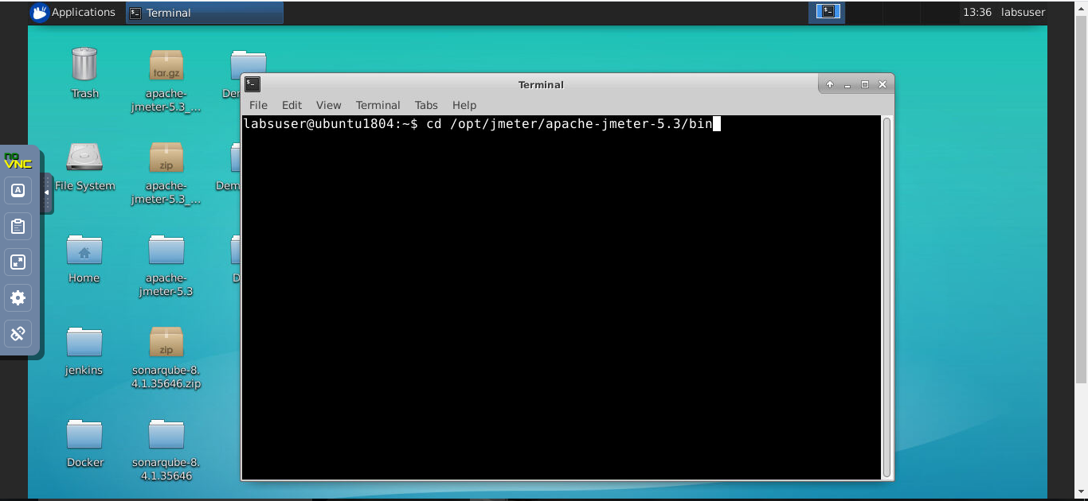

*$cd /opt/jmeter/apache-jmeter-5.3/bin/*

* Use the following command to run JMeter:

*$ ./jmeter*

**SonarQube:**

* SonarQube is already installed in the labs.
* Install SonarQube on your local system

Steps to setup **SonarQube**on a Windows machine:

1. Download the Community edition from [**https://www.sonarqube.org/downloads/**](https://www.sonarqube.org/downloads/)
2. Extract .zip file and navigate to the ***bin*** folder
3. Based on the machine configuration, go to the folders **windows-x86–32** and **windows-x86–64**
4. Run **StartSonar.bat** and after a few minutes, your SonarQube server will start
5. Navigate to [**http://localhost:9000/**](http://localhost:9000/)

The following SonarQube dashboard will appear:

