Royal Challengers Bangalore Report

Introduction
This document presents the SQL-based IPL analysis conducted to support Royal Challengers Bangalore (RCB) in evaluating player and team performance. It covers the given objective and subjective questions using SQL queries, outputs, visualizations where required, and analytical insights to support data-driven player selection and auction strategy.

Objective Questions

1. Question
List the different data types of columns in table “ball_by_ball”.

SQL Query
select
column_name,
data_type
from information_schema.columns
where table_schema = 'ipl'
and table_name = 'Ball_by_Ball';

SQL Output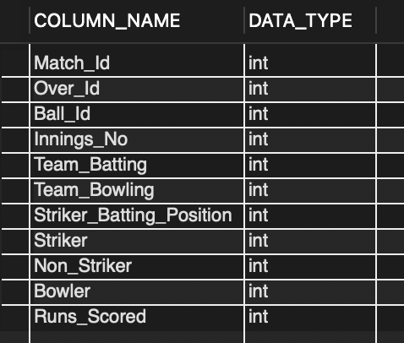

Brief Explanation
The query uses the information_schema.columns table to retrieve the column names and their corresponding data types from the Ball_by_Ball table. This helps identify the structure and data types of each column without querying the underlying match data.
- Visualization
Visualization: Not required, as this question focuses on
identifying the data types and structure of the
ball_by_ball table, which is best represented in
tabular form.

2. Question
What is the total number of runs scored in 1st season by RCB

SQL Query
with rcb_innings as (
select distinct
b.Match_Id,
b.Innings_No
from Ball_by_Ball b
join Matches m
on b.Match_Id = m.Match_Id
where b.Team_Batting = (
select Team_Id
from Team
where Team_Name = 'Royal Challengers Bangalore'
)
and m.Season_Id = (
select min(Season_Id)
from Matches
)
),
rcb_batting as (
select
sum(b.Runs_Scored) as batting_runs
from Ball_by_Ball b
join rcb_innings r
on b.Match_Id = r.Match_Id
and b.Innings_No = r.Innings_No
),
rcb_extras as (
select
sum(e.Extra_Runs) as extra_runs
from Extra_Runs e
join rcb_innings r
on e.Match_Id = r.Match_Id
and e.Innings_No = r.Innings_No
)
select
r.batting_runs as rcb_batting_runs,
r2.extra_runs as rcb_extra_runs,
r.batting_runs + r2.extra_runs as total_rcb_runs
from rcb_batting r
cross join rcb_extras r2;

SQL Output
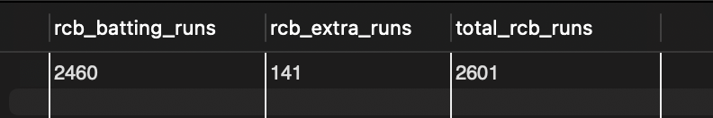

Brief Explanation
The query calculates the total runs scored by Royal Challengers Bangalore in their first available season, including both runs scored from deliveries and extra runs. It combines the batting runs with the corresponding extra runs to provide the complete run total for the season.

3. Question
How many players were more than the age of 25 during season 2014?

SQL Query
select
count(distinct p.player_id) as players_above_25
from player p
join player_match pm
on p.player_id = pm.player_id
join matches m
on pm.match_id = m.match_id
join season s
on m.season_id = s.season_id
where s.season_year = 2014
and timestampdiff(year, p.dob, m.match_date) > 25;

SQL Output
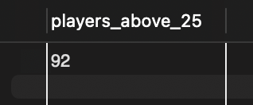

Brief Explanation
The query calculates the number of players who were above 25 years of age during the 2014 season. It uses the players' date of birth and the 2014 season information to determine their age and counts only those players who were older than 25.

4. Question
How many matches did RCB win in 2013?

SQL Query
select
count(*) as rcb_wins
from matches m
join season s
on m.season_id = s.season_id
join team t
on m.match_winner = t.team_id
where s.season_year = 2013
and t.team_name = 'Royal Challengers Bangalore';

SQL Output
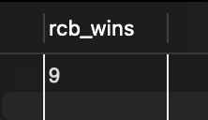

Brief Explanation
The query identifies matches played by Royal Challengers Bangalore in the 2013 season and counts the matches where RCB was the winning team. This gives the total number of matches won by RCB during the 2013 season.

5. Question
List the top 10 players according to their strike rate in the last 4
seasons

SQL Query
with last_4_seasons as (
select
season_id,
season_year
from season
order by season_year desc
limit 4
),
player_stats as (
select
p.player_id,
p.player_name,
sum(b.runs_scored) as total_runs,
count(b.ball_id) as balls_faced
from ball_by_ball b
join matches m
on b.match_id = m.match_id
join last_4_seasons s
on m.season_id = s.season_id
join player p
on b.striker = p.player_id
left join extra_runs e
on b.match_id = e.match_id
and b.over_id = e.over_id
and b.ball_id = e.ball_id
and b.innings_no = e.innings_no
left join extra_type et
on e.extra_type_id = et.extra_id
where et.extra_name is null
or et.extra_name not in ('wides', 'noballs')
group by
p.player_id,
p.player_name
)
select
player_id,
player_name,
total_runs,
balls_faced,
round(total_runs / balls_faced * 100, 2) as strike_rate
from player_stats
where balls_faced >= 500
order by strike_rate desc
limit 10;

SQL Output

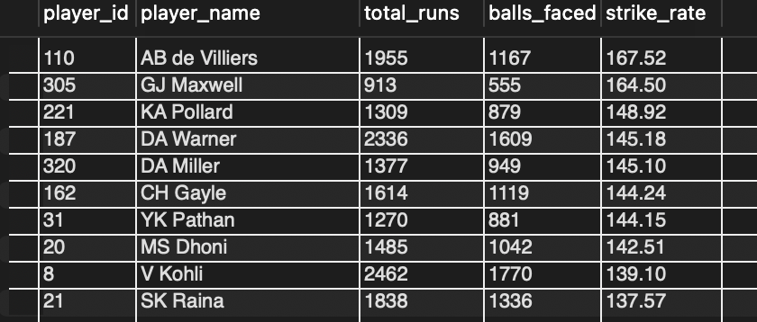

Brief Explanation
The query calculates player strike rates over the last four seasons and ranks the top 10 players. A minimum of 500 balls faced is used to ensure a reliable comparison based on sufficient batting opportunities.

6. Question
What are the average runs scored by each batsman considering all
the seasons?

SQL Query
with player_season_runs as (
select
b.striker as player_id,
m.season_id,
sum(b.runs_scored) as season_runs
from ball_by_ball b
join matches m
on b.match_id = m.match_id
group by
b.striker,
m.season_id
)
select
p.player_id,
p.player_name,
round(avg(psr.season_runs), 2) as average_runs
from player_season_runs psr
join player p
on psr.player_id = p.player_id
group by
p.player_id,
p.player_name
order by
average_runs desc;

SQL Output
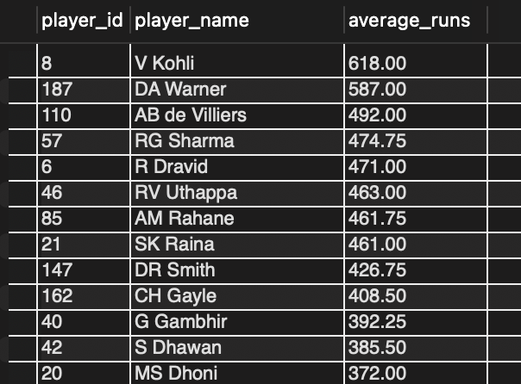

Brief Explanation
The query calculates the average runs scored by each batsman across all available seasons. It groups the batting records by player and computes the average runs scored, allowing comparison of the batsmen based on their overall scoring performance.

7. Question
What are the average wickets taken by each bowler considering all
the seasons?

SQL Query
with bowler_seasons as (
select distinct
b.bowler as player_id,
m.season_id
from ball_by_ball b
join matches m
on b.match_id = m.match_id
),
season_wickets as (
select
b.bowler as player_id,
m.season_id,
count(*) as season_wickets
from wicket_taken w
join ball_by_ball b
on w.match_id = b.match_id
and w.over_id = b.over_id
and w.ball_id = b.ball_id
and w.innings_no = b.innings_no
join matches m
on b.match_id = m.match_id
where w.kind_out in (
select out_id
from out_type
where out_name in (
'caught',
'bowled',
'lbw',
'stumped',
'caught and bowled',
'hit wicket'
)
)
group by
b.bowler,
m.season_id
)
select
p.player_id,
p.player_name,
round(avg(coalesce(sw.season_wickets, 0)), 2) as average_wickets
from bowler_seasons bs
join player p
on bs.player_id = p.player_id
left join season_wickets sw
on bs.player_id = sw.player_id
and bs.season_id = sw.season_id
group by
p.player_id,
p.player_name
order by
average_wickets desc;

SQL Output
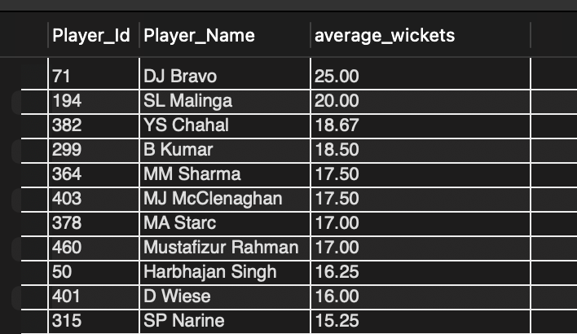

Brief Explanation
The query calculates each bowler's average wickets across all seasons they bowled, including seasons with zero wickets. This provides a more complete comparison of their overall bowling performance.

8. Question
List all the players who have average runs scored greater than the
overall average and who have taken wickets greater than the overall
average

SQL Query
with player_season_runs as (
select
b.Striker as player_id,
m.Season_Id,
sum(b.Runs_Scored) as season_runs
from Ball_by_Ball b
join Matches m
on b.Match_Id = m.Match_Id
group by
b.Striker,
m.Season_Id
),

player_average_runs as (
select
p.Player_Id,
p.Player_Name,
round(avg(psr.season_runs), 2) as average_runs
from player_season_runs psr
join Player p
on psr.player_id = p.Player_Id
group by
p.Player_Id,
p.Player_Name
),

bowler_season_wickets as (
select
b.Bowler as player_id,
m.Season_Id,
count(*) as season_wickets
from Wicket_Taken w
join Ball_by_Ball b
on w.Match_Id = b.Match_Id
and w.Over_Id = b.Over_Id
and w.Ball_Id = b.Ball_Id
and w.Innings_No = b.Innings_No
join Matches m
on w.Match_Id = m.Match_Id
where w.Kind_Out in (
select Out_Id
from Out_Type
where Out_Name in (
'caught',
'bowled',
'lbw',
'stumped',
'caught and bowled',
'hit wicket'
)
)
group by
b.Bowler,
m.Season_Id
),

player_average_wickets as (
select
p.Player_Id,
p.Player_Name,
round(avg(bsw.season_wickets), 2) as average_wickets
from bowler_season_wickets bsw
join Player p
on bsw.player_id = p.Player_Id
group by
p.Player_Id,
p.Player_Name
),

overall_averages as (
select
avg(average_runs) as overall_average_runs,
(
select avg(average_wickets)
from player_average_wickets
) as overall_average_wickets
from player_average_runs
)

select
r.Player_Id,
r.Player_Name,
r.average_runs,
w.average_wickets
from player_average_runs r
join player_average_wickets w
on r.Player_Id = w.Player_Id
cross join overall_averages oa
where r.average_runs > oa.overall_average_runs
and w.average_wickets > oa.overall_average_wickets
order by
r.average_runs desc,
w.average_wickets desc;

SQL Output
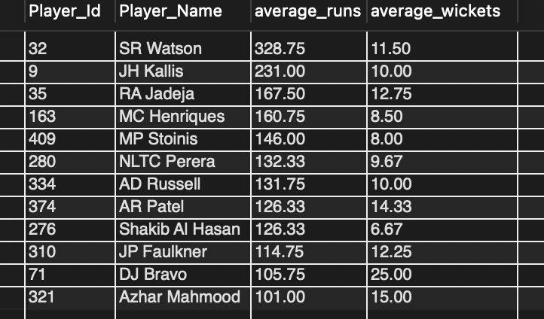

Brief Explanation
The query calculates each player's average runs and average wickets across all available seasons and compares them with the respective overall averages. It then lists players whose average runs and average wickets are both higher than the overall averages, identifying players who have demonstrated strong performance with both bat and ball.

9. Question
Create a table rcb_record table that shows the wins and losses of RCB
in an individual venue.

SQL Query
create table rcb_record as
select
v.Venue_Name,
sum(
case
when m.Match_Winner = (
select Team_Id
from Team
where Team_Name = 'Royal Challengers Bangalore'
)
then 1
else 0
end
) as wins,
sum(
case
when m.Match_Winner is not null
and m.Match_Winner <> (
select Team_Id
from Team
where Team_Name = 'Royal Challengers Bangalore'
)
then 1
else 0
end
) as losses
from Matches m
join Venue v
on m.Venue_Id = v.Venue_Id
where
m.Team_1 = (
select Team_Id
from Team
where Team_Name = 'Royal Challengers Bangalore'
)
or m.Team_2 = (
select Team_Id
from Team
where Team_Name = 'Royal Challengers Bangalore'
)
group by
v.Venue_Id,
v.Venue_Name;

select * from rcb_record;

SQL Output
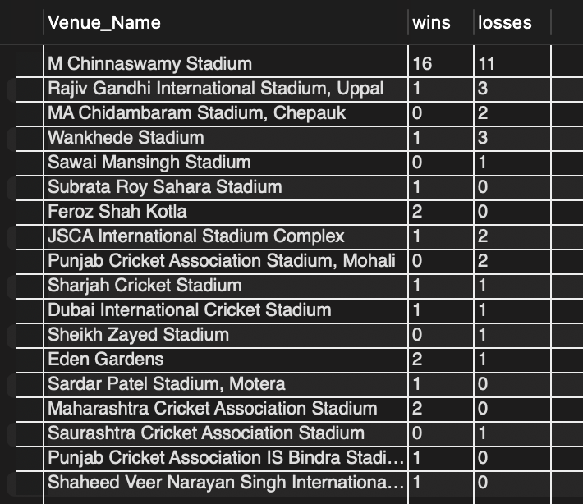

Brief Explanation
The query creates the rcb_record table to summarize Royal Challengers Bangalore's wins and losses at each venue. It groups the match results by venue and calculates the number of wins and losses, helping evaluate RCB's performance across different venues.

10. Question
What is the impact of bowling style on wickets taken?

SQL Query
select
bs.Bowling_skill as bowling_style,
count(distinct case
when ot.Out_Name in (
'caught',
'bowled',
'lbw',
'stumped',
'caught and bowled',
'hit wicket'
)
then concat(
w.Match_Id,
'-',
w.Over_Id,
'-',
w.Ball_Id,
'-',
w.Innings_No
)
end) as wickets_taken,
count(distinct case
when et.Extra_Name not in ('wides', 'noballs')
or et.Extra_Name is null
then concat(
b.Match_Id,
'-',
b.Over_Id,
'-',
b.Ball_Id,
'-',
b.Innings_No
)
end) as legal_balls_bowled,
round(
count(distinct case
when ot.Out_Name in (
'caught',
'bowled',
'lbw',
'stumped',
'caught and bowled',
'hit wicket'
)
then concat(
w.Match_Id,
'-',
w.Over_Id,
'-',
w.Ball_Id,
'-',
w.Innings_No
)
end) * 100.0
/
count(distinct case
when et.Extra_Name not in ('wides', 'noballs')
or et.Extra_Name is null
then concat(
b.Match_Id,
'-',
b.Over_Id,
'-',
b.Ball_Id,
'-',
b.Innings_No
)
end),
2
) as wickets_per_100_balls
from Ball_by_Ball b
join Player p
on b.Bowler = p.Player_Id
join Bowling_Style bs
on p.Bowling_skill = bs.Bowling_Id
left join Wicket_Taken w
on w.Match_Id = b.Match_Id
and w.Over_Id = b.Over_Id
and w.Ball_Id = b.Ball_Id
and w.Innings_No = b.Innings_No
left join Out_Type ot
on w.Kind_Out = ot.Out_Id
left join Extra_Runs er
on b.Match_Id = er.Match_Id
and b.Over_Id = er.Over_Id
and b.Ball_Id = er.Ball_Id
and b.Innings_No = er.Innings_No
left join Extra_Type et
on er.Extra_Type_Id = et.Extra_Id
group by
bs.Bowling_Id,
bs.Bowling_skill
order by
wickets_per_100_balls desc;

SQL Output
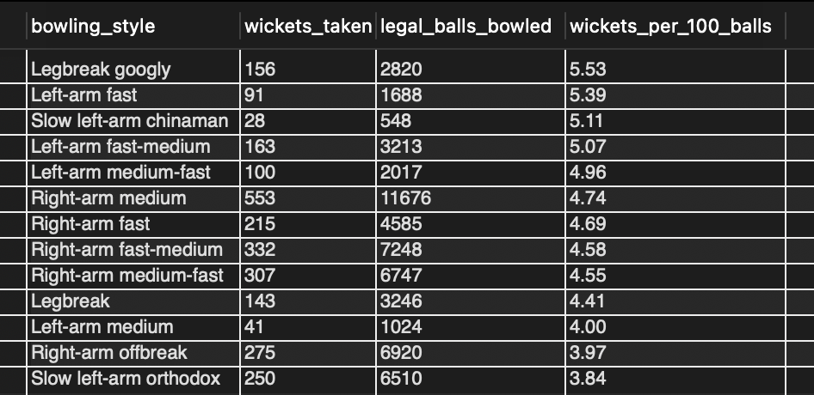

Brief Explanation
The query compares bowling styles based on wickets taken and wickets per 100 legal balls. Wickets per 100 balls provides a fair measure of wicket-taking effectiveness across different bowling styles.

11. Question
Write the SQL query to provide a status of whether the
performance of the team is better than the previous year's
performance on the basis of the number of runs scored by
the team in the season and the number of wickets taken

SQL Query
with season_runs as (
select
s.Season_Year,
sum(b.Runs_Scored) as total_runs
from Ball_by_Ball b
join Matches m
on b.Match_Id = m.Match_Id
join Season s
on m.Season_Id = s.Season_Id
where b.Team_Batting = (
select Team_Id
from Team
where Team_Name = 'Royal Challengers Bangalore'
)
group by s.Season_Year
),

season_wickets as (
select
s.Season_Year,
count(*) as total_wickets
from Wicket_Taken w
join Ball_by_Ball b
on w.Match_Id = b.Match_Id
and w.Over_Id = b.Over_Id
and w.Ball_Id = b.Ball_Id
and w.Innings_No = b.Innings_No
join Matches m
on w.Match_Id = m.Match_Id
join Season s
on m.Season_Id = s.Season_Id
where b.Team_Bowling = (
select Team_Id
from Team
where Team_Name = 'Royal Challengers Bangalore'
)
and w.Kind_Out in (
select Out_Id
from Out_Type
where Out_Name in (
'caught',
'bowled',
'lbw',
'stumped',
'caught and bowled',
'hit wicket'
)
)
group by s.Season_Year
),

season_performance as (
select
r.Season_Year,
r.total_runs,
w.total_wickets
from season_runs r
join season_wickets w
on r.Season_Year = w.Season_Year
),

performance_comparison as (
select
Season_Year,
total_runs,
total_wickets,
lag(total_runs) over (order by Season_Year) as previous_year_runs,
lag(total_wickets) over (order by Season_Year) as previous_year_wickets
from season_performance
)

select
Season_Year,
total_runs,
total_wickets,
previous_year_runs,
previous_year_wickets,
case
when previous_year_runs is null then 'No Previous Season'
when total_runs > previous_year_runs
and total_wickets > previous_year_wickets
then 'Better'
else 'Not Better'
end as performance_status
from performance_comparison
order by Season_Year;

SQL Output
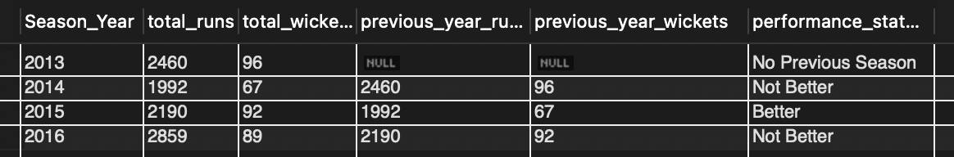

Brief Explanation
The query compares the team's total runs scored and wickets taken in each season with the previous season's performance. It uses the previous season's values as a benchmark to determine whether the team's overall performance improved or declined based on both runs and wickets.

12. Question
Can you derive more KPIs for the team strategy?

SQL Query
with rcb_matches as (
select
s.Season_Year,
count(distinct m.Match_Id) as matches_played,
count(
distinct case
when m.Match_Winner = (
select Team_Id
from Team
where Team_Name = 'Royal Challengers Bangalore'
)
then m.Match_Id
end
) as matches_won
from Matches m
join Season s
on m.Season_Id = s.Season_Id
where m.Team_1 = (
select Team_Id
from Team
where Team_Name = 'Royal Challengers Bangalore'
)
or m.Team_2 = (
select Team_Id
from Team
where Team_Name = 'Royal Challengers Bangalore'
)
group by s.Season_Year
),

rcb_batting_runs as (
select
s.Season_Year,
sum(b.Runs_Scored) as batting_runs
from Ball_by_Ball b
join Matches m
on b.Match_Id = m.Match_Id
join Season s
on m.Season_Id = s.Season_Id
where b.Team_Batting = (
select Team_Id
from Team
where Team_Name = 'Royal Challengers Bangalore'
)
group by s.Season_Year
),

rcb_innings as (
select distinct
b.Match_Id,
b.Innings_No
from Ball_by_Ball b
join Matches m
on b.Match_Id = m.Match_Id
join Season s
on m.Season_Id = s.Season_Id
where b.Team_Batting = (
select Team_Id
from Team
where Team_Name = 'Royal Challengers Bangalore'
)
),

rcb_extra_runs as (
select
s.Season_Year,
sum(e.Extra_Runs) as extra_runs
from Extra_Runs e
join rcb_innings r
on e.Match_Id = r.Match_Id
and e.Innings_No = r.Innings_No
join Matches m
on e.Match_Id = m.Match_Id
join Season s
on m.Season_Id = s.Season_Id
group by s.Season_Year
),

rcb_wickets as (
select
s.Season_Year,
count(*) as total_wickets
from Wicket_Taken w
join Ball_by_Ball b
on w.Match_Id = b.Match_Id
and w.Over_Id = b.Over_Id
and w.Ball_Id = b.Ball_Id
and w.Innings_No = b.Innings_No
join Matches m
on w.Match_Id = m.Match_Id
join Season s
on m.Season_Id = s.Season_Id
where b.Team_Bowling = (
select Team_Id
from Team
where Team_Name = 'Royal Challengers Bangalore'
)
and w.Kind_Out in (
select Out_Id
from Out_Type
where Out_Name in (
'caught',
'bowled',
'lbw',
'stumped',
'caught and bowled',
'hit wicket'
)
)
group by s.Season_Year
)

select
m.Season_Year,
m.matches_played,
m.matches_won,
round(m.matches_won * 100.0 / m.matches_played, 2) as win_percentage,
r.batting_runs + coalesce(e.extra_runs, 0) as total_runs,
round(
(r.batting_runs + coalesce(e.extra_runs, 0))
/ m.matches_played,
2
) as average_runs_per_match,
w.total_wickets,
round(w.total_wickets / m.matches_played, 2) as average_wickets_per_match
from rcb_matches m
join rcb_batting_runs r
on m.Season_Year = r.Season_Year
left join rcb_extra_runs e
on m.Season_Year = e.Season_Year
join rcb_wickets w
on m.Season_Year = w.Season_Year
order by m.Season_Year;

SQL Output
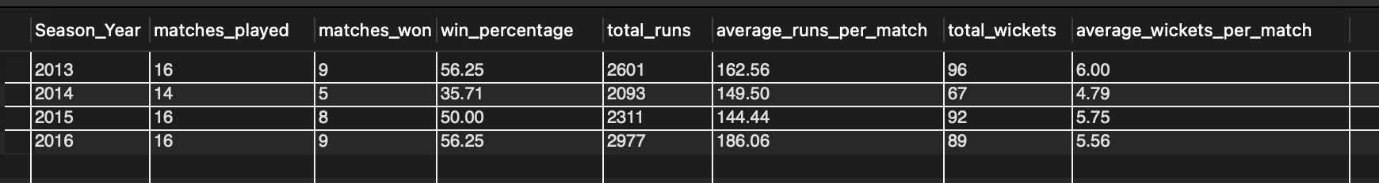

Brief Explanation
The query derives additional key performance indicators (KPIs) to evaluate RCB's overall team performance across seasons. These KPIs provide a broader view of the team's batting, bowling, and match performance and help identify areas that can support data-driven team strategy.

Visualization
RCB Win Percentage Across Seasons
The line chart shows the variation in RCB's win percentage
across seasons, highlighting the team's strongest and weakest
seasons.
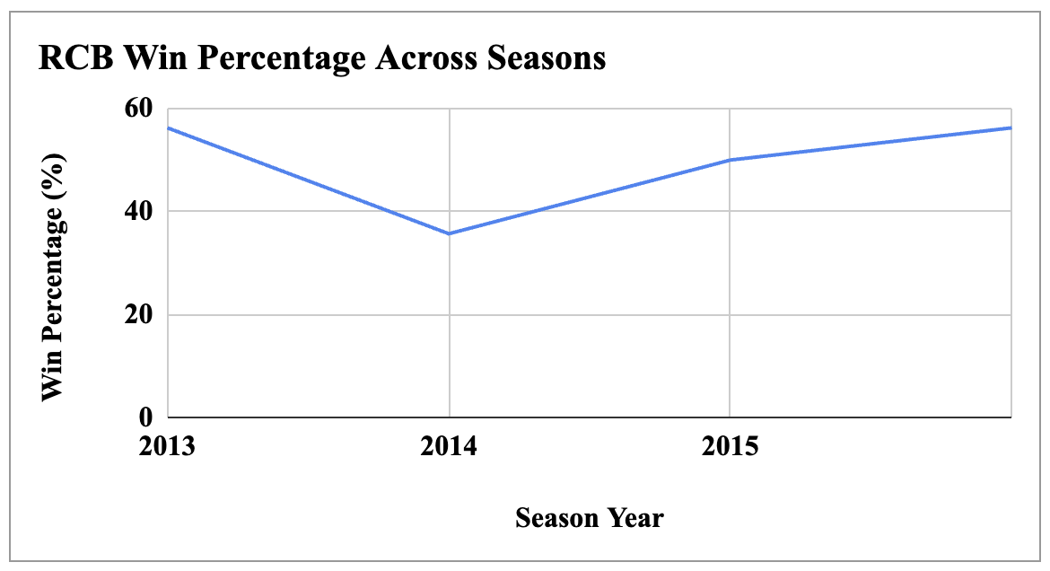

13. Question
Using SQL, write a query to find out the average wickets taken by
each bowler in each venue. Also, rank the gender according to the
average value.

SQL Query
with bowler_matches as (
select distinct
b.Bowler,
m.Venue_Id,
b.Match_Id
from Ball_by_Ball b
join Matches m
on b.Match_Id = m.Match_Id
),

match_wickets as (
select
b.Bowler,
b.Match_Id,
m.Venue_Id,
count(*) as wickets_taken
from Wicket_Taken w
join Ball_by_Ball b
on w.Match_Id = b.Match_Id
and w.Over_Id = b.Over_Id
and w.Ball_Id = b.Ball_Id
and w.Innings_No = b.Innings_No
join Matches m
on b.Match_Id = m.Match_Id
group by
b.Bowler,
b.Match_Id,
m.Venue_Id
),

bowler_venue_average as (
select
bm.Bowler,
bm.Venue_Id,
round(avg(coalesce(mw.wickets_taken, 0)), 2) as average_wickets
from bowler_matches bm
left join match_wickets mw
on bm.Bowler = mw.Bowler
and bm.Match_Id = mw.Match_Id
and bm.Venue_Id = mw.Venue_Id
group by
bm.Bowler,
bm.Venue_Id
)

select
bva.Bowler,
p.Player_Name,
v.Venue_Name,
bva.average_wickets,
dense_rank() over (
partition by bva.Venue_Id
order by bva.average_wickets desc
) as wicket_rank
from bowler_venue_average bva
join Player p
on bva.Bowler = p.Player_Id
join Venue v
on bva.Venue_Id = v.Venue_Id
order by
v.Venue_Name,
wicket_rank,
p.Player_Name;

SQL Output
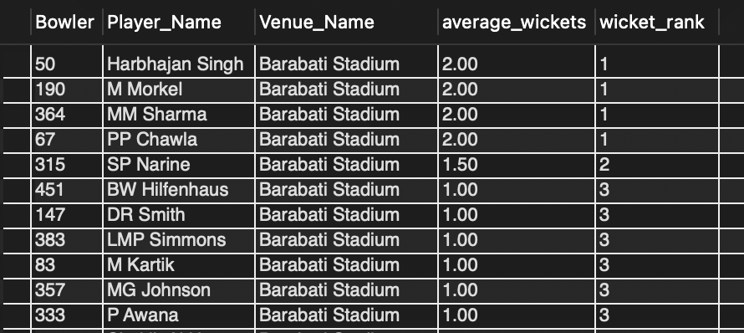

Brief Explanation
The query calculates the average wickets taken by each bowler at each venue and ranks bowlers within each venue using dense_rank(). It helps identify the most effective bowlers at different venues.

Visualization
The bar chart highlights bowlers with high average wickets at different venues, making it easier to compare strong bowling performances across venues.
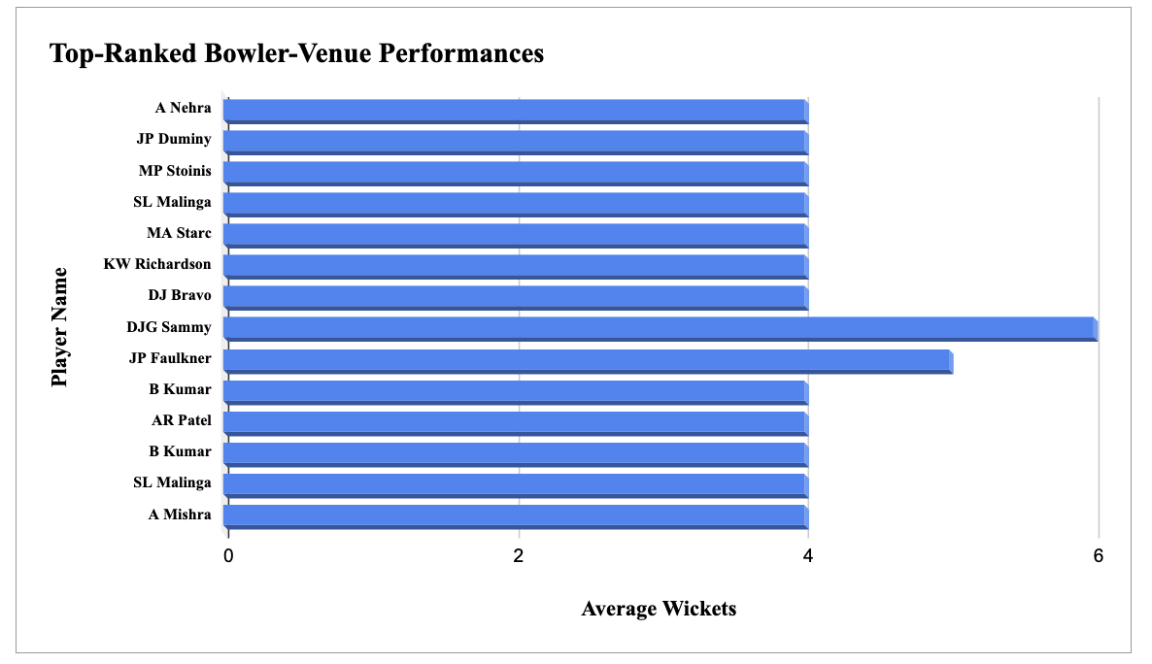

14. Question
Which of the given players have consistently performed well in
past seasons?

SQL Query
with batting_season as (
select
b.Striker as Player_Id,
m.Season_Id,
s.Season_Year,
sum(b.Runs_Scored) as season_runs
from Ball_by_Ball b
join Matches m
on b.Match_Id = m.Match_Id
join Season s
on m.Season_Id = s.Season_Id
group by
b.Striker,
m.Season_Id,
s.Season_Year
),

batting_overall_avg as (
select
avg(season_runs) as overall_avg_runs
from batting_season
),

batting_consistency as (
select
bs.Player_Id,
p.Player_Name,
'batting' as performance_type,
count(distinct bs.Season_Year) as seasons_played,
round(avg(bs.season_runs), 2) as average_season_performance,
sum(
case
when bs.season_runs > boa.overall_avg_runs
then 1
else 0
end
) as seasons_above_average
from batting_season bs
join Player p
on bs.Player_Id = p.Player_Id
cross join batting_overall_avg boa
group by
bs.Player_Id,
p.Player_Name
),

bowling_season as (
select
b.Bowler as Player_Id,
m.Season_Id,
s.Season_Year,
count(*) as season_wickets
from Wicket_Taken w
join Ball_by_Ball b
on w.Match_Id = b.Match_Id
and w.Over_Id = b.Over_Id
and w.Ball_Id = b.Ball_Id
and w.Innings_No = b.Innings_No
join Matches m
on b.Match_Id = m.Match_Id
join Season s
on m.Season_Id = s.Season_Id
where w.Kind_Out in (
select Out_Id
from Out_Type
where Out_Name in (
'caught',
'bowled',
'lbw',
'stumped',
'caught and bowled',
'hit wicket'
)
)
group by
b.Bowler,
m.Season_Id,
s.Season_Year
),

bowling_overall_avg as (
select
avg(season_wickets) as overall_avg_wickets
from bowling_season
),

bowling_consistency as (
select
bs.Player_Id,
p.Player_Name,
'bowling' as performance_type,
count(distinct bs.Season_Year) as seasons_played,
round(avg(bs.season_wickets), 2) as average_season_performance,
sum(
case
when bs.season_wickets > boa.overall_avg_wickets
then 1
else 0
end
) as seasons_above_average
from bowling_season bs
join Player p
on bs.Player_Id = p.Player_Id
cross join bowling_overall_avg boa
group by
bs.Player_Id,
p.Player_Name
)

select
Player_Id,
Player_Name,
performance_type,
seasons_played,
average_season_performance,
seasons_above_average
from batting_consistency
where seasons_played >= 3
and seasons_above_average >= 2

union all

select
Player_Id,
Player_Name,
performance_type,
seasons_played,
average_season_performance,
seasons_above_average
from bowling_consistency
where seasons_played >= 3
and seasons_above_average >= 2

order by
performance_type,
average_season_performance desc;

SQL Output
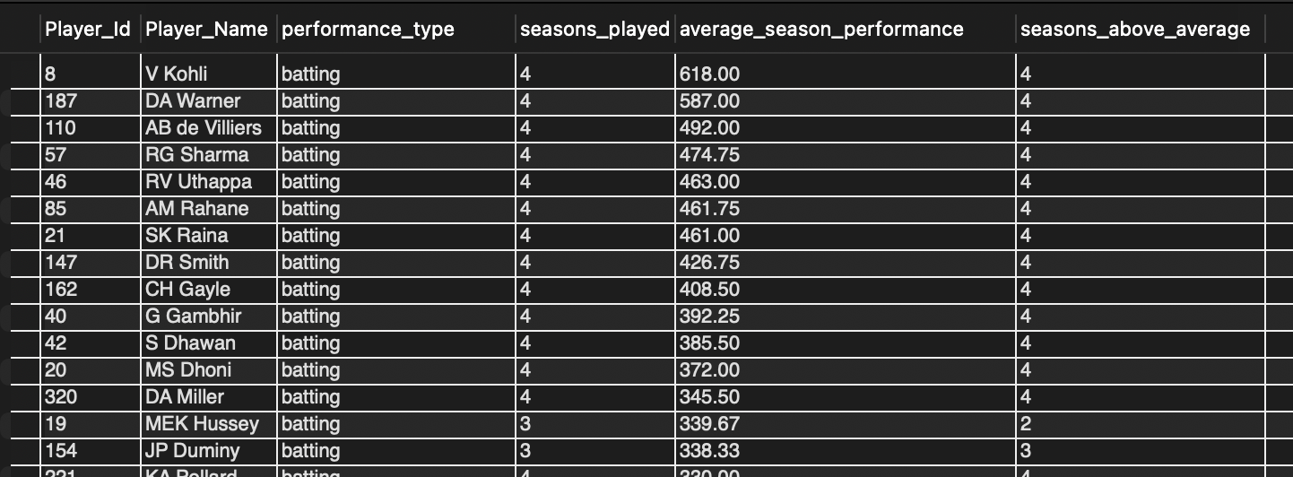

Brief Explanation
The query evaluates player consistency across the seasons they played by comparing their season-wise performance with the overall average performance. It calculates the number of seasons played, average season performance, and the number of seasons in which each player performed above average. A consistency percentage is then derived to identify players who consistently performed well in both batting and bowling.

Visualization
Two horizontal bar charts were created separately for batting
and bowling to identify players who consistently performed
above average across the seasons they played. Players with a
100% consistency rate was prioritized, and their average
season performance was used to compare their overall
performance level. This visualization makes it easier to identify
the strongest and most consistent performers for both batting
and bowling.

For Batting type performance
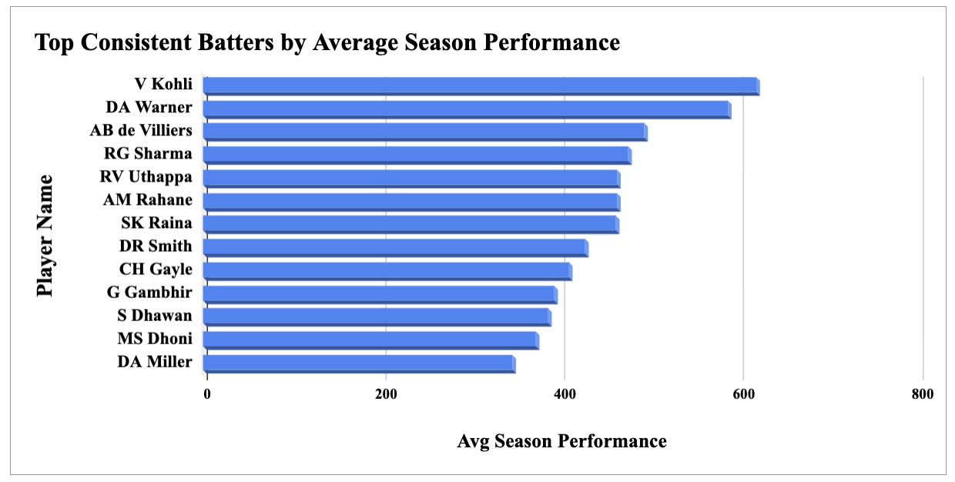

For Bowling type performance
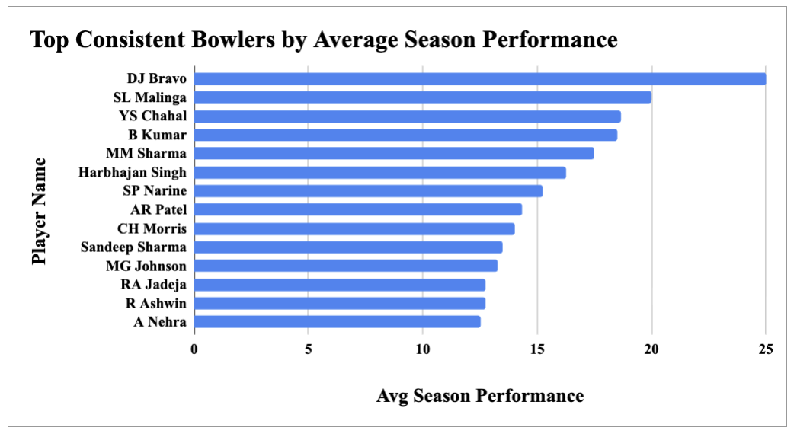

15. Question
Are there players whose performance is more suited to specific
venues or conditions?

SQL Query
with batting_venue as (
select
b.Striker as Player_Id,
p.Player_Name,
m.Venue_Id,
v.Venue_Name,
count(distinct b.Match_Id) as matches_played,
sum(b.Runs_Scored) as total_runs,
round(
sum(b.Runs_Scored) / count(distinct b.Match_Id),
2
) as average_performance,
'Batting' as performance_type
from Ball_by_Ball b
join Matches m
on b.Match_Id = m.Match_Id
join Venue v
on m.Venue_Id = v.Venue_Id
join Player p
on b.Striker = p.Player_Id
group by
b.Striker,
p.Player_Name,
m.Venue_Id,
v.Venue_Name
having count(distinct b.Match_Id) >= 3
),

bowling_venue as (
select
b.Bowler as Player_Id,
p.Player_Name,
m.Venue_Id,
v.Venue_Name,
count(distinct b.Match_Id) as matches_played,
count(*) as total_wickets,
round(
count(*) / count(distinct b.Match_Id),
2
) as average_performance,
'Bowling' as performance_type
from Wicket_Taken w
join Ball_by_Ball b
on w.Match_Id = b.Match_Id
and w.Over_Id = b.Over_Id
and w.Ball_Id = b.Ball_Id
and w.Innings_No = b.Innings_No
join Matches m
on b.Match_Id = m.Match_Id
join Venue v
on m.Venue_Id = v.Venue_Id
join Player p
on b.Bowler = p.Player_Id
group by
b.Bowler,
p.Player_Name,
m.Venue_Id,
v.Venue_Name
having count(distinct b.Match_Id) >= 3
)

select
Player_Id,
Player_Name,
Venue_Name,
matches_played,
total_runs as performance_value,
average_performance,
performance_type
from batting_venue

union all

select
Player_Id,
Player_Name,
Venue_Name,
matches_played,
total_wickets as performance_value,
average_performance,
performance_type
from bowling_venue

order by
performance_type,
average_performance desc;

SQL Output
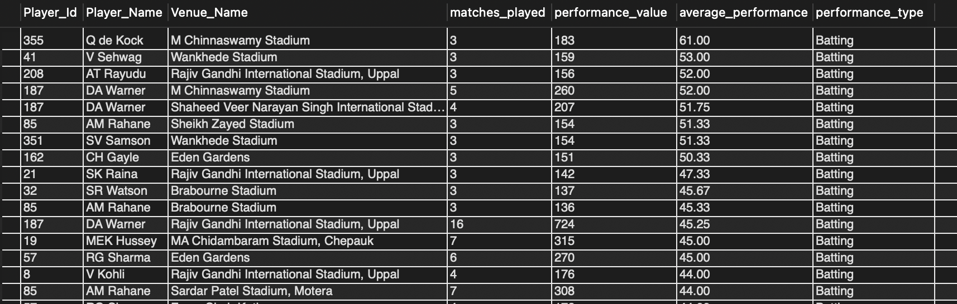

Brief Explanation
The query compares player performance across venues using average runs for batting and average wickets for bowling. It helps identify players who perform particularly well at specific venues.

Visualization
The visualizations identify the venues where individual players
have demonstrated their strongest batting or bowling
performance, supporting venue-specific player selection.

Batting
Shows the top player-venue combinations by average batting performance.
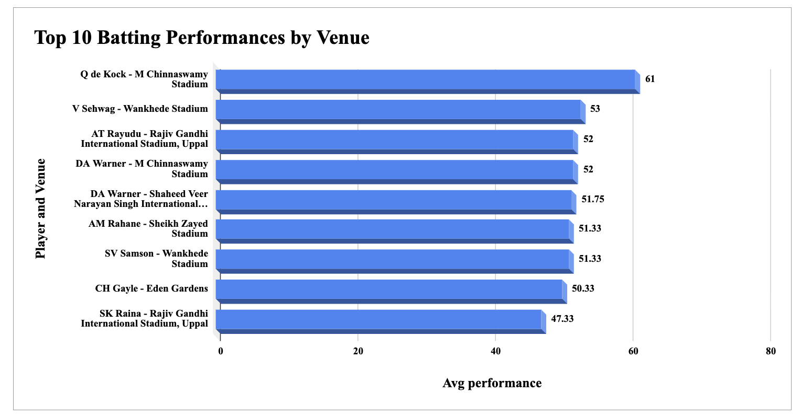

Bowling
Shows the top player-venue combinations by average bowling performance.
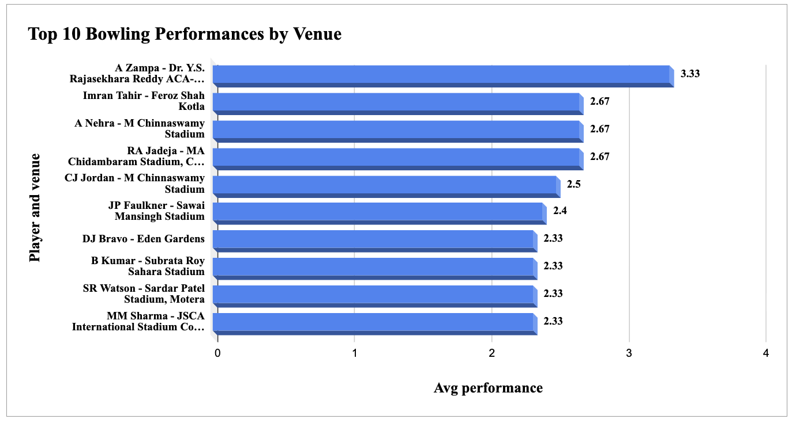

Subjective Questions

1. Question
How does the toss decision affect the result of the match? Which
visualizations could be used to present the answer better? And is
the impact limited to only specific venues?

SQL Query
Query 1: overall impact of toss decision

select
td.Toss_Name as toss_decision,
count(*) as total_matches,
sum(
case
when m.Toss_Winner = m.Match_Winner then 1
else 0
end
) as toss_winner_wins,
round(
sum(
case
when m.Toss_Winner = m.Match_Winner then 1
else 0
end
) * 100.0 / count(*),
2
) as win_percentage
from Matches m
join Toss_Decision td
on m.Toss_Decide = td.Toss_Id
where m.Match_Winner is not null
group by
td.Toss_Id,
td.Toss_Name
order by
win_percentage desc;

SQL Output 1
- Overall impact of toss decision on match results
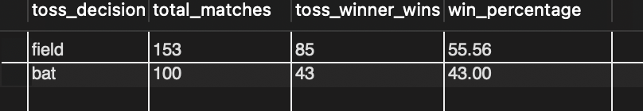

Query 2: venue-wise impact of toss decision

select
v.Venue_Name as venue_name,
td.Toss_Name as toss_decision,
count(*) as total_matches,
sum(
case
when m.Toss_Winner = m.Match_Winner then 1
else 0
end
) as toss_winner_wins,
round(
sum(
case
when m.Toss_Winner = m.Match_Winner then 1
else 0
end
) * 100.0 / count(*),
2
) as win_percentage
from Matches m
join Toss_Decision td
on m.Toss_Decide = td.Toss_Id
join Venue v
on m.Venue_Id = v.Venue_Id
where m.Match_Winner is not null
group by
v.Venue_Id,
v.Venue_Name,
td.Toss_Id,
td.Toss_Name
order by
v.Venue_Name,
win_percentage desc;

SQL Output 2
- Venue-wise impact of toss decision

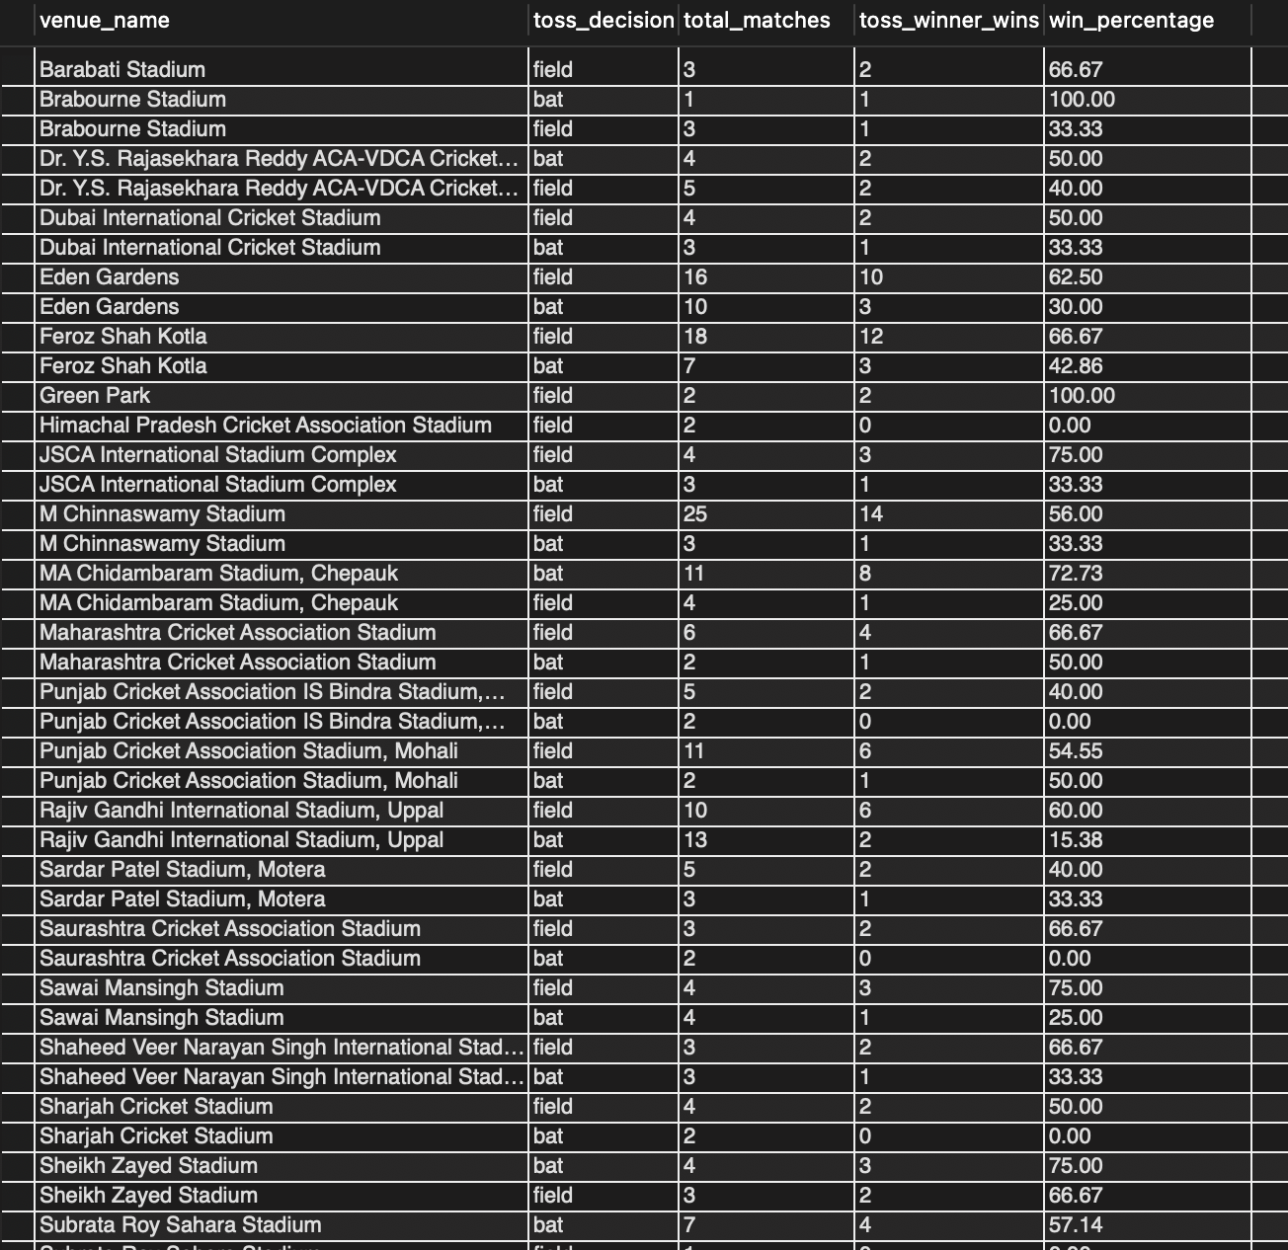

Visualization 1 — Toss Decision vs Toss Winner Win Percentage

The bar chart compares the win percentage of the toss-winning team for each toss decision. Teams choosing to field had a higher toss-winner win percentage of 55.56%, compared with 43.00% for teams choosing to bat.
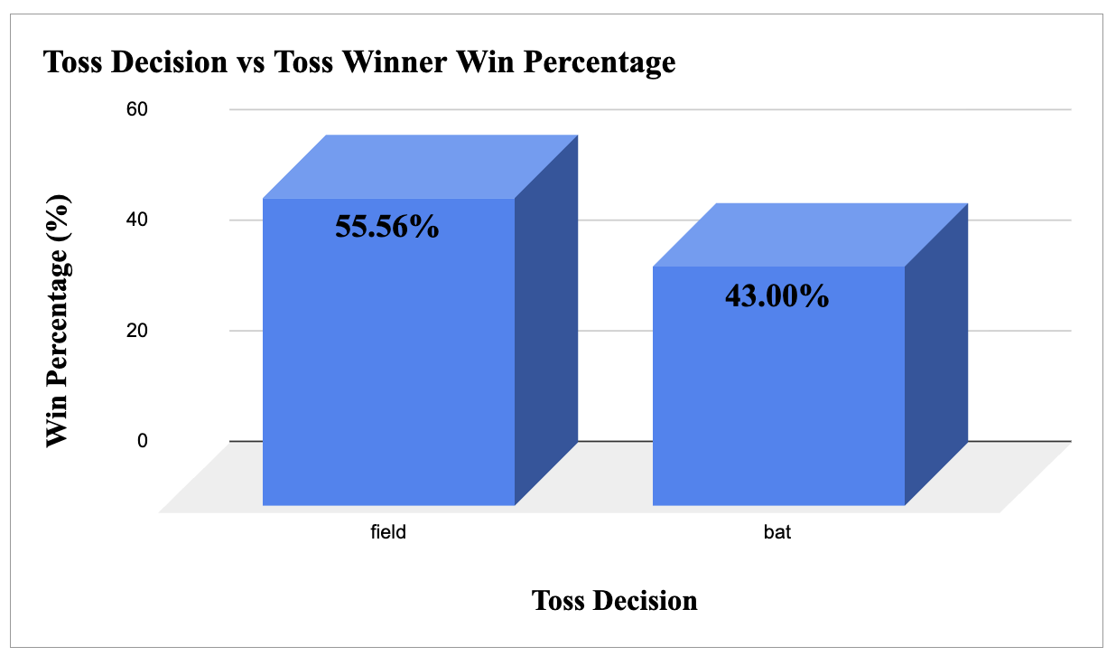

Visualization 2 — Venue-wise Heatmap

The heatmap compares toss-winner win percentages across venues for both toss decisions. It makes venue-level differences easier to identify and shows that the relationship between toss decision and match outcome varies across venues.

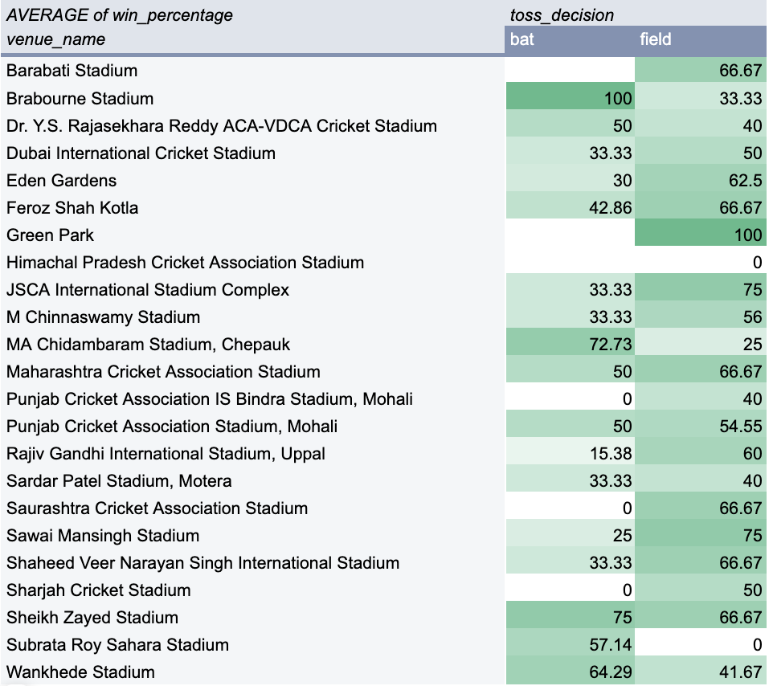

Approach
- First, the overall relationship between toss decision and match outcome was analyzed.
- The percentage of matches won by the toss-winning team was calculated separately for teams choosing to bat and field.
- A venue-wise analysis was then performed to determine whether the observed relationship remained consistent across different venues.
- A bar chart was used for the overall comparison, while a heatmap was used to identify venue-level patterns.

Insights
- Teams choosing to field after winning the toss had a higher toss-winner win percentage (55.56%) than teams choosing to bat (43.00%).
- The overall results indicate an association between the toss decision and match outcome.
- However, the venue-wise analysis shows that this pattern is not consistent across all venues.
- At some venues, choosing to bat produced a higher toss-winner win percentage, while at others, choosing to field performed better.
- For example, MA Chidambaram Stadium shows 72.73% for batting compared with 25.00% for fielding.
- Rajiv Gandhi International Stadium, Uppal shows 60.00% for fielding compared with 15.38% for batting.
- Therefore, the effect of the toss decision varies according to the venue and should not be treated as a universal pattern.
- Results based on venues with very few matches should be interpreted cautiously.

Recommendation
- RCB should consider fielding after winning the toss as a preferred option based on the overall historical win percentage.
- However, the decision should be adjusted according to venue-specific historical performance.
- Before making the final toss decision, RCB should consider venue conditions, historical toss outcomes, and the relative performance of batting and fielding at that venue.
- The toss should therefore be treated as one strategic input rather than the sole factor in match planning.

2. Question
Suggest some of the players who would be best fit for the team.

SQL Query
Query 1: Recommended Batsmen

with player_season_runs as (
select
b.striker as player_id,
m.season_id,
sum(b.runs_scored) as season_runs
from ball_by_ball b
join matches m
on b.match_id = m.match_id
group by
b.striker,
m.season_id
),
player_average_runs as (
select
p.player_id,
p.player_name,
round(avg(psr.season_runs), 2) as average_runs
from player_season_runs psr
join player p
on psr.player_id = p.player_id
group by
p.player_id,
p.player_name
)
select
player_id,
player_name,
average_runs
from player_average_runs
order by average_runs desc
limit 5;

SQL Output
- Best fit top 5 Batsman
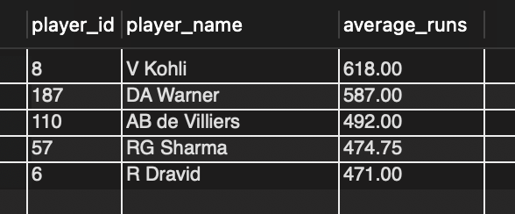

SQL Query
Query 2: Recommended Bowlers

with bowler_season_wickets as (
select
b.bowler as player_id,
m.season_id,
count(*) as season_wickets
from wicket_taken w
join ball_by_ball b
on w.match_id = b.match_id
and w.over_id = b.over_id
and w.ball_id = b.ball_id
and w.innings_no = b.innings_no
join matches m
on w.match_id = m.match_id
where w.kind_out in (
select out_id
from out_type
where out_name in (
'caught',
'bowled',
'lbw',
'stumped',
'caught and bowled',
'hit wicket'
)
)
group by
b.bowler,
m.season_id
),
player_average_wickets as (
select
p.player_id,
p.player_name,
round(avg(bsw.season_wickets), 2) as average_wickets
from bowler_season_wickets bsw
join player p
on bsw.player_id = p.player_id
group by
p.player_id,
p.player_name
)
select
player_id,
player_name,
average_wickets
from player_average_wickets
order by average_wickets desc
limit 5;

SQL Output
- Best fit top 5 Bowlers
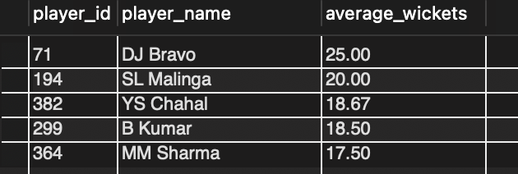

SQL Query
Query 2: Recommended All-Rounders

with player_season_runs as (
select
b.striker as player_id,
m.season_id,
sum(b.runs_scored) as season_runs
from ball_by_ball b
join matches m
on b.match_id = m.match_id
group by
b.striker,
m.season_id
),
player_average_runs as (
select
p.player_id,
p.player_name,
round(avg(psr.season_runs), 2) as average_runs
from player_season_runs psr
join player p
on psr.player_id = p.player_id
group by
p.player_id,
p.player_name
),
bowler_season_wickets as (
select
b.bowler as player_id,
m.season_id,
count(*) as season_wickets
from wicket_taken w
join ball_by_ball b
on w.match_id = b.match_id
and w.over_id = b.over_id
and w.ball_id = b.ball_id
and w.innings_no = b.innings_no
join matches m
on w.match_id = m.match_id
where w.kind_out in (
select out_id
from out_type
where out_name in (
'caught',
'bowled',
'lbw',
'stumped',
'caught and bowled',
'hit wicket'
)
)
group by
b.bowler,
m.season_id
),
player_average_wickets as (
select
p.player_id,
p.player_name,
round(avg(bsw.season_wickets), 2) as average_wickets
from bowler_season_wickets bsw
join player p
on bsw.player_id = p.player_id
group by
p.player_id,
p.player_name
),
overall_averages as (
select
(select avg(average_runs)
from player_average_runs) as overall_average_runs,
(select avg(average_wickets)
from player_average_wickets) as overall_average_wickets
)
select
r.player_id,
r.player_name,
r.average_runs,
w.average_wickets
from player_average_runs r
join player_average_wickets w
on r.player_id = w.player_id
cross join overall_averages oa
where r.average_runs > oa.overall_average_runs
and w.average_wickets > oa.overall_average_wickets
order by
r.average_runs desc,
w.average_wickets desc
limit 5;

SQL Output
- Best fit top 5 All-Rounders
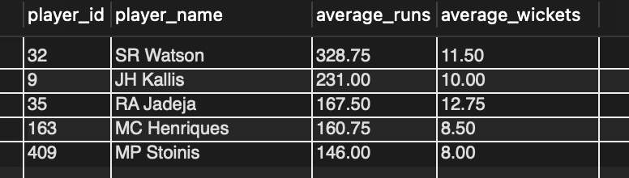

Approach
The analysis evaluates players separately based on their batting, bowling, and all-round performance. Batsmen are ranked using their average runs across seasons, while bowlers are ranked using their average wickets across seasons. Players who perform above the overall averages in both batting and bowling are identified as all-rounder candidates. The top-performing players from each category are then considered for RCB's squad selection.

Insights
The analysis identifies separate player recommendations for batting, bowling, and all-round capabilities. The batsman ranking highlights players with the strongest overall run-scoring performance, while the bowler ranking identifies players with the highest wicket-taking performance. The all-rounder analysis highlights players who have demonstrated above-average performance in both batting and bowling, providing RCB with balanced player options.

Recommendation
RCB should consider strengthening its squad by prioritizing the highest-ranked batsmen and bowlers from the respective performance rankings. Along with specialist players, the identified all-rounders can provide additional flexibility by contributing in both batting and bowling. These recommendations can support a balanced squad composition and data-driven player selection.

3. Question
What are some of the parameters that should be focused on while
selecting the players?

SQL Query
with batting_stats as (
select
b.striker as player_id,
count(distinct b.match_id) as batting_matches,
sum(b.runs_scored) as total_runs,
round(
sum(b.runs_scored) / count(distinct b.match_id),
2
) as average_runs_per_match,
round(
sum(b.runs_scored) * 100.0 /
nullif(
count(
case
when et.extra_name is null
or et.extra_name not in ('wides', 'noballs')
then 1
end
),
0
),
2
) as strike_rate
from ball_by_ball b
left join extra_runs e
on b.match_id = e.match_id
and b.over_id = e.over_id
and b.ball_id = e.ball_id
and b.innings_no = e.innings_no
left join extra_type et
on e.extra_type_id = et.extra_id
group by
b.striker
),

bowling_stats as (
select
b.bowler as player_id,
count(distinct b.match_id) as bowling_matches,
count(*) as total_wickets,
round(
count(*) * 1.0 /
count(distinct b.match_id),
2
) as average_wickets_per_match
from wicket_taken w
join ball_by_ball b
on w.match_id = b.match_id
and w.over_id = b.over_id
and w.ball_id = b.ball_id
and w.innings_no = b.innings_no
join out_type ot
on w.kind_out = ot.out_id
where ot.out_name in (
'caught',
'bowled',
'lbw',
'stumped',
'caught and bowled',
'hit wicket'
)
group by
b.bowler
)

select
p.player_id,
p.player_name,
coalesce(bs.batting_matches, 0) as batting_matches,
coalesce(bs.total_runs, 0) as total_runs,
coalesce(bs.average_runs_per_match, 0) as average_runs_per_match,
coalesce(bs.strike_rate, 0) as strike_rate,
coalesce(ws.bowling_matches, 0) as bowling_matches,
coalesce(ws.total_wickets, 0) as total_wickets,
coalesce(ws.average_wickets_per_match, 0) as average_wickets_per_match
from player p
left join batting_stats bs
on p.player_id = bs.player_id
left join bowling_stats ws
on p.player_id = ws.player_id
where
bs.player_id is not null
or ws.player_id is not null
order by
total_runs desc,
total_wickets desc;

SQL Output
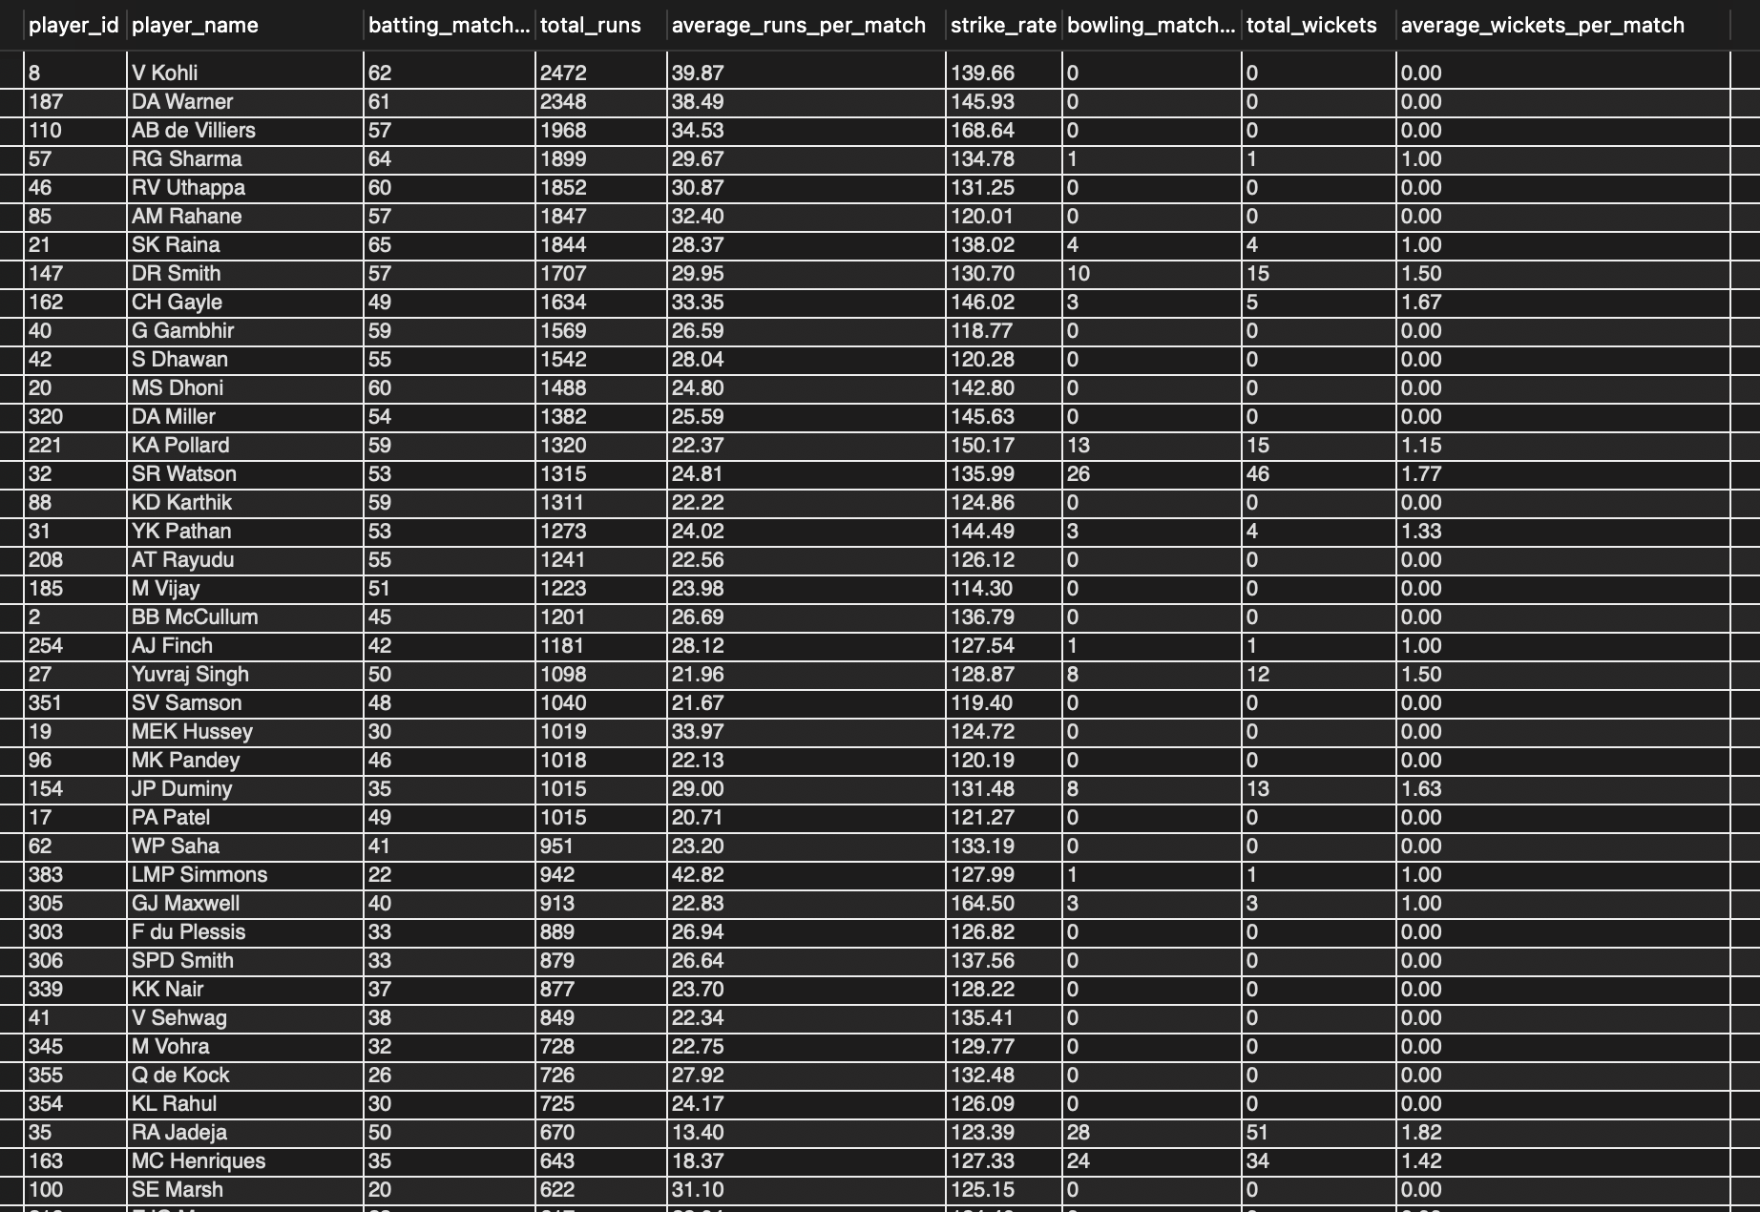

Visualization 1 — Batting Selection Parameters
- Compares average runs per match and strike rate to identify strong batting candidates.
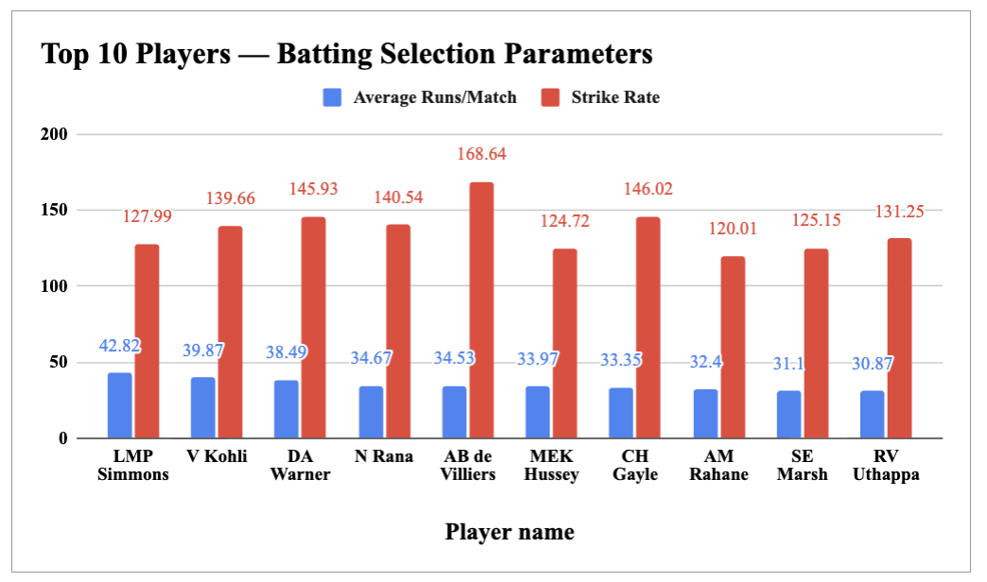

Visualization 2 — Bowling Selection Parameters
- Compares average wickets per match and total wickets to identify strong bowling candidates.
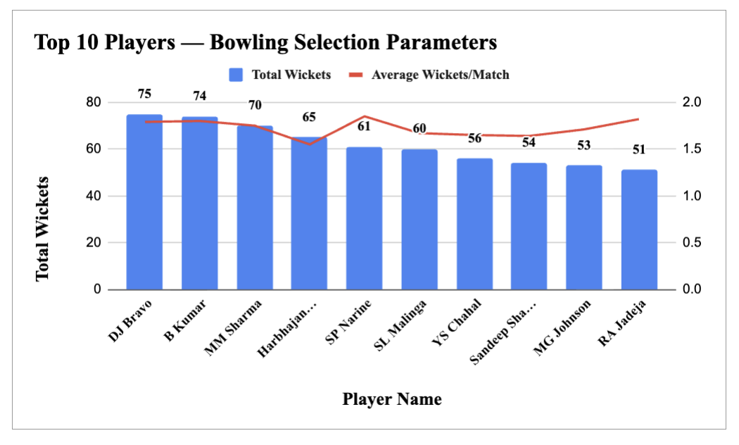

Approach
Player selection was evaluated using key batting and bowling performance parameters. For batting, average runs per match and strike rate were considered to measure scoring performance and efficiency. For bowling, total wickets and average wickets per match were considered to measure wicket-taking contribution and effectiveness. The top-performing players were then visualized separately for batting and bowling.

Insights
- Batting: Players such as LMP Simmons, V Kohli, DA Warner and AB de Villiers show strong batting performance based on average runs per match and strike rate.
- Bowling: DJ Bravo, B Kumar, MM Sharma and Harbhajan Singh recorded the highest total wickets among the displayed players.
- A player's selection should not depend on a single metric. Both performance volume and efficiency should be considered when evaluating players.
- The analysis highlights that batting and bowling require different selection parameters, allowing RCB to evaluate players according to their specific roles.

Recommandations
RCB should evaluate players using multiple performance parameters rather than relying on a single statistic. For batsmen, priority should be given to players with strong average runs per match and strike rate. For bowlers, total wickets and average wickets per match should be considered together. This approach can help RCB select players who provide stronger and more reliable overall contributions.

4. Question
Which players offer versatility in their skills and can contribute
effectively with both bat and ball?

SQL Query
with batting_stats as (
select
b.striker as player_id,
p.player_name,
round(
sum(b.runs_scored) / count(distinct b.match_id),
2
) as average_runs_per_match
from Ball_by_Ball b
join Player p
on b.striker = p.player_id
group by
b.striker,
p.player_name
),

bowling_stats as (
select
b.bowler as player_id,
round(
count(
case
when o.Out_Name in (
'caught',
'bowled',
'lbw',
'stumped',
'caught and bowled',
'hit wicket'
)
then 1
end
) / count(distinct b.match_id),
2
) as average_wickets_per_match
from Ball_by_Ball b
join Wicket_Taken w
on b.Match_Id = w.Match_Id
and b.Over_Id = w.Over_Id
and b.Ball_Id = w.Ball_Id
and b.Innings_No = w.Innings_No
join Out_Type o
on w.Kind_Out = o.Out_Id
group by
b.bowler
),

overall_batting as (
select
avg(average_runs_per_match) as avg_batting_performance
from batting_stats
),

overall_bowling as (
select
avg(average_wickets_per_match) as avg_bowling_performance
from bowling_stats
)

select
bs.player_id,
bs.player_name,
bs.average_runs_per_match,
ws.average_wickets_per_match
from batting_stats bs
join bowling_stats ws
on bs.player_id = ws.player_id
cross join overall_batting ob
cross join overall_bowling ow
where bs.average_runs_per_match > ob.avg_batting_performance
and ws.average_wickets_per_match > ow.avg_bowling_performance
order by
bs.average_runs_per_match desc,
ws.average_wickets_per_match desc;

SQL Output
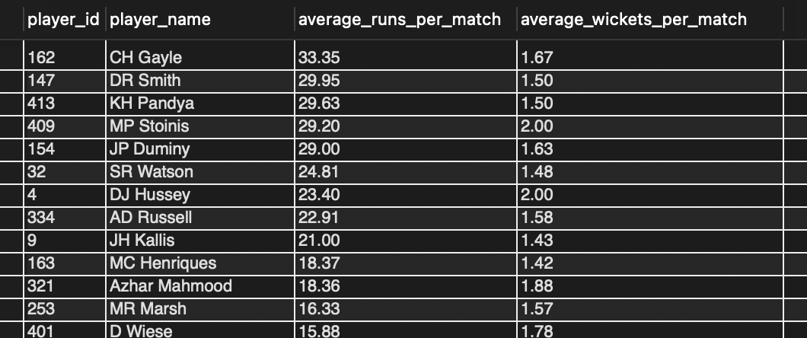

Visualization
The scatter plot compares average runs per match with average wickets per match to identify players who contribute effectively with both bat and ball.
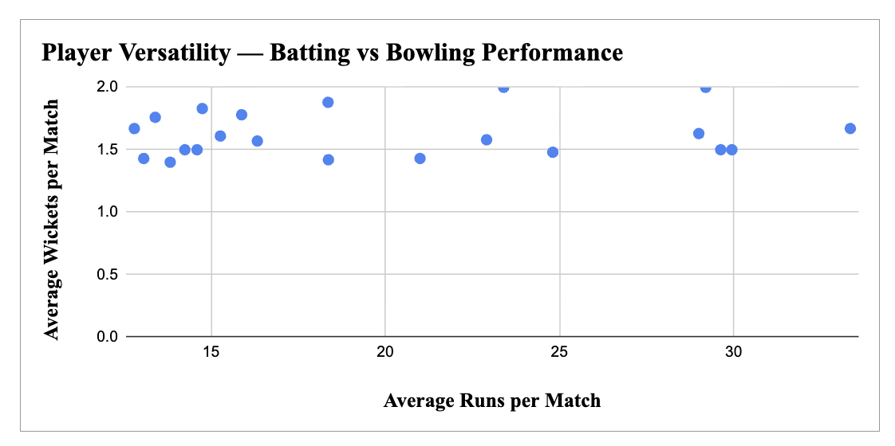

Approach
The analysis calculates each player's average runs per match and average wickets per match. Players performing above the overall average on both parameters are identified as versatile players who can contribute with both batting and bowling.

Insights
Players with strong performance in both batting and bowling provide greater all-round value and versatility to the team. Players positioned toward the upper-right of the scatter plot demonstrate relatively stronger contributions across both skills.

Recommandations
RCB should consider versatile players who demonstrate above-average performance in both batting and bowling, as they can provide balance to the playing XI and offer additional options during matches.

5. Question
Are there players whose presence positively influences the morale and
performance of the team?

SQL Query
with rcb_matches as (
select
m.Match_Id,
m.Match_Winner
from Matches m
where m.Team_1 = (
select Team_Id
from Team
where Team_Name = 'Royal Challengers Bangalore'
)
or m.Team_2 = (
select Team_Id
from Team
where Team_Name = 'Royal Challengers Bangalore'
)
),

rcb_overall as (
select
count(*) as total_matches,
sum(
case
when Match_Winner = (
select Team_Id
from Team
where Team_Name = 'Royal Challengers Bangalore'
)
then 1
else 0
end
) as total_wins
from rcb_matches
),

player_performance as (
select
pm.Player_Id,
p.Player_Name,
count(distinct pm.Match_Id) as matches_played,
sum(
case
when rm.Match_Winner = (
select Team_Id
from Team
where Team_Name = 'Royal Challengers Bangalore'
)
then 1
else 0
end
) as wins_when_played
from Player_Match pm
join Player p
on pm.Player_Id = p.Player_Id
join rcb_matches rm
on pm.Match_Id = rm.Match_Id
where pm.Team_Id = (
select Team_Id
from Team
where Team_Name = 'Royal Challengers Bangalore'
)
group by
pm.Player_Id,
p.Player_Name
)

select
pp.Player_Id,
pp.Player_Name,
pp.matches_played,
pp.wins_when_played,
round(
pp.wins_when_played * 100.0 / pp.matches_played,
2
) as win_percentage_when_played,
round(
ro.total_wins * 100.0 / ro.total_matches,
2
) as rcb_overall_win_percentage
from player_performance pp
cross join rcb_overall ro
where pp.matches_played >= 10
order by
win_percentage_when_played desc,
matches_played desc;

SQL Output
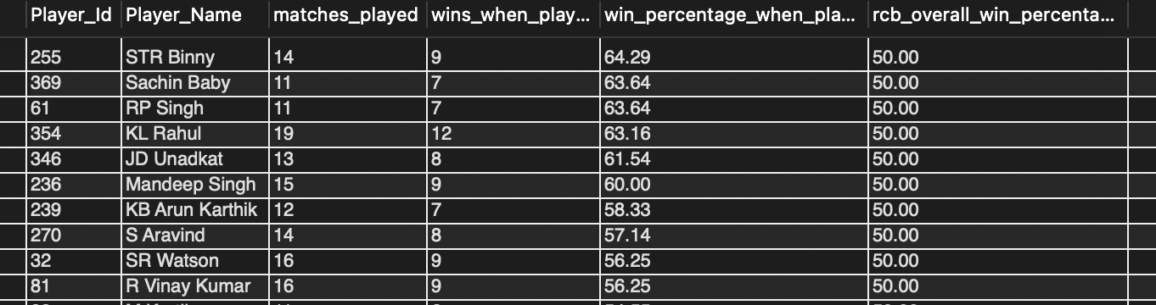

Visualization
The chart compares players' win percentage when playing with RCB against the team's overall 50% win rate.
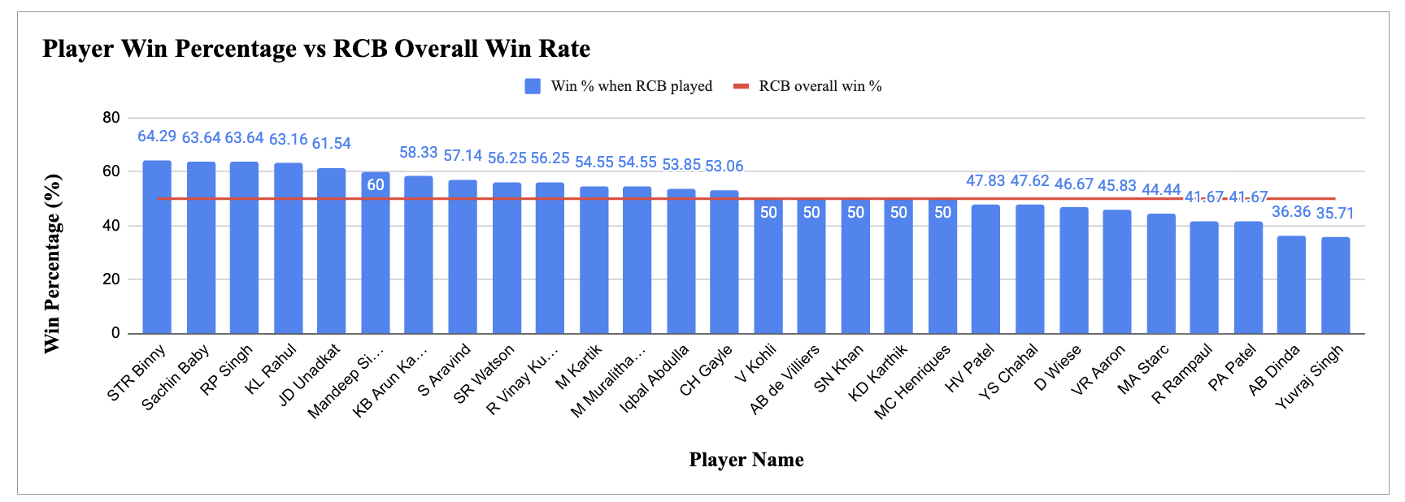

Approach
The analysis compares RCB's overall win percentage with the win percentage when individual players participated. Players were evaluated based on matches played, wins when played, and their win percentage relative to the team's overall performance.

Insights
Several players had a win percentage higher than RCB's overall 50% win rate. STR Binny, Sachin Baby, RP Singh and KL Rahul recorded some of the highest win percentages when they played.

Recommandation
RCB should consider players' win contribution along with their individual performance when making squad decisions. Players consistently associated with win percentages above the team benchmark can be considered valuable contributors.

6. Question
What would you suggest to RCB before going to the mega auction?

SQL Query
with rcb_matches as (
select
m.Match_Id
from Matches m
where m.Team_1 = 2
or m.Team_2 = 2
),

batting_stats as (
select
b.striker as player_id,
p.player_name,
count(distinct b.Match_Id) as matches_played,
sum(b.Runs_Scored) as total_runs,
round(
sum(b.Runs_Scored) / count(distinct b.Match_Id),
2
) as average_runs_per_match
from Ball_by_Ball b
join Player p
on b.striker = p.Player_Id
join rcb_matches rm
on b.Match_Id = rm.Match_Id
group by
b.striker,
p.player_name
),

player_wins as (
select
p.Player_Id as player_id,
count(distinct b.Match_Id) as wins_when_played
from Player p
join Ball_by_Ball b
on b.striker = p.Player_Id
or b.non_striker = p.Player_Id
or b.bowler = p.Player_Id
join Matches m
on b.Match_Id = m.Match_Id
where
(m.Team_1 = 2 or m.Team_2 = 2)
and m.Match_Winner = 2
group by
p.Player_Id
),

rcb_overall as (
select
count(*) as rcb_matches,
sum(
case
when m.Match_Winner = 2 then 1
else 0
end
) as rcb_wins
from Matches m
where
m.Team_1 = 2
or m.Team_2 = 2
)

select
bs.player_id,
bs.player_name,
bs.matches_played,
bs.total_runs,
bs.average_runs_per_match,
coalesce(pw.wins_when_played, 0) as wins_when_played,
round(
coalesce(pw.wins_when_played, 0) * 100.0
/ bs.matches_played,
2
) as win_percentage_when_played,
round(
ro.rcb_wins * 100.0 / ro.rcb_matches,
2
) as rcb_overall_win_percentage
from batting_stats bs
left join player_wins pw
on bs.player_id = pw.player_id
cross join rcb_overall ro
where
bs.average_runs_per_match >= 30
and (
coalesce(pw.wins_when_played, 0) * 100.0
/ bs.matches_played
) >= (
ro.rcb_wins * 100.0 / ro.rcb_matches
)
order by
bs.average_runs_per_match desc,
win_percentage_when_played desc;

SQL Output
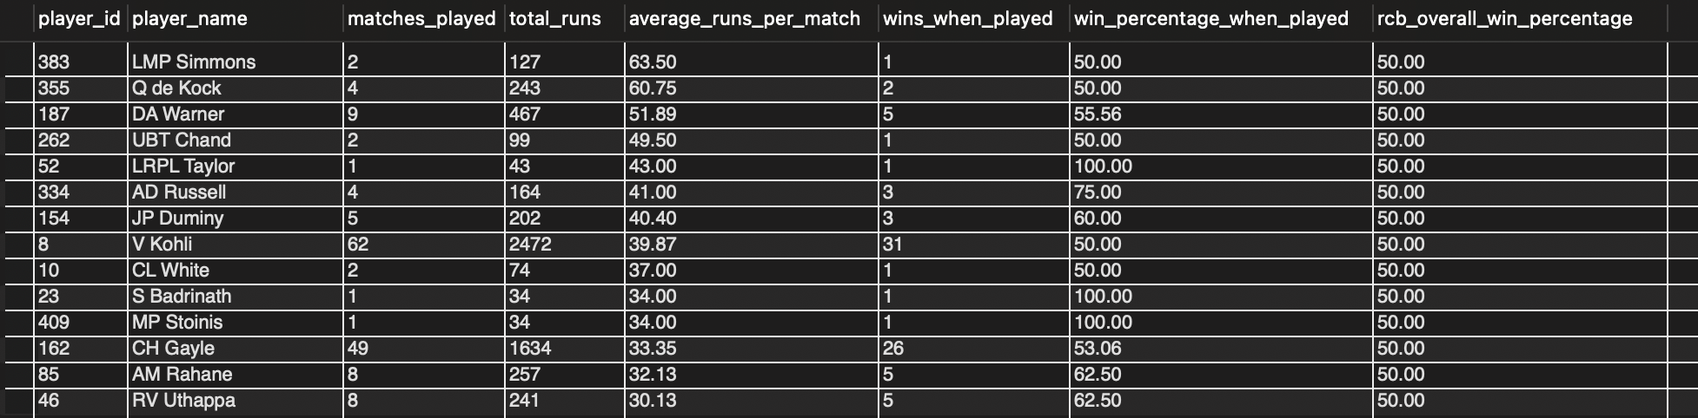

Visualization
The scatter plot compares average runs per match with win percentage when played. Players with high values on both measures can be considered stronger candidates for the mega auction.
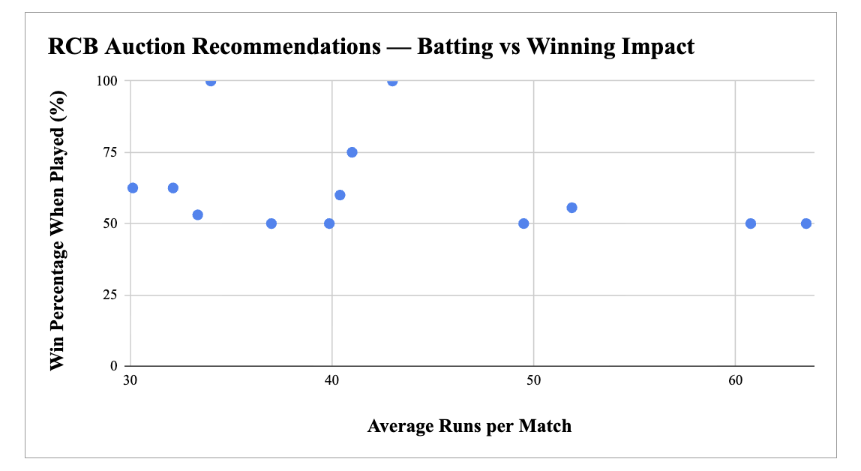

Approach
First, player-level batting statistics were calculated using total runs, matches played, and average runs per match. The number of wins achieved by RCB when each player was involved was then used to calculate the player's win percentage when played. This percentage was compared with RCB's overall win percentage. Players who demonstrated strong batting performance and a win percentage at or above RCB's overall benchmark were shortlisted as potential auction targets.

Insights
The analysis identifies players who combine strong batting performance with a positive winning impact. Several shortlisted players have an average of more than 30 runs per match while maintaining a win percentage when played that is equal to or higher than RCB's overall win percentage.
The results also show that some players have very high win percentages but have played only a small number of matches. Therefore, RCB should consider both performance and sample size rather than relying only on win percentage.

Recommandation
Before the mega auction, RCB should prioritize players who consistently contribute runs and have a positive impact on match outcomes. Players with high average runs per match and a win percentage at or above RCB's overall benchmark should be considered strong auction targets. However, RCB should give greater priority to players with a sufficiently large number of matches played, as their performance provides more reliable evidence than players with only one or two matches.

7. Question
What do you think could be the factors contributing to the high-scoring
matches and the impact on viewership and team strategies?

SQL Query
with rcb_matches as (
select
m.match_id,
m.match_winner,
m.venue_id
from matches m
where m.team_1 = 2
or m.team_2 = 2
),

extra_by_ball as (
select
match_id,
over_id,
ball_id,
innings_no,
sum(extra_runs) as extra_runs
from extra_runs
group by
match_id,
over_id,
ball_id,
innings_no
),

match_stats as (
select
b.match_id,

sum(b.runs_scored + coalesce(e.extra_runs, 0)) as total_match_runs,

sum(
case
when b.team_batting = 2
then b.runs_scored + coalesce(e.extra_runs, 0)
else 0
end
) as rcb_runs,

sum(
case
when b.team_batting = 2
and b.runs_scored = 4
then 1
else 0
end
) as rcb_fours,

sum(
case
when b.team_batting = 2
and b.runs_scored = 6
then 1
else 0
end
) as rcb_sixes,

sum(
case
when b.team_batting <> 2
and b.runs_scored = 4
then 1
else 0
end
) as opponent_fours,

sum(
case
when b.team_batting <> 2
and b.runs_scored = 6
then 1
else 0
end
) as opponent_sixes,

sum(
case
when b.team_batting = 2
then coalesce(e.extra_runs, 0)
else 0
end
) as rcb_extra_runs,

sum(
case
when b.team_batting <> 2
then coalesce(e.extra_runs, 0)
else 0
end
) as opponent_extra_runs

from ball_by_ball b
join rcb_matches r
on b.match_id = r.match_id
left join extra_by_ball e
on b.match_id = e.match_id
and b.over_id = e.over_id
and b.ball_id = e.ball_id
and b.innings_no = e.innings_no
group by
b.match_id
)

select
ms.match_id,
v.venue_name,

ms.rcb_runs,
ms.total_match_runs - ms.rcb_runs as opponent_runs,
ms.total_match_runs,

ms.rcb_fours,
ms.rcb_sixes,
ms.rcb_extra_runs,

ms.opponent_fours,
ms.opponent_sixes,
ms.opponent_extra_runs,

ms.rcb_fours + ms.rcb_sixes as rcb_boundaries,
ms.opponent_fours + ms.opponent_sixes as opponent_boundaries,

case
when r.match_winner = 2 then 'win'
else 'loss'
end as rcb_result

from match_stats ms
join rcb_matches r
on ms.match_id = r.match_id
join venue v
on r.venue_id = v.venue_id
order by
ms.total_match_runs desc
limit 20;

SQL Output
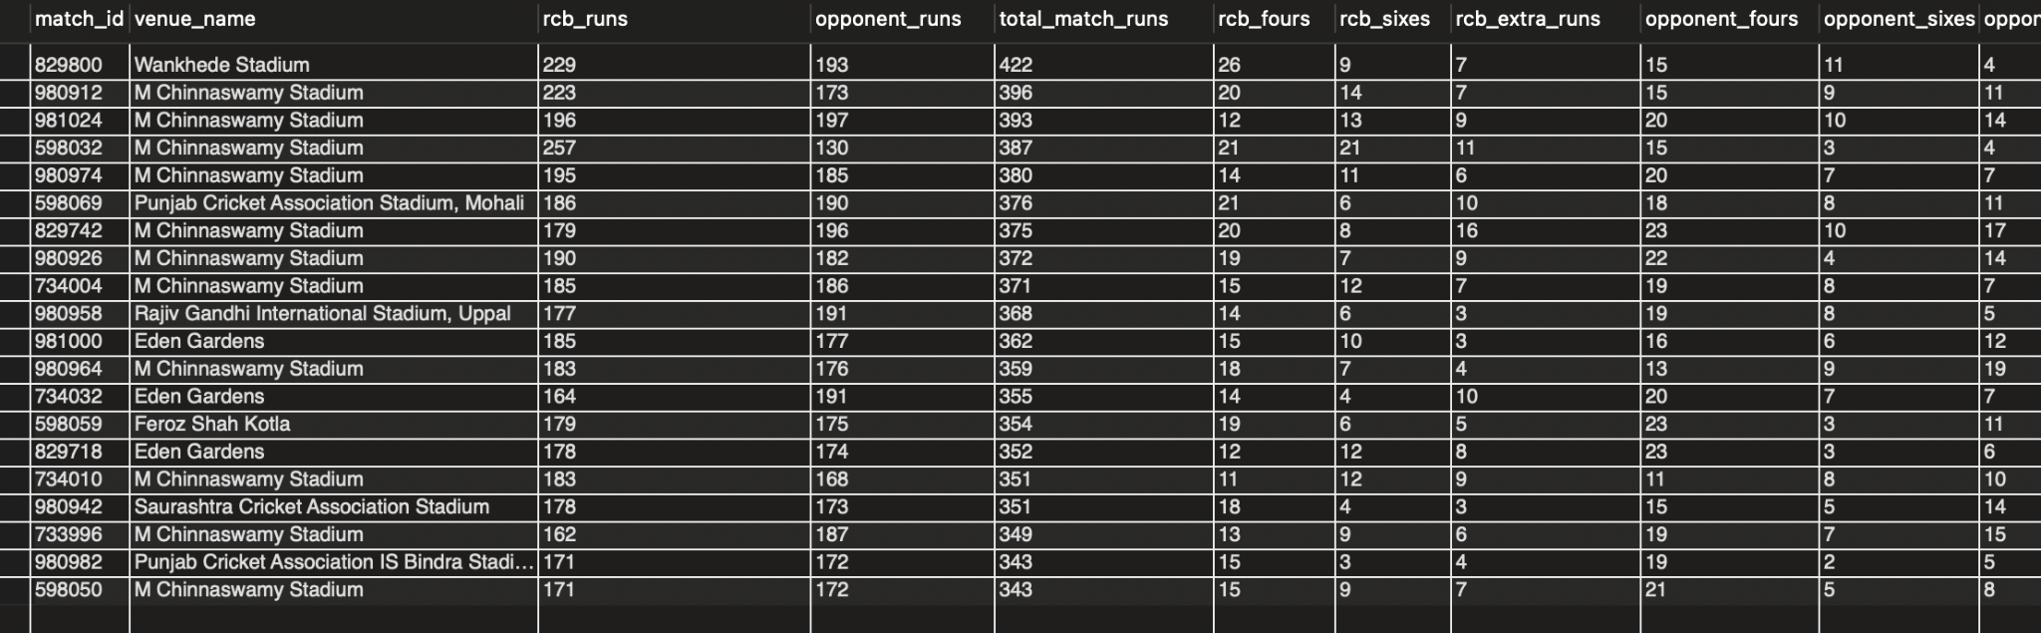

Visualization
The stacked column chart compares RCB and opponent contributions in the highest-scoring RCB matches, showing how total match scores were built.
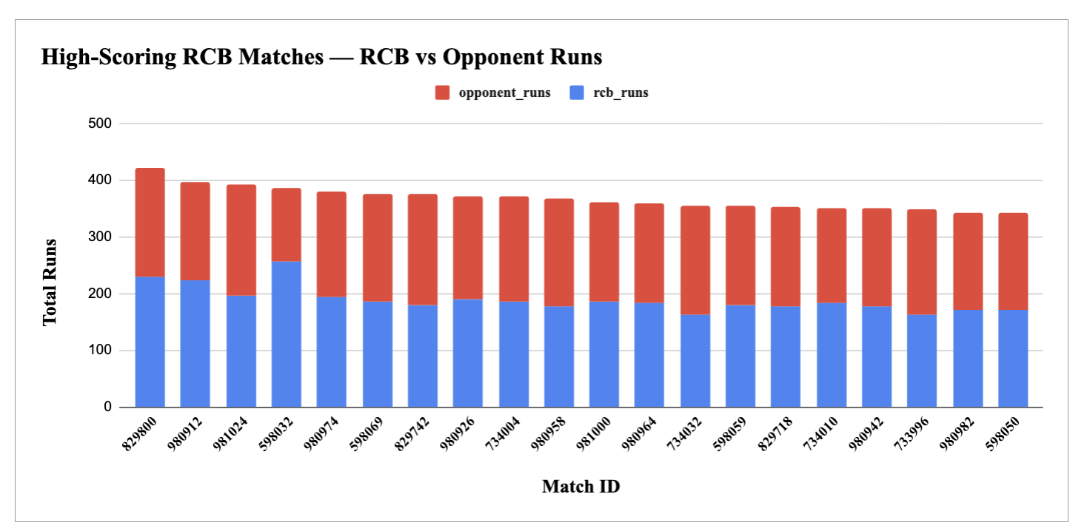

Approach
RCB matches were analyzed based on total runs scored by both teams. The highest-scoring matches were identified and compared using RCB runs, opponent runs, boundaries, extras, venue, and match result. This helps identify the factors associated with high-scoring matches and their implications for RCB's playing strategy.

Insights
The highest-scoring RCB matches show strong run contributions from both teams, with boundaries forming a major part of the scoring. Several high-scoring matches were played at M Chinnaswamy Stadium, indicating that venue conditions may support aggressive scoring. Some high-scoring matches resulted in RCB wins, while others ended in losses, showing that scoring heavily does not always guarantee victory.

Viewership Insights
High-scoring and boundary-heavy matches are likely to generate greater viewer engagement because they provide more frequent scoring events. However, direct viewership data is not available in the dataset, so this impact is an inference rather than a measured relationship.

Recommandation
RCB should build strategies suited to high-scoring conditions by strengthening boundary-hitting in batting and developing bowling plans that can restrict opponents' boundary scoring. Venue-specific planning should also be considered, especially at grounds that frequently produce high-scoring matches. The team should focus not only on scoring heavily but also on converting high-scoring games into wins.
RCB should combine aggressive batting with effective boundary prevention and venue-specific strategies to turn high-scoring opportunities into consistent wins.

8. Question
Analyze the impact of home-ground advantage on team performance
and identify strategies to maximize this advantage for RCB.

SQL Query
with rcb_matches as (
select
m.match_id,
m.match_winner,
m.venue_id,
case
when m.venue_id = 1 then 'Home Ground'
else 'Away'
end as match_type
from matches m
where
m.team_1 = 2
or m.team_2 = 2
),

extra_by_ball as (
select
match_id,
over_id,
ball_id,
innings_no,
sum(extra_runs) as extra_runs
from extra_runs
group by
match_id,
over_id,
ball_id,
innings_no
),

team_scores as (
select
r.match_id,
r.match_type,

sum(
case
when b.team_batting = 2
then b.runs_scored + coalesce(e.extra_runs, 0)
else 0
end
) as rcb_runs,

sum(
case
when b.team_batting <> 2
then b.runs_scored + coalesce(e.extra_runs, 0)
else 0
end
) as opponent_runs

from rcb_matches r
join ball_by_ball b
on r.match_id = b.match_id
left join extra_by_ball e
on b.match_id = e.match_id
and b.over_id = e.over_id
and b.ball_id = e.ball_id
and b.innings_no = e.innings_no
group by
r.match_id,
r.match_type
)

select
r.match_type,
count(*) as matches_played,

sum(
case
when r.match_winner = 2 then 1
else 0
end
) as wins,

sum(
case
when r.match_winner <> 2
and r.match_winner is not null
then 1
else 0
end
) as losses,

round(
sum(
case
when r.match_winner = 2 then 1
else 0
end
) * 100.0 / count(*),
2
) as win_percentage,

round(avg(ts.rcb_runs), 2) as average_runs_scored,

round(avg(ts.opponent_runs), 2) as average_runs_conceded

from rcb_matches r
join team_scores ts
on r.match_id = ts.match_id
group by
r.match_type
order by
r.match_type;

SQL Output
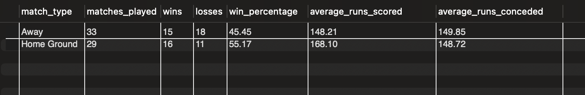

Visualization
The chart compares RCB's average runs scored and conceded at home and away venues, highlighting the difference in team performance under home-ground conditions.
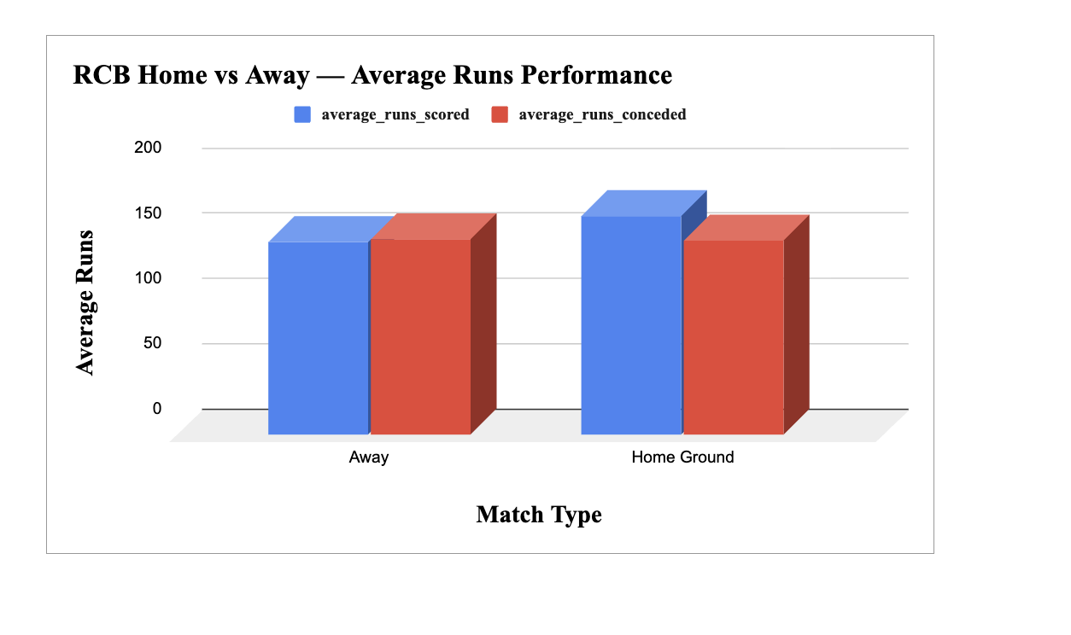

Approach
RCB matches were classified into home and away categories, with M Chinnaswamy Stadium treated as the home ground. Win percentage, average runs scored, and average runs conceded were then compared to measure the impact of home-ground advantage.

Insights
RCB performed better at home than away. The home win percentage was 55.17%, compared with 45.45% away. RCB also scored an average of 168.10 runs at home, compared with 148.21 runs away, while conceding slightly fewer runs at home (148.72 vs 149.85). This indicates a clear home-ground advantage in the analysed data.

Recommandation
RCB should maximize its home advantage by building strategies around the conditions at M Chinnaswamy Stadium. The team should leverage its stronger home batting performance, prepare venue-specific bowling plans, and select players who perform well under these conditions. Maintaining this home advantage while improving away performance should be a key strategic priority.
RCB should use its strong home batting and winning performance as a strategic advantage while developing stronger away-match strategies.

9. Question
Come up with a visual and analytical analysis of the RCB's past
season's performance and potential reasons for them not winning a
trophy.

SQL Query
with rcb_matches as (
select
m.match_id,
m.match_winner,
m.season_id
from matches m
where
m.team_1 = 2
or m.team_2 = 2
),

season_summary as (
select
s.season_year,
count(distinct r.match_id) as matches_played,
count(
distinct case
when r.match_winner = 2 then r.match_id
end
) as wins,
count(
distinct case
when r.match_winner <> 2
and r.match_winner is not null
then r.match_id
end
) as losses
from rcb_matches r
join season s
on r.season_id = s.season_id
group by
s.season_year
),

batting_stats as (
select
s.season_year,
sum(b.runs_scored) as total_runs
from ball_by_ball b
join matches m
on b.match_id = m.match_id
join season s
on m.season_id = s.season_id
where
b.team_batting = 2
group by
s.season_year
),

bowling_stats as (
select
s.season_year,
count(*) as total_wickets
from wicket_taken w
join ball_by_ball b
on w.match_id = b.match_id
and w.over_id = b.over_id
and w.ball_id = b.ball_id
and w.innings_no = b.innings_no
join matches m
on w.match_id = m.match_id
join season s
on m.season_id = s.season_id
where
b.team_bowling = 2
and w.kind_out in (
select out_id
from out_type
where out_name in (
'caught',
'bowled',
'lbw',
'stumped',
'caught and bowled',
'hit wicket'
)
)
group by
s.season_year
)

select
ss.season_year,
ss.matches_played,
ss.wins,
ss.losses,
round(
ss.wins * 100.0 / ss.matches_played,
2
) as win_percentage,
bs.total_runs,
round(
bs.total_runs * 1.0 / ss.matches_played,
2
) as average_runs_per_match,
ws.total_wickets,
round(
ws.total_wickets * 1.0 / ss.matches_played,
2
) as average_wickets_per_match
from season_summary ss
join batting_stats bs
on ss.season_year = bs.season_year
join bowling_stats ws
on ss.season_year = ws.season_year
order by
ss.season_year;

SQL Output
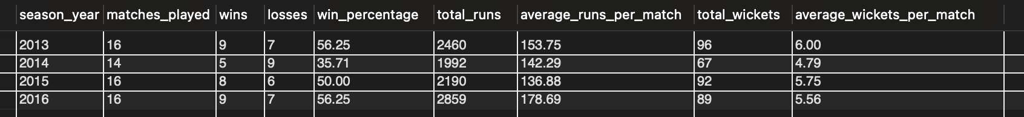

Visualization 1 — RCB Win Percentage Across Seasons
The line chart shows how RCB's win percentage changed across the available seasons, highlighting periods of stronger and weaker team performance.
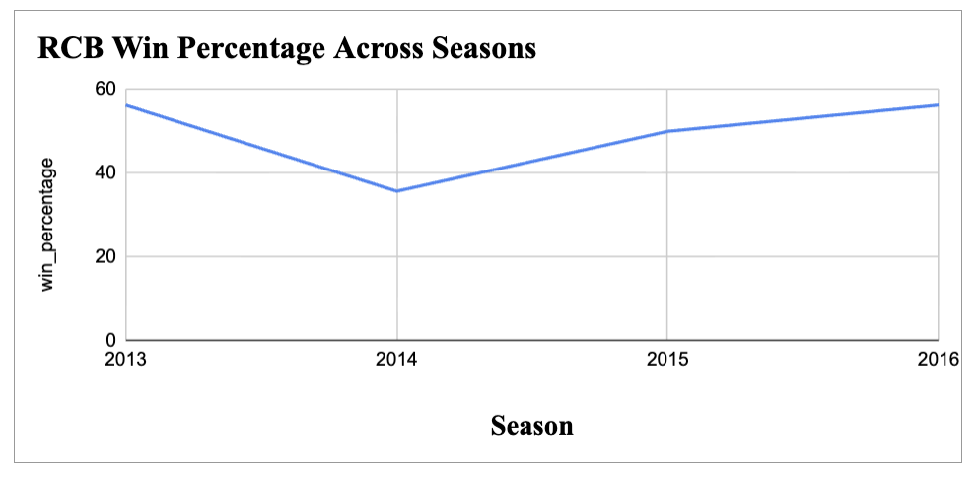

Visualization 2 — RCB Average Runs and Wickets per Match Across Seasons
The combo chart compares RCB's batting output and wicket-taking performance across seasons to identify changes in overall team balance.
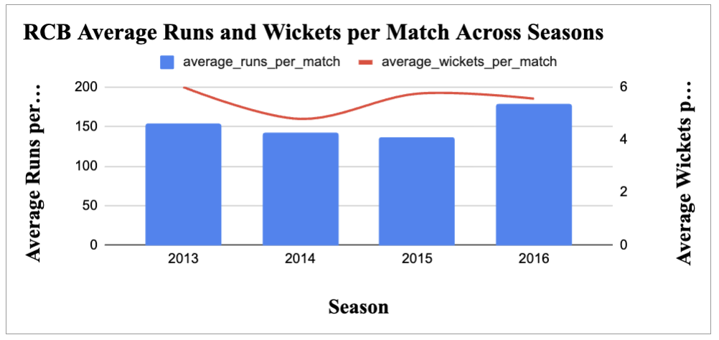

Approach
RCB's performance was analysed season by season using matches played, wins, losses, win percentage, total runs, average runs per match, total wickets, and average wickets per match. These metrics were compared across the available seasons to identify performance trends, strengths, weaknesses, and possible factors that may have affected RCB's ability to convert strong performances into sustained success.

Insights
RCB's performance varied across the analysed seasons. The team recorded its lowest win percentage in 2014 at 35.71%, while 2013 and 2016 recorded the highest win percentage at 56.25%. Batting performance was strongest in 2016, with an average of 178.69 runs per match, while 2014 had the lowest average at 142.29
Bowling performance was strongest in 2013, with an average of 6.00 wickets per match, and weakest in 2014, at 4.79 wickets per match. The results indicate that RCB's performance was not consistently strong across both batting and bowling, and fluctuations in team performance may have reduced their ability to maintain sustained success.

Recommandation
RCB should focus on maintaining a better balance between batting and bowling performance across seasons. Strong batting output should be supported by consistent wicket-taking and match-winning execution. The team should also work on reducing season-to-season performance fluctuations and converting strong individual or batting performances into more consistent wins.
Overall, the analysis suggests that inconsistency across seasons and an imbalance between batting and bowling performance were potential factors that limited RCB's ability to achieve sustained success.

9. Question
How would you approach this problem, if the objective and subjective
questions weren't given?

Approach
If the questions were not given, first I would try to understand the dataset and the main purpose of the project. I would check the available tables, columns, data types and relationships between the tables. After that, I would clean the data and check for missing values, duplicate records and incorrect values.
Then I would explore the data and try to find useful patterns related to RCB's performance. I would look at areas such as player performance, batting, bowling, team wins and losses, venue performance, seasons and toss decisions. Based on what I find, I would create my own questions and decide which KPIs would be useful for the analysis.
After getting the results, I would use suitable charts wherever they help explain the data better. Finally, I would identify the main insights and convert them into practical recommendations for RCB.

Insights
Without predefined questions, the main challenge would be to decide what is actually useful from the available data. I would focus on finding patterns that can help explain RCB's strengths, weaknesses and performance trends instead of analysing every column unnecessarily.

Recommandation
I would follow a step-by-step data-driven approach: first understand the data, then clean it, explore it, define useful KPIs, identify patterns, visualize important findings and finally give recommendations based on the results.

9. Question
In the "Match" table, some entries in the "Opponent_Team" column
are incorrectly spelled as "Delhi_Capitals" instead of
"Delhi_Daredevils". Write an SQL query to replace all occurrences
of "Delhi_Capitals" with "Delhi_Daredevils".

SQL Query
update Matches
set Opponent_Team = 'Delhi_Daredevils'
where Opponent_Team = 'Delhi_Capitals';

SQL Query 2 – Observation
describe Matches;

SQL Output
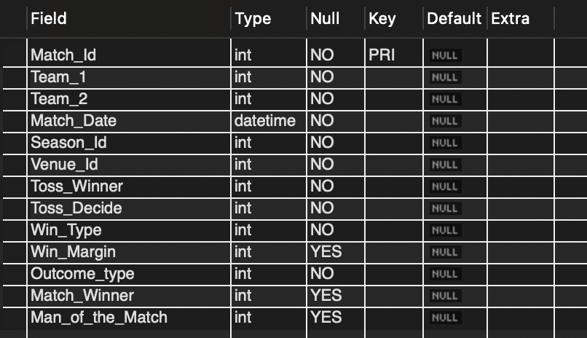

Approach
The provided query is intended to replace all occurrences of the incorrectly spelled team name Delhi_Capitals with Delhi_Daredevils in the Opponent_Team column. Before executing the update, the Matches table schema was checked using describe Matches.

Insights
The provided Matches table does not contain an Opponent_Team column. Instead, the table contains Team_1 and Team_2. Therefore, the requested update query cannot be executed on the available schema.

Recommandation
The database schema should first be verified against the project requirement. If an Opponent_Team field is required, the correct mapping or source column should be identified before making any data modification. The existing tables should not be altered just to force the query to run.
Execution Status: Query could not be executed because Opponent_Team is not present in the provided Matches table.

Project Completed

