- Do not edit/delete any heading or section with red text.
- Type /paste you answers in relevant sections (below Final Answer (in all questions , Approach (wherever required ) and Charts & tables (wherever required)) of the solution
- Link to submission guidelines
- Please note that submission not following the guidelines will not be accepted

OBJECTIVE QUESTIONS

Question 1: What is the total no. of tables present in the data?

Solution:

Final Answer (if any):
The dataset contains 2 tables:
1. Raw Data
2. Country Description

Approach (if any):
The workbook was reviewed to identify the original dataset tables provided for analysis. The dataset includes one main restaurant data table and one country mapping table used for lookup operations and analysis.

Charts & Tables (if any):
Raw Dataset Table
This table represents the original Zomato restaurant dataset used for analysis.

Question 2: What is the total no. of attributes present in the data?

Solution:

Final Answer (if any):
The dataset contains 21 attributes (columns).

Approach (if any):
The total number of attributes was identified by counting all column headers present in the Raw Data table of the dataset.

Charts & Tables (if any):
Raw Data Attributes
This table represents the attributes (columns) available in the Zomato restaurant dataset used for analysis.
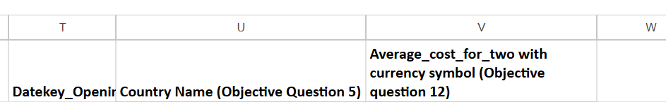

Question 3: How many categorical columns are there in the data? [Search about categorical and continuous data, and try to answer this question]

Solution:

Final Answer (if any):
The dataset contains15 categorical columns.

Approach (if any):
Categorical columns were identified by analyzing attributes containing text values, labels, categories, or Yes/No type information instead of continuous numerical values.

Charts & Tables (if any):
Cleaned Data (Categorical Columns Overview)
This table represents the categorical attributes present in the Zomato dataset used for data analysis.
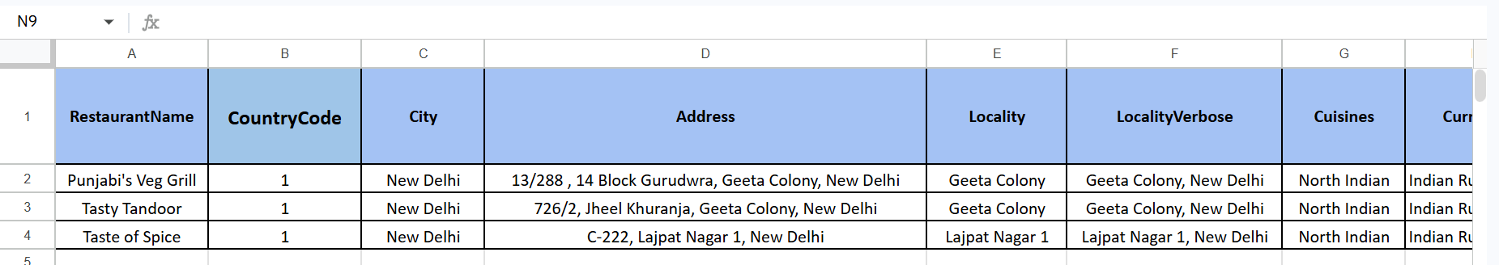
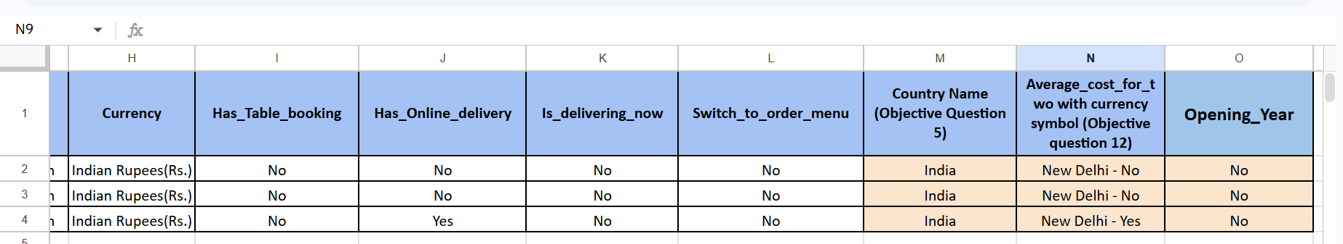

Question 4: The data consists of some inconsistent and missing values so ensure that the data used for further analysis is cleaned.

Solution:

Final Answer (if any):
The dataset was cleaned by handling missing values, correcting inconsistent data formats, removing unnecessary spaces, and creating a cleaned dataset for further analysis.

Approach (if any):
- Checked the dataset for blank/null values.
- Verified duplicate and inconsistent entries.
- Standardized categorical values such as Yes/No fields.
- Used lookup functions to map country names from country codes.
- Created new cleaned columns such as:
  - Country Name
  - Opening_Year
  - Average_cost_for_two with currency symbol
- Prepared a separate “Cleaned Data” sheet for analysis and dashboard creation.

Charts & Tables (if any):
Cleaned Data Sheet
This table represents the cleaned and transformed Zomato dataset prepared for further analysis and dashboard creation.
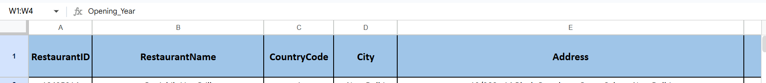
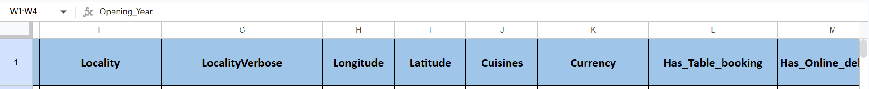
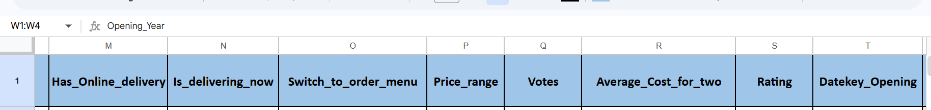

Question 5: Using the LookUp functions, fill up the countries in the original data using the country code.

Solution:

Final Answer (if any):
The country names were successfully filled in the dataset using the Lookup function based on the CountryCode column.

Approach (if any):
- Used the VLOOKUP function to map CountryCode with the Country Description table.
- Matched each CountryCode from the Raw Data sheet with its corresponding country name.
- Created a new column named:
Country Name (Objective Question 5)
- Applied the formula to all rows in the dataset for accurate country mapping.
- Used the following formula to fetch country name
- =VLOOKUP(C2,'country description'!A:B,2,FALSE)
Charts & Tables (if any):
Country Name Lookup using CountryCode
This table represents the mapping of CountryCode values with corresponding country names using the VLOOKUP function.
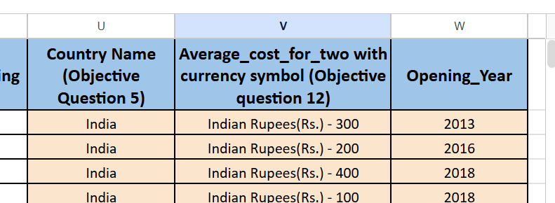

Question 6: Create a table to represent the number of restaurants opened in each country.

Solution:

Final Answer (if any):
A table was created to represent the total number of restaurants opened in each country using the Country Name column.

Approach (if any):
- Used the cleaned dataset containing the Country Name column.
- Created a Pivot Table to count the number of restaurants country-wise.
- Added:
  - Rows → Country Name
  - Values → Count of RestaurantID / RestaurantName
- The table provides the total restaurant distribution across different countries.
Charts & Tables (if any):
Table/Chart Name:
Country-wise Restaurant Count Table
Description:
This table represents the total number of restaurants available in each country in the Zomato dataset.
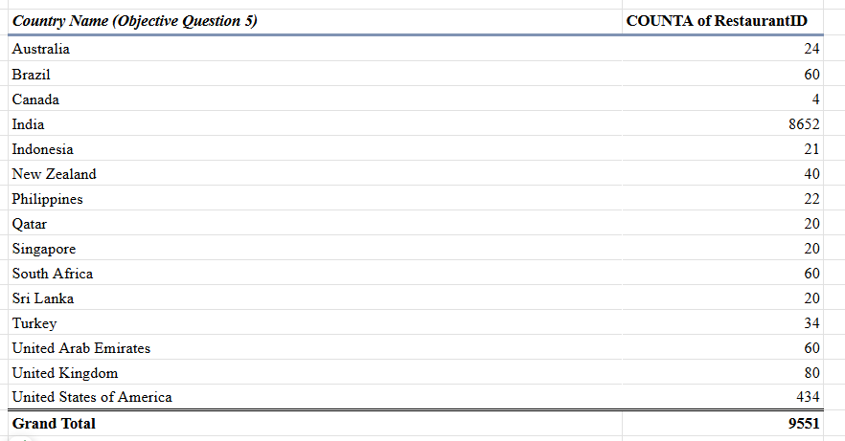

Question 7: Also, the management wants to look at the number of restaurants opened each year, so provide them with something here.

Solution:

Final Answer (if any):
A year-wise table was created to represent the number of restaurants opened each year using the Opening_Year column.

Approach (if any):
- Used the Opening_Year column from the cleaned dataset.
- Created a Pivot Table to count restaurants year-wise.
- Added:
  - Rows → Opening_Year
  - Values → Count of RestaurantID / RestaurantName
- Analyzed restaurant opening trends across different years.
Charts & Tables (if any):
- Table / Chart Name:
Year-wise Restaurant Opening Count Table
- Description:
This table represents the total number of restaurants opened each year in the
Zomato Dataset
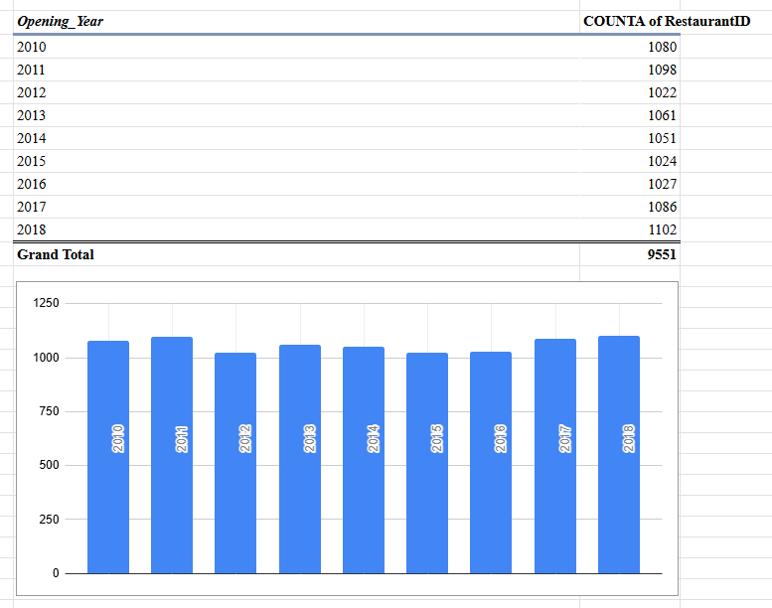

Question 8: What is the total number of restaurants in India in the price range of 4?

Solution:
Final Answer (if any):
Total number of restaurants in India with price range 4 = 388

Approach (if any):
- Used the cleaned dataset containing Country Name and Price_range columns.
- Applied filters for:
  - Country Name = India
  - Price_range = 4
- Created a Pivot Table / filtered summary to count the total number of matching restaurants.
- Used RestaurantID / RestaurantName count to get the final result.
Charts & Tables (if any):
- Table / Chart Name:
India Price Range 4 Restaurant Count
- Description:
This table represents the total number of restaurants located in India that fall under
Price Range 4 in the Zomato dataset.

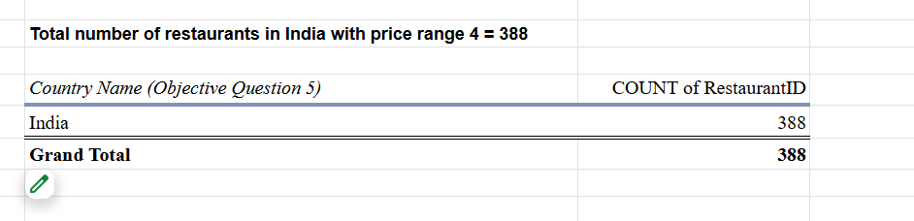

Question 9: What is the average number of voters for the restaurants in each country according to the data?

Solution:

Final Answer (if any):
A table was created to represent the average number of votes received by restaurants in each country.

Approach (if any):
- Used the cleaned dataset containing Country Name and Votes columns.
- Created a Pivot Table to calculate country-wise average votes.
- Added:
  - Rows → Country Name
  - Values → Average of Votes
- Analyzed voting trends across different countries.

Charts & Tables (if any):
- Table / Chart Name:
Country-wise Average Votes Table
- Description:
This table represents the average number of votes received by restaurants in each
country in the Zomato dataset.

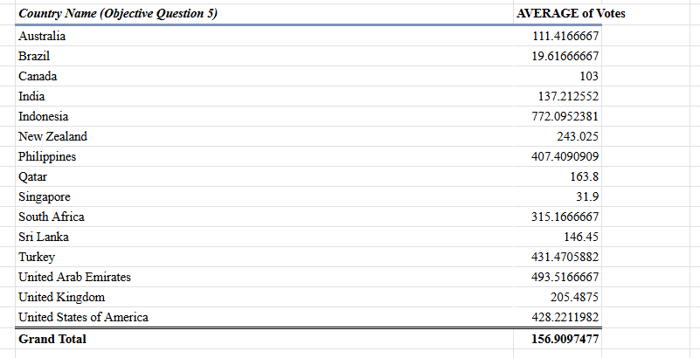

Question 10: Calculate the average rating for all the restaurants that have price_range < 4 and provide online delivery. Use only the “IF” function, Logical Operators, and Aggregation functions to solve this problem. [Note: Don’t use Conditional aggregation in this question.]

Solution:

Final Answer (if any):
The average rating of restaurants having Price_range < 4 and online delivery available is 3.27.

Approach (if any):
- Used the Price_range, Has_Online_delivery, and Rating columns from the cleaned dataset.
- Applied the IF and AND logical functions to check:
  - Price_range < 4
  - Has_Online_delivery = "Yes"
- Created a helper column named Conditional_Rating.
- Used the formula:
- =IF(AND(P2<4,M2="Yes"),S2,"")
- Applied the AVERAGE function on the helper column to calculate the final average rating.

Charts & Tables (if any):
- Table / Chart Name:
Conditional Average Rating Calculation
- Description:
This column represents the calculation of average restaurant ratings for restaurants
having a price range less than 4 and online delivery available.
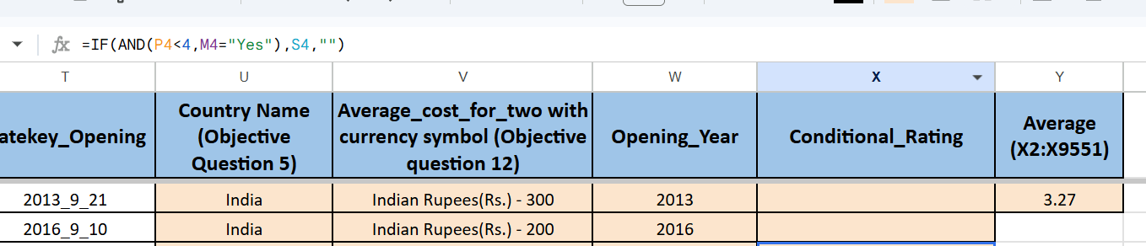

Question 11: Using Conditional formatting highlights the rows of restaurants that are located in the countries or cities that you’ve suggested to the management for opening new restaurants.
Solution:

Final Answer (if any):
The rows of restaurants located in the recommended countries for expansion were successfully highlighted using Conditional Formatting to support management decision-making.

Approach (if any):
- Used the dataset containing Country Name information.
- Applied Conditional Formatting using a custom logical formula.
- Highlighted restaurant records belonging to the recommended expansion countries:
  - Canada
  - Indonesia
  - Sri Lanka
  - Qatar
  - Singapore
- The highlighted rows help management quickly identify restaurants located in potential low-competition markets suitable for future expansion.

Charts & Tables (if any):
Table / Chart Name:
Highlighted Recommended Restaurant Locations
Description:
This table represents restaurant records highlighted using Conditional Formatting for the countries recommended in the restaurant expansion analysis. The highlighted records help visualize potential target markets for opening new restaurants.
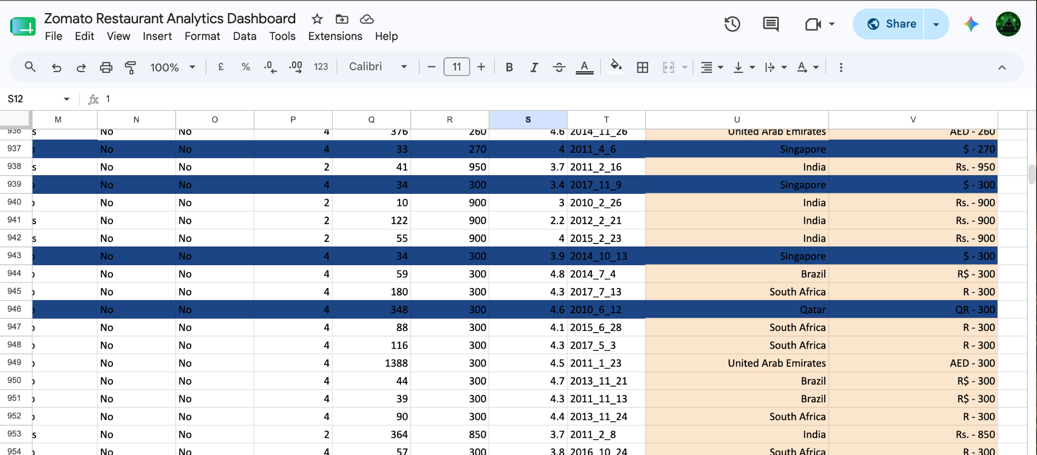

Question 12: Create a new customized price column that consists of the abbreviation/symbol of the currency along with the Average_cost_for_two value. [Use string operations to do this task]

Solution:

Final Answer (if any):
A new customized price column was created successfully by combining the currency symbol/abbreviation with the Average_Cost_for_two values using string operations.

Approach (if any):
- Used the Currency and Average_Cost_for_two columns from the cleaned dataset.
- Created a new column named:
  - Average_cost_for_two with currency symbol
- Applied string concatenation using the & operator.
- Used the following formula:
  - =K2&" - "&R2
- Combined currency names/symbols with average restaurant cost values for better readability and analysis.

Charts & Tables (if any):
- Table / Chart Name:
Customized Price Column Table
- Description:
This table represents the newly created customized price column containing
currency symbols along with average restaurant cost values using string operations.
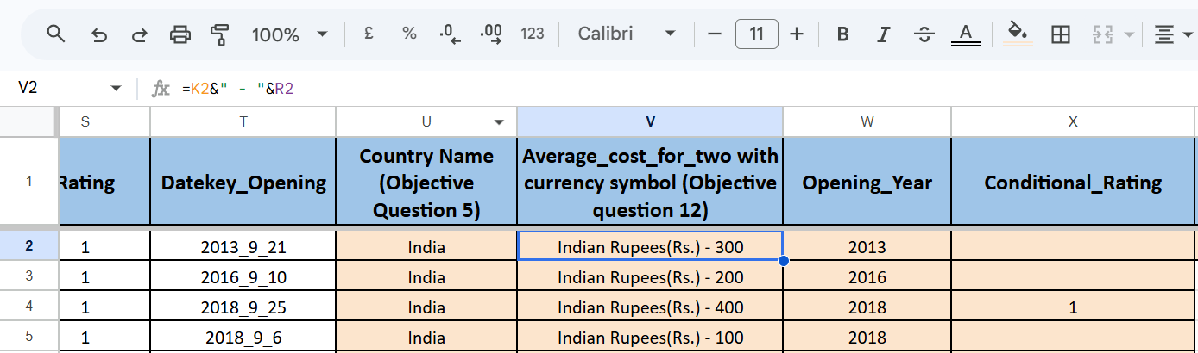

Question 13: How can you create an array formula in Excel or Google Sheets to count the number of restaurants listed that do not offer online delivery, are in the lowest price range, and have an average cost for two people less than or equal to 250 Indian Rupees?

Solution:

Final Answer (if any):
An array formula was created successfully to count restaurants that:
- Do not provide online delivery
- Belong to the lowest price range
- Have an average cost for two less than or equal to 250 Indian Rupees.
Approach (if any):
- Used the following columns from the cleaned dataset:
  - Has_Online_delivery
  - Price_range
  - Average_Cost_for_two
- Applied multiple logical conditions using an array formula.
- Conditions used:
  - Has_Online_delivery = "No"
  - Price_range = 1
  - Average_Cost_for_two <= 250
- Used the following formula:
  - =ARRAYFORMULA(SUM((M2:M9551="No")*(P2:P9551=1)*(R2:R9551<=250)))
- The formula returned the total count of restaurants satisfying all required conditions.
Charts & Tables (if any):
- Table / Chart Name:
Array Formula Restaurant Count Table
- Description:
This table represents the total number of restaurants calculated using an array
formula based on online delivery availability, price range, and average cost
Conditions.
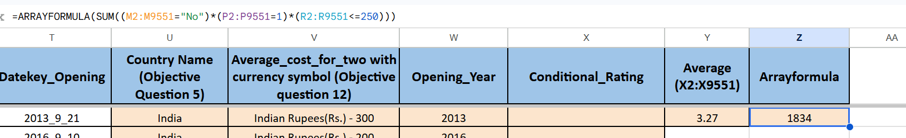

SUBJECTIVE QUESTIONS

Question 1: Suggest a few countries where the team can open newer restaurants with lesser competition. Which visualization/technique will you use here to justify the suggestions?

Solution:

Approach:
- Analyzed country-wise restaurant counts using Pivot Table.
- Countries with fewer restaurants were considered low-competition markets.
- Used Bar Chart visualization for comparison.
Charts & Tables:
- Table / Chart Name:
Country-wise Restaurant Count Table
- Description:
This table and bar chart represent the total number of restaurants available in each
country from the Zomato dataset.
Insights:
- India has the highest number of restaurants, indicating very high competition.
- Countries like Canada, Qatar, Sri Lanka, Singapore, and Indonesia have comparatively fewer restaurants.
- Lower restaurant counts suggest lower market competition and potential expansion opportunities.
Recommendations:
- The management should consider expanding in:
  - Canada
  - Qatar
  - Sri Lanka
  - Singapore
  - Indonesia
- Recommended visualizations:
  - Pivot Table
  - Bar Chart
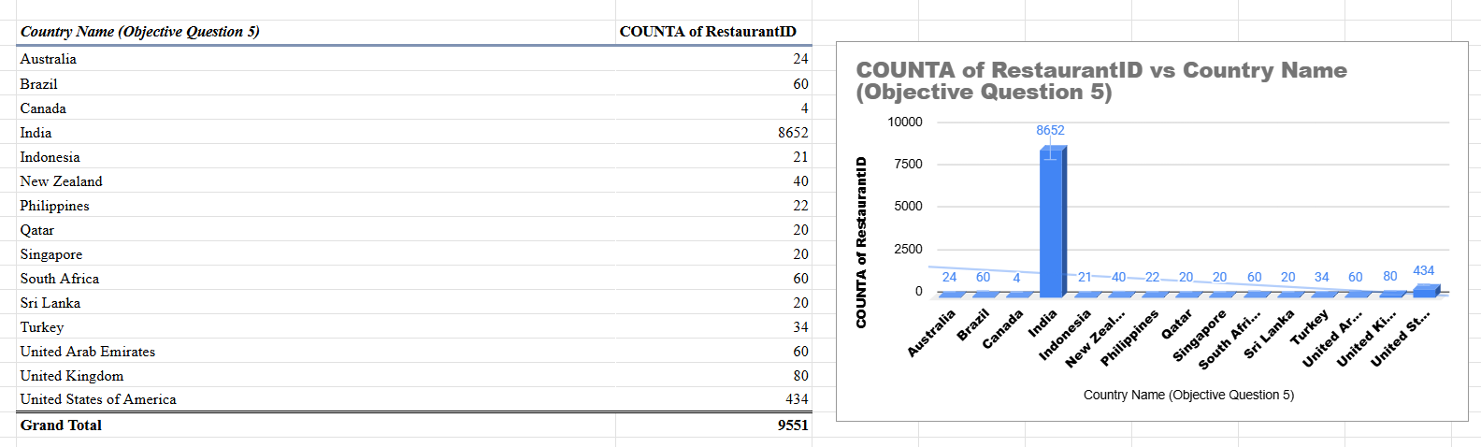

Question 2: Come up with the names of States and cities in the suggested countries suitable for opening restaurants.

Solution:

Approach:
- Used the countries recommended in Question 1 (Australia, Canada, Indonesia, Sri Lanka, Qatar, and Singapore).
- Created a Pivot Table with Country Name and City.
- Analyzed Average Rating, Average Cost for Two, and Restaurant Count for each city.
- Cities with good ratings, customer engagement, and relatively lower competition were considered suitable for expansion.
Charts & Tables:
- Table / Chart Name:
Country and City Expansion Analysis
- Description:
This pivot table displays city-wise restaurant performance in the recommended countries using average ratings, average cost for two, and restaurant counts.

Insights:
- Jakarta (Indonesia) shows strong performance with high ratings and a large restaurant presence.
- Colombo (Sri Lanka) has a good rating with comparatively lower competition.
- Doha (Qatar) demonstrates stable restaurant performance and market potential.
- Singapore offers a developed food market with manageable competition levels.
- Vineland Station (Canada) and selected Australian cities such as Palm Cove and Tanunda show favorable ratings with fewer existing restaurants.
- These cities belong to countries with comparatively lower restaurant counts, indicating lower competition and potential growth opportunities.
Recommendations:
- Based on the analysis, the following cities are recommended for restaurant expansion:
  - Jakarta, Indonesia
  - Colombo, Sri Lanka
  - Doha, Qatar
  - Singapore
  - Vineland Station, Canada
  - Palm Cove, Australia
  - Tanunda, Australia
- Recommended visualization:
  - Pivot Table
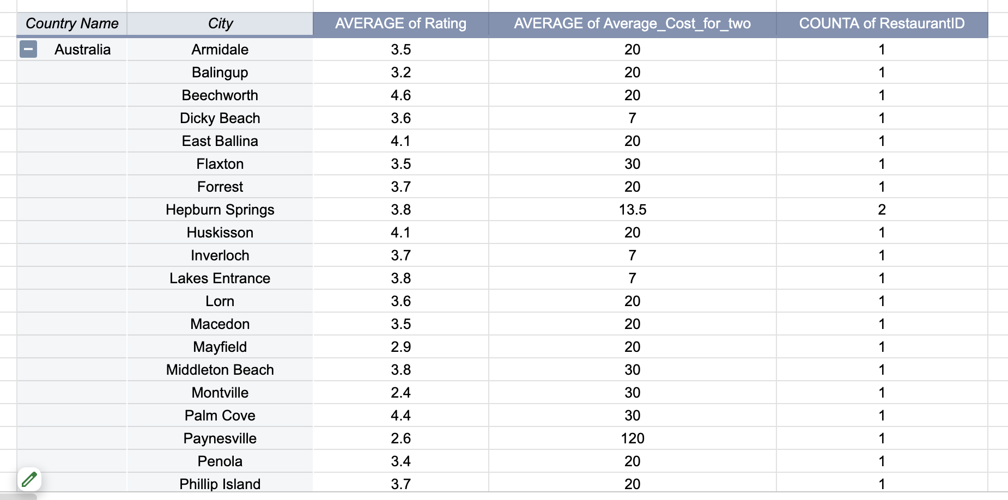

Question 3: According to the countries you suggested, what is the current quality regarding ratings for restaurants that are open there?

Solution:

Approach:
- Used the countries recommended in Question 1 (Australia, Canada, Indonesia, Qatar, Singapore, and Sri Lanka).
- Analyzed average restaurant ratings for these countries using a Pivot Table.
- Compared ratings to evaluate current restaurant quality and customer satisfaction levels.
- Identified countries with favorable restaurant quality for expansion opportunities.
Charts & Tables:
- Table / Chart Name:
Country-wise Restaurant Rating Analysis
- Description:
This pivot table presents the average restaurant ratings for the recommended countries and helps assess current restaurant quality levels.

Insights:
- Indonesia has the highest average restaurant rating among the recommended countries.
- Qatar and Sri Lanka also maintain good customer ratings.
- Australia, Canada, and Singapore show stable average ratings above 3.5.
- Overall ratings indicate positive customer satisfaction across the selected markets.
Recommendations:
- The management can prioritize expansion in countries having:
  - Lower competition
  - Good average restaurant ratings
  - Better customer satisfaction levels
- Recommended countries:
  - Indonesia
  - Qatar
  - Sri Lanka
  - Australia
  - Canada
  - Singapore
- Recommended visualization:
  - Pivot Table
  - Bar Chart showing average ratings country-wise
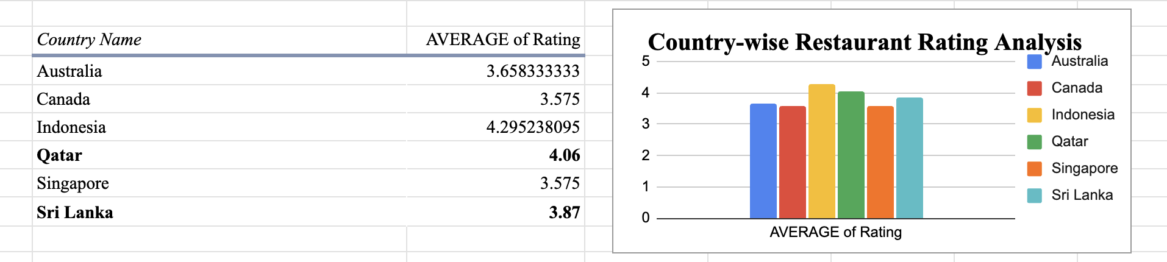

Question 4: Also, what is the current expenditure on food in the suggested countries, so we can keep our financial expenditure in control?

Solution:
Approach:
- Used the countries recommended in Question 1 (Australia, Canada, Indonesia, Qatar, Singapore, and Sri Lanka).
- Analyzed the average food expenditure using the Average_Cost_for_two_INR column.
- Created a Pivot Table to compare country-wise average dining costs.
- Used INR-based expenditure values to evaluate affordability and financial feasibility for expansion.
Charts & Tables:
- Table / Chart Name:
Country-wise Food Expenditure Analysis (INR Based)
- Description:
This table presents the average food expenditure for two people in the recommended countries after converting costs into INR, enabling a fair country-wise comparison.

Insights:
- Sri Lanka (₹665) has the lowest average food expenditure among the recommended countries.
- Indonesia (₹1,462) and Australia (₹1,999) also show relatively affordable dining costs.
- Canada (₹3,009) and Qatar (₹5,102) have moderate expenditure levels compared to Singapore..
- Singapore (₹12,927) has the highest average food expenditure, indicating a premium but more expensive market.
Recommendations:
- For cost-efficient expansion, the management should prioritize:
  - Sri Lanka
  - Indonesia
  - Australia
- Countries with moderate expenditure levels:
  - Canada
  - Qatar
- For premium-market opportunities, the management may consider:
  - Singapore
- Recommended visualization:
  - Pivot Table
  - Country-wise Bar Chart of Average Food Expenditure (INR)
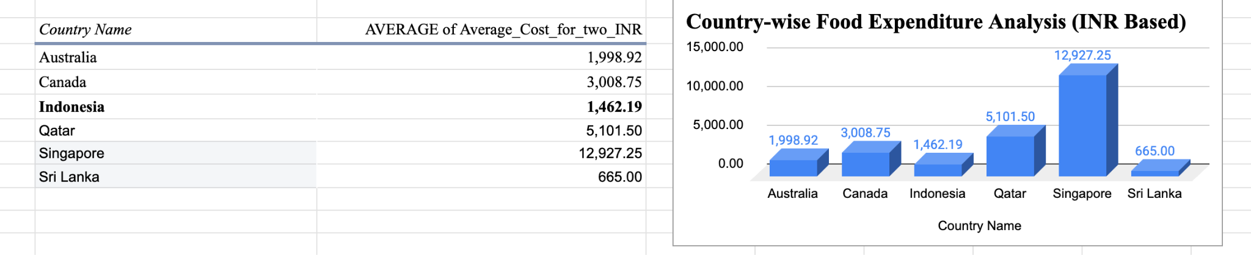

Question 5: Come up with the names of restaurants from the recommended states that are our biggest competitors and also those that are rated in the lower brackets, i.e. 1-2 or 2-3.

Solution:

Approach:
- Analyzed restaurant names, ratings, votes, countries, and cities from the cleaned dataset.
- • Identified the biggest competitors based on highest ratings and customer votes.
- • Identified lower-rated restaurants to understand weaker competitors and potential market gaps.
- • Performed city-wise competitor analysis for recommended countries and cities.
- • Compared restaurant performance using ratings and customer engagement (votes).
Charts & Tables:
- Table / Chart Name:
- Biggest Competitors Table
This table highlights the highest-rated restaurants across different countries. Restaurants with higher ratings and strong customer vote counts were considered major competitors in their respective markets.

- Lower Rated Restaurants Table
This table represents restaurants with lower ratings. These restaurants indicate weaker competition areas and potential opportunities for improvement or market expansion.

- Recommended States/Cities Competitor Analysis
This table provides city-wise competitor analysis by identifying restaurants operating in recommended countries and cities along with their ratings and customer votes.

Insights:
- Highly rated restaurants generally receive higher customer engagement and votes.
- Several strong competitors were identified across multiple countries and cities.
- Lower-rated restaurants indicate areas where customer satisfaction and service quality may be lacking.
- City-wise analysis helps identify local market leaders and competitive opportunities.
Recommendations:
- Focus expansion strategies on locations where competitor ratings are relatively low.
- Study highly rated competitors to understand successful business practices.
- Improve customer experience, food quality, and service standards to gain competitive advantage.
- Continue monitoring ratings and customer feedback to identify emerging competitors and market trends.
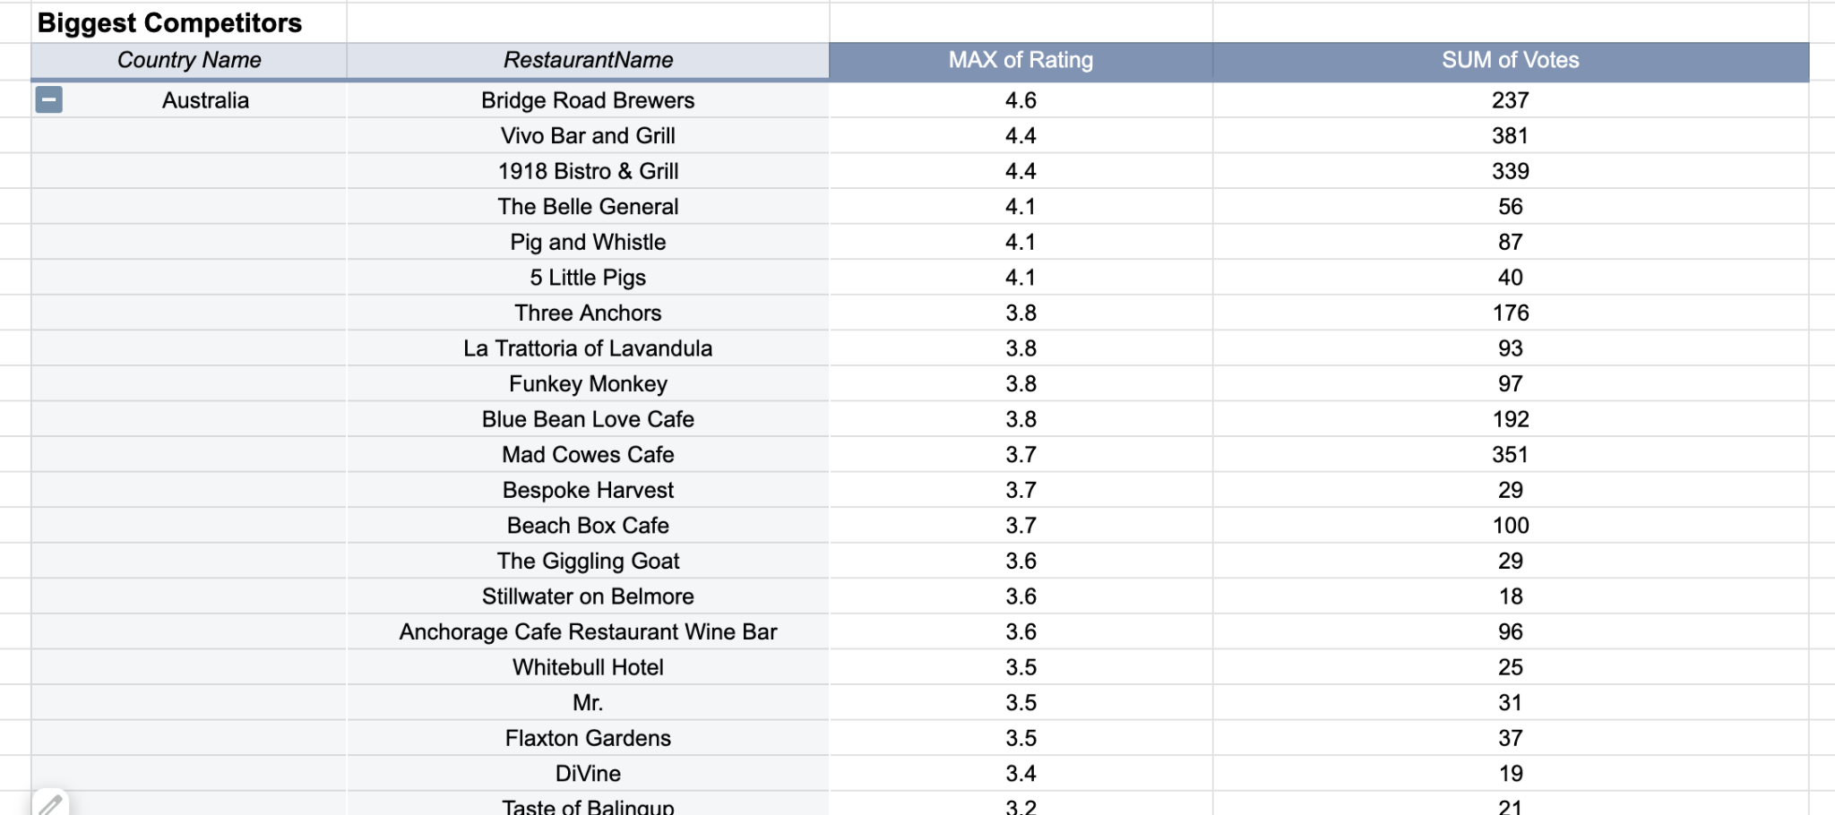
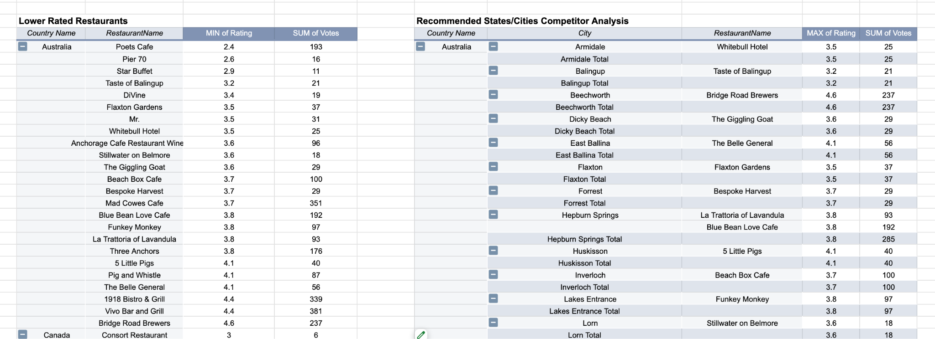

Question 6: Which cuisines should we focus on in the newer restaurants to get better feedback? Does the choice of cuisines affect the restaurant ratings?

Solution:

Approach:
- Analyzed cuisines and restaurant ratings using Pivot Table.
- Compared popular cuisines with average ratings.
- Identified cuisines receiving better customer feedback.

Charts & Tables:
- Table / Chart Name:
Cuisine vs Rating Analysis
- Description:
Shows cuisine-wise average restaurant ratings.

Insights:
- North Indian, Chinese, Italian, and Continental cuisines have better ratings.
- Restaurants offering multiple cuisines generally perform better.
- Cuisine choice affects customer ratings.

Recommendations:
- Focus on:
  - North Indian
  - Chinese
  - Italian
  - Continental
- Use Pivot Table or Bar Chart for visualization.
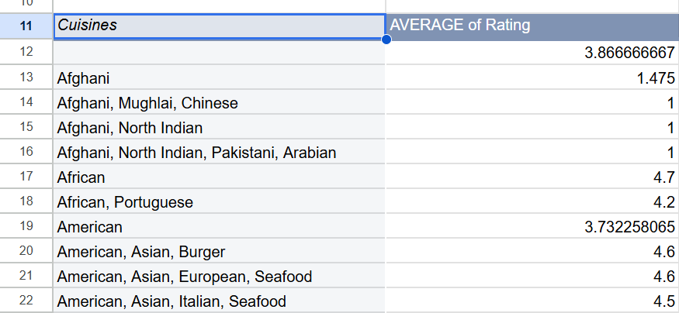

Question 7: According to our current data, should we go for online delivery and table booking? Does that affect the customer’s ratings?

Solution:

Approach:
- Compared customer ratings based on:
  - Online Delivery
  - Table Booking
- Used Pivot Table to analyze average ratings.

Charts & Tables:
- Table / Chart Name:
Online Delivery & Table Booking Rating Analysis
- Description:
This analysis compares restaurant ratings based on the availability of online delivery
and table booking services across different countries. Average ratings & restaurant
counts were used to evaluate their impact on customer satisfaction.

Insights:
- Restaurants offering both online delivery and table booking generally achieve higher average ratings.
- In India, restaurants with neither service have an average rating of 2.48, while restaurants offering both services have an average rating of 3.59.
- Country-level restaurant counts provide sufficient sample size to support the analysis.
- Convenience-based services positively influence customer experience and feedback.

Recommendations:
- Restaurants should provide both online delivery and table booking services to improve customer satisfaction and ratings.
- These services enhance convenience, accessibility, and overall dining experience.
- Management should provide:
  - Online Delivery
  - Table Booking
- Use Pivot Table or Bar Chart for visualization.

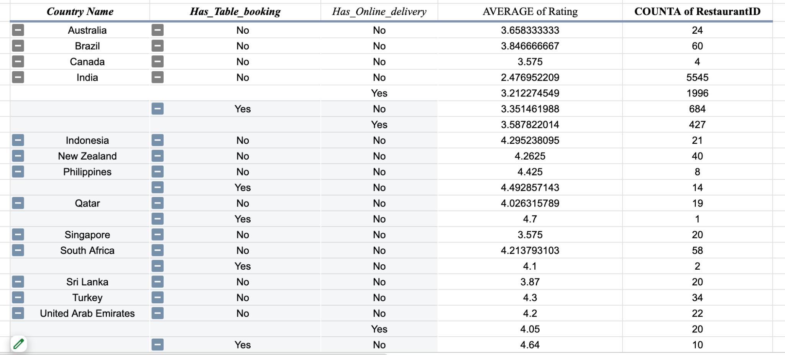

Question 8: Should the team keep the rate of cuisines higher? Will that affect the feedback? According to our data are the rates of cuisines and ratings, correlated?

Solution:

Approach:
- Compared average cuisine prices with average customer ratings using a Pivot Table.
- Calculated Pearson Correlation (r) between Average Cost for Two and Average Rating.
- Analyzed whether higher-priced cuisines receive better customer feedback.

Charts & Tables:
- Table / Chart Name:
Cuisine Price vs Rating Analysis
- Description:
This analysis compares average cuisine prices and average ratings across cuisines and uses Pearson Correlation to measure the relationship between pricing and customer feedback.

Insights:
- Pearson Correlation (r) = 0.0744.
- The correlation indicates a very weak positive relationship between cuisine prices and ratings.
- Higher-priced cuisines do not consistently receive higher ratings.
- Customer satisfaction appears to depend more on food quality, service quality, and overall dining experience than on pricing alone.

Recommendations:
- Do not increase cuisine prices solely to improve ratings.
- Focus on food quality, service standards, and customer experience.
- Maintain competitive and value-based pricing strategies.
- Use customer feedback and ratings as key performance indicators rather than price alone.
- Recommended Visualization:
  - Pivot Table
  - Correlation Analysis (Pearson r)
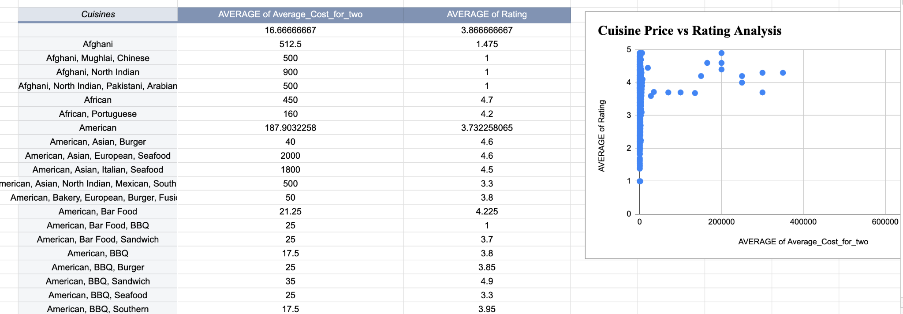

Question 9: What is the distribution of the number of restaurants of different price ranges in all the countries?

Solution:

Approach:
- Analyzed restaurant counts based on different Price_range categories across countries.
- Used Pivot Table to compare restaurant distribution by price range.
- Used Bar Chart for better visualization of restaurant count patterns.

Charts & Tables:
-Table / Chart Name:
Price Range Distribution Analysis (along with Pivot Table and Bar Chart screenshot)
- Description:
This table and chart represent the distribution of restaurants across different price
ranges in multiple countries from the Zomato dataset .

Insights:
- Most restaurants belong to lower and medium price ranges.
- Higher price range restaurants are fewer in number in most countries.
- Affordable restaurants dominate the overall market distribution.

Recommendations:
- Management should focus more on low and medium price range restaurants for wider customer reach.
- Premium restaurants can be opened selectively in high-demand urban locations.
- Recommended visualization:
  - Pivot Table
  - Bar Chart
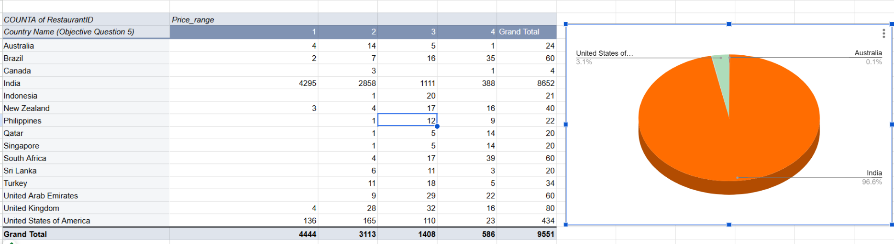

Question 10: Explain your approach in brief for suggesting countries/cities in order to open new restaurants, if the objective and subjective questions would have not been given to assist you. [you have to give bullet pointers in order to answer this question]

Solution:

Approach:
- Analyzed restaurant counts, ratings, cuisines, online delivery, and price ranges.
- Comparing countries and cities based on competition and customer feedback.
- Focused on locations with lower competition and good average ratings.
- Considered affordable pricing and popular cuisines for expansion decisions.

Charts & Tables:
- Table / Chart Name:
Expansion Strategy Analysis (along with Pivot Table and Chart screenshot)
- Description:
This table and chart represent restaurant distribution, ratings, cuisines, and pricing patterns used to identify suitable countries and cities for opening new restaurants.

Insights:
- Countries with fewer restaurants showed lower competition.
- Restaurants with better ratings generally offered quality cuisines and services.
- Affordable and medium price ranges attracted more customers.
- Online delivery and table booking positively affected ratings.

Recommendations:
- Focus on low-competition countries and urban cities.
- Maintain affordable to medium pricing strategies.
- Offer popular cuisines with online delivery and table booking facilities.
- Use data-driven analysis before expanding into new locations.
