**Tip:** Tool to Migrate your Local DB to Azure:

<http://sqlazuremw.codeplex.com/>

**Problem:** If we are using EntityFramework with WCF / Web API.

If there are any navigation properties between entities, the likelihood of this error is high.

“Type 'System.Data.Entity.DynamicProxies.Customers_21E6922CC8E7F8A73D5A7994864A471634C7ABE16025455F28EFDDCB65A9E574' with data contract name 'Customers_21E6922CC8E7F8A73D5A7994864A471634C7ABE16025455F28EFDDCB65A9E574:http://schemas.datacontract.org/2004/07/System.Data.Entity.DynamicProxies' is not expected. Consider using a DataContractResolver if you are using DataContractSerializer or add any types not known statically to the list of known types - for example, by using the KnownTypeAttribute attribute or by adding them to the list of known types passed to the serializer.”

Eg:

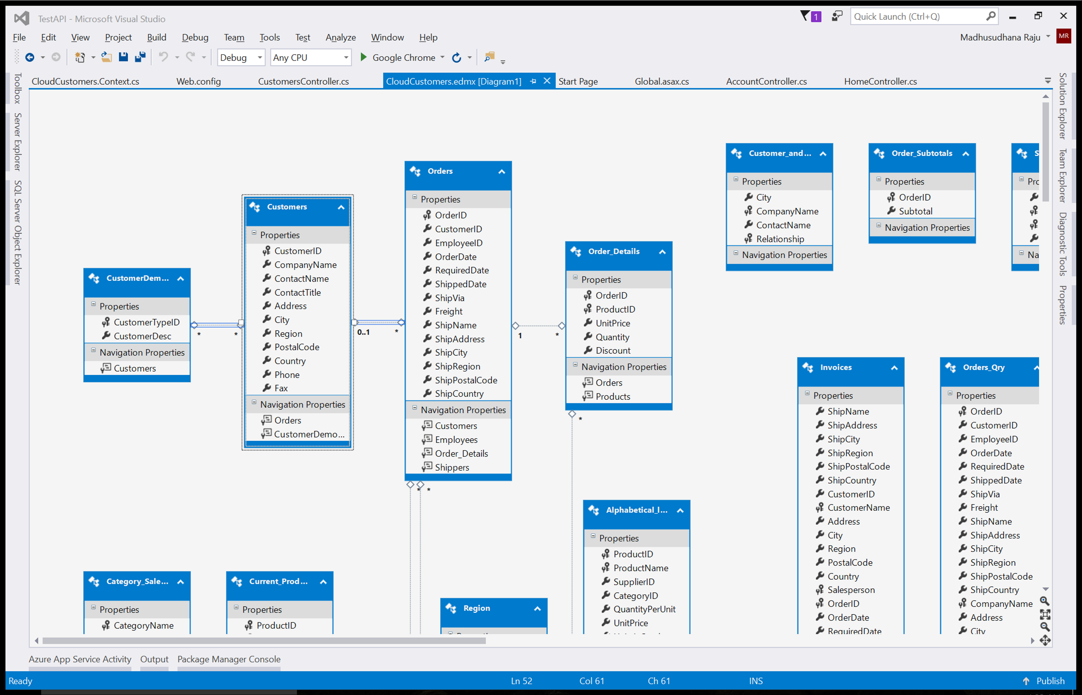

Say Serialization of Customers class is happening, WCF / Web API serializes the Customers class and closes the related context and disposes it. But serialization of navigation properties automatically triggers Lazy Loading, but now the serialization is happening on the closed context (Customers Context), which results in the above error.

Set the ProxyCreationEnabled to False in the dbContext class constructor.

public AdventureWorksEntities()

: base("name=AdventureWorksEntities")

{

base.Configuration.ProxyCreationEnabled = false;

}