**---------- ----------**

**ASSIGMENT 01**

**Que: 1. Create a new database called student_management.**

* use student_management

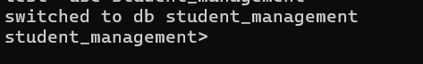

**Que: 2. Create a collection called students in the student_management database.**

* db.createCollection("student")

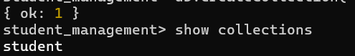

**Que: 3. Insert at least five students records into the student collection. Each record should have the following fields.**

* db.student.insertMany([{_id:101,name:"Akshay Kumar",age:21,department:"HR",course:

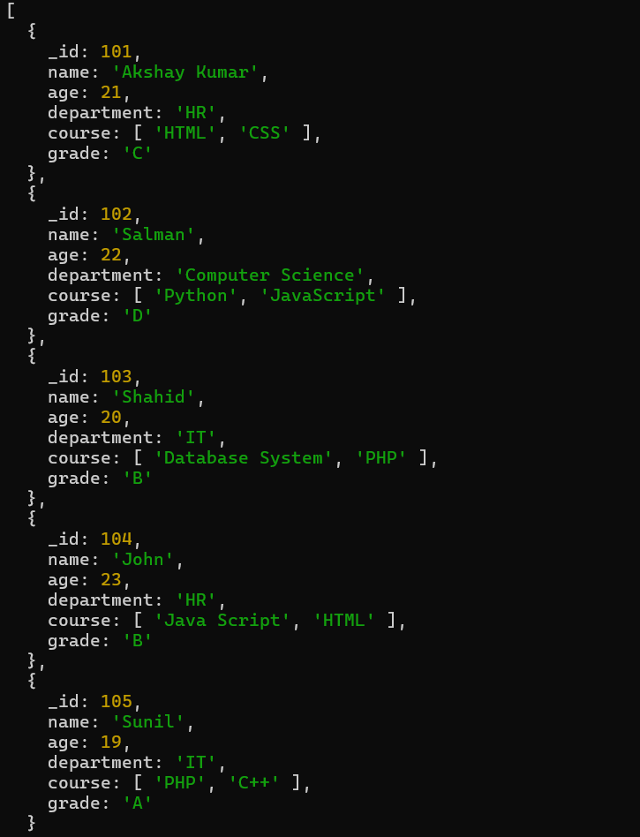

**Que: 4. Query**

* **Retrieve all students who are in the “Computer Science” department.**
* **db.student.find({department:"Computer Science"})**

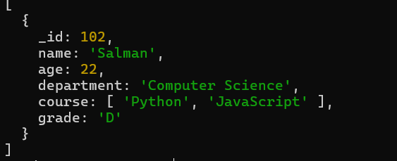

* **Retrieve students who have an age is greate then 21.**
* **db.student.find({age:{$gt:21}})**

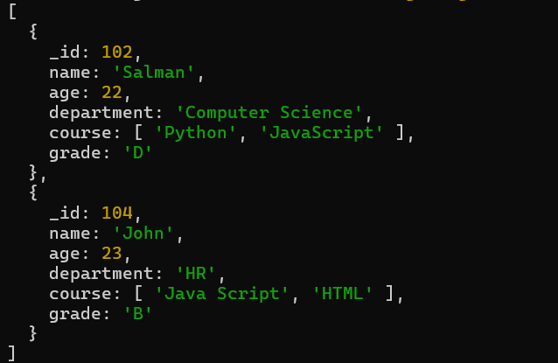

* **Retrieve students who are taking the Database System course**
* db.student.find({course:"Database System"})

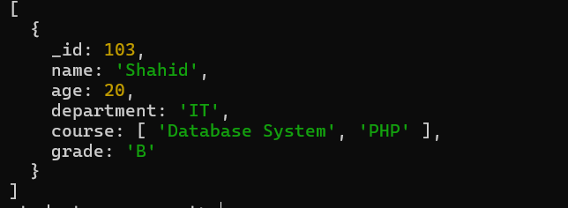

* **Retrieve students with a grade “A”.**
* db.student.find({grade:"A"})

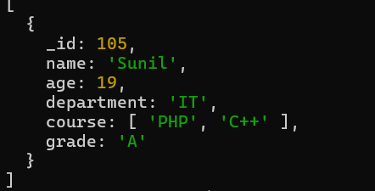

**Que: 5. Update Documents.**

* **Update the age of a student with student_id 104 to 21.**
* db.student.updateOne({_id:102},{$set:{age:21}})

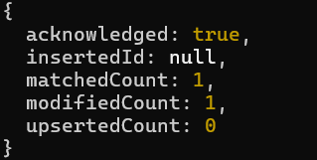

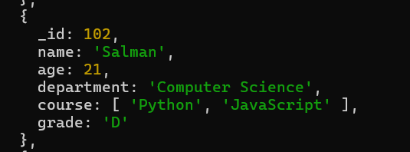

* **Add a new course “Machine Learning” to the courses in the “Computer Science” department.**
* db.student.updateOne({department:"Computer Science"},{$push:{course:"Machine Learning"}})

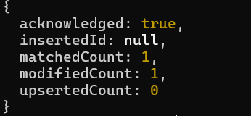

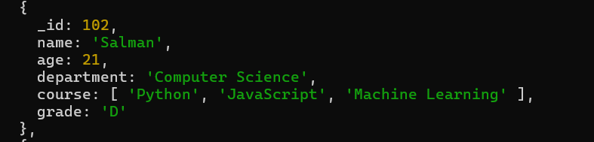

**Que: 6. Delete Documents**

* **Delete a student record with student_id 105.**
* db.student.deleteOne({Student_id:105})

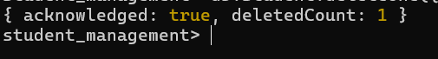

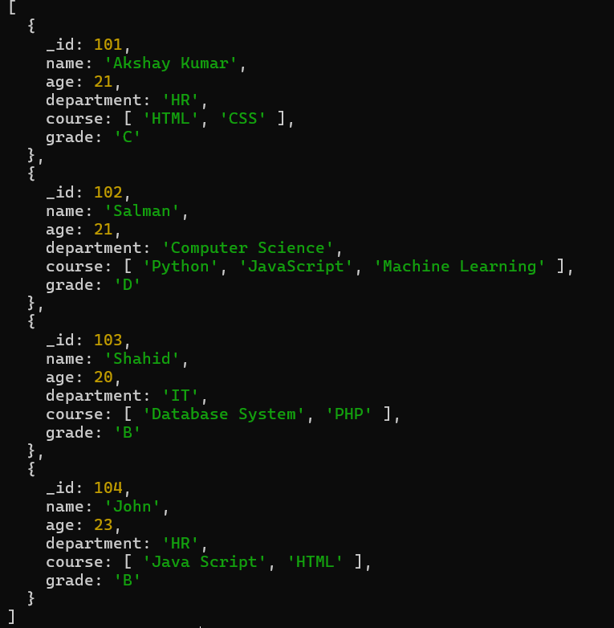

* **Delete all student who have a grade lower then “C”.**
  + db.student.deleteMany({Grade:{$gt:"C"}})

