Project Documentation:
Branch Office Enterprise Network

1. Introduction
This project demonstrates the design and implementation of a secure enterprise network using Cisco networking technologies. The objective is to build a functional, scalable, and well-segmented network environment that supports multiple departments—HR, IT, and Finance—each operating in its own isolated VLAN.
To enable controlled communication between departments, Inter-VLAN Routing is implemented using a router-on-a-stick configuration. All end-user devices obtain IPv4 addresses automatically via a centralized DHCP service for ease of management. Wireless connectivity is also provided to each department through dedicated access points mapped to their respective VLANs.

2. Objective
The primary goal of this project was to:
Design and implement a network structure with separate VLANs for different departments.
Set up Inter-VLAN Routing to allow communication between devices across different VLANs.
Ensure the network is secure by segmenting traffic through VLANs.
Test connectivity between devices in different VLANs.

3. Network Design
The network consists of the following components:
- One Router for routing traffic between VLANs.
- Three Layer 2 Switches to manage traffic within each VLAN.
- PCs and laptops distributed across three VLANs:
- IT VLAN: 192.168.10.0/24
- FINANCE VLAN: 192.168.20.0/24
- HR VLAN: 192.168.30.0/24
Each department is isolated within its own VLAN, and communication between VLANs is facilitated by Inter-VLAN Routing on the router.

4. IP Addressing Scheme

VLAN Name | VLAN ID | Subnet IP Range | Gateway IP | PCs IP Addresses
IT | 10 | 192.168.10.0/24 | 192.168.10.1 | 192.168.10.2, 192.168.10.3, 192.168.10.4,  192.168.10.5
FINANCE | 20 | 192.168.20.0/24 | 192.168.20.1 | 192.168.20.1, 192.168.20.2, 192.168.20.3,  192.168.20.4  192.168.20.5
HR | 30 | 192.168.30.0/24 | 192.168.30.1 | 192.168.30.4, 192.168.30.7, 192.168.30.3,  192.168.30.5

5. Configuration Details
Router Configuration:
- Sub-interfaces created for each VLAN (HR, IT, Finance).
- IP addresses assigned to each sub-interface (Gateway IP for each VLAN).
- Routing enabled to allow communication between VLANs.
Example router configuration:
interface g0/0.10
encapsulation dot1Q 10
ip address 192.168.10.1 255.255.255.0
interface g0/0.20
encapsulation dot1Q 20
ip address 192.168.20.1 255.255.255.0
interface g0/0.30
encapsulation dot1Q 30
ip address 192.168.30.1 255.255.255.0
Switch Configuration:
- Each switch is configured with the appropriate VLAN IDs (10, 20, 30).
- Ports assigned to their respective VLANs based on device location.
Example switch configuration:
vlan 10
name IT
1
vlan 20
name FINANCE
vlan 30
name HR

6. Network Connectivity and Testing
After completing the configuration, tests were performed to verify connectivity:
- Ping tests were conducted between PCs in different VLANs (HR to IT, Finance to IT) to ensure Inter-VLAN Routing was functional.
- HR-PC1, IT-PC1, and Finance-PC1 were successfully able to ping each other after inter-VLAN routing was enabled.
Test results:
- HR-PC1 (192.168.30.3) successfully pinged IT-PC1 (192.168.10.2) and Finance-PC1 (192.168.20.2).
- IT-PC1 (192.168.10.2) successfully pinged HR-PC1 (192.168.30.3) and Finance-PC1 (192.168.20.2).
- Finance-PC1 (192.168.20.2) successfully pinged HR-PC1 (192.168.30.3) and IT-PC1 (192.168.10.2).

7. Conclusion
This project successfully demonstrated the ability to create and configure a secure enterprise network using VLANs for different departments,
Inter-VLAN Routing for communication, and appropriate IP addressing. The network setup ensures proper segmentation, with each department
isolated in its own VLAN and able to communicate with others as needed.

8. Screenshots
relevant screenshots for the following:
1. Network Topology:
- Diagram of the network setup.
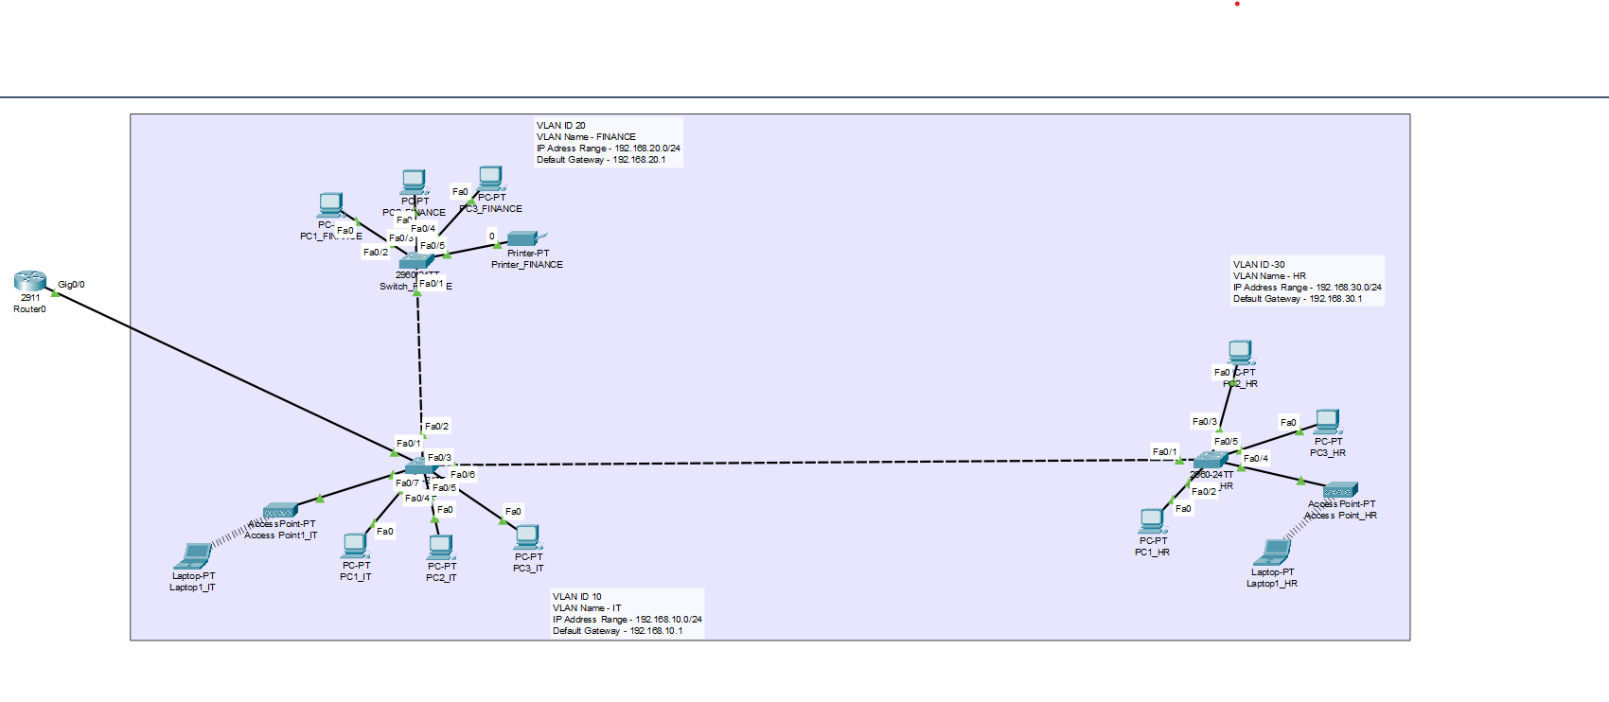
- Physical Setup
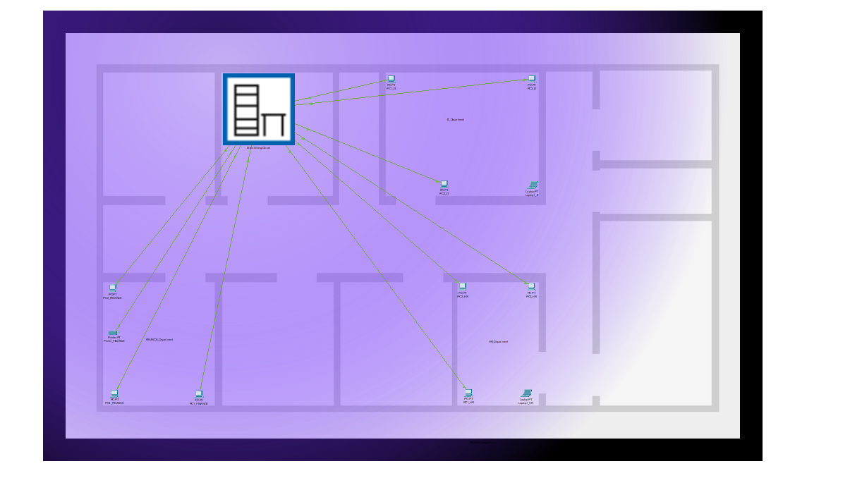

- Main Wiring Setup

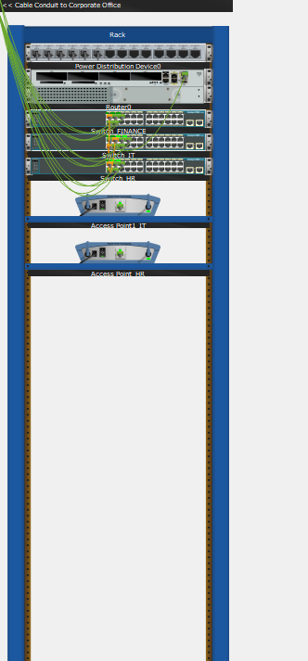

2. Router Configuration: Screenshot of the router interface configuration.

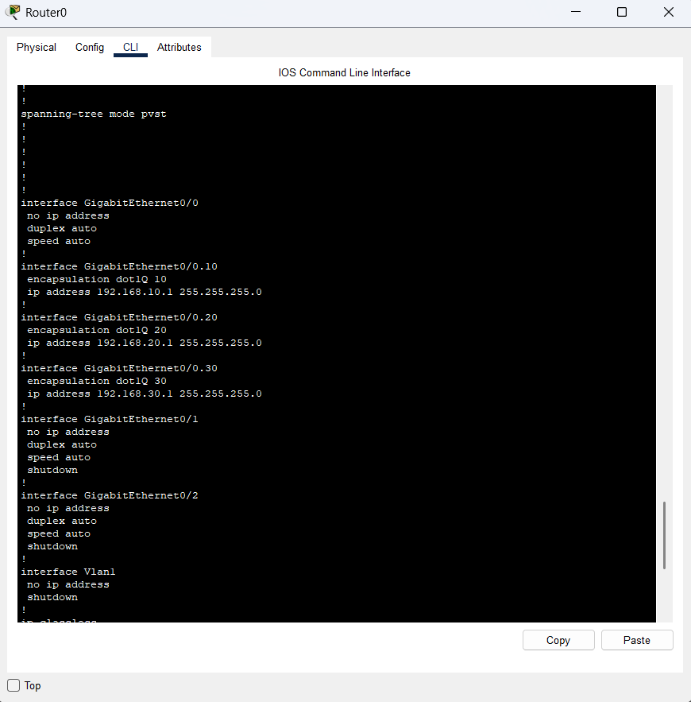

3. Switch Configuration: Screenshot of the switch VLAN configuration.

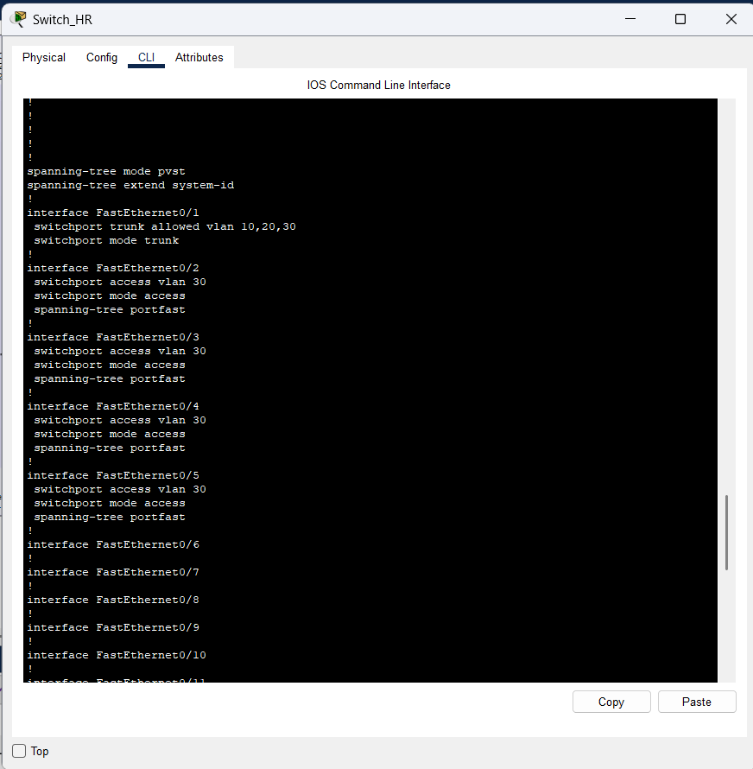
HR Switch

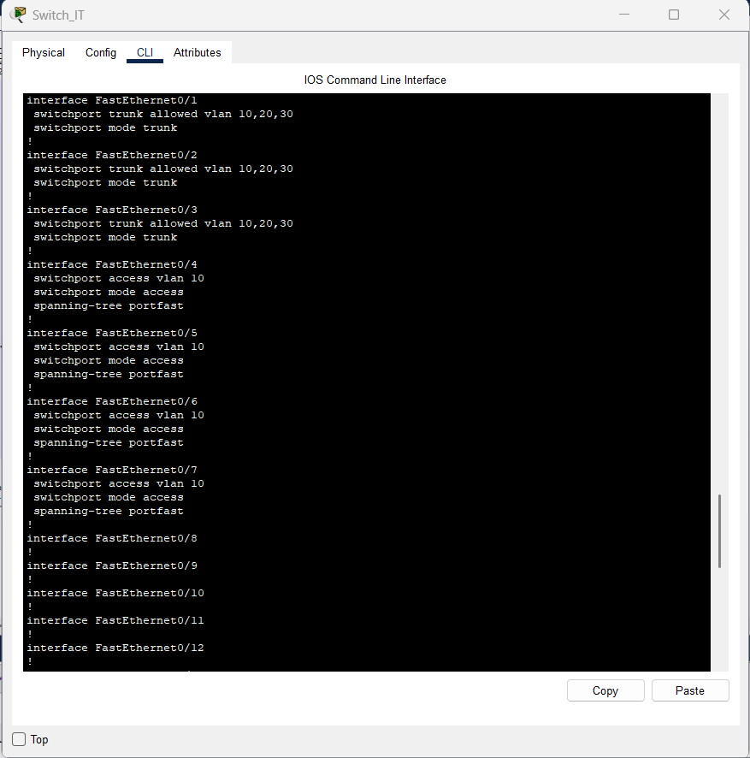
IT Switch

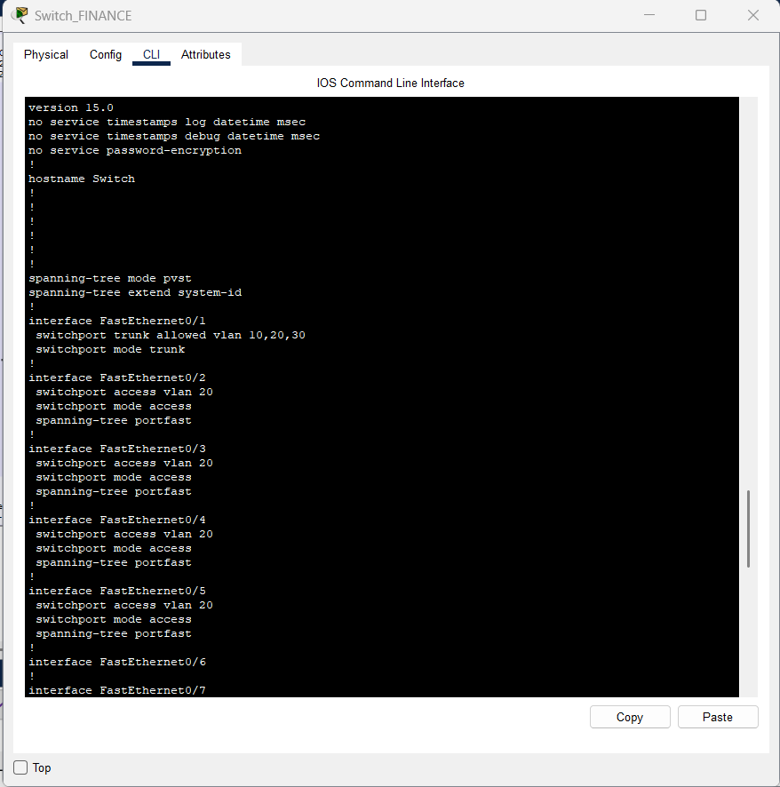
Finance Switch

4. Ping Test Results: Screenshots of successful ping tests between PCs in different VLANs.
Finance Switch

HR-PC
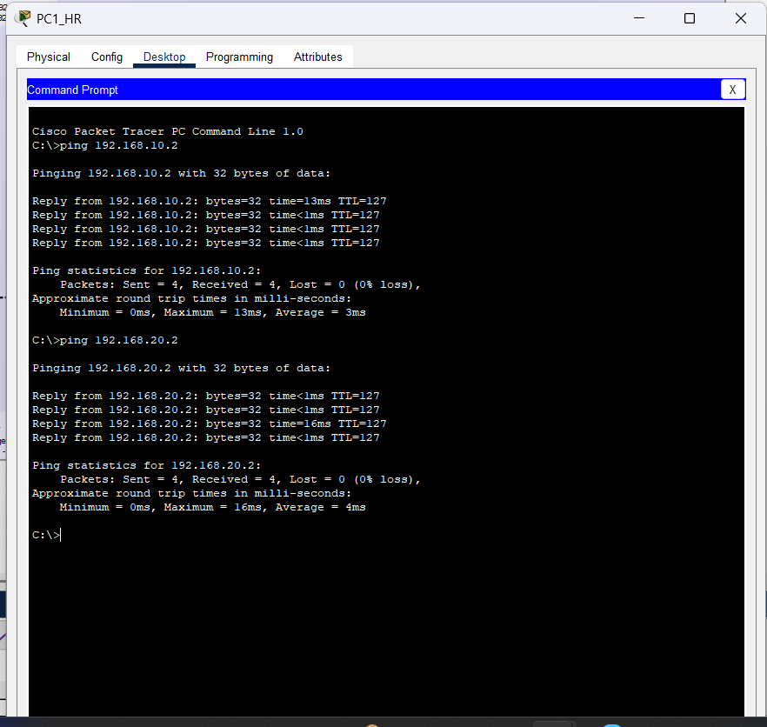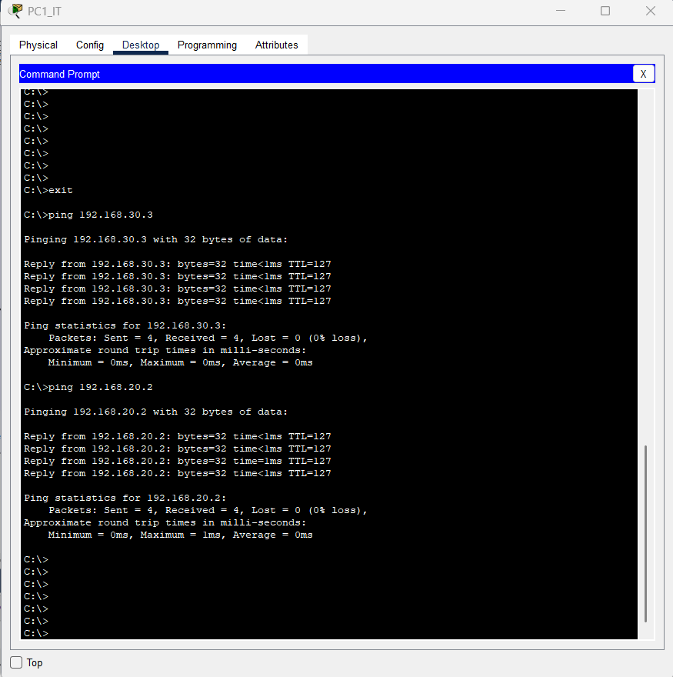
HR-PC1
IT- PC1

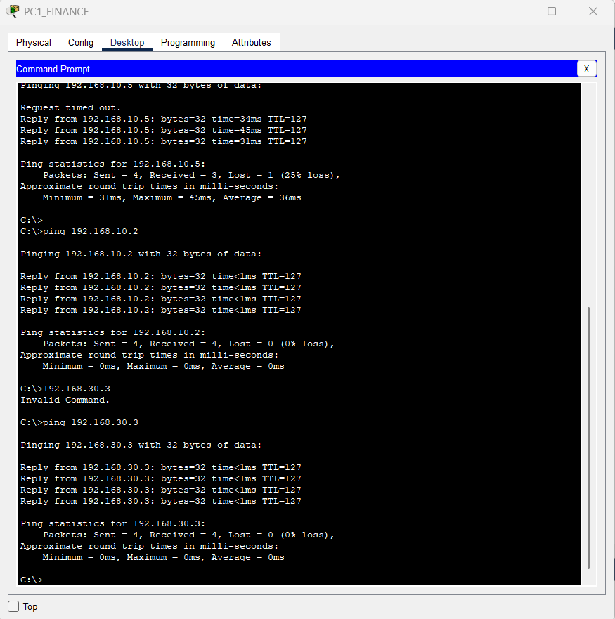
Finance- PC1

9. Future Enhancements
Firewall Integration for Advanced Security:Currently, inter-VLAN communication occurs without traffic filtering. Introducing a dedicated firewall would enable granular control over traffic between departments. This enhancement would help prevent unauthorized access, apply security policies per VLAN, and create a more secure enterprise-grade environment.

VPN Implementation for Secure Remote Access:A Virtual Private Network (VPN) can be deployed to allow employees to connect securely from remote locations. This would be especially beneficial for remote workers, branch offices, and administrators who need safe access to internal company resources over the internet.

