**AEEM6036 Spacecraft Dynamics Project II Yufeng Sun**

(All matlab code is attached in a separate zip file named “project_2”)

In general, the total angular momentum of the satellite system with reaction wheel system is

$h=h_{s}+h_{w}={}_{ }^{B}{J_{s}{{}_{ }^{B}ω}_{B/N}+}{}_{ }^{W}{J_{w}{{}_{ }^{W}ω}_{W/N}}$.

Assuming the direction cosine matrix from reaction wheels frame to satellite body frame is $C_{BW}$, which is identity matrix in this problem.

|  |
| --- |
| $$h={}_{ }^{B}{J_{s}{{}_{ }^{B}ω}_{B/N}+}C_{BW}{}_{ }^{W}{J_{w}}C_{BW}^{T}C_{BW}({{}_{ }^{W}ω}_{W/B}+{{}_{ }^{W}ω}_{B/N})$$ $={}_{ }^{B}{J_{s}{{}_{ }^{B}ω}_{B/N}+}C_{BW}{}_{ }^{W}{J_{w}}{{}_{ }^{W}ω}_{B/N}+C_{BW}{}_{ }^{W}{J_{w}}{{}_{ }^{W}ω}_{W/B}$ $=\left({}_{ }^{B}{J_{s}+}{}_{ }^{B}{J_{w}}\right){{}_{ }^{B}ω}_{B/N}+C_{BW}{}_{ }^{W}{J_{w}}{{}_{ }^{W}ω}_{W/B}$ |

1. Given ${{}_{ }^{B}ω}_{B/N}=ω$, ${{}_{ }^{W}ω}_{W/B}=ω_{w}$ and $J=J_{s}+J_{w}$, the total angular momentum of the satellite system describe in satellite body frame is

|  |
| --- |
| $$h=Jω+J_{w}ω_{w}$$ |

The Euler’s rotational equations of motion is

|  |
| --- |
| $$\dot{h}={}_{ }^{N}{\frac{d}{dt}(}Jω+J_{w}ω_{w})={}_{ }^{B}{\frac{d}{dt}(}Jω+J_{w}ω_{w})+ω×(Jω+J_{w}ω_{w})$$ $$=J\dot{ω}+J_{w}\dot{ω_{w}}+\left[ω^{×}\right]Jω+\left[ω^{×}\right]J_{w}ω_{w}$$ |

1. Let $J_{w}=\left[\begin{matrix}I_{w} & 0 & 0 \\ 0 & I_{w} & 0 \\ 0 & 0 & I_{w}\end{matrix}\right]$, $ω_{w}=Ω_{w}\hat{b_{3}}$, the Euler’s rotation equations of motion is

|  |
| --- |
| $$\dot{h}=J\dot{ω}+I_{w}\dot{Ω_{w}}\hat{b_{3}}+\left[ω^{×}\right]Jω+\left[ω^{×}\right]I_{w}Ω_{w}\hat{b_{3}}$$ |

1. Given $ω\left(t=0\right)={[5,0,0]}^{T} rpm={[0.523598775,0,0]}^{T} rad/sec$, the initial wheel momentum is 0, the nominal wheel momentum is $h_{n}=55 kg∙m^{2}/s$, and the spin-up duration is $t_{s}=5,000s$, assuming that the constant wheel control is designed as $\dot{h_{w}}=\frac{h_{n}}{t_{s}}$.

The spacecraft’s Euler’s rotation equation of motion is

$$\dot{h}=J\dot{ω}+\dot{h_{w}}+\left[ω^{×}\right](Jω+h_{w})$$

Assuming there is no external torque, $\dot{h}=0$, the dynamics equation is

$$\dot{ω}=J^{-1}(-\dot{h_{w}}-\left[ω^{×}\right]\left(Jω+h_{w}\right))$$

3-1: Given $J=\left[\begin{matrix}500 & 0 & 0 \\ 0 & 400 & -7 \\ 0 & -7 & 440\end{matrix}\right]kg∙m^{2}$, the plot of time response of the angular velocity of the satellite and the nutation angle $β\left(t\right)$ is



The 3D plot of the angular velocity is

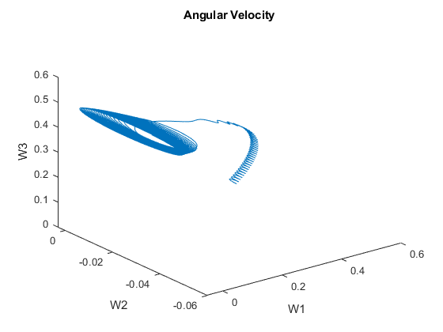

From the plots,

1. The angular velocities of the spacecraft changed slowly;
2. The $ω_{1}$ decreased from initial value to 0 rad/s approximately at time 2,900 s;
3. The $ω_{2}$ vibrated between -0.04 and 0;
4. The $ω_{3}$ increased from initial value to 0.5 rad/s approximately at time 2,900 s;
5. The nutation angle decreased from initial value as 90 deg to 0 deg approximately at time 2,900 s;
6. There are small vibrations in the angular velocities and the nutation angle.

3-2: Given $J=\left[\begin{matrix}500 & 0 & 0 \\ 0 & 400 & 0 \\ 0 & 0 & 440\end{matrix}\right]kg∙m^{2}$, the plot of time response of the angular velocity of the satellite and the nutation angle $β\left(t\right)$ is



The 3D plot of angular velocities is

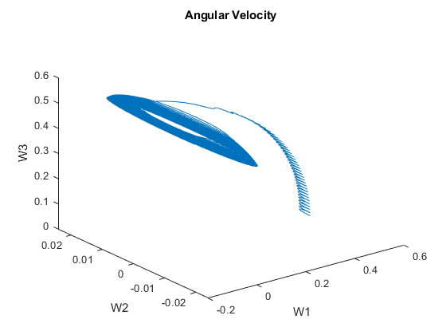

From the plots

1. These is no obvious change in the angular velocities and nutation angles with only changing the spacecraft inertial matrix off-diagonal elements with keeping the diagonal elements the same. Except the angular velocity $ω_{2}$, which vibration range is shift to -0.02 to 0.02.
2. At time 5,000 s, the observation of the sun sensor is ${}_{ }^{B}{v_{sun}={[0.8, -0.5,0.2]}^{T}}$ and the observation of the star tracker is ${}_{ }^{B}{v_{star}={[-0.3, -0.1,0.9]}^{T}}$, and the star tacker is twice as good as the sun sensor.

Using TRIAD method, the attitude estimation is

$$C_{BN_TRIAD}=\left[\begin{matrix}0.8262 & 0.4674 & -0.3145 \\ -0.5196 & 0.8479 & -0.1048 \\ 0.2177 & 0.2500 & 0.9435\end{matrix}\right]$$

Using QUEST method, the attitude estimation is

$$C_{BN_QUEST}=\left[\begin{matrix}0.8273 & 0.4674 & -0.3115 \\ -0.5193 & 0.8479 & -0.1067 \\ 0.2142 & 0.2500 & 0.9442\end{matrix}\right]$$

The attitude difference between $C_{BN_TRIAD}$ and $C_{BN_QUEST}$ described with principal rotation angle in degree is

0.2076 deg

1. Using the solution of the QUEST for the satellite attitude, angular velocity of the satellite, and the reaction wheel at time 5,000 s, control the satellite to stabilize the satellite into the zero attitudes and angular velocity in 50 s by a MRP-based nonlinear control law.

So, the initial conditions of satellite at time 5,000 s are

* Estimated Attitude is $C_{BN_QUEST}=\left[\begin{matrix}0.8273 & 0.4674 & -0.3115 \\ -0.5193 & 0.8479 & -0.1067 \\ 0.2142 & 0.2500 & 0.9442\end{matrix}\right]$
* The satellite angular velocity is $ω={\left[ 0.031 - 0.0259 0.4678\right]}^{T} rad/s$
* The wheel system angular velocity is $ω_{w}={\left[ 0 0 550\right]}^{T} rad/s$
* Inertial matrix for the satellite with the reaction wheel is $J=\left[\begin{matrix}500 & 0 & 0 \\ 0 & 400 & 0 \\ 0 & 0 & 440\end{matrix}\right]kg∙m^{2}$
* Inertial matrix for the reaction wheel system is $J_{w}=\left[\begin{matrix}0.1 & 0 & 0 \\ 0 & 0.1 & 0 \\ 0 & 0 & 0.1\end{matrix}\right]kg∙m^{2}$

5.1 From problem 1, we know that the Euler’s rotational equation of motion for the satellite is

$$\dot{h}=J\dot{ω}+J_{w}\dot{ω_{w}}+\left[ω^{×}\right]Jω+\left[ω^{×}\right]J_{w}ω_{w}$$

Assuming there is no external torque, the dynamics equation for the satellite is

$$J\dot{ω}=-\left[ω^{×}\right](Jω+J_{w}ω_{w})-J_{w}\dot{ω_{w}}$$

The last term is the control torque by wheel speed changes.

Th MRP (Modified Rodrigues parameters) $σ={[σ_{1},σ_{2},σ_{3}]}^{T}$ is defined in terms of the Euler Parameters

$$σ_{i}=\frac{β_{i}}{1+β_{0}}$$

where $i$ = 1, 2, and 3. The MRP kinematic differential equation is described as

$$\dot{σ}=Aω=\frac{1}{4}[\left(1-σ^{T}σ\right)I+2\left[σ^{×}\right]+2σσ^{T}]ω$$

So, for the zero-attitude control of satellite with a reaction wheel system $J\dot{ω}=-\left[ω^{×}\right]\left(Jω+J_{w}ω_{w}\right)+u$, an MRP-based control law can be defined as

$$u=\left[ω^{×}\right]\left(Jω+J_{w}ω_{w}\right)-Dω-Kσ$$

Where $D$ and $K$ are $3×3$ gain matrices. Consider a gain selection $K=kJ, D=dJ$, where $k, d$ are scalars. The closed-loop equations of motion then become

$$J\dot{ω}= -Dω-Kσ$$

$$\dot{σ}=\frac{1}{4}[\left(1-σ^{T}σ\right)I+2\left[σ^{×}\right]+2σσ^{T}]ω$$

Assuming $K^{-1}$ exists and that $K^{-1}J$ is positive defined, a Lyapunov function can be defined as

$$V=\frac{1}{2}ω^{T}K^{-1}Jω+2ln⁡(1+σ^{T}σ)$$

The time derivative of V is given by

$$\dot{V}=\frac{1}{2}\dot{ω^{T}}K^{-1}Jω+\frac{1}{2}ω^{T}K^{-1}J\dot{ω}+\frac{4σ^{T}\dot{σ}}{1+σ^{T}σ}$$

Assuming that $K^{-1}J={(K^{-1}J )}^{T}$, we can calculate $\dot{V}$ along the system trajectories as

$$\dot{V}=ω^{T}K^{-1}J\dot{ω}+\frac{4σ^{T}\dot{σ}}{1+σ^{T}σ}$$

As $σ^{T}\dot{σ}=\frac{1+σ^{T}σ}{4}σ^{T}ω$, then

${\dot{V}=ω}^{T}K^{-1}\left(-Dω-Kσ\right)+σ^{T}ω$

$=-ω^{T}K^{-1}Dω-ω^{T}σ+ω^{T}σ$

$=-ω^{T}K^{-1}Dω≤0$

if $K^{-1}D>0$, the above function guarantees the global stability.

Select $D=dJ$,

$$\dot{V}=-ω^{T}K^{-1}dJω=-dω^{T}K^{-1}Jω=-2d\left({\frac{1}{2}ω}^{T}K^{-1}Jω\right)≥-2dV$$

So, the maximal decay rate of selected Lyapunov function is defined as

$$V\left(t\right)≥V(t_{0})exp⁡[-2d(t-t_{0})]$$

5-2. Assuming that the angular rate $ω$ is small enough to satisfy $ω=\dot{∅}\hat{e}$, where $∅$ is the principle rotation angle along the unit vector of $\hat{e}$. The closed-loop dynamic equation can be approximated by

$$\left(\ddot{∅}+d\dot{∅}+\frac{k}{4}∅\right)J\hat{e}=0$$

Where the damping ratio $ζ$ and the natural frequency $ω_{n}$ satisfy

$$d=2ζω_{n};\frac{k}{4}={ω_{n}}^{2}$$

Assuming a $ζ≪1$, using settling time $T_{s}≈-\frac{ln⁡({10}^{-6})}{ζω_{n}}$, we can choose value of $d$ as 0.5526, for a critically damped response, we have $k=d^{2}=0.3054$, so the gain matrix $D$ and $K$ can be

$$D=\left[\begin{matrix}276 & 0 & 0 \\ 0 & 221 & 0 \\ 0 & 0 & 243\end{matrix}\right];K=\left[\begin{matrix}153 & 0 & 0 \\ 0 & 122 & 0 \\ 0 & 0 & 134\end{matrix}\right]$$

The time history of MRPs, angular velocity of the satellite, the wheel speed, and the control torque are shown in below plots



At time 50 s, the norm error for attitude is 7.9046e-06, and the normal error for angular velocity is 8.0490e-06.

Discussion:

1. The attitude and angular velocity of the satellite can be controlled to zero-attitude in required time with selected gain matrices for the designed PD controller.
2. The control torque input becomes zero when the satellite becomes zero-attitude, however the reaction wheels keep spinning