Jump on the Moon with a mass-spring system

**Specification**:

* Total system mass ($M$): 100 kg
* Gravity on the Moon ($g_{m}$): 9.81/6 N/kg
* Spring travel distance (maximum compression $∆l_{s}$): 0.1 meter
* Spring constant ($K$): 16000*9.81 N/m
* Spring length at rest: 0.34 meter
* Number of Spring: 2
* Spring initial state: full compressed

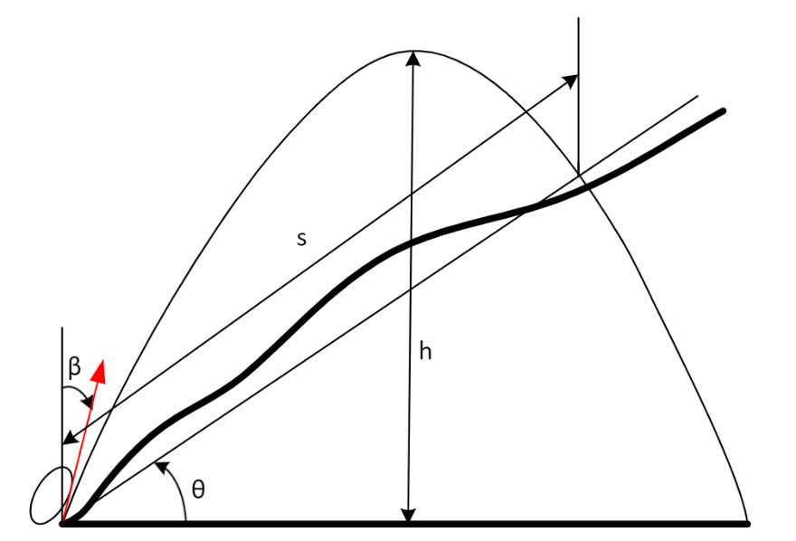

* $β$: mass object’s jumping inclination angle $∈[0°,90°]$
* $θ:$ slope inclination angle
* $h:$ mass object’s jumping height
* $s$: mass object’s jumping distance on the slope

1. **Power supply for vertical jump ($β=0°$)**

The force be supplied by each spring is

$$F=K∙∆l_{s}=156960∙0.1=156960N$$

The height that the robot can jump vertically on the moon with 2 springs is

$$h=\frac{K∙{∆l_{s}}^{2}}{M∙g_{m}}=\frac{156960∙0.01}{100∙\frac{9.81}{6}}=9.6 m$$

The total energy springs release is

$$E=K∙{∆l_{s}}^{2}=156960∙0.01=1569.6 N∙m=1569.6 J$$

the time that spring release the energy (by simulation)

$$∆t=0.04 s$$

The power required is

$$P=\frac{E}{∆t}=\frac{1568}{0.04}=39200 W=39.2 kW$$

By given a minute to compress the spring, the power of the 2 motors need to output is

$$P_{m}=\frac{39200}{60}=654 W$$

The output power for each motor is $327 W$ by assuming there is no energy wasted.

1. **Simulation of one-jump with $β=45° and θ=0°$:**

* Maximum force generated: 15390 N
* Zero Spring Force moment: 0.02822 sec
* Land time: 4.833 sec
* Maximum Height reached ($h$): 4.964 m
* Maximum distance reached ($s$): 19.36 m

**The figures of force, height, and distance over time**



1. **Simulations of one-jump with various $β and θ=0°$:**

|  |  |  |  |
| --- | --- | --- | --- |
| Inclination Angle $β$ (degree) | Maximum Height $h$ (meter) | Maximum Distance $s$ (meter) | Land  Time  (second) |
| 5 | **9.809** | 3.37 | 6.832 |
| 15 | 9.237 | 9.71 | 6.625 |
| 25 | 8.143 | 14.88 | 6.212 |
| 35 | 6.665 | 18.26 | 5.616 |
| 45 | 4.964 | **19.36** | 4.833 |
| 55 | 3.31 | 18.29 | 3.922 |
| 65 | 1.825 | 15.02 | 2.897 |
| 75 | 0.705 | 9.885 | 1.77 |
|  |  |  |  |

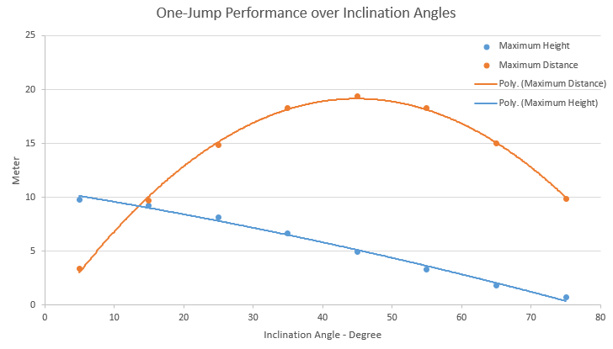

1. **Simulation of one-jump with K=24000, $β=45° and θ=0°$**

* Maximum force generated: 23530 N
* Zero Spring Force moment: 0.03438 sec
* Land time: 5.938 sec
* Maximum Height reached ($h$): 7.41 m
* Maximum distance reached ($s$): 29.1 m

**The figures of force, height, and distance over time**



1. **Simulation with virous jump inclination angles and slope inclination angles**

From the simulation with **K=24000,**

**Figure of jumping**

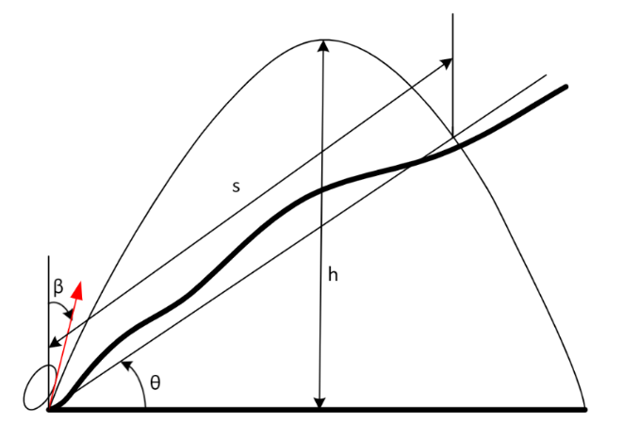

**Figure of jumping performance with $β=45°$**



Figure of jumping **performance with various $β$ and $θ$**

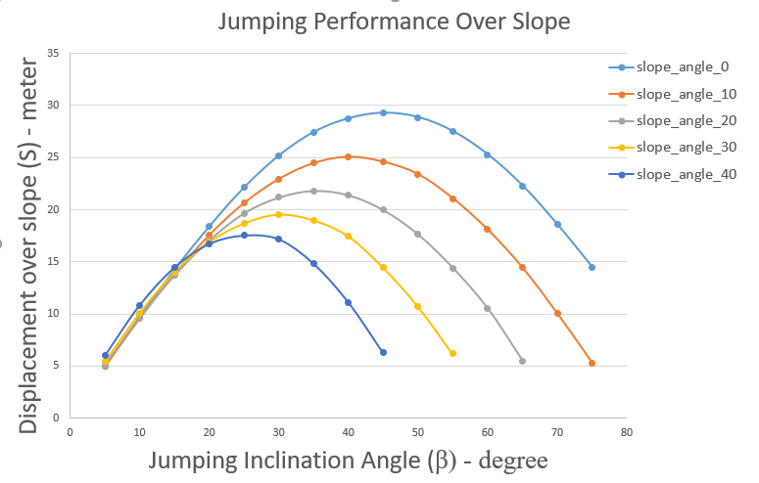

**Data of displacement over a slope**

|  |  |  |  |  |  |
| --- | --- | --- | --- | --- | --- |
| Jumping inclination angles (degree) | Slope with different inclination angles (degree) | | | | |
| 0 | 10 | 20 | 30 | 40 |
| 5 | 4.935 | 4.945128 | 5.097412 | 5.427093 | 5.965711 |
| 10 | 9.696 | 9.54501 | 9.630809 | 10.04589 | 10.80877 |
| 15 | 14.23 | 13.8098 | 13.67468 | 13.97188 | 14.4378 |
| 20 | 18.38 | 17.56688 | 17.04813 | 16.85863 | 16.70921 |
| 25 | 22.12 | 20.64362 | 19.66601 | 18.65996 | 17.51857 |
| 30 | 25.18 | 22.94864 | 21.17714 | 19.51444 | 17.16611 |
| 35 | 27.44 | 24.47178 | 21.81564 | 18.96018 | 14.82943 |
| 40 | 28.75 | 25.08104 | 21.38997 | 17.43598 | 11.12207 |
| 45 | 29.28 | 24.59363 | 19.95333 | 14.43376 | 6.265955 |
| 50 | 28.86 | 23.40558 | 17.61214 | 10.71562 |  |
| 55 | 27.51 | 21.0701 | 14.37704 | 6.166101 |  |
| 60 | 25.28 | 18.07459 | 10.48215 |  |  |
| 65 | 22.29 | 14.41906 | 5.44859 |  |  |
| 70 | 18.56 | 10.01211 |  |  |  |
| 75 | 14.47 | 5.290373 |  |  |  |

**Matlab Plots**

|  |  |  |
| --- | --- | --- |
| $β=5°$;  X0=4.935;  X10=4.87;  X20=4.79;  X30=4.7;  X40=4.57 | $β=10°$;  X0=9.696;  X10=9.4;  X20=9.05;  X30=8.7;  X40=8.28 | $β=15°$;  X0=14.23;  X10=13.6;  X20=12.85;  X30=12.1;  X40=11.06 |
|  |  |  |
| $β=20°$;  X0=18.38;  X10=17.3;  X20=16.02;  X30=14.6;  X40=12.8 | $β=25°$;  X0=22.12;  X10=20.33;  X20=18.48;  X30=16.16;  X40=13.42 | $β=30°$;  X0=25.18;  X10=22.6;  X20=19.9;  X30=16.9;  X40=13.15 |
|  |  |  |
| $β=35°$;  X0=27.44;  X10=24.1;  X20=20.5;  X30=16.42;  X40=11.36 | $β=40°$;  X0=28.75;  X10=24.7;  X20=20.1;  X30=15.1;  X40=8.52 | $β=45°$;  X0=29.28;  X10=24.22;  X20=18.75;  X30=12.5;  X40=4.8 |
|  |  |  |
| $β=50°$;  X0=28.86;  X10=23.05;  X20=16.55;  X30=9.28;  X40= | $β=55°$;  X0=27.51;  X10=20.75;  X20=13.51;  X30=5.34;  X40= | $β=60°$;  X0=25.28;  X10=17.8;  X20=9.85;  X30=;  X40= |
|  |  |  |
| $β=65°$;  X0=22.29;  X10=14.2;  X20=5.12;  X30=;  X40= | $β=70°$;  X0=18.56;  X10=9.86;  X20=;  X30=;  X40= | $β=75°$;  X0=14.47;  X10=5.21;  X20=;  X30=;  X40= |
|  |  |  |