Flight Test Plan

Test plans are written for all aspects of airplane testing such as

* Airframe structural tests
* Flying qualities and performance tests
* Avionics tests
* Simulator validation
* System software tests
* Engine tests

Test plan is a written document of the duties and responsibilities of those concerned with planning and conducting assigned projects. Thorough and timely reviews of the test plan can aid in ensuring that the test is conducted safely. All members of the test team should be familiar with the test plan prior to conducting test flights.

1. Background

This portion of the test plan introduces the project to the reader. It should include any pertinent information regarding the origin of the requirements for the test program. Reference should also be made as to who is requesting the tests and why. Include previously related tests, operational problems, or any other material which may pertain to the origin of the tests. Generally, this section will include a description of the test article including comments as to how well it represents the article to be deployed for operational service.

1. Purpose

This section provides a clear and concise statement as to the overall purpose of the tests. The test plan first must define the objectives of the test program so that the test team and management have a clear understanding as to why the tests are being conducted. Background material can be included to provide the team with a historical perspective into the program. Test objectives can include the following:

* Develop the system and subsystem
* Determine Compliance with Specified Goals: The most significant portion of flight tests is spent ensuring compliance with the goals specified of the airplane design. The test program should provide essential information for assessment of acquisition risk and for decision making.
* Determine Mission Suitability: The airplane must also be evaluated in the mission environment for which it was designed. Measures of effectiveness in the planned operational scenarios should be evaluated and presented.
* Document Enhancing Characteristics: The test program should allow the project engineer to determine the enhancing characteristics of the system. These would be things such as improvements over original systems or the ability of the system to drastically exceed the minimum requirements.
* Document Deficiencies: The test program should provide the project engineer the means to adequately determine the deficiencies of the system. The deficiencies of the system being tested can be identified as shortcomings of the equipment or system that adversely affect airworthiness of the aircraft, the ability of the aircraft to accomplish its mission, the effectiveness of the crew as an essential subsystem, the safety of the crew or the integrity of an essential subsystem, the ability of the system to meet the contract specifications, and maintainability and reliability of the system.

1. Description of Aircraft
2. Scope of Test

Once the objectives are stated the test plan must next define what the test team is going to do. The scope of tests section defines the exact test program that will be required to satisfy the objectives of the test. Typically found in the scope of tests paragraphs are a definition of the tests, the conditions under which the test will be conducted, the test envelope, test aircraft loadings, test aircraft configurations, and a definition of the standards under which the test results will be evaluated.

* + Test and Test Conditions
  + Test Envelope
  + Flight Clearance
  + Test Loading
  + Test Configurations
  + Test Standards

1. Method of Test

Most importantly, the test plan must define how the test will be performed. Test methods and procedures, airplane's instrumentation, data analysis, and use of check lists should be discussed.

* + Test Methods and Procedures
  + Instrumentations and Data Processing
  + Data Analysis
  + Support Requirements

1. Risk Analysis

The most important function of the safety plan is a comprehensive evaluation of the hazards involved in the test and a detailed presentation of the procedures and precautions that will be used to minimize the risk inherent in flight test. Of most importance is the hazard analysis which should include all of the foreseen hazards that could be encountered. A general outline for safety planning is presented in the following paragraphs.

* + Special Precautions
  + High Risk / Workload Data Points
  + Checklists
  + Data Management
  + Others (Aircraft downing discrepancies, Required ground check for project equipment, Special maintenance or handling procedures, locally manufactured parts, Aircraft discrepancy review procedures, Go-No Go criteria, Pre-flight and post flight briefing)

1. Project Management

* Funding and Resource Requirements
* Schedule and Milestones
* Personnel Assignment
* Reports

Examples of what should be covered in scope, method and risk analysis of flight test

**Scope of Test**

* Prerequisites
* Methodology
* First flight tasks
* Pilot proficiency
* Continued shakedown
* Instrumentation plan risk education
* Test team dry run for first flight
* Inspection buildup plan
* Flight clearance
* Limitations of scope

**Method of Test**

* Ground and pre-flight checks
* First flight Tasks
* Pilot proficiency/currency
* NO_GO criteria for safety and test
* Instrumentation and data
* Define first flight series profile

**Risk management**

* Safety checklist
* Risk identification, assessment and mitigation

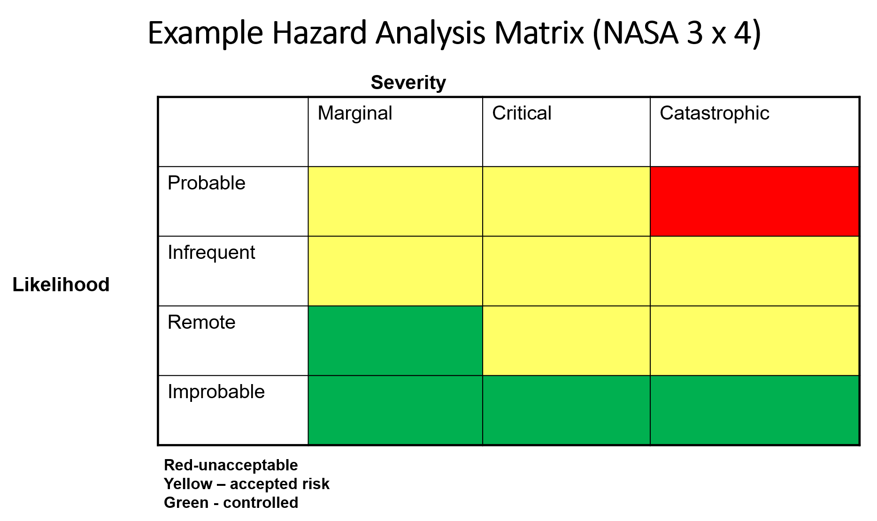

* + Battery failure
  + Motor failure
  + Receiver failure
  + …
* Environmental conditions
* Real-time data monitoring
* Potential risks