AI-POWERED NETWORK
INTRUSION DETECTION SYSTEM
Machine Learning, Suricata, and Cross-Flow Correlation
Final Technical Report
Prepared by Sunday Esumike
August 2026
Project status: completed portfolio prototype

Report Contents
Executive Summary
1. Project Goal and Scope
2. System Design
3. Data and Preprocessing
4. Model Development and Evaluation
5. Streamlit Dashboard
6. Live Laboratory and Suricata Integration
7. Controlled Port-Scan Findings
8. Cross-Flow Correlation
9. Main Findings
10. Limitations and Next Steps
11. Conclusion
Appendix A. Key Files and Reproduction Commands
Evidence basis
This report is based on the saved model summaries, prediction ledgers, Suricata JSON logs, final comparison tables, and dashboard screenshots produced during the project. The reported live-lab figures come from the final local run against the original captured flow files.

Executive Summary
This project built a practical network intrusion detection prototype that combines flow-based machine learning with a traditional rule-based intrusion detection system. The final design includes a binary detector, an attack-family classifier, a benign-trained anomaly detector, a Streamlit dashboard, Suricata, and a source-level cross-flow correlation rule.
The models performed very well when they were tested on attack patterns already represented in the training data. The group-aware known-attack test reached about 99.92% attack recall. The harder evaluation told a different story. When complete traffic scenarios were left out of training, supervised attack recall fell to 15.45%, while the anomaly detector reached 35.74%. This gap became the most important finding in the project.
The live laboratory confirmed the same issue. A controlled port scan created 502 SYN flows to 502 destination ports. The supervised model classified all 502 flows as benign, the anomaly detector flagged none, and the default Suricata rules emitted no scan alert. A tuned Suricata threshold rule detected the activity, and a separate cross-flow correlation rule produced one high-severity T1595 Active Scanning alert.
The main conclusion is simple: per-flow classification is useful, but it does not provide enough context for every attack. Combining machine learning, signature rules, and correlation across related flows gives a more complete view of network behavior.

Project at a Glance
Item | Final value
Processed flow records | 2,830,743
Predictive features | 77
Selected binary model | HistGradientBoosting
Known-attack recall | 99.92%
Complete-scenario supervised recall | 15.45%
Complete-scenario anomaly recall | 35.74%
Controlled scan flows | 502
Final correlated alert | High severity - T1595 Active Scanning

1. Project Goal and Scope
The goal was to build a working network intrusion detection system that could process flow records, classify known attack patterns, identify unusual behavior, and present the results in a form that a security analyst could review. The advanced phase added a real IDS engine and a controlled virtual lab so that rule-based and machine-learning results could be compared on the same traffic.
The project was designed as a portfolio-grade prototype rather than a production sensor. It demonstrates the full workflow from data preparation and model evaluation to packet capture, Suricata analysis, MITRE ATT&CK mapping, and dashboard presentation.

What the project includes
- A 77-feature flow compatibility layer for CICIDS/CICFlowMeter-style records.
- A binary model that classifies flows as BENIGN or ATTACK.
- A second-stage classifier that assigns broad operational attack families.
- An Isolation Forest trained on benign traffic for anomaly detection.
- A Streamlit dashboard for file upload, analysis, evidence review, and SOC-style triage.
- Suricata running on an Ubuntu virtual machine.
- A Kali Linux virtual machine used only for controlled testing against the Ubuntu VM.
- A source-level rolling correlation rule for detecting scanning behavior across multiple flows.

Scope boundaries
- The dashboard accepts prepared flow records, not raw packets or PCAP files directly.
- The attack-family stage runs only when the binary model predicts ATTACK.
- An anomaly result indicates deviation from the learned benign profile; it is not proof of malicious activity.
- All active testing was limited to systems owned and controlled inside the VMware lab.
- The current workflow is not a fully automated production packet-to-alert service.

2. System Design
The final system uses several detection paths because no single method performed well in every situation. Each path answers a different question.
Component | Purpose | Final implementation
Preprocessing | Create a consistent model-ready population | 77 aligned numeric flow features
Binary detector | Separate known attacks from benign traffic | HistGradientBoosting
Attack-family classifier | Provide broad attack context after an ATTACK decision | Random Forest
Anomaly detector | Flag flows outside the learned benign profile | Isolation Forest
Rule-based IDS | Match known signatures and configured thresholds | Suricata 8.0.3
Cross-flow correlation | Detect behavior that appears only across many related flows | 20 SYN flows to 20 ports within 10 seconds
Dashboard | Present evidence and support analyst review | Streamlit
Decision flow
Each flow is scored by the supervised binary model and the benign-trained anomaly model. If the binary model predicts ATTACK, the attack-family classifier runs. In parallel, source-level correlation reviews groups of flows over time. Suricata remains a separate rule-based layer against the same captured traffic.

3. Data and Preprocessing
The project used eight machine-learning CSV files and eight matching generated-flow context files. The preprocessing stage aligned the two collections and produced 2,830,743 valid rows. All row counts and shared-column hashes matched across the eight traffic scenarios.
One duplicate feature column, Fwd Header Length.1, was removed. The final predictive population contained 77 numeric features. Infinity values were replaced with missing values, but missing data was not filled during preprocessing. Imputation remained inside the training pipeline so that values were learned from training data only.
Preprocessing item | Result
Machine-learning files processed | 8
Generated-flow files processed | 8
Valid rows | 2,830,743
Predictive features | 77
Duplicate column removed | Fwd Header Length.1
Infinity values replaced with missing values | 4,376
Missing feature values retained for train-only imputation | 5,734
Alignment checks | All row counts and shared-column hashes matched

Live-lab compatibility
The live laboratory produced two prepared datasets: five benign HTTP flows and 502 controlled port-scan flows. Both files matched the exact 77-feature order, converted 23 timing fields to the expected units, and contained no missing model cells. This confirmed structural compatibility before inference.

4. Model Development and Evaluation

Binary detector
Four candidates were compared on the same validation population: a dummy prior model, logistic regression using SGD, Random Forest, and HistGradientBoosting. HistGradientBoosting was selected because it produced the strongest attack F2 score while maintaining very high recall and precision.

Evaluation design
The project did not rely on one train/test split. Three different views were used. A standard stratified split measured the basic model. A group-aware split kept session-like groups out of more than one partition. A complete-scenario holdout test removed whole traffic scenarios from training and measured how the model handled a new setting.
Evaluation | Attack recall | F2 | False-positive rate | PR-AUC
Stratified flow-level test | 99.92% | 99.82% | Not primary | 0.9998
Grouped known-attack test | 99.92% | 99.88% | 0.19% | 0.99997
Complete-scenario supervised test | 15.45% | 18.30% | 1.63% | 0.5819
Complete-scenario anomaly test | 35.74% | 40.47% | 1.44% | 0.5479
The difference between the grouped known-attack test and the complete-scenario test is important. The high grouped score shows that the model recognizes attack patterns it has already seen in some form. The low complete-scenario recall shows that this does not automatically translate to strong performance on a new traffic scenario.

Attack-family classifier
The second stage groups detected attacks into Denial of Service, Port Scan, Brute Force, Web Attack, or Other Malicious. Random Forest was selected for this stage. On the grouped test set, it reached 99.96% accuracy, 98.68% macro recall, and 98.85% macro F2. These results apply only after the binary detector opens the gate.

Anomaly detector
The Isolation Forest was trained on benign traffic and calibrated to a target false-positive rate near 1%. It improved novel-scenario recall from 15.45% to 35.74%, but it still missed most attacks in complete-scenario testing. This showed that anomaly detection added value, but did not solve the generalization problem by itself.
Interpretation
The strongest internal scores should be read as known-pattern performance, not as proof of zero-day or production detection. The complete-scenario and live-lab results are the more conservative view of generalization.

5. Streamlit Dashboard
The Streamlit dashboard loads the three saved model artifacts, checks for the expected 77 features, accepts a compatible CSV, and produces a prediction ledger. It also shows severity counts, attack-family summaries, source information when available, MITRE ATT&CK enrichment, and a SOC-style alert queue.
The dashboard keeps the component results separate. It does not present the severity-fusion rules as a fourth validated model. This distinction makes the evidence easier to understand and avoids overstating performance.
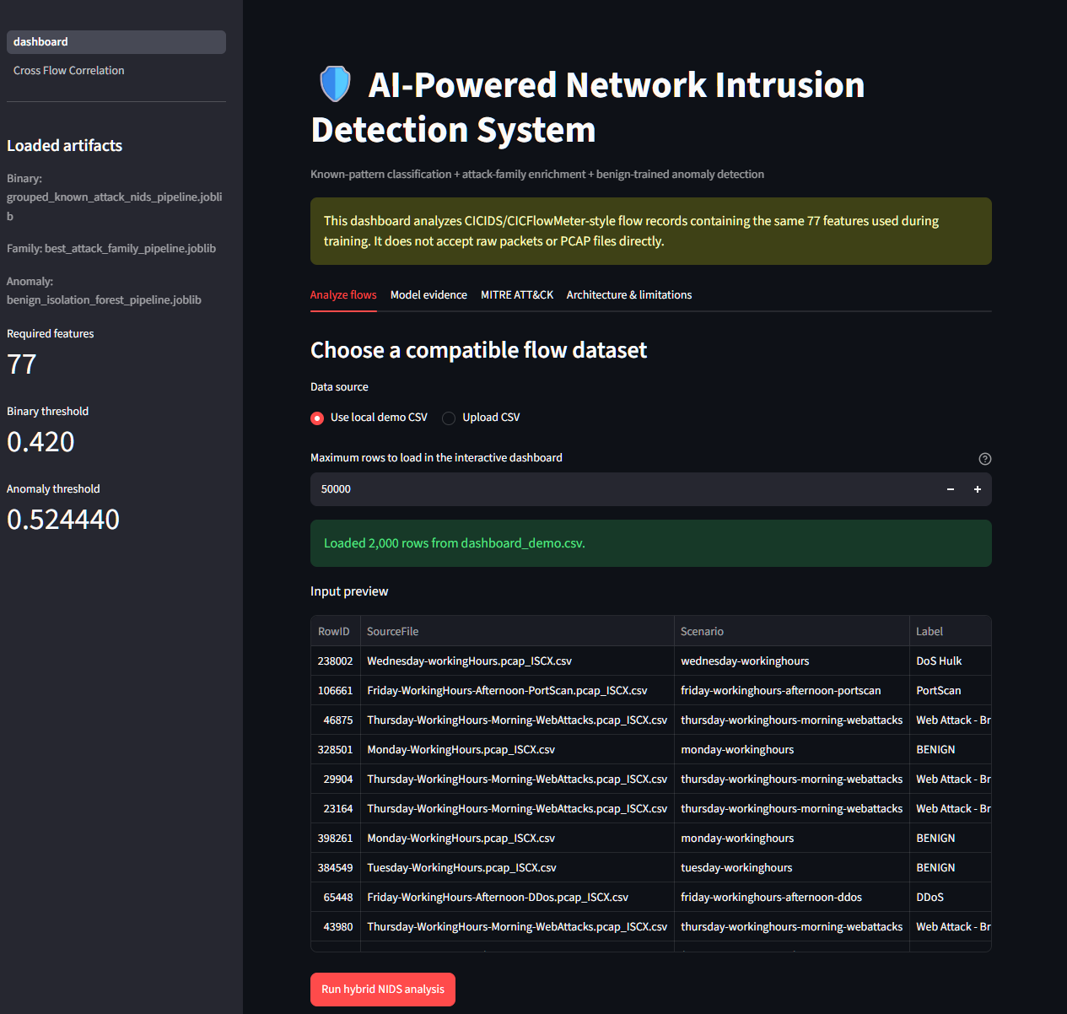
Figure 1. Main dashboard with the model artifacts, 77-feature requirement, input controls, and sample flow preview.

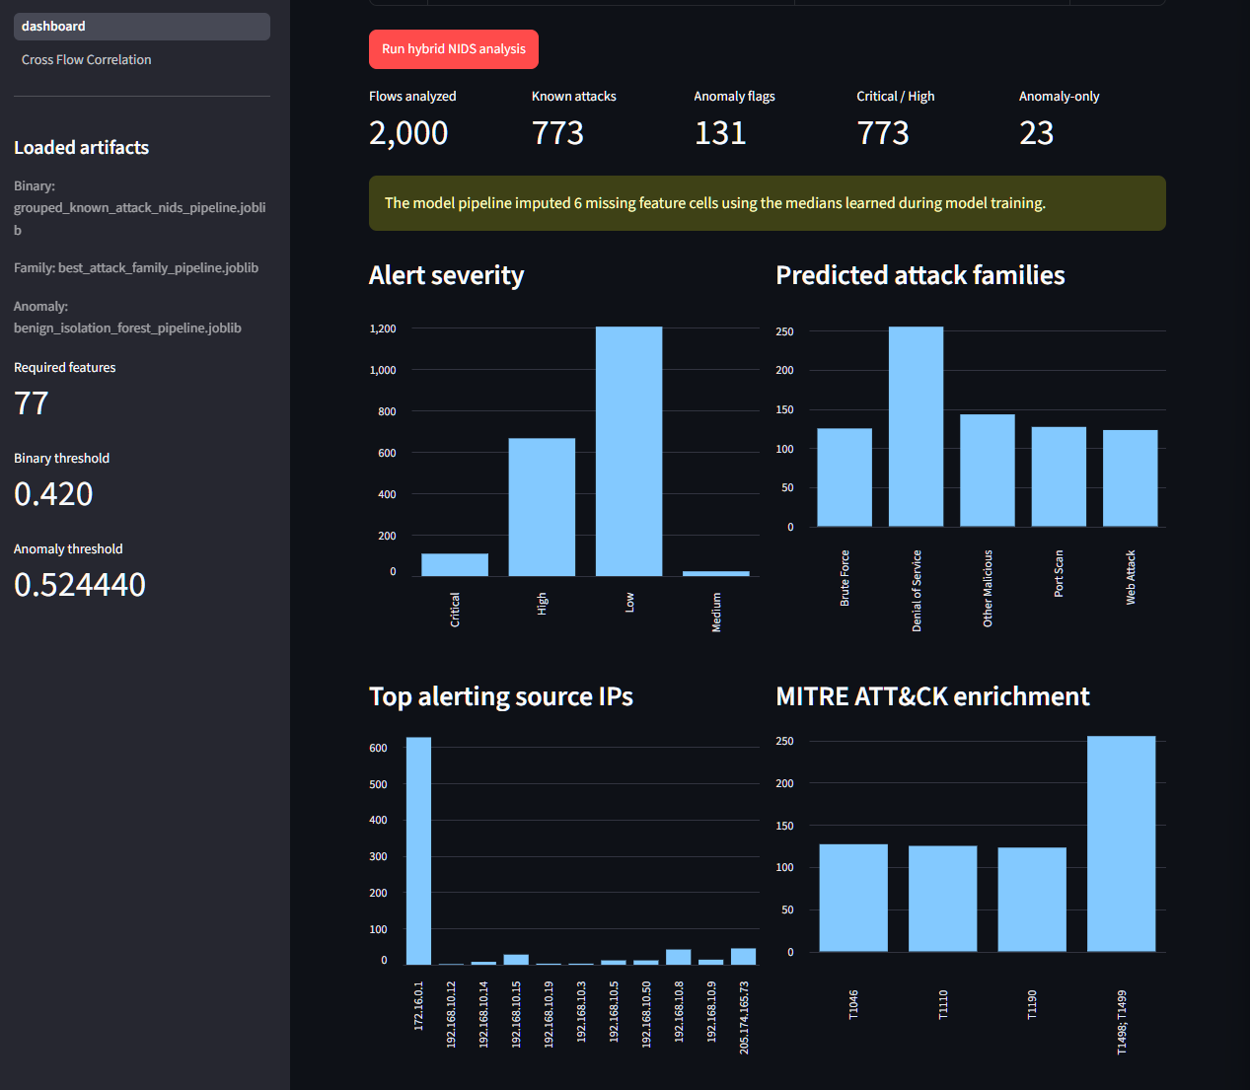
Figure 2. Dashboard summary showing severity, predicted attack families, source context, and MITRE ATT&CK enrichment.

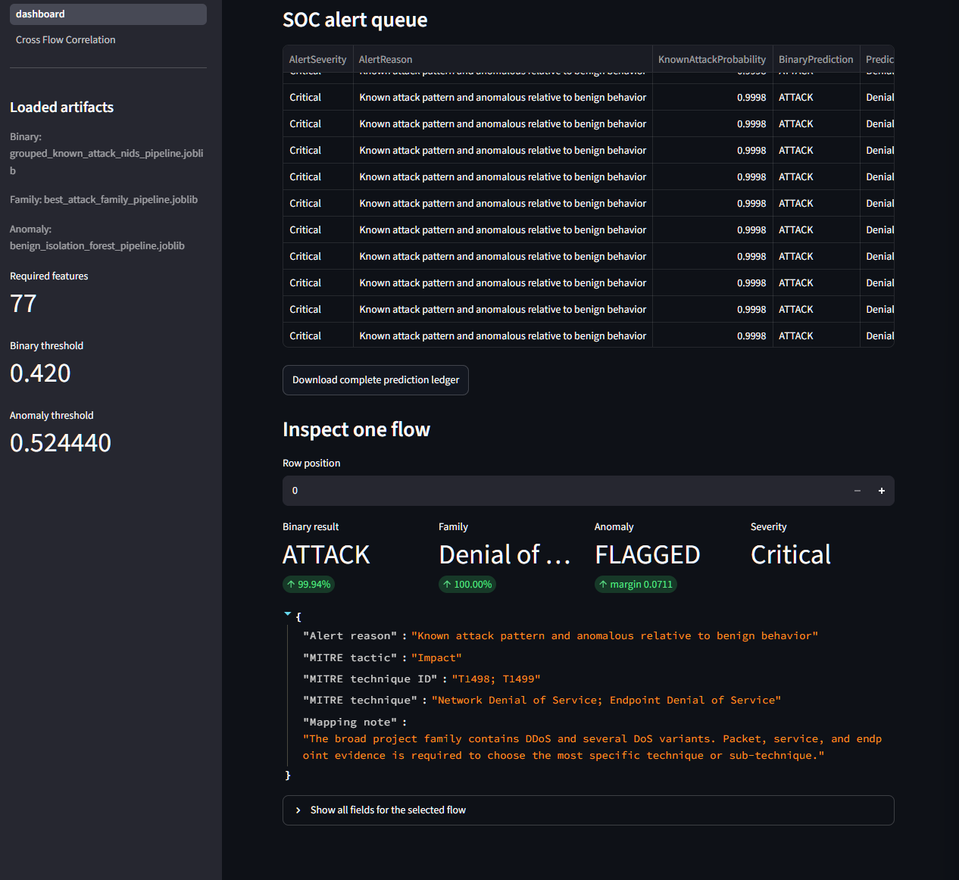
Figure 3. SOC alert queue and detailed review of one detected flow.

6. Live Laboratory and Suricata Integration
The advanced phase used two VMware virtual machines on an isolated host-only network. Kali Linux generated controlled traffic. Ubuntu hosted the target services and Suricata sensor.
Lab item | Configuration
Kali source VM | 192.168.244.10
Ubuntu target and sensor VM | 192.168.244.20
Suricata capture interface | ens37
Network | VMware host-only subnet 192.168.244.0/24
Benign activity | 4 ICMP echo requests and 5 HTTP requests
Controlled attack | Rate-limited TCP SYN scan against the Ubuntu VM

Benign baseline
The benign test included ping traffic and requests to a Python HTTP server. The prepared flow file contained five supported HTTP flows. The supervised model classified all five as benign, the anomaly detector produced no flags, and cross-flow correlation did not identify a scan pattern.
Suricata recorded 34 events during the benign baseline: four ICMP ping notices, five Python SimpleHTTP server-banner notices, and 25 TCP checksum decoder records. These were informational or decoder-related; no malicious activity was intentionally generated.

Suricata operation
Suricata 8.0.3 was configured as an IDS on interface ens37. After the interface and ruleset issues were corrected, the service ran with 52,242 rules loaded. The lab used offline PCAP replay for the final controlled comparison so that Suricata and the machine-learning models could be tested against the same traffic.

7. Controlled Port-Scan Findings
The controlled scan generated 502 SYN probes from Kali to Ubuntu and reached 502 unique destination ports. The same PCAP was used for Suricata replay and flow extraction. This created a direct comparison between the rule-based and machine-learning layers.
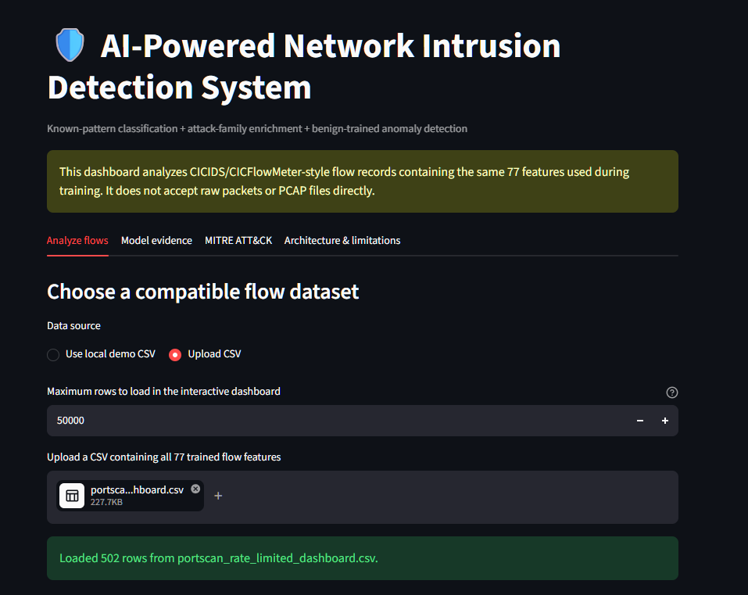
Figure 4. The 502-row port-scan flow file loaded into the dashboard.

Per-flow machine-learning result
The per-flow models missed the scan completely. All 502 flows were classified as benign, the attack-family stage did not run, and the Isolation Forest produced zero anomaly flags.
This was not a narrow threshold miss. The highest known-attack probability was 0.011319 against a decision threshold of 0.420000. The highest anomaly score was 0.380098 against an anomaly threshold of 0.524440. The scan flows were far below both thresholds.

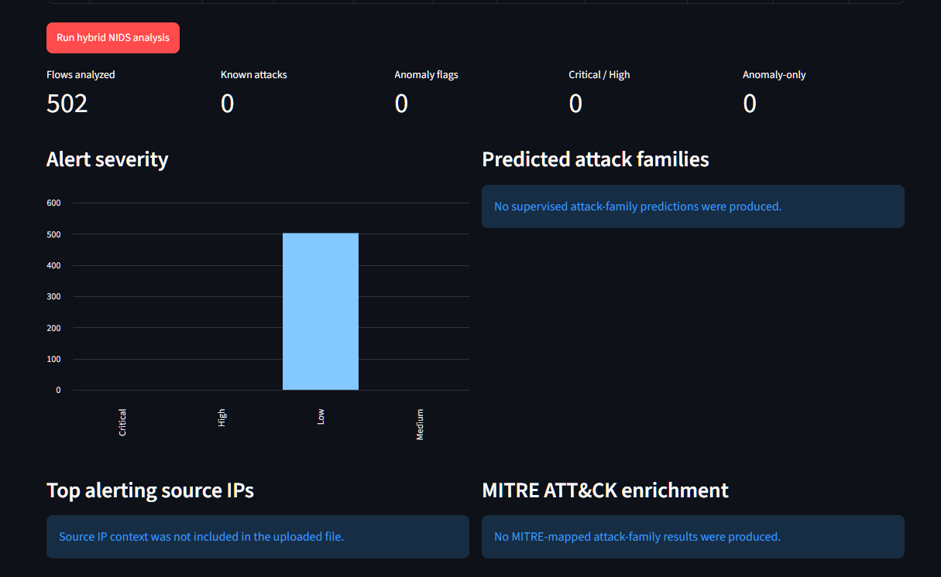
Figure 5. The controlled scan produced no supervised attack prediction and no anomaly flag in the per-flow dashboard.

Suricata result
Default Suricata processed 502 unique flow records and 502 SYN probes, but emitted no analyst-facing scan alert. Engine statistics showed three suppressed alerts. This confirmed that the traffic was processed even though the loaded rules did not produce an emitted detection.
A lab-specific threshold rule was then applied to the same PCAP. The rule required 20 SYN packets from one source within 10 seconds. It generated 24 threshold notification events. These records represent repeated alerts during one scan, not 24 separate attacks. The action remained allowed because Suricata was running as an IDS, not an inline IPS.
Layer | Benign result | Port-scan result | Analyst view
Default Suricata | 34 informational/decoder records | 0 emitted alerts; 3 suppressed | Missed the scan
Tuned Suricata | Not used for benign test | 24 threshold notifications | Detected the scan
Supervised ML | 5 of 5 BENIGN | 502 of 502 BENIGN | Missed the scan
Isolation Forest | 0 anomaly flags | 0 anomaly flags | Missed the scan
Cross-flow correlation | NO_SCAN_PATTERN | 1 PORT_SCAN alert | Detected the scan

8. Cross-Flow Correlation
The port scan showed the main weakness of the original architecture: every flow was scored separately. One SYN flow to one closed port can look harmless in isolation, but hundreds of similar flows from one source to many ports form a clear scanning pattern.
A deterministic correlation layer was added to group flows by source IP and review them in a rolling 10-second window. The tested condition required at least 20 SYN-bearing flows to at least 20 unique destination ports.
The benign baseline remained NO_SCAN_PATTERN. The controlled scan triggered one high-severity PORT_SCAN alert mapped to MITRE ATT&CK Reconnaissance, T1595 Active Scanning. The final local run observed a maximum of 276 unique destination ports inside a 10-second window.
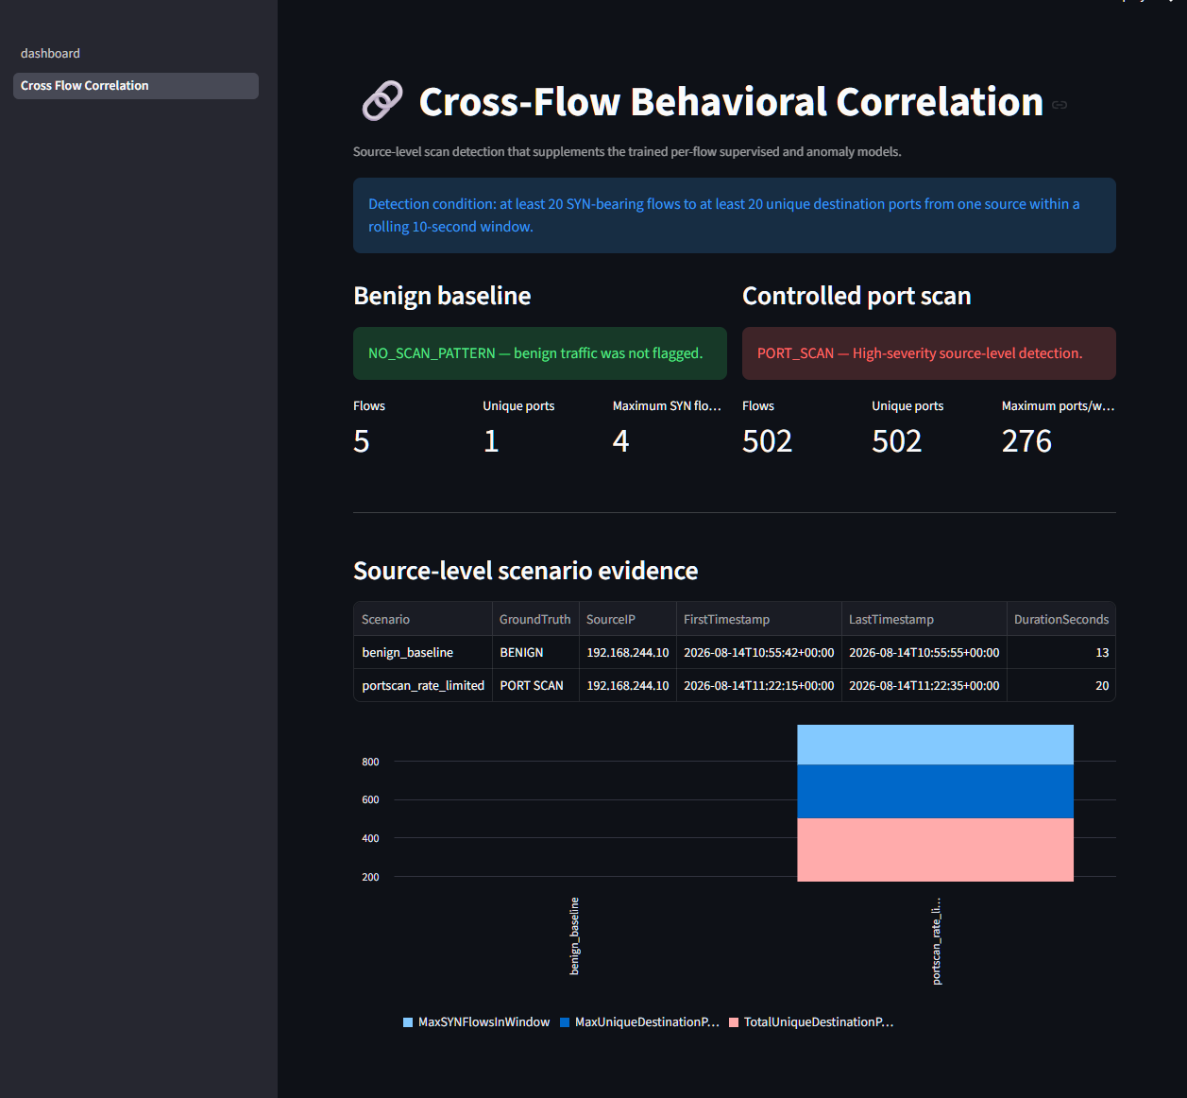
Figure 6. Cross-flow overview showing the benign baseline and controlled scan side by side.

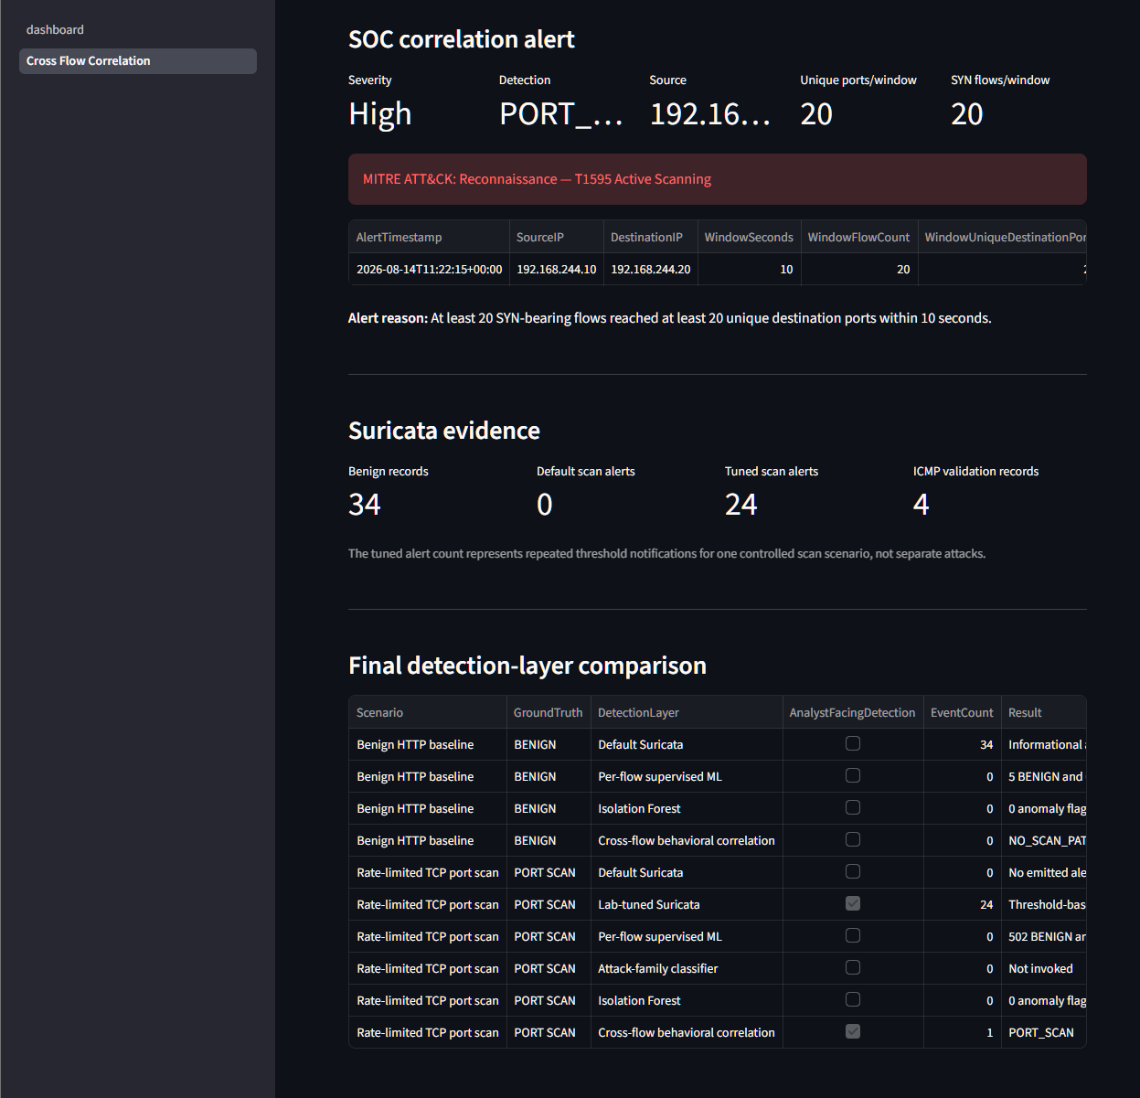
Figure 7. Source-level SOC alert, Suricata evidence counts, and the consolidated detection comparison.

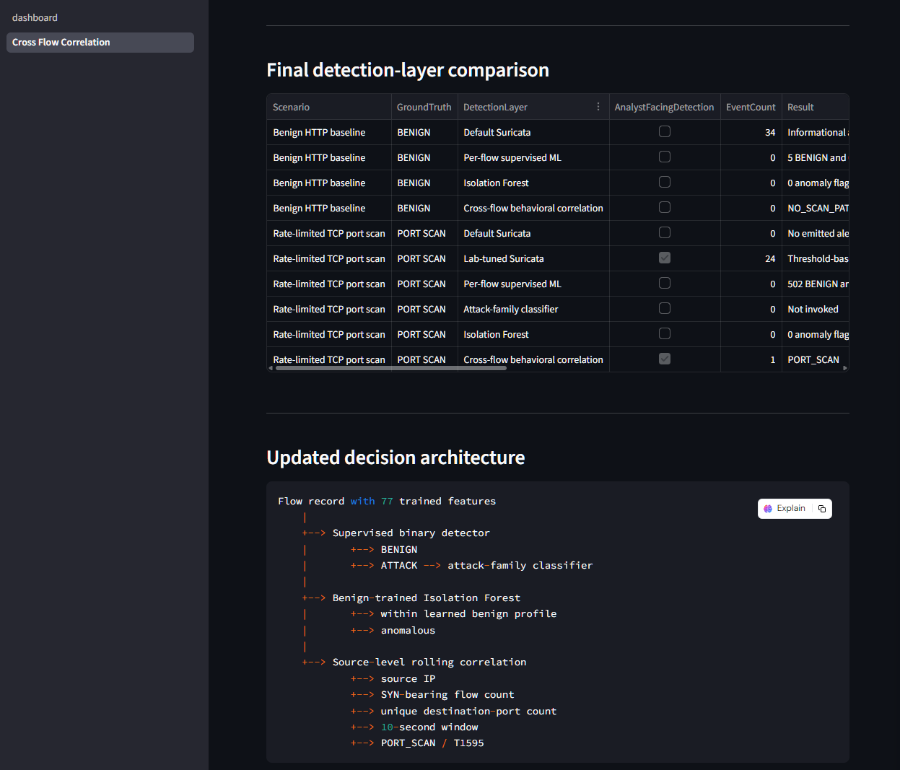
Figure 8. Final detection-layer comparison and updated architecture.

9. Main Findings
- Known-pattern performance was strong. The grouped binary detector and attack-family classifier performed very well when related attack patterns remained represented in training.
- Generalization was the real challenge. Complete-scenario recall was much lower than the grouped known-attack result.
- The controlled port scan exposed a clear per-flow blind spot. Neither the supervised model nor the anomaly detector recognized the individual scan flows as suspicious.
- Default Suricata also missed the rate-limited scan under the tested ruleset. A tuned threshold rule detected it on the same PCAP.
- Cross-flow correlation provided the missing context. It detected one source contacting many ports within a short period while leaving the benign baseline unflagged.
- The strongest design is layered. Machine learning, signatures, anomaly detection, and correlation each cover different parts of the problem.
Practical lesson
A high accuracy score on a familiar test set is not enough for a security system. Evaluation must include new scenarios, and the final design should preserve the failures as clearly as the successes.

10. Limitations and Next Steps

Current limitations
- The training data is historical and comes from one dataset family.
- The live-lab benign baseline is small and does not represent the variety of normal enterprise traffic.
- The community CICFlowMeter implementation may not reproduce every feature exactly as the original dataset-generation toolchain.
- The binary gate prevents attack-family classification when the first stage predicts benign.
- The tested cross-flow thresholds are lab settings and require broader tuning before operational use.
- The tuned Suricata rule is specific to the controlled scan pattern.
- The current process captures traffic, extracts flows, and then runs inference; it is not yet a continuous real-time pipeline.
- The project has not been validated on current external enterprise traffic.

Recommended next steps
- Automate packet capture, flow extraction, inference, correlation, and dashboard refresh.
- Collect a larger benign baseline from several hosts and services.
- Validate the system on newer external datasets and controlled enterprise-like traffic.
- Add source, destination, asset, and time-window features directly to model training.
- Tune alert suppression and deduplication policies.
- Add feature drift, model drift, and schema monitoring.
- Add analyst feedback and a controlled retraining process.
- Test other safe lab scenarios, including brute force and web attacks.

11. Conclusion
The project met its main goal: it produced a working hybrid intrusion detection prototype with trained models, a real IDS engine, a safe virtual lab, MITRE ATT&CK enrichment, and an operational dashboard.
The project also produced a useful negative result. The original per-flow models and default Suricata rules missed the controlled rate-limited scan. Instead of hiding that failure, the design was extended with a tuned IDS rule and a source-level correlation layer. Both detected the same scan while the benign baseline remained unflagged.
The final system is suitable as a portfolio and learning project. It demonstrates model development, honest evaluation, IDS integration, traffic capture, attack simulation, evidence handling, and SOC-style reporting. It should not be described as production-ready until it has broader validation, automated real-time processing, drift controls, secure logging, and operational tuning.
Final project status
Completed as a portfolio-grade hybrid NIDS prototype. Continuous production deployment remains future work.

Appendix A. Key Files and Reproduction Commands

Key evidence files
File | Purpose
reports/preprocessing_summary.txt | Preprocessing totals and controls
reports/binary_model_summary.txt | Selected binary model and final test metrics
reports/grouped_session_evaluation_summary.txt | Group-aware known-attack results
reports/scenario_holdout_summary.txt | Complete-scenario supervised results
reports/attack_family_model_summary.txt | Attack-family classifier results
reports/live_lab_probability_diagnostics.txt | Live-lab threshold diagnostics
reports/tables/final_live_lab_detection_comparison.csv | Final Suricata, ML, anomaly, and correlation comparison
reports/predictions/live_lab/cross_flow_scan_alerts.csv | Source-level T1595 alert
reports/evidence/suricata/ | Suricata summaries, rules, and alert ledgers

Run the cross-flow detector
python .\src\11_cross_flow_scan_correlation.py `
--input .\data\live_lab\model_ready\benign_baseline_dashboard.csv `
--input .\data\live_lab\model_ready\portscan_rate_limited_dashboard.csv `
--window-seconds 10 `
--minimum-unique-ports 20 `
--minimum-syn-flows 20

Start the dashboard
python -m streamlit run .\dashboard.py
If the dashboard entrypoint is stored in another folder, use its actual path. The project virtual environment should be active before running these commands.

