AI-POWERED NETWORK
INTRUSION DETECTION SYSTEM
A plain-language, step-by-step explanation of what was built, tested, and learned
Machine Learning | Suricata | VMware Lab | MITRE ATT&CK | Streamlit
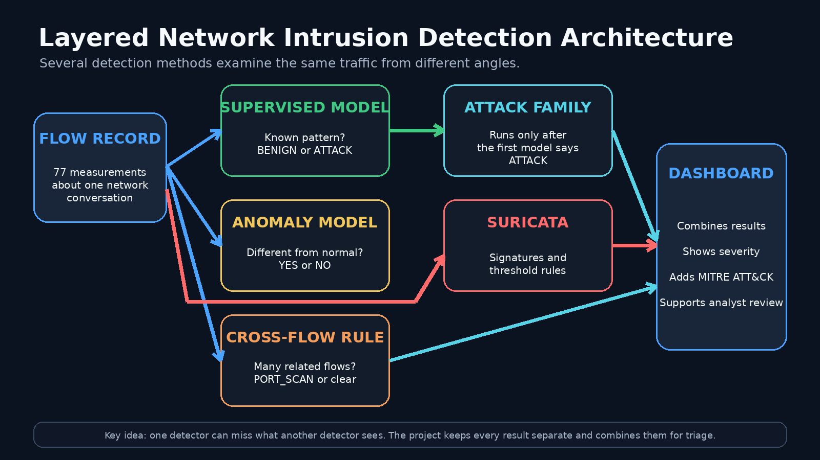
Prepared by Sunday Esumike
August 2026

How to Read This Walkthrough
This document explains the project in ordinary language. It focuses on what each part did, why it was needed, what the tests showed, and what the final system can and cannot claim.
The simplest way to think about the project
The project acts like a security checkpoint for network traffic. It measures each connection, checks it with several detection methods, and presents the results to an analyst on a dashboard.

The Whole Project in One Minute
The system takes summaries of network conversations, called flows, and uses 77 measurements to judge them. A supervised model decides whether each flow resembles a known attack. A second model adds a broad attack family when the first model says ATTACK. An Isolation Forest looks for unusual behavior. Suricata checks the same traffic against signatures and threshold rules. A cross-flow rule connects many related flows so behavior such as port scanning can be seen even when each individual flow looks harmless.
The most important test was a controlled scan of 502 destination ports. The per-flow machine-learning models and default Suricata rules missed the scan. A tuned Suricata rule and a new cross-flow correlation layer detected it. This showed why several detection layers are stronger than one detector working alone.

Figure 1. The final system uses several detection paths because each one sees a different part of the problem.

Project Stages
Stage | What happened
1 | Set up the workspace and Python environment
2 | Load and clean the training data
3 | Train and compare binary attack detectors
4 | Test known-pattern performance and new-scenario performance
5 | Add attack-family classification and anomaly detection
6 | Build the Streamlit dashboard
7 | Create a safe Kali and Ubuntu VMware lab
8 | Install and configure Suricata
9 | Capture benign traffic and a controlled port scan
10 | Compare Suricata and machine learning on the same traffic
11 | Add cross-flow correlation to detect the missed scan
12 | Preserve evidence and create the final reports

Step 1: Define the Goal
The goal was to build a working network intrusion detection prototype that could read flow records, recognize familiar attacks, identify unusual behavior, add standard security labels, and show the results in a form that a security analyst could review.
- Classify each flow as BENIGN or ATTACK.
- Assign a broad attack family after an ATTACK decision.
- Look for traffic that is unusual compared with normal behavior.
- Compare the machine-learning results with a real IDS called Suricata.
- Test the system safely inside a private VMware laboratory.
Scope boundary
This was built as a portfolio-grade prototype. It demonstrates the full workflow, but it is not yet a fully automated production sensor.

Step 2: Create an Organized Workspace
The project was organized into folders for raw data, processed data, reusable Python scripts, trained models, predictions, figures, evidence, and reports. A Python virtual environment named .venv kept the project packages separate from other Python work on the computer.
The virtual environment was important because it acted like a private toolbox. The project could use the versions of pandas, NumPy, scikit-learn, Streamlit, and other libraries it needed without interfering with unrelated projects.

Step 3: Load the Training Data
The project used eight machine-learning CSV files and eight matching generated-flow context files. After alignment and validation, the working population contained 2,830,743 valid flow records.
A flow is a summary of one network conversation. It records information such as destination port, connection duration, packet counts, packet sizes, TCP flags, and active or idle time. It is smaller and easier to analyze than a full packet recording.

Step 4: Clean and Prepare the Data
The raw files were not ready for model training. A preprocessing script removed one duplicate field, converted infinity values into missing values, created consistent targets, and checked that the two source collections remained aligned. The final model used 77 numeric features.
- 2,830,743 valid flow records were retained.
- 77 predictive features remained after duplicate removal.
- 4,376 infinity values were replaced with missing values.
- 5,734 missing feature values were left for training-only imputation.
- The raw CSV files were preserved without modification.
What a feature means
A feature is one measurement used to judge a connection. The model used 77 measurements in the same way a checkpoint might record a vehicle's speed, weight, plate number, and time of arrival.

Step 5: Create the Learning Targets
The original data contained detailed labels such as DDoS, PortScan, FTP-Patator, SSH-Patator, DoS Hulk, Web Attack, Bot, and Infiltration. These labels were reorganized into simpler targets for different stages of the system.
- Binary target: BENIGN or ATTACK.
- Attack-family target: Denial of Service, Port Scan, Brute Force, Web Attack, or Other Malicious.
- Original detailed label: retained for context and checking.

Step 6: Compare Several Binary Models
Four candidate models were trained on the same validation population so the comparison would be fair: Dummy Prior, Logistic Regression using SGD, Random Forest, and HistGradientBoosting.
HistGradientBoosting was selected because it produced the best attack-focused F2 score while maintaining very high recall and precision. The model learned mathematical relationships between the 77 flow measurements and the known labels.
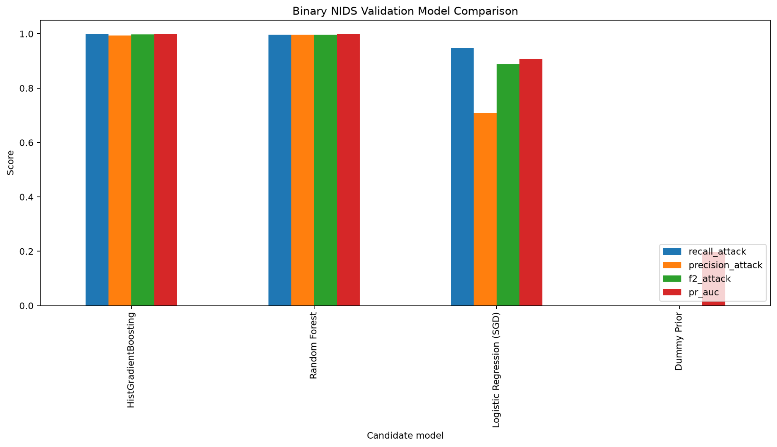
Figure 2. Comparison of the binary model candidates. HistGradientBoosting was selected.

Step 7: Evaluate the Model in Three Different Ways
The project did not rely on one easy train/test split. It used progressively harder tests so that familiar-pattern performance could be separated from performance on a new traffic setting.
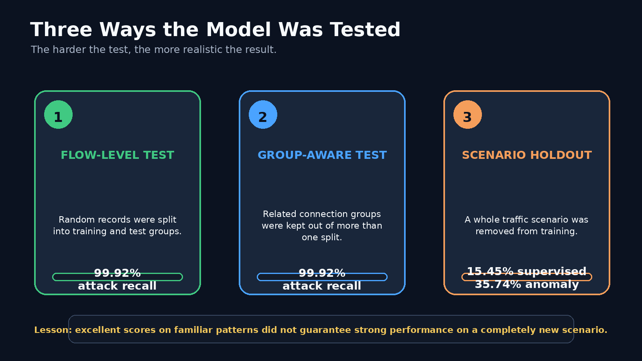
Figure 3. The scenario-holdout test was the hardest and most realistic test.
The grouped known-attack test reached about 99.92% attack recall. When complete traffic scenarios were removed from training, supervised recall fell to 15.45%, while the anomaly detector reached 35.74%. This showed that high internal scores did not automatically mean strong performance on a new environment.
Plain-language lesson
A student can score very well on familiar practice questions and still struggle when the same subject is presented in a completely new way. The model showed the same kind of gap.

Step 8: Add the Attack-Family Classifier
A second model added broader security context after the binary detector produced an ATTACK decision. It grouped attacks into Denial of Service, Port Scan, Brute Force, Web Attack, or Other Malicious.
The important limitation was the gate: if the first model said BENIGN, the attack-family model did not run. That mattered later because the controlled scan was classified as benign at the first stage.

Step 9: Add the Anomaly Detector
An Isolation Forest was trained on benign traffic. Instead of asking whether a flow looked like a known attack, it asked whether the flow looked different from the normal behavior learned during training.
The anomaly detector improved the complete-scenario recall, but it still missed most attacks in the hardest test. It added useful coverage, but it did not solve the generalization problem by itself.
An anomaly is not proof of an attack
Backups, software updates, new servers, and unusual user activity can all look different from normal behavior without being malicious.

Step 10: Add MITRE ATT&CK Mapping
MITRE ATT&CK is a standard way security teams describe attacker behavior. The project used it to turn a technical detection into a recognizable investigation label. For example, the final scan alert was mapped to Reconnaissance, T1595 Active Scanning.

Step 11: Build the Streamlit Dashboard
The dashboard became the analyst-facing part of the project. It loaded the saved model files, checked that an uploaded CSV had the required 77 features, ran the detection stages, and produced a complete prediction ledger.
- Input preview and file validation.
- BENIGN or ATTACK decisions.
- Anomaly scores and flags.
- Attack-family summaries.
- Severity counts and SOC alert queue.
- MITRE ATT&CK enrichment.
- Detailed inspection of one selected flow.
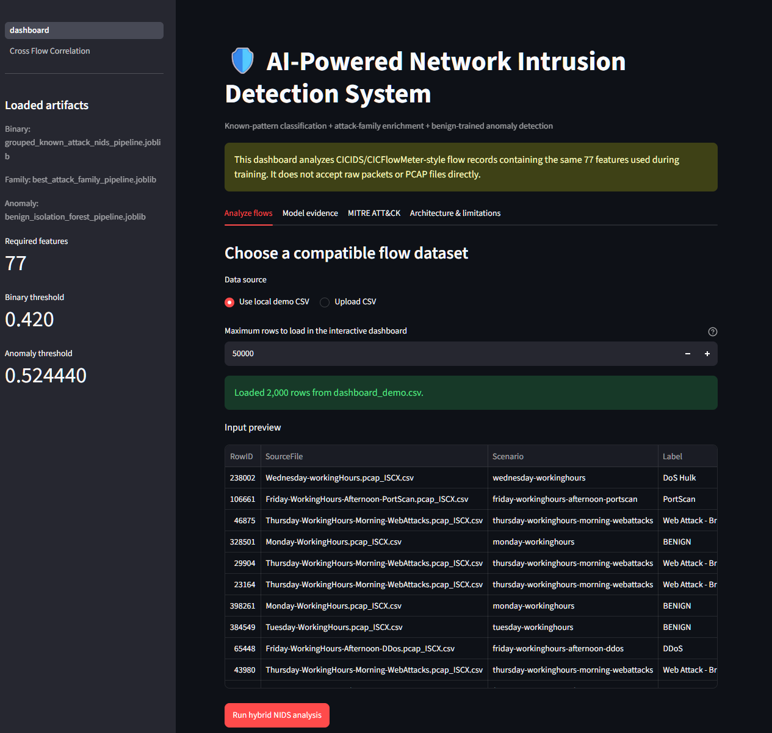
Figure 4. Main Streamlit dashboard with model artifacts, input controls, and a flow preview.

Step 12: Create a Safe Virtual Laboratory
Two VMware virtual machines were connected on a private host-only network. Kali Linux generated controlled traffic. Ubuntu hosted the target services and the Suricata sensor. No external system was targeted.
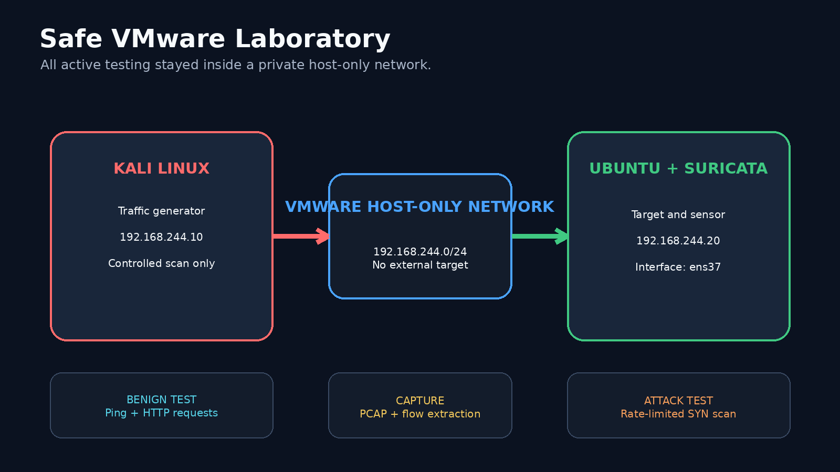
Figure 5. Kali generated traffic only against the Ubuntu VM inside the private VMware network.

Step 13: Install and Fix Suricata
Suricata initially failed because it was configured to monitor an interface named eth0 that did not exist on the Ubuntu VM. The correct sensor interface was ens37. The rule files also had to be loaded correctly.
After those issues were fixed, Suricata 8.0.3 ran as an IDS on ens37 with 52,242 rules loaded. For the final comparison, saved PCAP files were replayed so that Suricata and the machine-learning models examined the same traffic.

Step 14: Generate a Benign Baseline
The benign test used four ping requests and five HTTP requests to a small Python web server. The prepared flow file contained five supported HTTP flows.
- 5 of 5 flows were classified as BENIGN.
- 0 attack predictions were produced.
- 0 anomaly flags were produced.
- Cross-flow correlation reported NO_SCAN_PATTERN.
- Suricata produced 34 informational or decoder-related records, not a malicious verdict.

Step 15: Generate a Controlled Port Scan
A rate-limited TCP SYN scan was run from Kali against Ubuntu. A port scan is similar to trying many door handles to find out which doors are open. The controlled test sent 502 SYN probes to 502 different destination ports.
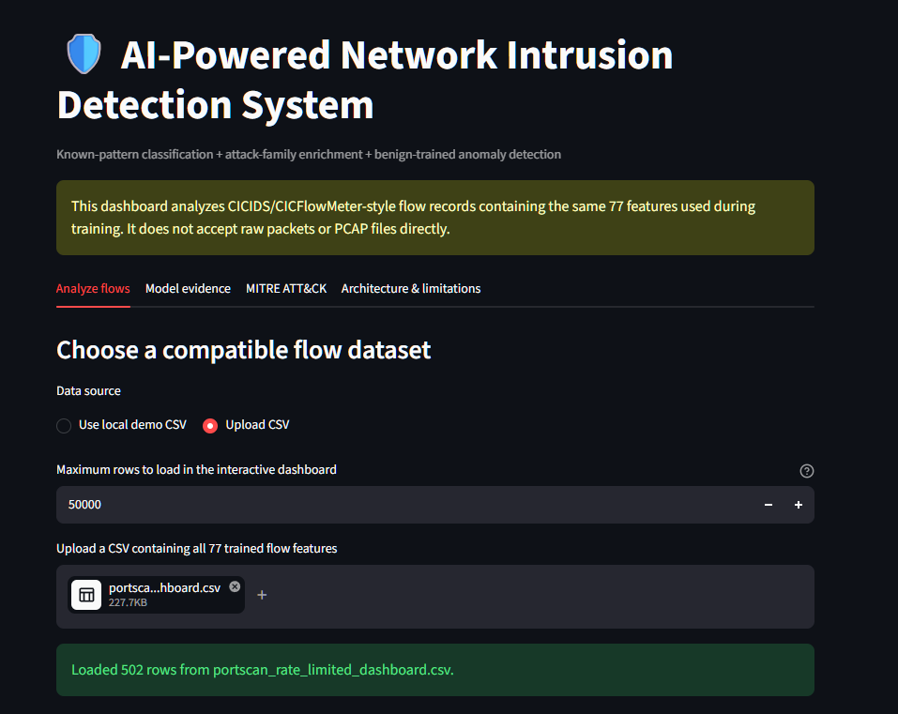
Figure 6. The 502-row controlled port-scan flow file loaded into the dashboard.

Step 16: Convert the PCAP into Model-Ready Flows
The models could not read raw PCAP files directly. CICFlowMeter converted packet captures into flow summaries. The installed command-line tool had an argument-handling bug, so a small Python wrapper called the extraction function correctly.
A preparation script then mapped the extracted columns into the exact 77-feature order expected by the trained models. The final live files contained five benign rows and 502 scan rows, converted 23 timing fields, and contained no missing model cells.

Step 17: Run the Captured Traffic Through the Models
The benign flows were handled correctly. The controlled scan was not. All 502 scan flows were classified as BENIGN, the attack-family stage did not run, and the Isolation Forest produced zero anomaly flags.
The highest known-attack probability was 0.011319 against a decision threshold of 0.420000. The highest anomaly score was 0.380098 against an anomaly threshold of 0.524440. The scan was therefore far below both thresholds, not just barely missed.
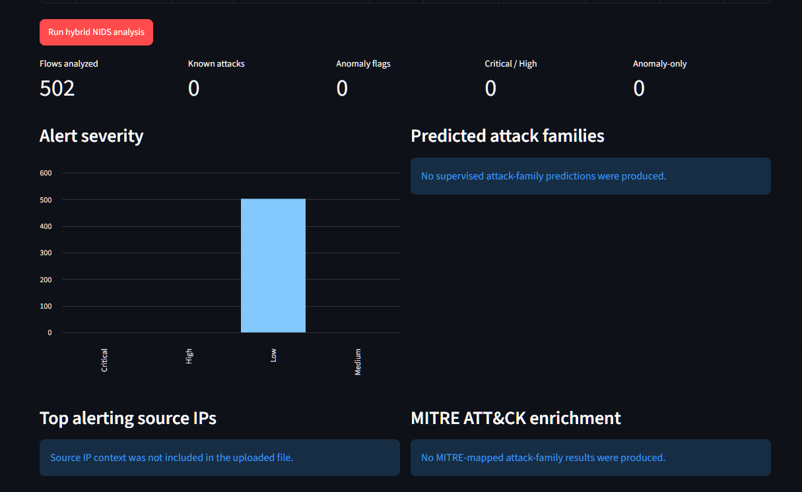
Figure 7. The per-flow dashboard shows 502 flows, zero known attacks, and zero anomaly flags.

Step 18: Test Default Suricata on the Same Scan
Default Suricata processed 502 unique flow records and 502 SYN probes but emitted no analyst-facing scan alert. Its engine statistics showed three suppressed alerts, confirming that the traffic was processed even though the active rules did not produce a visible detection.

Step 19: Tune Suricata for the Lab Pattern
A lab-specific threshold rule was added. The rule looked for 20 SYN packets from one source within 10 seconds. Replaying the same PCAP produced 24 threshold notification records.
Those 24 records represented repeated notifications during one scan, not 24 separate attacks. Suricata was running in IDS mode, so the traffic was logged and allowed rather than blocked.

Step 20: Understand Why the Per-Flow Layers Missed the Scan
The original models judged each flow separately. One short SYN flow to one closed port can appear harmless. The suspicious behavior became obvious only when hundreds of related flows were viewed together.
Simple analogy
Testing one office door may be innocent. Testing 500 office doors in a few seconds is a clear pattern. The cross-flow layer was built to see that pattern.

Step 21: Add Cross-Flow Correlation
The new correlation layer grouped flows by source IP and reviewed them inside a rolling 10-second window. The tested condition required at least 20 SYN-bearing flows to at least 20 unique destination ports from one source.
- Benign baseline: NO_SCAN_PATTERN.
- Controlled scan: PORT_SCAN.
- Severity: High.
- MITRE ATT&CK: Reconnaissance, T1595 Active Scanning.
- Maximum observed in one 10-second window: 276 unique destination ports.
- One de-duplicated source-level alert was created.
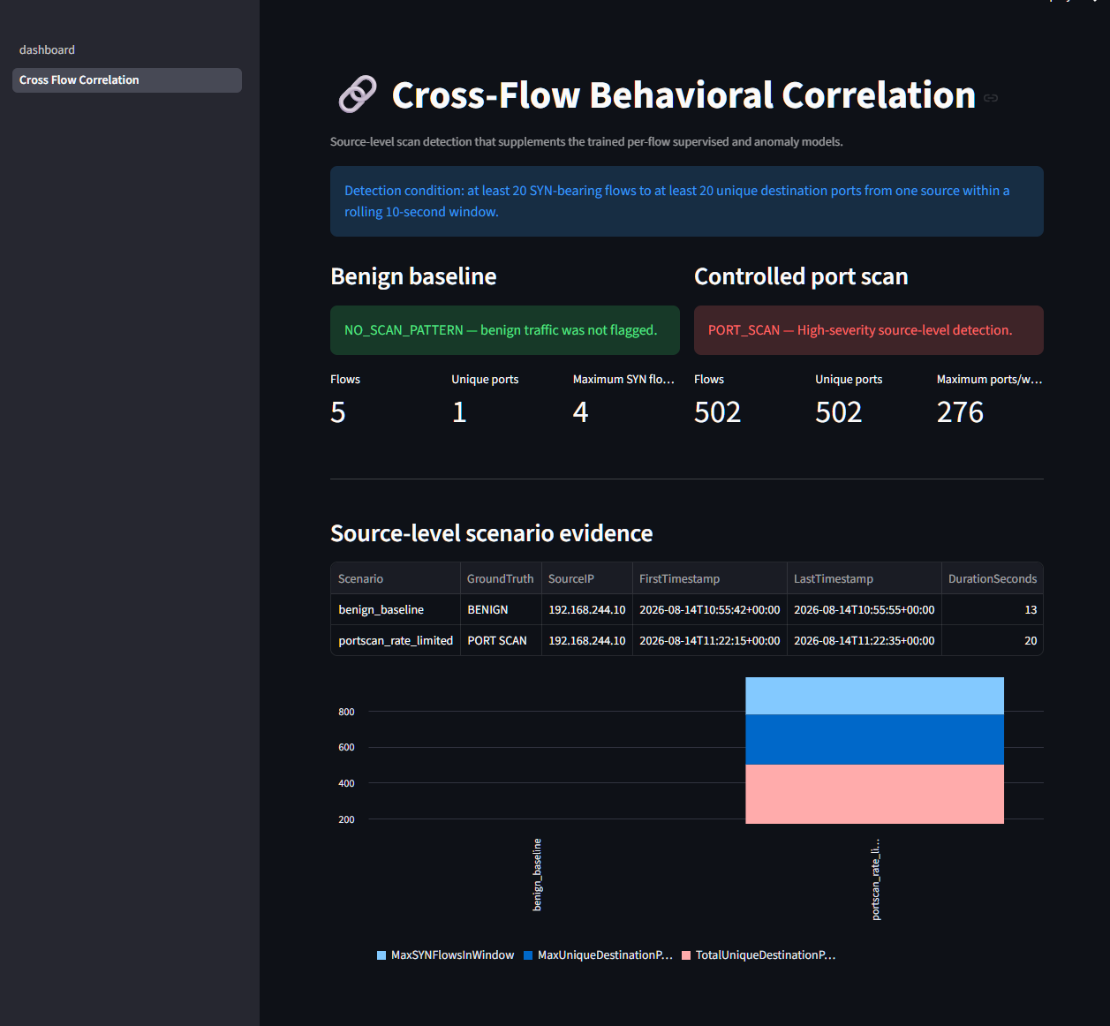
Figure 8. Cross-flow correlation left the benign baseline clear and detected the controlled scan.

Step 22: Add the New Layer to the Dashboard
A separate Cross-Flow Correlation page was added to Streamlit. It displayed the benign and scan scenarios side by side, the source-level alert, MITRE T1595 mapping, Suricata counts, and a final comparison of all detection layers.
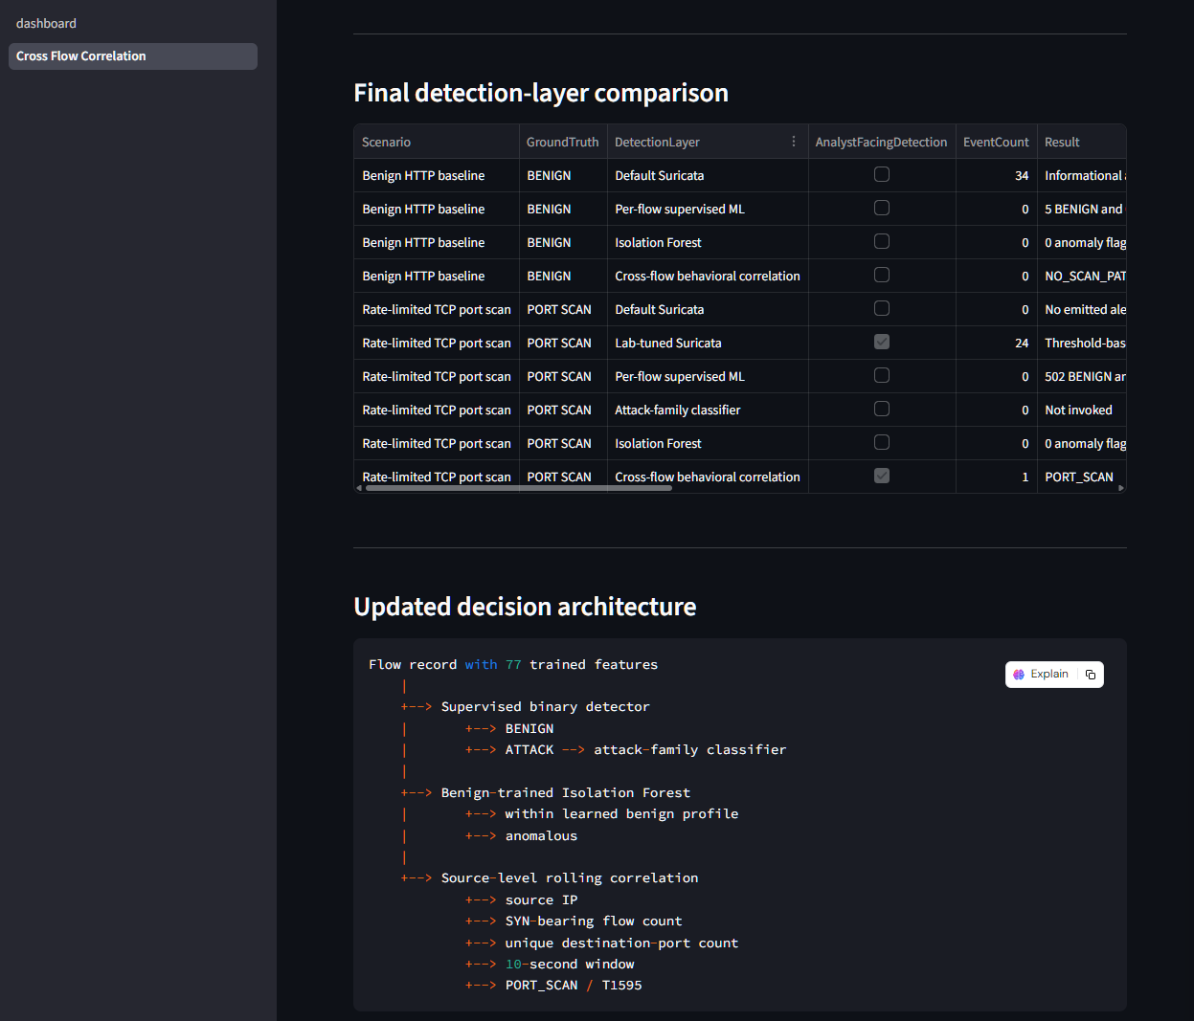
Figure 9. Final comparison and updated architecture in the dashboard.

What Each Major Component Does
Component | Plain-language question
Binary model | Does this one flow resemble a known attack?
Attack-family model | When the first model says ATTACK, what broad type is it?
Isolation Forest | Does this flow look unusual compared with normal traffic?
Suricata | Does the traffic match a written signature or threshold rule?
Cross-flow correlation | Do many related flows together form a suspicious pattern?
MITRE ATT&CK | What standard attacker behavior does the alert represent?
Streamlit dashboard | How can an analyst review and investigate the results?

Main Results
Test or layer | Result
Known-pattern grouped test | 99.92% attack recall
Complete-scenario supervised test | 15.45% attack recall
Complete-scenario anomaly test | 35.74% attack recall
Benign live flows | 5 of 5 BENIGN; no anomaly
Controlled scan | 502 SYN flows to 502 ports
Per-flow supervised model | 0 of 502 detected
Isolation Forest | 0 of 502 flagged
Default Suricata | 0 emitted scan alerts; 3 suppressed
Tuned Suricata | 24 repeated threshold notifications
Cross-flow correlation | 1 High-severity T1595 alert

What the Project Proved
- A model can score almost 100% on familiar data and still miss a simple real laboratory scan.
- Some attacks are visible only when multiple related events are connected.
- Machine learning should not be the only detection layer.
- Negative results are useful when they are preserved and investigated honestly.
- The strongest design combines supervised learning, anomaly detection, Suricata, correlation, MITRE mapping, and analyst review.

What the Project Does Not Yet Do
The completed system is a strong portfolio prototype, but it is not yet a continuously operating production sensor. The current workflow captures traffic, saves a PCAP, extracts flows, prepares 77 features, runs inference, performs correlation, and then displays the evidence.
- Automate packet capture, flow extraction, model inference, and dashboard refresh.
- Collect a much larger and more varied benign baseline.
- Test newer external datasets and enterprise-like traffic.
- Add model drift, feature drift, and schema monitoring.
- Add secure centralized logging, alert suppression, analyst feedback, and controlled retraining.

A 30-Second Explanation for an Interview or Class
Ready-to-use explanation
I built a hybrid network intrusion detection prototype. It converts network communications into 77 measurable features and uses machine learning to decide whether each flow is normal or an attack. It also uses a second model for attack families, an anomaly detector, Suricata, MITRE ATT&CK mapping, and a Streamlit dashboard. During testing, the original per-flow models and default Suricata rules missed a controlled 502-port scan. I added a tuned Suricata rule and a cross-flow correlation layer that examined many related connections together. Both detected the scan, while the benign baseline remained unflagged. The main lesson was that effective detection needs several layers and realistic testing on new traffic.

Final Status
The project was completed as a portfolio-grade hybrid network intrusion detection prototype. It demonstrates data preparation, model development, honest evaluation, real IDS integration, packet capture, safe attack simulation, MITRE ATT&CK enrichment, cross-flow correlation, evidence preservation, and SOC-style dashboard reporting.
The correct final claim is not that the system is production-ready. The correct claim is that it is a working, well-tested prototype that clearly shows both its strengths and its current limits.

Evidence Basis
The numbers and screenshots in this walkthrough come from the project's saved preprocessing summaries, model reports, prediction ledgers, Suricata logs, final comparison tables, dashboard screenshots, and final technical report.

