NORTHWIND SALES DASHBOARD
Using Microsoft Power BI — Project Report (Week 6)
Submitted by: Panuganti Sunethra
Roll No.: E25FA032
Course: B.Com (Fintech & AI)
College: SDNB Vaishnav College for Women, Chennai
Tool Used: Microsoft Power BI Desktop

1. Introduction
For this project I built an interactive sales dashboard in Microsoft Power BI using the Northwind trading dataset. The aim was to turn seven raw CSV files into a clean data model and then into visuals that answer simple business questions: how many orders were placed, how much was sold, which categories and products perform best, which employees handle the most orders, where the customers are, and how orders change month to month.
I imported the CSV files, cleaned them in Power Query, connected them through relationships, wrote DAX measures, and then designed a five-page report that includes KPI cards, charts, tables, slicers, a custom tooltip page and a drill-through page.

2. Objectives
- Load and prepare the Northwind data using Power Query.
- Build a proper data model with relationships between the tables.
- Create DAX measures for orders, sales, quantity, freight and customers.
- Show the overall business performance through KPI cards.
- Compare sales across product categories and orders across employees.
- Study the monthly trend of orders.
- Understand the geographical spread of customers.
- Analyse individual products in a detailed table.
- Make the dashboard interactive with slicers, a report-page tooltip and drill-through.

3. Data Source and Data Model
The data was imported from seven CSV files. Together they form a star-style model, where Orders and Order_details hold the transactions and the other tables describe them.
Table | Rows | What it contains
Orders | 830 | OrderID, customer, employee, order/required/shipped dates, shipper, freight
Order_details | 2,155 | Product, unit price, quantity and discount for each order line
Products | 77 | Product name, quantity per unit, unit price, category
Categories | 8 | Category names and descriptions
Customers | 91 | Company, contact, city and country
Employees | 8 | Employee name, title, city, country, reports-to
Shippers | 3 | Shipping company names

Relationships used (all many-to-one, single direction):
- Order_details[orderID] → Orders[orderID]
- Order_details[productID] → Products[productID]
- Products[categoryID] → Categories[categoryID]
- Orders[customerID] → Customers[customerID]
- Orders[employeeID] → Employees[employeeID]
- Orders[shipperID] → Shippers[shipperID]

[ Paste screenshot here: Model view showing the relationships ]

4. Data Transformation Using Power Query
Before building any visuals, I used Power Query Editor to prepare each table. The main steps were:
- Promote headers: the first row of each CSV was promoted to column headers.
- Change data types: IDs and quantities were set to whole numbers, prices, discount and freight to decimal numbers, dates to Date type, and names to text. Correct types are needed so that sums, averages and the date hierarchy work properly.
- Filter rows in Employees: rows where the reportsTo field was empty were removed, so the employee at the top of the hierarchy is not included in the Employees table.
Because the Employees table was filtered this way, 96 orders that belong to that removed employee have no matching name and appear as (Blank) in the Orders by Employee chart. I have kept this in mind while reading the chart.
[ Paste screenshot here: Power Query Editor showing the Applied Steps ]

5. DAX Measures
I created the following measures to analyse the dataset. They are used in the KPI cards, charts, tooltip page and drill-through page.
Measure | DAX formula
Total Orders | DISTINCTCOUNT(Order_details[orderID])
Total Sales | SUMX(Order_details, Order_details[unitPrice] * Order_details[quantity] * (1 - Order_details[discount]))
Total Quantity Sold | SUM(Order_details[quantity])
Total Freight | SUM(Orders[freight])
Average Freight | AVERAGE(Orders[freight])
Number of Customers | DISTINCTCOUNT(Customers[customerID])

Total Sales uses SUMX so that the price, quantity and discount are calculated line by line before adding them up, which gives the actual revenue after discount.
[ Paste screenshot here: Measure formulas shown in the formula bar (Model/Data view) ]

6. Dashboard Pages
No. | Page | Purpose
1 | Sales Overview | Main summary: KPI cards, orders by month, sales by category, orders by employee
2 | Product and Customer Analysis | Customers by country chart and a product sales summary table
3 | Interactive Sales Dashboard | Same key visuals with slicers (Year, Country, Category) and KPI cards
4 | Category Tooltip | A small report-page tooltip shown when hovering over a category
5 | Category Detail | Drill-through page with details of the selected category and a Back button

7. KPI Cards
Five KPI cards give a quick summary of the business before going into detail. The values below are for the full dataset with no filters applied.
KPI | Value
Total Orders | 830
Total Sales | 12,65,793.04 (about 1.27 million)
Total Quantity Sold | 51,317 units
Total Freight | 64,942.69
Average Freight (per order) | 78.24
Number of Customers | 91

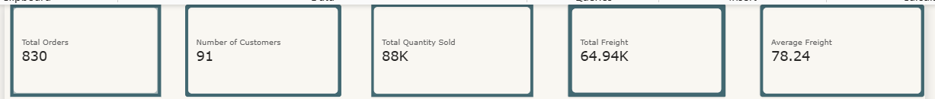
Figure: KPI cards on the Sales Overview page

8. Visualisations Used

8.1 Orders by Month (Line Chart)
This line chart uses the month from the Order Date hierarchy on the axis and Total Orders as the value. It shows how order activity rises and falls through the year. Orders are highest in March and April (103 and 105) and lowest in June (30) and May (46). The data runs from July 2013 to May 2015, so June appears only once in the data, which partly explains the low figure.

8.2 Sales by Product Category (Column Chart)
A column chart with Category Name and Total Sales shows how much each of the eight categories contributes. Beverages is the largest, followed by Dairy Products and Confections.
Category | Total Sales | Share of sales
Beverages | 2,67,868.18 | 21.2%
Dairy Products | 2,34,507.29 | 18.5%
Confections | 1,67,357.23 | 13.2%
Meat & Poultry | 1,63,022.36 | 12.9%
Seafood | 1,31,261.74 | 10.4%
Condiments | 1,06,047.09 | 8.4%
Produce | 99,984.58 | 7.9%
Grains & Cereals | 95,744.59 | 7.6%

8.3 Orders by Employee (Bar Chart)
This bar chart compares Total Orders for each employee. Margaret Peacock handles the most orders (156), followed by Janet Leverling (127) and Nancy Davolio (123). Anne Dodsworth (43) and Steven Buchanan (42) handle the fewest. The (Blank) bar with 96 orders comes from the filtered-out top-level employee, as explained in the Power Query section.
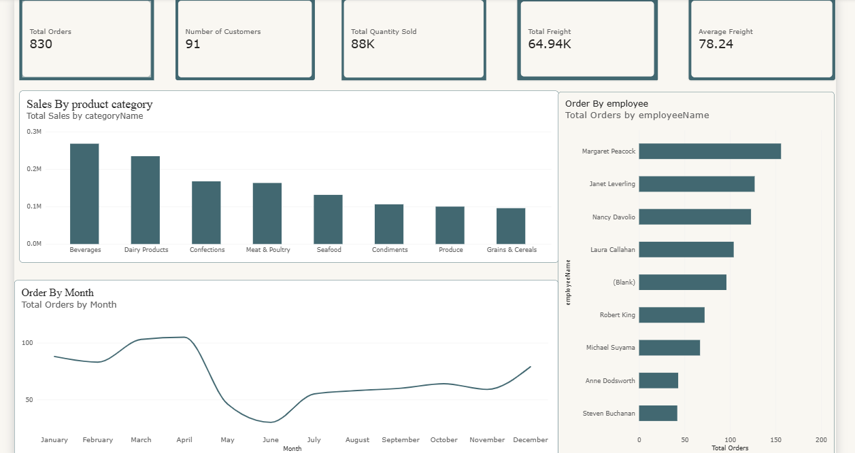
Figure: Sales by Product Category, Orders by Employee and Orders by Month

8.4 Customers by Country (Bar Chart)
This bar chart uses Country as the category and Number of Customers as the value. The customers come from 21 countries. The USA has the most (13), followed by Germany and France (11 each), Brazil (9) and the UK (7). Many countries have only one or two customers.

8.5 Product Sales Summary (Table)
A table lists Product Name, Total Quantity Sold, Total Sales and Category Name for all 77 products so that products can be compared directly. The best-selling product by value is Côte de Blaye, with sales of 1,41,396.74, which is about 11.2% of all sales. Thüringer Rostbratwurst (80,368.67) and Raclette Courdavault (71,155.70) come next.
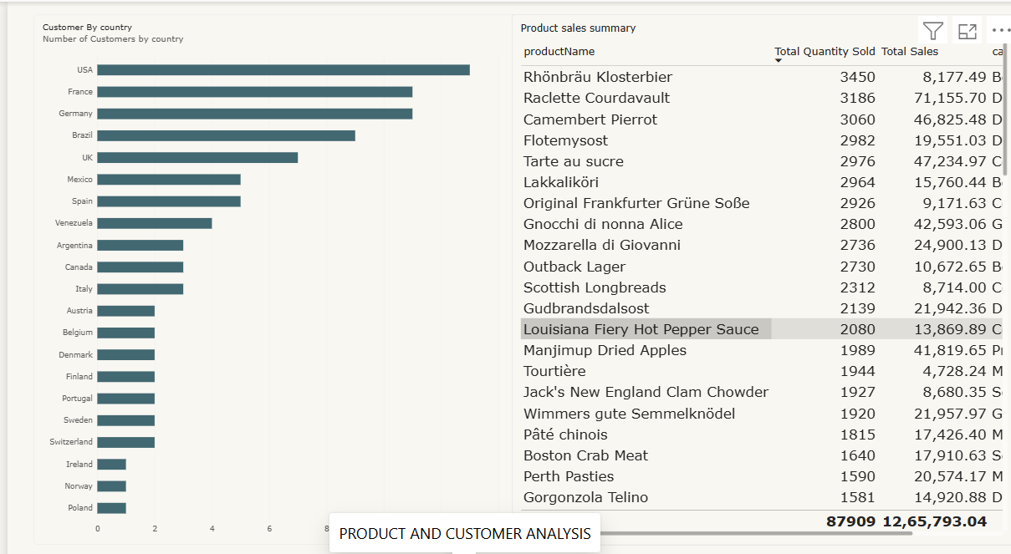
Figure: Product and Customer Analysis page

9. Tooltips
Besides the default tooltips that every visual shows, I created a custom report-page tooltip called Category Tooltip. It is attached to the Sales by Product Category chart on the Interactive Sales Dashboard page. When I hover over a category column, a small card appears showing Total Orders, Total Quantity Sold and Total Sales for that category. For example, hovering over Produce shows 129 orders and total sales of 99.98K. This keeps the main dashboard clean while still giving extra detail on demand.
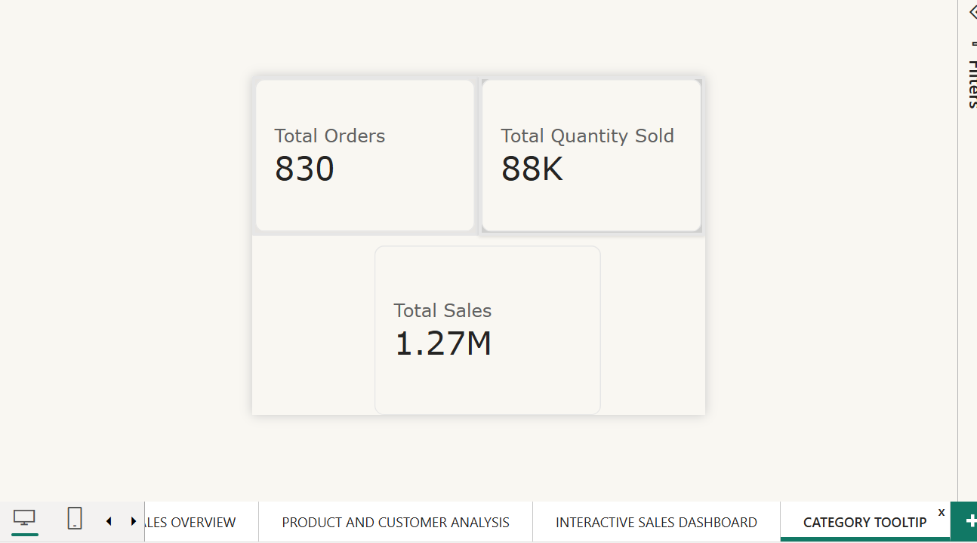
Figure: Category Tooltip report page
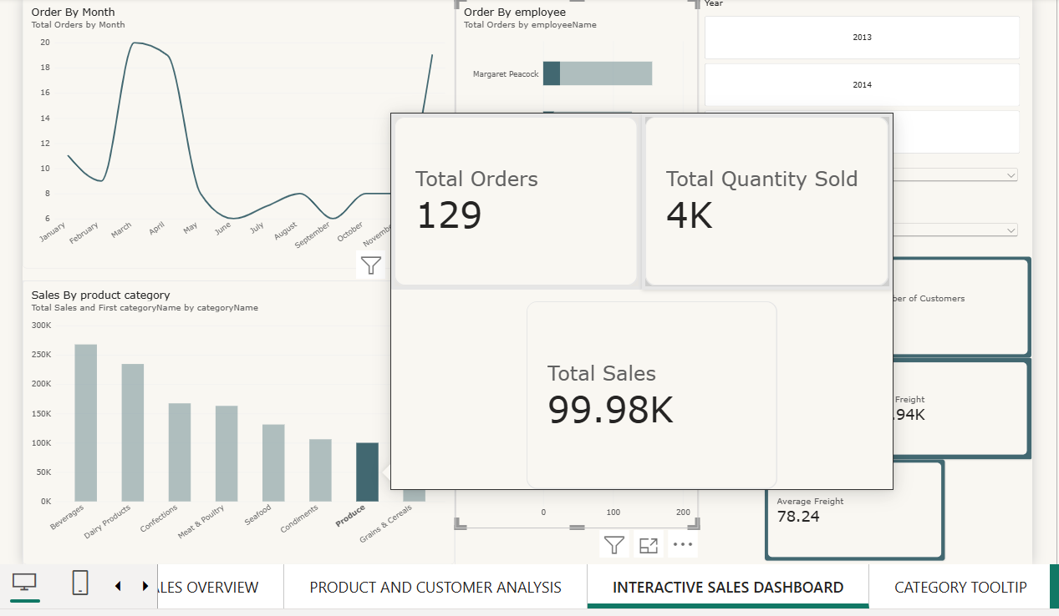
Figure: Tooltip appearing on hovering over the Produce column

10. Slicers and Interactivity
The Interactive Sales Dashboard page has three slicers:
- Year: a button-style slicer for the order year (2013, 2014, 2015).
- Country: a dropdown slicer on the customer country.
- Category: a dropdown slicer on the product category.
When a value is selected, all charts and KPI cards on the page update immediately, so the same dashboard can be used to look at the data from different angles. For example, orders by year in the data are 152 (2013), 408 (2014) and 270 (2015, up to 6 May).
Figure: Interactive Sales Dashboard with slicers; selecting a category cross-highlights the other visuals

11. Drill-through Analysis
The Category Detail page is a drill-through page filtered by Category Name. From the Sales by Product Category chart, I can right-click a category and choose Drill through → Category Detail. The page then shows cards for Total Orders, Total Sales and Total Quantity Sold, plus a product table, only for the selected category.
For example, drilling through on Grains & Cereals shows 182 orders and total sales of 95,744.59, with the seven products of that category listed in the table, such as Gnocchi di nonna Alice (42,593.06 in sales). A Back button on the page returns the user to the previous page.
Benefits of drill-through:
- The main page stays simple while detail is available when needed.
- The selected category filter carries over to the detail page.
- It links summary-level analysis with product-level analysis.

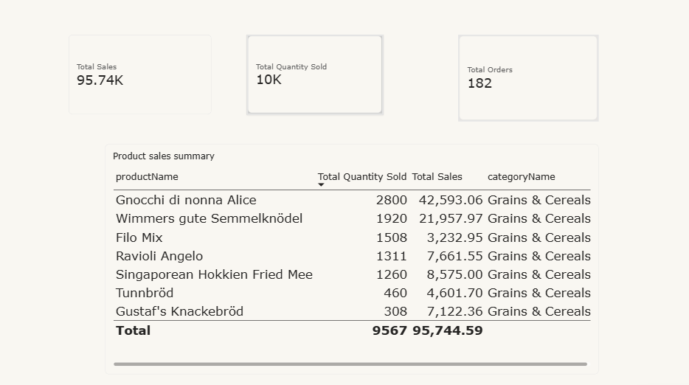
Figure: Category Detail drill-through page (Grains & Cereals)

12. Key Findings
- The business handled 830 orders from 91 customers, generating about 1.27 million in sales.
- Beverages and Dairy Products together contribute almost 40% of total sales (21.2% + 18.5%).
- Grains & Cereals and Produce are the smallest categories, each below 8% of sales.
- Order volume is highest in March–April and lowest in May–June.
- Margaret Peacock handles the highest number of orders (156), almost four times that of the lowest employees.
- The USA, Germany and France have the largest customer bases.
- One product, Côte de Blaye, alone accounts for over 11% of total sales.
- The average freight per order is about 78, and total freight is about 64.9 thousand.
- Slicers, the custom tooltip and drill-through make it easy to move from the overall picture to category-level detail.

13. Conclusion
Through this project I learned how raw CSV files can be turned into an interactive business dashboard in Power BI. I cleaned and typed the data in Power Query, connected the tables through relationships, and wrote DAX measures for orders, sales, quantity, freight and customers. I then used KPI cards, charts, a table, slicers, a report-page tooltip and a drill-through page to present the information clearly.
Overall, the project helped me understand how Power Query, the data model, DAX and visual design work together to support better business decisions.

