BUSINESS PERFORMANCE ANALYSIS
Electronics Retail Sales Dashboard
Week 12 Report
Data source: Power BI dashboard (Electronics_Retail_Sales_Dashboard_week_-12.pbix)
Reporting period: 12 January 2024 – 11 January 2026
Currency: Indian Rupees (1 Cr = 10 million)
Report date: 6 November 2026

1. Executive Summary
This report analyses the electronics retail sales dashboard to identify what drives revenue and profit, and where the business can improve. The key findings are:
- Scale: The business generated ₹470.7 Cr in revenue and ₹98.0 Cr in profit (20.8% margin) from 15,000 orders and 112,353 units.
- Channel concentration: The Online store contributes 69% of revenue; all physical stores together contribute the remaining 31%.
- Product concentration: Mobile Phones, Laptops and Televisions account for about 88% of revenue. Premium Smartphones are the single largest subcategory (₹89.4 Cr).
- Growth: Revenue peaked in October 2024 (₹25.6 Cr) and fell about 1.7% year on year in 2025 (₹230.8 Cr against ₹234.7 Cr).
- Data quality: Inconsistent text values, blank salesperson IDs and unadjusted returns reduce the reliability of some dashboard visuals.

2. Introduction and Scope
The objective of this report is to summarise the sales performance shown in the Power BI dashboard and to assess the quality of the underlying data. The data model follows a star schema: one fact table (Fact Sales, 15,000 transactions) connected to the Product, Store, City, State, Customer, Salesperson and Date dimensions. All figures were calculated directly from the model using the dashboard's own measures, so they match what the dashboard displays.
Measure | Definition
Total Revenue | Sum of total_amount
Total Cost | Sum of cost_amount
Total Profit | Sum of profit_amount
Total Orders | Distinct count of order_id
Average Order Value | Total Revenue ÷ Total Orders

The dashboard has three pages: Retail Sales Dashboard (main view), Store Type Tooltip (hover card) and Data validation (record-level checks). Figure 1 shows the main page layout, rebuilt from the dashboard data.
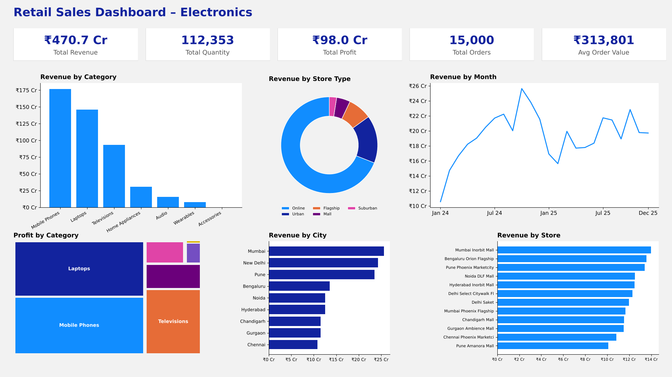
Figure 1: Overview of the Retail Sales Dashboard main page (rebuilt from the dashboard data).

3. Headline KPIs
The business recorded ₹470.7 Cr in revenue and ₹98.0 Cr in profit, a margin of 20.8%. Every order contains a single sales line, so the average order value of about ₹3.14 lakh reflects the high ticket size of phones, laptops and televisions.
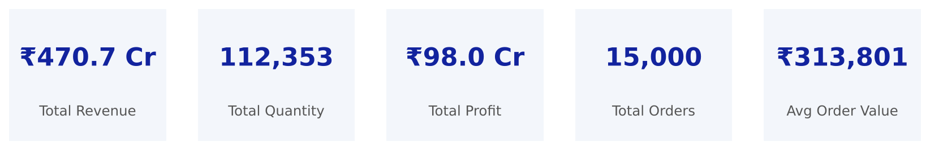
Figure 2: Headline KPI cards (Revenue, Quantity, Profit, Orders, Average Order Value).
KPI | Value
Total Revenue | ₹470.7 Cr
Total Cost | ₹372.7 Cr
Total Profit | ₹98.0 Cr
Profit margin | 20.8%
Total Quantity | 112,353 units
Total Orders | 15,000
Average Order Value | ₹3,13,801

4. Revenue Trend
Revenue rose steadily through 2024 and peaked in October 2024 at about ₹25.6 Cr, which is consistent with festive-season demand. The 2025 pattern was flatter and lower overall: ₹230.8 Cr against ₹234.7 Cr in 2024 (down about 1.7%), and the October peak was not repeated. January 2026 contains only 11 days of data, so it is excluded from the trend and should not be compared with full months.
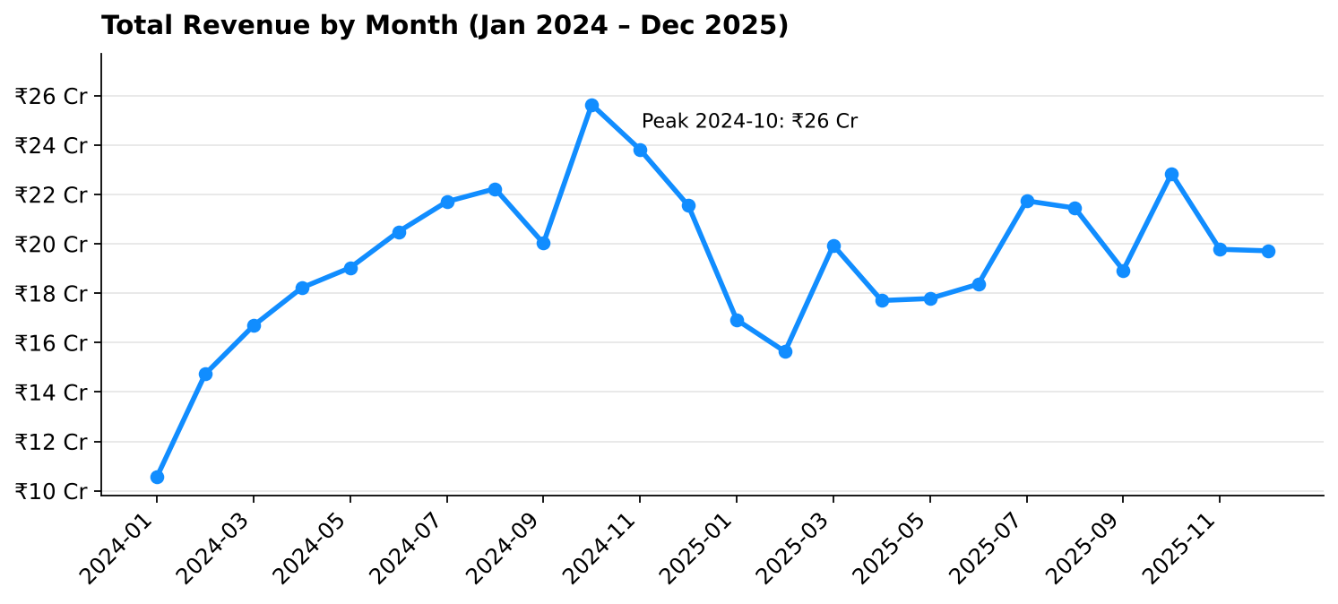
Figure 3: Monthly revenue, January 2024 to December 2025.
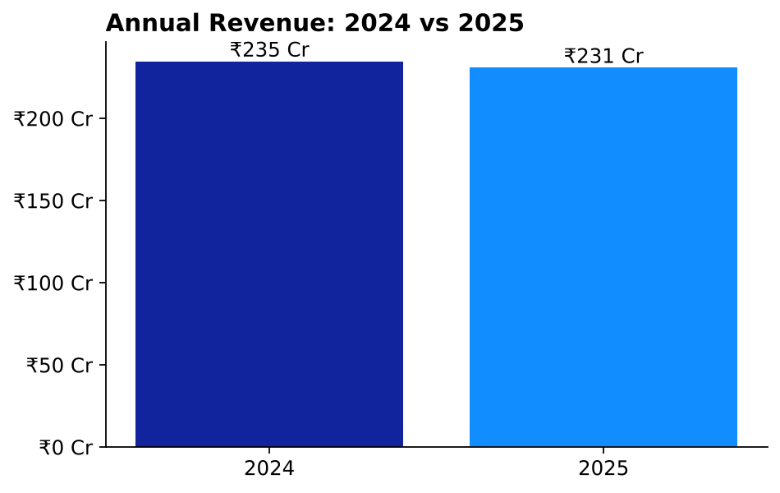
Figure 4: Annual revenue, 2024 against 2025 (January 2026 excluded).

5. Product Performance
Mobile Phones are the largest category at ₹176.9 Cr (37.6% of revenue), followed by Laptops at ₹145.8 Cr (31.0%) and Televisions at ₹93.2 Cr (19.8%). At subcategory level, Premium Smartphones alone generate ₹89.4 Cr, showing that revenue is concentrated in premium products.
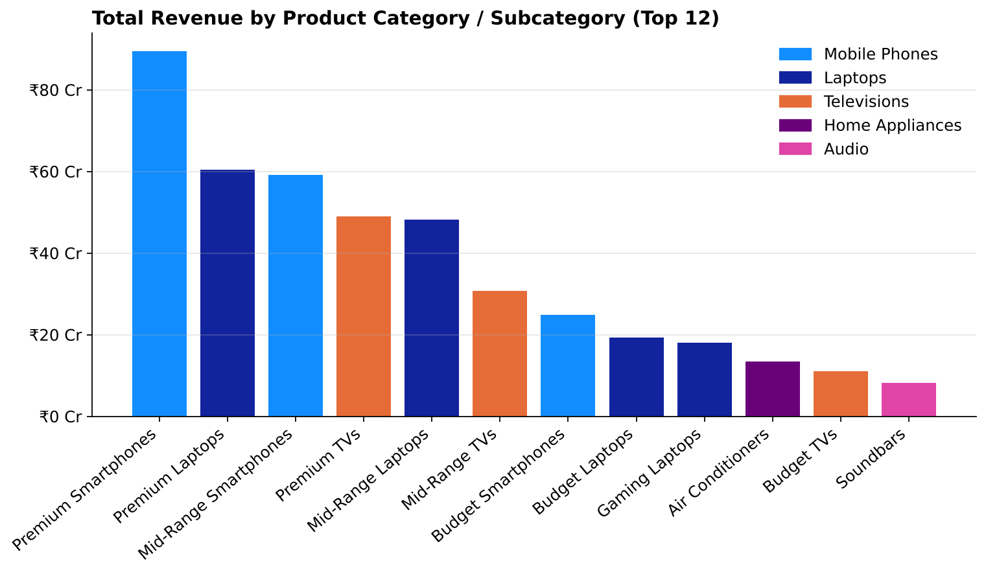
Figure 5: Revenue by product category and subcategory (top 12).
Profit differs slightly from revenue. Mobile Phones (₹34.9 Cr) and Laptops (₹33.5 Cr) are almost equal in profit, even though phones sell more, because laptops carry a better margin (23.0% against 19.7%). Televisions have the lowest margin among the big three at 18.3%. Accessories have the highest margin (36.7%) but are too small to matter at ₹0.25 Cr of revenue.
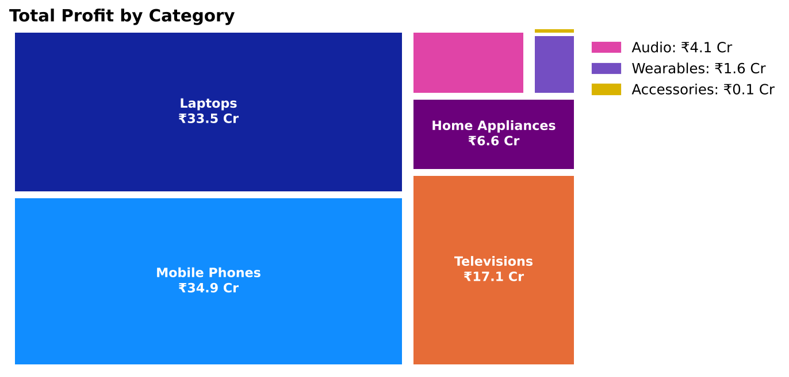
Figure 6: Profit contribution by category (treemap).
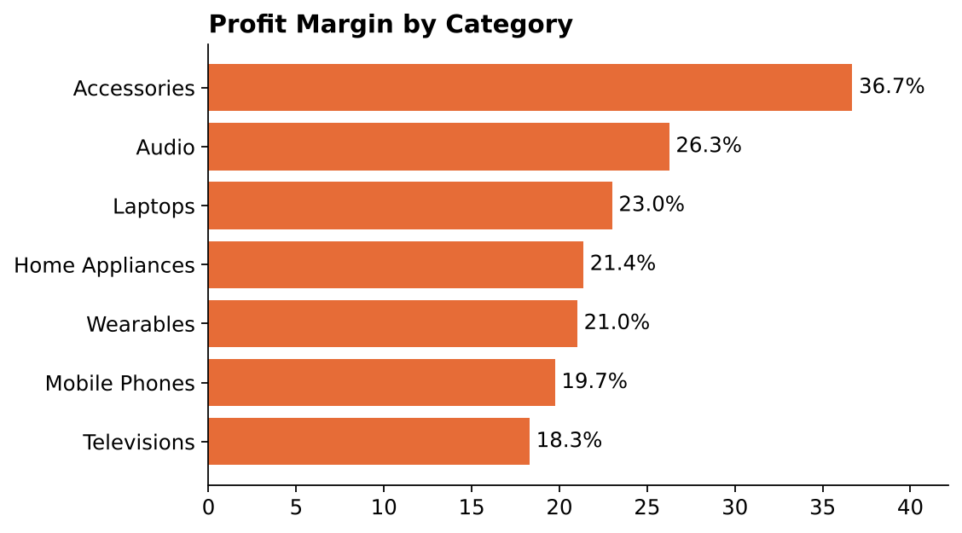
Figure 7: Profit margin by category.
Samsung (₹104.7 Cr) and Apple (₹90.6 Cr) are the two leading brands by revenue, together accounting for about 41% of the total, well ahead of LG (₹30.7 Cr) and Dell (₹29.9 Cr).
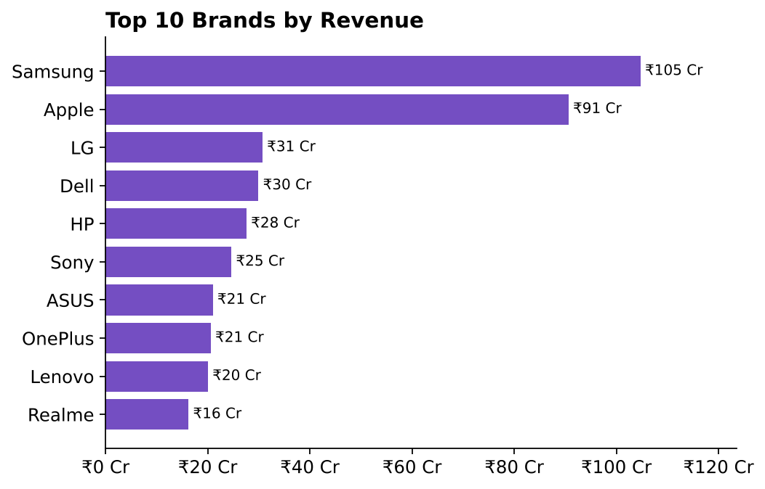
Figure 8: Top 10 brands by revenue.

6. Store Type and City Performance
The Online store is the dominant channel with ₹324.9 Cr, or 69% of total revenue. All physical stores combined contribute about ₹145.8 Cr. Among cities with physical stores, Mumbai (₹25.6 Cr), New Delhi (₹24.3 Cr) and Pune (₹23.5 Cr) lead.
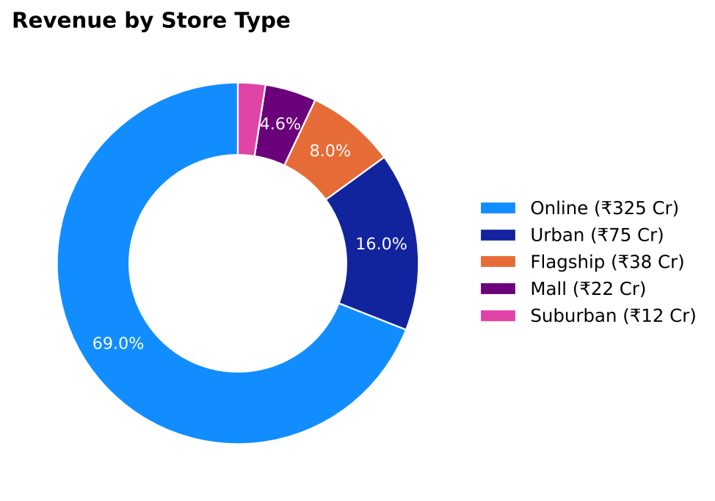
Figure 9: Revenue share by store type.
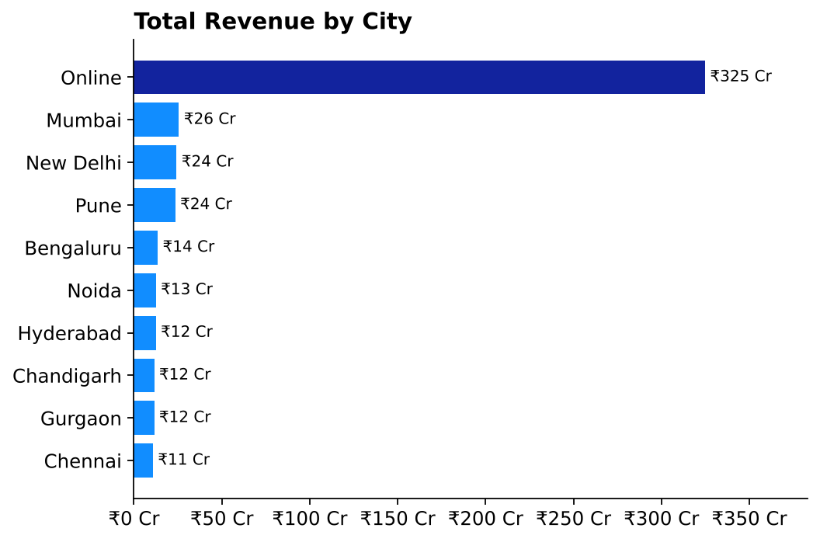
Figure 10: Revenue by city.
At state level, Maharashtra is the strongest physical-store market at ₹49.1 Cr, followed by Delhi (₹24.3 Cr) and Karnataka (₹13.6 Cr).
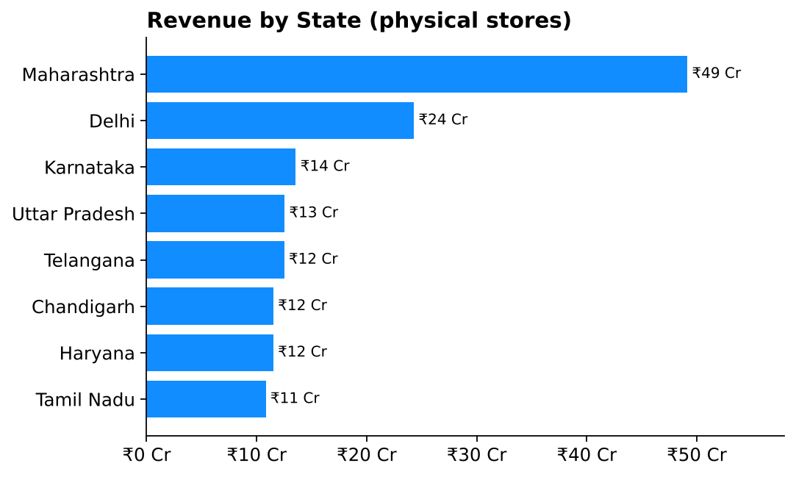
Figure 11: Revenue by state (physical stores).

7. Store-wise Performance
Among physical stores, Mumbai Inorbit Mall ranks first (₹14.0 Cr), followed by Bengaluru Orion Flagship (₹13.6 Cr) and Pune Phoenix Marketcity (₹13.4 Cr). The weakest store, Pune Amanora Mall (₹10.1 Cr), is not far behind, so performance across physical stores is fairly even.
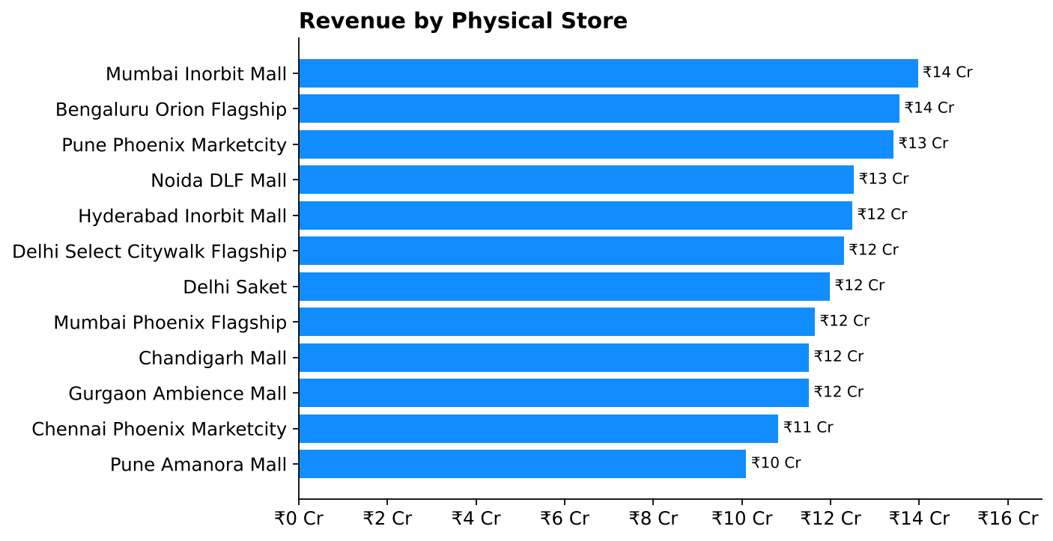
Figure 12: Revenue by physical store (Online store excluded).

8. Customer Segments
Regular customers contribute the most revenue (₹189.5 Cr), followed by Occasional customers (₹138.8 Cr). The Value and Premium segments contribute about ₹71 Cr each.
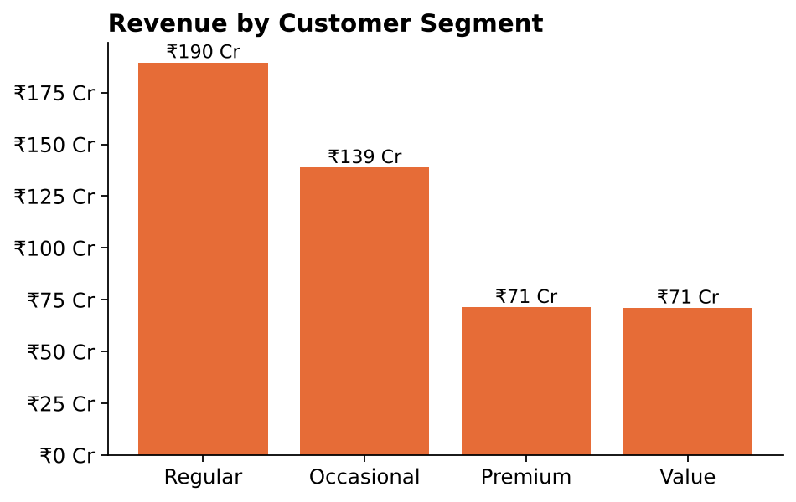
Figure 13: Revenue by customer segment.

9. Data Quality Findings
The Data validation page of the dashboard highlights record-level checks. Our review of the model found the following issues, which should be corrected in Power Query:
Issue | Where | Effect
Store type typed as " urban" (leading space, lowercase) | Dim Store | Shows as a separate slice from "Urban" in the donut and slicer. Noida DLF Mall (₹12.5 Cr) is split away
Customer segment typed as " PREMIUM" | Dim Customer | Appears as an extra segment next to "Premium" (₹0.47 Cr)
Blank salesperson_id | 300 sales rows | These sales cannot be attributed to any salesperson
Returned items | 292 sales rows | Returns are flagged but revenue is not reduced for them

The charts in this report merge the two text-case issues so that the figures are correct. The Power BI visuals will continue to show them as separate values until the text is cleaned (Transform data → Trim, then Capitalize Each Word).

10. Recommendations
- Reduce dependence on the Online channel. With 69% of revenue from one store, any disruption there has a large impact. Grow the physical stores, which have even performance and room to scale.
- Investigate the 2025 slowdown. Compare festive-season campaigns, pricing and stock between 2024 and 2025 to understand why the October peak did not repeat.
- Protect and grow premium segments. Premium Smartphones and Premium Laptops lead revenue; ensure stock and promotions focus on them. Review Televisions, which have the lowest margin (18.3%) among the major categories.
- Clean the data model. Trim and standardise text columns, assign missing salesperson IDs, and adjust revenue for returns so that the dashboard reflects the true position.

11. Conclusion
The business is strongly online-driven and depends on premium phones, laptops and televisions for about 88% of revenue. Revenue flattened in 2025 after a strong 2024, so the next step is to understand why the festive-season peak did not repeat and to clean the data so that the dashboard slicers are reliable.

