系統性文獻搜尋：紀錄表
Literature Search for Conducting Systematic Review: Documentation Form
- 研究問題Question
Question: | 學齡童增加身體活動可以促進體重管理嗎？
Population | 學齡童
Intervention | 身體活動
Comparison
Outcome | 體重管理 (實務上不會訂定單一outcome，也不一定會納入檢索)
收錄研究設計： | RCTs ☐ Cohort Studies ☐Systematic Reviews ☐Other:
我的研究設計： | SR/MA ☐Scoping Review ☐Umbrella Review ☐Other:
備註：
- 檢索詞 Search Terms每換行代表OR (不須標示) 在此請專注於詞彙整理
主題概念  🔪切出來 | 自由詞彙：中文同義字  Chinese Synonyms | 自由詞彙：英文同義字  English Synonyms |  | 控制詞彙  Controlled Vocabulary
主題概念  🔪切出來 | 自由詞彙：中文同義字  Chinese Synonyms | Before | After | 控制詞彙  Controlled Vocabulary
P | 學齡童  學童  學生  兒童  幼童 | schoolchild  schoolboy  schoolgirl  pupil  elementary student  elementary students  primary student | schoolchild*  schoolboy*  schoolgirl*  pupil*  ((elementary  primary)  相鄰3單字  (student*  child*)) | Academic Search Complete  SCHOOL children  ERIC  Elementary School Students  (拆開的也可考慮納入)  Elementary School  AND  Students  Children
I | 身體活動  運動  …
C | - | - | - | -
O | 體重  減重  …
蒐集  管道 |  | ☐控制詞彙表之同義詞清單  ☐控制詞彙表之狹義控制詞彙  ☐SR: Search Strategies Appendices; Supplementary; Methods  ☐瀏覽相關文章  ☐ChatGPT 發問架構 |  | ☐詞表查詢＞決定控制詞彙位階(廣/狹)  ☐高相關文章的控制詞彙給了甚麼  index term, index miner, subject filter  ☐ SR: Search Strategies  Appendices; Supplementary; Methods  ☐ 交叉檢查不同控制詞彙表的對應：若Embase有某個控制詞彙，應該推想另一個資料庫(MEDLINE等)也可能有對應的控制詞彙，反之亦然
重要  檢核 |  | ☐單字切截處理  跨庫通用性，建議使用字尾切截*，並使至少要包含名詞單複數，  必要時再擴至形容詞與動詞  字頭起始太短時，避免使用切截  例：hear*誤找heart。解法直接列出可能字尾變化hear、hearing  ☐詞彙去冗: 輸入一個單字(詞)即能找出含括者，不需冗贅列出  例: 使用exercise即能找到exercise therapy、physical exercise…  例: 使用"quality of life"能找到"health-related quality of life"  無法找到"life quality", "quality-adjusted of life"  ☐指定單字間的距離：一個詞彙由兩個單字(含以上)組成時  例gestational diabetes，必須指定其為下列三種關係之一  文章數由多到少如下，建議採用鄰近字或片語(超重要!)  交集: (gestational AND diabetes)  鄰近字: (gestational 鄰n單字內 diabetes)  有多個同義詞群時，並可簡化表達，請參考After範例  片語: "gestational diabetes"  採"雙直引號" 優於 “上下引號” 設定說明  ☐連字符號: 例anti-cancer = "anti cancer" ≠ anticancer  ☐所有格: "Parkinson* Disease*"  在Embase無法找出 "Parkinson's Disease*" ('s被視為一個單字)  三解法擇一: 只輸入Parkinson* (當不會找到太多非疾病時)  (Parkinson* NEXT/2 Disease*)  "Parkinson* Disease*" OR "Parkinson s Disease*" (勿用單引號's)  ☐舒適閱讀很重要，檢索詞大小寫法請一致 |  | ☐控制詞彙無切截用法 Exercise*  ☐控制詞彙的廣狹義(位階)  無互屬：適用都列出  Exercise、Exercise Therapy  有互屬：列出最適用位階詞 (皆列出亦可)  Exercise廣於Running  使用Exercise即可指定包含Running  語法將設定自動納入所有狹義詞  筆記時請利用縮格呈現廣狹義，有利釐清關係  可標灰表示不需檢索

- 搜尋資料庫 Searched Databases
資料庫  Database | 新文通知  Alert | 搜尋日期  Date searched | 筆數Citations
資料庫  Database | 新文通知  Alert | 搜尋日期  Date searched | 搜尋結果  Records identified from | 篇名摘要待篩選  Records screened |  | 全文待獲取  Reports sought for retrieval |  | 全文待篩選  Reports assessed for eligibility |  | 納入分析 Included
- ASC |  |  | 5,366 | included: |  | included: |  | included: |  | Studies included in review:  Reports of included studies:
- ERIC |  |  | 895
- Scopus
- Web of Science
other sources | - | -
文獻篩選流程PRISMA flow diagram:  篩選流程管理與去重複書目，可利用相關工具，例如EndNote、Rayyan等進行管理。 |  |  | included:
 |  |  | de-duplicates: |  | excluded: |  | excluded: |  | excluded:  說明排除理由

- 搜尋策略Search Strategy（投稿時附上此項為Appendix）
資料庫  Database | # | 搜尋語法  Search syntax | 結果筆數Citations found
- Academic Search Complete (ASC) [EBSCOhost] | 1
- Academic Search Complete (ASC) [EBSCOhost] | 2
- Academic Search Complete (ASC) [EBSCOhost] | 3
- Academic Search Complete (ASC) [EBSCOhost] | 4
- Academic Search Complete (ASC) [EBSCOhost] | 5
- Academic Search Complete (ASC) [EBSCOhost] | 6
- Academic Search Complete (ASC) [EBSCOhost] | 7
- Academic Search Complete (ASC) [EBSCOhost] | 8
- ERIC [EBSCOhost] | 1
- ERIC [EBSCOhost] | 2
- ERIC [EBSCOhost] | 3
- ERIC [EBSCOhost] | 4
- ERIC [EBSCOhost] | 5
- ERIC [EBSCOhost] | 6
- ERIC [EBSCOhost] | 7
- ERIC [EBSCOhost] | 8
Compendex (Engineering Village) | 1
Compendex (Engineering Village) | 2
Compendex (Engineering Village) | 3
Compendex (Engineering Village) | 4
Compendex (Engineering Village) | 5
Compendex (Engineering Village) | 6
Compendex (Engineering Village) | 7
Scopus  在進階介面輸入 | 1
Scopus  在進階介面輸入 | 2
Scopus  在進階介面輸入 | 3
Scopus  在進階介面輸入 | 4
Scopus  在進階介面輸入 | 5
Web of Science  在進階介面輸入 | 1
Web of Science  在進階介面輸入 | 2
Web of Science  在進階介面輸入 | 3
Web of Science  在進階介面輸入 | 4

- 檢索截圖／備忘

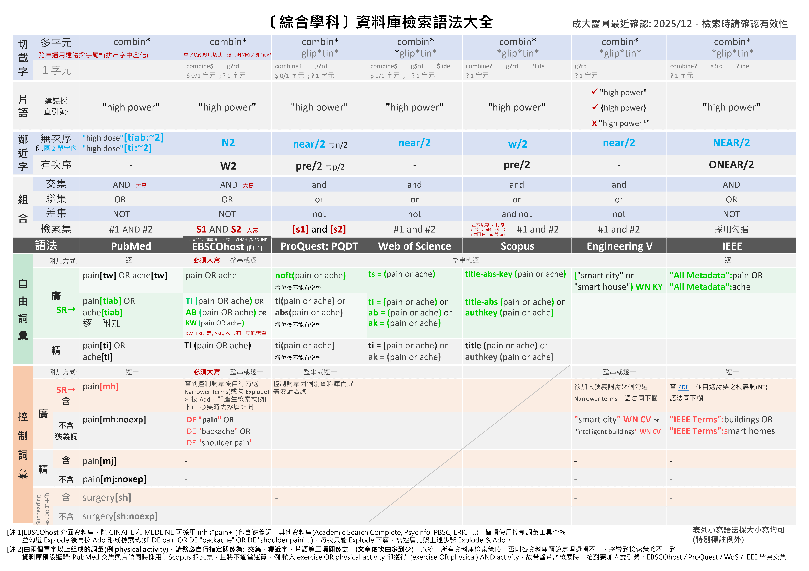
附錄1

附錄2a: Observational Study: Cross-Sectional Study (不同研究問題類型/研究設計、資料庫/平台，套用的Filters各異，請謹慎，如有需要請洽詢；紅字是有異於原始)
Embase [Elsevier] | Medline [Ovid] | Medline [PubMed] | CINAHL [EBSCOhost] | PsycInfo [EBSCOhost] | Web of Science
('cross-sectional study'/de OR 'correlational study'/de OR ('cross section*' OR crosssection* OR crossection* OR 'descriptive stud*'):ti,ab,kw)  Source: modified from Cochrane, https://www.cochrane.org/MR000041/METHOD_search-strategies-identify-observational-studies-medline-and-embase | (Cross-Sectional Studies/ OR ("cross section*" OR crosssection* OR crossection*).ti,ab.)  Source: modified from Cochrane, https://www.cochrane.org/MR000041/METHOD_search-strategies-identify-observational-studies-medline-and-embase | (Cross-Sectional Studies[mh:noexp] OR "cross section*"[tiab] OR crosssection*[tiab] OR crossection*[tiab])  Source: modified from Cochrane, http://bestpractice.bmj.com/info/toolkit/learn-ebm/study-design-search-filters/ | (MH ("Cross Sectional Studies" OR "Correlational Studies" OR "Descriptive Research") OR TI ("cross section*" OR crosssection* OR crossection* OR correlational OR "descriptive stud*" OR AB ("cross section*" OR crosssection* OR crossection* OR correlational OR "descriptive stud*"))  Source: modified from Cochrane, http://bestpractice.bmj.com/info/toolkit/learn-ebm/study-design-search-filters/ |  | TS=("cross section*" OR crosssection* OR crossection*)  Source: modified from Cochrane, http://bestpractice.bmj.com/info/toolkit/learn-ebm/study-design-search-filters/
 |  |  |  |  | Scopus
title-abs-key ("cross section*" OR crosssection* OR crossection*)

Source: modified from Cochrane, http://bestpractice.bmj.com/info/toolkit/learn-ebm/study-design-search-filters/

附錄2b: Qualitative Study (不同研究問題類型/研究設計、資料庫/平台，套用的Filters各異，請謹慎，如有需要請洽詢)
此區為成大醫圖自行彙整，可再加入研究所屬領域中較常使用的質性研究方法。亦可參考: https://hiruweb.mcmaster.ca/hkr/hedges/
Embase.com [Elsevier] | Medline [Ovid] | Medline [PubMed] | CINAHL [EBSCOhost] | PsycInfo [Ovid] | Web of Science
('qualitative research'/exp OR 'interview'/exp OR (qualitative OR interview* OR themes OR experience*):ti,ab,kw | (exp "Qualitative Research"/ OR interview.pt OR (qualitative OR interview* OR themes OR experience*).ti,ab,kf) | ("Qualitative Research"[mh] OR interview[pt] OR qualitative[tiab] OR interview*[tiab] OR themes[tiab] OR experience*[tiab]) | (MH ("Qualitative Studies+" OR "Interview+") OR TI (qualitative OR interview* OR themes OR experience*) OR AB (qualitative OR interview* OR themes OR experience*)) | (exp "Qualitative Methods"/ OR exp "Interview"/ OR (qualitative OR interview* OR themes OR experience*).ti,ab,kf)  包含mixed methods:  (exp "Qualitative Methods"/ OR exp "Interview"/ exp "Experiences (Events)"/ OR exp "Mixed Methods Research"/ OR (qualitative OR interview* OR themes OR experience* OR "mixed method*").ti,ab,kf) | TS = (qualitative OR interview* OR themes OR experience*)
 |  |  |  | Psychology and Behavioral Sciences Collection: PBSC (EBSCOhost) | Scopus
 |  |  |  | -- | Title-Abs-Key (qualitative OR interview* OR themes OR experience*)

附錄2c: Systematic Review (不同研究問題類型/研究設計、資料庫/平台，套用的Filters各異，請謹慎，如有需要請洽詢)
Embase.com [Elsevier] | Medline [Ovid] | Medline [PubMed] | CINAHL [EBSCOhost] | Web of Science | 華藝
((("review"/exp OR (literature NEAR/3 review*):ti,ab) AND ((medline or medlars or embase or pubmed or cinahl or amed or psychlit or psyclit or psychinfo or psycinfo or scisearch or cochrane):ti,ab OR "RETRACTED ARTICLE"/de)) OR ((systematic* NEAR/2 (review* or overview)) OR meta$anal* or "meta anal*" or "meta-anal*" or metaanal* or metanal*):ti,ab OR "meta analysis"/exp OR "systematic review"/exp)  Source: modify SR filter from BMJ Best Practice  https://bestpractice.bmj.com/info/toolkit/learn-ebm/study-design-search-filters/ | ((review.pt. AND ((medline or medlars or embase or pubmed or cochrane or scisearch or psychinfo or psycinfo or psychlit or psyclit or cinahl or (hand adj2 search$) or (manual$ adj2 search$) or "electronic database$" or "bibliographic database$" or "computeri?ed database$" or "online database$" or pooling or pooled or "mantel haenszel" or peto or dersimonian or "der simonian" or "fixed effect").tw,sh. or "retraction of publication".pt or "retracted publication".pt)) OR "meta-analysis".pt. or "meta-analysis".sh. OR (meta-analys$ or "meta analys$" or metaanalys$ or (systematic$ adj5 review$) or (systematic$ adj5 overview$) or (quantitativ$ adj5 review$) or (quantitativ$ adj5 overview$) or (quantitativ$ adj5 synthesis$) or (methodologic$ adj5 review$) or (methodologic$ adj5 overview$)).tw,sh OR "integrative research review$".tw or "research integration".tw)  Source: modify SR filter from BMJ Best Practice  https://bestpractice.bmj.com/info/toolkit/learn-ebm/study-design-search-filters/ | ((review[pt] AND (medline OR medlars OR embase OR pubmed OR cochrane OR scisearch OR psychinfo OR psycinfo OR psychlit OR psyclit OR cinahl OR (hand AND search*) OR (manual* AND search*) OR "electronic database*" OR "bibliographic database*" OR "computerised database*" OR "computerized database*" OR "online database*" OR pooling OR pooled OR "mantel haenszel" OR peto OR dersimonian OR "der simonian" OR "fixed effect" OR "retraction of publication"[pt] OR "retracted publication"[pt])) OR "meta-analysis"[pt] OR meta-analys* OR "meta analys*" OR metaanalys* OR ((systematic* OR quantitative* OR methodologic*) AND (review* OR overview*)) OR "integrative research review*" OR "research integration")  Source: modify SR filter from BMJ Best Practice  https://bestpractice.bmj.com/info/toolkit/learn-ebm/study-design-search-filters/ | ((TI (systematic* n3 review*)) or (AB (systematic* n3 review*)) or (TI (systematic* n3 bibliographic*)) or (AB (systematic* n3 bibliographic*)) or (TI (systematic* n3 literature)) or (AB (systematic* n3 literature)) or (TI (comprehensive* n3 literature)) or (AB (comprehensive* n3 literature)) or (TI (comprehensive* n3 bibliographic*)) or (AB (comprehensive* n3 bibliographic*)) or (TI (integrative n3 review)) or (AB (integrative n3 review)) or (JN “Cochrane Database of Systematic Reviews”) or (TI (information n2 synthesis)) or (TI (data n2 synthesis)) or (AB (information n2 synthesis)) or (AB (data n2 synthesis)) or (TI (data n2 extract*)) or (AB (data n2 extract*)) or (TI (medline or pubmed or psyclit or cinahl or (psycinfo not “psycinfo database”) or “web of science” or scopus or embase)) or (AB (medline or pubmed or psyclit or cinahl or (psycinfo not “psycinfo database”) or “web of science” or scopus or embase)) or (MH “Systematic Review”) or (MH “Meta Analysis”) or (TI (meta-analy* or metaanaly*)) or (AB (meta-analy* or metaanaly*)))  Source: SR filter from https://libguides.sph.uth.tmc.edu/search_filters/cinahl_filters | ((DT=(Review) and (TS=(medline or medlars or embase or pubmed or cochrane or scisearch or psychinfo or psycinfo or psychlit or psyclit or cinahl or (hand NEAR/3 search*) or (manual* NEAR/3 search*) or "electronic database*" or "bibliographic database*" or "computeri*ed database*" or "online database*" or pooling or pooled or "mantel haenszel" or peto or dersimonian or "der simonian" or "fixed effect") or DT=("Retracted Publication"))) OR TS=(meta-analys* or "meta analys*" or metaanalys* or (systematic* NEAR/4 review*) or (systematic* NEAR/4 overview*) or (quantitativ* NEAR/4 review*) or (quantitativ* NEAR/4 overview*) or (quantitativ* NEAR/4 synthesis*) or (methodologic* NEAR/4 review*) or (methodologic* NEAR/4 overview*)) OR TS=("integrative research review*" or "research integration"))  Source: modify SR filter from BMJ Best Practice  https://bestpractice.bmj.com/info/toolkit/learn-ebm/study-design-search-filters/ | [ALL3]:(系統性 OR 系統回顧 OR 系統綜述 OR 系統評價 OR 統合分析 OR 薈萃分析 OR 整合分析 OR 元分析 OR meta* OR "systematic* review*" OR "systematic* overview*" OR "quantitativ* review*" OR "quantitativ* overview*" OR "quantitativ* synthes*" OR "methodologic* review*" OR "methodologic* overview*" OR "integrative research review*" OR "research* integration*" OR "systematic* literature*" OR "comprehensive review*" OR "integrative review" OR "evidence synthes*" OR "pool* analys*" OR "survey paper*")  註: "系統性"結合題目仍找到過多不相關文章時，需要調整檢索詞。  Source: NCKU Medical Library
 |  |  |  | Scopus | CNKI
 |  |  |  | ((DOCTYPE(RE) AND (Title-Abs-Key (medline or medlars or embase or pubmed or cochrane or scisearch or psychinfo or psycinfo or psychlit or psyclit or cinahl or (hand w/3 search*) or (manual* w/3 search*) or "electronic database*" or "bibliographic database*" or "computeri*ed database*" or "online database*" or pooling or pooled or "mantel haenszel" or peto or dersimonian or "der simonian" or "fixed effect") or DOCTYPE(tb))) OR Title-Abs-Key (meta-analys* or "meta analys*" or metaanalys* or (systematic* w/4 review*) or (systematic* w/4 overview*) or (quantitativ* w/4 review*) or (quantitativ* w/4 overview*) or (quantitativ* w/4 synthesis*) or (methodologic* w/4 review*) or (methodologic* w/4 overview*)) OR Title-Abs-Key ("integrative research review*" or "research integration"))  Source: modify SR filter from BMJ Best Practice  https://bestpractice.bmj.com/info/toolkit/learn-ebm/study-design-search-filters/ | SU=(系统性 + 系统回顾 + 系统综述 + 系统评价 + 统合分析 + 荟萃分析 + 整合分析 + 元分析 + meta + metaanalysis + metaanalyses + "systematic review" + "systematic overview" + "quantitative review" + "quantitative overview" + "quantitative synthesis" + "methodologic review" + "methodologic overview" + "integrative research review" + "research integration" + "systematic literature" + "comprehensive review" + "integrative review" + "evidence synthesis" + "pooled analysis" + "pooling analysis" + "survey paper")  註: "系統性"結合題目仍找到過多不相關文章時，需要調整檢索詞。  Source: NCKU Medical Library
 |  |  |  | PsycInfo [Ovid] | 萬方數據
 |  |  |  | (((literature review.md. or exp "literature review"/) AND ((medline or medlars or embase or pubmed or cochrane or scisearch or psychinfo or psycinfo or psychlit or psyclit or cinahl or (hand adj2 search*) or (manual* adj2 search*) or "electronic database*" or "bibliographic database*" or "computeri?ed database*" or "online database*" or pooling or pooled or "mantel haenszel" or peto or dersimonian or "der simonian" or "fixed effect").tw,sh. or retraction.dt.)) OR systematic review.md OR "meta-analysis".md. or metasynthesis.md. OR (meta-analys* or "meta analys*" or metaanalys* or (systematic* adj5 review*) or (systematic* adj5 overview*) or (quantitativ* adj5 review*) or (quantitativ* adj5 overview*) or (quantitativ* adj5 synthesis*) or (methodologic* adj5 review*) or (methodologic* adj5 overview*)).tw,sh OR "integrative research review*".tw or "research integration".tw)  Source: modify SR filter from BMJ Best Practice  https://bestpractice.bmj.com/info/toolkit/learn-ebm/study-design-search-filters/ | 主題:("系統性" OR "系統回顧" OR "系統綜述" OR "系統評價" OR "統合分析" OR "薈萃分析" OR "整合分析" OR "元分析" OR meta* OR "systematic* review*" OR "systematic* overview*" OR "quantitativ* review*" OR "quantitativ* overview*" OR "quantitativ* synthes*" OR "methodologic* review*" OR "methodologic* overview*" OR "integrative research review*" OR "research* integration*" OR "systematic* literature*" OR "comprehensive review*" OR "integrative review" OR "evidence synthes*" OR "pool* analys*" OR "survey paper*")  註: "系統性"結合題目仍找到過多不相關文章時，需要調整檢索詞。  Source: NCKU Medical Library

