CV

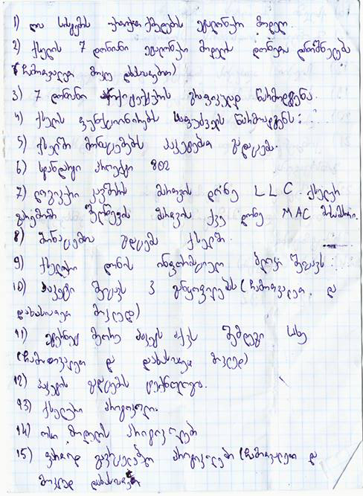

Name | asa
Surname | sdsd
Date Of Birth | asa
Address | sds
Mobile | asa
E-mail | sdsd

