CV

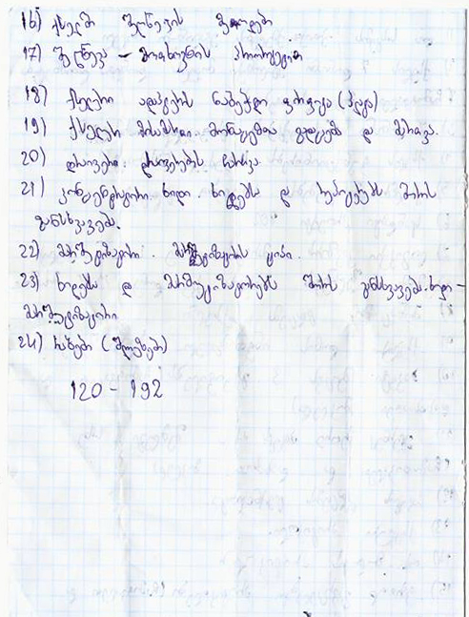
Personal Information
________________________________________________
Name | sds
Surname | sassd
Date Of Birth | a
Address | asas
Mobile | sds
E-mail | asas

