Efficient High-Resolution VQA under a Visual-Token Budget:
Joint Probe–Zoom Routing for HR-Bench 4K
Advanced Topics in Multimodal AI — Midterm Project 1 Student ID: 2026xxxxxx Name: ________

1. Overview
We design a training-free inference procedure that answers HR-Bench 4K (200 questions × 4 option orderings = 800 instances) with a frozen Qwen3-VL-2B-Instruct, while keeping the mean cumulative number of visual tokens per instance below 4,096 (Success 1) or 2,048 (Success 2). The method has three ingredients: (1) a joint probe that obtains both the answer distribution and an evidence bounding box from a single low-resolution global view, (2) confidence-based early stopping, and (3) a text-only question-type classifier that routes uncertain instances either to a zoomed crop or to a higher-resolution global re-observation.
Condition | Mean visual tokens | Accuracy (%) | Single | Cross | Target (Main / Optional)
Success 1 | 2730.2 ≤ 4,096 | 74.00 | 88.00 | 60.00 | ≥71 ✓ / ≥74 ✓
Success 2 | 1354.4 ≤ 2,048 | 71.88 | 88.75 | 55.00 | ≥68 ✓ / ≥71 ✓
Table 1. Final results (all 800 instances, end-to-end runs; a fresh re-run reproduced all 800 predictions and token counts).

2. Method

2.1 Visual-token accounting
Qwen3-VL uses 16×16 patches with 2×2 spatial merging, so one visual token covers 32×32 pixels. 136 of the 200 images are 4032×4032, which costs about 15,876 tokens at native resolution; the 4K and 2K budgets are therefore only 26% and 13% of the native cost. Every input image is resized by us (PIL Lanczos) to width and height that are multiples of 32 before it is passed to the official processor, so the processor does not resize it again. The token count is measured from the processor's image_grid_thw as N = t·h·w/4 (the number of <|image_pad|> tokens). An image sent twice within an instance is counted twice, and no KV cache is reused across calls. The dataset's category and answer fields are used only for scoring and analysis.

2.2 Inference pipeline
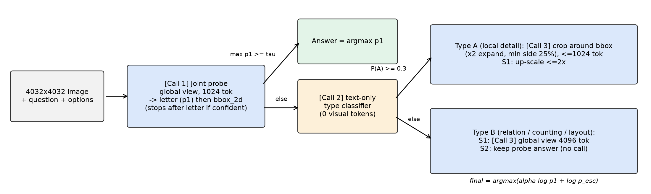
Figure 1. Final pipeline. Only the blue boxes consume visual tokens.
- Call 1 – Joint probe. The whole image is resized to 1,024 tokens (4032² → 1024² px) and the model is prompted to output the option letter first and then the bounding box of the evidence region. The A–D distribution p1 is the softmax over the four letter logits at the first decoding step. If max p1 ≥ τ, a stopping criterion ends generation right after that token. Otherwise the bbox_2d (0–1000 relative coordinates) produced later in the same generation is used, so locating the region costs no extra visual tokens.
- Call 2 – Type classification (0 visual tokens). Only for uncertain instances, Qwen sees the question and options without any image and decides whether the question needs (A) a fine detail of one object/region or (B) relations among multiple objects, counting, or scene layout. The instance is routed to A if P(A) ≥ 0.3 at the first token.
- Call 3 – Type-specific escalation. Type A: the probe box is expanded 2× (minimum side = 25% of the short image side, ≈1,008 px), cropped from the original image, and fed at ≤1,024 tokens (Success 1 additionally allows up to 2× up-scaling), with the prefix 'This image is a zoomed-in crop of a larger image.' Type B: Success 1 re-observes the whole image at 4,096 tokens; Success 2 keeps the probe answer and makes no further call.
- Fusion. Final answer = argmax(α·log p1 + log p_esc), with α = 0.25 for type A and α = 0 for type B.
Joint-probe prompt: "{question}\nA. …\nB. …\nC. …\nD. …\nAnswer with the option's letter from the given choices directly. Then, on a new line, output the bounding box of the image region that contains the evidence for your answer in JSON format {\"bbox_2d\": [x1, y1, x2, y2]}."
Type prompt: You will see a multiple-choice question about a high-resolution image. / Question: {question} / Options: / {options} / / Which kind of visual evidence is needed to answer it? / A. A fine detail of one single object or one small region (e.g., text, color, a small object's attribute). / B. The spatial relationship between multiple objects, counting several objects, or the overall layout of the scene. / Answer with A or B.
Config | Probe | τ | Type thr. | Type A (crop) | Type B | α (A / B)
Success 1 | 1,024 tok | 0.995 | 0.3 | ≤1,024 tok, 2× expand, up-scale ≤2 | global 4,096 tok | 0.25 / 0
Success 2 | 1,024 tok | 0.999 | 0.3 | ≤1,024 tok, 2× expand | keep probe answer | 0.25 / –
Table 2. Final hyper-parameters (configs/success1_4k.yaml, configs/success2_2k.yaml).
Configuration search. Each stage (probe, several crop variants, global re-observation) was first run once on all 800 instances without early stopping, logging per-instance A–D probabilities, boxes and token counts. Since later stages do not depend on the stopping threshold, the accuracy and exact mean token cost of any (τ, threshold, crop variant, α) combination can be computed offline without re-running the model. The selected configurations were then verified with full end-to-end runs (offline 74.00% / 72.00% → end-to-end 74.00% / 71.88%).

3. Experimental setup
One RTX 3090 (24 GB) per run, Python 3.11, PyTorch 2.5.1 (CUDA 12.4), transformers 4.57.1, bf16, SDPA attention, batch size 1. Every call uses the original Qwen/Qwen3-VL-2B-Instruct checkpoint and its official AutoProcessor. Decoding is greedy (do_sample=False, num_beams=1); thinking mode and beam search are not used. Multiple-choice answers are read from the A–D logits at the first decoding step, so there are no format errors. Latency is the end-to-end wall-clock time per instance, including image decoding and resizing. Every instance is processed independently; nothing is shared across the four orderings of the same question.

4. Results
Method | Mean visual tok | Acc | Single | Cross | Mean calls
Global resize 1024 | 1020.2 | 63.00 | 71.25 | 54.75 | 1.00
Global resize 2048 | 2028.2 | 66.38 | 78.00 | 54.75 | 1.00
Global resize 4096 | 4066.4 | 70.50 | 81.75 | 59.25 | 1.00
Global 512 + 2×2 tiles (384 tok each) | 2025.5 | 56.38 | 65.00 | 47.75 | 1.00
Global 1024 + 2×2 tiles (768 tok each) | 4040.4 | 62.25 | 73.50 | 51.00 | 1.00
Success 2 (ours) | 1354.4 | 71.88 | 88.75 | 55.00 | 2.10
Success 1 (ours) | 2730.2 | 74.00 | 88.00 | 60.00 | 2.34
Table 3. Comparison with baselines (HR-Bench 4K, 800 instances; Single/Cross have 400 instances each).
Global down-sampling gains only 3–4 points per doubling of tokens and reaches 70.5% at 4,096 tokens, below the 71% main target. Question-agnostic 2×2 tiling is even worse at the same budget (56.4% / 62.2%): each tile gains little resolution while splitting the scene, which hurts cross-instance questions most. Our method is +5.5 points above global-2048 while using only 1354 tokens, and +3.5 points above global-4096 with 2730 tokens. For reference, native resolution (≈15,800 tokens) reached 85.2% on a partial run of 54 instances.
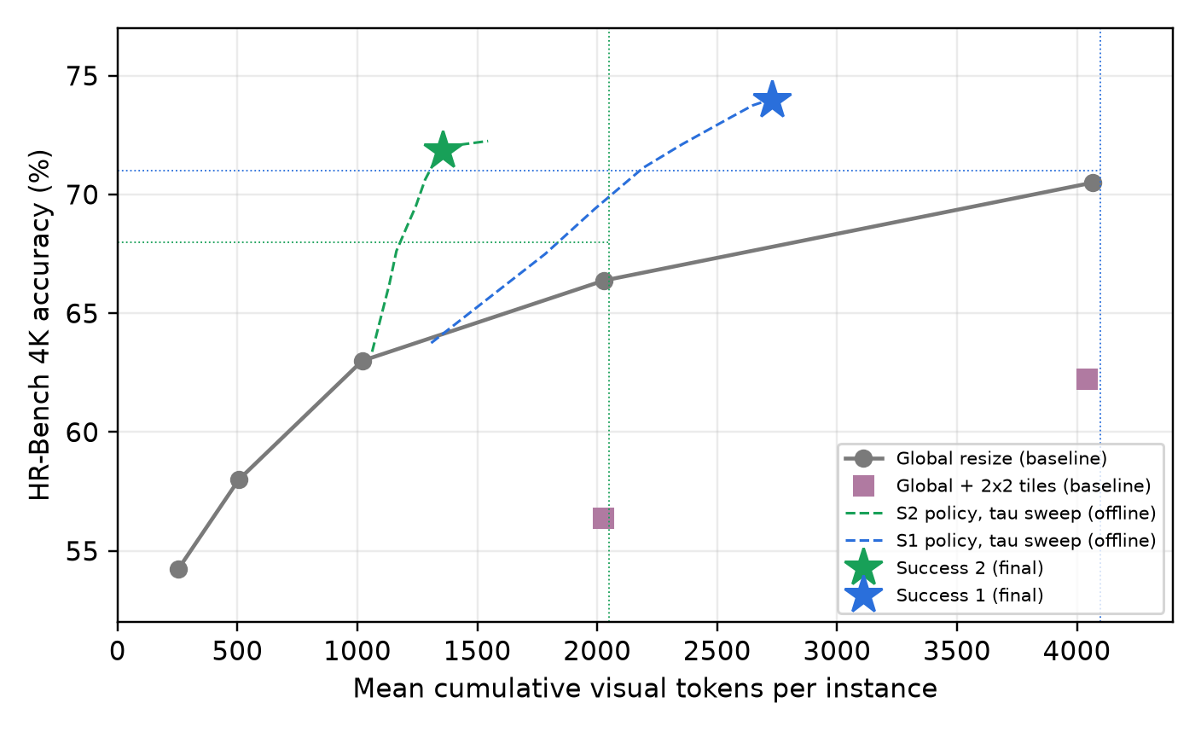
Figure 2. Accuracy vs. mean visual tokens. Dashed curves vary only τ of the final policies (offline); dotted lines mark budgets and main targets.

4.1 Per-call cost and token distribution
Config | Call | Count (/800) | Visual tok | Text input tok | Gen. tok | Latency (s)
S1 | Call 1 joint probe | 800 | 1020.2 | 106.9 | 34.6 | 1.270
S1 | Call 2 type classifier (text-only) | 536 | 0.0 | 130.9 | 1.0 | 0.035
S1 | Call 3 crop (type A) | 262 | 1016.4 | 73.1 | 1.0 | 0.201
S1 | Call 3 global 4096 (type B) | 273 | 4035.5 | 65.5 | 1.0 | 1.059
S2 | Call 1 joint probe | 800 | 1020.2 | 106.9 | 37.0 | 1.371
S2 | Call 2 type classifier (text-only) | 584 | 0.0 | 130.6 | 1.0 | 0.035
S2 | Call 3 crop (type A) | 296 | 903.1 | 72.7 | 1.0 | 0.182
Table 4. Mean cost per call type (text input tokens include the vision start/end special tokens).
An instance makes 2.34 (S1) / 2.10 (S2) Qwen calls and generates 35.9 / 38.1 tokens on average; most generated tokens are the bbox JSON of uncertain instances. End-to-end latency is 1.96 s mean / 4.62 s p95 (S1) and 1.64 s / 3.46 s (S2). Per-instance cost concentrates at 1,024 (early stop), ≈2,048 (crop) and ≈5,100 tokens (global re-observation), with maxima of 5120 (S1) and 2048 (S2) (Figure 3): tokens saved on easy instances are spent on hard ones.
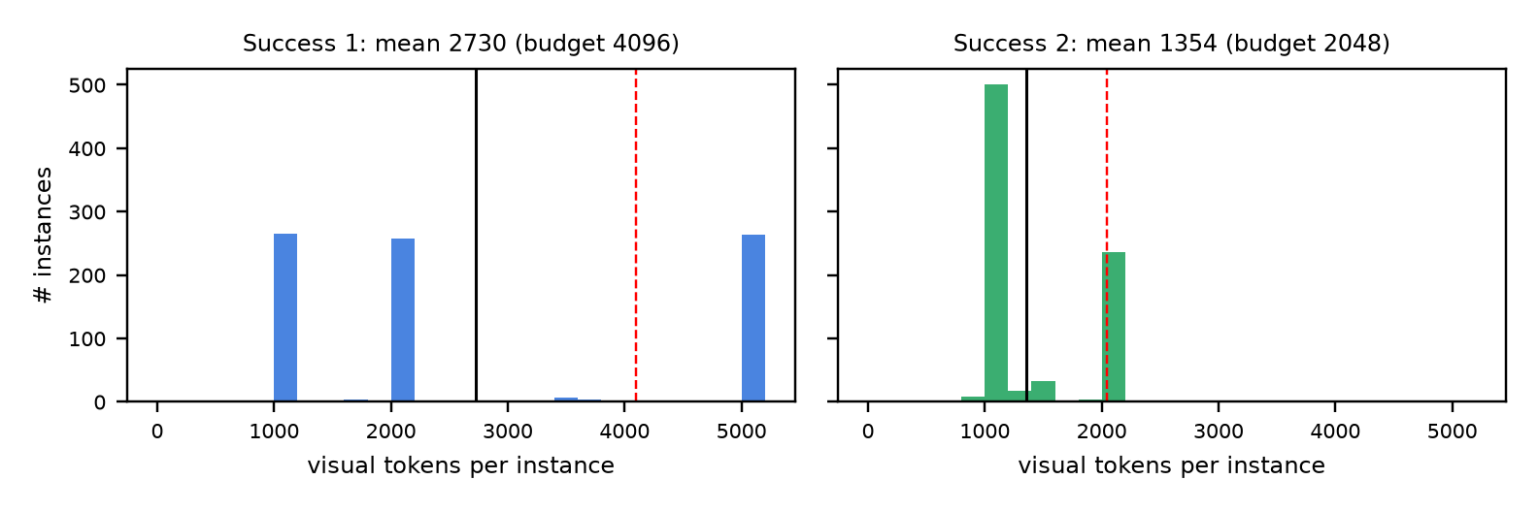
Figure 3. Distribution of cumulative visual tokens per instance (black: mean, red dashed: budget).

5. Key design decisions and ablation
- ① Confidence is well calibrated. On the 1,024-token probe, the 216 instances with max p1 ≥ 0.999 are 98.6% correct, whereas the remaining 584 are only 46.7% correct, so confidence is a reliable signal for deciding when to look closer.
- ② The joint probe makes localization free. Our first cascade used a separate grounding call after the probe, spending 1,024 tokens only to find the region. Asking for the bbox right after the answer letter removes that call: under the same policy it saves 246 tokens and changes accuracy by +1.88 points.
- ③ Zooming hurts cross-instance questions. Zooming fixed 86 and broke only 7 single-instance answers, but on cross-instance questions it fixed 54 while breaking 65. These questions (relative position, counting, map reasoning) need the whole scene, which motivated the image-free type router.
- ④ Type B benefits from a higher-resolution global view. With the 4K budget, type-B instances are re-observed globally at 4,096 tokens, raising cross accuracy from 55.5% to 60.0%.
Configuration (one factor changed) | Mean tok | Acc | Single | Cross
Success 2 (full) | 1356.7 | 72.00 | 89.00 | 55.00
− early stopping (τ = 1) | 1545.1 | 72.25 | 89.50 | 55.00
− type routing (crop for all) | 1610.6 | 71.88 | 89.00 | 54.75
− escalation (joint probe only) | 1020.2 | 60.75 | 69.25 | 52.25
separate grounding call instead of joint | 1602.8 | 70.12 | 83.00 | 57.25
Success 1 (full) | 2722.5 | 74.00 | 88.00 | 60.00
type B: keep probe (no re-observation) | 1355.6 | 71.50 | 87.50 | 55.50
type A: no up-scaling | 2682.0 | 73.75 | 88.00 | 59.50
type A: crop at 2,048 tok | 2705.3 | 73.62 | 87.75 | 59.50
Table 5. Controlled ablations computed from the same force-all logs (identical probe outputs and crops), changing one factor at a time.
Escalation is the largest contributor (probe only: 60.75%). Early stopping costs only 0.25 points while saving 188 tokens per instance. Type routing keeps 2K accuracy while saving 254 tokens. Raising the crop to 2,048 tokens does not help, so a 1,024-token crop is sufficient.

6. Success and failure analysis
Outcome | Success 1 | Success 2
Early stop – correct | 252 | 213
Early stop – wrong (premature stopping) | 12 | 3
Escalated – fixed (probe wrong → final correct) | 132 | 96
Escalated – stayed correct | 208 | 266
Unnecessary escalation (probe correct → final wrong) | 26 | 7
Escalated – still wrong | 170 | 215
Table 6. Instance-level outcome breakdown of the final runs.
Premature stopping is rare (12 in S1, 3 in S2); a typical case is a book-title question (#216) answered wrongly with probability 1.0. Unnecessary escalation affects 7 instances in S2 but 26 in S1, because S1 escalates more (lower τ) and does not fuse the probe for type B. Measured against the dataset labels (analysis only), the router sent 45 cross questions to type A and 19 single questions to type B in S1. Many of the former, such as identifying the president inside a red box on Mount Rushmore, really do need only one region and were answered correctly by the crop. The remaining errors are mostly cross-instance: map questions asking which numbered locations belong to the same country (48 instances) were answered correctly only 1 (S1) / 10 (S2) times, below chance, and counting questions (40 instances) 25 / 22 times.
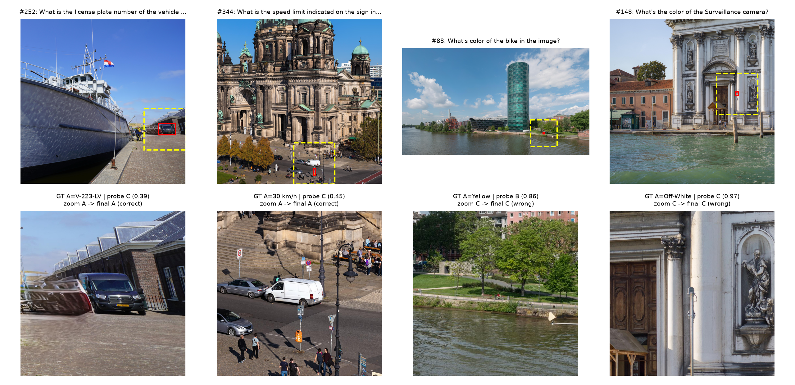
Figure 4. Representative cases (Success 2). Top: global view with probe box (red) and crop region (yellow, dashed). Bottom: the crop given to Call 3.
In #252 (license plate) and #344 (speed-limit sign), text that is unreadable in the 1,024-token global view becomes readable in the native-resolution crop, turning a wrong probe answer into a correct one. #88 combines unreadable detail with confusion: the box points near a bench where a person and the bicycle are, but the bicycle is only a few dozen pixels wide even at native resolution, and the model answers with the color of the person's red clothing. #148 is a recognition failure with the right region: a white object that appears to be the camera is on the pillar, yet the 2B model chooses 'there is no Surveillance camera'. Because the pipeline relies on a single box, a wrong first localization cannot be recovered.

7. Limitations and conclusion
- Tuning on the test set. τ, the type threshold, crop settings and α were selected on the same 800 instances without a separate validation set, and the type prompt was checked against the category labels. Accuracy varies by about one point for τ ∈ [0.99, 1], so the choice is not very sensitive, but the reported numbers may be slightly optimistic.
- Token accounting. Only <|image_pad|> tokens are counted. Adding the two vision start/end tokens per image (on average 1.67 images in S1 and 1.37 in S2) adds only 3.3 / 2.7 tokens, which keeps both runs within budget.
In summary, obtaining the model's own answer confidence and evidence box from one low-resolution call, and choosing how to look further with an image-free type decision, reaches 74.00% (Success 1) and 71.88% (Success 2) with fewer tokens than plain global down-sampling. The main remaining weakness is cross-instance reasoning, especially map questions that require reasoning over the whole scene.

