Now, we will discuss about the feasibility of the instruction based on the functionality of our completed product. Firstly, we will observe how far does the paper plane travel upon throwing. To observe the distance travelled by a paper plane, we will fly the airplane with attempting same force multiple times by following the last step in the instruction at different locations, which include central campus area and classroom. By varying the experimental environment, we can ensure that there is a contrast in wind speed in both areas. We will measure distance travelled by marking a starting point on the floor using a chalk. Then, we will stand on the mark and throw the paper plane. We will mark the spot that the paper plane landed on with the same chalk. After that, we will measure the distance travelled by the paper plane by using a measuring tape. We will then fly a simple paper plane as mentioned by repeating the steps. We will compare the result of both planes in both areas. The chart below shows the result:

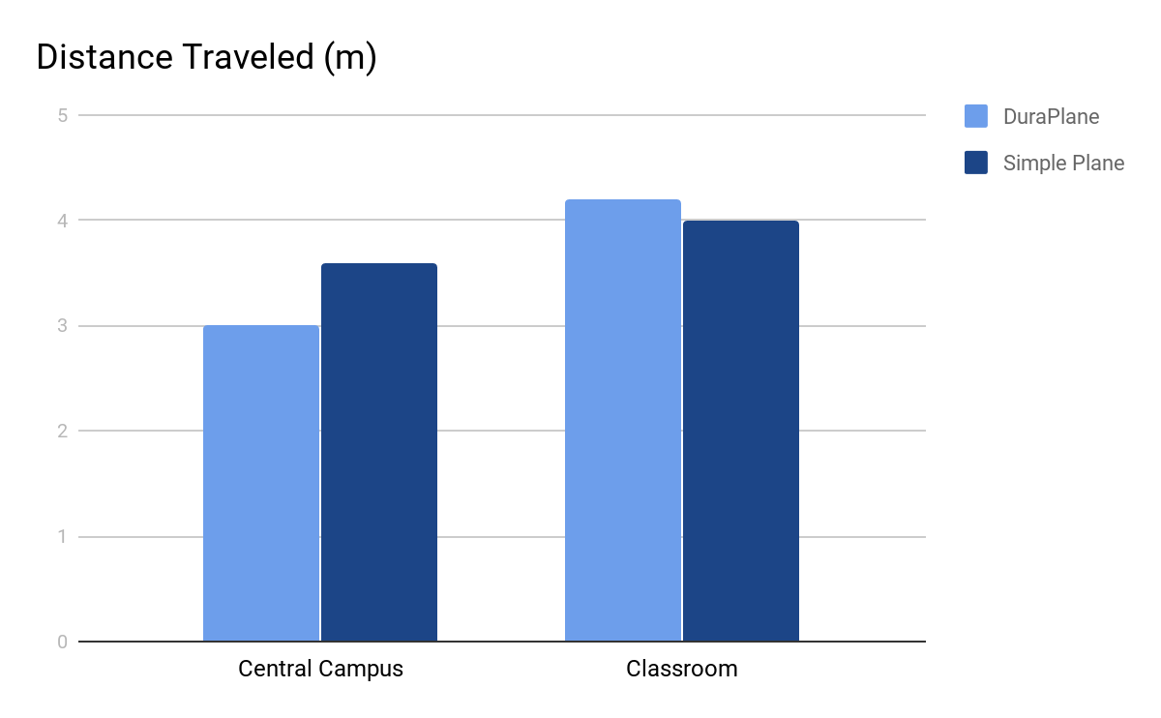

*Figure 1: Distance traveled by two different paper planes at different locations.*

From the chart above, we can observe that the differences between the distance travelled by DuraPlane and Simple Plane under different conditions are not significant. We can say that the DuraPlane does not resist wind as well as simple plane. Yet, DuraPlane still flies well in classroom. In conclusion, DuraPlane functions well and is a good product as a toy for people who want to release stress.

Secondly, we will inspect the durability of the product. In our experiment, we throw the airplane with attempting same force multiples times and stop throwing when it bends. Also, we throw a simple paper with the same step as mentioned. Then, we compare the number of times of hit that both paper planes can withstand before it bends. After the experiment, we record that DuraPlane could withstand 11 hits, while Simple Paper Plane could withstand 4 hits. From, our experiment, we can conclude that DuraPlane is much stronger than Simple Plane, thus it is durable.