Mobile Application Development

Assignment 1.

18309003 Roh sung ho

18309008 Nabil Madih

***Requirements:***

1, The prototype app should include functions such as,

* Look in the list of courses offered by a e-learing platform
* Navigate to the detailed course introductions such as course info , syllabus, registration and calendar and so on.
* Login to the E-learning platform
* Browse and search the learing materials which can be multi media.

2, Layouts for the above functions plus navigation through the layout UIs are necessary to be provided in this first stage prototype .

Function 1. Course List

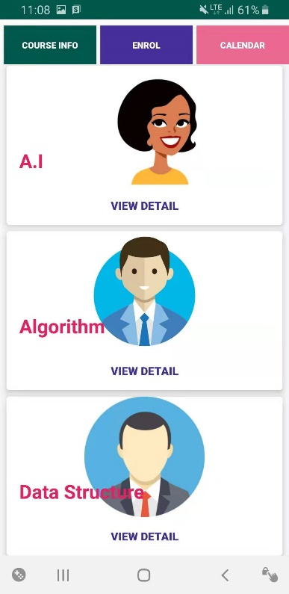

There is a proto type. So the design is not complemented…

We implemented the list of course which is offered by Learning platform. Also implemented the vertical scroll, User can swipe the screen up and down.

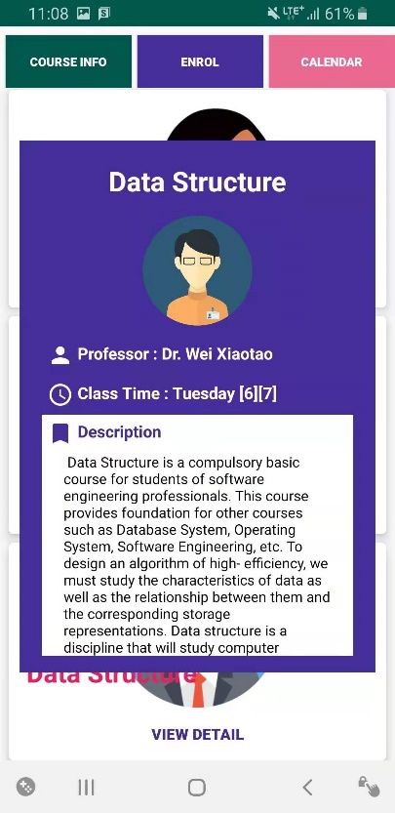

Using the Pop-up function, We implemented the course detail page.

Function 2. Login, Signup Function

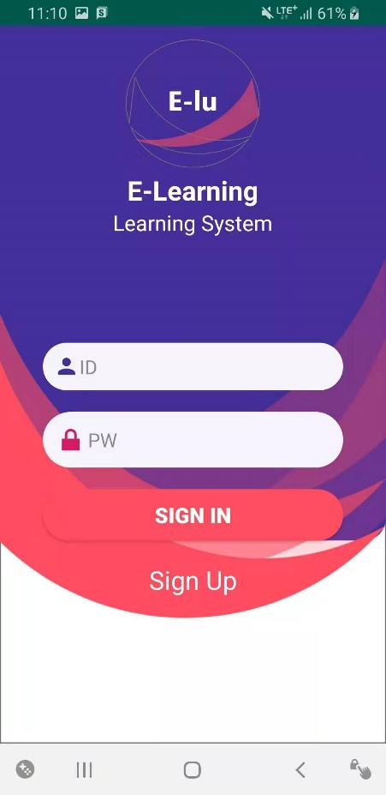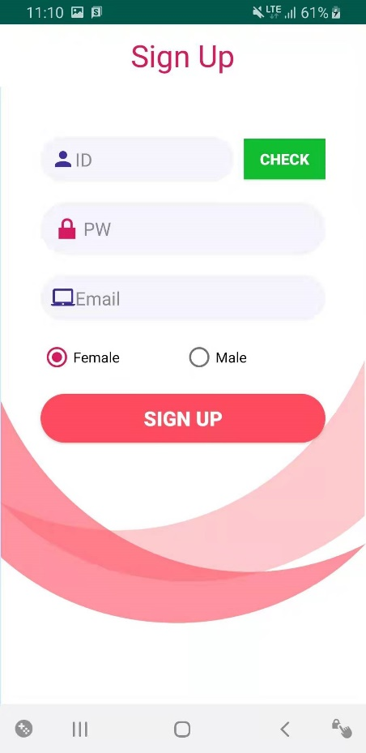

We implemented log-in, sign up function also.

When you write your username, This system can check if your ID is duplicated.

User date is stored in MySQL database system.

We need to use the PHP file for connect to the Database system.

This file is working for Register, when the user input the sign up form.

The date will be inserted in the M_USER table.

This PHP file is part of the Validation for check the Duplicate information.

This file is used when user login, System will get information from the M_USER table and check the information.

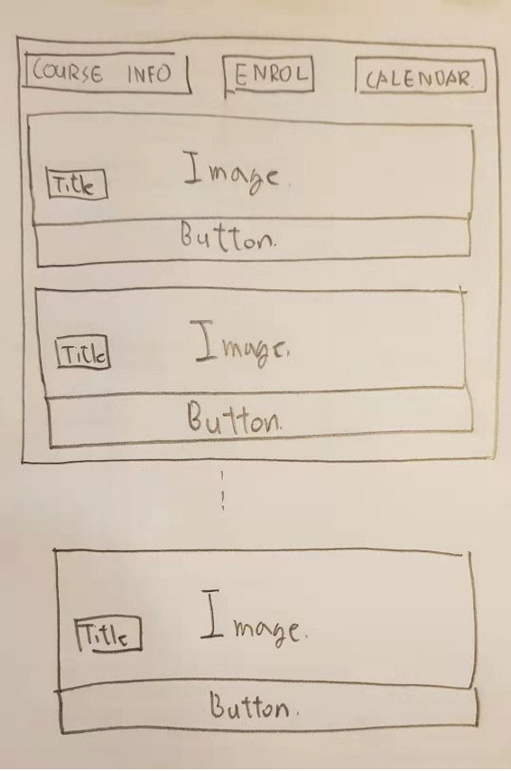

Here is a first design.